Redshift federated queries let you query live data in Aurora (or RDS) directly from Redshift, without first ETL-ing/copying it into Redshift.
How it works:
Redshift creates an external schema pointing to your Aurora (MySQL or PostgreSQL) database, using a Secrets Manager secret for credentials and a JDBC/native connection under the hood. Once that's set up, you can run a normal SQL query in Redshift that references tables in that external schema, and Redshift reaches out to Aurora in real time to pull the rows — you can even join federated Aurora tables with native Redshift tables in a single query.
Why it matters for a data warehouse lab: normally you'd build a pipeline (e.g., DMS, Glue, or COPY jobs) to periodically load operational data from Aurora into Redshift. Federated queries let you skip that lag — query the operational data as it currently is, or use it to do one-time/incremental loads into Redshift (INSERT INTO ... SELECT ... FROM external_schema.table) without a separate ETL tool.
Typical use case: combine live transactional data in Aurora (e.g., current inventory or orders) with historical, aggregated data already in Redshift, for a report that needs both up-to-the-minute and historical numbers.
Caveat: it works only with Aurora MySQL/PostgreSQL and RDS MySQL/PostgreSQL — not other databases — and read-only (you can query Aurora, not write to it from Redshift).
Amazon Aurora is AWS's managed relational database engine, compatible with MySQL and PostgreSQL. It's built for the cloud: storage is decoupled from compute and automatically replicated across multiple Availability Zones (6 copies across 3 AZs), it auto-scales storage up to 128TB, and it claims up to 5x the throughput of standard MySQL and 3x that of standard PostgreSQL. It's typically used as the operational/transactional database (OLTP) for an application — handling live reads and writes.
A federated query is a query that reaches across systems and queries data sitting in a different database engine, live, without moving or copying it first. In the Redshift context: Redshift is your analytical warehouse (OLAP), Aurora is your transactional database (OLTP). Instead of exporting Aurora data and loading it into Redshift before you can analyze it, a federated query lets Redshift reach into Aurora directly at query time and pull current rows, optionally joining them with tables already in Redshift in the same SQL statement.
So in your lab: Aurora holds the live operational data, and federated queries are the mechanism that lets your Redshift warehouse read that data on demand instead of waiting for a separate ETL load.
Question –
How redshift works in scenario of a query joinging orders in aurora my-sql and sales in redshift . Give some details of redshift working does it backed by parquet files?
Good question — there are actually three separate things people often conflate here: Redshift's own storage format, Redshift Spectrum, and federated queries. Let me walk through the orders/sales join specifically.
Step by step for SELECT ... FROM aurora_schema.orders o JOIN sales s ON ...
- You issue the query to the Redshift leader node — the leader node parses SQL and builds a query plan, same as any query.
- The leader node sees aurora_schema.orders is an external table pointing to Aurora (defined via CREATE EXTERNAL SCHEMA ... FROM POSTGRES/MYSQL ... IAM_ROLE ... SECRET_ARN ...). It knows this data doesn't live locally.
- Redshift pushes down as much of the filtering/predicate work as it can into Aurora — meaning if your query has a WHERE order_date > '2026-01-01', Redshift tries to have Aurora do that filtering before sending rows over, rather than pulling all of orders and filtering locally. This is query optimization to minimize data transfer.
- Redshift opens a connection to Aurora (via the federated query connector, authenticated through the Secrets Manager secret + IAM role) and streams the relevant Aurora rows into the Redshift compute nodes.
- Those Aurora rows are held temporarily in Redshift compute node memory/temp storage — not persisted as a table — and joined against the native sales table, which is already stored locally in Redshift's columnar format across the compute nodes.
- The compute nodes execute the join and aggregate/return results to the leader node, which returns the final result to you.
Is Redshift backed by Parquet?
Not for native tables, no. Two different storage layers to keep straight:
Native Redshift tables (like your sales table) use Redshift's own proprietary columnar storage format — data is compressed and stored in column-oriented blocks distributed across compute nodes according to your distribution style (KEY, ALL, EVEN). This is not Parquet; it's a closed, Redshift-specific format optimized for its MPP (massively parallel processing) engine. On RA3 node types, this data physically sits on S3 as "Redshift Managed Storage," but it's still in Redshift's internal block format, not open Parquet — you can't read those files directly with another tool.
Parquet enters the picture only with Redshift Spectrum, a separate feature from federated queries. Spectrum lets Redshift query external tables that are actual Parquet (or ORC, CSV, JSON) files sitting in S3 — typically your data lake — using an external Hive metastore or the Glue Data Catalog for schema. Spectrum has its own separate compute layer that scans S3 in parallel, distinct from federated queries hitting Aurora live over a database connection.
So for your specific scenario: orders comes from Aurora via a live database connection (federated query, no Parquet involved), and sales comes from Redshift's own columnar storage (also no Parquet, unless you'd instead defined sales as a Spectrum external table over S3 files).
That line is AWS marketing phrasing from their Redshift docs, and it bundles a few real technical things together. Breaking down what "custom-designed hardware" actually refers to:
AQUA (Advanced Query Accelerator)
The most direct answer. AQUA is a hardware-accelerated cache layer that sits between the Redshift compute nodes and the managed storage layer (S3). It runs on AWS-designed analytics processors — custom chips (FPGA-based) built specifically to do things like filtering, aggregation, compression, and encryption/decryption directly in the cache layer, without pulling all the raw data back to compute nodes first. This is what lets certain scan-heavy queries run much faster, since a lot of the "shrink the data down" work happens close to storage instead of in compute. Note: AQUA applies specifically to RA3 node types.
AWS Nitro System
Redshift's underlying compute nodes run on Nitro, AWS's custom-built hardware/hypervisor architecture (also used across EC2) that offloads virtualization, networking, and security functions to dedicated hardware chips instead of the host CPU. This frees up more of the actual server hardware for your workload rather than for virtualization overhead.
RA3 nodes + Redshift Managed Storage
RA3 instances separate compute from storage — compute nodes have high-speed SSD-based local caching, while the bulk of data sits durably on S3 (Redshift Managed Storage). This split, combined with the custom node hardware, is what lets you scale compute and storage independently instead of over-provisioning one to get more of the other.
Where the ML piece fits (separate from hardware)
This isn't hardware, but it's the other half of the sentence: Redshift uses ML for things like Automatic Table Optimization (auto-picks sort/distribution keys), Short Query Acceleration (predicts and prioritizes short-running queries so they don't queue behind big ones), materialized view auto-refresh/auto-creation, and Redshift Advisor recommendations. This is why the marketing line pairs "custom hardware" with "ML" — hardware for raw throughput, ML for workload-aware optimization.
So in short: when AWS says "custom-designed hardware," they mean primarily AQUA's custom analytics chips and the Nitro-based node architecture underlying RA3 instances.

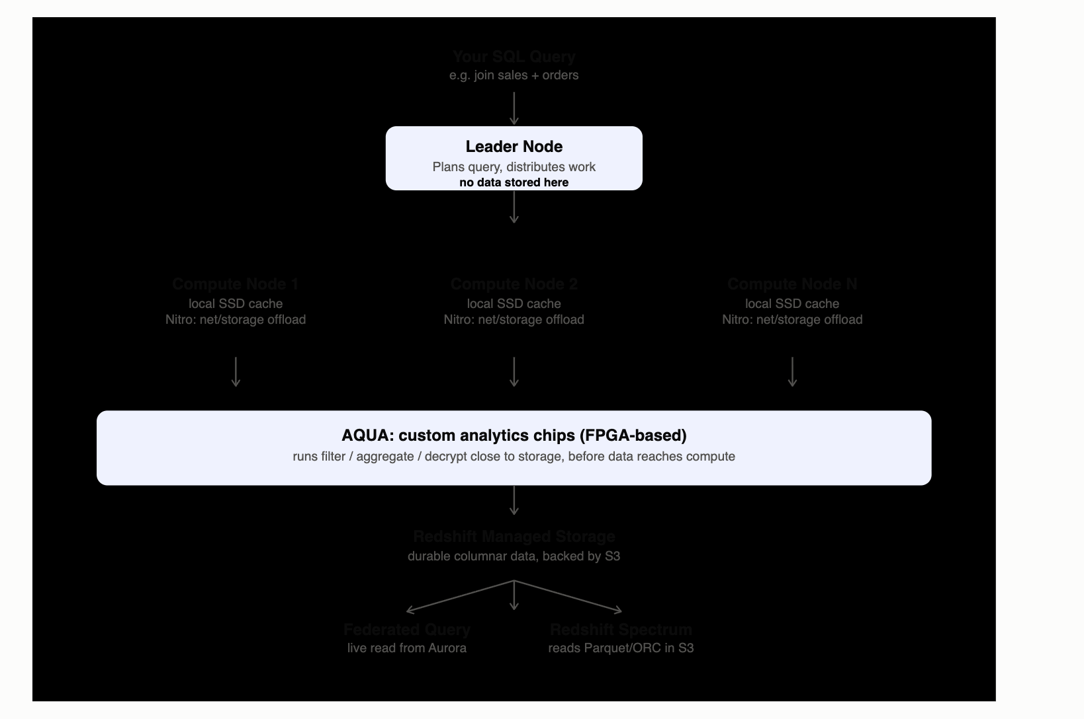
Here's the overall picture, then the know-how on each piece:
Nitro is the foundation layer, not Redshift-specific — it's AWS's custom hypervisor hardware (originally built for EC2) that each compute node runs on. Normally a chunk of a server's CPU/memory goes to virtualization, networking, and security overhead. Nitro moves that work onto dedicated offload chips, so nearly all the node's real hardware is available for actual query processing. Think of it as "why RA3 nodes are fast," not a Redshift-specific invention.
RA3 is the node type built on top of Nitro. Its key trait: compute and storage are decoupled. Each compute node keeps a local SSD cache of hot data, but the durable copy of your data lives separately in Redshift Managed Storage, backed by S3. This means you can scale compute (add/resize nodes) without also having to buy more storage, and vice versa — you're not stuck over-provisioning one to get more of the other, which was a real pain point in Redshift's older node types (DS2) where storage and compute were bolted together.
AQUA sits as a cache layer between the compute nodes and that S3-backed storage. It runs on custom-built analytics chips (FPGA-based, not general CPUs), and its trick is pushing basic operations — filtering, aggregation, decompression, decryption — down into the cache layer itself, close to where the data physically sits. So instead of hauling all the raw data up to the compute nodes and then filtering it there, a lot of the "shrink this down" work happens before it ever leaves storage. That's the main lever for scan-heavy query speedups.
Put together for your join example: your query hits the leader node, gets distributed to RA3 compute nodes, those nodes pull sales data that's cached locally or passes through AQUA on its way up from managed storage, while orders comes in separately via the federated connection straight to Aurora (AQUA and managed storage don't apply to that side — it's a live remote read).
A namespace is the data side — it's a collection of your database objects: schemas, tables, users, permissions, usage limits. Think of it as "what data exists and who's allowed to touch it."
A workgroup is the compute side — it's a collection of compute resources (measured in RPUs, Redshift Processing Units) plus network settings (VPC, subnet groups, security groups). Critically, each workgroup has its own connection endpoint that clients actually connect to and run queries against.
So the question is really asking: if two different groups of people (say, your BI team and your data science team) are both querying data, and you don't want their queries competing for the same compute or interfering with each other, which construct do you split them by?
The answer is workgroup, because that's the thing tied to compute capacity and the actual connection endpoint. If you give the BI team one workgroup and the data science team another, their queries run on physically separate compute allocations — one team running a heavy query won't slow down the other. A namespace wouldn't do this by itself since it's about data/permissions, not about isolating who's competing for processing power.
Rough mental model: namespace = "whose data is this," workgroup = "whose compute is this, and where do you plug in to query it." You can actually mix and match — one namespace's data can be accessed through multiple workgroups, letting you give different user groups separate compute/cost boundaries over the same underlying data.
Glue is serverless and purpose-built for ETL. You define a job (Spark or Python shell), Glue provisions and tears down the Spark cluster behind the scenes automatically — you never see or manage servers. It comes bundled with the Glue Data Catalog (a central metadata/schema store shared across Athena, Redshift Spectrum, EMR, etc.) and Crawlers that auto-discover schema from your data. It also has a visual ETL job builder (Glue Studio) that can generate PySpark code for you. The tradeoff: less control over the cluster — you can't tune instance types, install arbitrary software, or run things Glue wasn't designed for.
EMR is a managed Hadoop/Spark cluster — you're provisioning actual EC2 instances (or using EMR Serverless now too) and you get real control: choose instance types, install custom libraries, run not just Spark but also Hive, Presto/Trino, Flink, HBase, and other big-data frameworks side by side. It's built for when you need a general-purpose big-data compute platform, not just an ETL pipeline — think long-running data science workloads, complex multi-framework pipelines, or workloads needing fine-grained cluster tuning.
Rough way to decide which one a lab/exam question wants: if the scenario says "quick, simple, serverless ETL job, minimal ops overhead" → Glue. If it says "need full control over the Spark cluster," "running multiple frameworks (Hive, Presto, etc.)," or "large-scale custom big data processing" → EMR.
Cost/ops angle also matters for the exam: Glue bills per DPU-second with no cluster to manage; EMR gives you more control over cost-tuning (e.g., spot instances) but you own more of the operational burden (patching, scaling, cluster health).
So both can run Spark ETL — the real dividing line is how much control vs. how much hands-off simplicity you want, and whether you need Glue's Data Catalog/crawler ecosystem or EMR's broader framework support.

