Install docker and docker compose if not already installed. Following are for ubuntu

# Install docker latest version from original website

curl -fsSL https://get.docker.com/ | sh

# Adding your user to the "docker" group

sudo usermod -aG docker $(whoami)

Once docker is installed it should show docker version if everything looks fine. Install docker compose

sudo apt install docker-compose -y

Create folder airflow

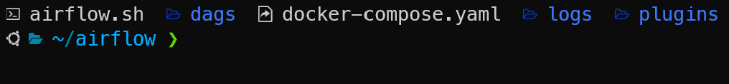

Following steps provided in <https://airflow.apache.org/docs/apache-airflow/stable/howto/docker-compose/index.html>.

Get airflow compose file

curl -LfO 'https://airflow.apache.org/docs/apache-airflow/2.5.3/docker-compose.yaml'

Create .env file and add below

echo -e "AIRFLOW_UID=**$(**id -u**)**" > .env

echo -e "AIRFLOW_UID=**$PWD**" >> .env

Create dags,logs and plugins folder to act as volume for dags, logs and plugins in container.

Run **docker compose up -d**, this should spin all containers and if everything is fine all show as healthy when docker ps is executed.

Run docker compose run airflow-worker airflow info to check all installation information.

Add postgres connection



If you go to **localhost:8080** airflow and click on connections you should see postgres_new.

For creating a dag, go to dags folder and create a file for example postgresoperator_demo.py.

If you go to airflow dags screen postgresoperator_demo should be available for execution.

Once this dag is processed successfully, data should get successfully inserted into table employee.

To validate, run docker ps to get postgres container id.

Run **docker exec -it $1 /bin/bash** where $1 is container id.

Go to postgres **psql -d airflow -U airflow**

Run **\dt** and it should show employee table created with data using airflow dags. To exit enter **\q** and exit out of postgres container use **CTRL+P** and **CTRL+Q**.

For shutting airflow down run **docker compose down**.