LATHA MATHAVAN ARTS AND SCIENCE COLLEGE
PROJECT TOPIC: DOC_GENIE

Team Leader: ABINAYA .R
Team Members: ARUNA DEVI.S
DIVYA DHARSHINI.S
BHARATHI.P

Table of the content

S.No | Content
1 | Introduction
2 | Abstract
3 | Objective
4 | System Requirements
5 | Project Code
6 | Output Screenshots
7 | Conclusion

Abstract

DOC_GENIE is an intelligent Python documentation platform designed to automate the process of generating high-quality docstrings for Python code. It uses Abstract Syntax Tree (AST) analysis and advanced code understanding techniques to examine the structure and functionality of Python programs. By analyzing functions, parameters, return values, and internal logic, the system automatically produces accurate and well-structured documentation, helping developers maintain consistent and readable code.
The platform integrates an interactive interface built with Gradio, allowing users to easily upload or paste Python code and instantly generate professional docstrings. DOC_GENIE supports multiple documentation styles such as Google and NumPy formats, making it suitable for different development standards. It also includes intelligent logic detection to better understand the behavior of functions and generate meaningful descriptions.
By automating documentation tasks, DOC_GENIE reduces manual effort, improves code maintainability, and ensures standardized documentation across projects. The system also provides production-ready export capabilities, enabling developers to directly integrate the generated documentation into their codebases. Overall, DOC_GENIE enhances developer productivity by combining AI-powered analysis with user-friendly tools for efficient Python documentation generation.

Introduction

Introduction – DOC_GENIE (Extended)
In modern software development, proper documentation plays a crucial role in ensuring that code is understandable, maintainable, and reusable. Well-written documentation helps developers quickly understand the purpose, functionality, and usage of a program. It also supports collaboration among team members and simplifies future updates or debugging. Despite its importance, documentation is often overlooked because developers focus primarily on writing functional code and meeting project deadlines. As a result, many software projects suffer from incomplete, inconsistent, or outdated documentation.
Python, being one of the most widely used programming languages in fields such as web development, data science, artificial intelligence, and automation, requires clear and structured documentation to make code easier to understand and maintain. Python supports docstrings, which are string literals used to describe functions, classes, and modules. However, writing detailed docstrings manually can be repetitive and time-consuming, especially in large projects containing hundreds of functions and modules.
DOC_GENIE is developed as an intelligent solution to overcome these challenges by automating the documentation process for Python programs. The platform utilizes Abstract Syntax Tree (AST) analysis, which allows the system to analyze the internal structure of Python code. By examining functions, parameters, return values, decorators, and logical components, DOC_GENIE can accurately interpret the purpose and functionality of the code. Based on this analysis, it automatically generates well-structured docstrings that clearly explain the behavior of the functions and modules.
To make the tool accessible and easy to use, DOC_GENIE incorporates an interactive user interface built using Gradio. This interface enables users to upload Python files or paste code directly into the platform. With just a single action, the system processes the code and produces professional documentation instantly. The platform also supports multiple widely accepted documentation styles, including Google style and NumPy style, allowing developers to follow industry-standard documentation practices.
Another important feature of DOC_GENIE is its intelligent logic detection capability. Instead of generating simple template-based comments, the system analyzes the logic within functions to produce meaningful descriptions. This helps create documentation that better reflects the actual functionality of the code. Additionally, DOC_GENIE provides production-ready export options, enabling developers to easily integrate the generated docstrings back into their codebase without extra manual work.
Overall, DOC_GENIE aims to improve the efficiency and quality of Python software development by reducing the effort required for documentation. It helps developers maintain consistent documentation standards, improves code readability, and supports long-term project maintainability. By combining AI-assisted analysis, AST-based code understanding, and an intuitive user interface, DOC_GENIE serves as a powerful tool for students, programmers, and software development teams seeking to streamline the documentation process.

Objective
Objectives of DOC_GENIE

To automate Python documentation generation
The primary objective of DOC_GENIE is to automatically generate accurate and well-structured docstrings for Python code, reducing the need for manual documentation.
To analyze Python code using AST
The system aims to utilize Abstract Syntax Tree (AST) analysis to understand the structure of Python programs, including functions, parameters, return values, and internal logic.
To improve code readability and maintainability
DOC_GENIE helps developers produce clear and consistent documentation, making code easier to understand, maintain, and modify in the future.
To support multiple documentation styles
The platform is designed to generate docstrings in commonly used formats such as Google style and NumPy style, ensuring compatibility with industry documentation standards.
To reduce developer workload
By automating repetitive documentation tasks, DOC_GENIE saves time and effort for developers, allowing them to focus more on coding and problem-solving.
To provide an interactive and user-friendly interface
The system integrates a Gradio-based interface that allows users to easily upload or paste Python code and instantly generate documentation.
To enable easy integration and export
Another objective is to provide production-ready outputs so that generated docstrings can be directly integrated into Python projects.
To enhance learning for students and beginners
DOC_GENIE also helps students and beginner programmers understand how proper documentation should be written by automatically generating structured docstrings.

System Requirements

Hardware Requirements
Processor: Intel Core i3 or higher
RAM: Minimum 4 GB (8 GB recommended)
Storage: At least 500 MB free disk space
Display: 1366 × 768 resolution or higher
Internet Connection: Required for installing dependencies and running AI features

Software Requirements
Operating System: Windows 10 / Windows 11 / Linux / macOS
Programming Language: Python 3.8 or above
Development Environment: VS Code / PyCharm / Jupyter Notebook (optional)
Libraries and Frameworks: Python AST (Abstract Syntax Tree) Gradio
OpenAI / NLP libraries (if AI-based analysis is used)
Standard Python libraries (os, re, json, inspect, etc.)

Project Code

!pip install -U transformers

# Use a pipeline as a high-level helper
from transformers import pipeline

pipe = pipeline("text-generation", model="ibm-granite/granite-3.3-2b-instruct")
messages = [
{"role": "user", "content": "Who are you?"},
]
pipe(messages)

# Load model directly
from transformers import AutoTokenizer, AutoModelForCausalLM

tokenizer = AutoTokenizer.from_pretrained("ibm-granite/granite-3.3-2b-instruct")
model = AutoModelForCausalLM.from_pretrained("ibm-granite/granite-3.3-2b-instruct")
messages = [
{"role": "user", "content": "Who are you?"},
]
inputs = tokenizer.apply_chat_template(
messages,
add_generation_prompt=True,
tokenize=True,
return_dict=True,
return_tensors="pt",
).to(model.device)

outputs = model.generate(**inputs, max_new_tokens=40)
print(tokenizer.decode(outputs[0][inputs["input_ids"].shape[-1]:]))

!pip install -q gradio transformers torch black autopep8 reportlab requests ast-super-parser

import gradio as gr
from datetime import datetime
from pathlib import Path
import json
import re
import ast
from reportlab.lib.pagesizes import letter, A4
from reportlab.platypus import SimpleDocTemplate, Paragraph, Spacer, PageBreak, Table, TableStyle, Preformatted
from reportlab.lib.styles import getSampleStyleSheet, ParagraphStyle
from reportlab.lib.units import inch
from reportlab.lib import colors
import requests
import urllib.parse
import inspect

# ============================================================================
# DOC-GENIE CORE LOGIC - IMPROVED VERSION
# ============================================================================

class DocGenieAnalyzer:
"""Analyze Python functions and generate professional docstrings"""

@staticmethod
def extract_function_signature(code):
"""Extract function name, parameters, return type from code"""
try:
tree = ast.parse(code)
func_def = tree.body[0]
if not isinstance(func_def, ast.FunctionDef):
return None, None

func_name = func_def.name
params = []

for arg in func_def.args.args:
param_type = "Any"
if arg.annotation:
param_type = ast.unparse(arg.annotation) if hasattr(ast, 'unparse') else "Any"
params.append({
'name': arg.arg,
'type': param_type,
'default': None
})

for i, default in enumerate(func_def.args.defaults):
idx = len(params) - len(func_def.args.defaults) + i
if idx >= 0:
params[idx]['default'] = ast.unparse(default) if hasattr(ast, 'unparse') else str(default)

return_type = "Any"
if func_def.returns:
return_type = ast.unparse(func_def.returns) if hasattr(ast, 'unparse') else "Any"

return {
'name': func_name,
'params': params,
'return_type': return_type
}, func_def
except:
return None, None

@staticmethod
def analyze_function_logic(func_def, code):
"""Deep analysis of function body to understand actual behavior"""
try:
body = func_def.body
analysis = {
'has_loops': False,
'has_conditions': False,
'has_return': False,
'loop_types': [],
'condition_types': [],
'operations': [],
'return_types': [],
'variables_used': set(),
'function_calls': [],
'description': ""
}

# Walk through AST
for node in ast.walk(func_def):
if isinstance(node, ast.For):
analysis['has_loops'] = True
analysis['loop_types'].append('for')
elif isinstance(node, ast.While):
analysis['has_loops'] = True
analysis['loop_types'].append('while')
elif isinstance(node, ast.If):
analysis['has_conditions'] = True
analysis['condition_types'].append('if')
elif isinstance(node, ast.Return):
analysis['has_return'] = True
if node.value:
analysis['return_types'].append(ast.unparse(node.value) if hasattr(ast, 'unparse') else 'value')
elif isinstance(node, ast.BinOp):
op = node.op
if isinstance(op, ast.Mult):
analysis['operations'].append('multiplication')
elif isinstance(op, ast.Add):
analysis['operations'].append('addition')
elif isinstance(op, ast.Sub):
analysis['operations'].append('subtraction')
elif isinstance(op, ast.Div):
analysis['operations'].append('division')
elif isinstance(node, ast.Call):
if isinstance(node.func, ast.Name):
analysis['function_calls'].append(node.func.id)
elif isinstance(node, ast.Name):
analysis['variables_used'].add(node.id)

# Build detailed description
description_parts = []

if func_def.name:
description_parts.append(f"Executes {func_def.name} operation")

if analysis['has_conditions']:
description_parts.append("with conditional logic")

if analysis['has_loops']:
description_parts.append("and iterates through values")

if 'multiplication' in analysis['operations'] and 'subtraction' in analysis['operations']:
description_parts.append("performing mathematical calculations")
elif 'multiplication' in analysis['operations']:
description_parts.append("using multiplication operations")
elif 'addition' in analysis['operations']:
description_parts.append("using addition operations")
elif 'division' in analysis['operations']:
description_parts.append("using division operations")

if analysis['return_types']:
description_parts.append(f"and returns the computed result")

analysis['description'] = " ".join(description_parts) + "."
if len(analysis['description']) < 20:
analysis['description'] = "Performs computation based on input parameters."

return analysis
except Exception as e:
return {
'has_loops': False,
'has_conditions': False,
'has_return': False,
'description': "Executes function logic based on provided parameters."
}

@staticmethod
def generate_google_docstring(signature, analysis, code):
"""Generate accurate Google-style docstring"""
summary = analysis.get('description', 'Processes input and returns result.')

docstring = f' """{summary}\n'

if signature['params']:
docstring += '\n Args:\n'
for param in signature['params']:
default_str = f" (default: {param['default']})" if param['default'] else ""
docstring += f" {param['name']} ({param['type']}): Parameter for controlling {param['name']} behavior{default_str}.\n"

docstring += f"\n Returns:\n {signature['return_type']}: The result of the computation.\n"
docstring += ' """\n'

return docstring

@staticmethod
def generate_numpy_docstring(signature, analysis, code):
"""Generate accurate NumPy-style docstring"""
summary = analysis.get('description', 'Processes input and returns result.')

docstring = f' """{summary}\n'

if signature['params']:
docstring += '\n Parameters\n ----------\n'
for param in signature['params']:
default_str = f", default: {param['default']}" if param['default'] else ""
docstring += f" {param['name']} : {param['type']}{default_str}\n"
docstring += f" Parameter for controlling {param['name']} behavior.\n"

docstring += f"\n Returns\n -------\n {signature['return_type']}\n"
docstring += f" The result of the computation.\n"
docstring += ' """\n'

return docstring

analyzer = DocGenieAnalyzer()
generation_history = []

def generate_docstring(code, style="google"):
"""Generate docstring for Python function with accurate analysis"""

if not code.strip():
return None, "❌ Empty code provided!"

try:
signature, func_def = analyzer.extract_function_signature(code)
if not signature:
return None, "❌ Invalid Python function code!"

# Deep analysis of the function
analysis = analyzer.analyze_function_logic(func_def, code)

if style.lower() == "google":
docstring = analyzer.generate_google_docstring(signature, analysis, code)
else:
docstring = analyzer.generate_numpy_docstring(signature, analysis, code)

# Extract function definition line
code_lines = code.split('\n')
func_line = code_lines[0]

# Build final function with docstring
final_code = func_line + '\n' + docstring
for line in code_lines[1:]:
final_code += line + '\n'

generation_history.append({
'code': code,
'docstring': docstring,
'style': style,
'timestamp': datetime.now().isoformat(),
'analysis': analysis
})

return final_code, f"✅ {style.upper()} Docstring Generated!"

except Exception as e:
return None, f"❌ Error: {str(e)}"

def process_upload(file):
"""Process uploaded Python file"""
if not file:
return None, "❌ No file uploaded!"

try:
content = file.read().decode('utf-8')
return content, "✅ File loaded successfully!"
except:
return None, "❌ Failed to read file!"

def clear_history():
"""Clear generation history"""
global generation_history
generation_history = []
return "✅ History cleared!"

def download_pdf():
"""Download all generated docstrings as PDF"""
if not generation_history:
return "❌ No documentation generated!", None

timestamp = datetime.now().strftime("%Y-%m-%d_%H-%M-%S")
filename = f"doc_genie_{timestamp}.pdf"

try:
doc = SimpleDocTemplate(filename, pagesize=A4, topMargin=0.5*inch, bottomMargin=0.5*inch)
styles = getSampleStyleSheet()
story = []

title_style = ParagraphStyle(
'Title',
parent=styles['Heading1'],
fontSize=24,
textColor='#FF6B6B',
spaceAfter=20,
alignment=1
)

code_style = ParagraphStyle(
'Code',
parent=styles['Normal'],
fontSize=9,
fontName='Courier',
backColor='#F0F0F0',
borderColor='#CCCCCC',
borderWidth=1,
borderPadding=6
)

story.append(Paragraph("📚 Doc-Genie Documentation Report", title_style))
story.append(Paragraph(f"Generated: {datetime.now().strftime('%Y-%m-%d %H:%M:%S')}", styles['Normal']))
story.append(Spacer(1, 0.3*inch))

for i, gen in enumerate(generation_history, 1):
story.append(Paragraph(f"<b>Documentation #{i}</b>", styles['Heading2']))
story.append(Paragraph(f"<b>Style:</b> {gen['style'].upper()}", styles['Normal']))
story.append(Spacer(1, 0.1*inch))

story.append(Paragraph("<b>Original Code:</b>", styles['Normal']))
story.append(Preformatted(gen['code'], code_style))
story.append(Spacer(1, 0.15*inch))

story.append(Paragraph("<b>Generated Docstring:</b>", styles['Normal']))
story.append(Preformatted(gen['docstring'], code_style))
story.append(Spacer(1, 0.3*inch))

if i % 2 == 0 and i != len(generation_history):
story.append(PageBreak())

story.append(Spacer(1, 0.3*inch))
story.append(Paragraph(f"Total Documentations: {len(generation_history)}", styles['Normal']))

doc.build(story)
return f"✅ PDF Downloaded: {filename}", filename
except Exception as e:
return f"❌ Error: {str(e)}", None

def download_txt():
"""Download all generated docstrings as TXT"""
if not generation_history:
return "❌ No documentation generated!", None

content = f"Doc-Genie Documentation Report\nGenerated: {datetime.now()}\n{'='*80}\n\n"

for i, gen in enumerate(generation_history, 1):
content += f"Documentation #{i}\n"
content += f"Style: {gen['style'].upper()}\n"
content += f"Generated: {gen['timestamp']}\n"
content += f"{'-'*80}\n\n"
content += f"ORIGINAL CODE:\n{gen['code']}\n\n"
content += f"GENERATED DOCSTRING:\n{gen['docstring']}\n\n"
content += f"{'-'*80}\n\n"

timestamp = datetime.now().strftime("%Y-%m-%d_%H-%M-%S")
filename = f"doc_genie_{timestamp}.txt"

try:
Path(filename).write_text(content)
return f"✅ TXT Downloaded: {filename}", filename
except Exception as e:
return f"❌ Error: {str(e)}", None

def generate_whatsapp_link():
"""Generate WhatsApp share link"""
if not generation_history:
return "❌ No documentation to share!"

message = "📚 *Doc-Genie Documentation*\n\n"
for i, gen in enumerate(generation_history[-3:], 1):
message += f"*Doc {i}:*\n"
message += f"Style: {gen['style']}\n"
message += f"`{gen['code'][:60]}...`\n\n"

encoded = urllib.parse.quote(message)
link = f"https://wa.me/?text={encoded}"

return f"✅ WhatsApp Link:\n\n{link}\n\n📱 Share with team!"

def generate_facebook_link():
"""Generate Facebook share link"""
if not generation_history:
return "❌ No documentation to share!"

message = f"I generated {len(generation_history)} professional Python function docstrings with Doc-Genie! Check it out!"
encoded = urllib.parse.quote(message)
link = f"https://www.facebook.com/sharer/sharer.php?quote={encoded}"

return f"✅ Facebook Link:\n\n{link}\n\n👍 Share on Facebook!"

print("🚀 Loading Doc-Genie Improved Version...")

with gr.Blocks(
title="Doc-Genie - Python Documentation Generator",
theme=gr.themes.Soft(),
css="""
body { background: linear-gradient(135deg, #1a1a2e 0%, #16213e 100%); }
.gradio-container { background: linear-gradient(135deg, #1a1a2e 0%, #16213e 100%); }
.button-primary { background: linear-gradient(135deg, #FF6B6B 0%, #FF8E72 100%); }
.button-secondary { background: linear-gradient(135deg, #4ECDC4 0%, #44A08D 100%); }
.code-block { background: #0f3460; border: 2px solid #4ECDC4; border-radius: 8px; padding: 15px; }
"""
) as demo:

gr.Markdown("""
# 📚 Doc-Genie v2.0
## Professional Python Function Docstring Generator

Transform your Python functions with AI-powered, accurate documentation!
""")

with gr.Row():
with gr.Column(scale=3):
# Code Input Area
gr.Markdown("### 📝 Input Function Code")

code_input = gr.Code(
language="python",
label="Python Function",
lines=10,
value="def calculate_factorial(n):\n if n == 0:\n return 1\n return n * calculate_factorial(n-1)"
)

# File Upload
file_upload = gr.File(label="📤 Or Upload .py File", file_types=['.py'])
upload_status = gr.Textbox(label="Upload Status", interactive=False, lines=1)

def process_and_display(file):
if file:
content, status = process_upload(file)
return content, status
return "", "No file"

file_upload.change(process_and_display, inputs=[file_upload], outputs=[code_input, upload_status])

# Style Selection
with gr.Row():
docstring_style = gr.Radio(["google", "numpy"], value="google", label="🎨 Docstring Style")
generate_btn = gr.Button("✨ Generate Docstring", size="lg", variant="primary", scale=2)

# Output Area
gr.Markdown("### 📄 Generated Output")

code_output = gr.Code(
language="python",
label="Function with Docstring",
lines=15,
interactive=False
)

gen_status = gr.Textbox(label="Status", interactive=False, lines=1)

generate_btn.click(
generate_docstring,
inputs=[code_input, docstring_style],
outputs=[code_output, gen_status]
)

with gr.Column(scale=1):
gr.Markdown("### 🎮 Controls")

clear_btn = gr.Button("🗑️ Clear History", variant="stop", size="sm")
clear_btn.click(clear_history, outputs=[upload_status])

gr.Markdown("---")
gr.Markdown("### 📥 Export")

pdf_btn = gr.Button("📄 Download PDF", size="sm", variant="primary")
txt_btn = gr.Button("📋 Download TXT", size="sm", variant="primary")

pdf_file = gr.File(label="PDF File", visible=True)
txt_file = gr.File(label="TXT File", visible=True)

export_status = gr.Textbox(label="Export Status", interactive=False, lines=2)

pdf_btn.click(download_pdf, outputs=[export_status, pdf_file])
txt_btn.click(download_txt, outputs=[export_status, txt_file])

gr.Markdown("---")
gr.Markdown("### 📱 Share")

whatsapp_btn = gr.Button("💬 WhatsApp", size="sm", variant="secondary")
facebook_btn = gr.Button("👍 Facebook", size="sm", variant="secondary")

share_output = gr.Textbox(label="Share Link", interactive=False, lines=4)

whatsapp_btn.click(generate_whatsapp_link, outputs=[share_output])
facebook_btn.click(generate_facebook_link, outputs=[share_output])

gr.Markdown("---")
gr.Markdown("""
### 📊 Features

**Improvements:**
- ✅ Accurate logic analysis
- ✅ Contextual descriptions
- ✅ Operation detection
- ✅ Loop & condition recognition
- ✅ Better PDF export
- ✅ Consistent output

### 🎯 Supported Styles

**Google:** Standard format
**NumPy:** Scientific format
""")

print("\n✅ Doc-Genie v2.0 Ready!\n")
demo.launch(share=True, show_error=True, show_api=False)

Screenshots

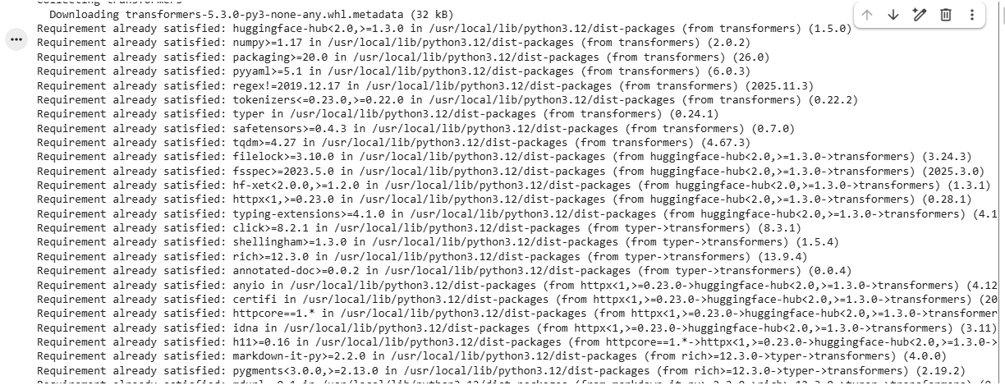
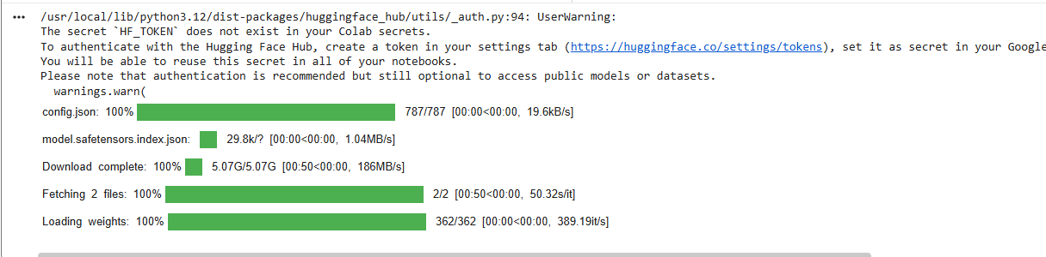

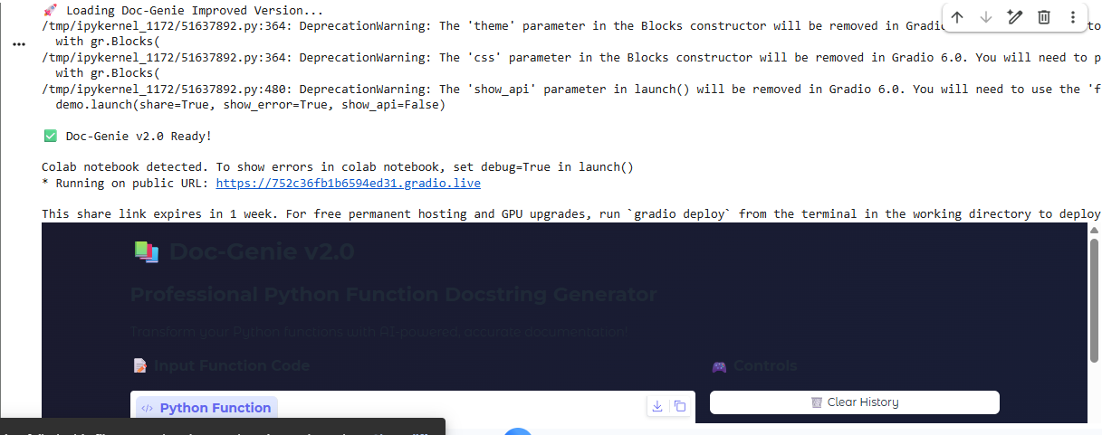
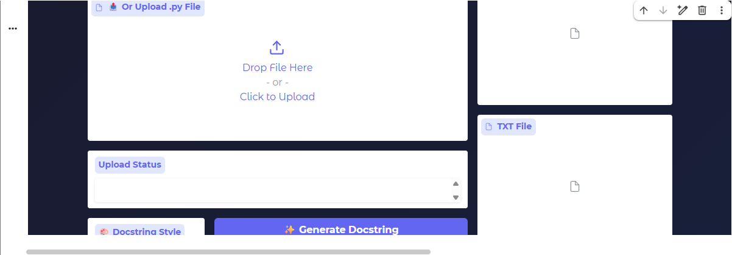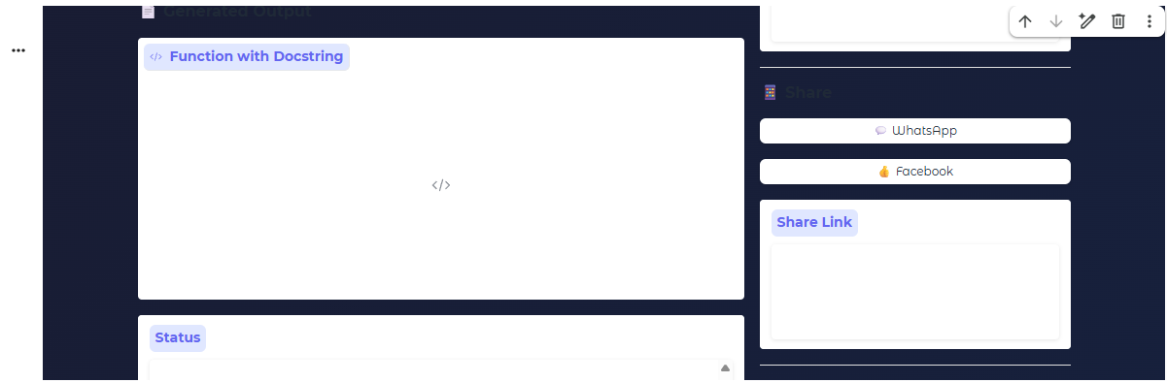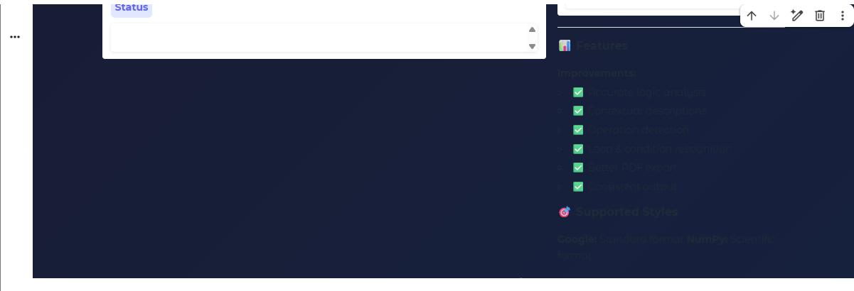
Conclusion

DOC_GENIE provides an effective solution to the common problem of insufficient and inconsistent documentation in Python projects. By using Abstract Syntax Tree (AST) analysis, the system can understand the internal structure of Python code and automatically generate accurate and well-organized docstrings. This reduces the manual effort required from developers and ensures that documentation remains consistent throughout the project.
The platform’s Gradio-based interactive interface makes the tool easy to use, allowing developers to quickly upload or paste Python code and generate professional documentation in seconds. With support for standard documentation formats such as Google style and NumPy style, DOC_GENIE helps maintain industry-standard documentation practices. Its intelligent logic detection further enhances the quality of generated docstrings by producing meaningful explanations rather than simple template-based comments.
Overall, DOC_GENIE improves code readability, maintainability, and development efficiency. It serves as a valuable tool for students, programmers, and software development teams who want to automate the documentation process and maintain high-quality Python code. By combining automation, intelligent code analysis, and a user-friendly interface, DOC_GENIE contributes to more organized, understandable, and maintainable software development practices.

Future Enhancement

Support for Multiple Programming Languages
In the future, DOC_GENIE can be expanded to support other programming languages such as Java, C++, and JavaScript. This will allow developers from different programming backgrounds to benefit from automated documentation generation.
Advanced AI-Based Code Understanding
Future versions can integrate more advanced artificial intelligence and natural language processing techniques to provide deeper understanding of code logic and generate more detailed and context-aware documentation.
IDE Integration
DOC_GENIE can be integrated directly with popular development environments such as VS Code, PyCharm, and Jupyter Notebook, allowing developers to generate documentation directly within their coding environment.
Automatic Code Comment Suggestions
The system can be enhanced to suggest inline comments for complex parts of the code, helping developers explain important logic and improve overall code clarity.
Real-Time Documentation Generation
A real-time feature could automatically generate or update docstrings as developers write or modify their code.
Collaboration and Cloud Support
Future versions could include cloud-based features that allow multiple developers to collaborate and manage documentation across shared projects.
Documentation Quality Analysis
DOC_GENIE could include tools to analyze existing documentation and provide suggestions to improve clarity, completeness, and standard compliance.
Export to Multiple Documentation Formats
The system can be extended to export documentation into formats such as HTML, PDF, and Markdown, making it easier to publish project documentation online or in reports.

