1. INTRODUCTION

Overview

Social media can be used to achieve speciﬁc goals or objectives A brief description about your project

Purpose

Create brand awarness

The use of this project. What can be achieved using this.

1. **Problem Deﬁnition & Design Thinking**

Empathy Map

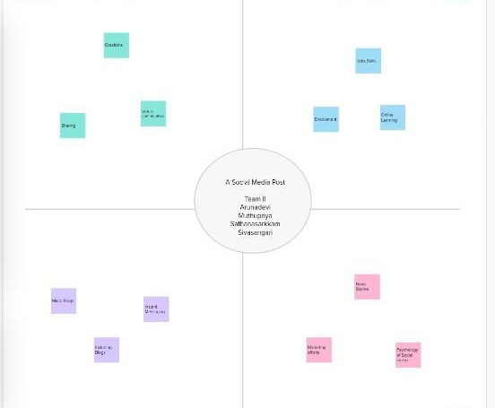

Paste the empathy map screenshot Ideation & Brainstorming Map

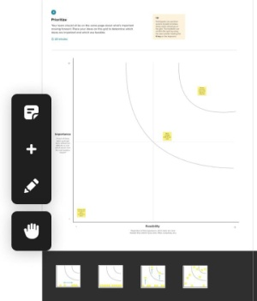

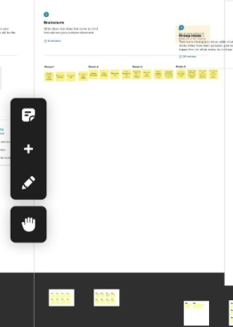

1. RESULT



Final ﬁndings (Output) of the project along with screenshots.

1 Connectivity is among the most Signiﬁcate Beneﬁt or social media

1. Addiction ,hacking , Cyberbulling

List of advantages and disadvantages of the proposed solution

* 1. APPLICATIONS ;It is my useful carrier work

The areas where this solution capplied

1. CONCLUSION;

This is my future work decision

Then i'm really understand this work.