SOFTWARE DESIGN DOCUMENT
FOR
RADAR SYNCHRONIZATION MODULE FOR S-BAND RADAR
DP-SPL-0220

DOCUMENT TITLE | SOFTWARE DESIGN DOCUMENT FOR RADAR SYNCHRONIZATION MODULE FOR S-BAND RADAR DP-SPL-0220
DOCUMENT REFERENCE | DP-SPL-0220-V1-01-SDD-1V00
VERSION NUMBER | 1.00
VERSION DATE | July 16,2024
PREPARED BY | Name: Madhuprakash R  Sign:
DOCUMENT REVIEW BY | Name: Gowthami V  Sign:
TECHNICAL REVIEW BY | Name: Vishnu Ram G  Sign:
PROCESS REVIEW BY | Name: Kingshuk Mitra  Sign:
APPROVED BY | Name: Design Review Board  Sign:

Copyright @ (2024) by Data Patterns
All right reserved. These materials are proprietary to Data Patterns and no part of these materials should be reproduced, published in any form by any means, electronic or mechanical including photocopy or any information storage or retrieval system nor should the materials be disclosed to third parties without the written authorization of Data Patterns.

Revision History

S. NO. | VER. NO. | VER. DATE | CHANGED BY | SECTION (S) CHANGED | DESCRIPTION  OF CHANGE
1 | 0V01 | February 23,  2024 | Gowthami V, Madhuprakash R | - | Initial Version
2 | 0V02 | March 27,  2024 | Gowthami V,  Madhuprakash R | 2.1.4.4.1,  2.1.4.4.4,  2.1.4.12 | DRB Comments Closed
3 | 0V03 | April 4, 2024 | Gowthami V,  Madhuprakash R | 2.1.4.6.1.1,  2.1.4.6.1.2,  2.1.4.5.1.3,  5.1.2.6.1.1,  5.1.2.6.1.2,  5.1.2.6.1.3 | DRB Comments Closed
4 | 0V04 | June 21,2024 | Gowthami V,  Madhuprakash R | 2.1.3.11.2,  2.1.4.6,  2.1.4.8.4  2.1.4.13,  2.2.1.11,  2.2.2.6,  2.2.2.13,  5.1.1.11.2,  5.1.2.6,  5.1.2.8.4  5.1.2.13 | Internal Comments Closed
5 | 0V05 | July 16,2024 | Madhuprakash R | 2.1.4.13.1.1,  2.1.4.13.1.2,  5.1.2.13.1.1,  5.1.2.13.1.2 | DRB Comments Closed
6 | 1V00 | July 16,2024 | Madhuprakash R | - | Baseline Version

Table of Contents
1. Introduction 1
1.1 Purpose 1
1.2 Scope 1
1.3 Definitions, Acronyms, and Abbreviations 2
1.4 References 3
1.5 Document Overview 3
2. Decomposition Description 4
2.1 Module Decomposition 4
2.1.1 Test Configuration 4
2.1.2 Test Performance 5
2.1.3 Processing Section 6
2.1.3.1 Processor test 6
2.1.3.1.1 ALU Test 6
2.1.3.1.2 FPU Test 7
2.1.3.2 DDR4 Test 8
2.1.3.2.1 Data Bus Test 8
2.1.3.2.2 Address Bus Test 9
2.1.3.2.3 Device Test 9
2.1.3.3 EEPROM Test 10
2.1.3.3.1 Upload Board Information 10
2.1.3.3.2 Data Retention Test 10
2.1.3.3.3 Checksum Test 11
2.1.3.3.4 Read/Write Test 11
2.1.3.4 MRAM Test 12
2.1.3.4.1 Upload Board Information 12
2.1.3.4.2 Data Retention Test 12
2.1.3.4.3 Checksum Test 13
2.1.3.4.4 Full Memory Test 13
2.1.3.5 NAND Flash Test 14
2.1.3.5.1 Upload Board Information 14
2.1.3.5.2 Data Retention Test 14
2.1.3.5.3 Check Sum Test 15
2.1.3.6 NOR Flash Test 15
2.1.3.6.1 Upload Board Information test 15
2.1.3.6.2 Data Retention Test 15
2.1.3.6.3 Check Sum Test 16
2.1.3.7 USB Test 16
2.1.3.7.1 Read/Write test 16
2.1.3.8 SATA Test 17
2.1.3.8.1 Read/Write test 17
2.1.3.9 SD Card Test 18
2.1.3.9.1 Read/Write test 18
2.1.3.10 UART Test 18
2.1.3.10.1 Write test 18
2.1.3.10.2 Read Test 19
2.1.3.11 Ethernet Test 19
2.1.3.11.1 Ethernet Ping test 19
2.1.3.11.2 Ethernet Socket Test 20
2.1.3.11.3 Ethernet Data Transfer rate test 20
2.1.3.12 Temperature sensor test 21
2.1.3.13 Voltage Monitoring test 21
2.1.4 Programmable Logic 22
2.1.4.1 DDR4(PL) Test 22
2.1.4.1.1 Data bus test 22
2.1.4.1.2 Address Bus Test 22
2.1.4.1.3 Device Test 23
2.1.4.1.4 Full memory test 23
2.1.4.2 UART (PL) Test 24
2.1.4.2.1 Write test 24
2.1.4.2.2 Read Test 24
2.1.4.3 NOR Flash (PL) test 25
2.1.4.3.1 Device ID 25
2.1.4.3.2 Chip /Die Erase 25
2.1.4.3.3 Sector erase 25
2.1.4.3.4 Single Write 26
2.1.4.3.5 Single Read 26
2.1.4.3.6 Page Write 26
2.1.4.3.7 Page Read 27
2.1.4.3.8 Full memory test 27
2.1.4.4 SFP Transceiver Operations 28
2.1.4.4.1 SFP Lane Status 28
2.1.4.4.2 Data Transfer Test 28
2.1.4.4.2.1 Data Transfer Reset 28
2.1.4.4.2.2 Tx Data Transfer 28
2.1.4.4.2.3 Rx Data Receiver 29
2.1.4.4.3 Bandwidth Test 29
2.1.4.4.3.1 Bandwidth Reset Test 29
2.1.4.4.3.2 Bandwidth Tx 29
2.1.4.4.3.3 Bandwidth Rx 29
2.1.4.4.4 SFP Diagnostic information 30
2.1.4.4.5 SFP IO Health Status 30
2.1.4.5 Digital Attenuator 30
2.1.4.5.1 Write Test 30
2.1.4.5.2 Read Test 31
2.1.4.6 GPIO 31
2.1.4.6.1 LVTTL 31
2.1.4.6.1.1 IO Mode test 31
2.1.4.6.1.2 Clock Mode test 32
2.1.4.6.2 TTL 32
2.1.4.6.2.1 Clock Mode Test 32
2.1.4.7 SFP TRS 32
2.1.4.7.1 Write Test 32
2.1.4.7.2 Read Test 33
2.1.4.8 LTC PLL 33
2.1.4.8.1 File write 33
2.1.4.8.2 File read 33
2.1.4.8.3 PLL Lock status verification 34
2.1.4.8.4 PLL Sync 34
2.1.4.9 NMEA test 34
2.1.4.10 IRIG-B test 34
2.1.4.11 PPS test 35
2.1.4.12 FPGA Junction Temperature 35
2.1.4.13 DP-SPL-5299 Test 36
2.1.4.13.1 PCIe Test 36
2.1.4.13.1.1 PCIe Enumeration Test 36
2.1.4.13.1.2 Read/Write Test 36
2.1.4.13.2 SFP Transceiver Operations 37
2.1.4.13.3 LVDS Test 37
2.1.4.13.3.1 Clock Transmit test 37
2.1.4.13.3.2 Clock Receive Test 37
2.2 Data Decomposition 38
2.2.1 Processing system Section 38
2.2.1.1 Processor Test 38
2.2.1.2 DDR4 test 39
2.2.1.3 EEPROM Test 39
2.2.1.4 MRAM Test 39
2.2.1.5 NAND Flash Test 40
2.2.1.6 NOR (Boot) Flash Test 40
2.2.1.7 USB Test 40
2.2.1.8 SATA Test 41
2.2.1.9 SD Card Test 41
2.2.1.10 UART Test 41
2.2.1.11 Ethernet Test 41
2.2.1.12 Temperature sensor test 42
2.2.1.13 Voltage monitoring test 42
2.2.2 Programmable Logic section 42
2.2.2.1 DDR4 (PL) 42
2.2.2.2 UART (PL) 42
2.2.2.3 NOR Flash (PL) 43
2.2.2.4 SFP Optical Transceiver 43
2.2.2.5 Digital Attenuator 44
2.2.2.6 GPIO 44
2.2.2.7 SFP TRS 44
2.2.2.8 LTC PLL 45
2.2.2.9 NMEA 45
2.2.2.10 IRIG-B 45
2.2.2.11 PPS 45
2.2.2.12 FPGA Junction Temperature 46
2.2.2.13 DP-SPL-5299 Test 46
2.2.2.13.1 PCIeTest 46
2.2.2.13.2 SFP Transceiver Test 46
2.2.2.13.3 LVDS Test 46
2.3 Process Decomposition 47
3. Dependency Description 48
3.1 Module Dependencies 48
3.1.1 DEPENDENCY BETWEEN THE MODULES “TEST CONFIGURATION” AND “TEST PERFORMANCE”: 48
3.2 Data Dependencies 48
3.3 Process Dependencies 48
3.3.1 DEPENDENCY BETWEEN THE PROCESS ‘USER INPUT’ AND ‘INPUT PROCESSING’ : 48
3.3.2 DEPENDENCY BETWEEN THE PROCESS 'INPUT PROCESSING' AND 'TEST RESULT' : 48
4. Interface Description 49
4.1 Module Interface 49
4.2 Process Interface 49
5. Detailed Design 50
5.1 Module Detailed Design 50
5.1.1 Processing Section 50
5.1.1.1 Processor Test 50
5.1.1.1.1 ALU Test 51
5.1.1.1.2 FPU Test 53
5.1.1.2 DDR4 Test 54
5.1.1.2.1 Data Bus Test 55
5.1.1.2.2 Address Bus Test 56
5.1.1.2.3 Device Test 57
5.1.1.3 EEPROM Test 58
5.1.1.3.1 Upload Board Information Test 59
5.1.1.3.2 Data Retention Test 60
5.1.1.3.3 Checksum Test 61
5.1.1.3.4 Read/Write Test 62
5.1.1.4 MRAM Test 63
5.1.1.4.1 Upload Board Information test 64
5.1.1.4.2 Data Retention test 65
5.1.1.4.3 Checksum Test 66
5.1.1.4.4 Full Memory test 67
5.1.1.5 NAND Flash Test 68
5.1.1.5.1 Upload Board Information test 69
5.1.1.5.2 Data Retention Test 70
5.1.1.5.3 Checksum Test 71
5.1.1.6 NOR Flash Test 72
5.1.1.6.1 Upload Board Information test 73
5.1.1.6.2 Data Retention Test 74
5.1.1.6.3 Checksum Test 75
5.1.1.7 USB Test 76
5.1.1.7.1 Read / Write Test 76
5.1.1.8 SATA Test 77
5.1.1.8.1 Read / Write Test 77
5.1.1.9 SD Card Test 78
5.1.1.9.1 Read / Write Test 78
5.1.1.10 UART Test 79
5.1.1.10.1 Write Test 80
5.1.1.10.2 Read Test 81
5.1.1.11 Ethernet Test 82
5.1.1.11.1 Ethernet ping Test 83
5.1.1.11.2 Ethernet Socket Test 84
5.1.1.11.2.1 Ethernet Socket Test: Server 85
5.1.1.11.2.2 Ethernet Socket Test: Client 86
5.1.1.12 Temperature Sensor Test 87
5.1.1.13 Voltage Monitoring Test 88
5.1.2 Programmable Logic 89
5.1.2.1 DDR4 (PL) 89
5.1.2.1.1 Data Bus test 90
5.1.2.1.2 Address Bus test 91
5.1.2.1.3 Device test 92
5.1.2.1.4 Full memory test 93
5.1.2.2 UART (PL) 94
5.1.2.2.1 Channel selection 95
5.1.2.2.2 Write test 96
5.1.2.2.3 Read test 97
5.1.2.3 NOR Flash (PL) test 98
5.1.2.3.1 Device ID 99
5.1.2.3.2 Sector erase 100
5.1.2.3.3 Chip / Die erase 101
5.1.2.3.4 Single Write 102
5.1.2.3.5 Single Read 103
5.1.2.3.6 Page Write 104
5.1.2.3.7 Page Read 105
5.1.2.3.8 Full memory test 106
5.1.2.4 SFP Optical transceiver 107
5.1.2.4.1 SFP lane status 108
5.1.2.4.2 Data Transfer test 109
5.1.2.4.2.1 Data validation reset 110
5.1.2.4.2.2 Tx Data Transfer 111
5.1.2.4.2.3 Rx Data Reciver 112
5.1.2.4.3 Bandwidth test 113
5.1.2.4.3.1 Bandwidth Reset 114
5.1.2.4.3.2 Bandwidth Tx 115
5.1.2.4.3.3 Bandwidth Rx 116
5.1.2.4.4 SFP Diagnostic information 117
5.1.2.4.5 SFP IO HealthStatus 118
5.1.2.5 Digital Attenuator 119
5.1.2.5.1 Write Test 120
5.1.2.5.2 Read test 121
5.1.2.6 GPIO 122
5.1.2.6.1 LVTTL 123
5.1.2.6.1.1 IO Mode test 124
5.1.2.6.1.2 Clock Mode Test 125
5.1.2.6.2 TTL 126
5.1.2.7 SFP TRS 127
5.1.2.7.1 Write test 128
5.1.2.7.2 Read test 129
5.1.2.8 LTC PLL 130
5.1.2.8.1 File Write 131
5.1.2.8.2 File Read 132
5.1.2.8.3 Lock status verification 133
5.1.2.8.4 PLL Sync 134
5.1.2.9 NMEA 135
5.1.2.10 IRIG-B 136
5.1.2.11 PPS 137
5.1.2.12 FPGA Junction Temperature 138
5.1.2.13 DP-SPL-5299 Test 139
5.1.2.13.1 PCIe Test 140
5.1.2.13.1.1 PCIe Enumeration Test 141
5.1.2.13.1.2 Read / Write Test 142
5.1.2.13.2 SFP Transceiver Operation 143
5.1.2.13.3 LVDS Test 143
5.1.2.13.3.1 Clock Transmit Test 144
5.1.2.13.3.2 Clock Receive Test 145
5.2 Data Detailed Design 146
5.2.1 Board Information Data 146
6. Requirements Traceability 147
Appendix A : Ethernet Data transfer rate test 150
Appendix B: Store default value Digital attenuator in the MRAM. 151

Introduction
This Software Design Document (SDD) describes the test application software design for DP-SPL-0220 Radar synchronization module for S-Band Radar. This document uses the software requirement specification of DP-SPL-0220 to understand the hardware qualification requirements and to develop the application.

Purpose
The purpose of this document to describe the detailed software design of application to validate DP-SPL-0220 Linux ATP. This document will assist the software developer in understanding the software design and also act as a guide to develop the software in terms of implementation. The design will reflect the requirements mentioned in the Software Requirements Specification (SRS) document and will be mapped with the requirement ID's for better understanding.
Table 1 :Entities involved in Test Application
Identification Number | DP-SPL-0220-V1-01-SDD-1V00
Title | SOFTWARE DESIGN DOCUMENT FOR RADAR SYNCHRONIZATION MODULE FOR S-BAND RADAR DP-SPL-0220
Version Number | 1.00
Abbreviation | SDD (Software Design Document)

Scope
The scope of the document was able to understanding detailed information about DP-SPL-0220 components. This document is to describe design details in order to make a software developer to understand the design perspective of test cases of the module and validating the peripheral devices of the modules.

Definitions, Acronyms, and Abbreviations
Table 2 : List of Acronyms and Abbreviations

SRS | Software Requirement Specification
DDR | Double Data Rate
PCIe | Peripheral Component Interconnect Express
SRS | Software Requirement Specification
HRS | Hardware Requirement Specification
PHY | Physical Interface Circuity
UART | Universal Asynchronous Receiver Transmitter
USB | Universal Synchronous Bus
SATA | Serial Advanced Technology Attachment
SD Card | Secure Digital Card
SPI | Serial Peripheral Interface
LVDS | Low voltage Differ-Entail Signaling
LVTTL | Low voltage Transistor – Transistor Logic
PLL | Phase Loop Locked
QSPI | Quad Serial Peripheral Interface
SGMII | Serial Gigabyte Media Independent Interface
RGMII | Reduced Gigabyte Media Independent Interface
NMEA | National Marine Electronics Association
PPS | Pulse Per Second
IRIG | Inter-range Instrumentation Group timecode
SFP | Small form Factor Pluggable
CCP | Console Command Processor
ECC | Error Correcting Code
eMMC | Embedded Multi Media Card
I2C | Inter Integrated Circuit
MRAM | Magneto-resistive Random Access Memory

References

S. No | Document | Board | Reference
 | SRS | DP-SPL-0220 | DP-SPL-0220-V1-01-SRS-0V08

Document Overview
Section 1: Describes the introduction about this SDD document.
Section 2: Describes the decomposition description of the ATP software.
Section 3: Describes the dependency description between the modules, processes and data.
Section 4: Describes the interface description of the modules and process.
Section 5: Describes the detailed design of the module and data.
Section 6: Describes the requirement traceability.

Decomposition Description
The design specification is mainly decomposed as follows:

- Test Configuration
- Test Performance

- Test Configuration
The test configuration effectively includes the configuration of the ATP test cases which describes the Manual /Auto mode test cases selection condition and test specific inputs from user. These test configuration details are stored in a file (DP_SPL_0220-ATP-Config) to be used for further performance of the test procedure with the same configuration details specific to the target processor.

- Test Performance
The requirement of the test performance is to perform Manual /Auto mode test cases that are enabled by the user using the test configuration. Only the selected test cases will be executed.

Module Decomposition

Test Configuration
The Test configuration is further decomposed as follows:
- Auto Mode Test Selection
- Manual Mode Test Selection
- Test Specific Details

- Auto Mode Test Selection:
This test configuration is to enable/disable the Auto Mode test cases to be performed for the target processor.

- Manual Mode Test Selection:
This test configuration is to enable/disable the Manual Mode test cases to be performed for the target processor.

- Test Specific Details
This includes the test inputs specific to the enabled test cases in either or both of Auto /Manual mode test case.

Test Performance
The Test Performance is further decomposed into the following modules:
- Manual Mode Test Performance
- Auto Mode Test Performance

- Manual Mode Test Performance
The requirement of the Manual mode test performance is to perform the manual mode test cases that are enabled by the user using the test configuration. The selected test cases will be displayed in the manual mode test case menu and can be selected to perform the particular test.

- Auto Mode Test Performance
The requirement of the Auto mode test performance is to perform the auto mode test cases that are enabled by the user using the test configuration. Only the selected test cases will be executed for the number of cylces specified by the user.

The Module Decomposition are as follows:
- Processing Section
- Processor test
- DDR4 test
- EEPROM test
- MRAM test
- NAND Flash test
- NOR Flash Test
- USB test
- SATA test
- SD Card test
- UART test
- Ethernet test
- Temperature sensor test
- Voltage monitoring test
- Programmable Logic
- DDR4(PL) Test
- NOR(PL) Flash Test
- GPIO test
- UART(PL) Test
- PPS Test
- IRIG-B Test
- NMEA Test
- SFP Transceiver Operations
- Digital Attenuator
- LTC PLL

Processing Section
This Section will hold the module decomposition for the Processing section.

Processor test
This test shall be performed to qualify the ALU and FPU in the processor board by carrying out the following test cases. Refer the section 2.2.1.1 and 5.1.1.1 for Data decomposition and Flowchart.

ALU Test
Requirement ID | DP_SPL_0220_MANUAL_PS_PRCS_01
Design Details | - In Addition test, two constant decimal numbers are added that are expected for the defined result. If the actual result is not equal to the expected result then print “Arithmetic addition operation: Failed” along with the expected and actual data, else continue to subtraction test  - In Subtraction test, two constant decimal numbers are subtracted that are expected for the defined result. If the actual result is not equal to the expected result then print “Arithmetic subtraction operation: Failed” along with the expected and actual data, else continue to Multiplication test.  - In Multiplication test, two constant decimal numbers are multiplied that are expected for the defined result. If the actual result is not equal to the expected result then print “Arithmetic Multiplication operation: Failed” along with the expected and actual data, else continue to Division test.  - In Division test, two constant decimal numbers are divided that are expected for the defined result. If the actual result is not equal to the expected result then print “Arithmetic Division operation : Failed” along with the expected and actual data, else continue to Left shift test.  - In Left Shift test, the value is left shifted by and expected for the defined result If the actual result is not equal to the expected result then print “Left shift operation: Failed” along with the expected and actual data, else continue to Right shift test.  - In Left Shift test, the value is right shifted by and expected for the defined result. If the actual result is not equal to the expected result then print “Right shift operation: Failed” along with the expected and actual data, else continue to AND test  - In AND test, the value is logical AND by and expected for the defined result. If the actual result is not equal to the expected result then print “Logical AND operation: Failed” along with the expected and actual data, else continue to OR test  - In OR test, the value is logical OR by and expected for the defined result. If the actual result is not equal to the expected result then print “Logical OR operation: Failed” along with the expected and actual data, else continue to NOT test.  - In NOT test, the value is logical NOT performed on the value and expected for the defined result.. If the actual result is not equal to the expected result then print “Logical OR operation: Failed” along with the expected and actual data, else print “ALU Test : Success” and then return.

FPU Test
Requirement ID | DP_SPL_0220_MANUAL_PS_PRCS_02
Design Details | - In Floating point addition test, two constant decimal numbers are added that are expected for the defined result. If the actual result is not equal to the expected result then print “Floating point addition: Failed” along with the expected and actual data, else continue to floating point subtraction test  - In Floating point subtraction test, two constant decimal numbers are subtracted that are expected for the defined result. If the actual result is not equal to the expected result then print “Floating point subtraction : Failed” along with the expected and actual data, else continue to floating point multiplication test  - In Floating point multiplication test, two constant decimal numbers are multiplied that are expected for the defined result. If the actual result is not equal to the expected result then print “Floating point multiplication: Failed” along with the expected and actual data, else continue to floating point division test  - In Floating point division test, two constant decimal numbers are divided that are expected for the defined result. If the actual result is not equal to the expected result then print “Floating point division: Failed” along with the expected and actual data, else print “FPU test : Success” and then return

DDR4 Test
This test shall be perform to qualify the DDR4 by carrying out to perform the following test cases. Refer the section 2.2.1.2 and 5.1.1.2 for Data decomposition and Flowchart.

Data Bus Test

Requirement ID | DP_SPL_0220_MANUAL_PS_DDR4_01
Design Details | - Perform memory walking ones test by shifting data to the left and writing 1 bit at a time until you reach 64 bits, read data from the same memory location.  - If write data and read data are not same print “Walking one’s test : Failed” along with the address ,expected and actual data. Else perform the walking zero’s test ,  - Perform memory walking zeros test by complement and shifting data to the left and writing 1 bit at a time until you reach 64 bits, read data from the same memory location.  - If write data and read data are not same print “Walking zero’s test : Failed” along with the address ,expected and actual data. Else print “Data bus test : Success” and then return.

Address Bus Test

Requirement ID | DP_SPL_0220_MANUAL_PS_DDR4_02
Design Details | - PATTERN data will be written in allocated memory of a particular size, ANTIPATTERN data will be written to the base address. Read all address values.  - Check if the content of all the address except base address is PATTERN. If its content is not equal to PATTERN, then print “Pattern test : Failed” along with the offset, actual and excepted data. Else reinitialize the base address with PATTERN.  - ANTIPATTERN data will be written to memory of a particular size. Read all address values.  - Check if the content of all the address except base address is a ANTIPATTERN. If its content is not equal to ANTIPATTERN, then If content is not equal to PATTERN, then print “Anti Pattern test : Failed” along with the offset, actual and excepted data. Else print the “Address bus test: Success”.

Device Test
Requirement ID | DP_SPL_0220_MANUAL_PS_DDR4_03
Design Details | - Write 64 bit incremental counter data to allocated memory of a certain size.  - Read the data from first memory location and check for previously written data, If both are not same then print “Increment counter test: Failed” along with the offset, expected data and actual data.  - Else write the inverted incremental counter data to the same location. Repeat this sequence for all memory location until the maximum size is reached.  - Read the data from first memory location and check the previously written inverted data. If both are not same then print “Inverted counter test: Failed” along with the offset, expected data and actual data.  - Else the print “Device test : Success” and then return.

EEPROM Test
This test shall be performed to qualify the EEPROM device by carrying out the following test cases. Refer the section 2.2.1.3 and 5.1.1.3 for Data decomposition and Flowchart.

Upload Board Information
Requirement ID | DP_SPL_0220_MANUAL_PS_EEPROM_01
Design Details | - Write the board information data to the device. If the write is failed  - Read board information from the device which was already written in the EEPROM.  - Compare the read data with the board information data which is stored in the board information structure.  - If both are not same then print “Upload board information Failed” along with structure field, excepted and actual data, else print “Upload board information : Success” and then return.  Note: Upload Board Information Test shall be done only once in a board.

Data Retention Test
Requirement ID | DP_SPL_0220_MANUAL_PS_EEPROM_02
Design Details | - Read the board signature from the device.  - Compare the read data with the Board info which is stored in the board information structure.  - If both are not same then print “Data Retention : Failed” along with the excepted and actual Board ID, else print “Data Retention : Success” and then return  Note: The system need to verify the data retention test after restart.

Checksum Test
Requirement ID | DP_SPL_0220_MANUAL_PS_EEPROM_03
Design Details | - Read the previously written data from a fixed area of the device and calculate the checksum from the read data omitting checksum field.  - Compare the calculated checksum with the checksum field in the read board information structure.  - If both are not same then print “Checksum : Failed” along with the excepted and actual Checksum, else print “Checksum : Success” and then return.

Read/Write Test

Requirement ID | DP_SPL_0220_MANUAL_PS_EEPROM_04
Design Details | - Get the address, location number and entry pattern from the user  - Write the data to the memory locations specified in the device,  - Read the data from the same location in the device, compare the data If both are not same then the print “Read/Write : Failed” along with excepted and actual data, Else print the “Read/ Write : Success” and then return.

MRAM Test
This test shall be performed to qualify the MRAM device by carrying out the following test cases. Refer the section 2.2.1.4 and 5.1.1.4 for Data decomposition and Flowchart.

Upload Board Information
Requirement ID | DP_SPL_0220_MANUAL_PS_MRAM_01
Design Details | - Write the board information data to the device. If the write is failed  - Read board information from the device which was already written in the MRAM.  - Compare the read data with the board information data which is stored in the board information structure.  - If both are not same then print “Upload board information Failed” along with structure field, excepted and actual data, else print “Upload board information : Success” and then return.  Note: Upload Board Information Test shall be done only once in a board.

Data Retention Test
Requirement ID | DP_SPL_0220_MANUAL_PS_MRAM_02
Design Details | - Read the board signature from the device.  - Compare the read data with the Board info which is stored in the board information structure.  - If both are not same then print “Data Retention : Failed” along with the excepted and actual Board ID, else print “Data Retention : Success” and then return  Note: The system need to verify the data retention test after restart.

Checksum Test
Requirement ID | DP_SPL_0220_MANUAL_PS_MRAM_03
Design Details | - Read the previously written data from a fixed area of the device and calculate the checksum from the read data omitting checksum field.  - Compare the calculated checksum with the checksum field in the read board information structure.  - If both are not same then print “Checksum : Failed” along with the excepted and actual Checksum, else print “Checksum : Success” and then return.

Full Memory Test

Requirement ID | DP_SPL_0220_MANUAL_PS_MRAM_03
Design Details | - Write the counter data to the all memory location except the board information location.  - Read the counter data from the memory locations.  - Compare the write and read data from the device.  - If both are not same then print “Full memory test : Failed” along with the excepted and actual data, else print “Full memory test : Success” and then return..

NAND Flash Test
This test shall be performed to qualify the data flash device by carrying out the following test cases. Refer the section 2.2.1.5 and 5.1.1.5 for Data decomposition and Flowchart.

Upload Board Information
Requirement ID | DP_SPL_0220_MANUAL_PS_NAND_01
Design Details | - Write the board information data to the device. If the write is failed  - Read board information from the device which was already written in the NAND.  - Compare the read data with the board information data which is stored in the board information structure.  - If both are not same then print “Upload board information Failed” along with structure field, excepted and actual data, else print “Upload board information : Success” and then return.  Note: Upload Board Information Test shall be done only once in a board.

Data Retention Test
Requirement ID | DP_SPL_0220_MANUAL_PS_NAND_02
Design Details | - Read the board signature from the device.  - Compare the read data with the Board info which is stored in the board information structure.  - If both are not same then print “Data Retention : Failed” along with the excepted and actual Board ID, else print “Data Retention : Success” and then return  Note: The system need to verify the data retention test after restart.

Check Sum Test
Requirement ID | DP_SPL_0220_MANUAL_PS_NAND_03
Design Details | - Read the previously written data from a fixed area of the device and calculate the checksum from the read data omitting checksum field.  - Compare the calculated checksum with the checksum field in the read board information structure.  - If both are not same then print “Checksum : Failed” along with the excepted and actual Checksum, else print “Checksum : Success” and then return.

NOR Flash Test
This test shall be performed to qualify the user flash device by carrying out the following test cases. Refer the section 2.2.1.6 and 5.1.1.6 for Data decomposition and Flowchart.

Upload Board Information test
Requirement ID | DP_SPL_0220_MANUAL_PS_NOR_FLASH_01
Design Details | - Write the board information data to the device. If the write is failed  - Read board information from the device which was already written in the NAND.  - Compare the read data with the board information data which is stored in the board information structure.  - If both are not same then print “Upload board information Failed” along with structure field, excepted and actual data, else print “Upload board information : Success” and then return.  Note: Upload Board Information Test shall be done only once in a board.

Data Retention Test
Requirement ID | DP_SPL_0220_MANUAL_PS_NOR_FLASH_02
Design Details | - Read the board signature from the device.  - Compare the read data with the Board info which is stored in the board information structure.  - If both are not same then print “Data Retention : Failed” along with the excepted and actual Board ID, else print “Data Retention : Success” and then return  Note: The system need to verify the data retention test after restart.

Check Sum Test
Requirement ID | DP_SPL_0220_MANUAL_PS_NOR_FLASH_03
Design Details | - Read the previously written data from a fixed area of the device and calculate the checksum from the read data omitting checksum field.  - Compare the calculated checksum with the checksum field in the read board information structure.  - If both are not same then print “Checksum : Failed” along with the excepted and actual Checksum, else print “Checksum : Success” and then return.

USB Test
This test shall be performed to qualify the USB port by carrying out the following test cases. Refer the section 2.2.1.7 and 5.1.1.7 for Data decomposition and Flowchart.

Read/Write test
Requirement ID | DP_SPL_0220_MANUAL_PS_USB_01
Design Details | - Get the Device name from the user. Mount the device using standard OS command.  - Create a file in Mounted Device. If File Creation is failed then print “File creation : Failed”.  - Else Write the Data up to 256bytes and Close the file.  - Re-open the file and Read the data. Compare Read Data with the previously written data  - If both data are not same then print “Data comparison Failed”  - Else delete the file and check if the file is deleted or not.  - If file was not deleted, then print “File Delete Failed” and Unmount the Device using standard OS command.  - Else Unmount the Device using standard OS command and print “Read / Write Test : Success”  Note: A text file with name “USBTest.txt” will be created for this test

SATA Test
This test shall be performed to qualify the SATA interface by carrying out the following case. Refer the section 2.2.1.8 and 5.1.1.8 for Data decomposition and Flowchart.

Read/Write test
Requirement ID | DP_SPL_0220_MANUAL_PS_SATA_01
Design Details | - Get the Device name from the user. Mount the device using standard OS command.  - Create a file in Mounted Device. If File Creation is failed then print “File creation : Failed”.  - Else Write the Data up to 256bytes and Close the file.  - Re-open the file and Read the data. Compare Read Data with the previously written data  - If both data are not same then print “Data comparison Failed”  - Else delete the file and check if the file is deleted or not.  - If file was not deleted, then print “File Delete Failed” and Unmount the Device.  - Else Unmount the Device using standard OS command and print “Read / Write Test : Success”  Note: A text file with name “SATATest.txt” will be created for this test

SD Card Test
This test shall be performed to qualify the SD Card port by carrying out the following test cases. Refer the section 2.2.1.9 and 5.1.1.9 for Data decomposition and Flowchart.

Read/Write test
Requirement ID | DP_SPL_0220_MANUAL_PS_SDCARD_01
Design Details | - Get the Device name from the user. Mount the device using standard OS command.  - Create a file in Mounted Device. If File Creation is failed then print “File creation : Failed”.  - Else Write the Data up to 256bytes and Close the file.  - Re-open the file and Read the data. Compare Read Data with the previously written data  - If both data are not same then print “Data comparison Failed”  - Else delete the file and check if the file is deleted or not.  - If file was not deleted, then print “File Delete Failed” and Unmount the Device using standard OS command.  - Else Unmount the Device using standard OS command and print “Read / Write Test : Success”  Note: A text file with name “SDCardTest.txt” will be created for this test

UART Test
This test shall be performed to qualify the UART module by carrying out the following test cases. Refer the section 2.2.1.10 and 5.1.1.10 for Data decomposition and Flowchart.

Write test
Requirement ID | DP_SPL_0220_MANUAL_PS_UART_01
Design Details | - Select the COM port to be tested.  - Get the Baud rate, number of stop bits and parity from user.  - Ask the user whether you want to enter the data or not.  - If yes, get the data to transmit from user else use fixed data of 256bytes.  - Open the COM port with selected baud rate, number of stop bits and parity.  - Ensure that the external system's COM port is configured with same baud rate and parity.  - Send the data to the external system.  - If Data Sent is same as the data received at the external system then consider it as Success  Note: Using the Dockilte software to test the UART module.

Read Test

Requirement ID | DP_SPL_0220_MANUAL_PS_UART_02
Design Details | - Select the COM port to be tested.  - Get the Baud rate, number of stop bits and parity from user.  - Open the COM port with selected baud rate, number of stop bits and parity.  - Ensure that the external system's COM port is configured with same baud rate and parity.  - Send the data From the external system.  - If Data received is same as the data sent from the external system then consider it as Success  Note: Using the Dockilte software to test the UART module.

Ethernet Test
This test shall be performed to qualify the Ethernet module and optical transceiver by carrying out the following test cases. Refer the section 2.2.1.11 and 5.1.1.11 for Data decomposition and Flowchart.

Ethernet Ping test
Requirement ID | DP_SPL_0220_MANUAL_PS_ETHERNET_01
Design Details | - Get the IP Address and the number of times to ping the IP address from the user.  - Ping the IP address using standard OS command. Set the target IP address ping up to the number of times specified by the user,  - If data is sent and received not Successfully, then print “Ethernet ping test : Failed” else print “Ethernet Ping test : Success” and then return.

Ethernet Socket Test
Requirement ID | DP_SPL_0220_MANUAL_PS_ETHERNET_02
Design Details | Server:  - Get the server IP and port number from the user  - Get the Input Data from the user  - Create the Socket and wait for client to connect.  - If the client is not connected to server, then print “Ethernet Socket test : Failed ”. Else the receive data from the client  - Transmit the Input data to the client. If Failed to Transmit the Data then print “Ethernet Socket Test : Failed”. Else print “Ethernet Socket Test : Success”.  Client:  - Get the Server IP, Client IP and Port number from the user.  - Ensure that Port number used in server and client side are same.  - Get the Input Data from the user.  - Create a Socket and connect to the server.  - In case connection is not established with server then print “Connect server to client is Failed”.  - Else send Input Data to the server and wait to receive the Data from the server.  - If Failed to receive the Data from the server then print “Ethernet Socket Test : Failed”.  - Else then print “Ethernet Socket Test : Success”.

Ethernet Data Transfer rate test
Requirement ID | DP_SPL_0220_MANUAL_PS_ETHERNET_03
Design Details | - This test will be performed through the standard utility / application / tools supported by the respective Operating System /Firmware.  E.g: In Linux Operating system , the “iperf” utility shall be used to report the data transfer rate at the console.  Note: Appendix A : Ethernet Data transfer rate test for detailed description.

Temperature sensor test
This test shall be performed to qualify the temperature sensor. Refer the section 2.2.1.12 and 5.1.1.12 for Data decomposition and Flowchart.

Requirement ID | DP_SPL_0220_MANUAL_PS_TEMPSNSR
Design Details | - Open the temperature sensor device, Set the lower and upper limits of local and external temperature to the device,  - Mentioned limits are write in the device, Get the lower and upper limit of local and external temperature from the device,  - Get the current local and external temperature from the device  - Check whether the read temperature values are between the upper and lower limit.  - If the temperatures are not within the defined limit then print “Temperature Sensor test : Failed” else print “Temperature Sensor test : Success”

Voltage Monitoring test
This test shall be performed to report the ADM input channel voltages of processor. Refer the section 2.2.1.13 and 5.1.1.13 for Data decomposition and Flowchart.

Requirement ID | DP_SPL_0220_MANUAL_PS_ADM
Design Details | - Get the upper and lower limits for all channels from the file and read the ADM input channel from processor.  - Display the read voltages limits on the console  - Check whether the read voltages within the user given limits,  - If voltages are not in the given limits then print “Voltage Monitoring test : Failed” else print “Voltage Monitoring test : Success”  NOTE: The voltage limits are given in a ADM limit file “dp_spl_0220_adm_limits.txt”

Programmable Logic
This Section will hold the module decomposition for the Programmable logic section.

DDR4(PL) Test
This test shall be perform to qualify the DDR4 by carrying out to perform the following test cases. Refer the section 2.2.2.1 and 5.1.2.1 for Data decomposition and Flowchart.

Data bus test

Requirement ID | DP_SPL_0220_MANUAL_PL_DDR4_01
Design Details | - Perform memory walking ones test by shifting data to the left and writing 1 bit at a time until you reach 64 bits, read data from the same memory location.  - If write data and read data are not same print “Walking one’s test : Failed” along with the address ,expected and actual data. Else perform the walking zero’s test,  - Perform memory walking zeros test by complement and shifting data to the left and writing 1 bit at a time until you reach 64 bits, read data from the same memory location.  - If Write data and read data are not same print “Walking zero’s test : Failed” along with the address ,expected and actual data. Else print “Data bus test : Success”.

Address Bus Test

Requirement ID | DP_SPL_0220_MANUAL_PL_DDR4_02
Design Details | - PATTERN data will be written in allocated memory of a particular size, ANTIPATTERN data will be written to the base address. Read all address values.  - Check if the content of all the address except base address is PATTERN.  - If its content is not equal to PATTERN, then print “Pattern test : Failed” along with the offset, actual and excepted data. Else reinitialize the base address with PATTERN.  - ANTIPATTERN data will be written to memory of a particular size. Read all address values.  - Check if the content of all the address except base address is a ANTIPATTERN.  - If its content is not equal to ANTIPATTERN, then If content is not equal to PATTERN, then print “Anti Pattern test : Failed” along with the offset, actual and excepted data. Else print the “Address bus test: Success”.
.

Device Test
Requirement ID | DP_SPL_0220_MANUAL_PL_DDR4_03
Design Details | - Write 64 bit incremental counter data to allocated memory of a certain size.  - Read the data from first memory location and check for previously written data, If both are not same then print “Increment counter test: Failed” along with the offset, expected data and actual data.  - Else write the inverted incremental counter data to the same location. Repeat this sequence for all memory location until the maximum size is reached.  - Read the data from first memory location and check the previously written inverted data.  - If both are not same then print “Inverted counter test: Failed” along with the offset, expected data and actual data, else the print “Device test: Success”.

Full memory test

Requirement ID | DP_SPL_0220_MANUAL_PL_DDR4_04
Design Details | - Write PATTERN DATA in the corresponding FPGA Register.  - Read Data from the corresponding FPGA Register.  - Compare both Write and Read Data from the memory.  - If Write Data and Read Data are same then Write ANTI PATTERN DATA in the corresponding FPGA Register, else the print “Full Memory test : Failed”.  - Compare both Write and Read Data from the memory  - If Write Data and Read Data are same then print “Full Memory test : Failed”, else then print “Full Memory test : Success”.

UART (PL) Test
This test shall be performed to qualify the UART module by carrying out the following test cases. Refer the section 2.2.2.2 and 5.1.2.2 for Data decomposition and Flowchart.

Write test
Requirement ID | DP_SPL_0220_MANUAL_PL_UART_01
Design Details | - Reset the TX FIFO by writing THREE and ZERO to the corresponding FPGA Register  - Select the UART channel by writing 0×01 in the corresponding FPGA Register  - Ensure that the external system's COM port is configured with baud rate 115200  - Write data in the corresponding FPGA Register.  - If Data sent is same as the Data received at the external system then consider it as Success, else consider as Failure  Note: Using the Dockilte software to test the UART module.

Read Test

Requirement ID | DP_SPL_0220_MANUAL_PL_UART_02
Design Details | - Reset the RX FIFO by corresponding data in the corresponding FPGA Register.  - Select the UART channel by corresponding data in the corresponding FPGA Register.  - Ensure that the external system's COM port is configured with baud rate 115200  - Send the data from the external system  - Read the data count from the corresponding FPGA Register.  - Read the data from the corresponding FPGA Register with respect to the count.  - If Data received is same as the Data sent from the external system then consider it as Success, else then consider as Failure.  Note: Using the Dockilte software to test the UART module.

NOR Flash (PL) test
This test shall be performed to qualify the NOR flash device by carrying out the following test cases. Refer the section 2.2.2.3 and 5.1.2.3 for Data decomposition and Flowchart.

Device ID

Requirement ID | DP_SPL_0220_MANUAL_PL_NOR_01
Design Details | - Reset the FIFO, write the data in the corresponding FPGA Registers.  - Check the flash busy status, if it is zero proceed to read data, else wait and repeat the process until it became zero.  - Read the Device ID from the Corresponding register, if Device ID is equal to Expected Device ID (0x20BB2110) the test is declared as Success, else declared as Failure.

Chip /Die Erase

Requirement ID | DP_SPL_0220_MANUAL_PL_NOR_02
Design Details | - Get the input from user to select the Die.  - Reset the FIFO, write the data in the corresponding FPGA Registers.  - Check the flash busy status. If it is zero then chip erase completed, else chip erase is in progress, repeat the process until get zero.  - If the chip erase completed the test is declared as Success, else declared as Failure.

Sector erase

Requirement ID | DP_SPL_0220_MANUAL_PL_NOR_03
Design Details | - Get the sector number from the user.  - Reset the FIFO, write the data in the corresponding FPGA Registers.  - Check the flash busy status. If it is zero Sector erase completed, else consider Sector erase in progress and repeat the process until get zero.  - If the Sector erase completed the test is declared as Success, else declared as Failure.  Note: 2048 Sectors are available in the PL NOR Flash Device.

Single Write

Requirement ID | DP_SPL_0220_MANUAL_PL_NOR_04
Design Details | - Get the Address and Data from the user.  - Reset the FIFO, write the data in the corresponding FPGA Registers.  - Check the flash busy status. If it is zero Single Write completed, else repeat the process until get zero.  - If Single write completed the test is declared as Success, else declared as Failure.

Single Read

Requirement ID | DP_SPL_0220_MANUAL_PL_NOR_05
Design Details | - Get the Address from the user.  - Reset the FIFO, write the data in the corresponding FPGA Registers.  - Check the flash busy status. If it is zero Single Read is completed, else repeat the process until get zero.  - Read the Data from Corresponding Read Register.  - If Read Data is equal to Write Data the test is declared as Success, else declared as Failure.

Page Write

Requirement ID | DP_SPL_0220_MANUAL_PL_NOR_06
Design Details | - Get the start page number and number of pages to be written from the user.  - Reset the FIFO, Write Data in the corresponding FPGA Registers.  - Write the Counter Data in the corresponding FPGA Registers.  - Check the flash busy status. If it is zero Page Write is completed, else repeat the process until get zero.  - If page write process completed the test is declared Success, else declared as Failure.  Note: 524288 pages are available in the PL NOR Flash Device.

Page Read

Requirement ID | DP_SPL_0220_MANUAL_PL_NOR_07
Design Details | - Get the start page number and number of pages to be read from the user.  - Reset the FIFO, write the data in the corresponding FPGA Registers.  - Check the flash busy status. If it is zero Page Read is completed, else repeat the process until get zero  - If Read Data is equal to Write Data the test is declared as Success, else declared as Failure.

Full memory test

Requirement ID | DP_SPL_0220_MANUAL_PL_NOR_08
Design Details | - Write the PATTERN DATA in the corresponding FPGA Register to the whole device.  - Check busy status data in the status register, if it is zero proceed to read data, else it is repeat the process until get zero.  - Read Data from the corresponding FPGA register.  - If Read Data is equal to Write Data the test is declared as Success, else declared as Failure.

SFP Transceiver Operations
This test shall be performed to qualify SFP Transreciver Operations device by carrying out the following test cases. Refer the section 2.2.2.4 and 5.1.2.4 for Data decomposition and Flowchart.

SFP Lane Status

Requirement ID | DP_SPL_0220_MANUAL_PL_SFP_01
Design Details | - Reset the Aurora Core, Enable the aurora controller by writing data in the corresponding FPGA Register.  - Read the core status from the Corresponding Registers.  - If Read Status is equal to 0x003C then it prints as “Transceiver Lane is Ready”, else prints as “Transceiver Lane is not Ready”.  Note: 14 No.of Transceivers are available to check the SFP lane Status.

Data Transfer Test

Data Transfer Reset

Requirement ID | DP_SPL_0220_MANUAL_PL_SFP_02_01
Design Details | - Reset the Tx and Rx by writing ONE and ZERO in the Reset Register.  - Reset Data transfer by writing 0x10 in Bandwidth control register.  - If Data Transfer Reset completed the test is declared as Success, else declared as Failure.

Tx Data Transfer

Requirement ID | DP_SPL_0220_MANUAL_PL_SFP_02_02
Design Details | - Get the Tx channel number and input file from the user.  - Read Data from the user input file and Write Data through corresponding FPGA Registers.  - If Write operation is completed the test is declared as Success, else declared as Failure.

Rx Data Receiver

Requirement ID | DP_SPL_0220_MANUAL_PL_SFP_02_03
Design Details | - Get the Rx channel number from the user.  - Read Data from the corresponding FPGA register.  - If Read Data is equal to Expected Data the test is declared as Success, else declared as Failure.

Bandwidth Test

Bandwidth Reset Test

Requirement ID | DP_SPL_0220_MANUAL_PL_SFP_03_01
Design Details | - Reset the Tx and Rx by writing One and Zero in the Reset Register.  - If Reset Completed then the test is declared as Success, else declared as Failure.

Bandwidth Tx

Requirement ID | DP_SPL_0220_MANUAL_PL_SFP_03_02
Design Details | - Get the input from the user that number of packets to be configured, packet size, Delay between the Packets and Tx channel Number.  - Write Data to the Corresponding FPGA Registers.  - If Bandwidth transmit is completed the test is declared as Success, else declared as Failure.

Bandwidth Rx

Requirement ID | DP_SPL_0220_MANUAL_PL_SFP_03_03
Design Details | - Get the Rx Channel number from the user.  - Read Data from the corresponding FPGA Registers.  - Display Received Rx Packet, Packet Lost, Rx Data Count, Packet time, Packet size, total time taken and bandwidth speed.

SFP Diagnostic information

Requirement ID | DP_SPL_0220_MANUAL_PL_SFP_04
Design Details | - Get the transceiver channel number from the user, Set the Slave ID based on the channel selection.  - Based on the SFP channel selection Write the SFP Channel address in corresponding FPGA Register.  - Read Data from the corresponding FPGA Registers.  - Display Temperature, Current, voltage, Tx power and Rx Power.

SFP IO Health Status

Requirement ID | DP_SPL_0220_MANUAL_PL_SFP_05
Design Details | - Set the Slave ID in the corresponding FPGA register  - Write Data to the corresponding FPGA Register.  - Read SFP Port Data from the corresponding FPGA Registers.  - Display the SFP Transceivers IO Status.

Digital Attenuator
This test shall be performed to qualify Digital attenuator device by carrying out the following test cases. Refer the section 2.2.2.5 and 5.1.2.5 for Data decomposition and Flowchart.

Write Test

Requirement ID | DP_SPL_0220_MANUAL_PL_DA_01
Design Details | - Get the Input Value from the user, Reset the Digital Attenuator.  - Write Data to the corresponding FPGA Registers.  - If Write operation is completed the test is declared as Success, else declared as Failure.

Read Test

Requirement ID | DP_SPL_0220_MANUAL_PL_DA_02
Design Details | - Read Data from the corresponding FPGA register.  - If Write Data and Read Data is equal the test is declared as Success, else declared as Failure.  Note: Hardware need to probe and check the clock pulse.

Note : Appendix B: Store default value Digital attenuator in the MRAM. for detailed description to store the data in the flash memory.

GPIO
This test shall be performed to qualify GPIO device by carrying out the following test cases. Refer the section 2.2.2.6 and 5.1.2.6 for Data decomposition and Flowchart.

LVTTL
This test shall be performed to qualify LVTTL device by carrying out the following test cases. Refer the section 2.2.2.6 and 5.1.2.6.1 for Data decomposition and Flowchart.

IO Mode test

Requirement ID | DP_SPL_0220_MANUAL_PL_GPIO_01_01
Design Details | - Get the IO set number from the user.  - Write Data to the corresponding FPGA Registers.  - Perform the walking one’s test in the input channels  - Read the data from the output channel.  - If both data are not same the test is declared as Failure, else then continue to perform the walking zero’s test.  - Perform the walking zero’s test in the input channels  - Read Data from the output channel.  - If both data are same the test is declared as Success, else declared as Failure.

Clock Mode test

Requirement ID | DP_SPL_0220_MANUAL_PL_GPIO_01_02
Design Details | - Get the IO pin number and Input clock data from the user.  - Write Data to the corresponding FPGA Registers.  - If Failed to Write the Data then the test is declared as Failure else declared as Success.

TTL
This test shall be performed to qualify TTL device by carrying out the following test cases. Refer the section 2.2.2.6 and 5.1.2.6.2 for Data decomposition and Flowchart.

Clock Mode Test

Requirement ID | DP_SPL_0220_MANUAL_PL_GPIO_02_01
Design Details | - Get the IO pin number from the user.  - Write Data to the corresponding FPGA Registers.  - Read Clock Data from the corresponding FPGA Register..  - If Failed to Read Clock Data then the test is declared as Failure, else declared as Success.

SFP TRS
This test shall be performed to qualify SFP TRS device by carrying out the following test cases. Refer the section 2.2.2.7 and 5.1.2.7 for Data decomposition and Flowchart.

Write Test

Requirement ID | DP_SPL_0220_MANUAL_PL_SFP_TRS_01
Design Details | - Get the Input Data (7bytes) and TRS channel number from the user.  - Write Data to the corresponding FPGA Registers.  - If Write Data and Read Data are same the test is declared as Success, else declared as Failure.

Read Test

Requirement ID | DP_SPL_0220_MANUAL_PL_SFP_TRS_02
Design Details | - Get the TRS channel selection from the user  - Read Data from the corresponding FPGA Registers.  - If Expected Data and Read Data are equal then the test is declared as Success, otherwise it declared as Failure.

LTC PLL
This test shall be performed to qualify LTC PLL device by carrying out the following test cases. Refer the section 2.2.2.8 and 5.1.2.8 for Data decomposition and Flowchart.

File write

Requirement ID | DP_SPL_0220_MANUAL_PL_LTC_PLL_01
Design Details | - Get the configuration file name from the user..  - Check whether the file is present or not.  - Read Data from the configuration file.  - Write Data to the corresponding FPGA Registers.  - Check busy status data in the corresponding FPGA Registers. if status is zero File write operation complete, else repeat the process until get zero.  - If File write process complete the test is declared as Success, else declared as Failure.

File read

Requirement ID | DP_SPL_0220_MANUAL_PL_LTC_PLL_02
Design Details | - Get the configuration file name from the user.  - Check whether the file is present or not.  - Read Data from the configuration file.  - Write the data to the corresponding FPGA Registers.  - Check busy status data corresponding FPGA Registers, if status is zero Write operation complete, else repeat the process until get zero.  - Create the Log File with the given file name.  - Read Data from the corresponding FPGA Registers and store it in the file.  - If File read process complete the test is declared as Success, else declared as Failure

PLL Lock status verification

Requirement ID | DP_SPL_0220_MANUAL_PL_LTC_PLL_03
Design Details | - Read Data from the corresponding FPGA Registers.  - If Read Data is equal to zero print “PLL: Locked”, else print “PLL: Not Locked”.

PLL Sync

Requirement ID | DP_SPL_0220_MANUAL_PL_LTC_PLL_04
Design Details | - Write the corresponding Data to the corresponding FPGA Registers.  - If failed to Write Data then test is declared as Failure, else declared as Success.  Note : Hardware need to probe and check clock synchronization.

NMEA test
This test shall be performed to qualify NMEA device by carrying out the following test cases. Refer the section 2.2.2.9 and 5.1.2.9 for Data decomposition and Flowchart.

Requirement ID | DP_SPL_0220_MANUAL_PL_NMEA
Design Details | - Read Data from the corresponding FPGA Register.  - Display Message ID, UTE Time, Longitude and Latitude.  - If failed to Read Data then test is declared as Failure, else declared as Success.

IRIG-B test

This test shall be performed to qualify IRIG-B device by carrying out the following test cases. Refer the section 2.2.2.10 and 5.1.2.10 for Data decomposition and Flowchart.

Requirement ID | DP_SPL_0220_MANUAL_PL_IRIG_B
Design Details | - Read Data from the corresponding FPGA Registers.  - Display UTC Time, Total number of Days, Current Year, Total seconds in a Day and IRIG-B Instruction status.  - If failed to Read Data then test is declared as Failure, else declared as Success.

1PPS test
This test shall be performed to qualify PPS device by carrying out the following test cases. Refer the section 2.2.2.11 and 5.1.2.11 for Data decomposition and Flowchart.

Requirement ID | DP_SPL_0220_MANUAL_PL_PPS
Design Details | - Get the Channel selection number from the user.  - Read Data from the corresponding FPGA Registers.  - Display On time and Off time Data.  - If failed to Read Data then test is declared as Failure, else declared as Success..

FPGA Junction Temperature
This test shall be performed to qualify FPGA Junction Temperature by carrying out the following test cases. Refer the section 2.2.2.11 and 5.1.2.12 for Data decomposition and Flowchart.

Requirement ID | DP_SPL_0220_MANUAL_PL_JN_TEMP
Design Details | - Read temperature from the corresponding FPGA Register.  - If failed to Read Data the test is declared as Failure, else declared as Success.

DP-SPL-5299 Test
This Section will provides a provision to test DP-SPL-5299 Module.

PCIe Test
This test shall be performed to qualify the PCI interface by carrying out the following test cases. Refer the section 2.2.2.13.1and 5.1.2.13.1 for Data decomposition and Flowchart.

PCIe Enumeration Test

Requirement ID | DP_SPL_0220_MANUAL_PS_PCI_01
Design Details | - Get the Vendor ID, Device ID and Device count from the connected Devices  - Enumerate all the PCIe Devices available on the board.  - Compare the enumerated Device ID with the expected Device ID.  - Print all the matched Device ID devices.  - Print all the new Device ID devices.  - If the connected or expected Device ID devices are not enumerated then print “PCIe Enumeration : Failed”,else print “PCIe Enumeration : Success”.  Note: TS256GMTE400S (256GB NVMe SSD) device mounted on the board to validate the PCI test cases.

Read/Write Test

Requirement ID | DPSPL5299_MANUAL_PS_PCI_02
Design Details | - Get the Device name from the user. Mount the device using standard OS command.  - Create a file in Mounted Device. If File Creation is failed then print “File creation : Failed”.  - Else Write the Data up to 256bytes and Close the file.  - Re-open the file and Read the Data from the file. Compare Read Data with the previously written data.  - If Write Data and Read Data are not same then print “Data comparison Failed”  - Else Delete the file and check if the file is deleted or not.  - If file was not deleted, then print “File Delete Failed” and Unmount the Device using standard OS command.  - Else Unmount the Device using standard OS command and print “Read / Write Test : Success”  Note: A text file with name “DP-SPL-5299_PCI_Test.txt” will be created for this test

SFP Transceiver Operations
- Refer the section 2.1.4.4

LVDS Test

This test shall be performed to qualify LVDS device by carrying out the following test cases. Refer the section 2.2.2.13.3 and 5.1.2.13.3 for Data decomposition and Flowchart.

Clock Transmit test

Requirement ID | DP_SPL_0220_MANUAL_PL_LVDS_01
Design Details | - Get the LVDS pin number and Input Clock data from the user  - Write the Corresponding Data to the FPGA Registers.  - If Failed to Write the Data then print “Clock transmit : Failed” else then print “Clock transmit : Success”.

Clock Receive Test

Requirement ID | DP_SPL_0220_MANUAL_PL_LVDS_01
Design Details | - Get the LVDS pin number from the user.  - Write the LVDS pin number to the Corresponding FPGA Register.  - Read the Clock data from the Corresponding FPGA Register  - If Failed to Read the Data then print “Clock Receive : Failed”, else print the Read Data and print “Clock Receive : Success”.

Data Decomposition
S. No | Data Name | Input/Output | Data Description
1. | Test configuration details | Input | This contains the entire configuration details including the Selected/Non-Selected state of all the test cases both in Auto Mode & Manual Mode test scenario.

The Test Configuration details is further decomposed into the following data:
- Auto Mode Test case Enable/Disable state given by user
- Manual Mode Test case Enable/Disable state.

Processing system Section
This Section contains the module decomposition for the processing system section.

Processor Test
Refer the section 2.1.3.1 and 5.1.1.1 for Module Decomposition and Flowchart.
S. No | Data Name | Input/Output | Data Description
1 | Arithmetic Unit Input Data | Input | 0xFFFF 0000 and 0x0001 FFFF
2 | Arithmetic Unit Expected Data | Output | Addition - 0x0000FFFF  Subtraction - 0xFFFD 0001  Multiplication - 0x00010000  Division - 0x00007FFF
3 | Shift Unit Input Data | Input | 0xFFFF 0000 and 16
4 | Shift Unit Expected Data | Output | Left Shift – 0x00000000  Right Shift – 0x0000FFFF
5 | Logical Unit Input Data | Input | AND/OR (0xFFFF 0000 and 0x0001 FFFF)  NOT (0xFFFF 0000)
6 | Logical Unit Expected Data | Output | AND – 1  OR – 1  NOT – 0
7 | Floating Point Unit Input Data | Input | 6.6 and 3.3
8 | Floating Point Expected Data | Output | Addition – (9.8999995 – 9.9000005)  Subtraction – (3.2999995 – 3.3000005)  Multiplication – (21.7799995 – 21.7800005)  Divison – (1.9999995 – 2.0000005)

DDR4 test
Refer the section 2.1.3.2 and 5.1.1.2 for Module Decomposition and Flowchart.
S. No | Data Name | Input/Output | Data Description
1 | Allocated memory size | Input | 2MB memory allocated for data bus test, address bus test and device test.
2 | Pattern data | Input | 0x555555555 for address bus test.
3 | Anti-Pattern data | Input | 0xAAAAAAAA for address bus test.

EEPROM Test
Refer the section 2.1.3.3 and 5.1.1.3 for Module Decomposition and Flowchart.
S. No | Data Name | Input/Output | Data Description
1 | Board information address | Input | Offset to write the Board Information data.
2 | Board information data | Input | Refer section 5.2.1
3 | Address from user | Input | For Read/Write ,User Checksum Test.
4 | Pattern data from user | Input | For Read/Write Test.
5 | Expected Checksum from user | Output | User Checksum Test
6 | Number of locations from user | Input | For Read / Write , User Checksum test.

MRAM Test

Refer the section 2.1.3.4 and 5.1.1.4 for Module Decomposition and Flowchart.
S. No | Data Name | Input/Output | Data Description
1 | Board information Offset. | Input | Offset to write the Board Information data.
2 | Board information data | Input | Refer section 5.2.1
3 | Address from user | Input | For User checksum test
4 | Number of locations from user | Input | For User Checksum test.
5 | Expected Checksum from user | Output | User Checksum Test

NAND Flash Test
Refer the section 2.1.3.4.4 and 5.1.1.5 for Module Decomposition and Flowchart.
S. No | Data Name | Input/Output | Data Description
1 | Board information Offset. | Input | Offset to write the Board Information data.
2 | Board information data | Input | Refer section 5.2.1
3 | Address from user | Input | For User checksum test
4 | Number of locations from user | Input | For User Checksum test.
5 | Expected Checksum from user | Output | User Checksum Test

NOR (Boot) Flash Test
Refer the section 2.1.3.6 and 5.1.1.6 for Module Decomposition and Flowchart.
S. No | Data Name | Input/Output | Data Description
1 | Board information Offset. | Input | Offset to write the Board Information data.
2 | Board information data | Input | Refer section .
3 | Address from user | Input | For User checksum test
4 | Number of locations from user | Input | For User Checksum test.
5 | Expected Checksum from user | Output | User Checksum Test

USB Test
Refer the section 2.1.3.7 and 5.1.1.7 for Module Decomposition and Flowchart.
S. No | Data Name | Input/Output | Data Description
1 | Device name / mount path / partition name | Input | Partition to mount and test .

SATA Test
Refer the section 2.1.3.8 and 5.1.1.8 for Module Decomposition and Flowchart.
S. No | Data Name | Input/Output | Data Description
1 | Device name / mount path / partition name | Input | Partition to mount and test .

SD Card Test
Refer the section 2.1.3.9 and 5.1.1.9 for Module Decomposition and Flowchart.
S. No | Data Name | Input/Output | Data Description
1 | Device name / mount path / partition name | Input | Partition to mount and test .

UART Test
Refer the section 2.1.3.10 and 5.1.1.10 for Module Decomposition and Flowchart.

S. No | Data Name | Input/Output | Data Description
 | Baud rate | Input | 4800/9600/19200/38400/57600/115200
 | Parity | Input | Odd or even or none.
 | COM Port | Input | Port to be tested.
 | Stop bit | Input | 1 or 2.
 | Data Size | Input | Size of data to be transferred (or) received. Maximum size is 255bytes.
 | Transmit data | Input | Data to be transmitted through the selected COM port.
 | Receive data | Output | Data to be received through the selected COM port.

Ethernet Test
Refer the section 2.1.3.11 and 5.1.1.11 for Module Decomposition and Flowchart.
S. No | Data Name | Input/Output | Data Description
 | IP Address | Input | IP address to send and receive the data.
 | Transmit Data | Input | Data to be transmitted through the socket test
 | Receive Data | Output | Data to be received through the socket test

Temperature sensor test
Refer the section 2.1.3.12 and 5.1.1.12 for Module Decomposition and Flowchart.
S. No | Data Name | Input/Output | Data Description
 | Upper and Lower limit | Input | Acceptable range.
 | Current temperature | Output | Temperature read from temperature sensor.

Voltage monitoring test
Refer the section 2.1.3.13 and 5.1.1.13 for Module Decomposition and Flowchart.
S. No | Data Name | Input/Output | Data Description
1 | Channel Voltages | Output | Read voltages of the ADM Input Channel from the processor.
2 | Upper and Lower limit | Input | Acceptable range.

Programmable Logic section
This Section contains the module decomposition for the programmable logic section

DDR4 (PL)
Refer the section 2.1.4.1 and 5.1.2.1 for Module Decomposition and Flowchart.

S. No | Data Name | Input/Output | Data Description
- 2 | Pattern data | Input | 0x55555555 for address bus test.
- 3 | Anti-Pattern data | Input | 0xAAAAAAAA for address bus test.

UART (PL)
Refer the section 2.1.4.2 and 5.1.2.2 for Module Decomposition and Flowchart.

S. No | Data Name | Input/Output | Data Description
 | Data Size | Input | Size of data to be transferred (or) received. Maximum size is 255bytes.
 | Transmit data | Input | Data to be transmitted through the selected COM port.
 | Receive data | Output | Data to be received through the selected COM port.

NOR Flash (PL)
Refer the section 2.1.4.3 and 5.1.2.3 for Module Decomposition and Flowchart.

S. No | Data Name | Input/Output | Data Description
- 2 | Pattern data | Input | 0x55555555 for full memory test.

SFP Optical Transceiver

Refer the section 2.1.4.4 and 5.1.2.4 for Module Decomposition and Flowchart.

S. No | Data Name | Input/Output | Data Description
 | Transceiver channel selection | Input | Select the SFP channel for transmitting data
 | Receive channel selection | Input | Receiving data from the selected channel
 | Transmit packets | Input | Packets are transmitted through the selected channel
 | Packets size | Input | Transmit each packet size.
 | Delay between the packet data | Input | Delay between the each transmitting packets.
 | Receive packets | Output | Receive packets through the selected channel
 | Lost packets | Output | Total number packets lost while receive packets from the selected channel.
 | Total time taken | Output | Time taken to receive packets from the channel.
 | Speed | Output | Packets receive speed of the channel.
 | Temperature | Output | Temperature
 | Voltage | Output | voltage
 | Transmit power | Output | transmit power
 | Receive power | Output | receive power

Digital Attenuator
Refer the section 2.1.4.5 and 5.1.2.5 for Module Decomposition and Flowchart.

S. No | Data Name | Input/Output | Data Description
 | Write data | Input | Pass the data in the device
 | Read data | Output | Read the data from the device

GPIO
Refer the section 2.1.4.6 and 5.1.2.2 for Module Decomposition and Flowchart.
S. No | Data Name | Input/Output | Data Description
 | Input pin | Input | Select the GPIO pin
 | Clock selection | Input | Select the clock need to transmit in the GPIO pin
 | TTL clock | Output | Receive the clock from the TTL pin
 | LVTTL clock | Output | Receive the clock from the LVTTL pin

SFP TRS

Refer the section 2.1.4.7 and 5.1.2.7 for Module Decomposition and Flowchart.

S. No | Data Name | Input/Output | Data Description
 | Input data | Input | Pass the data in the TRS Channel
 | Transmit channel | Input | Select the SFP channel for transmitting data
 | Receive channel | Input | Receiving data from the selected channel

LTC PLL

Refer the section 2.1.4.8 and 5.1.2.8 for Module Decomposition and Flowchart.

S. No | Data Name | Input/Output | Data Description
 | File write | Input | Get the PLL data from the configuration file.
 | File read | Output | Read PLL data from the device to the log file.

NMEA

Refer the section 2.1.4.9 and 5.1.2.9 for Module Decomposition and Flowchart.

S. No | Data Name | Input/Output | Data Description
 | NMEA data | Output | Get the NMEA data from the UTE.

IRIG-B

Refer the section 2.1.4.10 and 5.1.2.10 for Module Decomposition and Flowchart.

S. No | Data Name | Input/Output | Data Description
 | Time | Output | Get the time data from the UTE.
 | Total seconds in a day | Output | Get the total seconds data from the UTE.
 | Year and total number of days | Output | Read the number of days and year from the UTE.
 | IRIG-B control functions | Output | Read the control function from the UTE

1PPS

Refer the section 2.1.4.11 and 5.1.2.11 for Module Decomposition and Flowchart.

S. No | Data Name | Input/Output | Data Description
 | Channel selection | Input | Select the channel to read PPS data
 | PPS data | Output | Read on time and off time data from the selected channel .

FPGA Junction Temperature

Refer the section 2.1.4.12 and 5.1.2.12 for Module Decomposition and Flowchart.

S. No | Data Name | Input/Output | Data Description
 | FPGA Junction Temperature data | Output | Read temperature data from the device.

DP-SPL-5299 Test

PCIeTest
Refer the section 2.1.4.13.1 and 5.1.2.13.2 for Module Decomposition and Flowchart.

S. No | Data Name | Input/Output | Data Description
1 | Device ID | Output | Represent the PCI Device ID.
2 | Vendor ID | Output | Represent the PCI Vendor ID
3 | Device Count | Output | Total PCI device count
4 | Device name / mount path / partition name | Input | Partition to mount and test .

SFP Transceiver Test

- Refer Section 2.2.2.4

LVDS Test

Refer the section 2.1.4.13.3 and 5.1.2.13.3 for Module Decomposition and Flowchart.

S. No | Data Name | Input/Output | Data Description
 | Input pin | Input | Select the GPIO pin
 | Clock selection | Input | Select the clock need to transmit in the LVDS pin
 | LVDS pin | Input | Select the LVDS pin
 | LVDS clock | Output | Receive the clock from the LVDS pin

Process Decomposition
The entire process of the ATP software can be decomposed as follows :
- User Input
This includes the process of getting the inputs from the user such as the Test Configuration details which has to be executed during Auto/Manual mode.
- Input Processing
This includes the process of executing the test cases that were entered by the user as input along with some additional details if required, such as device name in-case of nand flash test.
- Test Result
This is to display the output of the requested test performance to the user at the terminal.

Dependency Description

Module Dependencies

DEPENDENCY BETWEEN THE MODULES “TEST CONFIGURATION” AND “TEST PERFORMANCE”:
Before performing any Auto Mode/Manual Mode test cases of the Test Performance module, the test to be performed should be initially enabled by the user using the Test Configuration module. Thus without Test Configuration module, the Test Performance module cannot be stabilized.

Data Dependencies
The test cases that are possible to be executed in the Auto Mode/Manual Mode Test Performance module depends on the test case selection (ENA/DIS) data of Test Configuration module.

Process Dependencies

DEPENDENCY BETWEEN THE PROCESS ‘USER INPUT’ AND ‘INPUT PROCESSING’ :
The process named as 'Input Processing' is meaningful only after completion of the process named as 'User Input' since the former requires the details given by the user in the later process for the execution of any test cases.

DEPENDENCY BETWEEN THE PROCESS 'INPUT PROCESSING' AND 'TEST RESULT' :
The process named, 'Test Result' depends on the 'Input Processing' since the result of any test case can be found only after the execution of particular test case.

Interface Description

Module Interface
The configuration details entered by the user stored in the configuration file (DP_SPL_0220-ATP-Config) is used for performing the test cases and thus acts as an interface between the modules.

Process Interface
NA

Detailed Design

Module Detailed Design

Note: In case of read/write failure in memory devices, failed offset/address, expected data and actual data will be printed along with the failure message

Processing Section

Processor Test
Refer the section 2.1.3.1 and 2.2.1.1 for Module Decomposition and Data Decomposition..
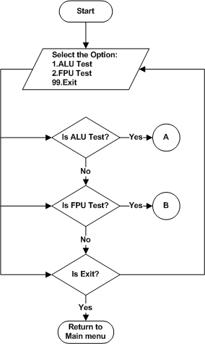
Figure 1 : Processor Test Menu

ALU Test
Refer the section 2.1.3.1.1and 2.2.1.1 for Module Decomposition and Data Decomposition..
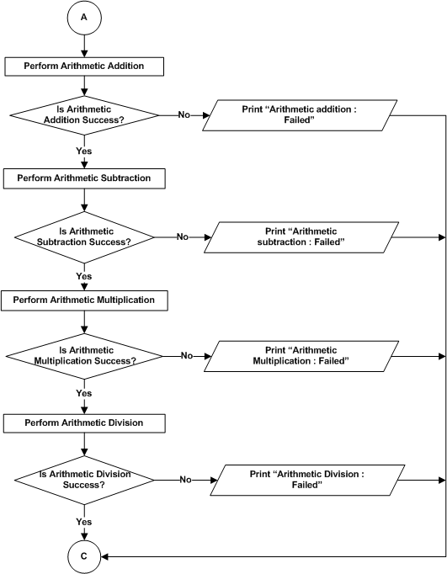

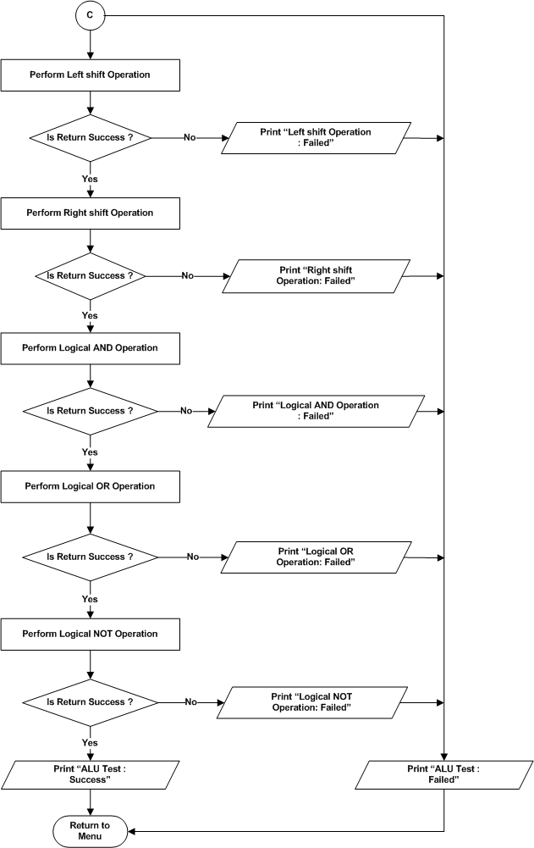
Figure 2: Processor Test - ALU Test

FPU Test
Refer the section 2.1.3.1.2 and 2.2.1.1for Module Decomposition and Data Decomposition..
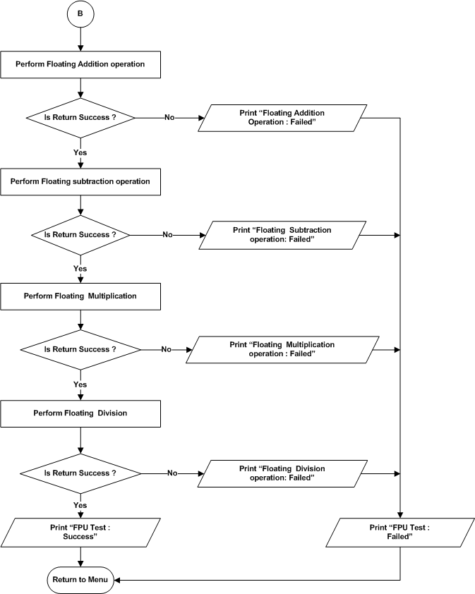
Figure 3 : Processor Test – FPU Test

DDR4 Test
Refer the section 2.1.3.2 and 2.2.1.3 for Module Decomposition and Data Decomposition..
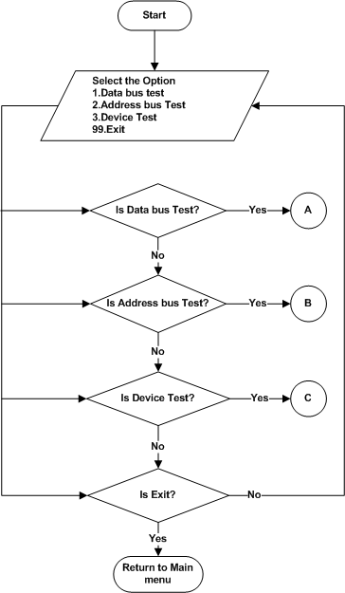

Figure 4 : DDR4 Test Menu

Data Bus Test
Refer the section 2.1.3.2.1 and 2.2.1.3 for Module Decomposition and Data Decomposition..
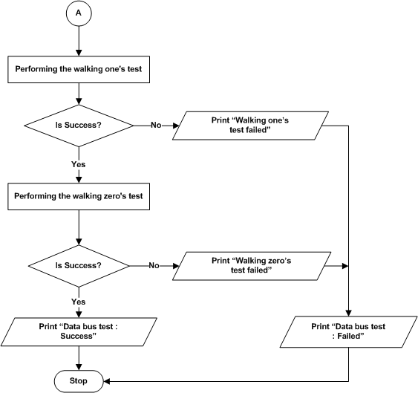
Figure 5: DDR4 Test – Data Bus Test

Address Bus Test
Refer the section 2.1.3.2.2 and 2.2.1.3 for Module Decomposition and Data Decomposition..
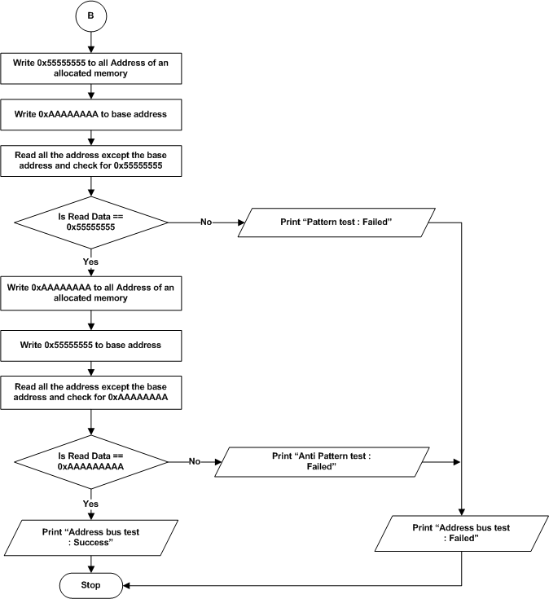
Figure 6: DDR4 Test – Address Bus Test

Device Test
Refer the section 2.1.3.2.3 and 2.2.1.3 for Module Decomposition and Data Decomposition..
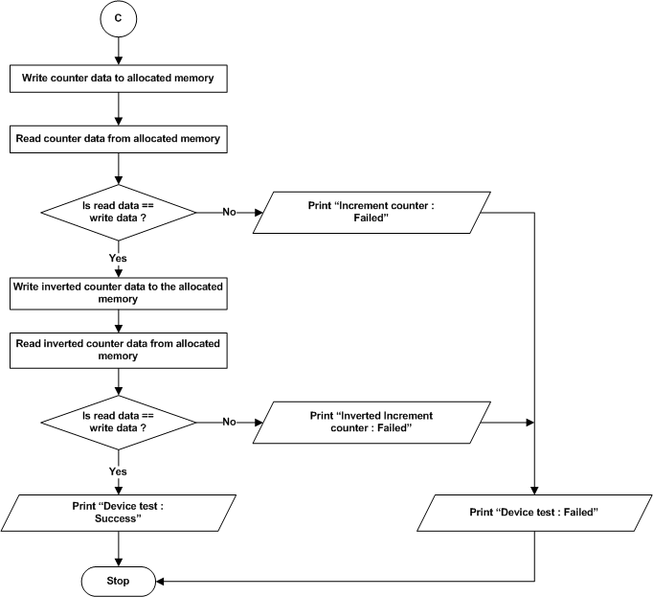
Figure 7: DDR4 Test –Device Test

EEPROM Test
Refer the section 2.1.3.3 and 2.2.1.3 for Module Decomposition and Data Decomposition..
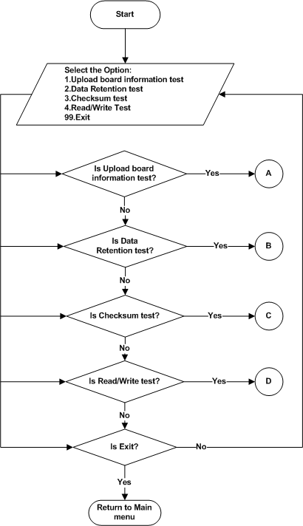
Figure 8 : EEPROM Test Menu

Upload Board Information Test
Refer the section 2.1.3.3.1 and 2.2.1.3 for Module Decomposition and Data Decomposition..
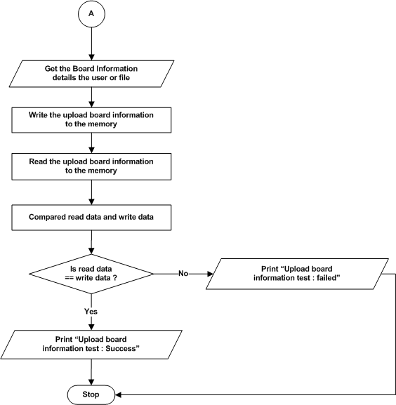

Figure 9 : EEPROM – Upload Board Information Test

Data Retention Test
Refer the section 2.1.3.3.2 and 2.2.1.3 for Module Decomposition and Data Decomposition..
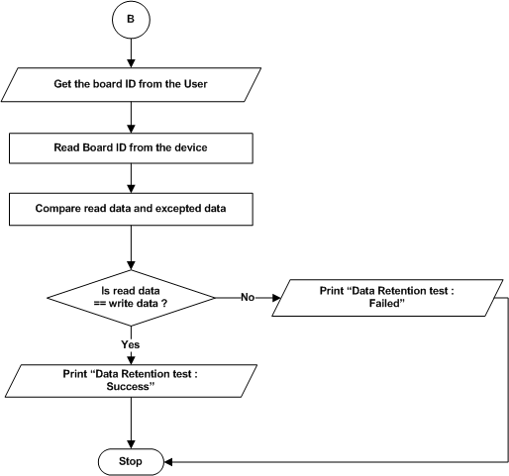
Figure 10 : EEPROM – Data Retention Test

Checksum Test
Refer the section 2.1.3.3.3 and 2.2.1.3 for Module Decomposition and Data Decomposition..
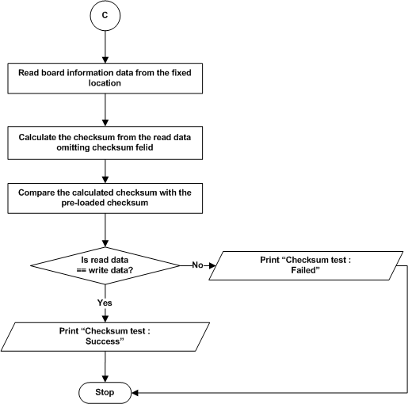

Figure 11 : EEPROM – Checksum Test

Read/Write Test
Refer the section 2.1.3.3.4 and 2.2.1.3 for Module Decomposition and Data Decomposition..
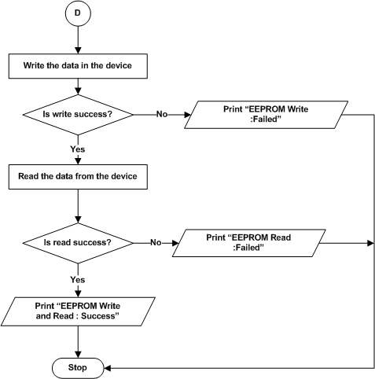

Figure 12 : EEPROM – Read/Write Test

MRAM Test
Refer the section 2.1.3.4 and 2.2.1.4 for Module Decomposition and Data Decomposition..
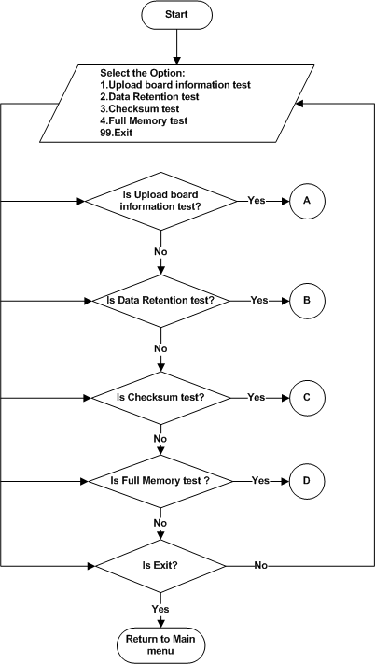

Figure 13 : MRAM Test Menu

Upload Board Information test

Refer the section 2.1.3.4.1 and 2.2.1.4 for Module Decomposition and Data Decomposition..
Figure 14 : MRAM – Upload board information Test

Data Retention test

Refer the section 2.1.3.4.2 and 2.2.1.4 for Module Decomposition and Data Decomposition..

Figure 15 : MRAM – Data Retention Test

Checksum Test
Refer the section 2.1.3.4.3 and 2.2.1.4 for Module Decomposition and Data Decomposition..

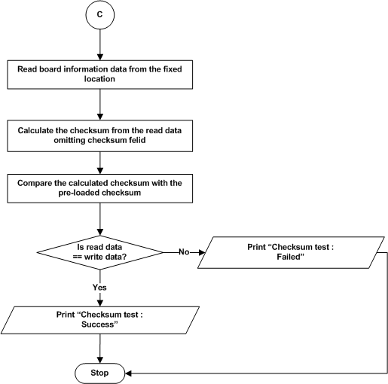
Figure 16 : MRAM – Checksum Test

Full Memory test

Refer the section 2.1.3.4.3 and 2.2.1.4 for Module Decomposition and Data Decomposition..

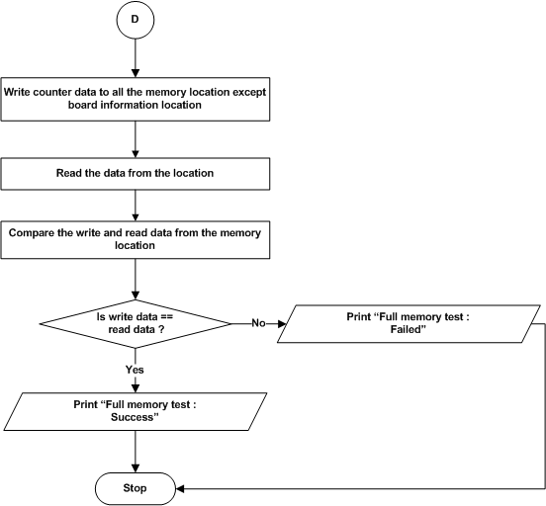
Figure 17 : MRAM – Full Memory Test

NAND Flash Test
Refer the section 2.1.3.4.4 and 2.2.1.5 for Module Decomposition and Data Decomposition..
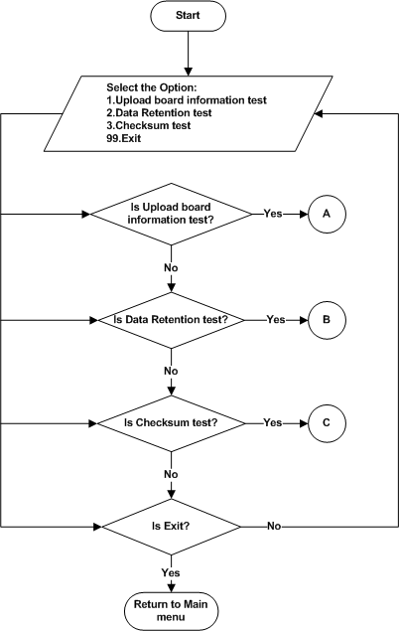
Figure 18 : NAND Flash Test Menu

Upload Board Information test
Refer the section 2.1.3.5.1 and 2.2.1.5 for Module Decomposition and Data Decomposition..
Figure 19 : NAND Flash – Upload board information test

Data Retention Test
Refer the section 2.1.3.5.2 and 2.2.1.5 for Module Decomposition and Data Decomposition..
Figure 20 : NAND Flash – Data Retention test

Checksum Test
Refer the section 2.1.3.5.3 and 2.2.1.5 for Module Decomposition and Data Decomposition..
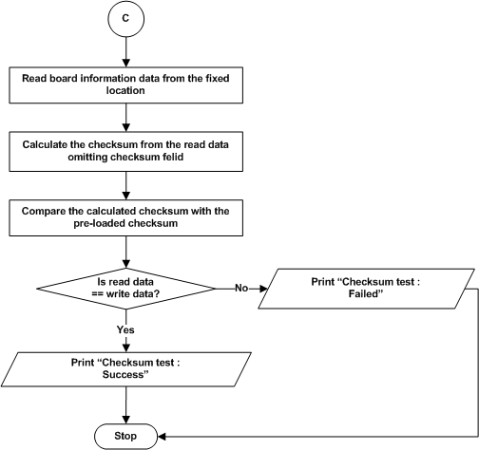
Figure 21 : NAND Flash – Checksum test

NOR Flash Test
Refer the section 2.1.3.6 and 2.2.1.6 for Module Decomposition and Data Decomposition..
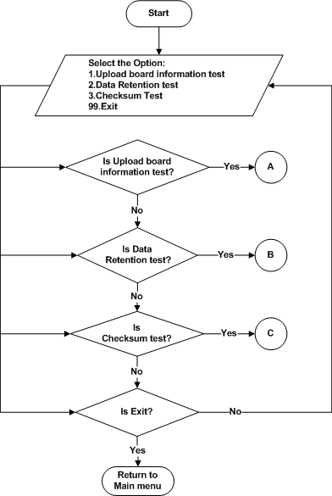
Figure 22 : NOR Flash Test Menu

Upload Board Information test
Refer the section 2.1.3.6.1 and 2.2.1.6 for Module Decomposition and Data Decomposition..
Figure 23 : NOR Flash – Upload board information test

Data Retention Test
Refer the section 2.1.3.6.2 and 2.2.1.6 for Module Decomposition and Data Decomposition..
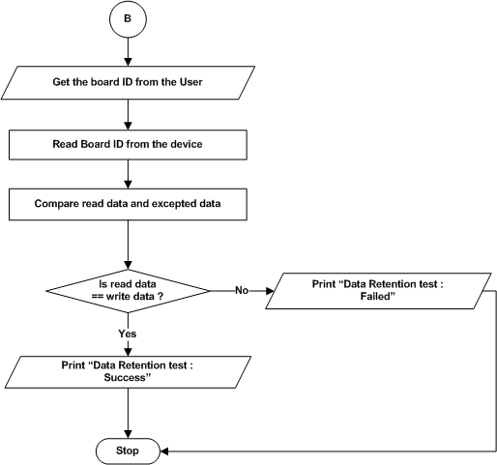
Figure 24 : NOR Flash – Data Retention test

Checksum Test
Refer the section 2.1.3.6.3 and 2.2.1.6 for Module Decomposition and Data Decomposition..
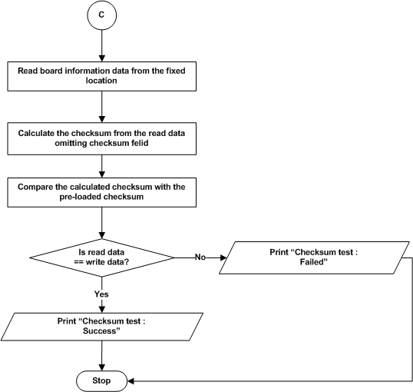
Figure 25 : NOR Flash – Checksum test

USB Test

Read / Write Test
Refer the section 2.1.3.7.1 and 2.2.1.7 for Module Decomposition and Data Decomposition.
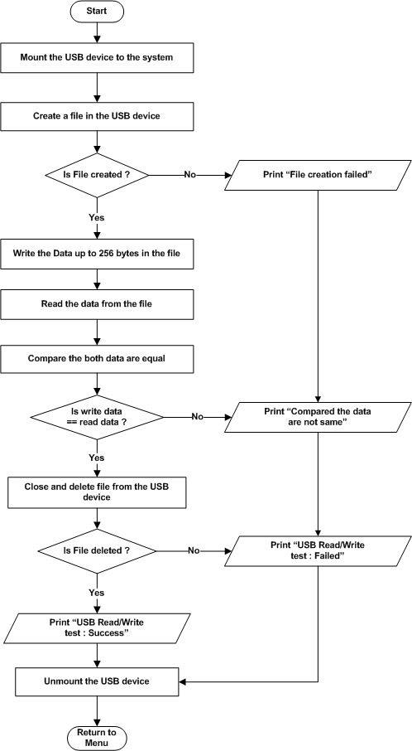
Figure 26: USB – Read / Write Test

SATA Test

Read / Write Test
Refer the section 2.1.3.8.1 and 2.2.1.8 for Module Decomposition and Data Decomposition..
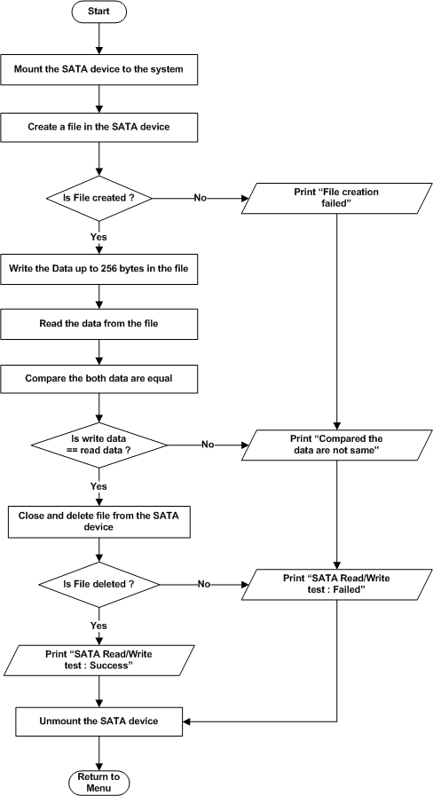
Figure 27 : SATA – Read / Write Test

SD Card Test

Read / Write Test
Refer the section 2.1.3.9.1 and 2.2.1.9 for Module Decomposition and Data Decomposition..
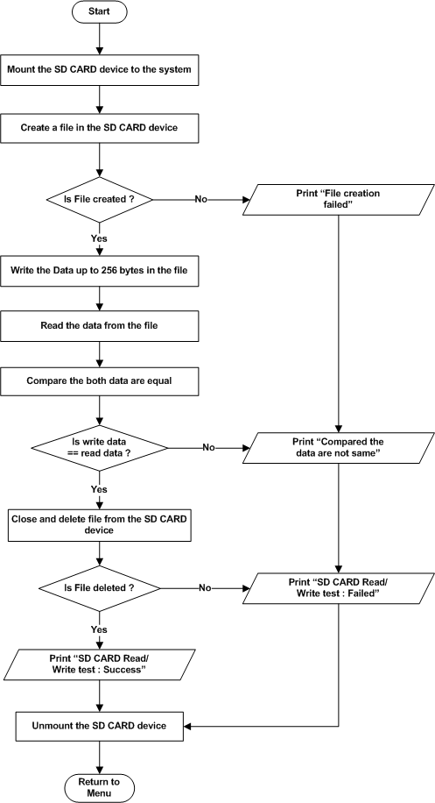
Figure 28 : SD Card – Read / Write Test

UART Test
Refer the section 2.1.3.10 and 2.2.1.10 for Module Decomposition and Data Decomposition..
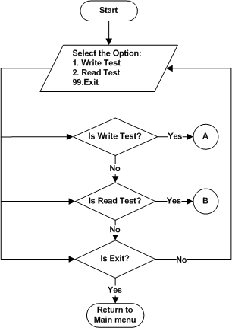

Figure 29 : UART Main Menu

Write Test
Refer the section 2.1.3.10.1 and 2.2.1.10 for Module Decomposition and Data Decomposition..
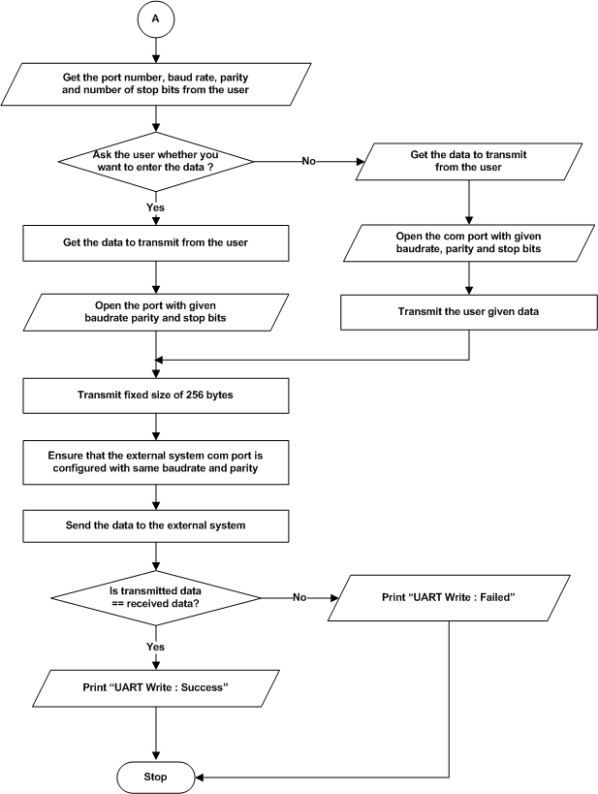
Figure 30 : UART – Write Test

Read Test
Refer the section 2.1.3.10.2 and 2.2.1.10for Module Decomposition and Data Decomposition..
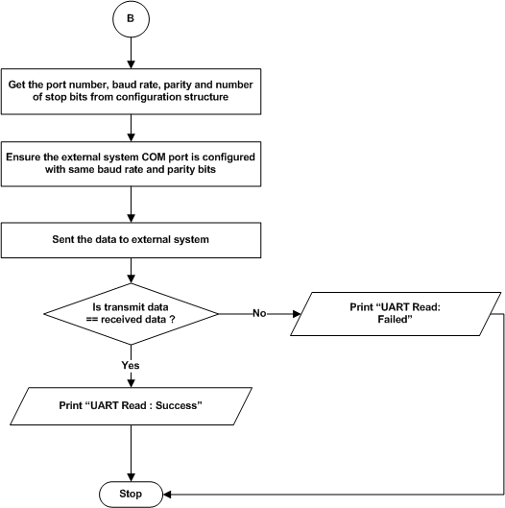
Figure 31 : UART – Read

Ethernet Test
Refer the section 2.1.3.11 and 2.2.1.11 for Module Decomposition and Data Decomposition..

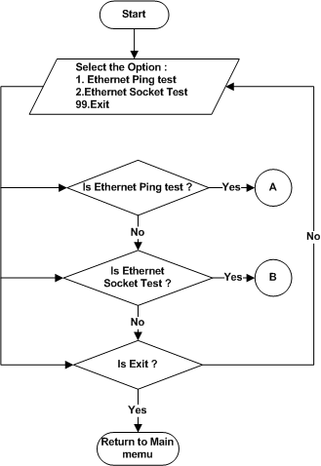

Figure 32 : Ethernet - Test Menu

Ethernet ping Test
Refer the section 2.1.3.11.1 and 2.2.1.11 for Module Decomposition and Data Decomposition..

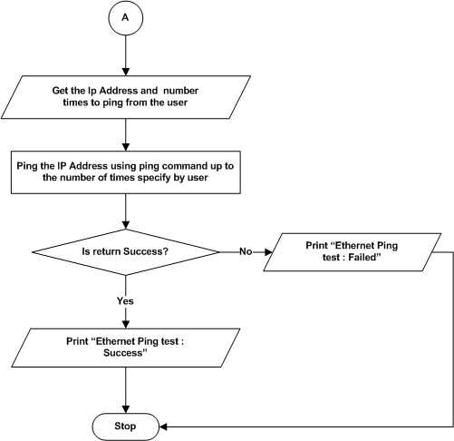

Figure 33 : Ethernet Ping Test

Ethernet Socket Test
Refer the section 2.1.3.11.2 and 2.2.1.11 for Module Decomposition and Data Decomposition.

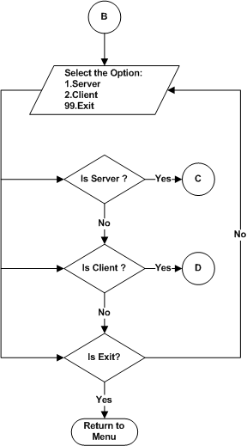

Figure 34 : Ethernet Socket Test Menu

Ethernet Socket Test: Server
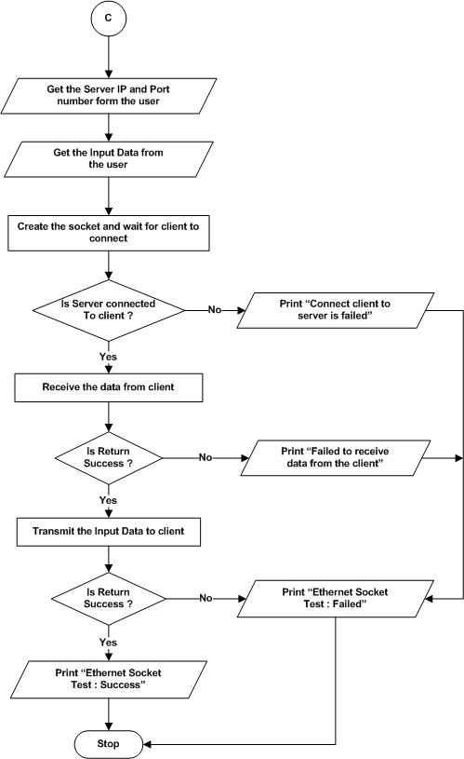
Figure 35 : Ethernet Socket Test : Server

Ethernet Socket Test: Client
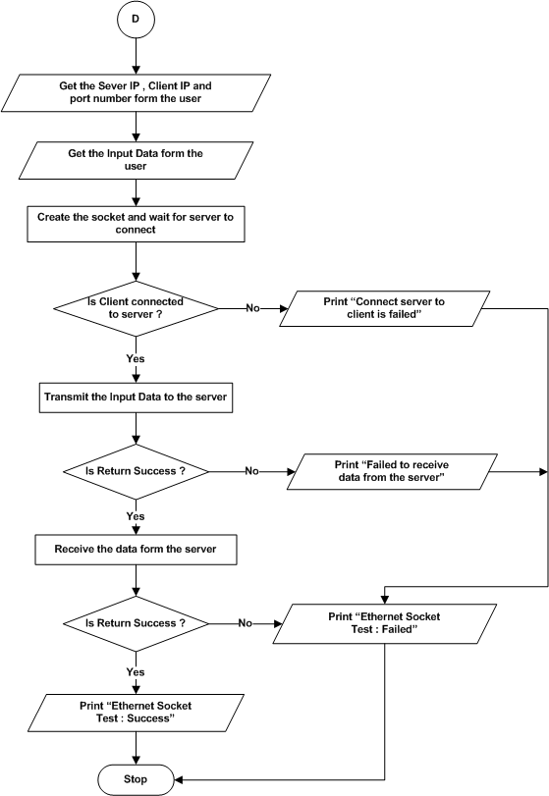

Figure 36 : Ethernet Socket Test : Client

Temperature Sensor Test
Refer the section 2.1.3.12 and 2.2.1.12 for Module Decomposition and Data Decomposition..
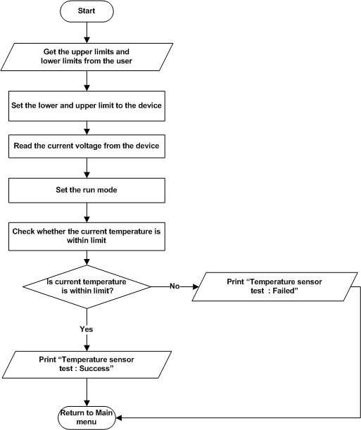
Figure 37 : Temperature Sensor Test

Voltage Monitoring Test
Refer the section 2.1.3.13 and 2.2.1.13 for Module Decomposition and Data Decomposition..
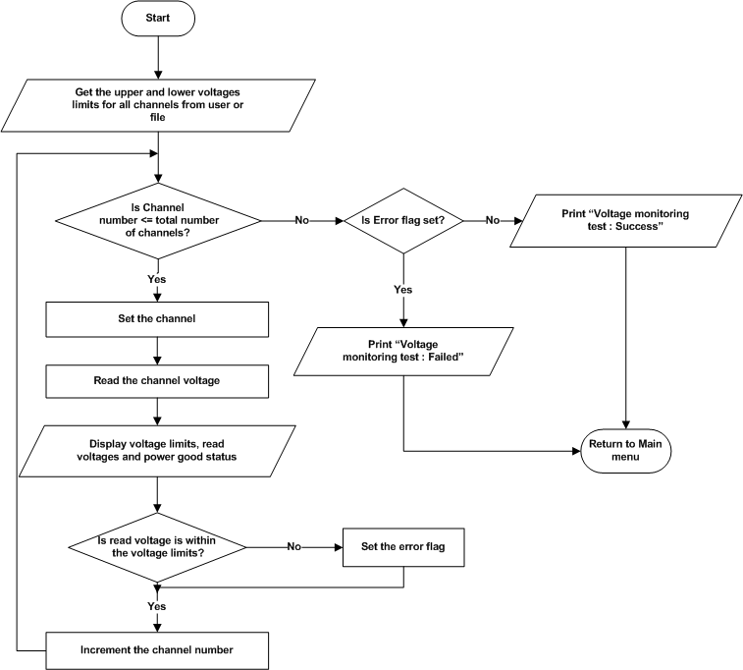
Figure 38 : ADM – Voltage Monitoring Test

Programmable Logic

DDR4 (PL)
Refer the section 2.1.4.1 and 2.2.2.1 for Module Decomposition and Data Decomposition..

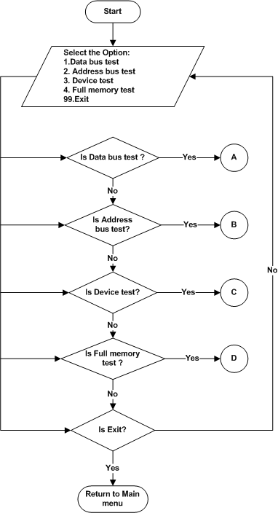

Figure 39 : DDR4 (PL) – Main menu

Data Bus test

Refer the section 2.1.4.1.1 and 2.2.2.1 for Module Decomposition and Data Decomposition..

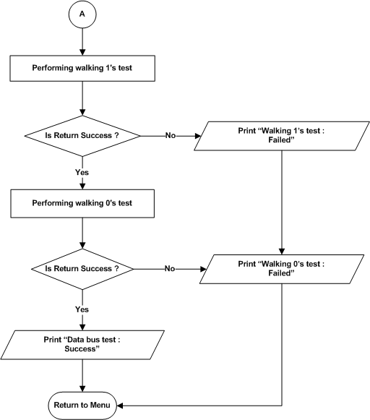
Figure 40 : DDR4 (PL) – Data bus test

Address Bus test

Refer the section 2.1.4.1.2 and 2.2.2.1 for Module Decomposition and Data Decomposition..
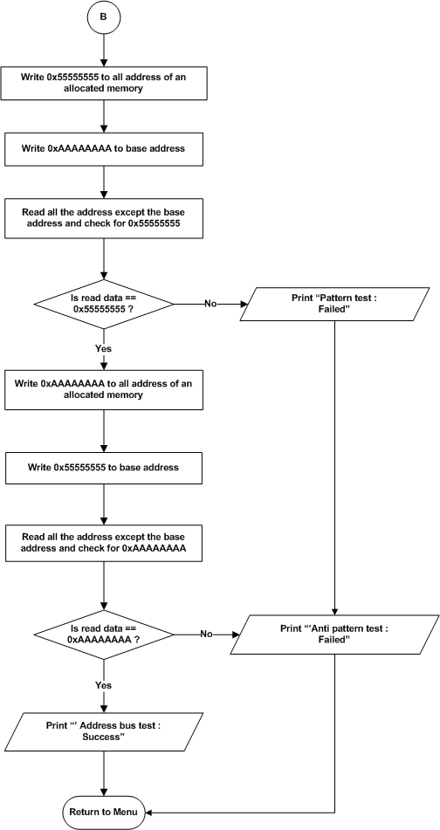
Figure 41 : DDR4 (PL) – Address Bus test

Device test

Refer the section 2.1.4.1.3 and 2.2.2.1 for Module Decomposition and Data Decomposition..

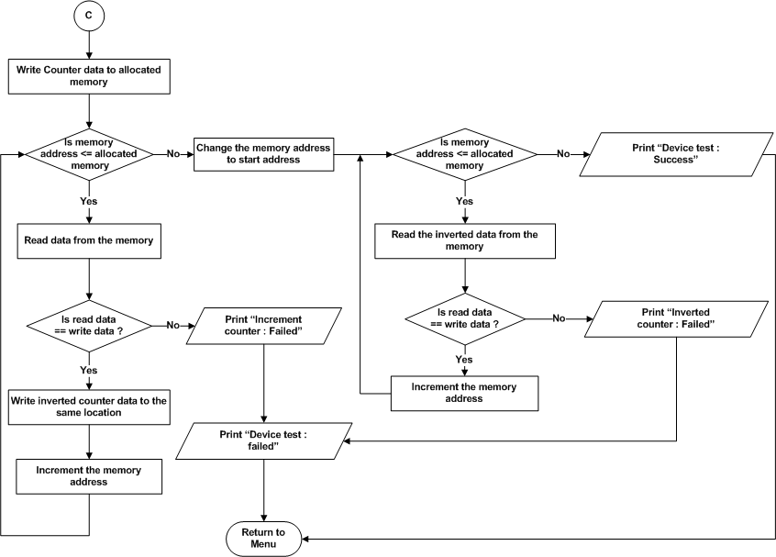
Figure 42 : DDR4 (PL) – Device test

Full memory test

Refer the section 2.1.4.1.4 and 2.2.2.1 for Module Decomposition and Data Decomposition..

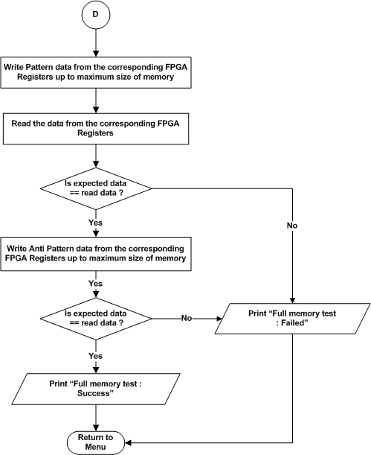

Figure 43 : DDR4 (PL) – Full memory test

UART (PL)
Refer the section 2.1.4.2 and 2.2.2.2 for Module Decomposition and Data Decomposition..
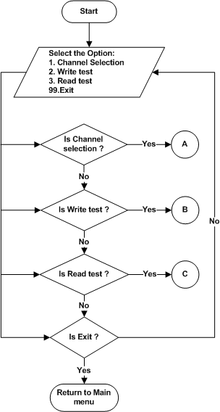

Figure 44 : UART (PL) – Main menu

Channel selection
Refer the section 2.1.4.2 and 2.2.2.2 for Module Decomposition and Data Decomposition..

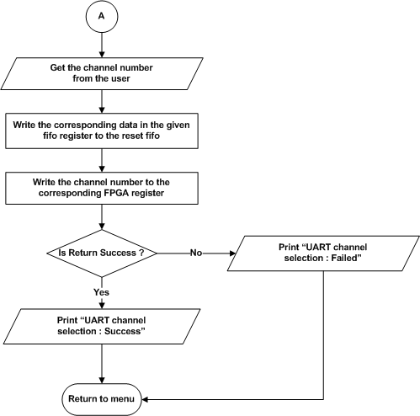

Figure 45 : UART (PL) – Channel selection

Write test

Refer the section 2.1.4.2.1 and 2.2.2.2 for Module Decomposition and Data Decomposition..

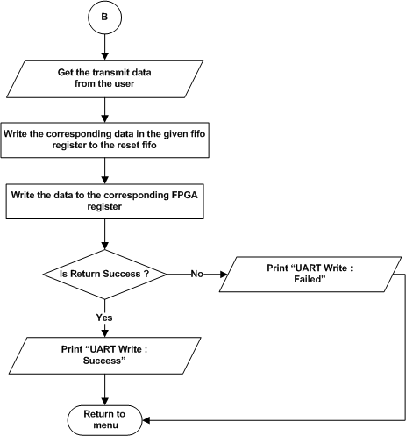

Figure 46 : UART (PL) – Write test

Read test
Refer the section 2.1.4.2.2 and 2.2.2.2 for Module Decomposition and Data Decomposition..
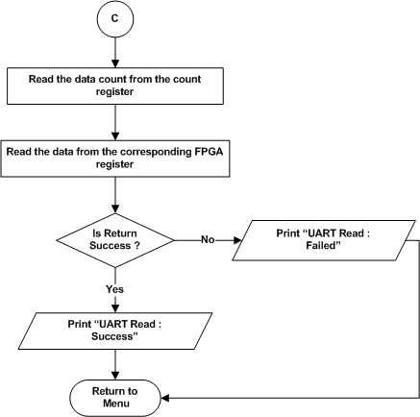

Figure 47 : UART (PL) – Read test

NOR Flash (PL) test
Refer the section 2.1.4.3 and 2.2.2.3 for Module and Data decomposition

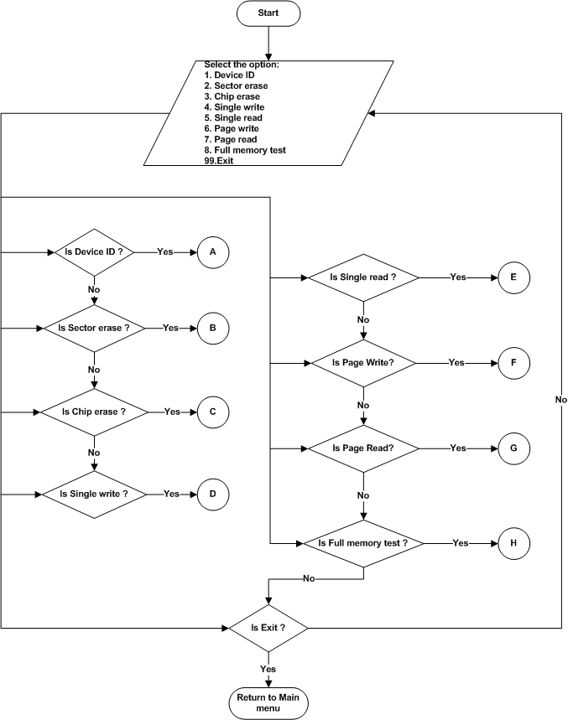
Figure 48 : PL NOR Flash – Main menu

Device ID
Refer the section 2.1.4.3.1 and 2.2.2.3 for Module and Data decomposition

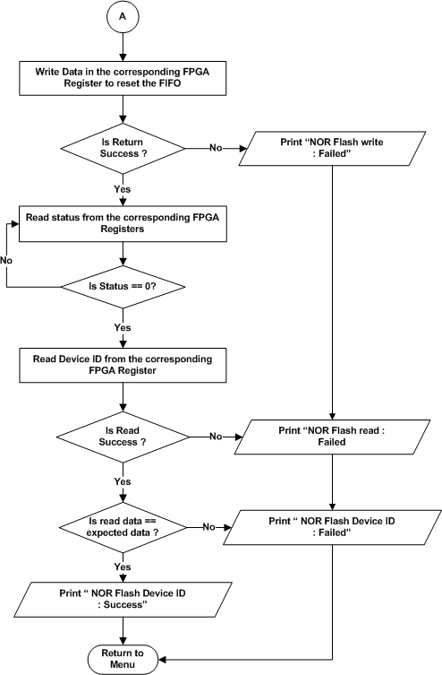
Figure 49 : PL NOR Flash – Device ID

Sector erase
Refer the section 2.1.4.3.3 and 2.2.2.3 for Module and Data decomposition

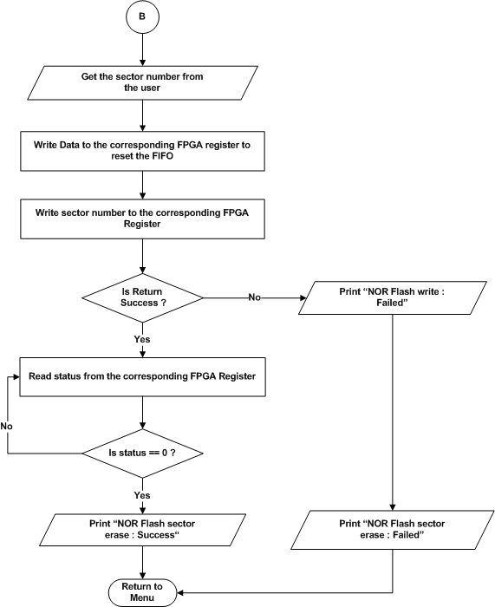
Figure 50 : PL NOR Flash – Sector erase

Chip / Die erase
Refer the section 2.1.4.3.2 and 2.2.2.3 for Module and Data decomposition

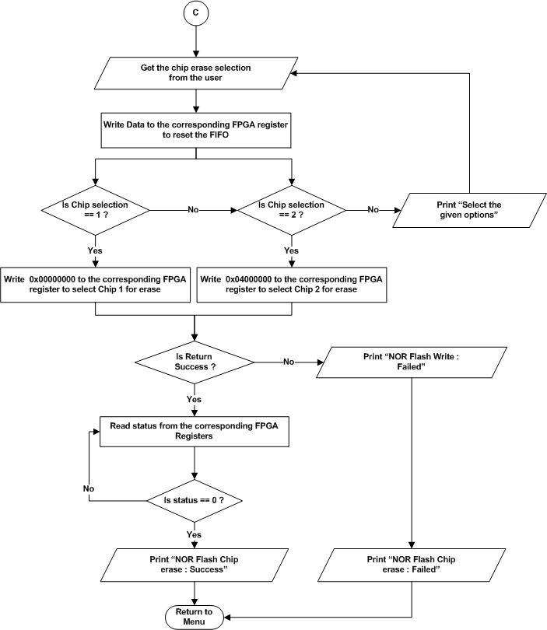
Figure 51 : PL NOR Flash – Chip erase

Single Write
Refer the section 2.1.4.3.4 and 2.2.2.3 for Module and Data decomposition

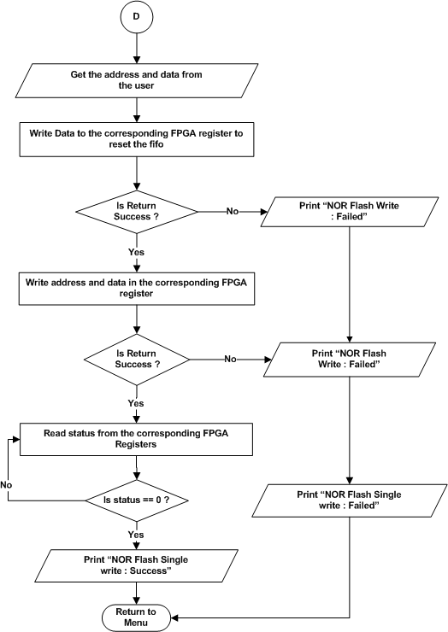

Figure 52 : PL NOR Flash – Single Write

Single Read
Refer the section 2.1.4.3.5 and 2.2.2.3 for Module and Data decomposition

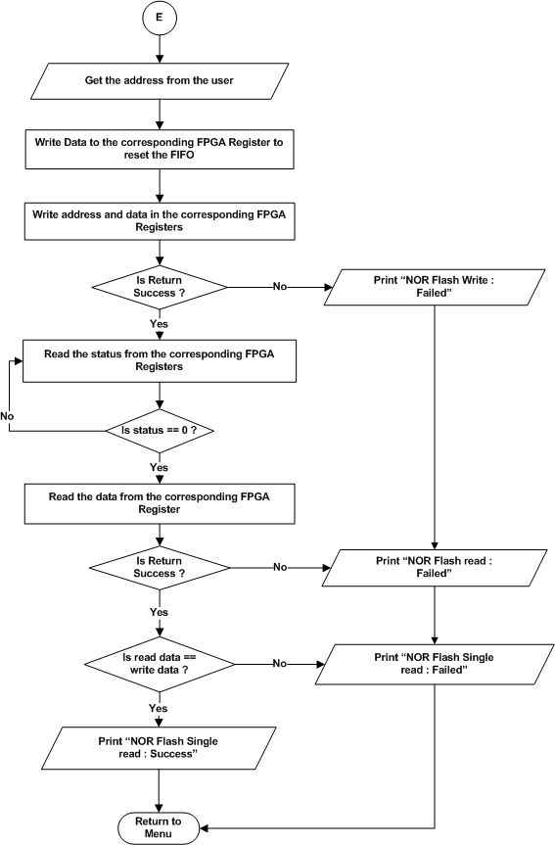
Figure 53 : PL NOR Flash – Single Read

Page Write
Refer the section 2.1.4.3.6 and 2.2.2.3 for Module and Data decomposition

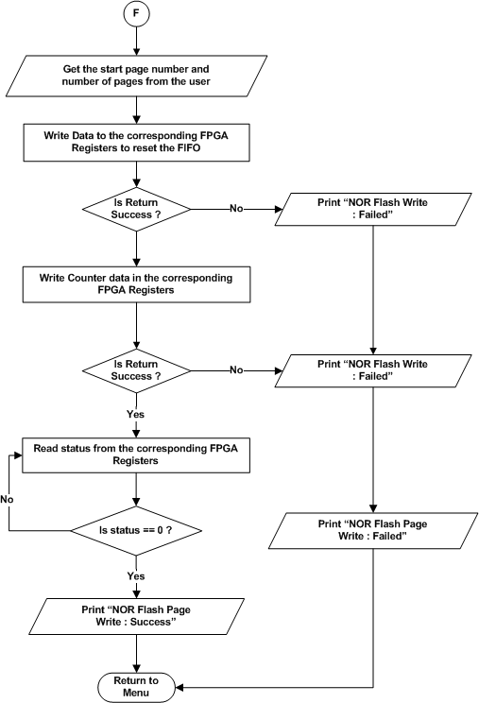

Figure 54 : PL NOR Flash – Page Write

Page Read
Refer the section 2.1.4.3.7 and 2.2.2.3 for Module and Data decomposition
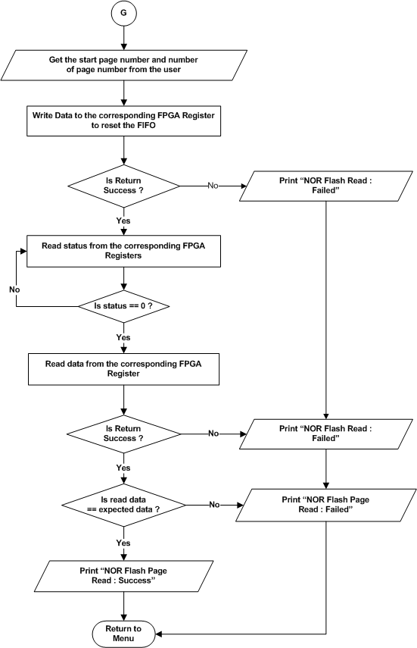
Figure 55 : PL NOR Flash – Page Read

Full memory test
Refer the section 2.1.4.3.8 and 2.2.2.6 for Module and Data decomposition
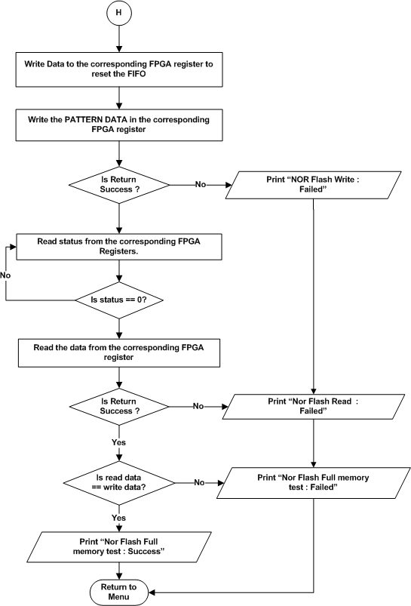
Figure 56 : PL NOR Flash – Full memory test

SFP Optical transceiver
Refer the section 2.1.4.4 and 2.2.2.6 for Module and Data decomposition
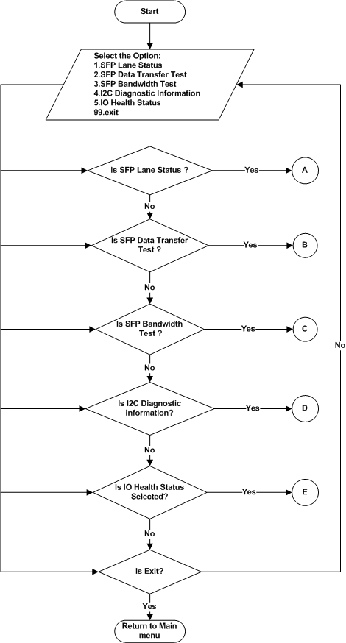
Figure 57 : SFP Optical Transceiver – Main menu

SFP lane status
Refer the section 2.1.4.4.1 and 2.2.2.4 for Module and Data decomposition

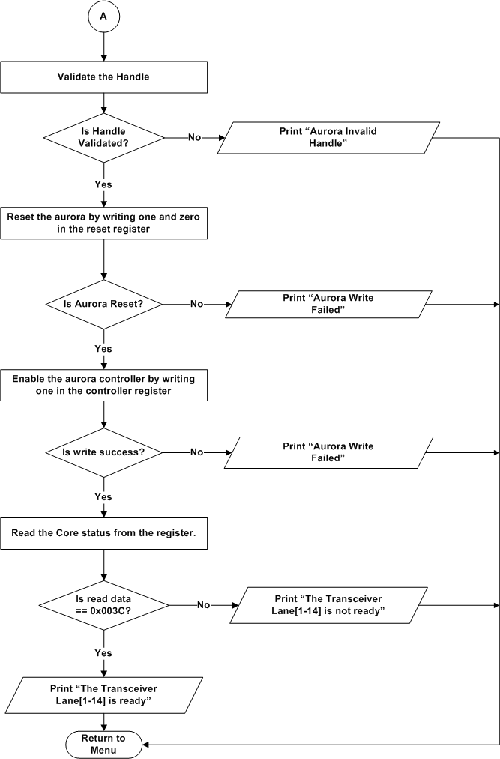
Figure 58 : SFP Optical Transceiver – SFP lane status

Data Transfer test
Refer the section 2.1.4.4.2 and 2.2.2.4 for Module and Data decomposition

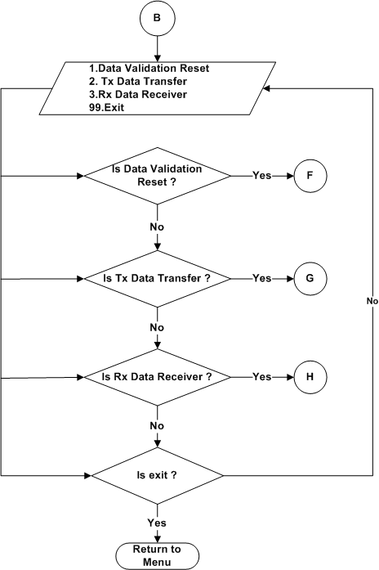

Figure 59 : Data Transfer test – test menu

Data validation reset
Refer the section 2.1.4.4.2.1 and 2.2.2.4 for Module and Data decomposition

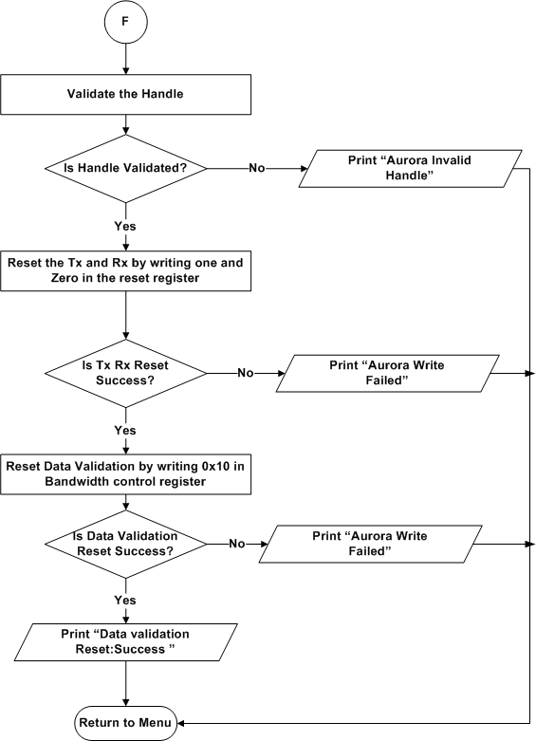

Figure 60 : Data Transfer test - Data validation reset

Tx Data Transfer
Refer the section 2.1.4.4.2.2 and 2.2.2.4 for Module and Data decomposition

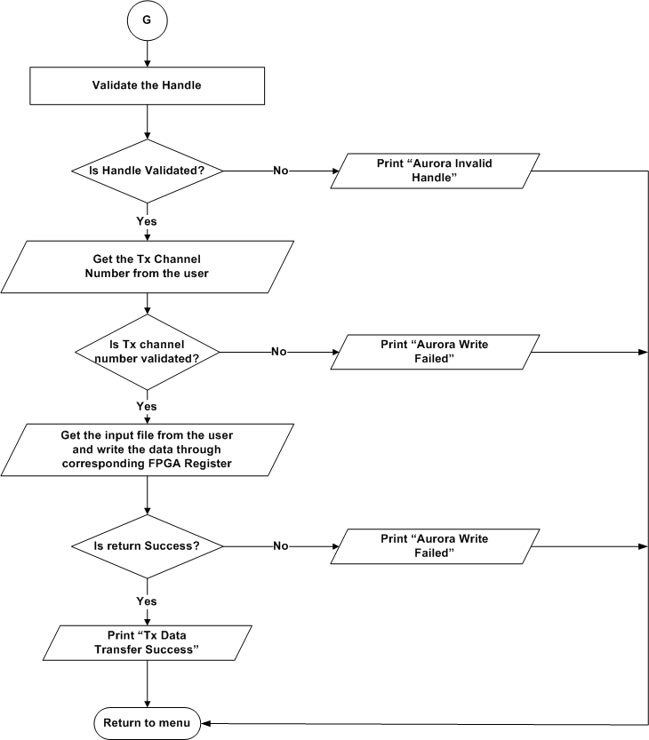

Figure 61 : Data Transfer test – Tx data transfer

Rx Data Reciver
Refer the section 2.1.4.4.2.3 and 2.2.2.4 for Module and Data decomposition
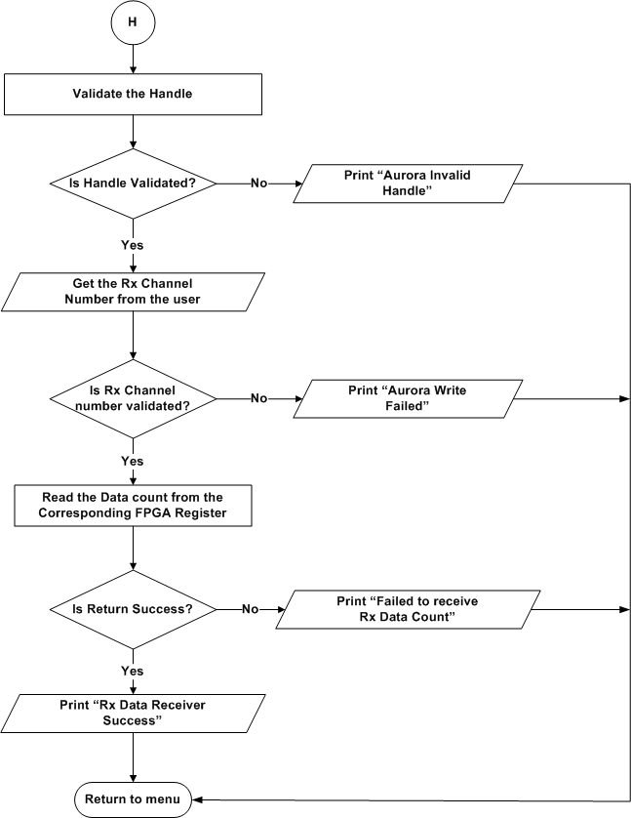

Figure 62 : Data Transfer test – Rx data transfer

Bandwidth test
Refer the section 2.1.4.4.3 and 2.2.2.4 for Module and Data decomposition

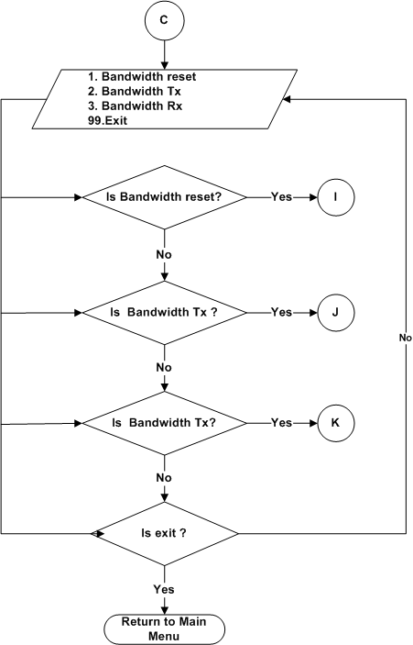

Figure 63 : Bandwidth test – test menu

Bandwidth Reset
Refer the section 2.1.4.4.3.1 and 2.2.2.4 for Module and Data decomposition.

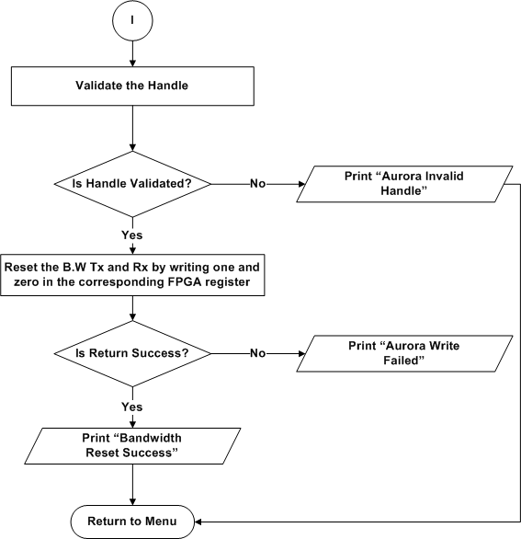

Figure 64 : Bandwidth test – Bandwidth reset

Bandwidth Tx
Refer the section 2.1.4.4.3.2 and 2.2.2.4 for Module and Data decomposition
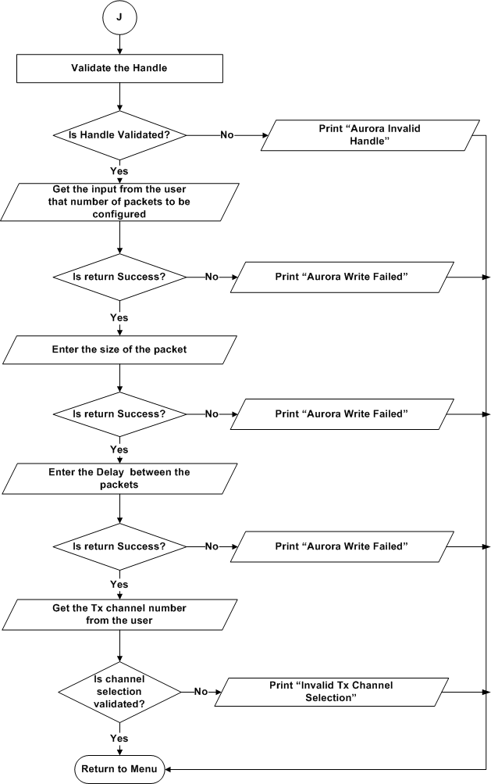
Figure 65 : Bandwidth test – Bandwidth Tx

Bandwidth Rx
Refer the section 2.1.4.4.3.3 and 2.2.2.4 for Module and Data decomposition

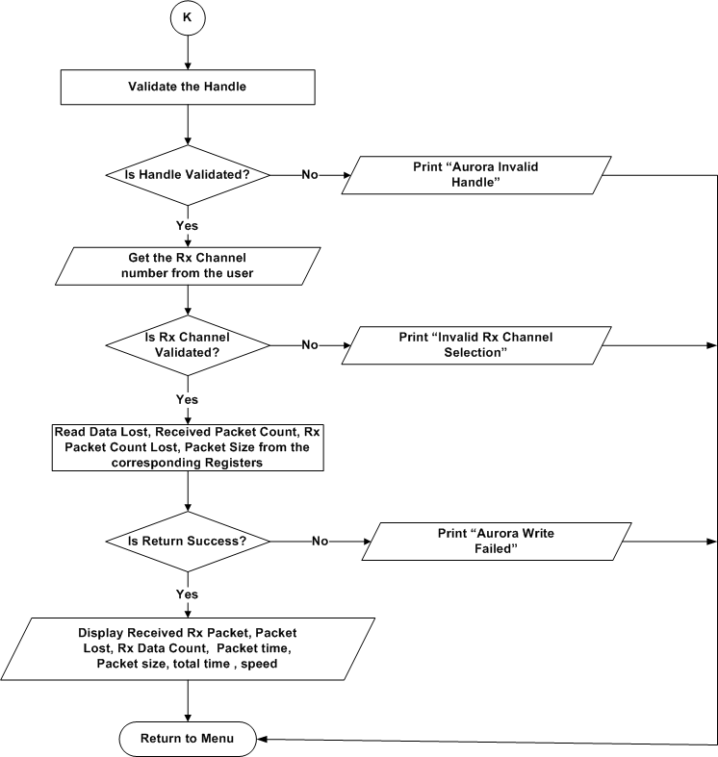
Figure 66 : Bandwidth test – Bandwidth Rx

SFP Diagnostic information
Refer the section 2.1.4.4.4 and 2.2.2.4 for Module and Data decomposition

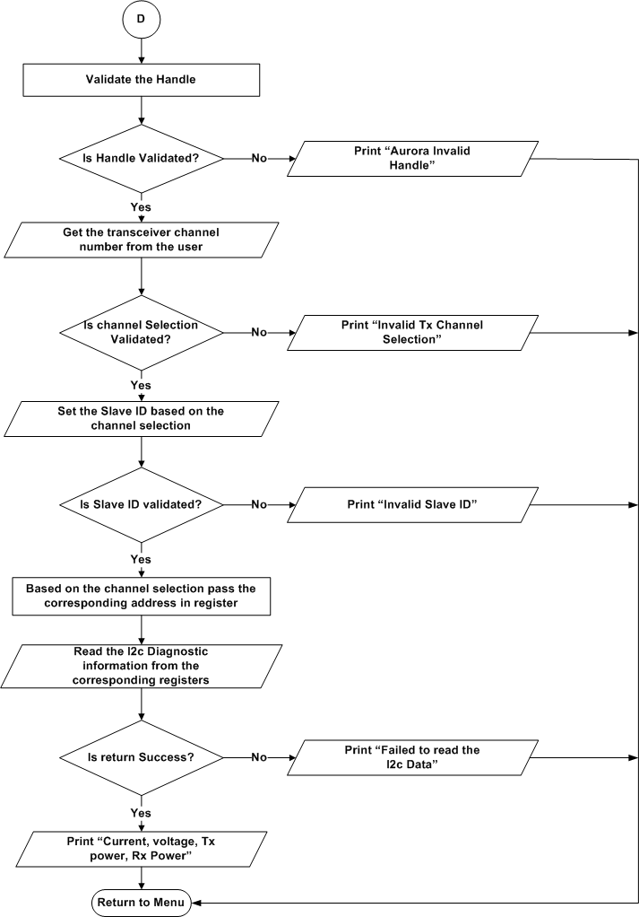
Figure 67 : SFP Optical Transceiver – SFP Diagnostic information

SFP IO HealthStatus
Refer the section 2.1.4.4.5 and 2.2.2.4 for Module and Data decomposition

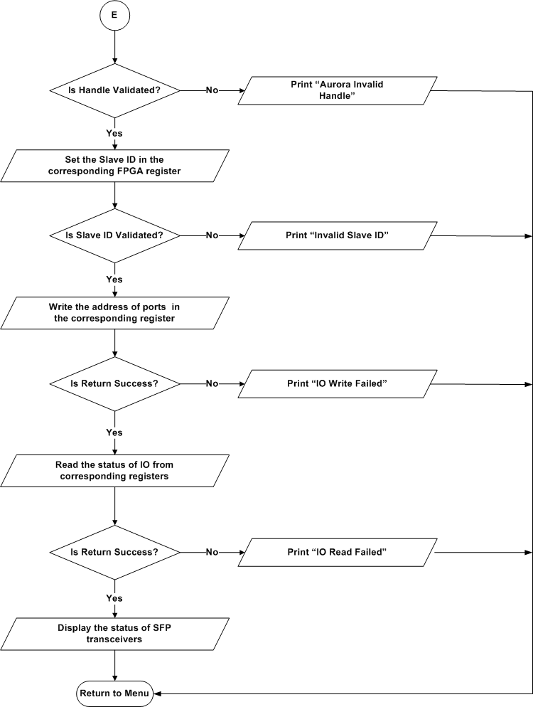
Figure 68 : SFP Optical Transceiver – SFP IO Health Status

Digital Attenuator
` Refer the section 2.1.4.5 and 2.2.2.5 for Module and Data decomposition

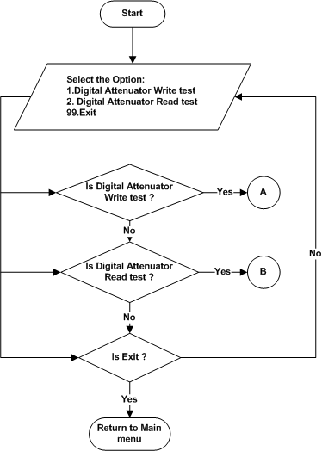
Figure 69 : Digital Attenuator – Main menu

Write Test
Refer the section 2.1.4.5.1 and 2.2.2.5 for Module and Data decomposition

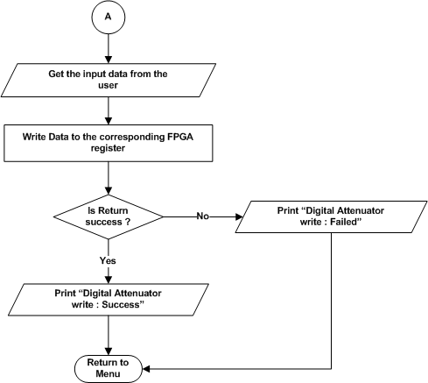
Figure 70 : Digital Attenuator – Write test

Read test
Refer the section 2.1.4.5.2 and 2.2.2.5 for Module and Data decomposition

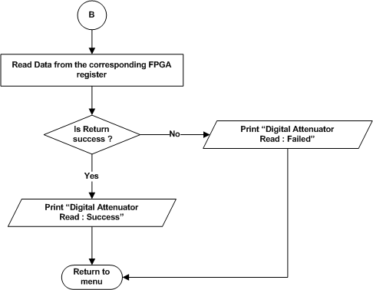
Figure 71 : Digital Attenuator – Read test

GPIO
Refer the section 2.1.4.6 and 2.2.2.6 for Module and Data decomposition

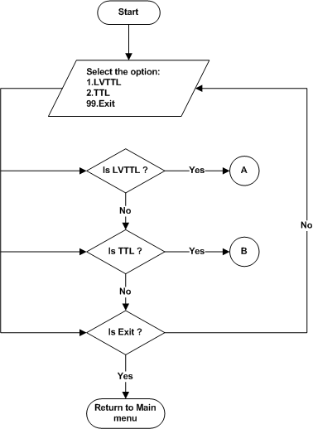
Figure 72 : GPIO – Main menu

LVTTL
Refer the section 2.1.4.6.1 and 2.2.2.6 for Module and Data decomposition

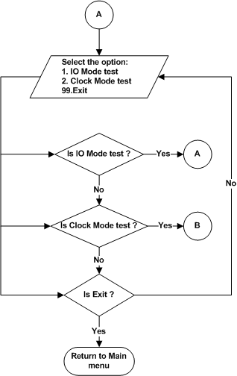

Figure 73 : LVTTL – Menu

IO Mode test
Refer the section 2.1.4.6.1.1 and 2.2.2.6 for Module and Data decomposition

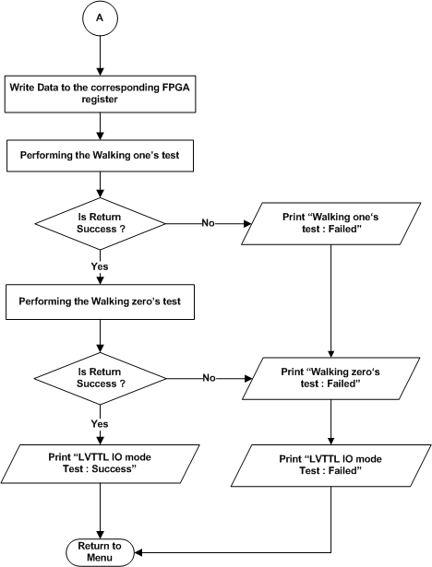
Figure 74 : LVTTL – IO Mode test

Clock Mode Test
Refer the section 2.1.4.6.1.2 and 2.2.2.6 for Module and Data decomposition

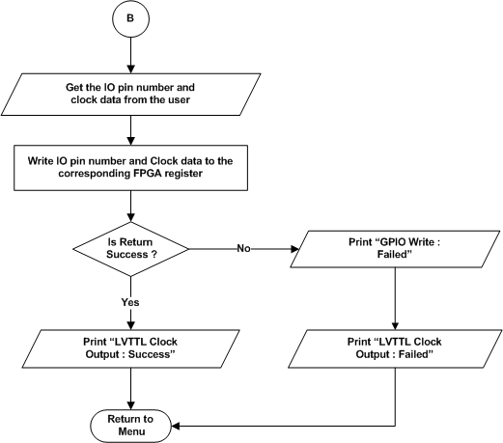

Figure 75 : LVTTL - Clock Mode test

TTL
Refer the section 2.1.4.6.1.2 and 2.2.2.6 for Module and Data decomposition
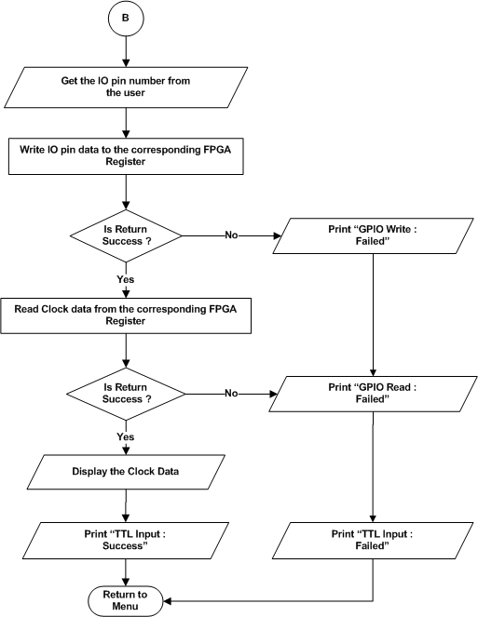
Figure 76 : TTL – Clock test

SFP TRS
Refer the section 2.1.4.7 and 2.2.2.7 for Module and Data decomposition.

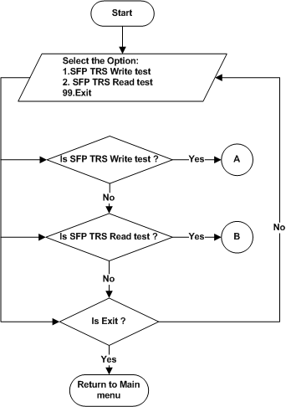
Figure 77 : SFP TRS – Main menu

Write test
Refer the section 2.1.4.7.1 and 2.2.2.7 for Module and Data decomposition.

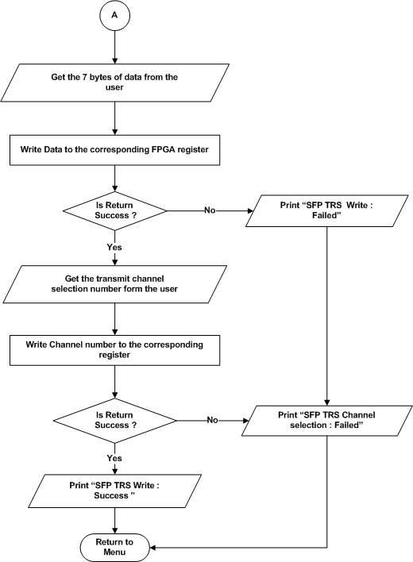
Figure 78 : SFP TRS – Write Test

Read test
Refer the section 2.1.4.7.2 and 2.2.2.7 for Module and Data decomposition.

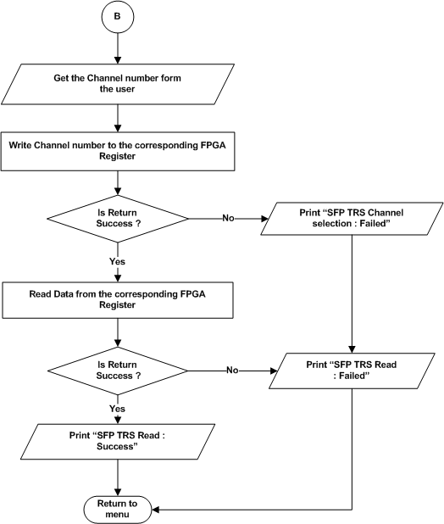

Figure 79 : SFP TRS – Read test

LTC PLL
Refer the section 2.1.4.8 and 2.2.2.8 for Module and Data decomposition.

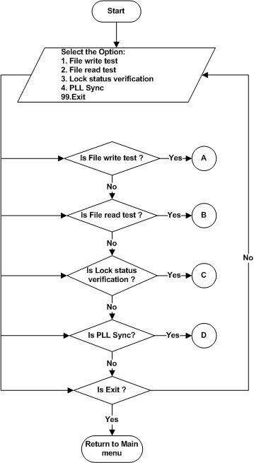
Figure 80 : LTC PLL – Main menu

File Write
Refer the section 2.1.4.8.1 and 2.2.2.8 for Module and Data decomposition.

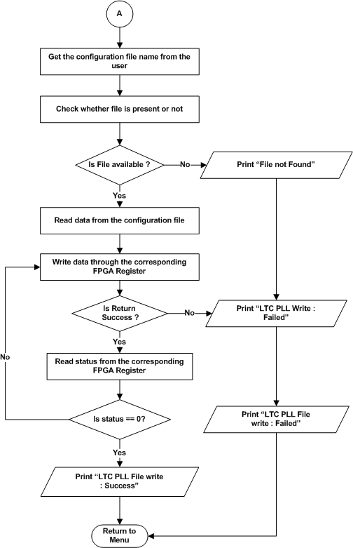
Figure 81 : LTC PLL – File Write

File Read
Refer the section 2.1.4.8.2 and 2.2.2.8 for Module and Data decomposition.
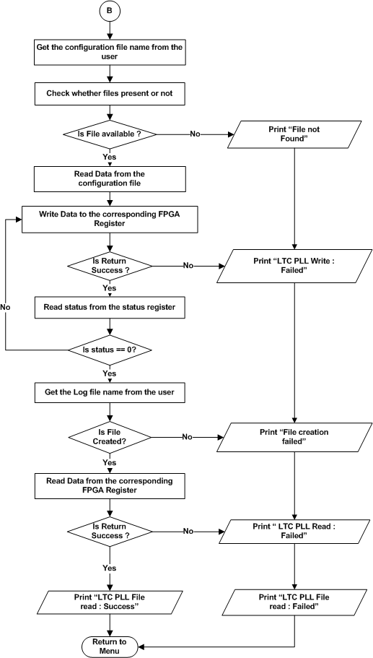
Figure 82 : LTC PLL – File Read

Lock status verification
Refer the section 2.1.4.8.3 and 2.2.2.8 for Module and Data decomposition.

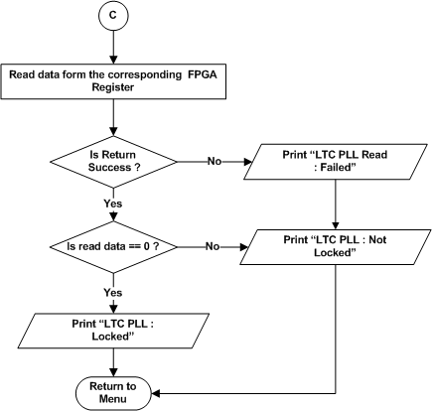
Figure 83 : LTC PLL – Lock status

PLL Sync
Refer the section 2.1.4.8.3 and 2.2.2.8 for Module and Data decomposition.

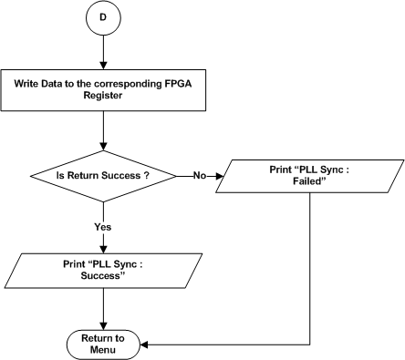

Figure 84 : LTC PLL – PLL Sync

NMEA
Refer the section 2.1.4.9 and 2.2.2.9 for Module and Data decomposition.

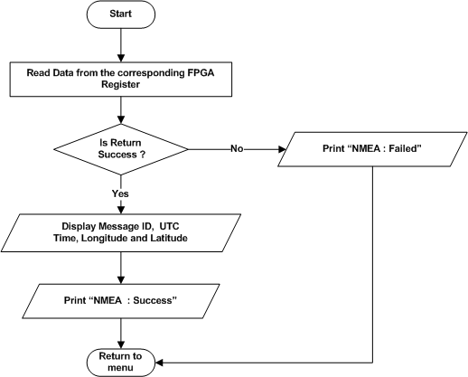
Figure 85 : NMEA

IRIG-B
Refer the section 2.1.4.10 and 2.2.2.10 for Module and Data decomposition.

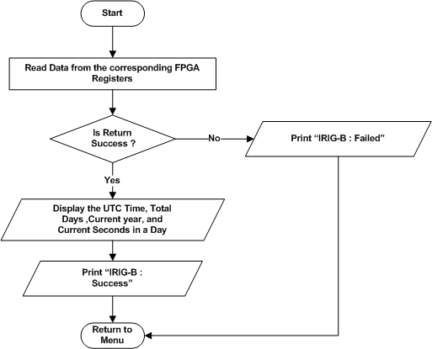
Figure 86 : IRIG-B

1PPS
Refer the section 2.1.4.11 and 2.2.2.11 for Module and Data decomposition.

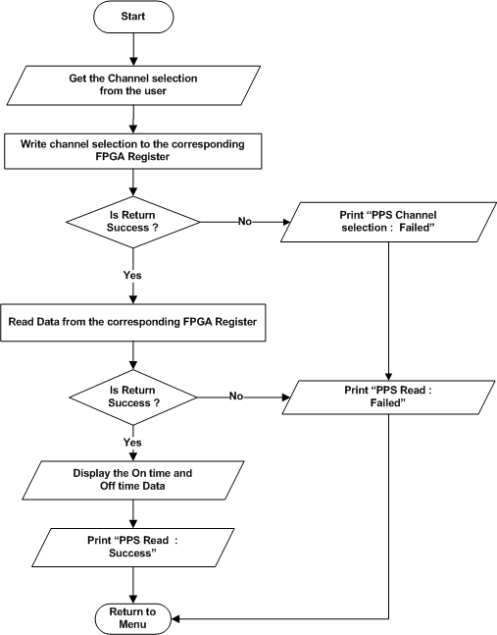
Figure 87 : 1PPS

FPGA Junction Temperature

Refer the section 2.1.4.12 and 2.2.2.12 for Module and Data decomposition.

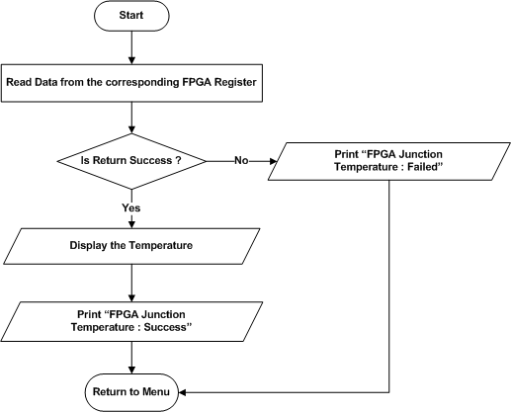

Figure 88 : FPGA Junction Temperature

DP-SPL-5299 Test
Refer the section 2.1.4.13 and 2.2.2.13 for Module and Data decomposition.

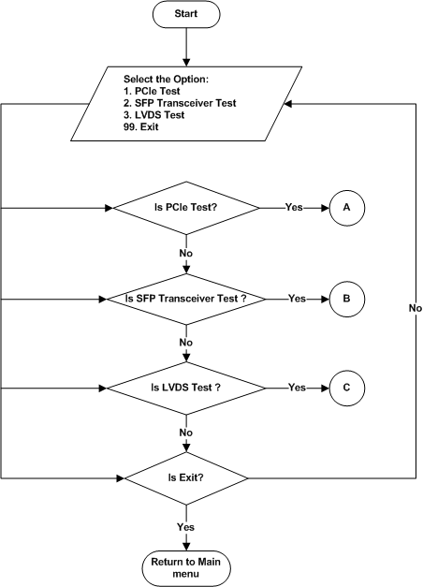
Figure 89 : DP-SPL-5299 Test menu

PCIe Test
Refer the section 2.1.4.13.1 and 2.2.2.13.1 for Module and Data decomposition.

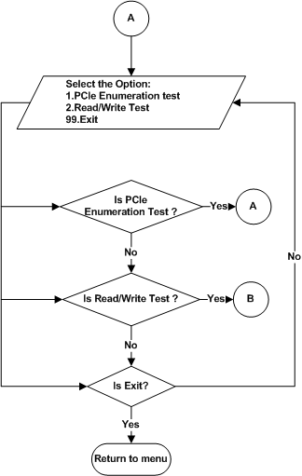

Figure 90 : DP-SPL-5299 - PCIe Test menu

PCIe Enumeration Test

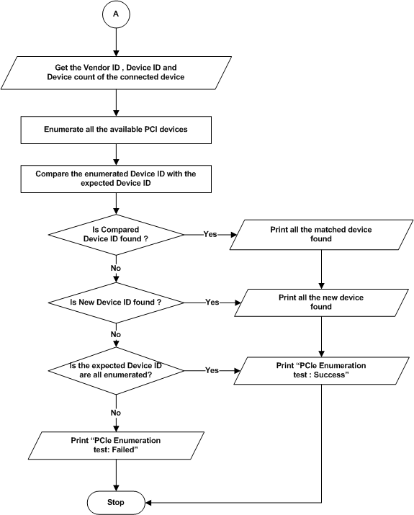
Figure 91 : PCIe Test - PCI Enumeratioin Test

Read / Write Test
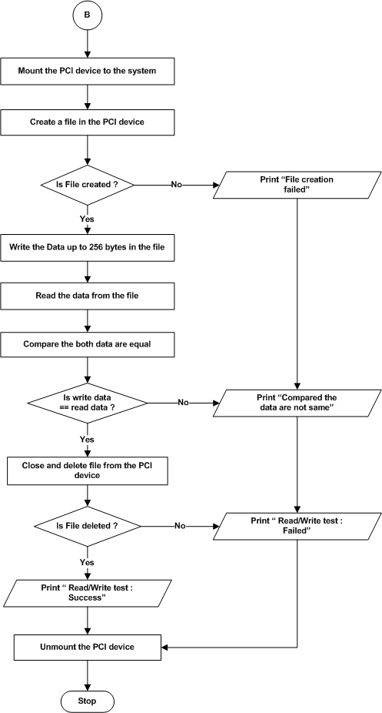
Figure 92 : PCIe Test - Read\ Write Test

SFP Transceiver Operation
Refer Section : 2.1.4.4

LVDS Test
Refer the section 2.1.4.13.3 and 2.2.2.13.3 for Module and Data decomposition.

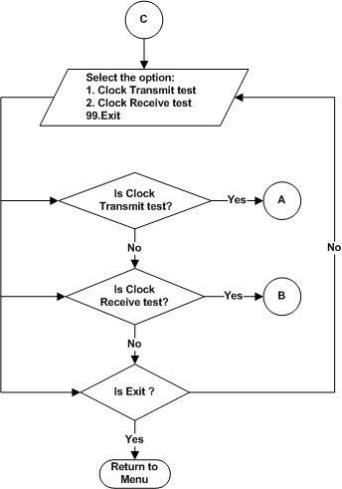
Figure 93 : DP-SPL-5299 Test – LVDS Test Menu

Clock Transmit Test

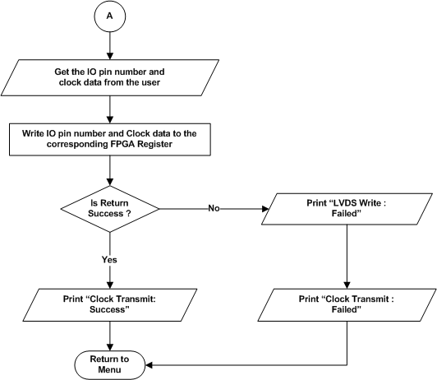

Figure 94 : LVDS Test – Clock Transmit Test

Clock Receive Test
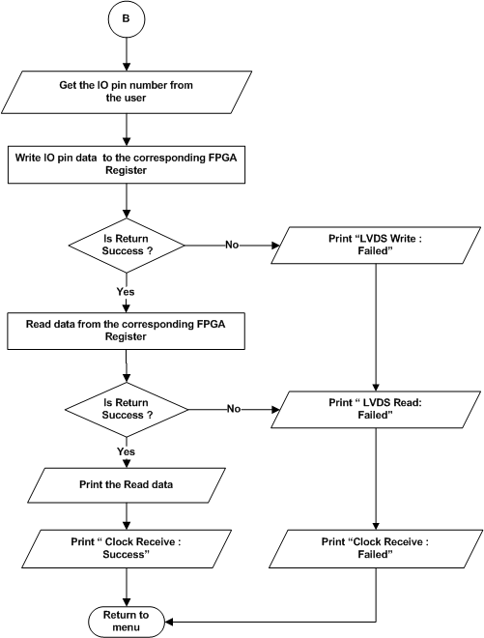
Figure 95 : LVDS Test – Clock Receive Test

Data Detailed Design

Board Information Data
- Board ID : DP-SPL-0220
- Hardware version : Current version of the hardware
- Software version : Current version of the Linux ATP Software
- Serial number of the board : Serial number given for the specific board
- DDR4 size : 4 GB
- User flash size : 128 MB
- NAND Flash size : 16 GB
- MRAM size : 4 Mb
- EEPROM size : 4 Kb

Requirements Traceability

Sl No. | Test Cases | Requirement ID in SRS | Section Number in SDD
1 | Processor Test | DP_SPL_0220_MANUAL_PS_PROCS | 2.1.3.1
1 | ALU Test | DP_SPL_0220_MANUAL_PS_PRCS_01 | 2.1.3.1.1
1 | FPU Test | DP_SPL_0220_MANUAL_PS_PRCS_02 | 2.1.3.1.2
2 | DDR4 Test | DP_SPL_0220_MANUAL_PS_DDR | 2.1.3.2
2 | Data bus Test | DP_SPL_0220_MANUAL_PS_DDR4_01 | 2.1.3.2.1
2 | Address bus Test | DP_SPL_0220_MANUAL_PS_DDR4_02 | 2.1.3.2.2
2 | Device Test | DP_SPL_0220_MANUAL_PS_DDR4_03 | 2.1.3.2.3
3 | EEPROM Test | DP_SPL_0220_MANUAL_PS_EEPROM | 2.1.3.3
3 | Upload Information Test | DP_SPL_0220_MANUAL_PS_EEPROM_01 | 2.1.3.3.1
3 | Data Retention Test | DP_SPL_0220_MANUAL_PS_EEPROM_02 | 2.1.3.3.2
3 | Checksum Test | DP_SPL_0220_MANUAL_PS_EEPROM_03 | 2.1.3.3.3
3 | Read/Write Test | DP_SPL_0220_MANUAL_PS_EEPROM_04 | 2.1.3.3.4
4 | MRAM Test | DP_SPL_0220_MANUAL_PS_MRAM | 2.1.3.4
4 | Upload Information Test | DP_SPL_0220_MANUAL_PS_MRAM_01 | 2.1.3.4.1
4 | Data Retention Test | DP_SPL_0220_MANUAL_PS_MRAM_02 | 2.1.3.4.2
4 | Checksum Test | DP_SPL_0220_MANUAL_PS_MRAM_03 | 2.1.3.4.3
4 | Full Memory Test | DP_SPL_0220_MANUAL_PS_MRAM_04 | 2.1.3.4.4
5 | NAND Test | DP_SPL_0220_MANUAL_PS_NAND | 2.1.3.4.4
5 | Upload Information Test | DP_SPL_0220_MANUAL_PS_NAND_01 | 2.1.3.5.1
5 | Data Retention Test | DP_SPL_0220_MANUAL_PS_NAND_02 | 2.1.3.5.2
5 | Checksum Test | DP_SPL_0220_MANUAL_PS_NAND_03 | 2.1.3.5.3
6 | NOR Test | DP_SPL_0220_MANUAL_PS_NOR | 2.1.3.6
6 | Upload Information Test | DP_SPL_0220_MANUAL_PS_NOR_01 | 2.1.3.6.1
6 | Data Retention Test | DP_SPL_0220_MANUAL_PS_NOR_02 | 2.1.3.6.2
6 | Checksum Test | DP_SPL_0220_MANUAL_PS_NOR_03 | 2.1.3.6.3
7 | USB Test | DP_SPL_0220_MANUAL_PS_USB | 2.1.3.7
7 | Read/Write Test | DP_SPL_0220_MANUAL_PS_USB_01 | 2.1.3.7.1
8 | SATA Test | DP_SPL_0220_MANUAL_PS_SATA | 2.1.3.8
8 | Read/Write Test | DP_SPL_0220_MANUAL_PS_SATA_01 | 2.1.3.8.1
9 | SD Card Test | DP_SPL_0220_MANUAL_PS_SDCARD | 2.1.3.9
9 | Read/Write Test | DP_SPL_0220_MANUAL_PS_SDCARD_01 | 2.1.3.9.1
10 | UART Test | DP_SPL_0220_MANUAL_PS_UART | 2.1.3.10
10 | Write Test | DP_SPL_0220_MANUAL_PS_UART_01 | 2.1.3.10.1
10 | Read Test | DP_SPL_0220_MANUAL_PS_UART_02 | 2.1.3.10.2
11 | Ethernet Test | DP_SPL_0220_MANUAL_PS_ETH | 2.1.3.11
11 | Ethernet ping Test | DP_SPL_0220_MANUAL_PS_ETH_01 | 2.1.3.11.1
12 | Temperature Sensor Test | DP_SPL_0220_MANUAL_PS_TEMPSNSR | 2.1.3.12
13 | Voltage Monitoring Test | DP_SPL_0220_MANUAL_PS_ADM | 2.1.3.13
14 | DDR4(PL) Test | DP_SPL_0220_MANUAL_PL_DDR4 | 2.1.4.1
14 | Data bus test | DP_SPL_0220_MANUAL_PL_DDR4_01 | 2.1.4.1.1
14 | Address bus test | DP_SPL_0220_MANUAL_PL_DDR4_02 | 2.1.4.1.2
14 | Device test | DP_SPL_0220_MANUAL_PL_DDR4_03 | 2.1.4.1.3
14 | Full Memory test | DP_SPL_0220_MANUAL_PL_DDR4_04 | 2.1.4.1.4
15 | UART (PL) Test | DP_SPL_0220_MANUAL_PL_UART | 2.1.4.2
15 | Write Test | DP_SPL_0220_MANUAL_PL_UART_01 | 2.1.4.2.1
15 | Read Test | DP_SPL_0220_MANUAL_PL_UART_02 | 2.1.4.2.2
16 | NOR Flash (PL) test | DP_SPL_0220_MANUAL_PL_NOR | 2.1.4.3
16 | Device ID | DP_SPL_0220_MANUAL_PL_NOR_01 | 2.1.4.3.1
16 | Chip erase | DP_SPL_0220_MANUAL_PL_NOR_02 | 2.1.4.3.2
16 | Sector erase | DP_SPL_0220_MANUAL_PL_NOR_03 | 2.1.4.3.3
16 | Single write | DP_SPL_0220_MANUAL_PL_NOR_04 | 2.1.4.3.4
16 | Single read | DP_SPL_0220_MANUAL_PL_NOR_05 | 2.1.4.3.5
16 | Page write | DP_SPL_0220_MANUAL_PL_NOR_06 | 2.1.4.3.5
16 | Page read | DP_SPL_0220_MANUAL_PL_NOR_07 | 2.1.4.3.7
16 | Full memory test | DP_SPL_0220_MANUAL_PL_NOR_08 | 2.1.4.3.8
17 | SFP Optical transceiver | DP_SPL_0220_MANUAL_PL_SFP | 2.1.4.4
17 | SFP Lane Status | DP_SPL_0220_MANUAL_PL_SFP_01 | 2.1.4.4.1
17 | SFP Data Trasnfer | DP_SPL_0220_MANUAL_PL_SFP_02 | 2.1.4.4.2
17 | Data Validation reset | DP_SPL_0220_MANUAL_PL_SFP_02_01 | 2.1.4.4.2.1
17 | Tx Data Transfer | DP_SPL_0220_MANUAL_PL_SFP_02_02 | 2.1.4.4.2.2
17 | Rx Data Transfer | DP_SPL_0220_MANUAL_PL_SFP_02_03 | 2.1.4.4.2.3
17 | SFP Bandwidth | DP_SPL_0220_MANUAL_PL_SFP_03 | 2.1.4.4.3
17 | Bandwidth reset | DP_SPL_0220_MANUAL_PL_SFP_03_01 | 2.1.4.4.3.1
17 | Bandwidth Tx | DP_SPL_0220_MANUAL_PL_SFP_03_02 | 2.1.4.4.3.2
17 | Bandwidth Rx | DP_SPL_0220_MANUAL_PL_SFP_03_03 | 2.1.4.4.3.3
17 | SFP Configuration | DP_SPL_0220_MANUAL_PL_SFP_04 | 2.1.4.4.4
17 | SFP IO Status | DP_SPL_0220_MANUAL_PL_SFP_05 | 2.1.4.4.5
18 | Digital Attenuator | DP_SPL_0220_MANUAL_PL_DA | 2.1.4.5
18 | Write test | DP_SPL_0220_MANUAL_PL_DA_01 | 2.1.4.5.1
18 | Read test | DP_SPL_0220_MANUAL_PL_DA_02 | 2.1.4.5.2
19 | GPIO | DP_SPL_0220_MANUAL_PL_GPIO | 2.1.4.6
19 | LVTTL | DP_SPL_0220_MANUAL_PL_GPIO_01 | 2.1.4.6.1
19 | IO Mode | DP_SPL_0220_MANUAL_PL_GPIO_01_01 | 2.1.4.6.1.1
19 | Clock Mode | DP_SPL_0220_MANUAL_PL_GPIO_01_02 | 2.1.4.6.1.2
19 | TTL | DP_SPL_0220_MANUAL_PL_GPIO_02 | 2.1.4.6.2
20 | SFP TRS | DP_SPL_0220_MANUAL_PL_SFP_TRS | 2.1.4.7
20 | Write Test | DP_SPL_0220_MANUAL_PL_SFP_TRS_01 | 2.1.4.7.1
20 | Read Test | DP_SPL_0220_MANUAL_PL_SFP_TRS_02 | 2.1.4.7.2
21 | LTC PLL | DP_SPL_0220_MANUAL_PL_LTC_PLL | 2.1.4.8
21 | File write | DP_SPL_0220_MANUAL_PL_LTC_PLL_01 | 2.1.4.8.1
21 | File read | DP_SPL_0220_MANUAL_PL_LTC_PLL_02 | 2.1.4.8.2
21 | Lock status verification | DP_SPL_0220_MANUAL_PL_LTC_PLL_03 | 2.1.4.8.3
21 | PLL Sync | DP_SPL_0220_MANUAL_PL_LTC_PLL_04 | 2.1.4.8.4
23 | NMEA | DP_SPL_0220_MANUAL_PL_NMEA | 2.1.4.9
24 | IRIG-B | DP_SPL_0220_MANUAL_PL_IRIG_B | 2.1.4.10
25 | PPS | DP_SPL_0220_MANUAL_PL_PPS | 2.1.4.11
26 | FPGA Junction Temperature | DP_SPL_0220_MANUAL_PL_JN_TEMP | 2.1.4.12
27 | DP-SPL-5299 Test |  | 2.1.4.13
27 | PCI Test | DP_SPL_0220_MANUAL_PS_PCI | 2.1.4.13.1
27 | PCI Enumeration Test | DP_SPL_0220_MANUAL_PS_PCI_01 | 2.1.4.13.1.1
27 | Read / Write Test | DP_SPL_0220_MANUAL_PS_PCI_02 | 2.1.4.13.1.2
27 | SFP Optical transceiver | DP_SPL_0220_MANUAL_PL_SFP | 2.1.4.4
27 | LVDS Test | DP_SPL_0220_MANUAL_PL_LVDS | 2.1.4.13.3
27 | Clock Transmit Test | DP_SPL_0220_MANUAL_PL_LVDS_01 | 2.1.4.13.3.1
27 | Clock Receive Test | DP_SPL_0220_MANUAL_PL_LVDS_02 | 2.1.4.13.3.2

Appendix A : Ethernet Data transfer rate test

Note : “iperf” tool will be work on linux operating system so , make sure HOST PC should be in linux OS.

Host as server and Target as client

- Set an IP address to the board. Enter the command “ifconfig” to find the IP address.
- Enter the following command in the host terminal.
“iperf – s”
- Enter the following command in the target terminal.
“iperf – c <server ip>”
- After the execution of the commands in the both terminals, it prints the bandwidth by transferring some data between client and server.

Appendix B: Store default value Digital attenuator in the MRAM.
Note : Default value of the digital attenutor got changed every time by the checking phase noise of SFP. This values are fixed by the Hardware team.

- After the successful write and read test in the Digital attenuator. Proceed to store finalized value in the MRAM memory
- Select the “Update Digital attenuator” in the Digital attenuator menu.
- Enter the SFP Phase noise value to store in MRAM, the entered value will be store in MRAM memory.
- After Power on the Default Value will display under Digital Attenutator Test case.

