SOFTWARE DESIGN DOCUMENT
FOR
6U VPX Zynq MPSoC and AFE7906 based Digital receiver Module with 12Channel 3GSPS ADC I/P 5MHz to 12 GHz I/P IBW 600MHz

DOCUMENT TITLE | SOFTWARE DESIGN DOCUMENT FOR 6U VPX Zynq MPSoC and AFE7906 based Digital receiver Module with 12Channel 3GSPS ADC I/P 5MHz to 12 GHz I/P IBW 600MHz
DOCUMENT REFERENCE | DP-VPX-0227-V1-01-SDD-1V00
VERSION NUMBER | 1.00
VERSION DATE | April 16, 2025
PREPARED BY | Name: Ashok R  Sign:
DOCUMENT REVIEW BY | Name: Gowthami V  Sign:
TECHNICAL REVIEW BY | Name: Kingshuk Mitra  Sign:
PROCESS REVIEW BY | Name: Gowthami V  Sign:
APPROVED BY | Name: DRB  Sign:

Copyright @ (2024) by Data Patterns
All right reserved. These materials are proprietary to Data Patterns and no part of these materials should be reproduced, published in any form by any means, electronic or mechanical including photocopy or any information storage or retrieval system nor should the materials be disclosed to third parties without the written authorization of Data Patterns.

Revision History
S. NO. | VER. NO. | VER. DATE | CHANGED BY | SECTION (S) CHANGED | DESCRIPTION  OF CHANGE
1 | 0V01 | October 08, 2024 | Ashok R | - | Initial Version
2 | 0V02 | February 21,  2025 | Ashok R | 2.1.4.5 to 2.1.4.8 and 5.1.2.5 to 5.1.2.8 | Internal Comments closed(Refer DP-VPX-0227-V1-01-SRR-0V02)
3 | 0V03 | March 24,  2025 | Ashok R | 5.1.2.10 to 5.1.2.12, 2.1.4.2.8 and 2.2.2.8 | Internal Comments closed(Refer DP-VPX-0227-V1-01-SRR-0V03)
4 | 0V04 | March 31,  2025 | Ashok R | 1.4, 2.1.4.10, 2.2.2, 2.1.4.2, 5.1.2.2 and Appendix A and B | Internal Comments closed(Refer DP-VPX-0227-V1-01-SRR-0V04)
5 | 0V05 | April 8,  2025 | Ashok R | 2.1.4.3, 2.2.2.9 and 5.1.2.3 | DRB Comments closed(Refer DP-VPX-0227-V1-01-SRR-0V05) DRB APPROVED ON 16-4-2025.
6 | 1V00 | March 24, 2026 | Gowthami V | - | Base Lined

Table of Contents
1. Introduction 1
1.1 Purpose 1
1.2 Scope 1
1.3 Definitions, Acronyms, and Abbreviations 2
1.4 References 3
1.5 Document Overview 3
2. Decomposition Description 4
2.1 Module Decomposition 4
2.1.1 Test Configuration 4
2.1.2 Test Performance 5
2.1.3 Processing Section 6
2.1.3.1 Processor test 6
2.1.3.1.1 ALU Test 6
2.1.3.1.2 FPU Test 7
2.1.3.2 DDR4 Test 8
2.1.3.2.1 Data Bus Test 8
2.1.3.2.2 Address Bus Test 8
2.1.3.2.3 Device Test 9
2.1.3.3 EEPROM Test 9
2.1.3.3.1 Upload Board Information 9
2.1.3.3.2 Data Retention Test 9
2.1.3.3.3 Checksum Test 10
2.1.3.3.4 Read/Write Test 10
2.1.3.4 MRAM Test 10
2.1.3.4.1 Upload Board Information 10
2.1.3.4.2 Data Retention Test 10
2.1.3.4.3 Checksum Test 10
2.1.3.4.4 Full Memory Test 11
2.1.3.5 NAND Flash Test 11
2.1.3.5.1 Upload Board Information 11
2.1.3.5.2 Data Retention Test 11
2.1.3.5.3 Check Sum Test 11
2.1.3.6 NOR Flash Test 12
2.1.3.6.1 Upload Board Information test 12
2.1.3.6.2 Data Retention Test 12
2.1.3.6.3 Check Sum Test 12
2.1.3.7 USB Test 12
2.1.3.7.1 Read/Write test 12
2.1.3.8 SATA Test 13
2.1.3.8.1 Read/Write test 13
2.1.3.9 UART Test 14
2.1.3.9.1 Write test 14
2.1.3.9.2 Read Test 14
2.1.3.10 Ethernet Test 15
2.1.3.10.1 Ethernet Ping test 15
2.1.3.10.2 Ethernet Data Transfer rate test 15
2.1.3.11 Temperature sensor 16
2.1.3.11.1 Temperature sensor test 16
2.1.3.12 RTC Test 16
2.1.3.12.1 Manual RTC Test 16
2.1.4 Programmable Logic section 17
2.1.4.1 LMK04828 PLL 17
2.1.4.1.1 File Configuration 17
2.1.4.1.2 File Dump 17
2.1.4.1.3 Single Write 18
2.1.4.1.4 Single Read 18
2.1.4.2 AFE7906 ADC Test Cases 18
2.1.4.2.1 AFE Core Reset 18
2.1.4.2.2 AFE Single Write 19
2.1.4.2.3 AFE Single Read 19
2.1.4.2.4 AFE Bringup 19
2.1.4.2.5 AFE Core Initialization 20
2.1.4.2.6 JESD Bond status 20
2.1.4.2.7 ADC Sync 20
2.1.4.2.8 ADC Band Selection 21
2.1.4.2.9 ADC Data Logging 21
2.1.4.2.10 HD2 Correction Enable 22
2.1.4.2.10.1 HD2 Coefficient Write 22
2.1.4.2.10.2 HD2 Coefficient Read 22
2.1.4.2.11 NCO Update 23
2.1.4.2.11.1 All Channel Enable 23
2.1.4.2.11.2 Single Channel Enable 23
2.1.4.2.11.3 All Channel Disable 23
2.1.4.2.11.4 Single Channel Disable 24
2.1.4.2.12 ADC Dynamic Configuration 24
2.1.4.2.12.1 Device Status 24
2.1.4.2.12.2 Update Rx Nco 24
2.1.4.2.12.3 Set Rx DSA 25
2.1.4.2.12.4 Update Fb Nco 25
2.1.4.2.12.5 Set Fb DSA 25
2.1.4.2.13 ADC Automation 25
2.1.4.2.13.1 Data Logging 25
2.1.4.2.13.1.1 Host Application 25
2.1.4.2.13.1.2 Target Application 26
2.1.4.2.13.2 Phase Matching 26
2.1.4.2.13.2.1 Host Application 26
2.1.4.2.13.2.2 Target Application 26
2.1.4.3 Digital Attenuation 27
2.1.4.3.1 Attenuation Write 27
2.1.4.3.2 Attenuation Read 27
2.1.4.4 DDR4 (PL) Test 28
2.1.4.4.1 Data bus test 28
2.1.4.4.2 Address bus test 28
2.1.4.4.3 Device test 28
2.1.4.4.4 Full Memory test 28
2.1.4.5 NOR Flash (PL) test 29
2.1.4.5.1 Device ID 29
2.1.4.5.2 Sector erase 29
2.1.4.5.3 Chip /Die Erase 30
2.1.4.5.4 Single Write 30
2.1.4.5.5 Single Read 30
2.1.4.5.6 Page Write 31
2.1.4.5.7 Page Read 31
2.1.4.5.8 Full memory test 31
2.1.4.6 RGMII test 32
2.1.4.6.1 RGMII IP Configuration 32
2.1.4.6.2 RGMII IP Dump 32
2.1.4.6.3 RGMII Bandwidth Test 33
2.1.4.6.3.1 Bandwidth Reset 33
2.1.4.6.3.2 Bandwidth Tx 33
2.1.4.6.3.3 Bandwidth Rx 33
2.1.4.7 Aurora test 34
2.1.4.7.1 Aurora Core Reset 34
2.1.4.7.2 Aurora Lane Status 34
2.1.4.7.3 Aurora Bandwidth Test 34
2.1.4.7.3.1 Bandwidth Reset 34
2.1.4.7.3.2 Bandwidth Tx 34
2.1.4.7.3.3 Bandwidth Rx 35
2.1.4.8 10G Test cases 35
2.1.4.8.1 10G IP configuration 35
2.1.4.8.2 10G IP Dump 35
2.1.4.8.3 10G Core Reset 36
2.1.4.8.4 10G Core Status 36
2.1.4.8.5 10G Bandwidth Test 36
2.1.4.8.5.1 10G Bandwidth Reset 36
2.1.4.8.5.2 10G Bandwidth Tx 36
2.1.4.8.5.3 10G Bandwidth Rx 36
2.1.4.9 ADM (PL) Test 37
2.1.4.9.1 Voltage Monitoring Test 37
2.1.4.10 UART (PL) Test 37
2.1.4.10.1 UART Tx Channel Selection 37
2.1.4.10.2 UART Write 38
2.1.4.10.3 Rx Channel Selection 38
2.1.4.10.4 UART Read 38
2.1.4.11 IO Test Cases 38
2.1.4.11.1 GPIO Clock OUT 38
2.1.4.11.2 GPIO Clock IN 39
2.1.4.12 LVDS Test Cases 39
2.1.4.12.1 IO Validation 39
2.1.4.12.2 LVDS Clock OUT 40
2.1.4.12.3 LVDS Clock IN 40
2.1.4.13 TTL test cases 41
2.1.4.13.1 TTL Clock OUT 41
2.1.4.13.2 TTL IO Validation 41
2.1.4.14 Junction Temperature 42
2.1.4.14.1 Junction Temperature Read 42
2.1.4.15 PCIe Test 42
2.1.4.15.1 PCIe Write 42
2.1.4.15.2 PCIe Read 42
2.1.4.15.3 PCIe Full Memory Test 43
2.2 Data Decomposition 44
2.2.1 Processing Section 44
2.2.1.1 Processor Test 44
2.2.1.2 DDR4 test 45
2.2.1.3 EEPROM Test 45
2.2.1.4 MRAM Test 45
2.2.1.5 NAND Flash Test 46
2.2.1.6 NOR Flash Test 46
2.2.1.7 USB Test 47
2.2.1.8 SATA Test 47
2.2.1.9 UART Test 47
2.2.1.10 Ethernet Test 48
2.2.1.11 Temperature sensor test 48
2.2.1.12 RTC Test 48
2.2.2 Programmable Logic section 49
2.2.2.1 LMK04828 PLL 49
2.2.2.2 AFE7906 ADC 49
2.2.2.3 Digital Attenuation 50
2.2.2.4 DDR4 (PL) Test 50
2.2.2.5 NOR Flash (PL) 50
2.2.2.6 RGMII test 51
2.2.2.7 Aurora test 51
2.2.2.8 10G (PL) test 52
2.2.2.9 ADM (PL) 52
2.2.2.10 UART (PL) Test 53
2.2.2.11 IO Test 53
2.2.2.12 LVDS Test 53
2.2.2.13 TTL Test 53
2.2.2.14 Junction Temperature 53
2.2.2.15 PCIe Test 54
2.3 Process Decomposition 54
3. Dependency Description 55
3.1 Module Dependencies 55
3.1.1 DEPENDENCY BETWEEN THE MODULES “TEST CONFIGURATION” AND “TEST PERFORMANCE”: 55
3.2 Data Dependencies 55
3.3 Process Dependencies 55
3.3.1 DEPENDENCY BETWEEN THE PROCESS ‘USER INPUT’ AND ‘INPUT PROCESSING’ : 55
3.3.2 DEPENDENCY BETWEEN THE PROCESS 'INPUT PROCESSING' AND 'TEST RESULT' : 55
4. Interface Description 56
4.1 Module Interface 56
4.2 Process Interface 56
5. Detailed Design 57
5.1 Module Detailed Design 57
5.1.1 Processing Section 57
5.1.1.1 Processor Test 57
5.1.1.1.1 ALU Test 58
5.1.1.1.2 FPU Test 60
5.1.1.2 DDR4 Test 61
5.1.1.2.1 Data Bus Test 62
5.1.1.2.2 Address Bus Test 63
5.1.1.2.3 Device Test 64
5.1.1.3 EEPROM Test 65
5.1.1.3.1 Upload Board Information Test 66
5.1.1.3.2 Data Retention Test 67
5.1.1.3.3 Checksum Test 68
5.1.1.3.4 Read/Write Test 69
5.1.1.4 MRAM Test 70
5.1.1.4.1 Upload Board Information test 71
5.1.1.4.2 Data Retention test 71
5.1.1.4.3 Checksum Test 71
5.1.1.4.4 Full Memory test 72
5.1.1.5 NAND Flash Test 73
5.1.1.5.1 Upload Board Information test 74
5.1.1.5.2 Data Retention Test 74
5.1.1.5.3 Checksum Test 74
5.1.1.6 NOR Flash Test 75
5.1.1.6.1 Upload Board Information test 76
5.1.1.6.2 Data Retention Test 76
5.1.1.6.3 Checksum Test 76
5.1.1.7 USB Test 77
5.1.1.7.1 Read / Write Test 77
5.1.1.8 SATA Test 78
5.1.1.8.1 Read / Write Test 78
5.1.1.9 UART Test 79
5.1.1.9.1 Write Test 80
5.1.1.9.2 Read Test 81
5.1.1.10 Ethernet Test 82
5.1.1.10.1 Ethernet ping Test 83
5.1.1.11 Temperature Sensor 84
5.1.1.11.1 Temperature Sensor Test 84
5.1.1.12 RTC Test 85
5.1.1.12.1 RTC Test 85
5.1.2 Programmable Logic 86
5.1.2.1 LMK04828 PLL 86
5.1.2.1.1 File Configuration 87
5.1.2.1.2 File Dump 88
5.1.2.1.3 Single Write 89
5.1.2.1.4 Single Read 90
5.1.2.2 AFE7906 ADC 91
5.1.2.2.1 AFE Core Reset 92
5.1.2.2.2 AFE Single Write 93
5.1.2.2.3 AFE Single Read 94
5.1.2.2.4 AFE Bringup 95
5.1.2.2.5 AFE Core Initialization 96
5.1.2.2.6 JESD Bond status 97
5.1.2.2.7 ADC Sync 98
5.1.2.2.8 ADC Band Selection 99
5.1.2.2.9 ADC Data Logging 100
5.1.2.2.10 HD2 Correction Enable 101
5.1.2.2.10.1.1 HD2 Correction Write 102
5.1.2.2.10.1.2 HD2 Correction Read 103
5.1.2.2.11 NCO Update 104
5.1.2.2.11.1 NCO Enable 105
5.1.2.2.11.1.1 All Channel Enable 106
5.1.2.2.11.1.2 Single Channel Enable 107
5.1.2.2.11.2 NCO Disable 108
5.1.2.2.11.2.1 All Channel Disable 109
5.1.2.2.11.2.2 Single Channel Disable 110
5.1.2.2.12 ADC Dynamic Configuration 111
5.1.2.2.12.1 Device Status 112
5.1.2.2.12.2 Update Rx Nco 113
5.1.2.2.12.3 Set DSA 114
5.1.2.2.12.4 Update Fb Nco 115
5.1.2.2.12.5 Set Fb DSA 115
5.1.2.2.13 ADC Automation 116
5.1.2.2.13.1 Data Logging Host 116
5.1.2.2.13.2 Data Logging Target 117
5.1.2.2.13.3 Phase Matching Host 118
5.1.2.2.13.4 Phase Matching Target 119
5.1.2.3 Digital Attenuation 120
5.1.2.3.1 Attenuation Write 121
5.1.2.3.2 Attenuation Read 122
5.1.2.4 DDR4 (PL) Test 123
5.1.2.4.1 Data Bus test 124
5.1.2.4.2 Address Bus test 125
5.1.2.4.3 Device test 126
5.1.2.4.4 Full memory test 127
5.1.2.5 NOR Flash (PL) test 128
5.1.2.5.1 Device ID 129
5.1.2.5.2 Sector erase 130
5.1.2.5.3 Chip / Die erase 131
5.1.2.5.4 Single Write 132
5.1.2.5.5 Single Read 133
5.1.2.5.6 Page Write 134
5.1.2.5.7 Page Read 135
5.1.2.5.8 Full memory test 136
5.1.2.6 RGMII Test 137
5.1.2.6.1 RGMII IP Configuration 138
5.1.2.6.2 RGMII IP Dump 139
5.1.2.6.3 RGMII Bandwidth Test 140
5.1.2.6.3.1 Bandwidth Reset 141
5.1.2.6.3.2 Bandwidth Tx 142
5.1.2.6.3.3 RGMII Bandwidth Rx 143
5.1.2.7 Aurora Test 144
5.1.2.7.1 Aurora Reset 145
5.1.2.7.2 Aurora lane Status 146
5.1.2.7.3 Aurora Bandwidth Test 147
5.1.2.7.3.1 Bandwidth Reset 147
5.1.2.7.3.2 Bandwidth Tx 147
5.1.2.7.3.3 Bandwidth Rx 147
5.1.2.8 10G Test 148
5.1.2.8.1 IP Configuration 149
5.1.2.8.2 IP Dump 150
5.1.2.8.3 10G Core Reset 151
5.1.2.8.4 10G Core Status 152
5.1.2.8.5 10G Bandwidth Test 153
5.1.2.8.5.1 Bandwidth Reset 153
5.1.2.8.5.2 Bandwidth Tx 153
5.1.2.8.5.3 Bandwidth Rx 153
5.1.2.9 ADM (PL) 154
5.1.2.9.1 Voltage Monitoring Test 154
5.1.2.10 UART (PL) Test 155
5.1.2.10.1 UART Tx Channel Selection 156
5.1.2.10.2 UART Write 157
5.1.2.10.3 UART Rx Channel Selection 158
5.1.2.10.4 UART Read 159
5.1.2.11 IO Test Cases 160
5.1.2.11.1 GPIO Clock OUT 161
5.1.2.11.2 GPIO Clock IN 162
5.1.2.12 LVDS Test 163
5.1.2.12.1 IO Validation 164
5.1.2.12.2 LVDS Clock OUT 165
5.1.2.12.3 LVDS Clock IN 166
5.1.2.13 TTL Test 167
5.1.2.13.1 TTL Clock OUT 168
5.1.2.13.2 TTL IO 169
5.1.2.14 Junction Temperature 170
5.1.2.14.1 Junction Temperature Read 170
5.1.2.15 PCIe Test 171
5.1.2.15.1 PCIe Write 172
5.1.2.15.2 PCIe Read 173
5.1.2.15.3 PCIe Full Memory Test 174
5.2 Data Detailed Design 175
5.2.1 Board Information Data 175
6. Requirements Traceability 176
Appendix A 180
Appendix B 182

Introduction
This Software Design Document (SDD) describes the test application software design for
DP-VPX-0227. This document uses the software requirement specification of DP-VPX-0227 to understand the hardware qualification requirements and to develop the application.

Purpose
The purpose of this document to describe the detailed software design of application to validate DP-VPX-0227. This document will assist the software developer in understanding the software design and also act as a guide to develop the software in terms of implementation. The design will reflect the requirements mentioned in the Software Requirements Specification (SRS) document and will be mapped with the requirement ID's for better understanding.

Table 1: Entities involved in Test Application
Identification Number | DP-VPX-0227
Title | SOFTWARE DESIGN DOCUMENT FOR 6U VPX Zynq MPSoC and AFE7906 based Digital receiver Module with 12Channel 3GSPS ADC I/P 5MHz to 12 GHz I/P IBW 600MHz DP-SPL-1270
Version Number | 1.00
Abbreviation | SDD (Software Design Document)

Scope
The scope of this document is to describe the Software Design details in detail in order to make a software developer to understand the design perspective of test cases of the module and implement the software for testing and validating the peripheral devices of the modules.

Definitions, Acronyms, and Abbreviations
The acronyms and abbreviations used in this document are listed in the below Table 2.

Table 2 : List of Acronyms and Abbreviations

Acronyms | Abbreviation
HRS | Hardware Requirement Specification
SRS | Software Requirement Specification
DDR4 | Double Data Rate
EEPROM | Electrically Erasable Programmable Read Only Memory
PCIe | Peripheral Component Interconnect Express
SATA | Serial AT Attachment
USB | Universal Serial Bus
ADC | Analog to Digital Converter
SPI | Serial Peripheral Interface
PLL | Phase Locked Loop
RF | Radio Frequency
IF | Intermediate Frequency
UART | Universal Asynchronous Receiver Transmitter
PL | Programmable Logic
PS | Processing System
LVDS | Low Voltage Differential Signaling
RTC | Real Time Clock
JESD | JEDEC Serializer De-serializer
ATP | Acceptance Test Plan
I2C | Inter – Integrated Circuit
MRAM | Magneto-resistive Random Access Memory
TTL | Transistor- Transistor Logic
LVTTL | Low Voltage Transistor- Transistor Logic
AGC | Automatic Gain Control
CAL | CALibration
MSTC | Measured Stationary Transmission Coefficient
NCO | Numerical Controller Oscillator Frequency

References
The following list of documents were referred for deriving this requirements specification
Table 3 : Reference Documents
S. No | Document Name | Document Reference
1 | Software Requirement Specification - DP-VPX-0227 | DP-VPX-0227-V1-SRS-0V05
2 | Software Design Document - DP-SPL-0220 | DP-SPL-0220-V1-01-SDD-1V00
3 | Common Software Design Document | DP-COMMON-SDG-SDD(ATP-ATE)-0V05-DRAFT

Document Overview
Section 1: Describes the introduction about this SDD document.
Section 2: Describes the decomposition description of the ATP software.
Section 3: Describes the dependency description between the modules, processes and data.
Section 4: Describes the interface description of the modules and process.
Section 5: Describes the detailed design of the module and data.
Section 6: Describes the requirement traceability.

Decomposition Description
The design specification is mainly decomposed as follows:

- Test Configuration
- Test Performance

- Test Configuration
The test configuration effectively includes the configuration of the ATP test cases which describes the Manual /Auto mode test cases selection condition and test specific inputs from user. These test configuration details are stored in a file to be used for further performance of the test procedure with the same configuration details specific to the target processor.

- Test Performance
The requirement of the test performance is to perform Manual /Auto mode test cases that are enabled by the user using the test configuration. Only the selected test cases will be executed.

Module Decomposition

Test Configuration
The Test configuration is further decomposed as follows:
- Auto Mode Test Selection
- Manual Mode Test Selection
- Test Specific Details

- Auto Mode Test Selection:
This test configuration is to enable/disable the Auto Mode test cases to be performed for the target processor.

- Manual Mode Test Selection:
This test configuration is to enable/disable the Manual Mode test cases to be performed for the target processor.

- Test Specific Details
This includes the test inputs specific to the enabled test cases in either or both of Auto /Manual mode test case.

Test Performance
The Test Performance is further decomposed into the following modules:
- Manual Mode Test Performance
- Auto Mode Test Performance

- Manual Mode Test Performance
The requirement of the Manual mode test performance is to perform the manual mode test cases that are enabled by the user using the test configuration. The selected test cases will be displayed in the manual mode test case menu and can be selected to perform the particular test.

- Auto Mode Test Performance
The requirement of the Auto mode test performance is to perform the auto mode test cases that are enabled by the user using the test configuration. Only the selected test cases will be executed for the number of cylces specified by the user.

The Module Decomposition are as follows:
- Processing Section
- Processor test
- DDR4 test
- EEPROM test
- MRAM test
- NAND Flash test
- NOR Flash Test
- USB test
- SATA test
- UART test
- Ethernet test
- Real Time Clock Test
- Temperature sensor test
- Programmable Logic
- PLL Test
- ADC Test
- Digital Attenuation
- DDR4 (PL) test
- NOR Flash (PL) Test
- RGMII Test
- TTL Test
- LVTTL Test
- LVDS Test
- UART (PL) Test
- ADM (PL)
- Junction Temperature
- PCIe Test

Processing Section
This Section will hold the module decomposition for the Processing section. Refer the section 2.2.1 and 5.1.1 for data decomposition and flowchart.

Processor test
This test shall be performed to qualify the ALU and FPU in the processor board by carrying out the following test cases. Refer the section 2.2.1.1 and 5.1.1.1 for Data decomposition and Flowchart.

ALU Test
Requirement ID | DP_VPX_0227_MANUAL_PS_PRCS_01
Design Details | - In Addition test, two constant decimal numbers are added that are expected for the defined result. If the actual result is not equal to the expected result then arithmetic addition operation is failed.  - In Subtraction test, two constant decimal numbers are subtracted that are expected for the defined result. If the actual result is not equal to the expected result then arithmetic subtraction operation is failed.  - In Multiplication test, two constant decimal numbers are multiplied that are expected for the defined result. If the actual result is not equal to the expected result then arithmetic multiplication operation is failed.  - In Division test, two constant decimal numbers are divided that are expected for the defined result. If the actual result is not equal to the expected result then arithmetic division operation is failed.  - In Left Shift test, the value is left shifted and expected for the defined result If the actual result is not equal to the expected result then left shift operation is failed.  - In Right Shift test, the value is right shifted and expected for the defined result. If the actual result is not equal to the expected result then right shift operation is failed.  - In AND test, the value is logical AND by and expected for the defined result. If the actual result is not equal to the expected result then logical AND operation is failed.  - In OR test, the value is performed logical OR and expected for the defined result. If the actual result is not equal to the expected result then logical OR operation is failed.  - In NOT test, the value is performed logical NOT and expected for the defined result. If the actual result is not equal to the expected result then logical NOT operation is failed.

FPU Test
Requirement ID | DP_VPX_0227_MANUAL_PS_PRCS_02
Design Details | - In Floating point addition test, two constant decimal numbers are added that are expected for the defined result. If the actual result is not equal to the expected result then floating point addition operation is failed.  - In Floating point subtraction test, two constant decimal numbers are subtracted that are expected for the defined result. If the actual result is not equal to the expected result then floating point subtraction operation is failed.  - In Floating point multiplication test, two constant floating point numbers are multiplied that are expected for the defined result. If the actual result is not equal to the expected result then floating point multiplication operation is failed.  - In Floating point division test, two constant decimal numbers are divided that are expected for the defined result. If the actual result is not equal to the expected result then floating point division operation is failed.

DDR4 Test
This test shall be perform to qualify the DDR4 by carrying out to perform the following test cases. Refer the section 2.2.1.2 and 5.1.1.2 for Data decomposition and Flowchart.

Data Bus Test

Requirement ID | DP_VPX_0227_MANUAL_PS_DDR4_01
Design Details | - Perform memory walking ones test by shifting data to the left and writing 1 bit at a time, read data from the same memory location.  - If write data and read data are not same then walking one’s test is failed.  - Perform memory walking zeros test by complement and shifting data to the left and writing 1 bit at a time, read data from the same memory location.  - If write data and read data are not same walking zero’s test is failed.

Address Bus Test

Requirement ID | DP_VPX_0227_MANUAL_PS_DDR4_02
Design Details | - PATTERN data will be written to memory of a particular size, ANTIPATTERN data will be written to the base address. Read all data from address locations.  - Check if the data of all the address locations except base address location is PATTERN data If its content is not equal to PATTERN data, then pattern test is failed.  - ANTIPATTERN data will be written to memory of a particular size. PATTERN data will be written to the base address. Read all data from address locations.  - Check if the data of all the address locations except base address location is ANTIPATTERN data. If its content is not equal to ANTIPATTERN data, then anti pattern test is failed.

Device Test
Requirement ID | DP_VPX_0227_MANUAL_PS_DDR4_03
Design Details | - Write 64 bit incremental counter data to a memory of a certain size.  - Read the data from the memory locations where the data is already written, check for previously written data then increment counter test is failed.  - Write the inverted incremental counter data to memory locations.  - Read the data from the memory locations where the data is already written, check for previously written data then inverted increment counter test is failed.

EEPROM Test
This test shall be performed to qualify the EEPROM device by carrying out the following test cases. Refer the section 2.2.1.3 and 5.1.1.3 for Data decomposition and Flowchart.

Upload Board Information
Requirement ID | DP_VPX_0227_MANUAL_PS_EEPROM_01
Design Details | - Write the board information data to the device.  - Read board information from the device which was already written in the EEPROM.  - Compare the read data with the board information data which is stored in the board information structure.  - If both are not same, then upload board information is failed.  Note: Upload Board Information Test shall be done only once in a board.

Data Retention Test
Requirement ID | DP_VPX_0227_MANUAL_PS_EEPROM_02
Design Details | - Read the board information from the EEPROM.  - Compare the read data with the Board info which is stored in the board information structure.  - If both are not same then data retention is failed.  Note: The system need to verify the data retention test after restart.

Checksum Test
Requirement ID | DP_VPX_0227_MANUAL_PS_EEPROM_03
Design Details | - Read the previously written data from the EEPROM and calculate the checksum from the read data.  - Compare the calculated checksum with the checksum field in the read board information structure.  - If both are not same then checksum test is failed.

Read/Write Test
Requirement ID | DP_VPX_0227_MANUAL_PS_EEPROM_04
Design Details | - Get the address, location number and entry pattern from the user  - Write the data to the memory locations specified in the device,  - Read the data from the same location in the device, compare the data If both are not same then the print “Read/Write : Failed” along with excepted and actual data, Else print the “Read/ Write : Success” and then return.

MRAM Test
This test shall be performed to qualify the MRAM device by carrying out the following test cases. Refer the section 2.2.1.4 and 5.1.1.4 for Data decomposition and Flowchart.

Upload Board Information
Requirement ID | DP_VPX_0227_MANUAL_PS_MRAM_01
Design Details | - Refer the section 2.1.3.3.1

Data Retention Test
Requirement ID | DP_VPX_0227_MANUAL_PS_MRAM_02
Design Details | - Refer the section 2.1.3.3.2

Checksum Test
Requirement ID | DP_VPX_0227_MANUAL_PS_MRAM_03
Design Details | - Refer the section 2.1.3.3.3

Full Memory Test
Requirement ID | DP_VPX_0227_MANUAL_PS_MRAM_03
Design Details | - Write the counter data to the all memory location except the board information location.  - Read the counter data from the memory locations.  - Compare the write and read data from the device.  - If both are not same, then full memory test.

NAND Flash Test
This test shall be performed to qualify the NAND flash device by carrying out the following test cases. Refer the section 2.2.1.5 and 5.1.1.5 for Data decomposition and Flowchart.

Upload Board Information
Requirement ID | DP_VPX_0227_MANUAL_PS_NAND_01
Design Details | - Refer the section 2.1.3.3.1

Data Retention Test
Requirement ID | DP_VPX_0227_MANUAL_PS_NAND_02
Design Details | - Refer the section 2.1.3.3.2

Check Sum Test
Requirement ID | DP_VPX_0227_MANUAL_PS_NAND_03
Design Details | - Refer the section 2.1.3.3.3

NOR Flash Test
This test shall be performed to qualify the user flash device by carrying out the following test cases. Refer the section 2.2.1.6 and 5.1.1.6 for Data decomposition and Flowchart.

Upload Board Information test
Requirement ID | DP_VPX_0227_MANUAL_PS_NOR_FLASH_01
Design Details | - Refer the section 2.1.3.3.1

Data Retention Test
Requirement ID | DP_VPX_0227_MANUAL_PS_NOR_FLASH_02
Design Details | - Refer the section 2.1.3.3.2

Check Sum Test
Requirement ID | DP_VPX_0227_MANUAL_PS_NOR_FLASH_03
Design Details | - Refer the section 2.1.3.3.3

USB Test
This test shall be performed to qualify the USB port by carrying out the following test cases. Refer the section 2.2.1.7 and 5.1.1.7 for Data decomposition and Flowchart.

Read/Write test
Requirement ID | DP_VPX_0227_MANUAL_PS_USB_01
Design Details | - Get the Device name from the user. Mount the device using standard OS command.  - Create a file in Mounted Device. If File Creation is failed then print “File creation : Failed”.  - Else Write the Data up to 256bytes and Close the file.  - Re-open the file and Read the data. Compare Read Data with the previously written data  - If both data are not same then print “Data comparison Failed”  - Else delete the file and check if the file is deleted or not.  - If file was not deleted, then print “File Delete Failed” and Unmount the Device using standard OS command.  - Else Unmount the Device using standard OS command and print “Read / Write Test : Success”  Note: A text file with name “USBTest.txt” will be created for this test

SATA Test
This test shall be performed to qualify the SATA interface by carrying out the following case. Refer the section 2.2.1.8 and 5.1.1.8 for Data decomposition and Flowchart.

Read/Write test
Requirement ID | DP_VPX_0227_MANUAL_PS_SATA_01
Design Details | - Get the Device name from the user. Mount the device using standard OS command.  - Create a file in Mounted Device. If File Creation is failed then print “File creation : Failed”.  - Else Write the Data up to 256bytes and Close the file.  - Re-open the file and Read the data. Compare Read Data with the previously written data  - If both data are not same then print “Data comparison Failed”  - Else delete the file and check if the file is deleted or not.  - If file was not deleted, then print “File Delete Failed” and Unmount the Device.  - Else Unmount the Device using standard OS command and print “Read / Write Test : Success”  Note: A text file with name “SATATest.txt” will be created for this test

UART Test
This test shall be performed to qualify the UART module by carrying out the following test cases. Refer the section 2.2.1.9 and 5.1.1.9 for Data decomposition and Flowchart.

Write test
Requirement ID | DP_VPX_0227_MANUAL_PS_UART_01
Design Details | - Select the COM port to be tested.  - Get the Baud rate, number of stop bits and parity from user.  - Ask the user whether you want to enter the data or not.  - If yes, get the data to transmit from user else use fixed data of 256bytes.  - Open the COM port with selected baud rate, number of stop bits and parity.  - Ensure that the external system's COM port is configured with same baud rate and parity.  - Send the data to the external system.  - If Data Sent is same as the data received at the external system then consider it as Success  Note: Using the Dockilte software to test the UART module.

Read Test
Requirement ID | DP_VPX_0227_MANUAL_PS_UART_02
Design Details | - Select the COM port to be tested.  - Get the Baud rate, number of stop bits and parity from user.  - Open the COM port with selected baud rate, number of stop bits and parity.  - Ensure that the external system's COM port is configured with same baud rate and parity.  - Send the data From the external system.  - If Data received is same as the data sent from the external system then consider it as Success  Note: Using the Dockilte software to test the UART module.

Ethernet Test
This test shall be performed to qualify the Ethernet module and optical transceiver by carrying out the following test cases. Refer the section 2.2.1.10 and 5.1.1.10 for Data decomposition and Flowchart.

Ethernet Ping test
Requirement ID | DP_VPX_0227_MANUAL_PS_ETHERNET_01
Design Details | - Select IP Address and the number of times to ping the IP address.  - Ping the IP address using standard OS command. Set the target IP address ping up to the selected number of times.  - If ping operation is not occurred for the selected number of times, then ping test is failed.

Ethernet Data Transfer rate test
Requirement ID | DP_VPX_0227_MANUAL_PS_ETHERNET_03
Design Details | - This test will be performed through the standard utility / application / tools supported by the respective Operating System /Firmware.  E.g: In Linux Operating system, the “iperf” utility shall be used to report the data transfer rate at the console.  Note: Using the “iperf” software to test data transfer test for the Ethernet.

Temperature sensor
This test shall be performed to qualify the temperature sensor. Refer the section 2.2.1.11and 5.1.1.11 for Data decomposition and Flowchart.

Temperature sensor test
Requirement ID | DP_VPX_0227_MANUAL_PS_TEMPSNSR
Design Details | - Open the temperature sensor device.  - Get the current local and external temperature from the device.  - Check whether the read temperature values are between the upper and lower limits.  - If the temperatures are not within the limits, then temperature sensor test is failed.

RTC Test
This test shall be performed to qualify the RTC by carrying out the following test cases. Refer the section 2.2.1.12 and 5.1.1.12 for data decomposition and flowchart.

Manual RTC Test
Requirement ID | DP_VPX_0227_MANUAL_PS_RTC_01
Description | - Get the date and time from user.  - Set the RTC date and time.  - Wait for the delay for 8 seconds.  - Read the RTC date and time.  - If the read time is not updated with an addition of 8 seconds, then RTC test is failed.  Note: The test result with tolerance of +/-1 second in addition to the expected seconds will be accepted.

Programmable Logic section
This Section will hold the module decomposition for the Programmable logic section.
Refer the section 2.2.2 and 5.1.2 for data decomposition and flowchart.

LMK04828 PLL
The purpose of this test is to qualify the LMK04828 PLL by carrying out the following test cases. Refer the section 2.2.2.1 and 5.1.2.1 for data decomposition and flowchart.

File Configuration
Requirement ID | DP_VPX_0227_MANUAL_PL_PLL_01
Design Details | - Validate the Handle.  - Get the configuration file name from the user.  - Check whether the file is present or not.  - Read Data from the configuration file.  - Write Data to the corresponding FPGA Registers.  - If File write process completed then the test case is declared as Success, else it declared as Failure.

File Dump
Requirement ID | DP_VPX_0227_MANUAL_PL_PLL_02
Design Details | - Validate the Handle.  - Get the configuration file name from the user.  - Check whether the file is present or not.  - Read Data from the corresponding FPGA Registers and store it in the Output file.  - If File Read process completed, then the test case is declared as Success, else it declared as Failure.

Single Write
Requirement ID | DP_VPX_0227_MANUAL_PL_PLL_03
Design Details | - Validate the Handle.  - Get the address and Data from the user.  - Write the Data and Address in the corresponding FPGA Registers.  - If write was completed then the test case is declared as Success, else it declared as Failure.

Single Read
Requirement ID | DP_VPX_0227_MANUAL_PL_PLL_04
Design Details | - Validate the Handle.  - Get the address from the user.  - Read the Data from the Corresponding FPGA Read register.  - If Read was completed then the test case is declared as Success, else it declared as Failure.

AFE7906 ADC Test Cases
The purpose of this test is to qualify the AFE7906 ADC by carrying out the following test cases. Refer the section 2.2.2.2 and 5.1.2.2 for data decomposition and flowchart.

AFE Core Reset
Requirement ID | DP_VPX_0227_MANUAL_PL_AFE7906_ADC_01
Design Details | - Validate the Handle.  - Validate the Chip Selection.  - Reset the AFE chip by writing 1 and 0 in the corresponding FPGA Registers.  - If Reset was Completed then the test case is declared as Success, else it declared as Failure.

AFE Single Write
Requirement ID | DP_VPX_0227_MANUAL_PL_AFE7906_ADC_02
Design Details | - Validate the Handle.  - Get the Chip selection, address and Data from the user.  - Validate the Chip Selection.  - Write the Data and Address in the corresponding FPGA Registers.  - If write was completed then the test case is declared as Success, else it declared as Failure.

AFE Single Read
Requirement ID | DP_VPX_0227_MANUAL_PL_AFE7906_ADC_03
Design Details | - Validate the Handle.  - Get the Chip selection and address from the user.  - Validate the Chip Selection.  - Read the Data from the Corresponding FPGA Read register.  - If Read was completed then the test case is declared as Success, else it declared as Failure.

AFE Bringup
Requirement ID | DP_VPX_0227_MANUAL_PL_AFE7906_ADC_04
Design Details | - Validate the Handle.  - Get the chip selection from the user which AFE need to configure.  - Validate the Chip Selection.  - Get the ADC Configuration File from user.  - Write the Data and Read the Data From the corresponding FPGA Registers.  - If File Configuration is completed, then the test case is declared as SUCCESS, else it declared as FAIL.  Note: 2 Chips are available for Configuration.

AFE Core Initialization
Requirement ID | DP_VPX_0227_MANUAL_PL_AFE7906_ADC_05
Design Details | - Validate the Handle.  - Validate the Chip Selection.  - Based on the chip selection write corresponding Data to the FPGA Register.  - Then Read the Core Initialization Data from the Corresponding Read Register.  - Compare the Read Data it must be equal to 0x7FFFFFF.  - If Comparison was Success, then declare the test case as SUCCESS, else it declared as FAIL.

JESD Bond status

Requirement ID | DP_VPX_0227_MANUAL_PL_AFE7906_ADC_06
Design Details | - Validate the Handle.  - Validate the Chip Selection.  - Based on the chip selection write corresponding Data to the FPGA Register.  - Then Read the JESD Bond status from the corresponding FPGA Register.  - If 1st bit is in high then chip 1 configured and JESD is Bonded Successfully, else declare it as FAIL.  - If 2nd bit is in high then chip 2 is configured and JESD is Bonded Successfully, else declare it as FAIL.

ADC Sync
Requirement ID | DP_VPX_0227_MANUAL_PL_AFE7906_ADC_07
Design Details | - Validate the Handle.  - Write 0x10000 and 0x20000 in the corresponding FPGA Registers and then write 0.  - If write was Completed then declare the test case as SUCCESS, else declare it as FAIL.

ADC Band Selection
Requirement ID | DP_VPX_0227_MANUAL_PL_AFE7906_ADC_08
Design Details | - Validate the Handle.  - Write 0x0 in ADC Band Selection Register for selecting both Hardware and FPGA as NARROW Band.  - Write 0x1FF in ADC Band Selection Register for selecting both Hardware and FPGA as WIDE Band.  - Write 0x0FF in ADC Band Selection Register for selecting FPGA as NARROW Band and Hardware as WIDE Band.  - Write 0x100 in ADC Band Selection Register for selecting FPGA as WIDEBand and Hardware as NARROW Band.

ADC Data Logging
Requirement ID | DP_VPX_0227_MANUAL_PL_AFE7906_ADC_09
Design Details | - Validate the Handle.  - Validate the Rx Channel Selection.  - Validate the Sample count.  - Select the Rx channel by writing channel number in the corresponding FPGA Register.  - Clear the ADC by writing Corresponding Data in the ADC Reset Register.  - Read the FIFO count from the corresponding Register.  - FIFO count must be greater or equal to the number of samples entered by user.  - Read the Data from the corresponding FPGA Register and log in to a File.  Note: 9 number of Rx channels are available to collect Data.

HD2 Correction Enable

HD2 Coefficient Write

Requirement ID | DP_VPX_0227_MANUAL_PL_AFE7906_ADC_HD2_10_1
Design Details | - Validate the Handle.  - Validate the Rx Channel Selection.  - Enable the HD2 pages by writing corresponding values in the corresponding registers.  - Write the channel selection Data in the corresponding Register.  - Get 2129 and 212a Data from the user.  - Enable the write sequence by writing corresponding data in the corresponding Registers.  - If write is completed, then declare the test case as SUCCESS, else declare it as FAIL.  Note: This sequence was shared by TI.

HD2 Coefficient Read

Requirement ID | DP_VPX_0227_MANUAL_PL_AFE7906_ADC_HD2_10_2
Design Details | - Validate the Handle.  - Validate the Channel Selection.  - Write the channel selection Data in the corresponding Register.  - Read the Data from 2129 and 212a .  - Display the Read values.  - If Reading Data is completed, then declare the test case as SUCCESS, else declare it as FAIL.

NCO Update

All Channel Enable
Requirement ID | DP_VPX_0227_MANUAL_PL_AFE7906_ADC_NCO_11_1
Design Details | - Validate the Handle.  - Write 0x1FF in corresponding FPGA register to enable all channel NCO update.  - If Write process is completed, then declare the test case as SUCCESS, else declare it as FAIL.

Single Channel Enable
Requirement ID | DP_VPX_0227_MANUAL_PL_AFE7906_ADC_NCO_11_2
Design Details | - Validate the Handle.  - Get the Channel number from the user.  - Write the Channel number in corresponding FPGA register to enable channel NCO update.  - If Write process is completed, then declare the test case as SUCCESS, else declare it as FAIL.

All Channel Disable
Requirement ID | DP_VPX_0227_MANUAL_PL_AFE7906_ADC_NCO_11_3
Design Details | - Validate the Handle.  - Write 0x0 in corresponding FPGA register to disable all channel NCO update.  - If Write process is completed, then declare the test case as SUCCESS, else declare it as FAIL.

Single Channel Disable
Requirement ID | DP_VPX_0227_MANUAL_PL_AFE7906_ADC_NCO_11_4
Design Details | - Validate the Handle.  - Get the Channel number from the user.  - Write the Channel number in corresponding FPGA register to disable channel NCO update.  - If Write process is completed, then declare the test case as SUCCESS, else declare it as FAIL.

ADC Dynamic Configuration
ADC Dynamic Configuration shall be a part of the Acceptance test application and shall be performed to update NCO and DSA Settings.

Device Status
Requirement ID | DP_VPX_0227_MANUAL_PL_AFE7906_ADC_12_01
Design Details | - Get the chip Selection from the user  - Read the Health Status from the Corresponding Registers and display the Status.

Update Rx Nco
Requirement ID | DP_VPX_0227_MANUAL_PL_AFE7906_ADC_12_02
Design Details | - Get the Rx Mixer frequency from the user in MHZ  - Get the Rx Band number from the user  - Get the Rx NCO number from the user.  - Write the Data in the corresponding Registers.  - If Write process completed, then declare the test case as Success, else declare it as Failure.  Note: The Rx mixer Frequency varies from [900- 1800MHz)  The Band Number and NCO number varies inbetween[0-1].

Set Rx DSA
Requirement ID | DP_VPX_0227_MANUAL_PL_AFE7906_ADC_12_03
Design Details | - Get the Attenuation Value from the user.  - Write the value in the corresponding Registers.  - If Write process Completed, then declare the test case as Success, else declare it as Failure.  Note: The DSA Value varies from 0 to 25 dbfs.

Update Fb Nco
Requirement ID | DP_VPX_0227_MANUAL_PL_AFE7906_ADC_12_04
Design Details | - Refer section 2.1.4.2.12.2

Set Fb DSA
Requirement ID | DP_VPX_0227_MANUAL_PL_AFE7906_ADC_12_05
Design Details | - Refer section 2.1.4.2.12.3

ADC Automation
ADC Automation shall be a part of the Acceptance test application and shall be performed to automate the Data logging and Phase matching.

Data Logging

Host Application
Requirement ID | DP_VPX_0227_MANUAL_PL_AFE7906_ADC_13_01
Design Details | - Connect the Host application with Target application by click on “Initialize”.  - Enter the configured IP address of Target in GUI panel.  - Get the Rx channel number, no.of samples and Input file from the User. Then, Click on “Start” Button.  - Frame the command packet with Command ID and Test ID send to target application.  - Receive the response packet From target and Display the result in the GUI panel.  - On Successful transmission it displays success message, else it displays the error message or failure message.  Note : HSDC Pro Required for this automation.

Target Application
Requirement ID | DP_VPX_0227_MANUAL_PL_AFE7906_ADC_13_02
Design Details | - Receive the Command Packet from Host.  - Execute the test case based on the Command ID and Test ID.  - Read the Data from the corresponding FPGA Register(Refer Section 2.1.4.2.9 ).  - Frame the Response packet and send to Host application.

Phase Matching

Host Application
Requirement ID | DP_VPX_0227_MANUAL_PL_AFE7906_ADC_13_03
Design Details | - Connect the Host application with Target application by click on “Initialize”.  - Enter the configured IP address of Target in GUI panel.  - Click on “Phase Matching” button.  - Frame the command packet with Command ID and Test ID send to target application.  - Receive the response packet From target and Display the result in the GUI panel.  - On Successful transmission it displays success message, else it displays the error message or failure message.  Note : Refer Appendix B for detailed description.

Target Application
Requirement ID | DP_VPX_0227_MANUAL_PL_AFE7906_ADC_13_04
Design Details | - Receive the Command Packet from Host.  - Execute the test case based on the Command ID and Test ID.  - Validate the Handle.  - Validate the Sample count.  - Select the Rx channel by writing channel number in the corresponding FPGA Register.  - Clear the ADC by writing Corresponding Data in the ADC Reset Register.  - Read the FIFO count from the corresponding Register.  - FIFO count must be greater or equal to the number of samples entered by user.  - Read the Data from the corresponding FPGA Register and log in to a Files.  - Frame the Response packet and send to Host application.  Note: 9 number of Rx channels are available to collect Data at a time.

Digital Attenuation

Attenuation Write

Requirement ID | DP_VPX_0227_MANUAL_PL_AFE7906_ADC_11_01
Design Details | - Validate the Handle.  - Validate the Channel Selection.  - Get the Channel Selection from the User.  - Get the AGC , MSTC & CAL value from the user, write in the corresponding FPGA Register.  - If Write is Completed, then declare the test case as SUCCESS, else declare it as FAIL.

Attenuation Read
Requirement ID | DP_VPX_0227_MANUAL_PL_AFE7906_ADC_11_02
Design Details | - Validate the Handle.  - Validate the Channel Selection.  - Get the Channel Selection from the User.  - Read AGC , MSTC & CAL value from the corresponding FPGA Register.  - Display the Read values for AGC, MSTC and Cal Attenuation Values.  - If Read is Completed, then declare the test case as SUCCESS, else declare it as FAIL.

DDR4 (PL) Test
The purpose of this test is to qualify the DDR4 (PL) by carrying out the following test cases. Refer the section 2.2.2.4 and 5.1.2.4 for data decomposition and flowchart.

Data bus test
Requirement ID | DP_VPX_0227_MANUAL_PL_DDR4_01
Design Details | Refer the Section 2.1.3.2.1

Address bus test
Requirement ID | DP_VPX_0227_MANUAL_PL_DDR4_02
Design Details | Refer the Section 2.1.3.2.2

Device test
Requirement ID | DP_VPX_0227_MANUAL_PL_DDR4_03
Design Details | Refer the Section 2.1.3.2.3

Full Memory test
Requirement ID | DP_VPX_0227_MANUAL_PL_DDR4_04
Design Details | - Write PATTERN DATA in the corresponding FPGA Register.  - Read Data from the corresponding FPGA Register.  - Compare both Write and Read Data from the memory.  - If Write Data and Read Data are same then Write ANTI PATTERN DATA in the corresponding FPGA Register, else the print “Full Memory test : Failed”.  - Compare both Write and Read Data from the memory  - If Write Data and Read Data are same then print “Full Memory test : Failed”, else then print “Full Memory test : Success”.

NOR Flash (PL) test
This test shall be performed to qualify the NOR flash device by carrying out the following test cases. Refer the section 2.2.2.5 and 5.1.2.5 for Data decomposition and Flowchart.

Device ID

Requirement ID | DP_VPX_0227_MANUAL_PL_NOR_01
Design Details | - Validate the Handle  - Reset the FIFO, write the Data in the corresponding FPGA Registers.  - Check the flash busy status, if it is zero proceed to read data, else wait and repeat the process until it became zero.  - Read the Device ID from the Corresponding register, if Device ID is equal to Expected Device ID (0x20BB2110) the test is declared as Success, else declared as Failure.

Sector erase

Requirement ID | DP_VPX_0227_MANUAL_PL_NOR_03
Design Details | - Validate the Handle  - Get the sector number from the user.  - Reset the FIFO, write the data in the corresponding FPGA Registers.  - Check the flash busy status. If it is zero Sector erase completed, else consider Sector erase in progress and repeat the process until get zero.  - If the Sector erase completed the test is declared as Success, else declared as Failure.  Note: 2048 Sectors are available in the NOR Flash (PL) Device.

Chip /Die Erase

Requirement ID | DP_VPX_0227_MANUAL_PL_NOR_02
Design Details | - Validate the Handle  - Get the chip number from the user.  - Reset the FIFO, write the data in the corresponding FPGA Registers.  - Check the flash busy status. If it is zero then chip erase completed, else chip erase is in progress, repeat the process until get zero.  - If the chip erase completed the test is declared as Success, else declared as Failure.

Single Write
Requirement ID | DP_VPX_0227_MANUAL_PL_NOR_04
Design Details | - Validate the Handle  - Get the Address and Data from the user.  - Reset the FIFO, write the data in the corresponding FPGA Registers.  - Check the flash busy status. If it is zero Single Write completed, else repeat the process until get zero.  - If Single write completed the test is declared as Success, else declared as Failure.

Single Read
Requirement ID | DP_VPX_0227_MANUAL_PL_NOR_05
Design Details | - Validate the Handle  - Get the Address from the user.  - Reset the FIFO, write the data in the corresponding FPGA Registers.  - Check the flash busy status. If it is zero Single Read is completed, else repeat the process until get zero.  - Read the Data from Corresponding Read Register.  - If Read Data is equal to Write Data the test is declared as Success, else declared as Failure.

Page Write
Requirement ID | DP_VPX_0227_MANUAL_PL_NOR_06
Design Details | - Validate the Handle  - Get the start page number and number of pages to be written from the user.  - Reset the FIFO, Write Data in the corresponding FPGA Registers.  - Write the Counter Data in the corresponding FPGA Registers.  - Check the flash busy status. If it is zero Page Write is completed, else repeat the process until get zero.  - If page write process completed the test is declared Success, else declared as Failure.  Note: 524288 pages are available in the NOR Flash (PL) Device.

Page Read
Requirement ID | DP_VPX_0227_MANUAL_PL_NOR_07
Design Details | - Validate the Handle  - Get the start page number and number of pages to be read from the user.  - Reset the FIFO, write the data in the corresponding FPGA Registers.  - Check the flash busy status. If it is zero Page Read is completed, else repeat the process until get zero  - If Read Data is equal to Write Data the test is declared as Success, else declared as Failure.

Full memory test
Requirement ID | DP_VPX_0227_MANUAL_PL_NOR_08
Design Details | - Validate the Handle  - Write the PATTERN DATA in the corresponding FPGA Register to the whole device.  - Check busy status data in the status register, if it is zero proceed to read data, else it is repeat the process until get zero.  - Read Data from the corresponding FPGA register.  - If Read Data is equal to Write Data the test is declared as Success, else declared as Failure.

RGMII test
This test shall be performed to qualify the RGMII by carrying out the following test cases. Refer the section 2.2.2.6 and 5.1.2.6 for Data decomposition and Flowchart.

RGMII IP Configuration
Requirement ID | DP_VPX_0227_MANUAL_PL_RGMII_01
Design Details | - Get the configuration file from the user which contains Mac address, source and destination ip address, subnet mask, gateway address and source and destination port number.  - Mac address data is 48 bit. So, we split that into 32 bit LSB data and 16 bit MSB data. Then write the Mac address’s data in their corresponding FPGA registers.  - Source and Destination port number data are 16 bit data. So, we merge that into 32 bit data and write it in their corresponding register.  - Remaining configuration data are write in their corresponding FPGA registers.  - If write operation is complete then it is declared as Success, else declared as Failure.

RGMII IP Dump
Requirement ID | DP_VPX_0227_MANUAL_PL_RGMII_02
Design Details | - Validate the Handle  - Get the IP Configuration file name from the user.  - Write the channel number in their corresponding FPGA register.  - Read MAC Address, Source and Destination IP address, Subnet mask, Gateway Address and Source and Destination port number from the corresponding FPGA Registers and log the data into File.  - If read operation is completed, then it is declared as Success, else declared as Failure.

RGMII Bandwidth Test
This test shall be performed to qualify the RGMII bandwidth by carrying out the following test cases.

Bandwidth Reset
Requirement ID | DP_VPX_0227_MANUAL_PL_RGMII_03_01
Design Details | - Validate the Handle  - Reset the Tx and Rx by writing One and Zero in the Reset Register.  - If Reset Completed then the test is declared as Success, else declared as Failure.

Bandwidth Tx
Requirement ID | DP_VPX_0227_MANUAL_PL_RGMII_03_02
Design Details | - Validate the Handle  - Get the input from the user that number of packets to be configured, packet size, Delay between the Packets and Tx channel Number.  - Write Data to the Corresponding FPGA Registers.  - If Bandwidth transmit is completed the test is declared as Success, else declared as Failure.

Bandwidth Rx
Requirement ID | DP_VPX_0227_MANUAL_PL_RGMII_03_03
Design Details | - Validate the Handle  - Get the Rx Channel number from the user.  - Read Data from the corresponding FPGA Registers.  - Display Received Rx Packet, Packet Lost, Rx Data Count, Packet time, Packet size, total time taken and bandwidth speed.

Aurora test
This test shall be performed to qualify the Aurora by carrying out the following test cases. Refer the section 2.2.2.7 and 5.1.2.7 for Data decomposition and Flowchart.

Aurora Core Reset
Requirement ID | DP_VPX_0227_MANUAL_PL_AURORA_01
Design Details | - Reset the 10G core by by writing 0x1, 0x0, 0x2 and 0x0 in the Core Reset Register.  - If write operation is completed then it is declared as SUCCESS, else declared as FAIL.

Aurora Lane Status
Requirement ID | DP_VPX_0227_MANUAL_PL_AURORA_02
Design Details | - Validate the Handle.  - Reset the Aurora Core, Enable the aurora controller by writing data in the corresponding FPGA Register.  - Read the core status from the Corresponding Registers.  - If Read Status is equal to 0x003C then it prints as channel number “Link Up”, else prints as channel number “Link Down”.  Note: 18 No.of of Aurora Lanes are available to Check the Lane Status.

Aurora Bandwidth Test
This test shall be performed to qualify the Aurora bandwidth by carrying out the following test cases.

Bandwidth Reset
Requirement ID | DP_VPX_0227_MANUAL_PL_AURORA_03_01
Design Details | - Refer section 2.1.4.6.3.1 for Bandwidth Reset.

Bandwidth Tx
Requirement ID | DP_VPX_0227_MANUAL_PL_AURORA_03_02
Design Details | - Refer section 2.1.4.6.3.2 for Bandwidth Tx.

Bandwidth Rx
Requirement ID | DP_VPX_0227_MANUAL_PL_AURORA_03_03
Design Details | - Refer section 2.1.4.6.3.2 for Bandwidth Rx.

10G Test cases
This test shall be performed to qualify the PL 10G by carrying out the following test cases. Refer the section 2.2.2.8 and 5.1.2.8 for Data decomposition and Flowchart.

10G IP configuration
Requirement ID | DP_VPX_0227_MANUAL_PL_10G_01
Design Details | - Validate the Handle.  - Get the configuration file from the user which contains MAC Address, Source and Destination IP address, Subnet mask, Gateway Address and Source and Destination port number .  - Write the channel number in their corresponding FPGA register.  - If write operation is completed, then the test case is declared as SUCCESS, else it declared as FAIL.  Note: 6 no.of 10G Channels are available for IP Configuration.

10G IP Dump
Requirement ID | DP_VPX_0227_MANUAL_PL_10G_02
Design Details | - Validate the Handle  - Get the IP Configuration file name from the user.  - Write the channel number in their corresponding FPGA register.  - Read MAC Address, Source and Destination IP address, Subnet mask, Gateway Address and Source and Destination port number from the corresponding FPGA Registers and log the data into File.  - If read operation is completed, then it is declared as SUCCESS, else declared as Failure.

10G Core Reset
Requirement ID | DP_VPX_0227_MANUAL_PL_10G_03
Design Details | - Reset the 10G core by by writing 1, 0 and 0x100 in the Core Reset Register.  - If write operation is completed then it is declared as SUCCESS, else declared as FAIL.

10G Core Status
Requirement ID | DP_VPX_0227_MANUAL_PL_10G_04
Design Details | - Refer the Section 2.1.4.7.2 .

10G Bandwidth Test
This test shall be performed to qualify the PL10G bandwidth by carrying out the following test cases.

10G Bandwidth Reset
Requirement ID | DP_VPX_0227_MANUAL_PL_10G_05_01
Design Details | - Refer section 2.1.4.6.3.1 for Bandwidth Reset.

10G Bandwidth Tx
Requirement ID | DP_VPX_0227_MANUAL_PL_10G_05_02
Design Details | - Refer section 2.1.4.6.3.2 for Bandwidth Tx.

10G Bandwidth Rx
Requirement ID | DP_VPX_0227_MANUAL_PL_10G_05_03
Design Details | - Refer section 2.1.4.6.3.2 for Bandwidth Rx.

ADM (PL) Test

Voltage Monitoring Test
This test shall be performed to qualify the PL Voltage Monitoring Test by carrying out the following test cases. Refer the section 2.2.2.9 and 5.1.2.9 for Data decomposition and Flowchart.
Requirement ID | DP_VPX_0227_MANUAL_PL_ADM_01
Design Details | - Get the configuration file From the user which is consisting of Lower Limit and Higher Limit.  - Get the PL ADM configuration file from the user which contains low and high limits for voltage monitoring.  - Based on the channel selection pass the corresponding Attenuation value in corresponding FPGA Register.  - Read the Voltage Values from the corresponding FPGA Registers and display the Values.  - Compare the Read values whether the limits are inbetween Lower Limit and Upper Limit.  - If the Limits are not matched then it is declared FAIL, else declare it as SUCCESS.

UART (PL) Test
This test shall be performed to qualify the PL UART by carrying out the following test cases. Refer the section 2.2.2.10 and 5.1.2.10 for Data decomposition and Flowchart.

UART Tx Channel Selection
Requirement ID | DP_VPX_0227_MANUAL_PL_UART_01
Design Details | - Validate the Handle.  - Get the Tx Channel selection from the user.  - Reset the FIFO by writing THREE and ZERO in the corresponding FPGA Register.  - Write the channel number in the corresponding FPGA Register  - If Write operation is completed, then declare the test case as SUCCESS, else declare it as FAIL.

UART Write
Requirement ID | DP_VPX_0227_MANUAL_PL_UART_02
Design Details | - Validate the Handle.  - Get the input data from user.  - Reset the FIFO by writing THREE and ZERO in the corresponding FPGA Register.  - If write operation is completed, then declare the test case as SUCCESS, else declare it as FAIL.  Note: A Separate utility Docklite is used for uart validation.

Rx Channel Selection
Requirement ID | DP_VPX_0227_MANUAL_PL_UART_03
Design Details | - Refer Section 2.1.4.10.1 .

UART Read
Requirement ID | DP_VPX_0227_MANUAL_PL_UART_04
Design Details | - Validate the Handle.  - Read the FIFO Count from corresponding FPGA Register.  - Read the UART Data from the corresponding FPGA Register.  - If Read is completed, then the test case is declared as SUCCESS, else it declared as FAIL.

IO Test Cases

This test shall be performed to qualify the PL IOs by carrying out the following test cases. Refer the section 2.2.2.11 and 5.1.2.11 for Data decomposition and Flowchart.

GPIO Clock OUT
Requirement ID | DP_VPX_0227_MANUAL_PL_IO_01
Design Details | - Validate the handle  - Get the IO Channel number from the user.  - Write the channel number in the corresponding FPGA Register.  - If Write is completed, then declare the test case as SUCCESS, else declare it as FAIL.  Note: 11 no.of IO pins are available for validating Clock Out.  Hardware need to check the clock.

GPIO Clock IN
Requirement ID | DP_VPX_0227_MANUAL_PL_IO_02
Design Details | - Validate the Handle.  - Get the IO Channel number from the user.  - Read the Data from the Corresponding FPGA Register and Display the Data.  - If Read Operation is completed, then declare the test case as SUCCESS, else it declare as FAIL.  Note: 11 no.of IO Pins are available for Validating Clock Input.

LVDS Test Cases
This test shall be performed to qualify the PL LVDS by carrying out the following test cases. Refer the section 2.2.2.12 and 5.1.2.12 for Data decomposition and Flowchart.

IO Validation
Requirement ID | DP_VPX_0227_MANUAL_PL_IO_03
Design Details | - Validate the Handle.  - Write Data to the corresponding FPGA Registers.  - Perform the walking one’s test in the input channels  - Read the data from the output channel.  - If Both Data are not same then the test case is declared as Failure, else then continue to perform the walking zero’s test.  - Perform the walking zero’s test .  - Read Data from the Corresponding FPGA Register.  - If Both Data are same then the test is declared as SUCCESS, else declared as FAIL.  Note: 4 no.of LVDS IN and OUT pins

LVDS Clock OUT
Requirement ID | DP_VPX_0227_MANUAL_PL_IO_04
Design Details | - Validate the Handle.  - Get the Output pin number from the user.  - Write the pin number in the corresponding FPGA Register.  - Get the number of pulse, ON time and OFF Time from the user and write in the corresponding FPGA Register.  - If write is completed, then the test case is declared as SUCCESS, else declared as FAIL.  Note: 4 no.of LVDS IN and OUT pins

LVDS Clock IN
Requirement ID | DP_VPX_0227_MANUAL_PL_IO_05
Design Details | - Validate the Handle.  - Reset the clock by writing Corresponding Data in the FPGA Register.  - Read the pulse count, on time count, off time count, glitch count and pulse time count from the corresponding registers.  - By using Pulse count and glitch count we can calculate the time period value.  - If Read is completed, then the test case is declared as SUCCESS, else declared as FAIL.  Note: 4 no.of LVDS IN and OUT pins

TTL test cases
This test shall be performed to qualify the PL TTL by carrying out the following test cases. Refer the section 2.2.2.13 and 5.1.2.13 for Data decomposition and Flowchart.

TTL Clock OUT

Requirement ID | DP_VPX_0227_MANUAL_PL_IO_06
Design Details | - Validate the Handle.  - Get the Output pin number from the user.  - Write the pin number in the corresponding FPGA Register.  - Get the number of pulse, ON time and OFF Time from the user and write in the corresponding FPGA Register.  - If write is completed, then the test case is declared as SUCCESS, else declared as FAIL.  Note: 12 no.of TTL pins are available for output validation.

TTL IO Validation

Requirement ID | DP_VPX_0227_MANUAL_PL_IO_07
Design Details | - Validate the Handle.  - Get the OUT pin from the user.  - Write the pin number in their corresponding FPGA regsiter.  - If Write is completed, then the test case is declared as SUCCESS, else declared as FAIL.  Note: 12 no.of TTL pins are available for output validation.

Junction Temperature
This test shall be performed to qualify the PL Junction Temperature by carrying out the following test cases. Refer the section 2.2.2.14 and 5.1.2.14 for Data decomposition and Flowchart.

Junction Temperature Read
Requirement ID | DP_VPX_0227_MANUAL_PL_JUNC_TEMP_01
Design Details | - Validate the Handle.  - Read the FPGA junction temperature from the corresponding register.  - Display the Read value.  - If read process is completed, then the test case is declared as SUCCESS, else declared as FAIL.

PCIe Test
This test shall be performed to qualify the PCIe Test by carrying out the following test cases. Refer the section 2.2.2.15 and 5.1.2.14 for Data decomposition and Flowchart.

PCIe Write
Requirement ID | DP_VPX_0227_MANUAL_PL_PCIe_01
Design Details | - Validate the Handle.  - Get the address and data from the user.  - Write the data in the address through PCIe driver.  - Read back the data from the same address and compare it with written data.  - If both are same, then the test case is declared as SUCCESS, else declared as FAIL.

PCIe Read
Requirement ID | DP_VPX_0227_MANUAL_PL_PCIe_02
Design Details | - Validate the Handle.  - Get the address from the user.  - Read the data from the given address through PCIe driver .  - If read process is completed, then the test case is declared as SUCCESS and print the read data, else declared as FAIL.

PCIe Full Memory Test
Requirement ID | DP_VPX_0227_MANUAL_PL_PCIe_03
Design Details | - Validate the Handle.  - Write the counter data in the address and read back the written data to compare.  - If compare failed then declared as FAIL, else repeat the process until the maximum address reached.  - If process is completed, then the test case is declared as SUCCESS, else declared as FAIL.  Note : Maximum size = 8192 Bytes.

Data Decomposition
The Test Configuration details is further decomposed into the following data:
- Auto Mode Test cases can be enabled in the respective test case files.
- Manual Mode Test case can be performed by the user directly.

Processing Section
This Section contains the data decomposition for the processing section. Refer the section 2.1.3 and 5.1.1 for module decomposition and flowchart.

Processor Test
Refer the section 2.1.3.1 and 5.1.1.1 for module decomposition and flowchart.
S. No | Data Name | Input/Output | Data Description
1 | Arithmetic Unit Input Data | Input | 0xFFFF 0000 and 0x0001 FFFF
2 | Arithmetic Unit Expected Data | Output | Addition - 0x0000FFFF  Subtraction - 0xFFFD 0001  Multiplication - 0x00010000  Division - 0x00007FFF
3 | Shift Unit Input Data | Input | 0xFFFF 0000 and 16
4 | Shift Unit Expected Data | Output | Left Shift – 0x00000000  Right Shift – 0x0000FFFF
5 | Logical Unit Input Data | Input | AND/OR (0xFFFF 0000 and 0x0001 FFFF)  NOT (0xFFFF 0000)
6 | Logical Unit Expected Data | Output | AND – 1  OR – 1  NOT – 0
7 | Floating Point Unit Input Data | Input | 6.6 and 3.3
8 | Floating Point Expected Data | Output | Addition – (9.8999995 – 9.9000005)  Subtraction – (3.2999995 – 3.3000005)  Multiplication – (21.7799995 – 21.7800005)  Divison – (1.9999995 – 2.0000005)

DDR4 test
Refer the section 2.1.3.2 and 5.1.1.2 for module decomposition and flowchart.
Table 4: DDR4 Test
S. No | Data Name | Input/Output | Data Description
1 | Allocated memory size | Input | 2MB memory allocated for data bus test, address bus test and device test.
2 | Pattern data | Input | 0x555555555 for address bus test.
3 | Anti-Pattern data | Input | 0xAAAAAAAA for address bus test.

EEPROM Test
Refer the section 2.1.3.3 and 5.1.1.3 for module decomposition and flowchart.
Table 5: EEPROM Test
S. No | Data Name | Input/Output | Data Description
1 | Board information address | Input | Offset to write the Board Information data.
2 | Board information data | Input | Refer section 5.2.1
3 | Address from user | Input | For Read/Write ,User Checksum Test.
4 | Pattern data from user | Input | For Read/Write Test.
5 | Expected Checksum from user | Output | User Checksum Test
6 | Number of locations from user | Input | For Read / Write , User Checksum test.

MRAM Test
Refer the section 2.1.3.4 and 5.1.1.4 for module decomposition and flowchart.
Table 6: MRAM Test
S. No | Data Name | Input/Output | Data Description
1 | Board information Offset. | Input | Offset to write the Board Information data.
2 | Board information data | Input | Refer section 5.2.1.
3 | Address from user | Input | For User checksum test
4 | Number of locations from user | Input | For User Checksum test.
5 | Expected Checksum from user | Output | User Checksum Test

NAND Flash Test
Refer the section 2.1.3.5 and 5.1.1.5 for module decomposition and flowchart.
Table 7: NAND Flash Test
S. No | Data Name | Input/Output | Data Description
1 | Board information Offset. | Input | Offset to write the Board Information data.
2 | Board information data | Input | Refer section 5.2.1.
3 | Address from user | Input | For User checksum test
4 | Number of locations from user | Input | For User Checksum test.
5 | Expected Checksum from user | Output | User Checksum Test

NOR Flash Test
Refer the section 2.1.3.6 and 5.1.1.6 for module decomposition and flowchart.
Table 8: NOR Flash Test
S. No | Data Name | Input/Output | Data Description
1 | Board information Offset. | Input | Offset to write the Board Information data.
2 | Board information data | Input | Refer section 5.2.1.
3 | Address from user | Input | For User checksum test
4 | Number of locations from user | Input | For User Checksum test.
5 | Expected Checksum from user | Output | User Checksum Test

USB Test
Refer the section 2.1.3.7 and 5.1.1.7 for module decomposition and flowchart.
Table 9: USB Test
S. No | Data Name | Input/Output | Data Description
1 | Device name / mount path / partition nam`e | Input | Partition to mount and test .

SATA Test
Refer the section 2.1.3.8 and 5.1.1.8 for module decomposition and flowchart.
Table 10: SATA Test
S. No | Data Name | Input/Output | Data Description
1 | Device name / mount path / partition nam`e | Input | Partition to mount and test .

UART Test
Refer the section 2.1.3.9 and 5.1.1.9 for module decomposition and flowchart.
Table 11: UART Test
S. No | Data Name | Input/Output | Data Description
 | Baud rate | Input | 4800/9600/19200/38400/57600/115200
 | Parity | Input | Odd or even or none.
 | COM Port | Input | Port to be tested.
 | Stop bit | Input | 1 or 2.
 | Data Size | Input | Size of data to be transferred (or) received. Maximum size is 255bytes.
 | Transmit data | Input | Data to be transmitted through the selected COM port.
 | Receive data | Output | Data to be received through the selected COM port.

Ethernet Test
Refer the section 2.1.3.10 and 5.1.1.10 for module decomposition and flowchart.
Table 12: Ethernet Test
S. No | Data Name | Input/Output | Data Description
 | IP Address | Input | IP address to send and receive the data.
 | Port Number | Input | Port number for client server model connection establishment.  (1034 - 1044)

Temperature sensor test
Refer the section 2.1.3.11 and 5.1.1.11 for module decomposition and flowchart.
Table 13: Temperature sensor Test
S. No | Data Name | Input/Output | Data Description
 | Upper and Lower limit | Input | Acceptable range.
 | Current temperature | Output | Temperature read from temperature sensor.

RTC Test
Refer the section 2.1.3.12 and 5.1.1.12 for module decomposition and flowchart.
Table 14: RTC Test
S. No | Data Name | Input/Output | Data Description
1 | Year, Month, Date, Hour,  Minutes, Seconds | Input | Data configured for RTC.
2 | Year, Month, Date, Hour,  Minutes, Seconds | Output | Data read after the delay of 8 seconds.

Programmable Logic section
This Section will hold the data decomposition for the Programmable logic section.
Refer the section 2.1.4 and 5.1.2 for module decomposition and flowchart.

LMK04828 PLL
Refer the section 2.1.4.1 and 5.1.2.1 for Module Decomposition and Flowchart.
S. No | Data Name | Input/Output | Data Description
1 | Configuration File | Input | Provides for Input Configuration File.
2 | Read Log File | Output | Provides for Output Log File.
3 | SPI Address | Input | Provides for SPI Offset
4 | Write Data | Input | Provides for SPI offset and SPI Data
5 | Read Data | Output | Provides for SPI Read Data

AFE7906 ADC
Refer the section 2.1.4.2 and 5.1.2.2 for Module Decomposition and Flowchart.

S. No | Data Name | Input/Output | Data Description
1 | AFE Chip number | Input | Provides for AFE Chip Selection
2 | SPI Address | Input | Provides for SPI Offset
3 | Write Data | Input | Provides for SPI offset and SPI Data
4 | Read Data | Output | Provides for SPI Read Data
5 | Bring up File | Input | Provides for AFE Configuration FIle
6 | Band Selection | Input | Specifies the Band Selection Narrow/Wide band  - Narrow Band 1400 +/- 2.5MHz  - Wide Band 1320 +/- 180MHz
7 | Channel Number | Input | Specifies the Rx Channel Number[1-9]
8 | Sample Data | Input | Specifies for no.of Samples[2K-512K]
9 | Data Log File | Output | Provides for IQ Data Logging from ADC

Digital Attenuation
Refer the section 2.1.4.3 and 5.1.2.2 for Module Decomposition and Flowchart.
S. No | Data Name | Input/Output | Data Description
1 | AGC Attenuation data | Input/Output | Provides for AGC Attenuation Write and Read Data.
2 | CAL Attenuation data | Input/Output | Provides for CAL Attenuation Write and Read Data.
3 | MSTC Attenuation data | Input/Output | Provides for MSTC Attenuation Write and Read Data.

DDR4 (PL) Test
Refer the section 2.1.4.4 and 5.1.2.4 for Module Decomposition and Flowchart.
S. No | Data Name | Input/Output | Data Description
1 | Pattern data | Input | 0x55555555 for address bus test.
2 | Anti-Pattern data | Input | 0xAAAAAAAA for address bus test.

NOR Flash (PL)
Refer the section 2.1.4.5 and 5.1.2.5 for Module Decomposition and Flowchart.
S. No | Data Name | Input/Output | Data Description
1 | Read data | Output | Device Id and data to be written in specified nor flash register.
2 | Chip number | Input | Data to specify the chip number of nor flash.
3 | Overall time data | Output | Read the time taken by chip erase.
4 | Sector number | Input | To specify the sector number.
5 | Address | Input | Nor Flash address for read and write operation.
6 | Write data | Input | Data to be written in specified nor flash register.
7 | Page write number | Input | Data to be written in specified nor flash address register
8 | Page read number | Input | Data to be read in specified nor flash address register
9 | Write File | Input | File data to be written in page write
10 | Read File | Output | File data to be read from page read

RGMII test
Refer the section 2.1.4.6 and 5.1.2.6 for Module Decomposition and Flowchart.
S. No | Data Name | Input/Output | Data Description
1 | Configuration File | Input | Provides for RGMII Configuration File.
2 | Dump File | Output | Provides to Log the Read Data .
3 | Tx Frames | Input | Provides for Setting the No.of packets.
4 | Tx Data Size | Input | Provides for Setting the Data Size.
5 | Tx Frame Delay | Input | Provides for Setting delay between the frames.
6 | Rx receive packet | Output | Provides for Getting Rx Receive Packets
7 | Rx packet Data Loss | Output | Provides for Getting Rx Receive Packets Data Loss
8 | Rx packet Count Loss | Output | Provides for Getting Rx Receive Packets Count Loss
9 | Rx packet size | Output | Provides for Getting Rx Receive Packets Size
10 | Rx total time | Output | Provides for Getting Rx Receive Packets Total Time
11 | Rx speed | Output | Provides for Getting Rx Receive Packets Speed
12 | Busy status | Output | Provides for Checking Busy status

Aurora test
Refer the section 2.1.4.7 and 5.1.2.7 for Module Decomposition and Flowchart.
S. No | Data Name | Input/Output | Data Description
1 | Link status | Output | Provides for Getting the Link Status of Aurora Channels
2 | Tx packets | Input | Provides for Setting the No.of packets.
3 | Tx packet size | Input | Provides for Setting the Data Size.
4 | Tx packet delay | Input | Provides for Setting delay between the frames.
5 | Channel selection | Input | Provides for Setting the Channel Selection
6 | Rx receive packet | Output | Provides for Getting Rx Receive Packets
7 | Rx packet data loss | Output | Provides for Getting Rx Receive Packets Data Loss
8 | Rx packet count loss | Output | Provides for Getting Rx Receive Packets Count Loss
9 | Rx packet size | Output | Provides for Getting Rx Receive Packets Size
10 | Rx total time | Output | Provides for Getting Rx Receive Packets Total Time
11 | Rx speed | Output | Provides for Getting Rx Receive Packets Speed
12 | Busy status | Output | Provides for Checking Busy status

10G (PL) test
Refer the section 2.1.4.8 and 5.1.2.8 for Module Decomposition and Flowchart.
S. No | Data Name | Input/Output | Data Description
1 | Configuration File | Input | Provides for 10G Configuration File.
2 | Dump File | Output | Provides to Log the Read Data .
3 | Core status | Output | Provides for Getting the Core Status of 10G
4 | Tx packets | Input | Provides for Setting the No.of packets.
5 | Tx packet size | Input | Provides for Setting the Data Size.
6 | Tx packet delay | Input | Provides for Setting delay between the frames.
7 | Channel selection | Input | Provides for Setting the Channel Selection
8 | Rx receive packet | Output | Provides for Getting Rx Receive Packets
9 | Rx packet data loss | Output | Provides for Getting Rx Receive Packets Data Loss
10 | Rx packet count loss | Output | Provides for Getting Rx Receive Packets Count Loss
11 | Rx packet size | Output | Provides for Getting Rx Receive Packets Size
12 | Rx total time | Output | Provides for Getting Rx Receive Packets Total Time
13 | Rx speed | Output | Provides for Getting Rx Receive Packets Speed
14 | Busy status | Output | Provides for Checking Busy status

ADM (PL)
Refer the section 2.1.4.9 and 5.1.2.9 for Module Decomposition and Flowchart.
S. No | Data Name | Input/Output | Data Description
1 | Read Voltage | Output | Provides for reading ADM Voltages.  Limit Range of ADM (PL) :  Minimum Limit to Maximum Limit  VH: 12V = 9.986v to 13.016v  VP4: 6V = 2.300v to 3.000v  VP1: 5V = 4.888v to 5.149v  VP2: 3.7V = 3.598v to 3.804v  VP3: 2.2V = 2.101v to 2.300v  VX5: 1.8V = 0.850v to 0.935v  VX4: 1.5V = 1.375v to 1.6v  VX3: 1.2V = 1.123v to 1.265v  VX2: 0.95V = 0.875v to 0.998v  VX1: 0.85V = 0.812v to 0.891v  AUX1: 5V = 4.000v to 6.000v  AUX2: 3.5V = 2.500v to 4.500v

UART (PL) Test
Refer the section 2.1.4.10 and 5.1.2.10 for Module Decomposition and Flowchart.
S. No | Data Name | Input/Output | Data Description
1 | Channel selection | Input | Provides for Setting the Channel Selection
2 | UART write data | Input | Provides for Setting the Write Data
3 | UART read data | Output | Provides for Getting the Read Data

IO Test
Refer the section 2.1.4.11 and 5.1.2.11 for Module Decomposition and Flowchart.
S. No | Data Name | Input/Output | Data Description
1 | Clock OUT pin | Input | Provides for Setting the OUT Pin Selection
2 | Clock IN pin | Output | Provides for Getting the Read Data from IN Pin

LVDS Test
Refer the section 2.1.4.12 and 5.1.2.12 for Module Decomposition and Flowchart.
S. No | Data Name | Input/Output | Data Description
1 | Clock OUT pin | Input | Provides for Setting the OUT Pin Selection
2 | Clock IN pin | Input | Provides for Setting the IN Pin Selection
3 | No of pulse | Input/Output | Provides for Setting and Getting the No of Pulse
4 | On time | Input/Output | Provides for Setting and Getting the On Time
5 | Off time | Input/Output | Provides for Setting and Getting the Off Time
6 | Time period | Output | Provides for Getting the One Pulse Time Period.

TTL Test
Refer the section 2.1.4.13 and 5.1.2.13 for Module Decomposition and Flowchart.
S. No | Data Name | Input/Output | Data Description
1 | Clock OUT pin | Input | Provides for Setting the OUT Pin Selection
2 | No of pulse | Input | Provides for Setting the No of Pulse
3 | On time | Input | Provides for Setting the On Time
4 | Off time | Input | Provides for Setting the Off Time

Junction Temperature
Refer the section 2.1.4.14 and 5.1.2.14 for Module Decomposition and Flowchart.
S. No | Data Name | Input/Output | Data Description
1 | Temperature | Output | Provides for getting the Junction Temperature

PCIe Test
Refer the section 2.1.4.15 and 5.1.2.14 for Module Decomposition and Flowchart.
S. No | Data Name | Input/Output | Data Description
1 | PCIe write data | Input | Provides for Setting the Write Data
2 | PCIe read data | Output | Provides for Getting the Read Data

Process Decomposition
The entire process of the ATP software can be decomposed as follows :
- User Input
This includes the process of getting the inputs from the user such as the Test Configuration details which has to be executed during Auto/Manual mode.
- Input Processing
This includes the process of executing the test cases that were entered by the user as input along with some additional details if required, such as device name in-case of nand flash test.
- Test Result
This is to display the output of the requested test performance to the user at the terminal.

Dependency Description

Module Dependencies

DEPENDENCY BETWEEN THE MODULES “TEST CONFIGURATION” AND “TEST PERFORMANCE”:
Before performing any Auto Mode/Manual Mode test cases of the Test Performance module, the test to be performed should be initially enabled by the user using the Test Configuration module. Thus without Test Configuration module, the Test Performance module cannot be stabilized.

Data Dependencies
The test cases that are possible to be executed in the Auto Mode/Manual Mode Test Performance module depends on the test case selection (ENA/DIS) data of Test Configuration module.

Process Dependencies

DEPENDENCY BETWEEN THE PROCESS ‘USER INPUT’ AND ‘INPUT PROCESSING’ :
The process named as 'Input Processing' is meaningful only after completion of the process named as 'User Input' since the former requires the details given by the user in the later process for the execution of any test cases.

DEPENDENCY BETWEEN THE PROCESS 'INPUT PROCESSING' AND 'TEST RESULT' :
The process named, 'Test Result' depends on the 'Input Processing' since the result of any test case can be found only after the execution of particular test case.

Interface Description

Module Interface
The configuration details entered by the user stored in the configuration file (DP_VPX_0227-ATP-Config) is used for performing the test cases and thus acts as an interface between the modules.

Process Interface
NA

Detailed Design

Module Detailed Design
Note: In case of read/write failure in memory devices, failed offset/address, expected data and actual data will be printed along with the failure message.

Processing Section
This Section will hold the flow chart for the Processing section. Refer the section 2.1.3 and 2.2.1 for module decomposition and data decomposition.

Processor Test
Refer the section 2.1.3.1 and 2.2.1.1 for Module Decomposition and Data Decomposition.
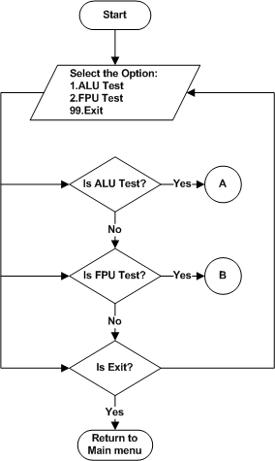
Figure 1 : Processor Test Menu

ALU Test
Refer the section 2.1.3.1.1and 2.2.1.1 for Module Decomposition and Data Decomposition.

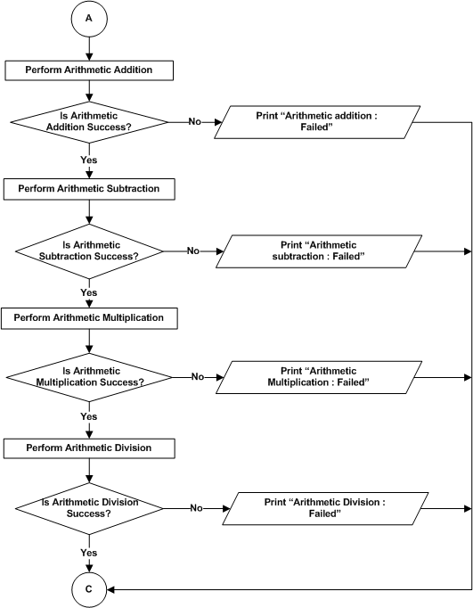

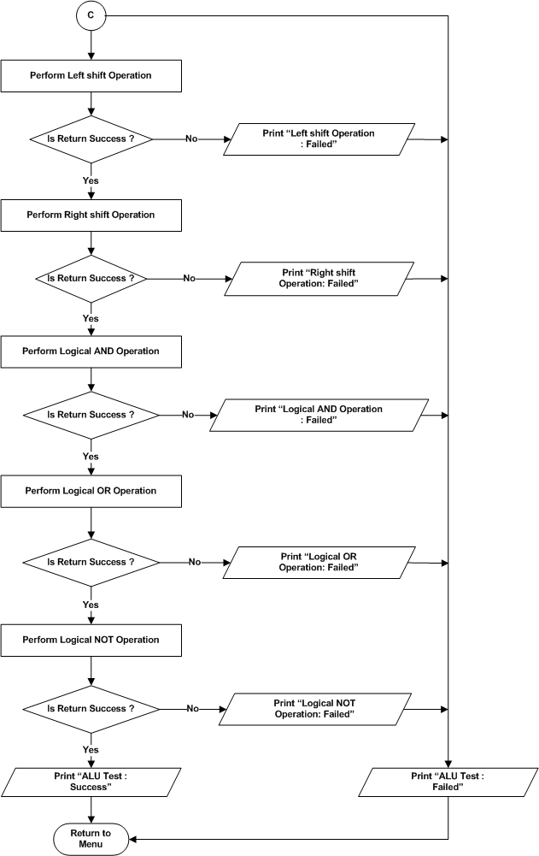
Figure 2: Processor Test - ALU Test

FPU Test
Refer the section 2.1.3.1.2 and 2.2.1.1for Module Decomposition and Data Decomposition.
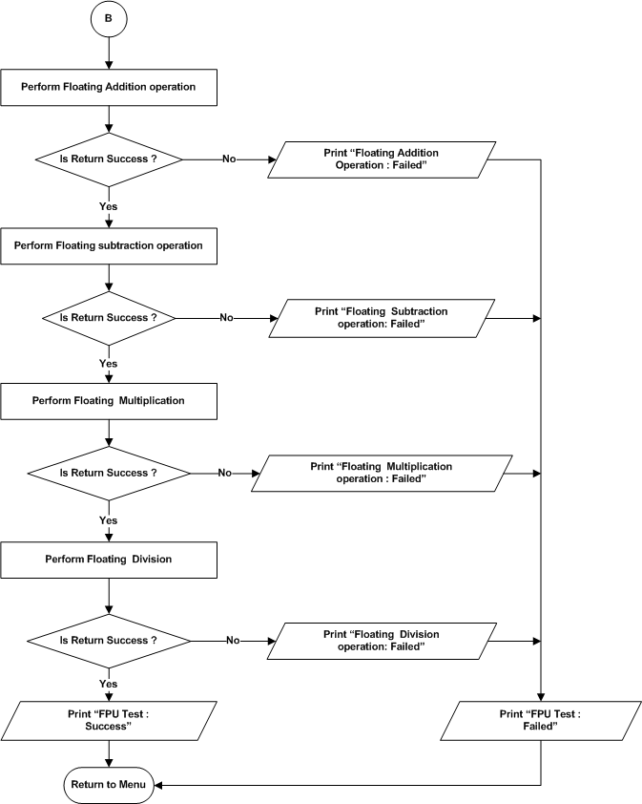
Figure 3 : Processor Test – FPU Test

DDR4 Test
Refer the section 2.1.3.2 and 2.2.1.2 for Module Decomposition and Data Decomposition.
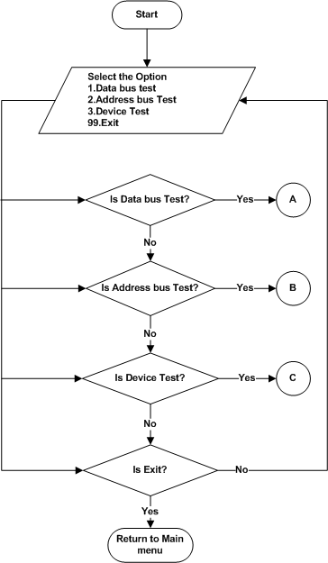
Figure 4 : DDR4 Test Menu

Data Bus Test
Refer the section 2.1.3.2.1 and 2.2.1.2 for Module Decomposition and Data Decomposition.
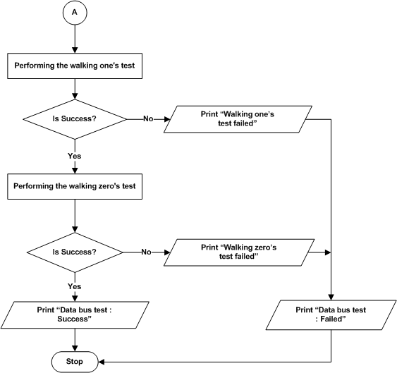
Figure 5: DDR4 Test – Data Bus Test

Address Bus Test
Refer the section 2.1.3.2.2 and 2.2.1.2 for Module Decomposition and Data Decomposition.

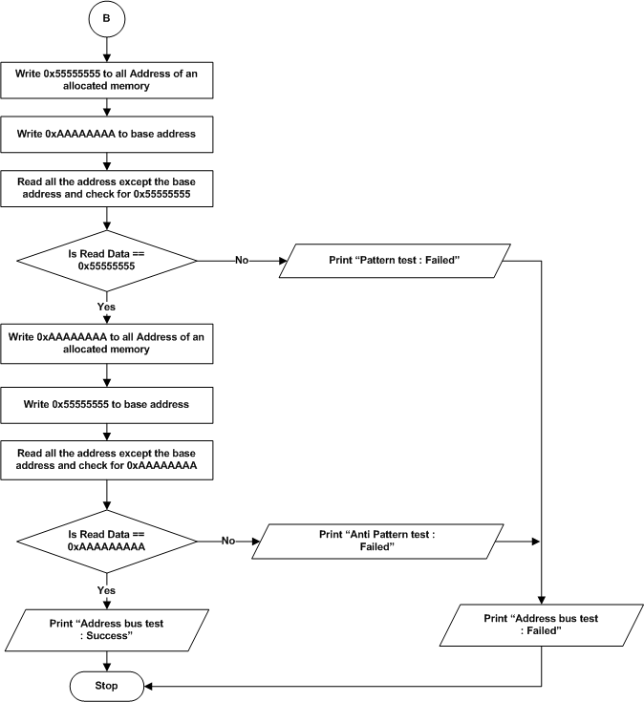

Figure 6: DDR4 Test – Address Bus Test

Device Test
Refer the section 2.1.3.2.3 and 2.2.1.2 for Module Decomposition and Data Decomposition.
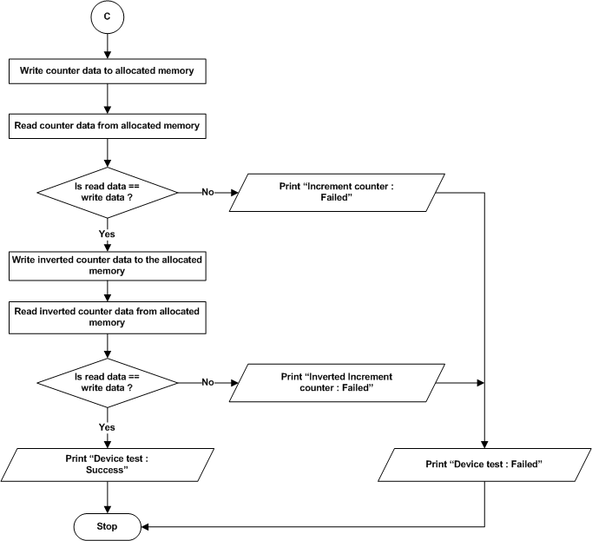

Figure 7: DDR4 Test –Device Test

EEPROM Test
Refer the section 2.1.3.3 and 2.2.1.3 for Module Decomposition and Data Decomposition.
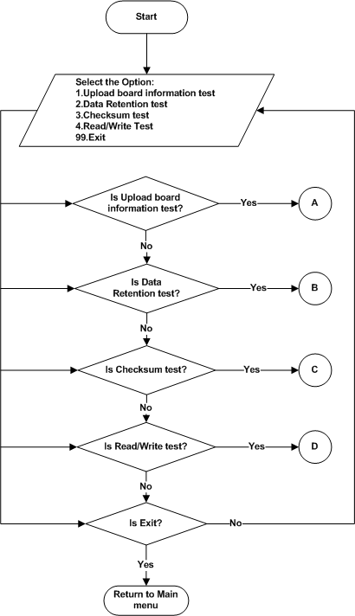

Figure 8 : EEPROM Test Menu

Upload Board Information Test
Refer the section 2.1.3.3.1 and 2.2.1.3 for Module Decomposition and Data Decomposition.
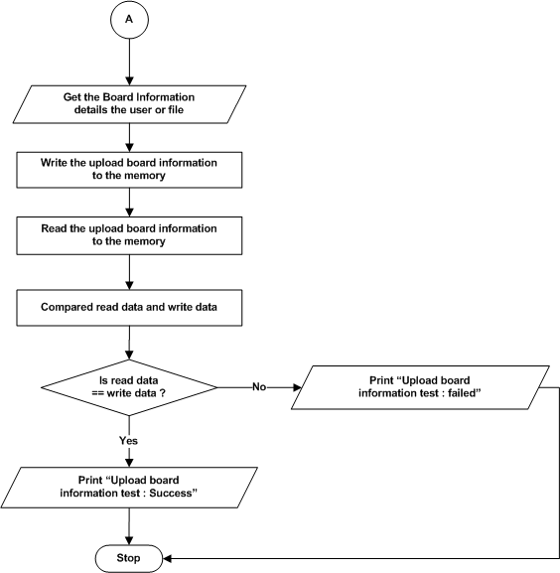

Figure 9 : EEPROM – Upload Board Information Test

Data Retention Test
Refer the section 2.1.3.3.2 and 2.2.1.3 for Module Decomposition and Data Decomposition.
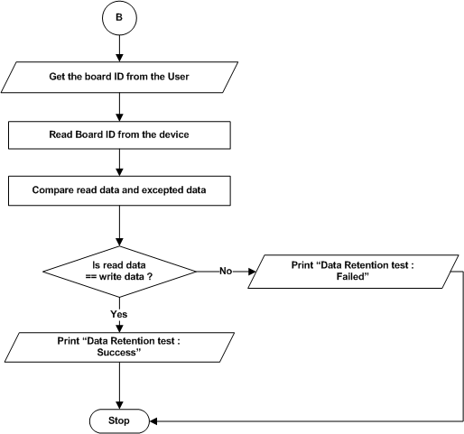
Figure 10 : EEPROM – Data Retention Test

Checksum Test
Refer the section 2.1.3.3.3 and 2.2.1.3 for Module Decomposition and Data Decomposition.
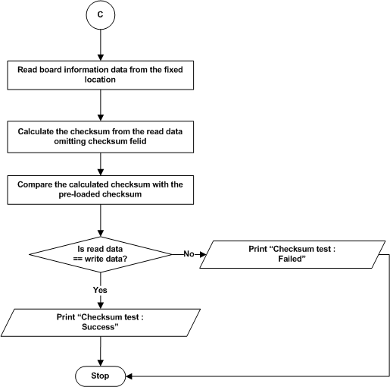
Figure 11 : EEPROM – Checksum Test

Read/Write Test
Refer the section 2.1.3.3.4 and 2.2.1.3 for Module Decomposition and Data Decomposition.

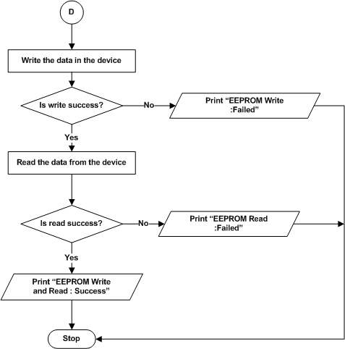

Figure 12 : EEPROM – Read/Write Test

MRAM Test
Refer the section 2.1.3.4 and 2.2.1.4 for Module Decomposition and Data Decomposition.
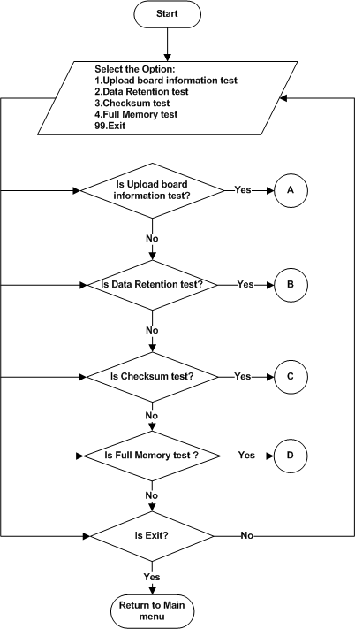

Figure 13 : MRAM Test Menu

Upload Board Information test

Refer the section 2.1.3.4.1 and 2.2.1.4 for Module Decomposition and Data Decomposition.
- Refer section 5.1.1.3.1 for flow chart of Upload Board Information test.

Data Retention test

Refer the section 2.1.3.4.2 and 2.2.1.4 for Module Decomposition and Data Decomposition.
- Refer section 5.1.1.3.2 for flow chart of Data Retention test.

Checksum Test
Refer the section 2.1.3.4.3 and 2.2.1.4 for Module Decomposition and Data Decomposition.
- Refer section 5.1.1.3.2 for flow chart of Checksum test.

Full Memory test

Refer the section 2.1.3.4.3 and 2.2.1.4 for Module Decomposition and Data Decomposition.
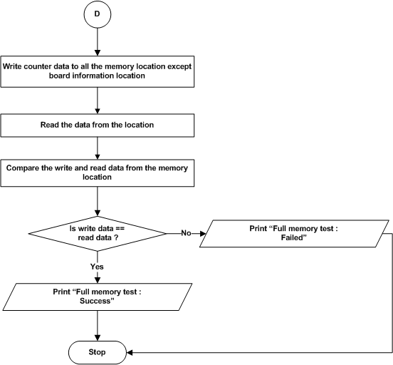

Figure 14 : MRAM – Full Memory Test

NAND Flash Test
Refer the section 2.1.3.5 and 2.2.1.5 for Module Decomposition and Data Decomposition.
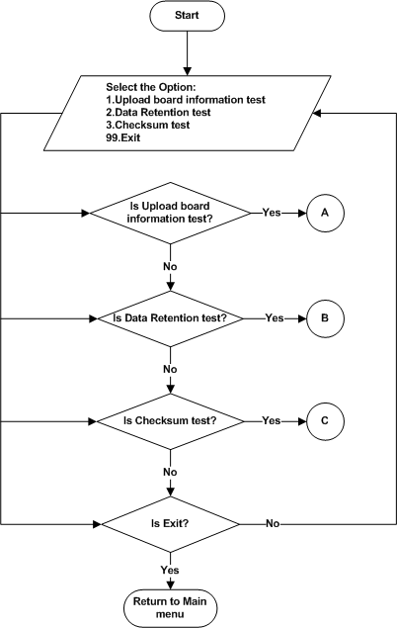
Figure 15 : NAND Flash Test Menu

Upload Board Information test
Refer the section 2.1.3.5.1 and 2.2.1.5 for Module Decomposition and Data Decomposition.
- Refer section 5.1.1.3.1 for flow chart of Upload Board Information test.

Data Retention Test
Refer the section 2.1.3.5.2 and 2.2.1.5 for Module Decomposition and Data Decomposition.
- Refer section 5.1.1.3.2 for flow chart of Data Retention test.

Checksum Test
Refer the section 2.1.3.5.3 and 2.2.1.5 for Module Decomposition and Data Decomposition.
- Refer section 5.1.1.3.2 for flow chart of Checksum test.

NOR Flash Test
Refer the section 2.1.3.6 and 2.2.1.6 for Module Decomposition and Data Decomposition.
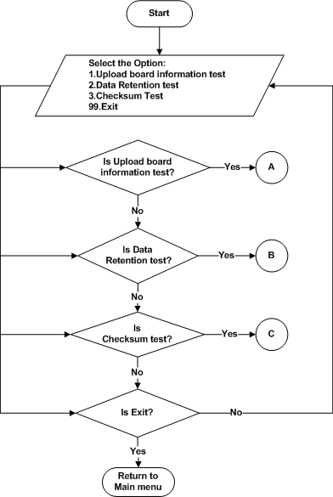
Figure 16 : NOR Flash Test Menu

Upload Board Information test
Refer the section 2.1.3.6.1 and 2.2.1.6 for Module Decomposition and Data Decomposition.
- Refer section 5.1.1.3.1 for flow chart of Upload Board Information test.

Data Retention Test
Refer the section 2.1.3.6.2 and 2.2.1.6 for Module Decomposition and Data Decomposition.
- Refer section 5.1.1.3.2 for flow chart of Data Retention test.

Checksum Test
Refer the section 2.1.3.6.3 and 2.2.1.6 for Module Decomposition and Data Decomposition.
- Refer section 5.1.1.3.2 for flow chart of Checksum test.

USB Test

Read / Write Test
Refer the section 2.1.3.7 and 2.2.1.7 for Module Decomposition and Data Decomposition.
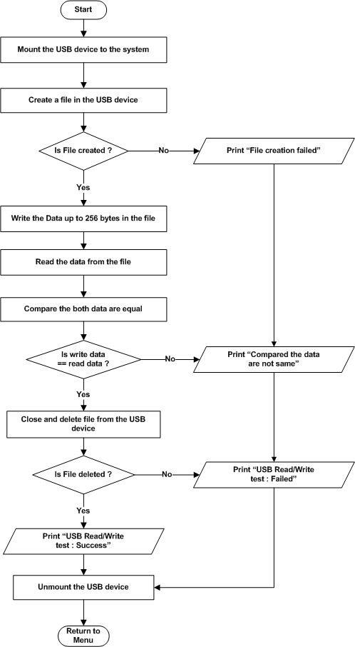
Figure 17: USB – Read / Write Test

SATA Test

Read / Write Test
Refer the section 2.1.3.8 and 2.2.1.8 for Module Decomposition and Data Decomposition.
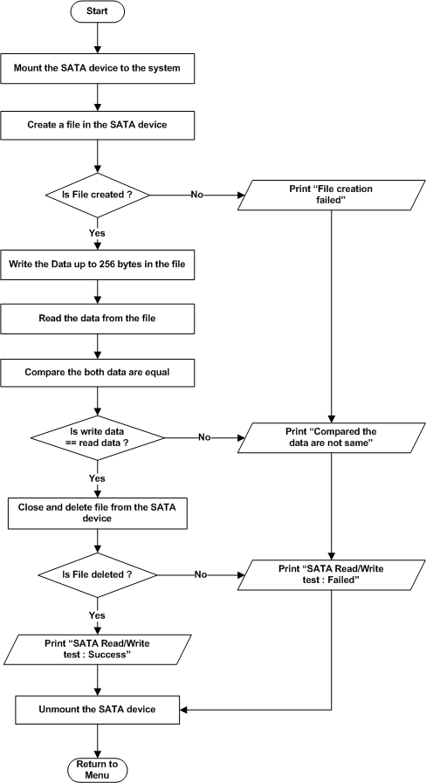
Figure 18 : SATA – Read / Write Test

UART Test
Refer the section 2.1.3.9 and 2.2.1.9 for Module Decomposition and Data Decomposition.
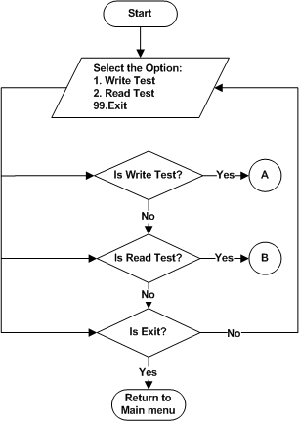
Figure 19 : UART Main Menu

Write Test
Refer the section 2.1.3.9.1 and 2.2.1.9 for Module Decomposition and Data Decomposition.
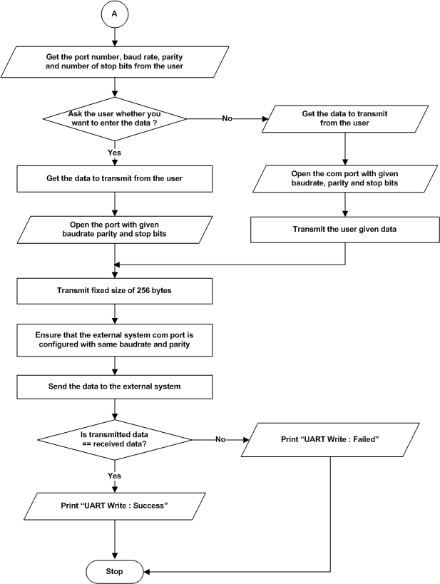
Figure 20 : UART – Write Test

Read Test
Refer the section 2.1.3.9.2 and 2.2.1.9 for Module Decomposition and Data Decomposition.
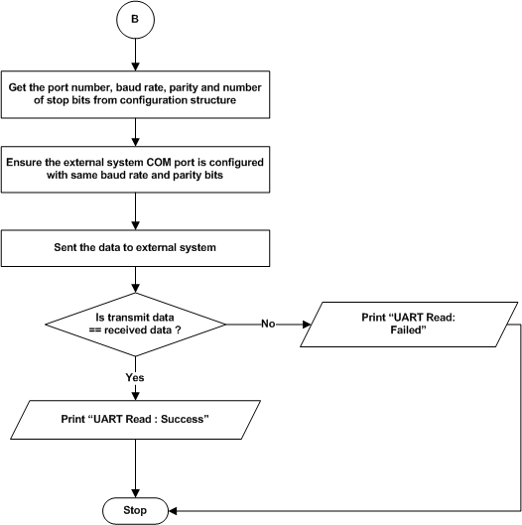
Figure 21 : UART – Read

Ethernet Test
Refer the section 2.1.3.10 and 2.2.1.10 for Module Decomposition and Data Decomposition.

Start
Select the Option:
1.Ethernet Ping test
99.Exit
Is Ethernet Ping test?
A
Is Exit?
Return to Main Menu
No
No
Yes
Yes

Figure 22 : Ethernet - Test Menu

Ethernet ping Test
Refer the section 2.1.3.10.1 and 2.2.1.10 for Module Decomposition and Data Decomposition.

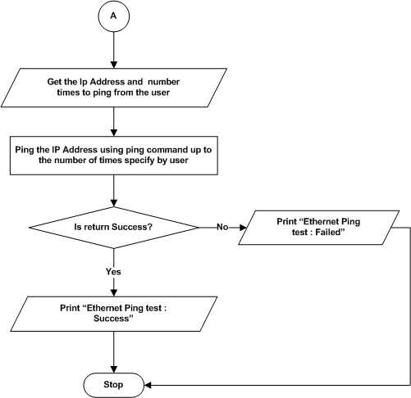

Figure 23 : Ethernet Ping Test

Temperature Sensor

Temperature Sensor Test
Refer the section 2.1.3.11 and 2.2.1.11 for Module Decomposition and Data Decomposition.
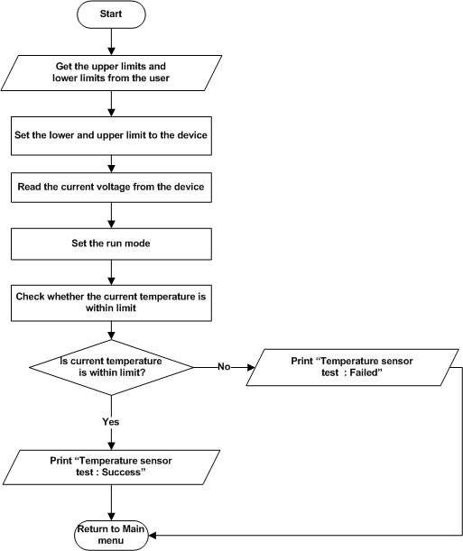
Figure 24 : Temperature Sensor Test

RTC Test

RTC Test
Refer the section 2.1.3.12 and 2.2.1.12 for Module Decomposition and Data Decomposition.

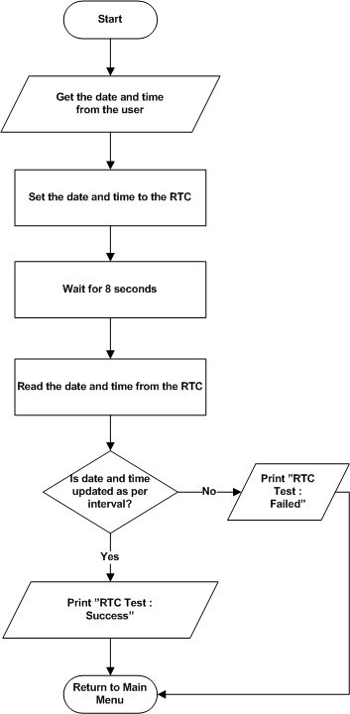

Figure 25 : RTC Test

Programmable Logic
This Section will hold the flow chart for the Programmable logic section. Refer the section 2.1.4 and 2.2.2 for module decomposition and data decomposition.

LMK04828 PLL
Refer the section 2.1.4.1 and 2.2.2.1 for Module Decomposition and Data Decomposition.
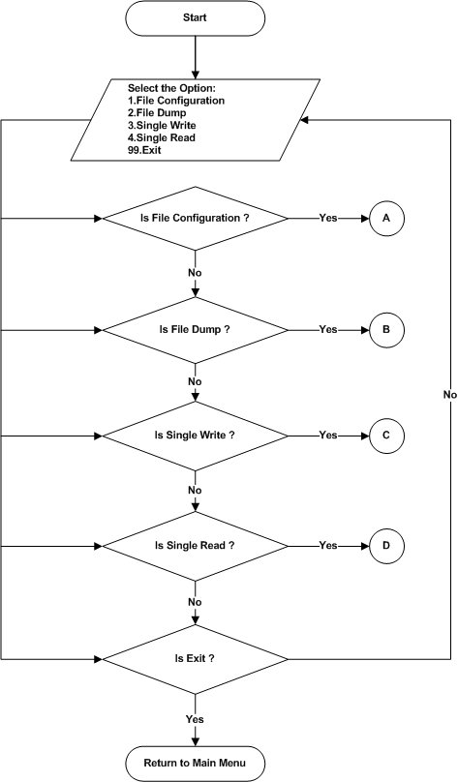
Figure 26 : LMK04828 PLL Menu

File Configuration

Refer the section 2.1.4.1.1 and 2.2.2.1 for Module Decomposition and Data Decomposition.
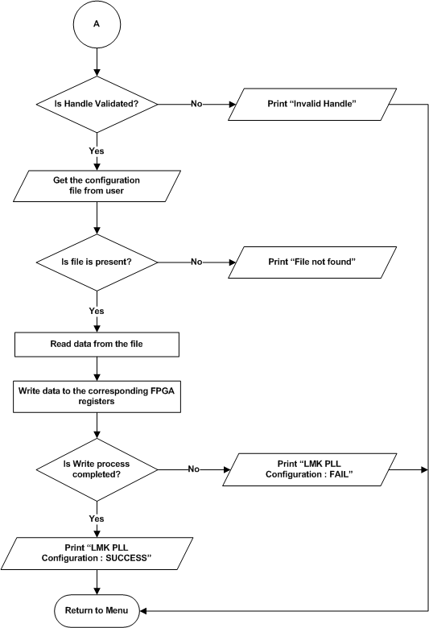
Figure 27 : LMK04828 PLL - File Configuration

File Dump

Refer the section 2.1.4.1.2 and 2.2.2.1 for Module Decomposition and Data Decomposition.
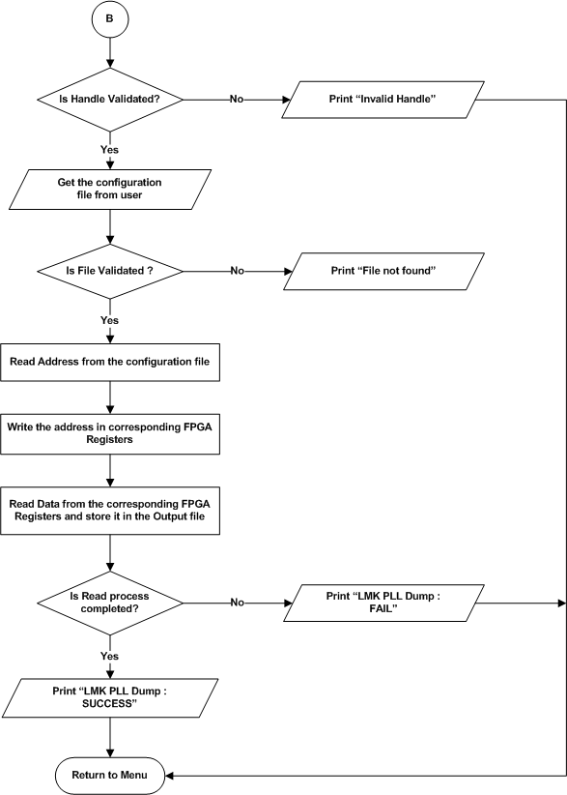

Figure 28 : LMK04828 PLL - File Dump

Single Write

Refer the section 2.1.4.1.3 and 2.2.2.1 for Module Decomposition and Data Decomposition.

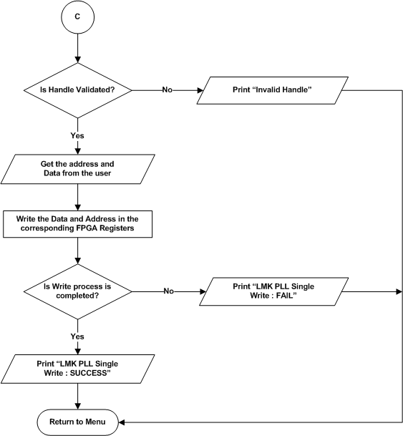

Figure 29 : LMK04828 PLL – Single Write

Single Read

Refer the section 2.1.4.1.4 and 2.2.2.1 for Module Decomposition and Data Decomposition.
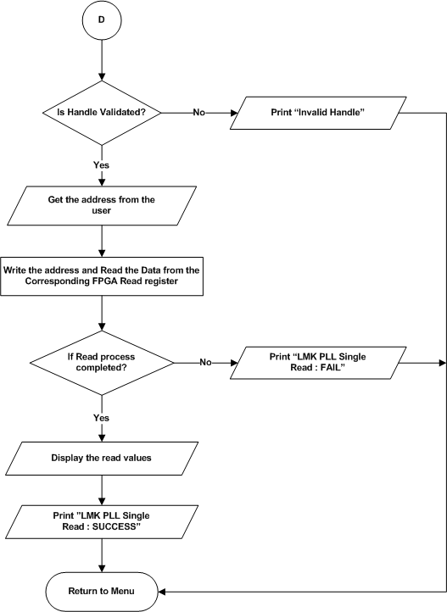

Figure 30 : LMK04828 PLL – Single Read

AFE7906 ADC
Refer the section 2.1.4.2 and 2.2.2.2 for Module Decomposition and Data Decomposition.
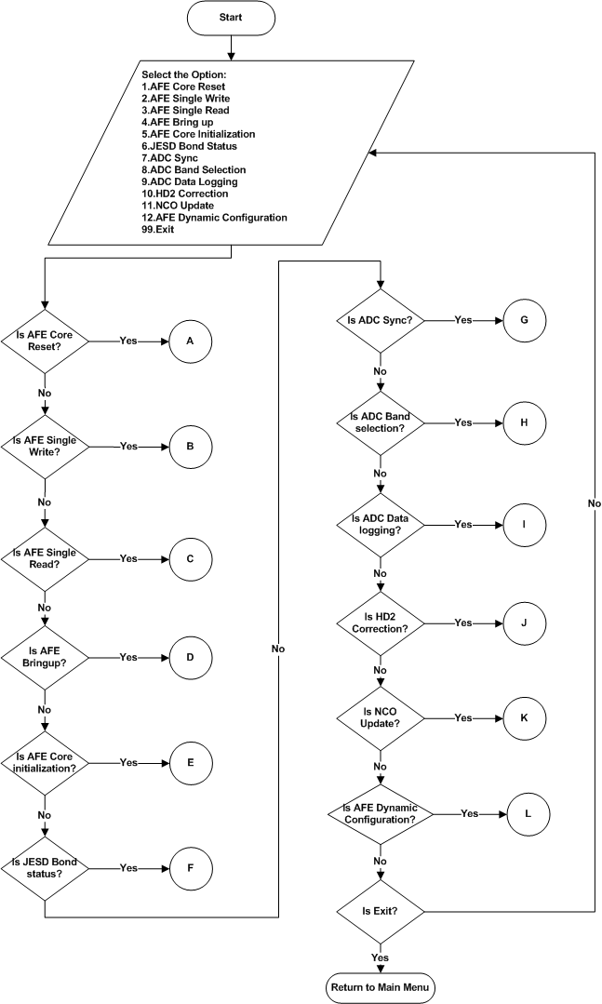
Figure 31 : AFE7906 ADC Menu

AFE Core Reset
Refer the section 2.1.4.2.1 and 2.2.2.2 for Module Decomposition and Data Decomposition.
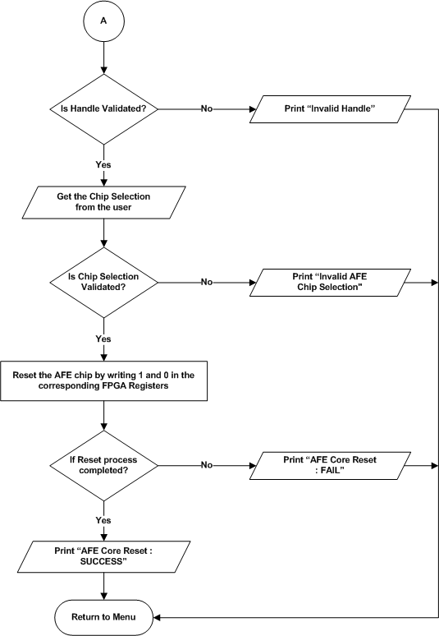
Figure 32 : AFE7906 ADC – AFE Core Reset

AFE Single Write
Refer the section 2.1.4.2.2 and 2.2.2.2 for Module Decomposition and Data Decomposition.
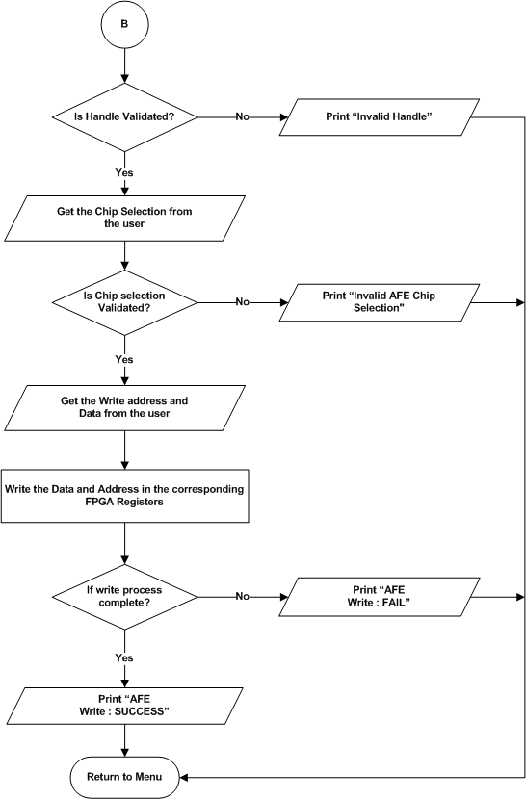
Figure 33 : AFE7906 ADC – AFE Single Write

AFE Single Read
Refer the section 2.1.4.2.3 and 2.2.2.2 for Module Decomposition and Data Decomposition.
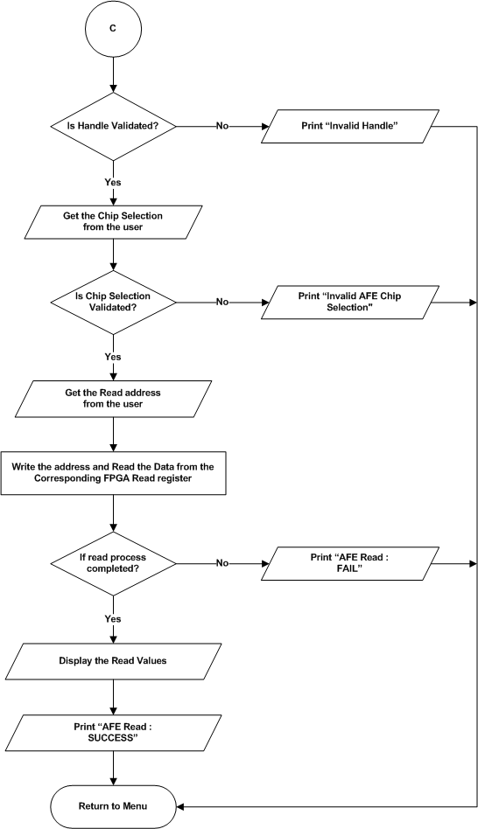
Figure 34 : AFE7906 ADC – AFE Single Read

AFE Bringup
Refer the section 2.1.4.2.4 and 2.2.2.2 for Module Decomposition and Data Decomposition.
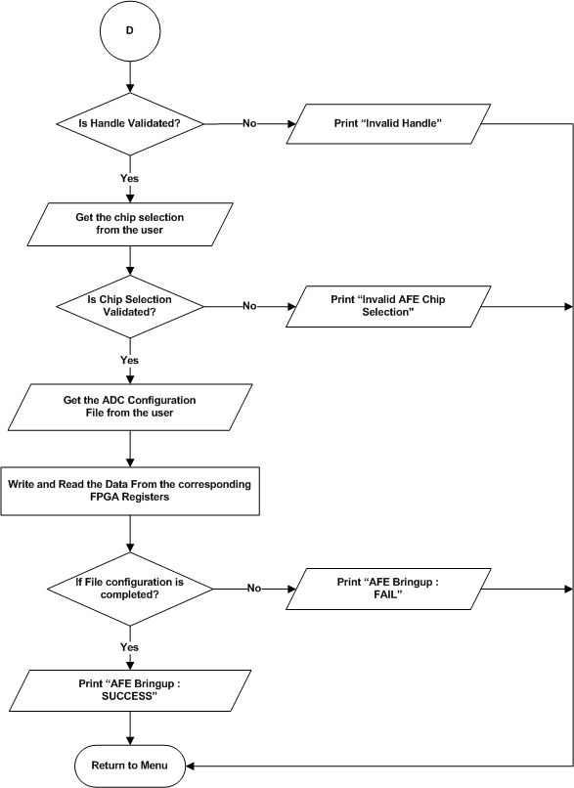
Figure 35 : AFE7906 ADC – AFE Bringup

AFE Core Initialization
Refer the section 2.1.4.2.5 and 2.2.2.2 for Module Decomposition and Data Decomposition.
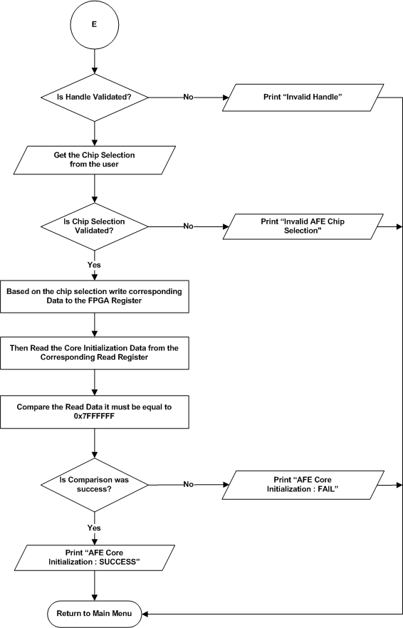
Figure 36 : AFE7906 ADC – AFE Core Initialization

JESD Bond status
Refer the section 2.1.4.2.6 and 2.2.2.2 for Module Decomposition and Data Decomposition.
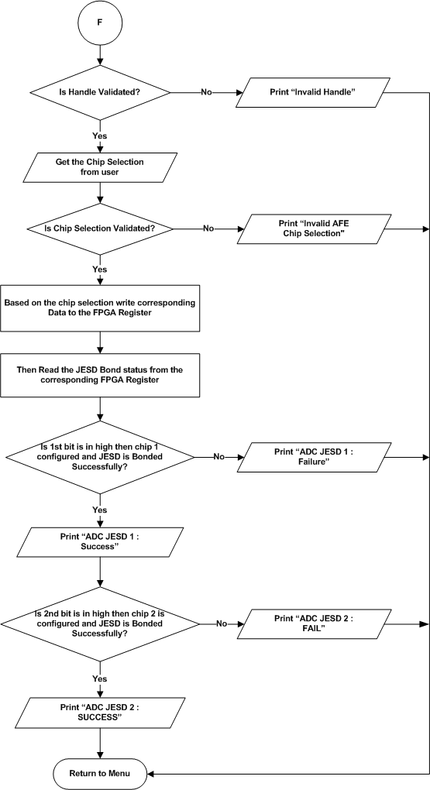
Figure 37 : AFE7906 ADC – JESD Bond status

ADC Sync
Refer the section 2.1.4.2.7 and 2.2.2.2 for Module Decomposition and Data Decomposition.

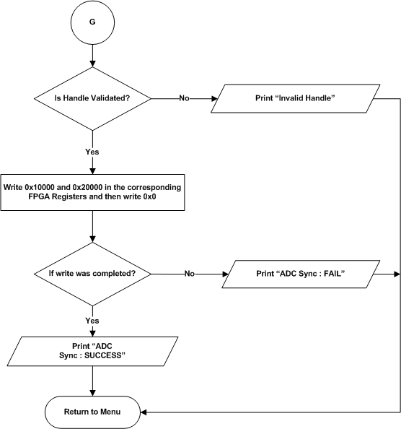
Figure 38 : AFE7906 ADC – ADC Sync

ADC Band Selection
Refer the section 2.1.4.2.8 and 2.2.2.2 for Module Decomposition and Data Decomposition.
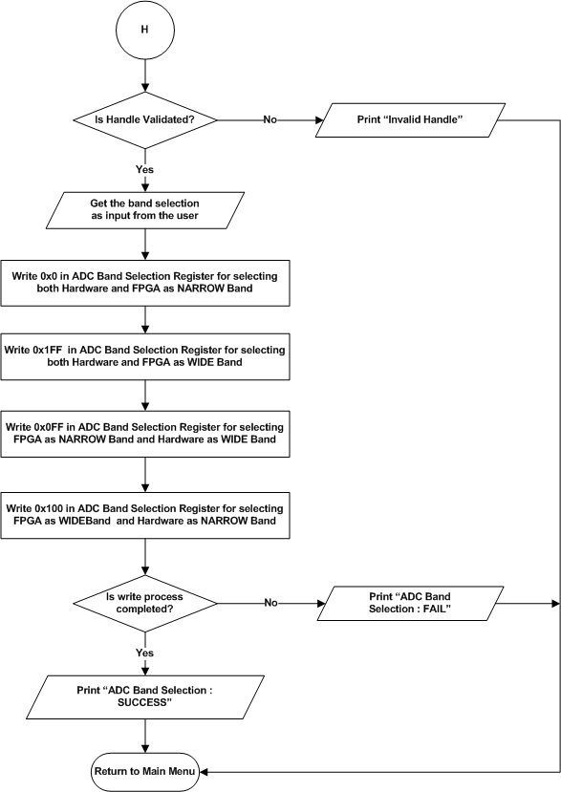
Figure 39 : AFE7906 ADC – ADC Band Selection

ADC Data Logging
Refer the section 2.1.4.2.9 and 2.2.2.2 for Module Decomposition and Data Decomposition.
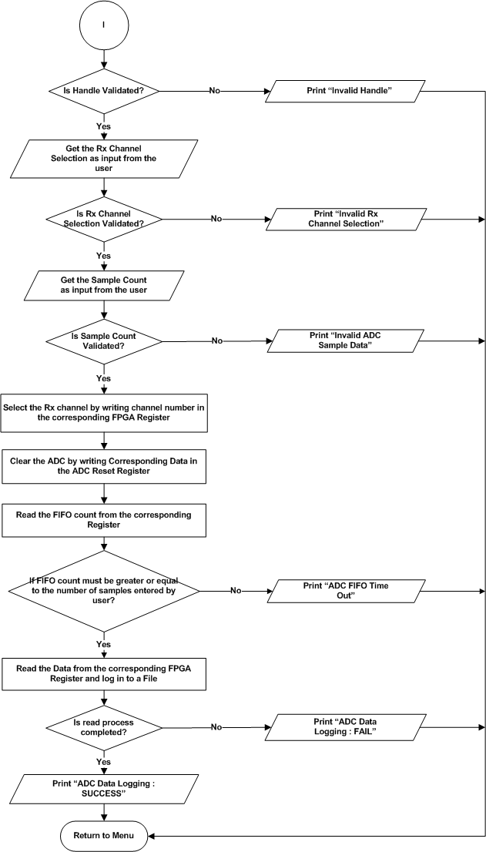
Figure 40 : AFE7906 ADC – ADC Data Logging

HD2 Correction Enable
Refer the section 2.1.4.2.10 and 2.2.2.2 for Module Decomposition and Data Decomposition.

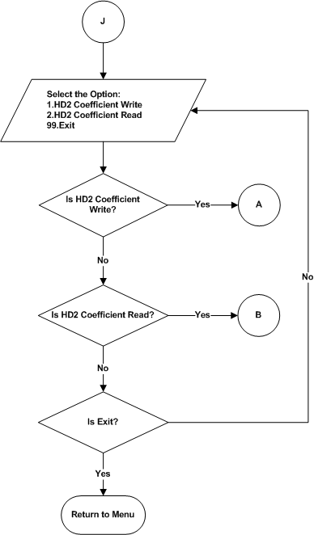

Figure 41 : AFE7906 ADC – HD2 Correction Enable

HD2 Correction Write
Refer the section 2.1.4.2.10.1 and 2.2.2.2 for Module Decomposition and Data Decomposition.
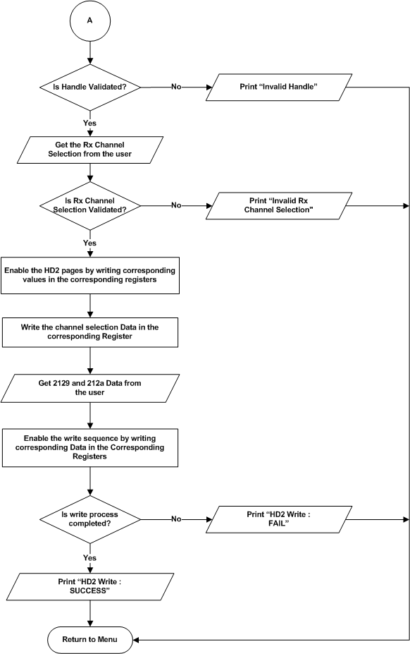
Figure 42 : AFE7906 ADC – HD2 Correction Write

HD2 Correction Read
Refer the section 2.1.4.2.10.2 and 2.2.2.2 for Module Decomposition and Data Decomposition.
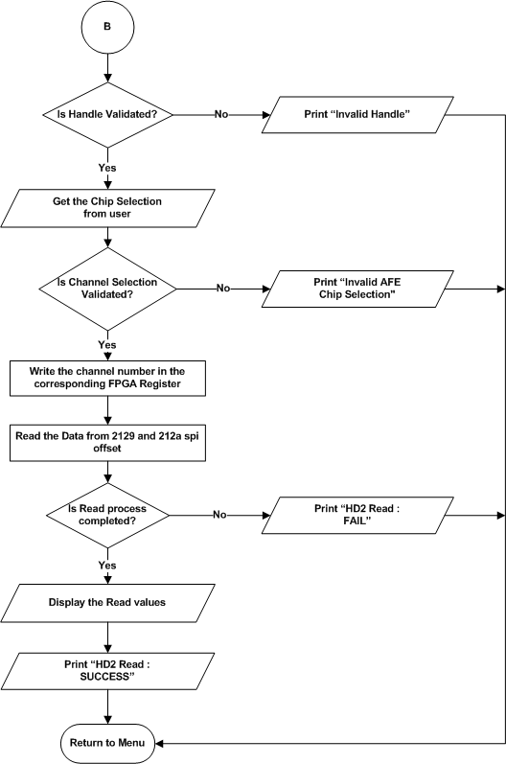
Figure 43 : AFE7906 ADC – HD2 Correction Read

NCO Update
Refer the section 2.1.4.2.11 and 2.2.2.2 for Module Decomposition and Data Decomposition.

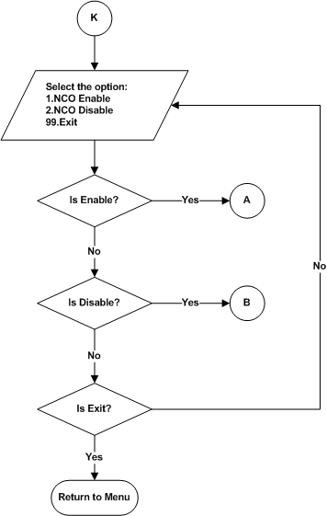
Figure 44 : AFE7906 ADC – NCO Update

NCO Enable
Refer the section 2.1.4.2.11 and 2.2.2.2 for Module Decomposition and Data Decomposition.
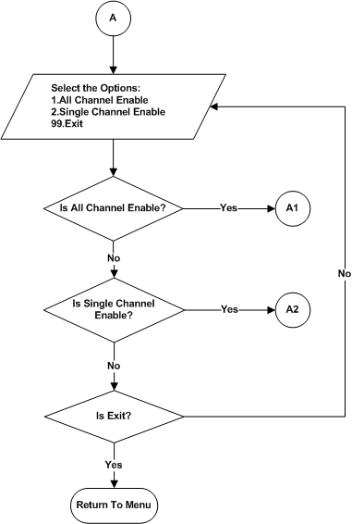
Figure 45 : AFE7906 ADC – NCO Enable

All Channel Enable
Refer the section 2.1.4.2.11.1 and 2.2.2.2 for Module Decomposition and Data Decomposition.
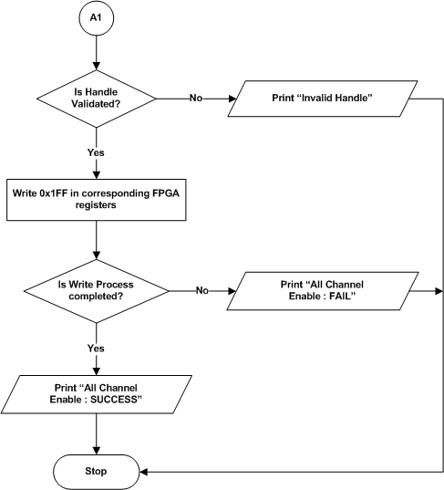
Figure 46 : AFE7906 ADC – All Channel Enable

Single Channel Enable
Refer the section 2.1.4.2.11.2 and 2.2.2.2 for Module Decomposition and Data Decomposition.
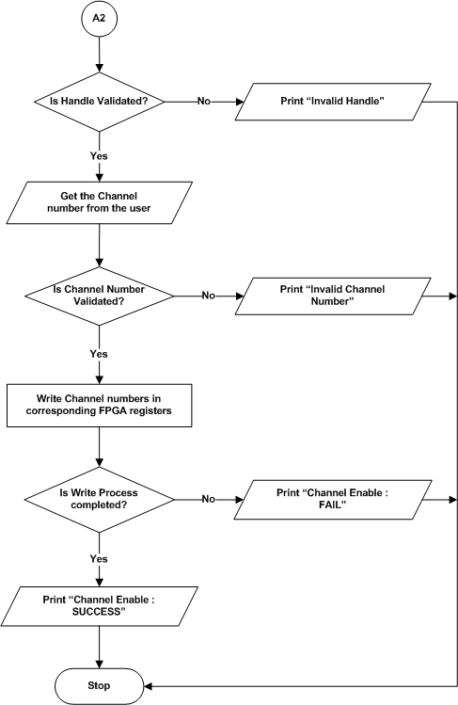
Figure 47 : AFE7906 ADC – Single Channel Enable

NCO Disable
Refer the section 2.1.4.2.11 and 2.2.2.2 for Module Decomposition and Data Decomposition.
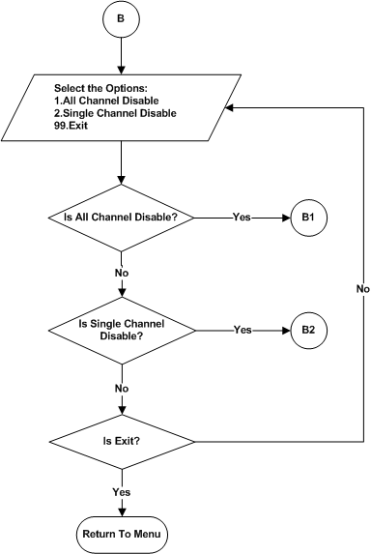

Figure 48 : AFE7906 ADC – NCO Disable

All Channel Disable
Refer the section 2.1.4.2.11.3 and 2.2.2.2 for Module Decomposition and Data Decomposition.

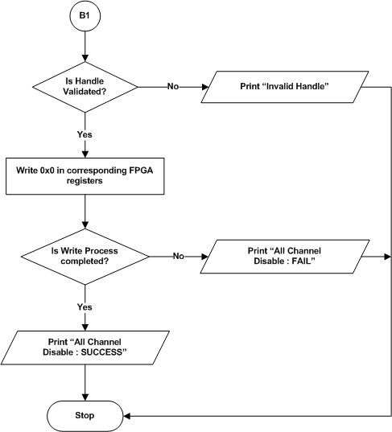
Figure 49 : AFE7906 ADC – All Channel Disable

Single Channel Disable
Refer the section 2.1.4.2.11.4 and 2.2.2.2 for Module Decomposition and Data Decomposition.
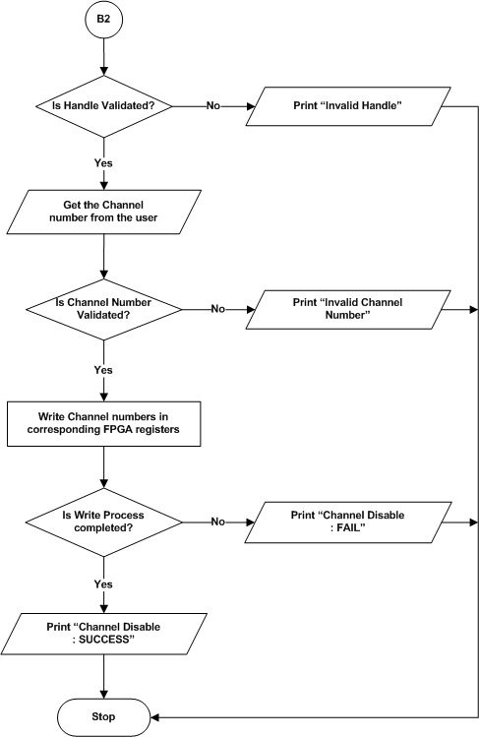
Figure 50 : AFE7906 ADC – Single Channel Disable

ADC Dynamic Configuration
Refer the section 2.1.4.2.12 and 2.2.2.2 for Module Decomposition and Data Decomposition.
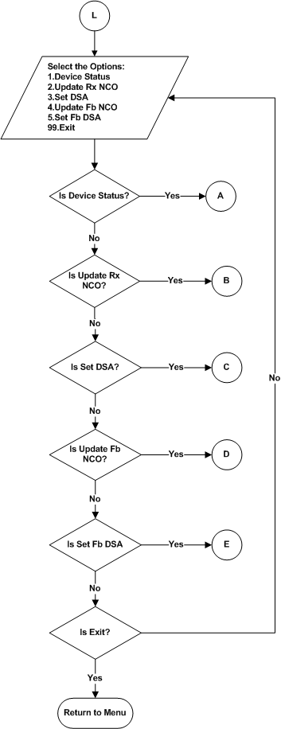
Figure 51 : AFE7906 ADC – Dynamic Configuration Menu

Device Status
Refer the section 2.1.4.2.12.1 and 2.2.2.2 for Module Decomposition and Data Decomposition.

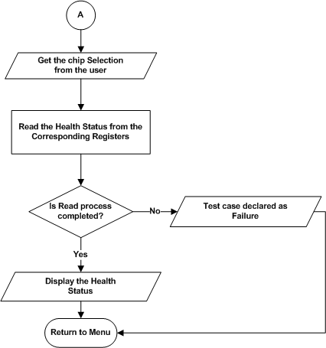

Figure 52 : AFE7906 ADC – Device Status

Update Rx Nco
Refer the section 2.1.4.2.12.1 and 2.2.2.2 for Module Decomposition and Data Decomposition.
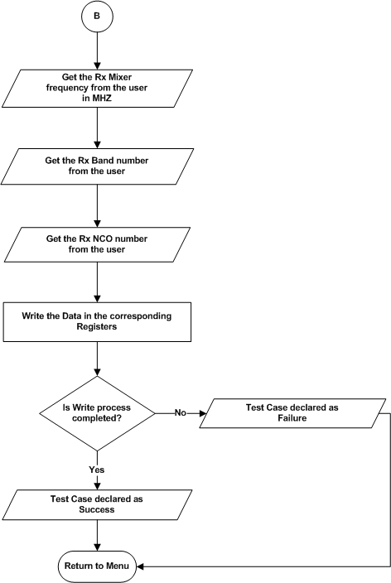

Figure 53 : AFE7906 ADC – Update Rx Nco

Set DSA
Refer the section 2.1.4.2.12.3 and 2.2.2.2 for Module Decomposition and Data Decomposition.
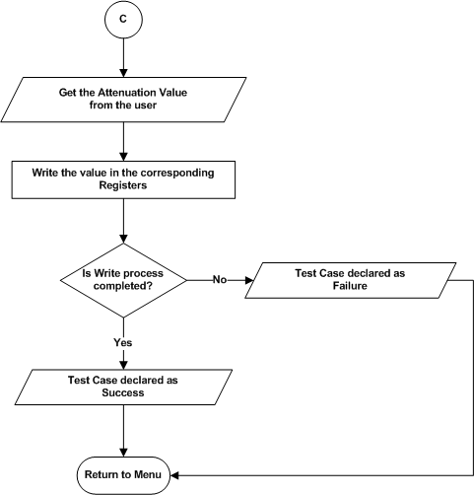

Figure 54 : AFE7906 ADC – Set DSA

Update Fb Nco
Refer the section 2.1.4.2.12.4 and 2.2.2.2 for Module Decomposition and Data Decomposition.
- Refer section 5.1.2.2.12.2 for flow chart.

Set Fb DSA
Refer the section 2.1.4.2.12.4 and 2.2.2.2 for Module Decomposition and Data Decomposition.
- Refer section 5.1.2.2.12.3 for flow chart.

ADC Automation

Data Logging Host
Refer the section 2.1.4.2.13.1.1 and 2.2.2.2 for Module Decomposition and Data Decomposition.
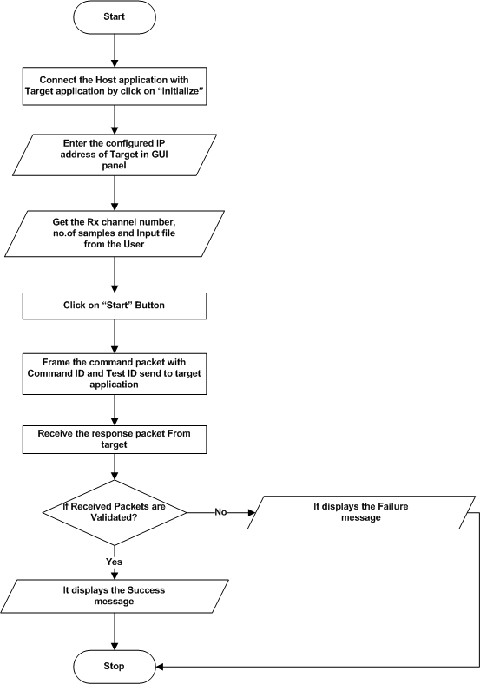
Figure 55 : AFE7906 ADC – Automation Data Logging HOST

Data Logging Target
Refer the section 2.1.4.2.13.1.2 and 2.2.2.2 for Module Decomposition and Data Decomposition.

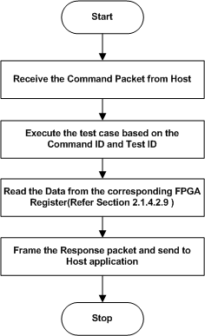

Figure 56 : AFE7906 ADC – Automation Data Logging TARGET

Phase Matching Host
Refer the section 2.1.4.2.13.1.2 and 2.2.2.2 for Module Decomposition and Data Decomposition.
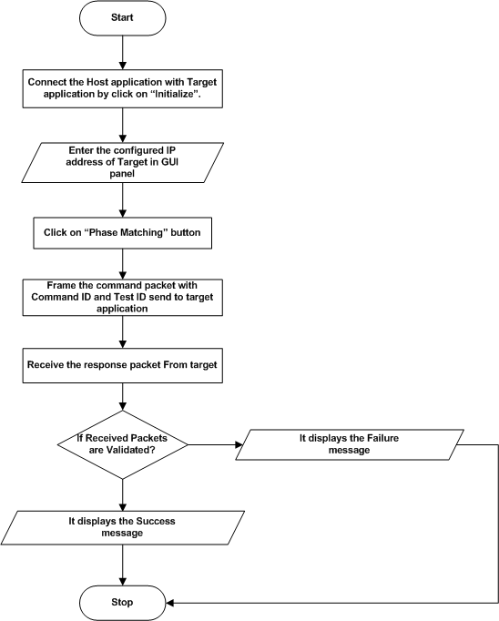
Figure 57 : AFE7906 ADC – Automation Phase Matching HOST

Phase Matching Target
Refer the section 2.1.4.2.13.1.2 and 2.2.2.2 for Module Decomposition and Data Decomposition.
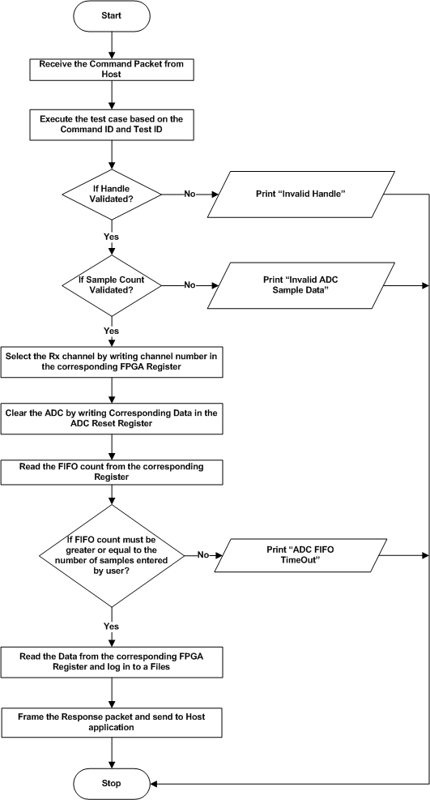
Figure 58 : AFE7906 ADC – Automation Phase Matching TARGET

Digital Attenuation
Refer the section 2.1.4.3 and 2.2.2.3 for Module Decomposition and Data Decomposition.

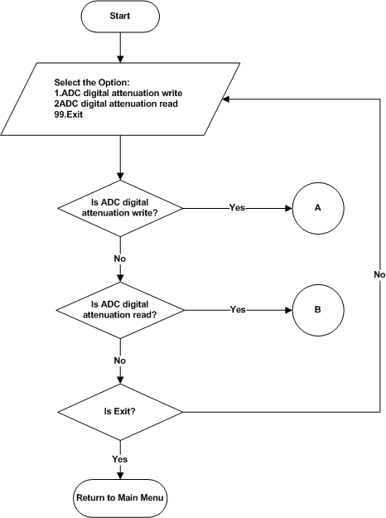

Figure 59 : Digital Attenuation – Main menu

Attenuation Write
Refer the section 2.1.4.3.1 and 2.2.2.3 for Module Decomposition and Data Decomposition.
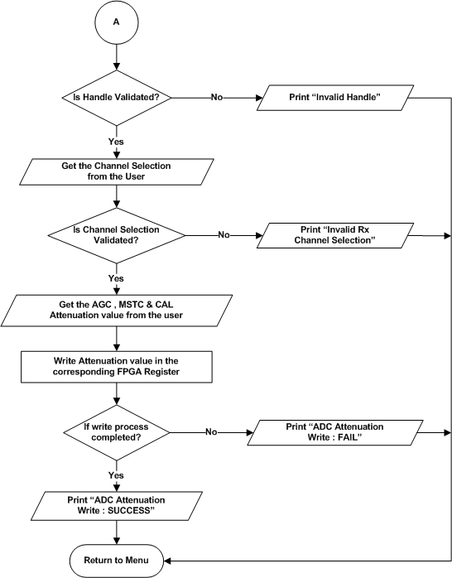

Figure 60 : Digital Attenuation – Write

Attenuation Read
Refer the section 2.1.4.3.2 and 2.2.2.3 for Module Decomposition and Data Decomposition.
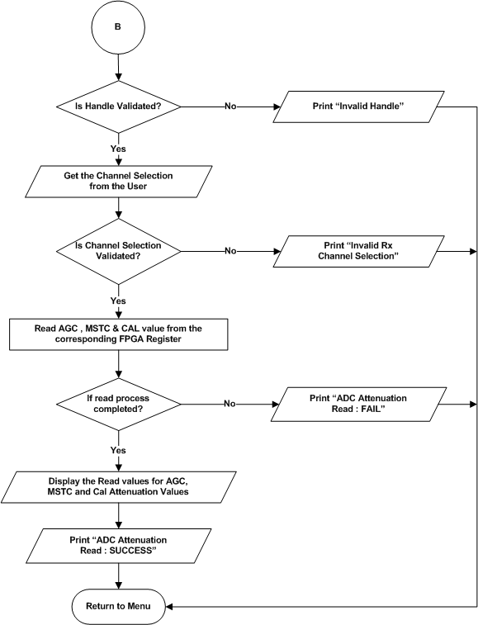
Figure 61 : Digital Attenuation – Read

DDR4 (PL) Test
Refer the section 2.1.4.4 and 2.2.2.4 for Module Decomposition and Data Decomposition.
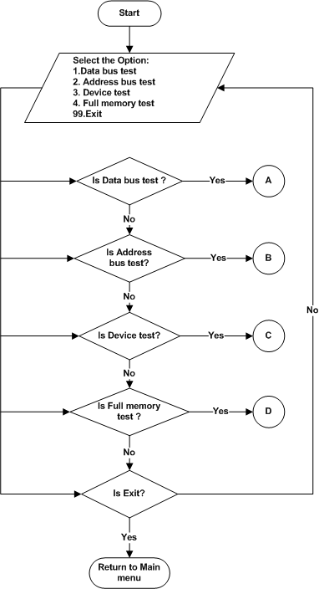

Figure 62 : DDR4 (PL) – Main menu

Data Bus test
Refer the section 2.1.4.4.1 and 2.2.2.4 for Module Decomposition and Data Decomposition.

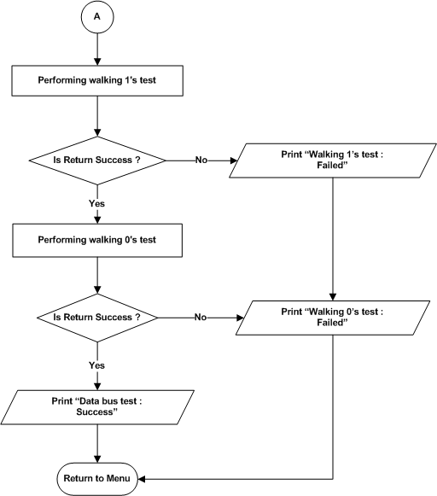

Figure 63 : DDR4 (PL) – Data Bus Test

Address Bus test
Refer the section 2.1.4.4.2 and 2.2.2.4 for Module Decomposition and Data Decomposition.
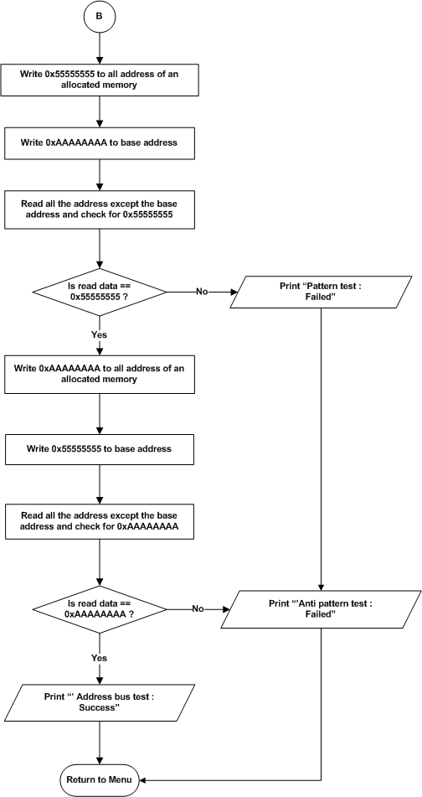
Figure 64 : DDR4 (PL) – Address Bus test

Device test
Refer the section 2.1.4.4.3 and 2.2.2.4 for Module Decomposition and Data Decomposition.

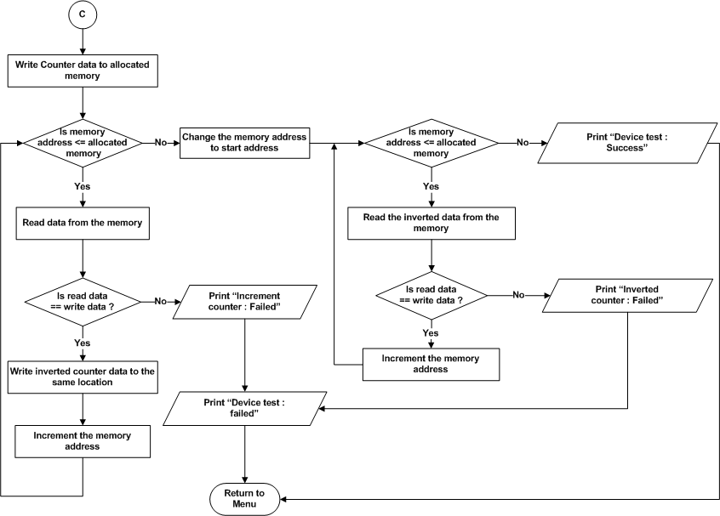

Figure 65 : DDR4 (PL) – Device test

Full memory test

Refer the section 2.1.4.4.4 and 2.2.2.4 for Module Decomposition and Data Decomposition.

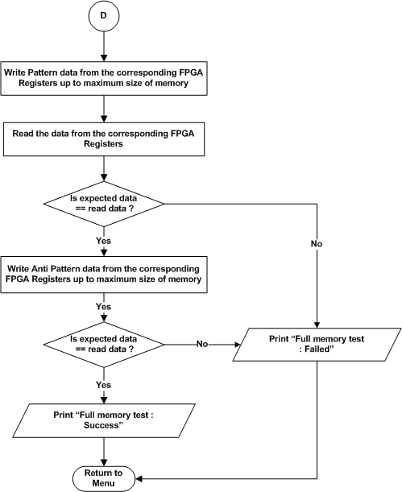

Figure 66 : DDR4 (PL) – Full Memory test

NOR Flash (PL) test
Refer the section 2.1.4.5 and 2.2.2.5 for Module Decomposition and Data Decomposition.
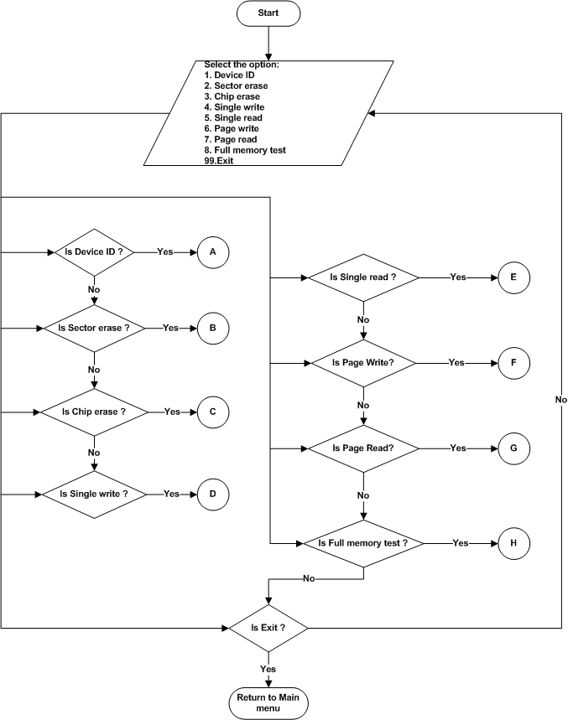
Figure 67 : NOR Flash (PL) – Main menu

Device ID
Refer the section 2.1.4.5.1 and 2.2.2.5 for Module Decomposition and Data Decomposition.

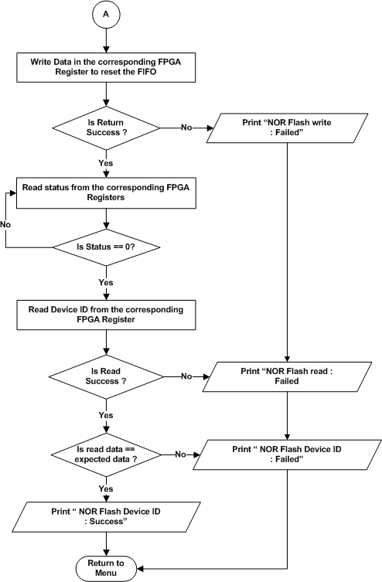

Figure 68 : NOR Flash (PL) – Device ID

Sector erase
Refer the section 2.1.4.5.2 and 2.2.2.5 for Module Decomposition and Data Decomposition.
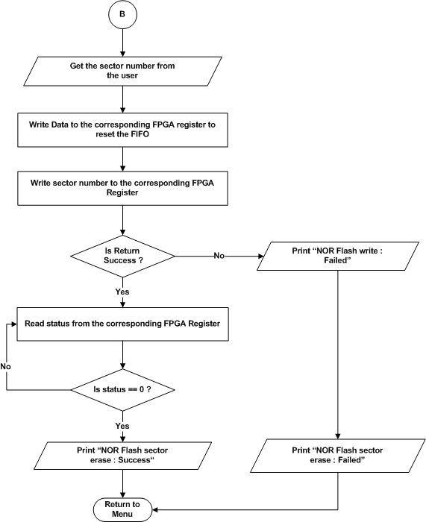
Figure 69 : NOR Flash (PL) – Sector erase

Chip / Die erase
Refer the section 2.1.4.5.3 and 2.2.2.5 for Module Decomposition and Data Decomposition.
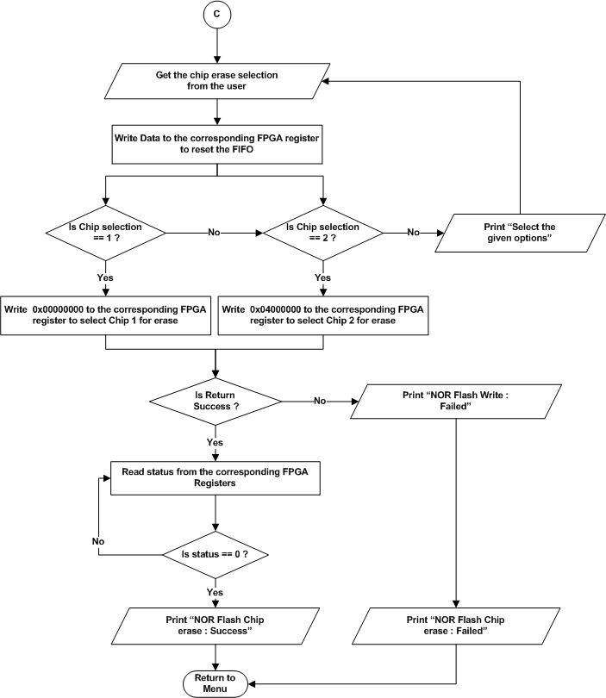
Figure 70 : NOR Flash (PL) – Chip erase

Single Write
Refer the section 2.1.4.5.4 and 2.2.2.5 for Module Decomposition and Data Decomposition.
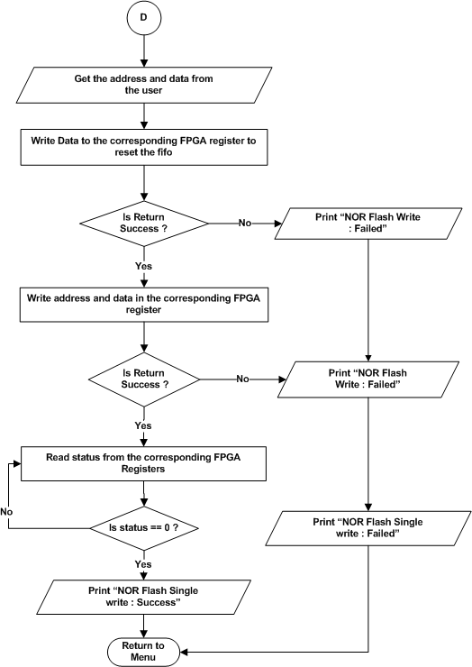
Figure 71 : NOR Flash (PL) – Single Write

Single Read
Refer the section 2.1.4.5.5 and 2.2.2.5 for Module Decomposition and Data Decomposition.
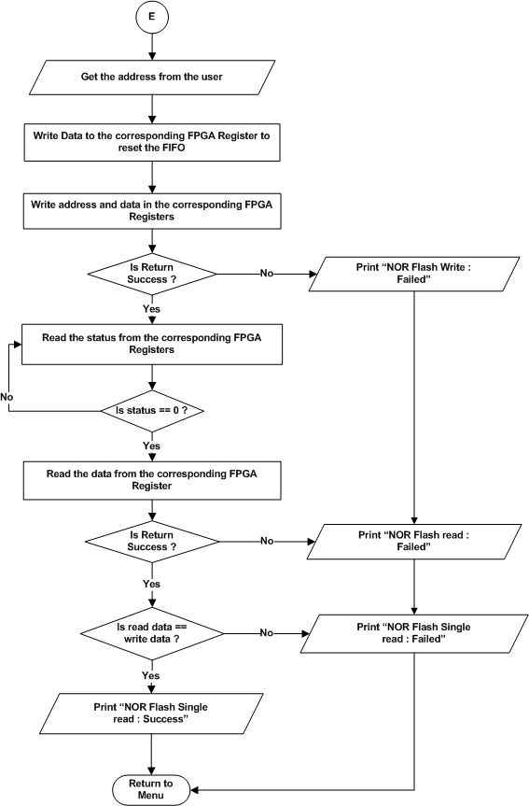
Figure 72 : NOR Flash (PL) – Single Read

Page Write
Refer the section 2.1.4.5.6 and 2.2.2.5 for Module Decomposition and Data Decomposition.
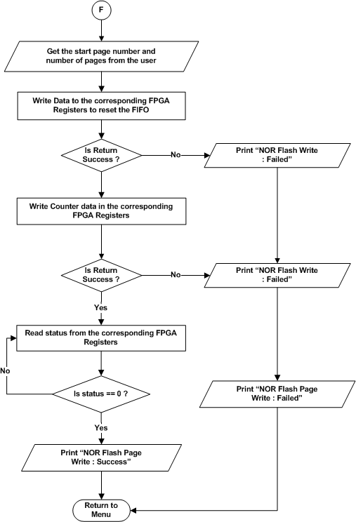

Figure 73 : NOR Flash (PL) – Page Write

Page Read
Refer the section 2.1.4.5.7 and 2.2.2.5 for Module Decomposition and Data Decomposition.
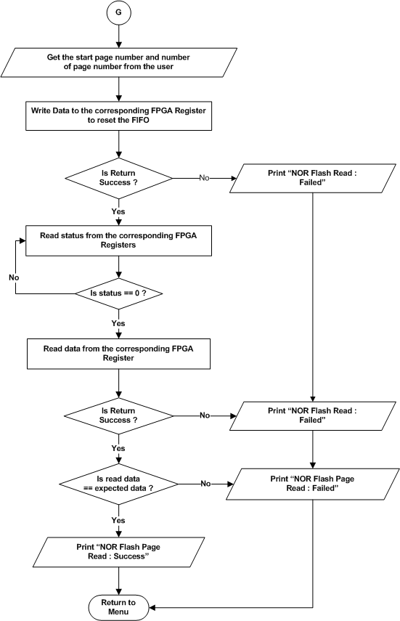
Figure 74 : NOR Flash (PL) – Page Read

Full memory test
Refer the section 2.1.4.5.8 and 2.2.2.5 for Module Decomposition and Data Decomposition.
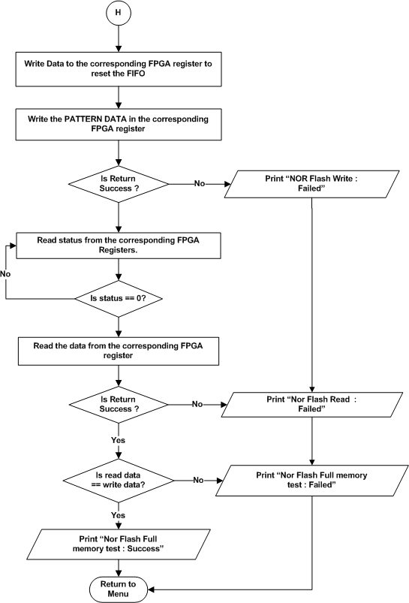
Figure 75 : NOR Flash (PL) – Full memory test

RGMII Test
Refer the section 2.1.4.6 and 2.2.2.6 for Module Decomposition and Data Decomposition.

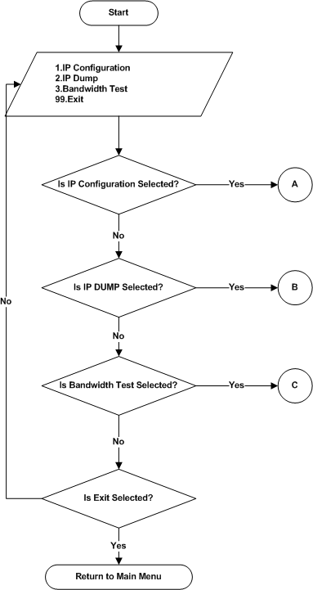

Figure 76 : RGMII Test Main Menu

RGMII IP Configuration
Refer the section 2.1.4.6.1 and 2.2.2.6 for Module Decomposition and Data Decomposition.
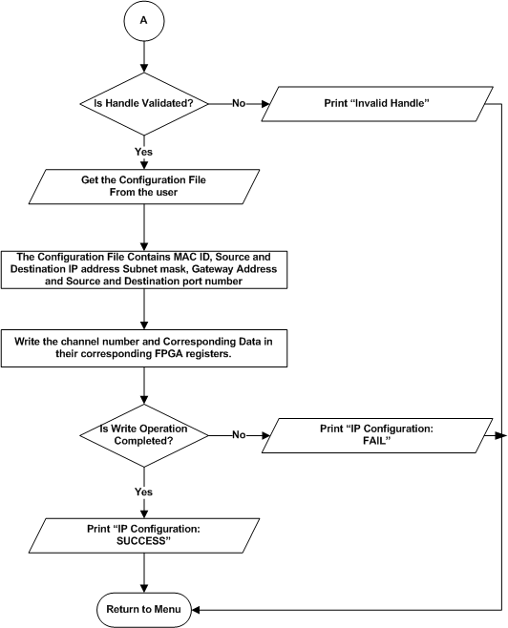

Figure 77 : RGMII Test – IP Configuration

RGMII IP Dump
Refer the section 2.1.4.6.2 and 2.2.2.6 for Module Decomposition and Data Decomposition.
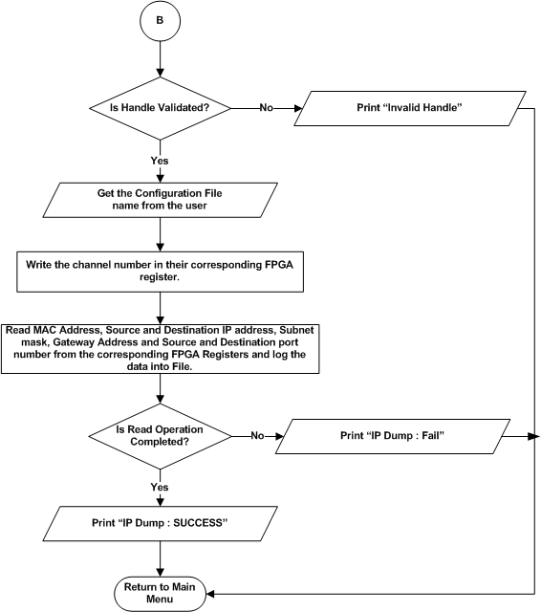

Figure 78 : RGMII Test – IP Dump

RGMII Bandwidth Test
Refer the section 2.1.4.6.3 and 2.2.2.6 for Module Decomposition and Data Decomposition.

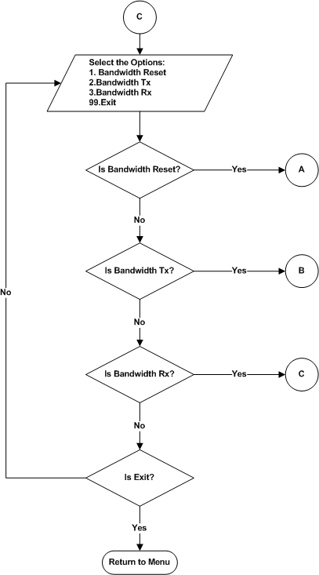
Figure 79 : RGMII Test – Bandwidth Test Main Menu

Bandwidth Reset
Refer the section 2.1.4.6.3.1 and 2.2.2.6 for Module Decomposition and Data Decomposition.
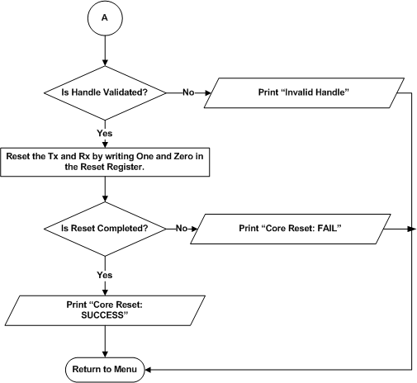

Figure 80 : RGMII Test – Bandwidth Reset

Bandwidth Tx
Refer the section 2.1.4.6.3.2 and 2.2.2.6 for Module Decomposition and Data Decomposition.
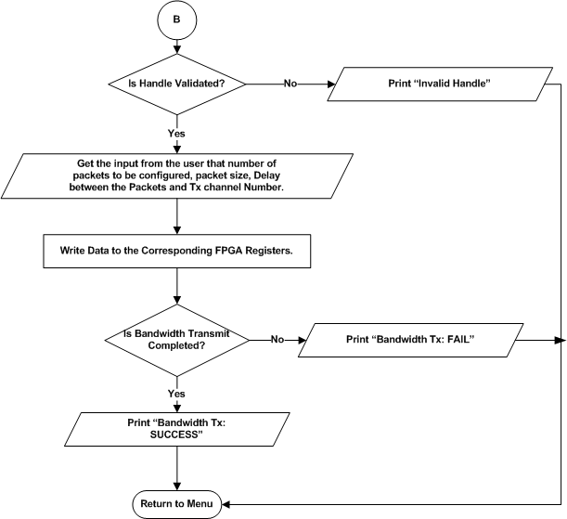

Figure 81 : RGMII Test – Bandwidth Tx

RGMII Bandwidth Rx
Refer the section 2.1.4.6.3.3 and 2.2.2.6 for Module Decomposition and Data Decomposition.
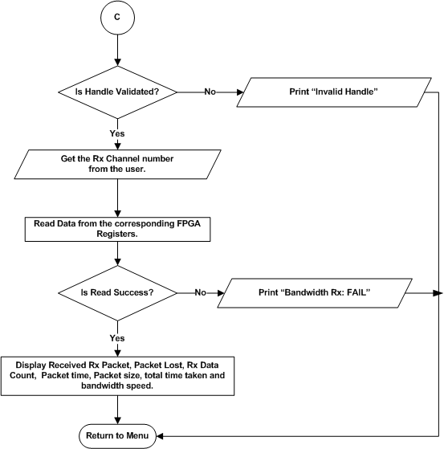
Figure 82 : RGMII Test – Bandwidth Rx

Aurora Test
Refer the section 2.1.4.7 and 2.2.2.7 for Module Decomposition and Data Decomposition.

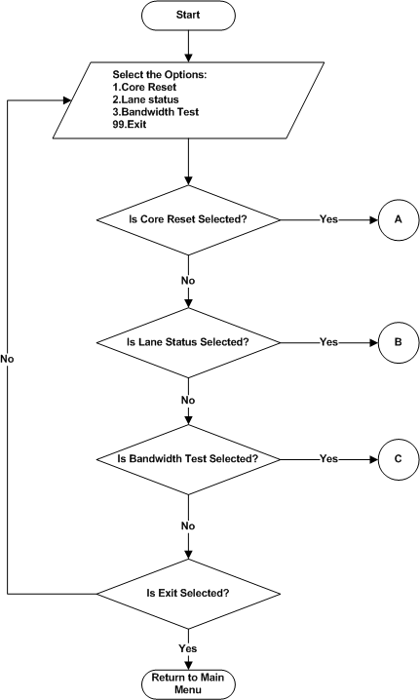
Figure 83 : Aurora Test – Main Menu

Aurora Reset
Refer the section 2.1.4.7.1 and 2.2.2.7 for Module Decomposition and Data Decomposition.

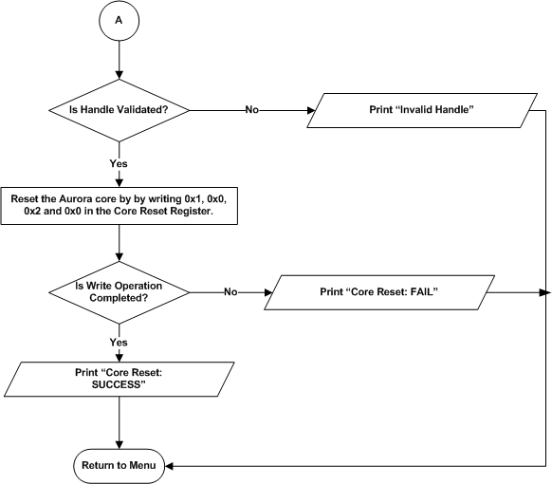

Figure 84 : Aurora Test – Core reset

Aurora lane Status
Refer the section 2.1.4.7.2 and 2.2.2.7 for Module Decomposition and Data Decomposition.
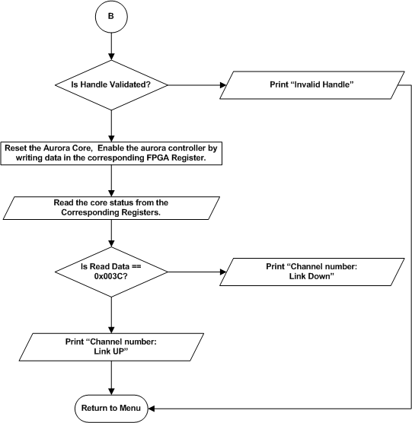

Figure 85 : Aurora Test – Lane Status

Aurora Bandwidth Test
Refer the section 2.1.4.7.3 and 2.2.2.7 for Module Decomposition and Data Decomposition.
- Refer section 5.1.2.6.3 for flow chart of Bandwidth Test.

Bandwidth Reset
Refer the section 2.1.4.7.3.1 and 2.2.2.7 for Module Decomposition and Data Decomposition.
- Refer section 5.1.2.6.3.1 for flow chart of Bandwidth Reset.

Bandwidth Tx
Refer the section 2.1.4.7.3.2 and 2.2.2.7 for Module Decomposition and Data Decomposition.
- Refer section 5.1.2.6.3.2 for flow chart of Bandwidth Tx.

Bandwidth Rx
Refer the section 2.1.4.7.3.3 and 2.2.2.7 for Module Decomposition and Data Decomposition.
- Refer section 5.1.2.6.3.3 for flow chart of Bandwidth Rx.

10G Test
Refer the section 2.1.4.8 and 2.2.2.8 for Module Decomposition and Data Decomposition.
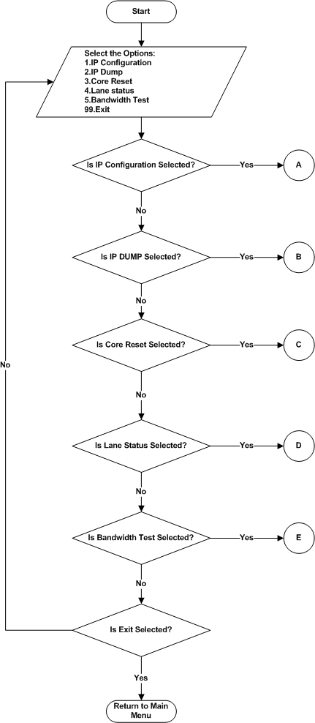
Figure 86 : 10G Test Menu

IP Configuration
Refer the section 2.1.4.8.1 and 2.2.2.8 for Module Decomposition and Data Decomposition.

Figure 87 : 10G Test – IP Configuration

IP Dump
Refer the section 2.1.4.8.2 and 2.2.2.8 for Module Decomposition and Data Decomposition.

Figure 88 : 10G Test – IP Dump

10G Core Reset
Refer the section 2.1.4.8.3 and 2.2.2.8 for Module Decomposition and Data Decomposition.

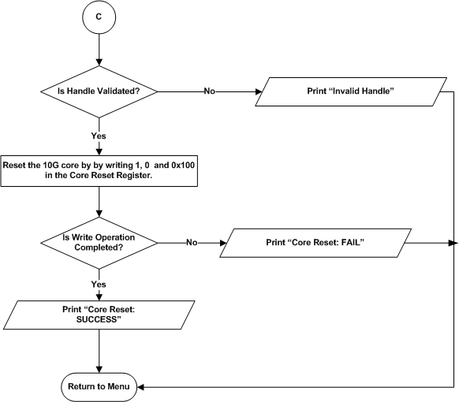

Figure 89 : 10G Test – Core Reset

10G Core Status
Refer the section 2.1.4.8.4 and 2.2.2.8 for Module Decomposition and Data Decomposition.
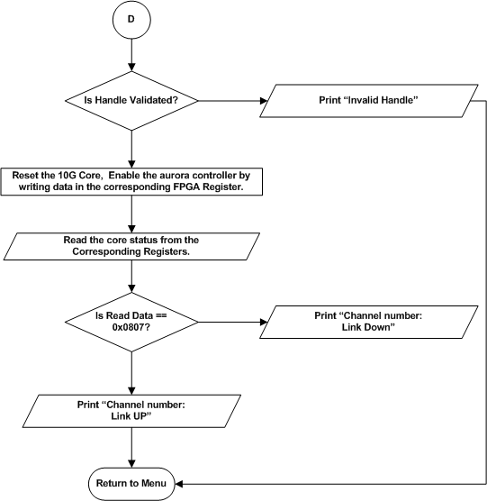

Figure 90 : 10G Test – Core Status

10G Bandwidth Test
Refer the section 2.1.4.8.5 and 2.2.2.8 for Module Decomposition and Data Decomposition.
- Refer section 5.1.2.6.3 for flow chart of Bandwidth Test.

Bandwidth Reset
Refer the section 2.1.4.8.5.1 and 2.2.2.8 for Module Decomposition and Data Decomposition.
- Refer section 5.1.2.6.3.1 for flow chart of Bandwidth Reset.

Bandwidth Tx
Refer the section 2.1.4.8.5.2 and 2.2.2.8 for Module Decomposition and Data Decomposition.
- Refer section 5.1.2.6.3.2 for flow chart of Bandwidth Tx.

Bandwidth Rx
Refer the section 2.1.4.8.5.3 and 2.2.2.8 for Module Decomposition and Data Decomposition.
- Refer section 5.1.2.6.3.3 for flow chart of Bandwidth Rx.

ADM (PL)

Voltage Monitoring Test
Refer the section 2.1.4.9 and 2.2.2.9 for Module Decomposition and Data Decomposition.
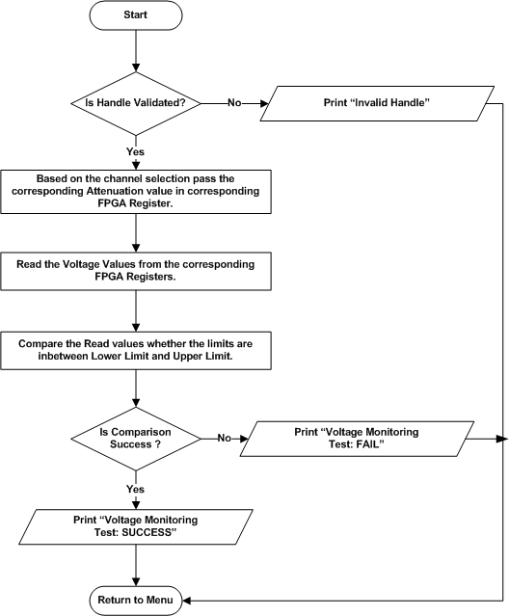

Figure 91 : Voltage Monitoring Test

UART (PL) Test
Refer the section 2.1.4.10 and 2.2.2.10 for Module Decomposition and Data Decomposition.

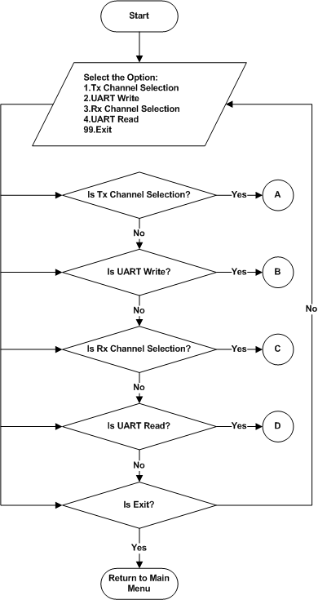
Figure 92 : UART (PL) Test Menu

UART Tx Channel Selection
Refer the section 2.1.4.10.1 and 2.2.2.10 for Module Decomposition and Data Decomposition.

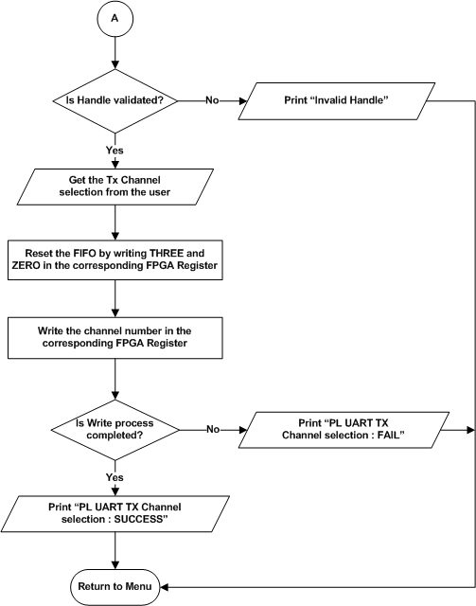
Figure 93 : UART (PL) Test – Tx Channel Selection

UART Write
Refer the section 2.1.4.10.2 and 2.2.2.10 for Module Decomposition and Data Decomposition.

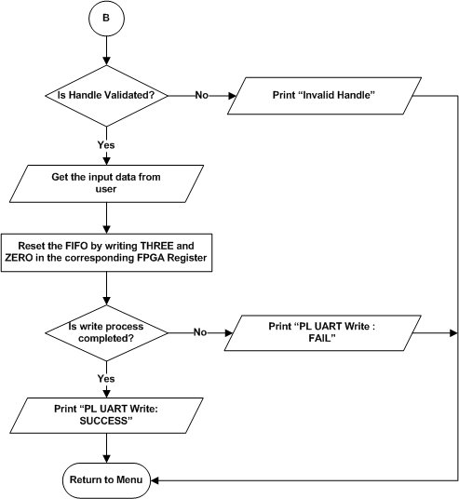

Figure 94 : UART (PL) Test – UART Write

UART Rx Channel Selection
Refer the section 2.1.4.10.3 and 2.2.2.10 for Module Decomposition and Data Decomposition.

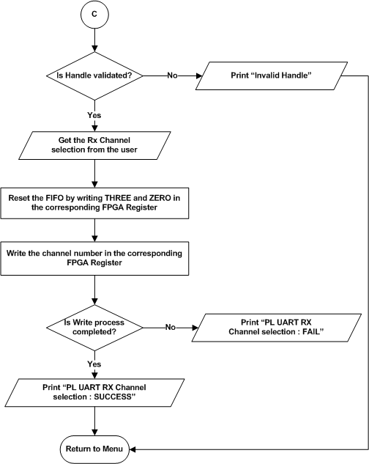
Figure 95 : UART (PL) Test – Rx Channel Selection

UART Read
Refer the section 2.1.4.10.4 and 2.2.2.10 for Module Decomposition and Data Decomposition.

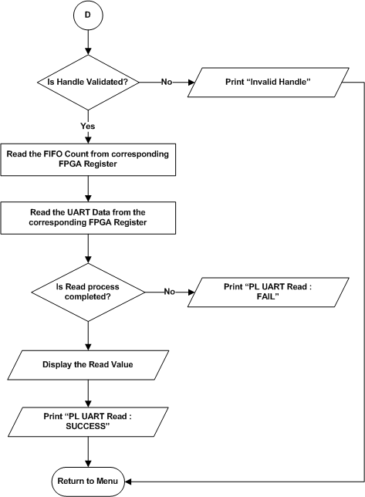
Figure 96 : UART (PL) Test – UART Read

IO Test Cases
Refer the section 2.1.4.11 and 2.2.2.11 for Module Decomposition and Data Decomposition.

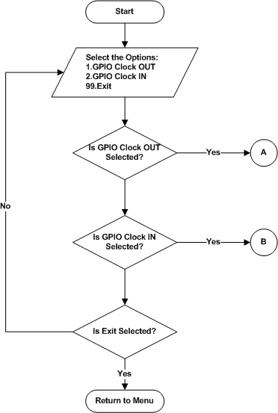
Figure 97 : IO Test Menu

GPIO Clock OUT
Refer the section 2.1.4.11.1 and 2.2.2.11 for Module Decomposition and Data Decomposition.

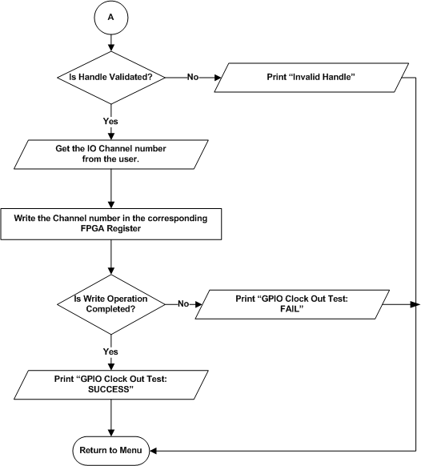
Figure 98 : IO Test – GPIO Clock OUT

GPIO Clock IN
Refer the section 2.1.4.11.2 and 2.2.2.11 for Module Decomposition and Data Decomposition.
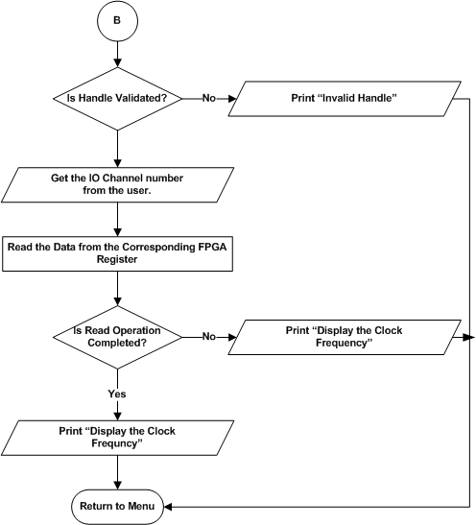

Figure 99 : IO Test – GPIO Clock IN

LVDS Test
Refer the section 2.1.4.12 and 2.2.2.12 for Module Decomposition and Data Decomposition.
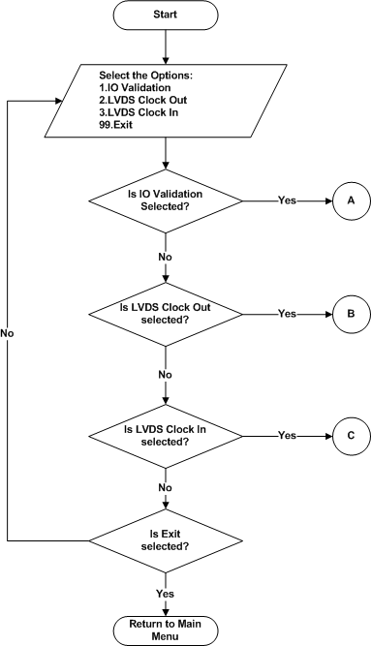

Figure 100 : LVDS Test Menu

IO Validation
Refer the section 2.1.4.12.1 and 2.2.2.12 for Module Decomposition and Data Decomposition.
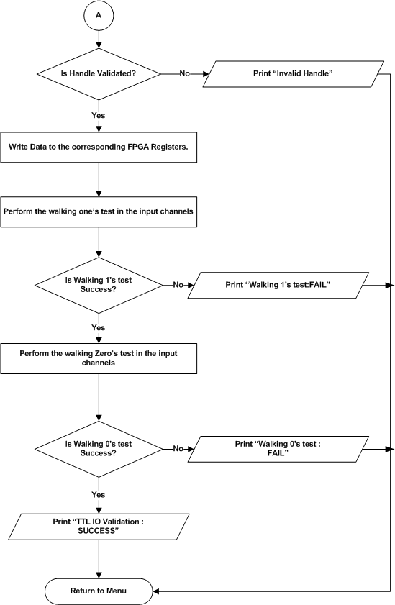
Figure 101 : LVDS Test – IO Validation

LVDS Clock OUT
Refer the section 2.1.4.12.2 and 2.2.2.12 for Module Decomposition and Data Decomposition.
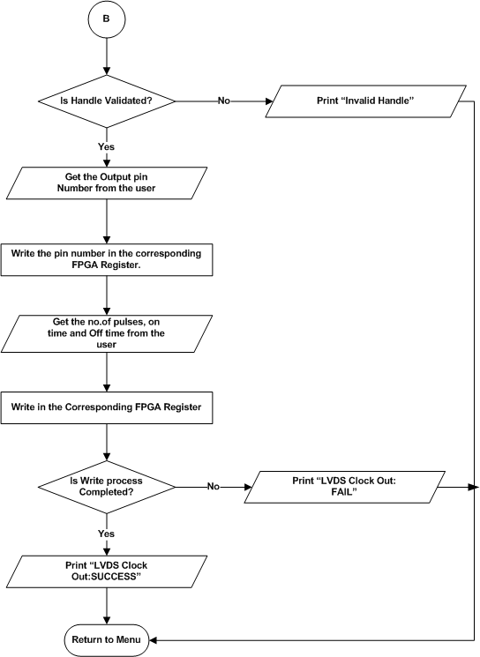
Figure 102 : LVDS Test – Clock OUT

LVDS Clock IN
Refer the section 2.1.4.12.3 and 2.2.2.12 for Module Decomposition and Data Decomposition.
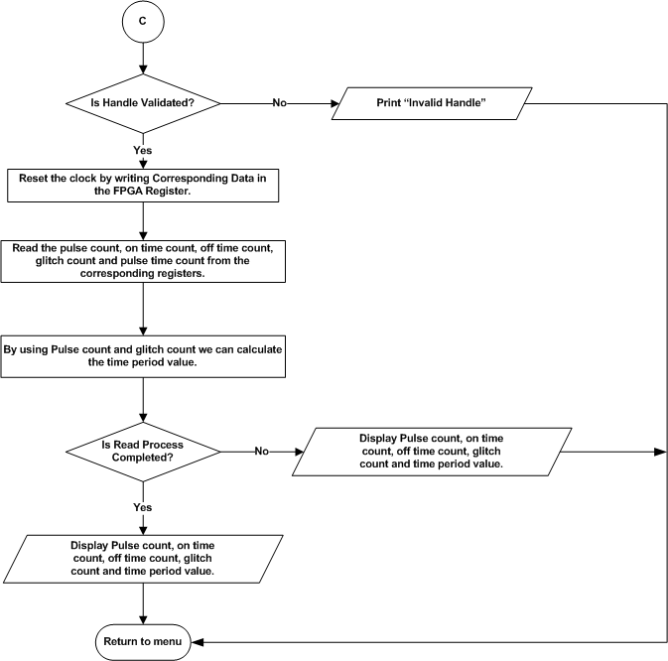
Figure 103 : LVDS Test – Clock IN

TTL Test
Refer the section 2.1.4.13 and 2.2.2.13 for Module Decomposition and Data Decomposition.
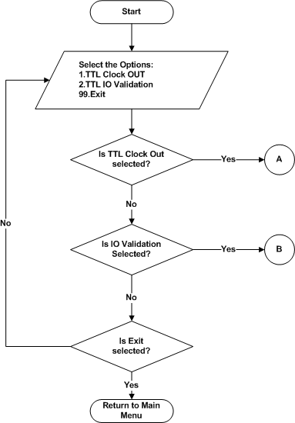

Figure 104 : TTL Test Menu

TTL Clock OUT
Refer the section 2.1.4.13.1 and 2.2.2.13 for Module Decomposition and Data Decomposition.
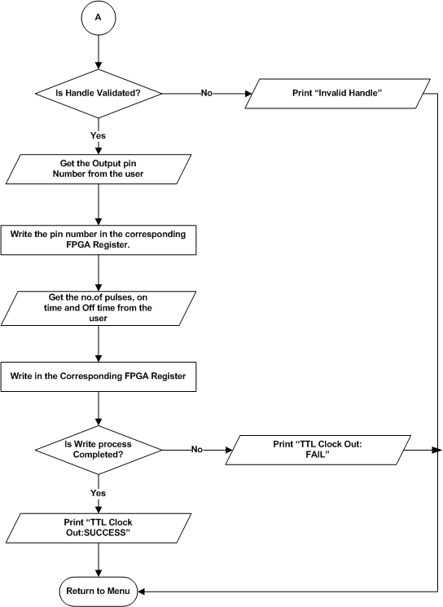

Figure 105 : LVDS Test – Clock OUT

TTL IO
Refer the section 2.1.4.13.2 and 2.2.2.13 for Module Decomposition and Data Decomposition.

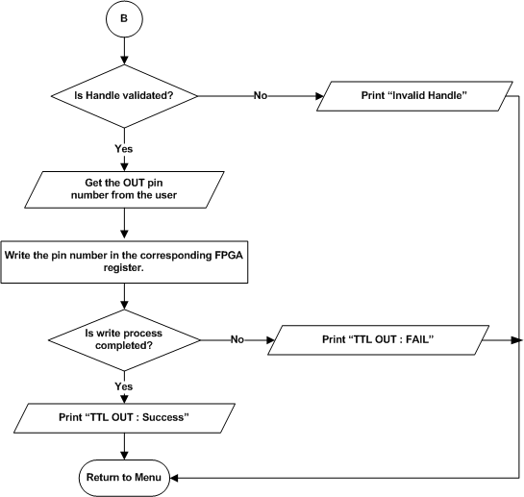
Figure 106 : LVDS Test – IO

Junction Temperature

Junction Temperature Read
Refer the section 2.1.4.14 and 2.2.2.14 for Module Decomposition and Data Decomposition.

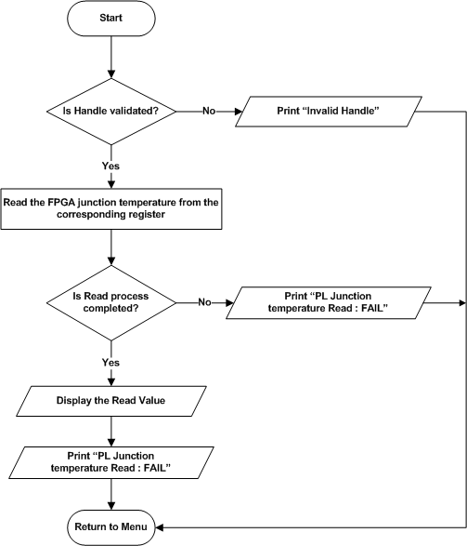
Figure 107 : Junction Temperature Read

PCIe Test
Refer the section 2.1.4.15 and 2.2.2.15 for Module Decomposition and Data Decomposition.

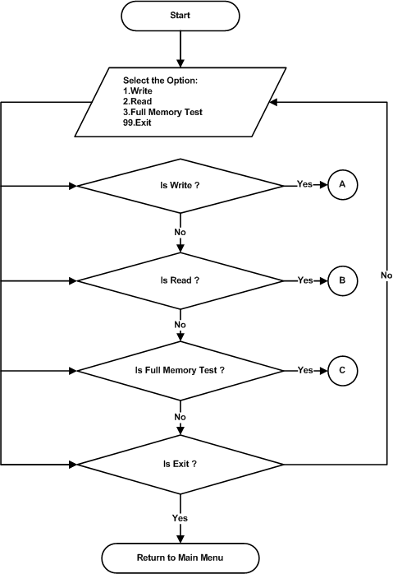

Figure 108 : PCIe Test Menu

PCIe Write
Refer the section 2.1.4.15.1 and 2.2.2.15 for Module Decomposition and Data Decomposition.

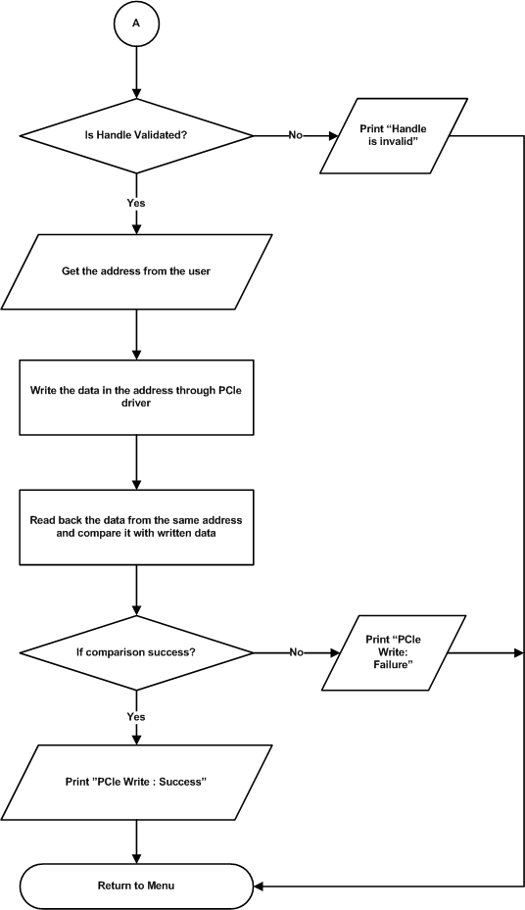

Figure 109 : PCIe Write

PCIe Read
Refer the section 2.1.4.15.2 and 2.2.2.15 for Module Decomposition and Data Decomposition.

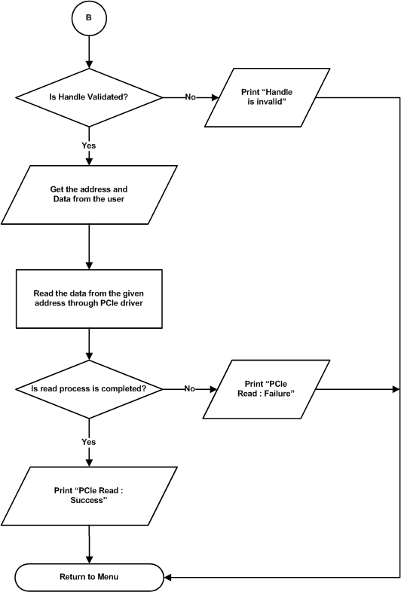

Figure 110 : PCIe Read

PCIe Full Memory Test
Refer the section 2.1.4.15.3 and 2.2.2.15 for Module Decomposition and Data Decomposition.

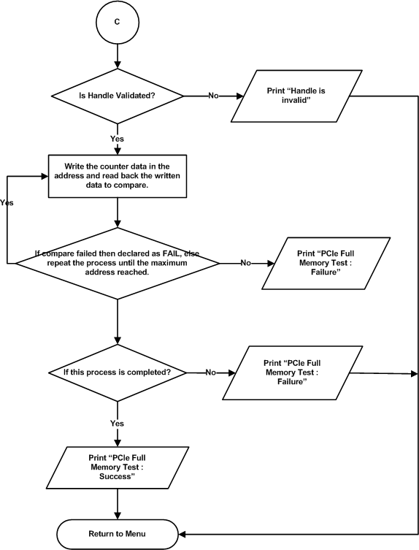
Figure 111 : PCIe Full Memory Test

Data Detailed Design

Board Information Data
- Board ID : DP-VPX-0227
- Hardware version : Current version of the hardware
- Software version : Current version of the Linux ATP Software
- Serial number of the board : Serial number given for the specific board
- DDR4 size : 4 GB
- User flash size : 128 MB
- NAND Flash size : 16 GB
- MRAM size : 4 Mb
- EEPROM size : 4 Kb

Requirements Traceability
Sl No. | Test Cases | Requirement ID in SRS | Section Number in SDD
1 | Processor Test | DP_VPX_0227_MANUAL_PS_PRCS | 2.1.3.1
1 | ALU Test | DP_VPX_0227_MANUAL_PS_PRCS_01 | 2.1.3.1.1
1 | FPU Test | DP_VPX_0227_MANUAL_PS_PRCS_02 | 2.1.3.1.2
2 | DDR4 Test | DP_VPX_0227_MANUAL_PS_DDR4 | 2.1.3.2
2 | Data bus Test | DP_VPX_0227_MANUAL_PS_DDR4_01 | 2.1.3.2.1
2 | Address bus Test | DP_VPX_0227_MANUAL_PS_DDR4_02 | 2.1.3.2.2
2 | Device Test | DP_VPX_0227_MANUAL_PS_DDR4_03 | 2.1.3.2.3
3 | EEPROM Test | DP_VPX_0227_MANUAL_PS_EEPROM | 2.1.3.3
3 | Upload Information Test | DP_VPX_0227_MANUAL_PS_EEPROM_01 | 2.1.3.3.1
3 | Data Retention Test | DP_VPX_0227_MANUAL_PS_EEPROM_02 | 2.1.3.3.2
3 | Checksum Test | DP_VPX_0227_MANUAL_PS_EEPROM_03 | 2.1.3.3.3
3 | Read/Write Test | DP_VPX_0227_MANUAL_PS_EEPROM_04 | 2.1.3.3.4
4 | MRAM Test | DP_VPX_0227_MANUAL_PS_MRAM | 2.1.3.4
4 | Upload Information Test | DP_VPX_0227_MANUAL_PS_MRAM_01 | 2.1.3.4.1
4 | Data Retention Test | DP_VPX_0227_MANUAL_PS_MRAM_02 | 2.1.3.4.2
4 | Checksum Test | DP_VPX_0227_MANUAL_PS_MRAM_03 | 2.1.3.4.3
4 | Full Memory Test | DP_VPX_0227_MANUAL_PS_MRAM_04 | 2.1.3.4.3
5 | NAND Test | DP_VPX_0227_MANUAL_PS_NAND | 2.1.3.5
5 | Upload Information Test | DP_VPX_0227_MANUAL_PS_NAND_01 | 2.1.3.5.1
5 | Data Retention Test | DP_VPX_0227_MANUAL_PS_NAND_02 | 2.1.3.5.2
5 | Checksum Test | DP_VPX_0227_MANUAL_PS_NAND_03 | 2.1.3.5.3
6 | NOR Test | DP_VPX_0227_MANUAL_PS_NOR | 2.1.3.6
6 | Upload Information Test | DP_VPX_0227_MANUAL_PS_NOR_01 | 2.1.3.6.1
6 | Data Retention Test | DP_VPX_0227_MANUAL_PS_NOR_02 | 2.1.3.6.2
6 | Checksum Test | DP_VPX_0227_MANUAL_PS_NOR_03 | 2.1.3.6.3
7 | USB Test | DP_VPX_0227_MANUAL_PS_USB | 2.1.3.7
7 | Read/Write Test | DP_VPX_0227_MANUAL_PS_USB_01 | 2.1.3.7.1
8 | SATA Test | DP_VPX_0227_MANUAL_PS_SATA | 2.1.3.8
8 | Read/Write Test | DP_VPX_0227_MANUAL_PS_SATA_01 | 2.1.3.8.1
9 | UART Test | DP_VPX_0227_MANUAL_PS_UART | 2.1.3.9
9 | Write Test | DP_VPX_0227_MANUAL_PS_UART_01 | 2.1.3.9.1
9 | Read Test | DP_VPX_0227_MANUAL_PS_UART_02 | 2.1.3.9.2
10 | Ethernet Test | DP_VPX_0227_MANUAL_PS_ETH | 2.1.3.10
10 | Ethernet ping Test | DP_VPX_0227_MANUAL_PS_ETH_01 | 2.1.3.10.1
11 | Temperature Sensor Test | DP_VPX_0227_MANUAL_PS_TEMPSNSR | 2.1.3.11
11 | Temperature Sensor Test | DP_VPX_0227_MANUAL_PS_TEMPSNSR_01 | 2.1.3.11.1
12 | RTC | DP_VPX_0227_MANUAL_PS_RTC | 2.1.3.12
12 | RTC Test | DP_VPX_0227_MANUAL_PS_RTC_01 | 2.1.3.12.1
13 | LMK04828 PLL | DP_VPX_0227_MANUAL_PL_LMK04828 PLL | 2.1.4.1
13 | File Configuration | DP_VPX_0227_MANUAL_PL_LMK04828 PLL_01 | 2.1.4.1.1
13 | File Dump | DP_VPX_0227_MANUAL_PL_LMK04828 PLL_02 | 2.1.4.1.2
13 | Single Write | DP_VPX_0227_MANUAL_PL_LMK04828 PLL_03 | 2.1.4.1.3
13 | Single Read | DP_VPX_0227_MANUAL_PL_LMK04828 PLL_04 | 2.1.4.1.4
14 | AFE7906 ADC | DP_VPX_0227_MANUAL_PL_AFE7906_ADC | 2.1.4.2
14 | AFE Core Reset | DP_VPX_0227_MANUAL_PL_AFE7906_ADC_01 | 2.1.4.2.1
14 | AFE Single Write | DP_VPX_0227_MANUAL_PL_AFE7906_ADC_02 | 2.1.4.2.2
14 | AFE Single Read | DP_VPX_0227_MANUAL_PL_AFE7906_ADC_03 | 2.1.4.2.3
14 | AFE Bringup | DP_VPX_0227_MANUAL_PL_AFE7906_ADC_04 | 2.1.4.2.4
14 | AFE Core Initialization | DP_VPX_0227_MANUAL_PL_AFE7906_ADC_05 | 2.1.4.2.5
14 | JESD Bond status | DP_VPX_0227_MANUAL_PL_AFE7906_ADC_06 | 2.1.4.2.6
14 | ADC Sync | DP_VPX_0227_MANUAL_PL_AFE7906_ADC_07 | 2.1.4.2.7
14 | ADC Band Selection | DP_VPX_0227_MANUAL_PL_AFE7906_ADC_08 | 2.1.4.2.8
14 | ADC Data Logging | DP_VPX_0227_MANUAL_PL_AFE7906_ADC_09 | 2.1.4.2.9
14 | HD2 Coefficient Write | DP_VPX_0227_MANUAL_PL_AFE7906_HD2_01 | 2.1.4.2.10.1
14 | HD2 Coefficient Read | DP_VPX_0227_MANUAL_PL_AFE7906_HD2_02 | 2.1.4.2.10.2
14 | Dynamic Configuration | DP_VPX_0227_MANUAL_PL_AFE7906_ADC_DYNAMIC | 2.1.4.2.12
14 | Automation | DP_VPX_0227_MANUAL_PL_AFE7906_ADC_AUTOMATION | 2.1.4.2.13
15 | Digital Attenuation | DP_VPX_0227_MANUAL_PL_AFE7906_DA | 2.1.4.3
15 | Attenuation Write | DP_VPX_0227_MANUAL_PL_AFE7906_DA | 2.1.4.3.1
15 | Attenuation Read | DP_VPX_0227_MANUAL_PL_AFE7906_DA | 2.1.4.3.2
16 | DDR4 (PL) Test | DP_VPX_0227_MANUAL_PL_DDR4 | 2.1.4.4
16 | Data bus test | DP_VPX_0227_MANUAL_PL_DDR4_01 | 2.1.4.4.1
16 | Address bus test | DP_VPX_0227_MANUAL_PL_DDR4_02 | 2.1.4.4.2
16 | Device test | DP_VPX_0227_MANUAL_PL_DDR4_03 | 2.1.4.4.3
16 | Full Memory test | DP_VPX_0227_MANUAL_PL_DDR4_04 | 2.1.4.4.4
17 | NOR Flash (PL) test | DP_VPX_0227_MANUAL_PL_NORFLASH | 2.1.4.5
17 | Device ID | DP_VPX_0227_MANUAL_PL_NORFLASH_01 | 2.1.4.5.1
17 | Chip erase | DP_VPX_0227_MANUAL_PL_NORFLASH_02 | 2.1.4.5.3
17 | Sector erase | DP_VPX_0227_MANUAL_PL_NORFLASH_03 | 2.1.4.5.2
17 | Single write | DP_VPX_0227_MANUAL_PL_NORFLASH_04 | 2.1.4.5.4
17 | Single read | DP_VPX_0227_MANUAL_PL_NORFLASH_05 | 2.1.4.5.5
17 | Page write | DP_VPX_0227_MANUAL_PL_NORFLASH_06 | 2.1.4.5.5
17 | Page read | DP_VPX_0227_MANUAL_PL_NORFLASH_07 | 2.1.4.5.7
17 | Full memory test | DP_VPX_0227_MANUAL_PL_NORFLASH_08 | 2.1.4.5.8
18 | RGMII test | DP_VPX_0227_MANUAL_PL_RGMII | 2.1.4.6
18 | RGMII IP Configuration | DP_VPX_0227_MANUAL_PL_RGMII_01 | 2.1.4.6.1
18 | RGMII IP Dump | DP_VPX_0227_MANUAL_PL_RGMII_02 | 2.1.4.6.2
18 | Bandwidth Reset | DP_VPX_0227_MANUAL_PL_RGMII_03_01 | 2.1.4.6.3.1
18 | Bandwidth Tx | DP_VPX_0227_MANUAL_PL_RGMII_03_02 | 2.1.4.6.3.2
18 | Bandwidth Rx | DP_VPX_0227_MANUAL_PL_RGMII_03_03 | 2.1.4.6.3.3
19 | Aurora Test | DP_VPX_0227_MANUAL_PL_AURORA | 2.1.4.7
19 | Aurora Core Reset | DP_VPX_0227_MANUAL_PL_AURORA_01 | 2.1.4.7.1
19 | Aurora Lane Status | DP_VPX_0227_MANUAL_PL_AURORA_02 | 2.1.4.7.2
19 | Aurora Bandwidth Reset | DP_VPX_0227_MANUAL_PL_AURORA_03_01 | 2.1.4.7.3.1
19 | Aurora Bandwidth Tx | DP_VPX_0227_MANUAL_PL_AURORA_03_02 | 2.1.4.7.3.2
19 | Aurora Bandwidth Rx | DP_VPX_0227_MANUAL_PL_AURORA_03_03 | 2.1.4.7.3.3
20 | 10G Test | DP_VPX_0227_MANUAL_PL_10G | 2.1.4.8
20 | 10G IP Configuration | DP_VPX_0227_MANUAL_PL_10G_01 | 2.1.4.8.1
20 | 10G IP Dump | DP_VPX_0227_MANUAL_PL_10G_02 | 2.1.4.8.2
20 | 10G Core Reset | DP_VPX_0227_MANUAL_PL_10G_03 | 2.1.4.8.3
20 | 10G Core Status | DP_VPX_0227_MANUAL_PL_10G_04 | 2.1.4.8.4
20 | 10G Bandwidth Reset | DP_VPX_0227_MANUAL_PL_10G_05_01 | 2.1.4.8.5.1
20 | 10G Bandwidth Tx | DP_VPX_0227_MANUAL_PL_10G_05_02 | 2.1.4.8.5.2
20 | 10G Bandwidth Rx | DP_VPX_0227_MANUAL_PL_10G_05_03 | 2.1.4.8.5.3
21 | ADM (PL) | DP_VPX_0227_MANUAL_PL_ADM | 2.1.4.9
21 | Voltage Monitoring Test | DP_VPX_0227_MANUAL_PL_ADM_01 | 2.1.4.9.1
22 | PL UART | DP_VPX_0227_MANUAL_PL_UART | 2.1.4.10
22 | Uart Tx Selection | DP_VPX_0227_MANUAL_PL_UART_01 | 2.1.4.10.1
22 | UART Write | DP_VPX_0227_MANUAL_PL_UART_02 | 2.1.4.10.2
22 | UART Rx Selection | DP_VPX_0227_MANUAL_PL_UART_03 | 2.1.4.10.3
22 | UART Read | DP_VPX_0227_MANUAL_PL_UART_04 | 2.1.4.10.4
23 | GPIO Clock Test | DP_VPX_0227_MANUAL_PL_GPIO_CLOCK | 2.1.4.11
23 | GPIO Clock OUT | DP_VPX_0227_MANUAL_PL_GPIO_CLOCK_01 | 2.1.4.11.1
23 | GPIO Clock IN | DP_VPX_0227_MANUAL_PL_GPIO_CLOCK_01 | 2.1.4.11.2
24 | LVDS IO Test | DP_VPX_0227_MANUAL_PL_LVDS_IO | 2.1.4.12
24 | LVDS IO Validation | DP_VPX_0227_MANUAL_PL_LVDS_IO_01 | 2.1.4.12.1
24 | LVDS Clock OUT | DP_VPX_0227_MANUAL_PL_LVDS_IO_02 | 2.1.4.12.2
24 | LVDS Clock IN | DP_VPX_0227_MANUAL_PL_LVDS_IO_02 | 2.1.4.12.3
25 | TTL IO Test | DP_VPX_0227_MANUAL_PL_TTL_IO | 2.1.4.13
25 | TTL Clock OUT | DP_VPX_0227_MANUAL_PL_TTL_IO_01 | 2.1.4.13.1
25 | TTL IO Validation | DP_VPX_0227_MANUAL_PL_TTL_IO_02 | 2.1.4.13.2
26 | Junction Temperature | DP_VPX_0227_MANUAL_PL_JUNC_TEMP | 2.1.4.14
26 | Junction Temperature Read | DP_VPX_0227_MANUAL_PL_JUNC_TEMP_01 | 2.1.4.14.1
27 | PCIe Test | DP_VPX_0227_MANUAL_PL_PCIe_Test | 2.1.4.15
27 | PCIe Write | DP_VPX_0227_MANUAL_PL_PCIe_01 | 2.1.4.15.1
27 | PCIe Read | DP_VPX_0227_MANUAL_PL_PCIe_02 | 2.1.4.15.2
27 | PCIe Full Memory Test | DP_VPX_0227_MANUAL_PL_PCIe_03 | 2.1.4.15.3

Appendix A
Structure Name : _SDPVPX0227_Command_Header
Member Name | Type | Description
m_uiHeader | Unsigned int | It indicates the test case Id for performing the respective test case operations.  DPVPX0227_HDR_HOST_CMD = 0x40510C3D,  DPVPX0227_HDR_TRGT_RSP = 0x1B610859
m_ucGroupID | Unsigned Char | It refers the selected test mode such as ADC Automation and Phase Matching.  DPVPX0227_GID_ADC = 0,  DPVPX0227_GID_ADC_PHASE_MATCH = 1
m_ucTestID | Unsigned Char | It indicates the test case Id for performing the respective test case operations .  DPVPX0227_TID_ADC_AUTOMATION = 0,  DPVPX0227_TID_ADC_PHASE_MATCH = 1,  DPVPX0227_TID_ADC_GAIN_MATCH = 2,  DPVPX0227_TID_ADC_SET_DEFAULT = 3

Structure Name : _SDPVPX0227_Command_Packet
Member Name | Type | Description
m_SHeader | SDPVPX0227_Command_Header | It refers the fixed value for data integrity.
m_usDataSz | Unsigned Short | It refers the Size of the data.
m_arrcData | Char | It refers the Array of Buffer data.
m_ucCheckSum | Unsigned Char | It refers the Checksum of this packet to identify the data loss.

Structure Name : _SDPVPX0227_Response_Packet
Member Name | Type | Description
m_SHeader | SDPVPX0227_Command_Header | It refers the fixed value for data integrity.
m_usDataSz | Unsigned Short | It refers the Size of the data.
m_arrcData | Char | It refers the Array of Buffer data.
m_cMsgStatus | Char | It refers the Status of the command packet.
m_ucCheckSum | Unsigned Char | It refers the Checksum of this packet to identify the data loss.

Structure Name : _SDPVPX0227_PL_RFADC_GET_DATA_LOG_IN
Member Name | Type | Description
m_uiChannelNo | Unsigned Int | It refers the Channel number of ADC.
m_uiSamplingCount | Unsigned Int | It refers the Sampling Count for ADC.

Structure Name : _SDPVPX0227_PL_RFADC_BRAM_OPS_OUT
Member Name | Type | Description
m_uiTestStatus | Unsigned Int | It refers the Test Status of Current Operation.
m_iErrorCode | Int | It refers the Error Code of Current Operation
m_carrCurrentOperation | Char | It refers the Current Operation name
m_carrErrorMsg | Char | It refers the Error Message of Current Operation

Structure Name : _SDPVPX0227_Err
Member Name | Type | Description
m_iGrpId | Int | It refers the Group ID of Current Operation
m_iTstId | Int | It refers the Test ID of Current Operation
m_iTestSts | Int | It refers the Test Status of Current Operation
m_iErrorCode | Int | It refers the Error Code of Current Operation
m_carrErrorMsg | Char | It refers the Error Message of Current Operation
m_carrCurrentOperation | Char | It refers the Current Operation name

Appendix B
Description for Phase Matching Buttons:

Set Default :
This Button is used to write the default values of Attenuation(AGC, CAL and MSTC) in their corresponding FPGA Registers through Target Application.

Get Data :
This Button is used to get the Non-Calibrated values and their Phase Angle and Fundamental Power of each channels in ADC through Target Application.

Calibrate Phase :
This Button is used to Export the Phase Difference of the ADC channels in Log file. This File contains Phase Matching values of All ADC Channels.

Measure Phase Difference :
This Button is used to get Calibrated values and their Phase Angle and Fundamental Power of each channels in ADC.

Calibrate Gain :
This Button is used to get minimal gain value of fundamental power and apply that to all channel’s CAL attenuation register through Target, and Log the minimal values of all channels in a file.

Gain From File :
This Button is used to apply the gain values from the file to the CAL registers through Target.

