SOFTWARE DESIGN DOCUMENT
FOR
3U VPX Zynq MPSoC with 6 Channels 14-bit 0.02 to 2GHZ I/P 3GSPS AFE7906 based Digital Receiver Module

DOCUMENT TITLE | SOFTWARE DESIGN DOCUMENT FOR 3U VPX Zynq MPSoC with 6 Channels 14-bit 0.02 to 2GHZ I/P 3GSPS AFE7906 based Digital Receiver Module DP-VPX-0233
DOCUMENT REFERENCE | DP-VPX-0233-V1-01-SDD-0V07
VERSION NUMBER | 0.07
VERSION DATE | February 17, 2026
PREPARED BY | Name: Magima V M  Sign:
DOCUMENT REVIEW BY | Name: Gowthami V  Sign:
TECHNICAL REVIEW BY | Name: Kingshuk Mitra  Sign:
PROCESS REVIEW BY | Name: Gowthami V  Sign:
APPROVED BY | Name:  Sign:

Copyright @ (2025) by Data Patterns
All right reserved. These materials are proprietary to Data Patterns and no part of these materials should be reproduced, published in any form by any means, electronic or mechanical including photocopy or any information storage or retrieval system nor should the materials be disclosed to third parties without the written authorization of Data Patterns.

Revision History

S. NO. | VER. NO. | VER. DATE | CHANGED BY | SECTION (S) CHANGED | DESCRIPTION  OF CHANGE
1 | 0V01 | 03/11/2025 | Magima V M | - | Initial Version
2 | 0V02 | 21/04/2025 | Magima V M | Section 2.1, 2.2, 2.1.4.1.5 ,Section 5.2 , Appendix A , B | Internal Comments closed with DP-VPX-0233-SDG-SRR-0V04
3 | 0V03 | 02/05/2025 | Gowthami V | Section 2.2.1.14 , 2.2.2.4 , 2.2.2.5 | DRB Comments closed with DP-VPX-0233-SDG-SRR-0V05
4 | 0V04 | 10/07/2025 | Magima V M | Section 2.1.4.1.6 , 2.1.4.3.7 , 2.1.4.4.4 , 5.1.2.1.6 , 5.1.2.3.7 , 5.1.2.4.4 | QC Comments closed with DP-VPX-0233-SDG-SRR-0V06
5 | 0V05 | 22/07/2025 | Magima V M | Section 5.1.2.3.7 | DRB Comments closed with DP-VPX-0233-SDG-SRR-0V06
6 | 0V06 | 15/12/2025 | Gowthami V ,  Magima V M | Section 2.1 , 2.2 , 5.1 | DRB Comments for TPR Documents closed with DP-VPX-0233-SDG-SRR-0V07
7 | 0V07 | 17/02/2026 | Magima V M | Section 2.1.1.4.2.11 , 5.1.1.2.2.11 | New requirement closed with DP-VPX-0233-SDG-SRR-0V08

Table of Contents
1 Introduction 14
1.1 Purpose 14
1.2 Scope 14
1.3 Definitions, Acronyms, and Abbreviations 15
1.4 References 16
1.5 Document Overview 16
2 Decomposition Description 17
2.1 Module Decomposition 17
2.1.1 DPVPX0233 Module 17
2.1.1.1 Test Configuration 17
2.1.1.2 Test Performance 18
2.1.1.3 Processing Section 19
2.1.1.3.1 Processor test 19
2.1.1.3.1.1 ALU Test 19
2.1.1.3.1.2 FPU Test 20
2.1.1.3.2 DDR4 Test 21
2.1.1.3.2.1 Data Bus Test 21
2.1.1.3.2.2 Address Bus Test 22
2.1.1.3.2.3 Device Test 22
2.1.1.3.3 EEPROM Test 23
2.1.1.3.3.1 Upload Board Information 23
2.1.1.3.3.2 Data Retention Test 23
2.1.1.3.3.3 Checksum Test 24
2.1.1.3.3.4 Read/Write Test 24
2.1.1.3.4 MRAM Test 24
2.1.1.3.4.1 Upload Board Information 24
2.1.1.3.4.2 Data Retention Test 25
2.1.1.3.4.3 Checksum Test 25
2.1.1.3.4.4 Full Memory Test 25
2.1.1.3.5 NAND Flash Test 25
2.1.1.3.5.1 Upload Board Information 25
2.1.1.3.5.2 Data Retention Test 26
2.1.1.3.5.3 Check Sum Test 26
2.1.1.3.6 NOR Flash Test 26
2.1.1.3.6.1 Upload Board Information test 26
2.1.1.3.6.2 Data Retention Test 26
2.1.1.3.6.3 Check Sum Test 26
2.1.1.3.7 USB Test 27
2.1.1.3.7.1 Read/Write test 27
2.1.1.3.8 SATA Test 28
2.1.1.3.8.1 Read/Write test 28
2.1.1.3.9 UART Test 28
2.1.1.3.9.1 Write test 28
2.1.1.3.9.2 Read Test 29
2.1.1.3.10 Ethernet Test 29
2.1.1.3.10.1 Ethernet Ping test 29
2.1.1.3.11 RTC test 30
2.1.1.3.12 PCI Enumeration Test 30
2.1.1.3.13 Temperature sensor test 31
2.1.1.3.14 Voltage Monitoring test 31
2.1.1.4 Programmable Logic 32
2.1.1.4.1 LMK PLL Test 32
2.1.1.4.1.1 File Configuration 32
2.1.1.4.1.2 File Dump 32
2.1.1.4.1.3 Single Data Write 33
2.1.1.4.1.4 Single Data Read 33
2.1.1.4.1.5 PLL Lock Status 33
2.1.1.4.1.6 Sysref Enable/Disable 34
2.1.1.4.1.6.1 Sysref Enable 34
2.1.1.4.1.6.2 Sysref Disable 34
2.1.1.4.2 AFE7906 ADC Test 34
2.1.1.4.2.1 AFE Core Reset 34
2.1.1.4.2.2 AFE Single Write 35
2.1.1.4.2.3 AFE Single Read 35
2.1.1.4.2.4 AFE Bring up 35
2.1.1.4.2.5 AFE Core Initialization 36
2.1.1.4.2.6 JESD Bond status 36
2.1.1.4.2.7 ADC Data Logging 36
2.1.1.4.2.8 HD2 Correction Enable 37
2.1.1.4.2.8.1 HD2 Coefficient Write 37
2.1.1.4.2.8.2 HD2 Coefficient Read 37
2.1.1.4.2.9 NCO Update 38
2.1.1.4.2.9.1 All Channel Enable 38
2.1.1.4.2.9.2 Single Channel Enable 38
2.1.1.4.2.9.3 All Channel Disable 39
2.1.1.4.2.9.4 Single Channel Disable 39
2.1.1.4.2.10 ADC Dynamic Configuration 39
2.1.1.4.2.10.1 Device Health Status 40
2.1.1.4.2.10.2 Update Rx NCO 40
2.1.1.4.2.10.3 Set Rx DSA 40
2.1.1.4.2.10.4 Update Fb NCO 41
2.1.1.4.2.10.5 Set Fb DSA 41
2.1.1.4.2.10.6 Read Rx NCO 41
2.1.1.4.2.10.7 Read Fb NCO 41
2.1.1.4.2.11 Band Selection 41
2.1.1.4.2.12 ADC Automation 42
2.1.1.4.2.12.1 Host Application 42
2.1.1.4.2.12.2 Target Application 42
2.1.1.4.3 LVTTL Test 43
2.1.1.4.3.1 IO Mode Test 43
2.1.1.4.3.2 Clock Mode Test 43
2.1.1.4.3.3 Manual IO Mode Test 44
2.1.1.4.3.4 Manual Clock Mode Test 44
2.1.1.4.3.4.1 Manual Clock ON Test 44
2.1.1.4.3.4.2 Manual Clock OFF Test 45
2.1.1.4.4 LVDS Test 45
2.1.1.4.4.1 IO Mode Test 45
2.1.1.4.4.2 Clock Mode Test 46
2.1.1.4.4.3 Manual Mode Test 46
2.1.1.4.5 GPI/GPO Test 46
2.1.1.4.5.1 IO Mode Test 47
2.1.1.4.6 UART(PL) Test 47
2.1.1.4.6.1 Write test 47
2.1.1.4.6.2 Read Test 48
2.1.1.4.7 DDR4(PL) Test 48
2.1.1.4.7.1 DDR4 Reset 48
2.1.1.4.7.2 Full memory test 49
2.1.1.4.7.3 Data bus test 49
2.1.1.4.7.4 Address Bus Test 49
2.1.1.4.7.5 Device Test 49
2.1.1.4.8 10G Ethernet Test 50
2.1.1.4.8.1 Lane Repeater Configuration 50
2.1.1.4.8.2 Core Reset 50
2.1.1.4.8.3 Ethernet Reset 50
2.1.1.4.8.4 Network Configuration 51
2.1.1.4.8.5 Transmit Data 51
2.1.1.4.8.6 Receiver Packet Summary 51
2.1.2 DPSPL1255 Module 52
2.1.2.1 Test Performance 52
2.1.2.2 Programmable Logic 52
2.1.2.2.1 LMK PLL Test 52
2.1.2.2.1.1 File Configuration 52
2.1.2.2.1.2 File Dump 52
2.1.2.2.1.3 Single Data Write 52
2.1.2.2.1.4 Single Data Read 52
2.1.2.2.1.5 PLL Lock Status 53
2.1.2.2.2 RFDAC Test 53
2.1.2.2.2.1 File Write 53
2.1.2.2.2.2 File Read 53
2.1.2.2.2.3 Single Data Write 54
2.1.2.2.2.4 Single Data Read 54
2.1.2.2.2.5 Power Level Transmission 54
2.1.2.2.2.6 RFDAC Data Transmission 54
2.1.2.2.2.7 RFDAC Reset 55
2.1.3 DPSPL1276 Module 55
2.1.3.1 Programmable Logic 55
2.1.3.1.1 LMK PLL Test 55
2.1.3.1.1.1 File Configuration 55
2.1.3.1.1.2 File Dump 56
2.1.3.1.1.3 Single Data Write 56
2.1.3.1.1.4 Single Data Read 56
2.1.3.1.1.5 PLL Lock Status 56
2.1.3.1.2 RFDAC Test 56
2.1.3.1.2.1 File Write 56
2.1.3.1.2.2 File Read 56
2.1.3.1.2.3 Single Data Write 56
2.1.3.1.2.4 Single Data Read 56
2.1.3.1.2.5 Power Level Transmission 56
2.1.3.1.2.6 RFDAC Data Transmission 56
2.1.3.1.2.7 RFDAC Reset 56
2.2 Data Decomposition 57
2.2.1 DPVPX0233 Module 57
2.2.1.1 Processing Section 57
2.2.1.1.1 Processor Test 57
2.2.1.1.2 DDR Test 58
2.2.1.1.3 EEPROM Test 58
2.2.1.1.4 MRAM Test 59
2.2.1.1.5 NAND Flash Test 59
2.2.1.1.6 NOR Flash Test 60
2.2.1.1.7 USB Test 60
2.2.1.1.8 SATA Test 60
2.2.1.1.9 UART Test 61
2.2.1.1.10 Ethernet Test 61
2.2.1.1.11 RTC Test 61
2.2.1.1.12 PCI Enumeration Test 62
2.2.1.1.13 Temperature Sensor Test 62
2.2.1.1.14 Voltage Monitoring Test 62
2.2.1.2 Programmable Logic 63
2.2.1.2.1 LMK PLL Test 63
2.2.1.2.2 AFE7906 Test 64
2.2.1.2.3 LVTTL Test 64
2.2.1.2.4 LVDS Test 64
2.2.1.2.5 GPI GPO Test 65
2.2.1.2.6 UART (PL) Test 65
2.2.1.2.7 DDR4 (PL) Test 65
2.2.1.2.8 10G Ethernet Test 66
2.2.2 DPSPL1255 Module 66
2.2.2.1 Programmable Logic 66
2.2.2.1.1 LMK PLL Test 66
2.2.2.1.2 RFDAC Test 66
2.2.3 DPSPL1276 Module 67
2.2.3.1 Programmable Logic 67
2.2.3.1.1 LMK PLL Test 67
2.2.3.1.2 RFDAC Test 67
2.3 Process Decomposition 67
3 Dependency Description 69
3.1 Module Dependencies 69
3.1.1 DEPENDENCY BETWEEN THE MODULES “TEST CONFIGURATION” AND “TEST PERFORMANCE”: 69
3.2 Data Dependencies 69
3.3 Process Dependencies 69
3.3.1 DEPENDENCY BETWEEN THE PROCESS ‘USER INPUT’ AND ‘INPUT PROCESSING’ : 69
3.3.2 DEPENDENCY BETWEEN THE PROCESS 'INPUT PROCESSING' AND 'TEST RESULT' : 69
4 Interface Description 70
4.1 Module Interface 70
4.2 Process Interface 70
5 Detailed Design 71
5.1 Module Detailed Design 71
5.1.1 DPVPX0233 Module 71
5.1.1.1 Processing Section 71
5.1.1.1.1 Processor Test 71
5.1.1.1.1.1 ALU Test 72
5.1.1.1.1.2 FPU Test 74
5.1.1.1.2 DDR4 Test 75
5.1.1.1.2.1 Data Bus Test 76
5.1.1.1.2.2 Address Bus Test 77
5.1.1.1.2.3 Device Test 78
5.1.1.1.3 EEPROM Test 79
5.1.1.1.3.1 Upload Board Information Test 80
5.1.1.1.3.2 Data Retention Test 81
5.1.1.1.3.3 Checksum Test 82
5.1.1.1.3.4 Read/Write Test 83
5.1.1.1.4 MRAM Test 84
5.1.1.1.4.1 Upload Board Information test 85
5.1.1.1.4.2 Data Retention test 85
5.1.1.1.4.3 Checksum Test 85
5.1.1.1.4.4 Full Memory test 86
5.1.1.1.5 NAND Flash Test 87
5.1.1.1.5.1 Upload Board Information test 88
5.1.1.1.5.2 Data Retention Test 88
5.1.1.1.5.3 Checksum Test 88
5.1.1.1.5.4 NOR Flash Test 89
5.1.1.1.5.5 Upload Board Information test 90
5.1.1.1.5.6 Data Retention Test 90
5.1.1.1.5.7 Checksum Test 90
5.1.1.1.6 USB Test 91
5.1.1.1.6.1 Read / Write Test 91
5.1.1.1.7 SATA Test 92
5.1.1.1.7.1 Read / Write Test 92
5.1.1.1.8 UART Test 92
5.1.1.1.8.1 Write Test 93
5.1.1.1.8.2 Read Test 94
5.1.1.1.9 Ethernet Test 95
5.1.1.1.9.1 Ethernet ping Test 96
5.1.1.1.10 RTC 97
5.1.1.1.11 PCI Enumeration Test 98
5.1.1.1.12 Temperature Sensor Test 99
5.1.1.1.13 Voltage Monitoring Test 100
5.1.1.2 Programmable Logic 101
5.1.1.2.1 LMK PLL Test 101
5.1.1.2.1.1 File Configuration 102
5.1.1.2.1.2 File Dump 103
5.1.1.2.1.3 Single Data Write 104
5.1.1.2.1.4 Single Data Read 105
5.1.1.2.1.5 PLL Lock Status 106
5.1.1.2.1.6 Sysref Enable/Disable 107
5.1.1.2.1.6.1 Sysref Enable 108
5.1.1.2.1.6.2 Sysref Disable 109
5.1.1.2.2 AFE7096 ADC Test 110
5.1.1.2.2.1 AFE Core Reset 111
5.1.1.2.2.2 AFE Single Write 112
5.1.1.2.2.3 AFE Single Read 113
5.1.1.2.2.4 AFE Bring up 114
5.1.1.2.2.5 AFE Core Initialization 115
5.1.1.2.2.6 JESD Bond Status 116
5.1.1.2.2.7 Data Logging 117
5.1.1.2.2.8 HD2 Correction Enable 118
5.1.1.2.2.8.1 HD2 Coefficient Write 119
5.1.1.2.2.8.2 HD2 Coefficient Read 120
5.1.1.2.2.9 NCO Update 121
5.1.1.2.2.9.1 NCO Enable menu 122

5.1.1.2.2.9.1.1 All Channel Enable 123

5.1.1.2.2.9.1.2 Single Channel Enable 124
5.1.1.2.2.9.2 NCO Disable menu 125

5.1.1.2.2.9.2.1 All Channel Disable 126

5.1.1.2.2.9.2.2 Single Channel Disable 127
5.1.1.2.2.10 AFE Dynamic Configuration 128
5.1.1.2.2.10.1 Device Health Status 129
5.1.1.2.2.10.2 Update Rx NCO 130
5.1.1.2.2.10.3 Set Rx DSA 131
5.1.1.2.2.10.4 Update Fb NCO 132
5.1.1.2.2.10.5 Set Fb DSA 132
5.1.1.2.2.10.6 Read Fb NCO 132
5.1.1.2.2.10.7 Read Rx NCO 133
5.1.1.2.2.11 Band Selection 134
5.1.1.2.3 LVTTL Test 135
5.1.1.2.3.1 IO Mode Test 136
5.1.1.2.3.2 Clock Mode Test 138
5.1.1.2.3.3 Manual IO Mode Test 139
5.1.1.2.3.3.1 Manual Clock Mode Test 140

5.1.1.2.3.3.1.1 Manual Clock ON Test 141

5.1.1.2.3.3.1.2 Manual Clock OFF Test 142
5.1.1.2.4 LVDS Test 143
5.1.1.2.4.1 IO Mode Test 144
5.1.1.2.4.2 Clock Mode Test 146
5.1.1.2.4.3 Manual Mode Test 147
5.1.1.2.5 GPI/GPO Test 148
5.1.1.2.5.1 IO Mode Test 149
5.1.1.2.6 UART Test 151
5.1.1.2.6.1 UART Read 152
5.1.1.2.6.2 UART write 153
5.1.1.2.7 DDR4(PL) Test 154
5.1.1.2.7.1 DDR4 Reset 155
5.1.1.2.7.2 Full Memory Test 156
5.1.1.2.7.3 Data Bus Test 157
5.1.1.2.7.4 Address Bus Test 157
5.1.1.2.7.5 Device Test 157
5.1.1.2.8 10G Ethernet Test 158
5.1.1.2.8.1 Lane Repeater Configuration 159
5.1.1.2.8.2 Core Reset 160
5.1.1.2.8.3 Ethernet Reset 161
5.1.1.2.8.4 Network Configuration 162
5.1.1.2.8.5 Transmit Data 163
5.1.1.2.8.6 Receiver Packet Summary 164
5.1.2 DPSPL1255 Module 165
5.1.2.1 Programmable Logic 165
5.1.2.1.1 LMK PLL Test 165
5.1.2.1.1.1 File Configuration 165
5.1.2.1.1.2 File Dump 165
5.1.2.1.1.3 Single Data Write 165
5.1.2.1.1.4 Single Data Read 165
5.1.2.1.1.5 PLL Lock Status 165
5.1.2.1.2 RFDAC Test 166
5.1.2.1.2.1 File Write 167
5.1.2.1.2.2 File Read 168
5.1.2.1.2.3 Single Data Write 170
5.1.2.1.2.4 Single Data Read 171
5.1.2.1.2.5 Power Level Transmission 172
5.1.2.1.2.6 RFDAC Data Transmission 173
5.1.2.1.2.7 RFDAC Reset 174
5.1.3 DPSPL1276 Module 175
5.1.3.1 Programmable Logic 175
5.1.3.1.1 LMK PLL Test 175
5.1.3.1.1.1 File Configuration 175
5.1.3.1.1.2 File Dump 175
5.1.3.1.1.3 Single Data Write 175
5.1.3.1.1.4 Single Data Read 175
5.1.3.1.1.5 PLL Lock Status 175
5.1.3.1.2 RFDAC Test 175
5.1.3.1.2.1 File Write 175
5.1.3.1.2.2 File Read 175
5.1.3.1.2.3 Single Data Write 175
5.1.3.1.2.4 Single Data Read 176
5.1.3.1.2.5 Power Level Transmission 176
5.1.3.1.2.6 RFDAC Data Transmission 176
5.1.3.1.2.7 RFDAC Reset 176
5.2 Data Detailed Design 177
5.2.1 Board Information Data 177
6 Requirements Traceability 178
Appendix A 182
Appendix B 183

Introduction
This Software Design Document (SDD) describes the test application software design for DP-VPX-0233 module. This document uses the software requirement specification of DP-VPX-0233 to understand the hardware qualification requirements and to develop the application.

Purpose
The purpose of this document to describe the detailed software design of application to validate DP-VPX-0233 module through console application. This document will assist the software developer in understanding the software design and also act as a guide to develop the software in terms of implementation. The design will reflect the requirements mentioned in the Software Requirements Specification (SRS) document and will be mapped with the requirement ID's for better understanding.

Table 1 :Entities involved in Test Application
Identification Number | DP-VPX-0233-V1-01-SDD-0V07
Title | SOFTWARE DESIGN DOCUMENT FOR 3U VPX Zynq MPSoC with 6 Channels 14-bit 0.02 to 2GHZ I/P 3GSPS AFE7906 based Digital Receiver Module DP-VPX-0233
Version Number | 0.07
Abbreviation | SDD (Software Design Document)

Scope
The scope of the document was able to understanding detailed information about DP-VPX-0233 components. This document is to describe design details in order to make a software developer to understand the design perspective of test cases of the module and validating the peripheral devices of the modules.

Definitions, Acronyms, and Abbreviations

Table 2: List of Acronyms and Abbreviations
ATP | Acceptance Test Plan
UART | Universal Asynchronous Receiver Transmitter
DDR | Double Data Rate
PCI | Peripheral Component Interconnect
SRS | Software Requirement Specification
HRS | Hardware Requirement Specification
RTC | Real Time Clock
MRAM | Magneto-resistive Random Access Memory
UART | Universal Asynchronous Receiver Transmitter
USB | Universal Synchronous Bus
SATA | Serial Advanced Technology Attachment
RAM | Random Access Memory
EEPROM | Electrically Erasable Programmable Read-Only Memory
JTAG | Joint Test Action Group
FPGA | Field Programmable Gate Array
SPI | Serial Peripheral Interface
PLL | Phase Locked Loop
RF | Radio Frequency
IF | Intermediate Frequency
ADC | Analog to Digital Converter
DAC | Digital to Analog Converter
LVTTL | Low Voltage Transistor to Transistor Logic
LVDS | Low Voltage Differential Signalling
GPI/GPO | General Purpose Input / Output
NCO | Numerically Controlled Oscillator Frequency
DSA | Digital Step Attenuator

References
Table 3: Reference Documents
S. No | Document | Board | Reference
 | SRS | DP-VPX-0233 | DP-VPX-0233-V1-01-SRS-0V05
 | SDD | Common | DP-COMMON-SDG-SDD(ATP-ATE)-0V05-DRAFT

Document Overview
Section 1: Describes the introduction about this SDD document.

Section 2: Describes the decomposition description of the ATP software.

Section 3: Describes the dependency description between the modules, processes and data.

Section 4: Describes the interface description of the modules and process.

Section 5: Describes the detailed design of the module and data.

Section 6: Describes the requirement traceability.

Decomposition Description
The design specification is mainly decomposed as follows:

- Test Configuration
- Test Performance

- Test Configuration
The test configuration effectively includes the configuration of the ATP test cases which describes the Manual / Auto mode test cases selection condition and test specific inputs from user. These test configuration details are stored in a file to be used for further performance of the test procedure with the same configuration details specific to the target processor.

- Test Performance
The requirement of the test performance is to perform Manual /Auto mode test cases that are enabled by the user using the test configuration. Only the selected test cases will be executed.

Module Decomposition

DPVPX0233 Module

Test Configuration
The Test configuration is further decomposed as follows:
- Auto Mode Test Selection
- Manual Mode Test Selection
- Test Specific Details

- Auto Mode Test Selection:
This test configuration is to enable/disable the Auto Mode test cases to be performed for the target processor.

- Manual Mode Test Selection:
This test configuration is to enable/disable the Manual Mode test cases to be performed for the target processor.

- Test Specific Details
This includes the test inputs specific to the enabled test cases in either or both of Auto /Manual mode test case.

Test Performance
The Test Performance is further decomposed into the following modules:
- Manual Mode Test Performance
- Auto Mode Test Performance

- Manual Mode Test Performance
The requirement of the Manual mode test performance is to perform the manual mode test cases that are enabled by the user using the test configuration. The selected test cases will be displayed in the manual mode test case menu and can be selected to perform the particular test.

- Auto Mode Test Performance
The requirement of the Auto mode test performance is to perform the auto mode test cases that are enabled by the user using the test configuration. Only the selected test cases will be executed for the number of cycles specified by the user.

The Module Decomposition are as follows:
- Processing Section
- Processor test
- DDR4 test
- EEPROM test
- MRAM test
- NOR Flash Test
- NAND Flash test
- USB test
- SATA test
- UART test
- Ethernet test
- RTC
- Temperature sensor test
- Voltage monitoring test
- PCI Enumeration test
- Programmable Logic
- LMK PLL test
- AFE7906 ADC test
- DDR4 test
- 10G Ethernet test
- UART test
- LVTTL test
- LVDS test
- GPI&GPO test

Processing Section
This Section will hold the module decomposition for the Processing section.

Processor test

This test shall be performed to qualify the ALU and FPU in the processor board by carrying out the following test cases. Refer the section 2.2.1.1.1 and 5.1.1.1.1 for Data decomposition and Flowchart.

ALU Test
- Refer the section 5.1.1.1.1.1 for Flowchart.

Requirement ID | DP_VPX_0233_MANUAL_PS_PRCS_01
Design Details | - In Addition test, two constant decimal numbers are added that are expected for the defined result. If the actual result is not equal to the expected result then print “Arithmetic addition operation: Failed” along with the expected and actual data, else continue to subtraction test  - In Subtraction test, two constant decimal numbers are subtracted that are expected for the defined result. If the actual result is not equal to the expected result then print “Arithmetic subtraction operation: Failed” along with the expected and actual data, else continue to Multiplication test.  - In Multiplication test, two constant decimal numbers are multiplied that are expected for the defined result. If the actual result is not equal to the expected result then print “Arithmetic Multiplication operation: Failed” along with the expected and actual data, else continue to Division test.  - In Division test, two constant decimal numbers are divided that are expected for the defined result. If the actual result is not equal to the expected result then print “Arithmetic Division operation : Failed” along with the expected and actual data, else continue to Left shift test.  - In Left Shift test, the value is left shifted by and expected for the defined result If the actual result is not equal to the expected result then print “Left shift operation: Failed” along with the expected and actual data, else continue to Right shift test.  - In Left Shift test, the value is right shifted by and expected for the defined result. If the actual result is not equal to the expected result then print “Right shift operation: Failed” along with the expected and actual data, else continue to AND test  - In AND test, the value is logical AND by and expected for the defined result. If the actual result is not equal to the expected result then print “Logical AND operation: Failed” along with the expected and actual data, else continue to OR test  - In OR test, the value is logical OR by and expected for the defined result. If the actual result is not equal to the expected result then print “Logical OR operation: Failed” along with the expected and actual data, else continue to NOT test.  - In NOT test, the value is logical NOT performed on the value and expected for the defined result.. If the actual result is not equal to the expected result then print “Logical OR operation: Failed” along with the expected and actual data, else print “ALU Test : Success” and then return.

FPU Test

- Refer the section 5.1.1.1.1.2 for Flowchart.

Requirement ID | DP_VPX_0233_MANUAL_PS_PRCS_02
Design Details | - In Floating point addition test, two constant decimal numbers are added that are expected for the defined result. If the actual result is not equal to the expected result then print “Floating point addition: Failed” along with the expected and actual data, else continue to floating point subtraction test.  - In Floating point subtraction test, two constant decimal numbers are subtracted that are expected for the defined result. If the actual result is not equal to the expected result then print “Floating point subtraction : Failed” along with the expected and actual data, else continue to floating point multiplication test.  - In Floating point multiplication test, two constant decimal numbers are multiplied that are expected for the defined result. If the actual result is not equal to the expected result then print “Floating point multiplication: Failed” along with the expected and actual data, else continue to floating point division test.  - In Floating point division test, two constant decimal numbers are divided that are expected for the defined result. If the actual result is not equal to the expected result then print “Floating point division: Failed” along with the expected and actual data, else print “FPU test : Success” and then return.

DDR4 Test
This test shall be perform to qualify the DDR4 by carrying out to perform the following test cases. Refer the section 2.2.1.1.2 and 5.1.1.1.2 for Data decomposition and Flowchart.

Data Bus Test

- Refer the section 5.1.1.1.2.1 for Flowchart.

Requirement ID | DP_VPX_0233_MANUAL_PS_DDR4_01
Design Details | - Perform memory walking ones test by shifting data to the left and writing 1 bit at a time until you reach 64th bit, read data from the same memory location.  - If write data and read data are not same print “Walking one’s test : Failed” along with the address ,expected and actual data. Else perform the walking zero’s test ,  - Perform memory walking zeros test by complement and shifting data to the left and writing 1 bit at a time until you reach 64 bits, read data from the same memory location.  - If write data and read data are not same print “Walking zero’s test : Failed” along with the address ,expected and actual data. Else print “Data bus test : Success” and then return.

Address Bus Test
- Refer the section 5.1.1.1.2.2 for Flowchart.

Requirement ID | DP_VPX_0233_MANUAL_PS_DDR4_02
Design Details | - PATTERN data will be written in allocated memory of a particular size, ANTIPATTERN data will be written to the base address. Read all address values.  - Check if the content of all the address except base address is PATTERN. If its content is not equal to PATTERN, then print “Pattern test : Failed” along with the offset, actual and excepted data. Else reinitialize the base address with PATTERN.  - ANTIPATTERN data will be written to memory of a particular size. Read all address values.  - Check if the content of all the address except base address is a ANTIPATTERN. If its content is not equal to ANTIPATTERN, then If content is not equal to PATTERN, then print “Anti Pattern test : Failed” along with the offset, actual and excepted data. Else print the “Address bus test: Success”.

Device Test
- Refer the section 5.1.1.1.2.3 for Flowchart.

Requirement ID | DP_VPX_0233_MANUAL_PS_DDR4_03
Design Details | - Write 64 bit incremental counter data to allocated memory of a certain size.  - Read the data from first memory location and check for previously written data, If both are not same then print “Increment counter test: Failed” along with the offset, expected data and actual data.  - Else write the inverted incremental counter data to the same location. Repeat this sequence for all memory location until the maximum size is reached.  - Read the data from first memory location and check the previously written inverted data. If both are not same then print “Inverted counter test: Failed” along with the offset, expected data and actual data.  - Else the print “Device test : Success” and then return.

EEPROM Test
This test shall be performed to qualify the EEPROM device by carrying out the following test cases. Refer the section 2.2.1.1.3 and 5.1.1.1.3 for Data decomposition and Flowchart.

Upload Board Information
- Refer the section 5.1.1.1.3.1 for Flowchart.

Requirement ID | DP_VPX_0233_MANUAL_PS_EEPROM_01
Design Details | - Write the board information data to the device.  - Read board information from the device which was already written in the EEPROM.  - Compare the read data with the board information data which is stored in the board information structure.  - If both are not same then print “Upload board information Failed” along with structure field, excepted and actual data, else print “Upload board information : Success” and then return.  Note: Upload Board Information Test shall be done only once in a board.

Data Retention Test
- Refer the section 5.1.1.1.3.2 for Flowchart.

Requirement ID | DP_VPX_0233_MANUAL_PS_EEPROM_02
Design Details | - Read the board signature from the device.  - Compare the read data with the Board info which is stored in the board information structure.  - If both are not same then print “Data Retention : Failed” along with the excepted and actual Board ID, else print “Data Retention : Success” and then return  Note: The system need to verify the data retention test after restart.

Checksum Test
- Refer the section 5.1.1.1.3.3 for Flowchart.

Requirement ID | DP_VPX_0233_MANUAL_PS_EEPROM_03
Design Details | - Read the previously written data from a fixed area of the device and calculate the checksum from the read data omitting checksum field.  - Compare the calculated checksum with the checksum field in the read board information structure.  - If both are not same then print “Checksum : Failed” along with the excepted and actual Checksum, else print “Checksum : Success” and then return.

Read/Write Test

- Refer the section 5.1.1.1.3.4 for Flowchart.

Requirement ID | DP_VPX_0233_MANUAL_PS_EEPROM_04
Design Details | - Get the address, location number and entry pattern from the user.  - Write the data to the memory locations specified in the device.  - Read the data from the same location in the device, compare the data. If both are not same then the print “Read/Write : Failed” along with excepted and actual data, Else print the “Read/ Write : Success” and then return.

MRAM Test
This test shall be performed to qualify the MRAM device by carrying out the following test cases. Refer the section 2.2.1.1.4 and 5.1.1.1.4 for Data decomposition and Flowchart.

Upload Board Information
- Refer the section 5.1.1.1.4.1 for Flowchart.

Requirement ID | DP_VPX_0233_MANUAL_PS_MRAM_01
Design Details | Refer the Section 2.1.1.3.3.1

Data Retention Test
- Refer the section 5.1.1.1.4.2 for Flowchart.

Requirement ID | DP_VPX_0233_MANUAL_PS_MRAM_02
Design Details | Refer the Section 2.1.1.3.3.2

Checksum Test
- Refer the section 5.1.1.1.4.3 for Flowchart.

Requirement ID | DP_VPX_0233_MANUAL_PS_MRAM_03
Design Details | Refer the Section 2.1.1.3.3.3

Full Memory Test

- Refer the section 5.1.1.1.4.4 for Flowchart.

Requirement ID | DP_VPX_0233_MANUAL_PS_MRAM_04
Design Details | - Write the counter data to the all memory location except the board information location.  - Read the counter data from the memory locations.  - Compare the write and read data from the device.  - If both are not same then print “Full memory test : Failed” along with the excepted and actual data, else print “Full memory test : Success” and then return.

NAND Flash Test
This test shall be performed to qualify the data flash device by carrying out the following test cases. Refer the section 2.2.1.1.5 and 5.1.1.1.5 for Data decomposition and Flowchart.

Upload Board Information
- Refer the section 5.1.1.1.5.1 for Flowchart.

Requirement ID | DP_VPX_0233_MANUAL_PS_NAND_01
Design Details | Refer the Section 2.1.1.3.3.1

Data Retention Test
- Refer the section 5.1.1.1.5.2 for Flowchart.

Requirement ID | DP_VPX_0233_MANUAL_PS_NAND_02
Design Details | Refer the Section 2.1.1.3.3.2

Check Sum Test
- Refer the section 5.1.1.1.5.3 for Flowchart.

Requirement ID | DP_VPX_0233_MANUAL_PS_NAND_03
Design Details | Refer the Section 2.1.1.3.3.3

NOR Flash Test
This test shall be performed to qualify the user flash device by carrying out the following test cases. Refer the section 2.2.1.1.6 and 5.1.1.1.5.4 for Data decomposition and Flowchart.

Upload Board Information test
- Refer the section 5.1.1.1.5.5 for Flowchart.

Requirement ID | DP_VPX_0233_MANUAL_PS_NOR_01
Design Details | Refer the Section 2.1.1.3.3.1

Data Retention Test
- Refer the section 5.1.1.1.5.6 for Flowchart.

Requirement ID | DP_VPX_0233_MANUAL_PS_NOR_02
Design Details | Refer the Section 2.1.1.3.3.2

Check Sum Test
- Refer the section 5.1.1.1.5.7 for Flowchart.
Requirement ID | DP_VPX_0233_MANUAL_PS_NOR_03
Design Details | Refer the Section 2.1.1.3.3.3

USB Test

This test shall be performed to qualify the USB port by carrying out the following test cases. Refer the section 2.2.1.1.7 and 5.1.1.1.6 for Data decomposition and Flowchart.

Read/Write test

- Refer the section 5.1.1.1.6.1 for Flowchart.

Requirement ID | DP_VPX_0233_MANUAL_PS_USB_01
Design Details | - Get the device name / mount path (e.g sda1, sdb1) to be tested from the user.  - Mount the device (if required, based on the OS/firmware) through the standard OS command  - Create a file in mounted device.  - If file creation failed then print “CREATE AND OPEN FILE FAILED”.  - Else write the sample data and close the file.  - Re-open the file and read the data from the file.  - Verify the read data with the previously written data.  - If both are not same then print “DATA NOT MATCHING” along with the expected and actual data.  - Else delete the file created on the device.  - Check whether the file is deleted or not.  - If the file is not deleted then then print “DELETE FILE FAILED” else print “READ / WRITE TEST PASSED”.  - Unmount the device and then return.  Note : A text file with name “USBTest.txt“ will be created for this test.

SATA Test
This test shall be performed to qualify the SATA interface by carrying out the following case. Refer the section 2.2.1.1.8 and 5.1.1.1.7 for Data decomposition and Flowchart.

Read/Write test

- Refer the section 5.1.1.1.7.1 for Flowchart.

Requirement ID | DP_VPX_0233_MANUAL_PS_SATA_01
Design Details | Refer the Section 2.1.1.3.7.1

UART Test

This test shall be performed to qualify the UART module by carrying out the following test cases. Refer the section 2.2.1.1.9 and 5.1.1.1.8 for Data decomposition and Flowchart.

Write test

- Refer the section 5.1.1.1.8.1 for Flowchart.

Requirement ID | DP_VPX_0233_MANUAL_PS_UART_01
Design Details | - Select the COM port to be tested.  - Get the Baud rate, number of stop bits and parity from user.  - Ask the user whether you want to enter the data or not.  - If yes, get the data to transmit from user else use fixed data of 256bytes.  - Open the COM port with selected baud rate, number of stop bits and parity.  - Ensure that the external system's COM port is configured with same baud rate and parity.  - Send the data to the external system.  - If Data Sent is same as the data received at the external system then consider it as Success  Note: Using the Docklite software to test the UART module.

Read Test

- Refer the section 5.1.1.1.8.2 for Flowchart.

Requirement ID | DP_VPX_0233_MANUAL_PS_UART_02
Design Details | - Select the COM port to be tested.  - Get the Baud rate, number of stop bits and parity from user.  - Open the COM port with selected baud rate, number of stop bits and parity.  - Ensure that the external system's COM port is configured with same baud rate and parity.  - Send the data From the external system.  - If Data received is same as the data sent from the external system then consider it as Success  Note: Using the Docklite software to test the UART module.

Ethernet Test

This test shall be performed to qualify the Ethernet module and optical transceiver by carrying out the following test cases. Refer the section 2.2.1.1.10 and 5.1.1.1.9 for Data decomposition and Flowchart.

Ethernet Ping test
- Refer the section 5.1.1.1.9.1 for Flowchart.

Requirement ID | DP_VPX_0233_MANUAL_PS_ETHERNET_01
Design Details | - Get the IP Address and the number of times to ping the IP address from the user.  - Ping the IP address using standard OS command. Set the target IP address ping up to the number of times specified by the user.  - If data is sent and received not Successfully, then print “Ethernet ping test : Failed” else print “Ethernet Ping test : Success” and then return.

RTC test

This test shall be performed to qualify the RTC device. Refer the section 2.2.1.1.11 and 5.1.1.1.10 for data decomposition and flowchart.

Requirement ID | DP_VPX_0233_MANUAL_PS_RTC
Design Details | - Get the date and time from the user.  - Set the entered date and time to the RTC.  - Wait for 8 seconds.  - Read the date and time from RTC.  - Print the values and compare the values with the expected date and time with +/-1 second tolerance.  - If the values matches then print “RTC TEST PASSED” else print “RTC TEST FAILED”.

PCI Enumeration Test

This test shall be performed to qualify the PCI interface. Refer the section 2.2.1.1.12 and 5.1.1.1.11 for data decomposition and flowchart.

Requirement ID | DP_VPX_0233_MANUAL_PS_PCI
Design Details | - Get the Vendor ID, Device ID and Device count of devices to be enumerated from the user.  - Enumerate all the PCI devices available on the board.  - Compare the enumerated devices with the expected devices.  - Print all the matched device.  - Print all the new device (if any).  - If all the expected devices are enumerated then print “PCI ENUMERATION TEST PASSED” else print “PCI ENUMERATION TEST FAILED”.

Temperature sensor test
This test shall be performed to qualify the temperature sensor. Refer the section 2.2.1.1.13 and 5.1.1.1.12 for Data decomposition and Flowchart.

Requirement ID | DP_VPX_0233_MANUAL_PS_TEMPSNSR
Design Details | - Open the temperature sensor device, Set the lower and upper limits of local [ -10 to 70 ] and external temperature to the device [ -10 to 70 ].  - Mentioned limits are write in the device, Get the lower and upper limit of local and external temperature from the device.  - Get the current local and external temperature from the device.  - Check whether the read temperature values are between the upper and lower limit.  - If the temperatures are not within the defined limit then print “Temperature Sensor test : Failed” else print “Temperature Sensor test : Success”.

Voltage Monitoring test
This test shall be performed to report the ADM input channel voltages of processor. Refer the section 2.2.1.1.14 and 5.1.1.1.13 for Data decomposition and Flowchart.

Requirement ID | DP_VPX_0233_MANUAL_PS_ADM
Design Details | - Get the upper and lower limits for all channels from the file and read the ADM input channel from processor.  - Display the read voltages limits on the console.  - Check whether the read voltages within the user given limits,  - If voltages are not in the given limits then print “Voltage Monitoring test : Failed” else print “Voltage Monitoring test : Success”.  Note: The voltage limits are given in a ADM limit file “dpvpx0233_adm_limits.txt”.

Programmable Logic
This Section will hold the module decomposition for the Programmable logic section.

LMK PLL Test

This test shall be performed to qualify the LMK PLL Test. Refer the section 2.2.1.2.1 and 5.1.1.2.1 for Data decomposition and Flowchart.

File Configuration

- Refer the section 5.1.1.2.1.1 for Flowchart.

Requirement ID | DP_VPX_0233_MANUAL_PL_LMK_PLL_01
Design Details | - Validate the Handle.  - Get the configuration file name from the user.  - Check whether the file is present or not.  - Read Data from the configuration file.  - Write Data to the corresponding FPGA Registers.  - If File write process completed then the test case is declared as Success, else it declared as Failure.

File Dump
- Refer the section 5.1.1.2.1.2 for Flowchart.

Requirement ID | DP_VPX_0233_MANUAL_PL_LMK_PLL_02
Design Details | - Validate the Handle.  - Get the configuration file name from the user.  - Check whether the file is present or not.  - Read Data from the corresponding FPGA Registers and store it in the Output file.  - If File Read process completed, then the test case is declared as Success, else it declared as Failure.

Single Data Write

- Refer the section 5.1.1.2.1.3 for Flowchart.

Requirement ID | DP_VPX_0233_MANUAL_PL_LMK_PLL_03
Design Details | - Validate the Handle.  - Get the address and Data from the user.  - Write the Data and Address in the corresponding FPGA Registers.  - If write was completed then the test case is declared as Success, else it declared as Failure.

Single Data Read

- Refer the section 5.1.1.2.1.4 for Flowchart.

Requirement ID | DP_VPX_0233_MANUAL_PL_LMK_PLL_04
Design Details | - Validate the Handle.  - Get the address from the user.  - Read the Data from the Corresponding FPGA Read register.  - If Read was completed then the test case is declared as Success, else it declared as Failure.

PLL Lock Status

- Refer the section 5.1.1.2.1.5 for Flowchart.

Requirement ID | DP_VPX_0233_MANUAL_PL_LMK_PLL_05
Design Details | - Validate the Handle.  - Read lock status from the corresponding PLL status register.  - If the read data is equal to 0x30 , then the test case is declared as Success, else it declared as Failure.

Sysref Enable/Disable

- Refer the section 5.1.1.2.1.6 for Flowchart.

Sysref Enable

- Refer the section 5.1.1.2.1.6.1 for Flowchart.
Requirement ID | DP_VPX_0233_MANUAL_PL_LMK_PLL_06_01
Design Details | - Validate the Handle.  - Write Data 0x15 in the corresponding register.  - If the write process completed, then the test case is declared as Success, else it declared as Failure.

Sysref Disable

- Refer the section 5.1.1.2.1.6.2 for Flowchart.
Requirement ID | DP_VPX_0233_MANUAL_PL_LMK_PLL_06_02
Design Details | - Validate the Handle.  - Write Data 0x5 in the corresponding register.  - If the write process completed, then the test case is declared as Success, else it declared as Failure.

AFE7906 ADC Test

The purpose of this test is to qualify the AFE7906 ADC by carrying out the following test cases.
Refer the section 2.2.1.2.2 and 5.1.1.2.2 for data decomposition and flowchart.

AFE Core Reset
- Refer the section 5.1.1.2.2.1 for Flowchart.
Requirement ID | DP_VPX_0233_MANUAL_PL_AFE7906_ADC_01
Design Details | - Validate the Handle.  - Reset the AFE chip by writing 1 and 0 in the corresponding FPGA Registers.  - If Reset was Completed then the test case is declared as Success, else it declared as Failure.

AFE Single Write
- Refer the section 5.1.1.2.2.2 for Flowchart.

Requirement ID | DP_VPX_0233_MANUAL_PL_AFE7906_ADC_02
Design Details | - Validate the Handle.  - Get the address and Data from the user.  - Write the Data and Address in the corresponding FPGA Registers.  - If write was completed then the test case is declared as Success, else it declared as Failure.

AFE Single Read
- Refer the section 5.1.1.2.2.3 for Flowchart.
Requirement ID | DP_VPX_0233_MANUAL_PL_AFE7906_ADC_03
Design Details | - Validate the Handle.  - Get the address from the user.  - Read the Data from the Corresponding FPGA Read register.  - If Read was completed then the test case is declared as Success, else it declared as Failure.

AFE Bring up

- Refer the section 5.1.1.2.2.4 for Flowchart.
Requirement ID | DP_VPX_0233_MANUAL_PL_AFE7906_ADC_04
Design Details | - Validate the Handle.  - Get the ADC Configuration File from the user.  - Write the Data and Read the Data From the corresponding FPGA Registers.  - If File Configuration is completed, then the test case is declared as SUCCESS, else it declared as FAIL.

AFE Core Initialization

- Refer the section 5.1.1.2.2.5 for Flowchart.
Requirement ID | DP_VPX_0233_MANUAL_PL_AFE7906_ADC_05
Design Details | - Validate the Handle.  - Write corresponding Data to the FPGA Register.  - Then Read the Core Initialization Data from the Corresponding Read Register.  - Compare the Read Data it must be equal to 0xFFFFF.  - If Comparison was Success, then declare the test case as SUCCESS, else it declared as FAIL.

JESD Bond status
- Refer the section 5.1.1.2.2.6 for Flowchart.

Requirement ID | DP_VPX_0233_MANUAL_PL_AFE7906_ADC_06
Design Details | - Validate the Handle.  - Write corresponding Data to the FPGA Register.  - Then Read the JESD Bond status from the corresponding FPGA Register.  - If 1st bit is in high then chip is configured and JESD is Bonded Successfully, else declare it as FAIL.

ADC Data Logging
- Refer the section 5.1.1.2.2.7 for Flowchart.
Requirement ID | DP_VPX_0233_MANUAL_PL_AFE7906_ADC_07
Design Details | - Validate the Handle.  - Validate the Rx Channel Selection.  - Validate the Sample count.  - Select the Rx channel by writing channel number in the corresponding FPGA Register.  - Clear the ADC by writing Corresponding Data in the ADC Reset Register.  - Read the FIFO count from the corresponding Register.  - FIFO count must be greater or equal to the number of samples entered by user.  - Read the Data from the corresponding FPGA Register and log in to a File.  Note: 6 number of Rx channels are available to collect Data.

HD2 Correction Enable

- Refer the section 5.1.1.2.2.8 for Flowchart.

HD2 Coefficient Write

- Refer the section 5.1.1.2.2.8.1 for Flowchart.

Requirement ID | DP_VPX_0233_MANUAL_PL_AFE7906_ADC_08_01
Design Details | - Validate the Handle.  - Validate the Rx Channel Selection.  - Enable the HD2 pages by writing corresponding values in the corresponding registers.  - Write the channel selection Data in the corresponding Register.  - Get 2129 and 212a Data from the user .  - Enable the write sequence by writing corresponding data in the corresponding Registers.  - If write is completed, then declare the test case as SUCCESS, else declare it as FAIL.  Note: This sequence was shared by TI.

HD2 Coefficient Read

- Refer the section 5.1.1.2.2.8.2 for Flowchart.

Requirement ID | DP_VPX_0233_MANUAL_PL_AFE7906_ADC_08_02
Design Details | - Validate the Handle.  - Validate the Channel Selection.  - Write the channel selection Data in the corresponding Register.  - Read the Data from 2129 and 212a .  - Display the Read values.  - If Reading Data is completed, then declare the test case as SUCCESS, else declare it as FAIL.

NCO Update

- Refer the section 5.1.1.2.2.9 for Flowchart.

All Channel Enable

- Refer the section 5.1.1.2.2.9.1.1 for Flowchart.

Requirement ID | DP_VPX_0233_MANUAL_PL_AFE7906_ADC_09_01
Design Details | - Validate the Handle.  - Write the Data 0x3F to the corresponding FPGA register to enable all channel NCO update.  - If write is completed, then declare the test case as SUCCESS, else declare it as FAIL.

Single Channel Enable

- Refer the section 5.1.1.2.2.9.1.2 for Flowchart.
.
Requirement ID | DP_VPX_0233_MANUAL_PL_AFE7906_ADC_09_02
Design Details | - Validate the Handle.  - Get the channel Number from the user.  - Validate the channel Number.  - Write the Data to the corresponding FPGA Register to enable single channel NCO update.  - If write is completed, then declare the test case as SUCCESS, else declare it as FAIL.

All Channel Disable

- Refer the section 5.1.1.2.2.9.2.1 for Flowchart.
Requirement ID | DP_VPX_0233_MANUAL_PL_AFE7906_ADC_09_03
Design Details | - Validate the Handle.  - Write the Data 0x0 to the corresponding FPGA register to enable all channel NCO update.  - If write is completed, then declare the test case as SUCCESS, else declare it as FAIL.

Single Channel Disable

- Refer the section 5.1.1.2.2.9.2.2 for Flowchart.

Requirement ID | DP_VPX_0233_MANUAL_PL_AFE7906_ADC_09_04
Design Details | - Validate the Handle.  - Get the channel Number from the user.  - Validate the channel Number.  - Write the Data to the corresponding FPGA Register to disable single channel NCO update.  - If write is completed, then declare the test case as SUCCESS, else declare it as FAIL.

ADC Dynamic Configuration

ADC Dynamic Configuration shall be a part of the Acceptance test application and shall be performed to update NCO and DSA Settings.

- Refer the section 5.1.1.2.2.10 for Flowchart.

Device Health Status

- Refer the section 5.1.1.2.2.10.1 for Flowchart.

Requirement ID | DP_VPX_0233_MANUAL_PL_AFE7906_ADC_10_01
Design Details | - Read the Health status of the chip from the corresponding registers.  - If read is completed, then declare the test case as SUCCESS, else declare it as FAIL.

Update Rx NCO

- Refer the section 5.1.1.2.2.10.2 for Flowchart.

Requirement ID | DP_VPX_0233_MANUAL_PL_AFE7906_ADC_10_02
Design Details | - Get the Rx Mixer frequency from the user in MHZ  - Get the Rx Band number from the user  - Get the Rx NCO number from the user.  - Write the Data in the corresponding Registers.  - If Write process completed, then declare the test case as Success, else declare it as Failure.  Note: The Rx mixer Frequency varies from [0 MHz - 2457.6 MHz)  The Band Number and NCO number varies inbetween[0-1].

Set Rx DSA

- Refer the section 5.1.1.2.2.10.3 for Flowchart.

Requirement ID | DP_VPX_0233_MANUAL_PL_AFE7906_ADC_10_03
Design Details | - Get the Attentuation value from the user.  - Write the value in the corresponding registers.  - If write is completed, then declare the test case as SUCCESS, else declare it as FAIL.  Note: The DSA Value varies from 0 to 25 dbfs.

Update Fb NCO

- Refer the section 5.1.1.2.2.10.4 for Flowchart.

Requirement ID | DP_VPX_0233_MANUAL_PL_AFE7906_ADC_10_04
Design Details | Refer the Section 2.1.1.4.2.10.2

Set Fb DSA

- Refer the section 5.1.1.2.2.10.5 for Flowchart.
Requirement ID | DP_VPX_0233_MANUAL_PL_AFE7906_ADC_10_05
Design Details | Refer the Section 2.1.1.4.2.10.3

Read Rx NCO

- Refer the section 5.1.1.2.2.10.7 for Flowchart.
Requirement ID | DP_VPX_0233_MANUAL_PL_AFE7906_ADC_10_06
Design Details | - Get the Rx Band number from the user.  - Get the Rx NCO number from the user.  - Read the data from the corresponding register.  - If read is completed, then declare the test case as SUCCESS, else declare it as FAIL.

Read Fb NCO

- Refer the section 5.1.1.2.2.10.6 for Flowchart.

Requirement ID | DP_VPX_0233_MANUAL_PL_AFE7906_ADC_10_07
Design Details | Refer the Section 2.1.1.4.2.10.6

Band Selection
- Refer the section 5.1.1.2.2.11 for Flowchart.

Requirement ID | DP_VPX_0233_MANUAL_PL_AFE7906_ADC_11
Design Details | - Validate the Handle.  - Write 0x1 in ADC Band Selection Register for selecting NARROW Band.  - Write 0x0 in ADC Band Selection Register for selecting WIDE Band.

ADC Automation
ADC Automation shall be a part of the acceptance test application and shall be performed to automate the data logging and phase matching.

Data Logging

Host Application
Requirement ID | DP_VPX_0233_MANUAL_PL_AFE7906_ADC_12_01_01
Design Details | - Connect the Host application with Target application by click on “Initialize”.  - Enter the configured IP address of Target in GUI panel.  - Get the Rx channel number, no. of samples and Input file from the User. Then, Click on “Start” Button.  - Frame the command packet with Command ID and Test ID send to target application.  - Receive the response packet From target and Display the result in the GUI panel.  - On Successful transmission it displays success message, else it displays the error message or failure message.  Note : HSDC Pro Required for this automation.

Target Application

Requirement ID | DP_VPX_0233_MANUAL_PL_AFE7906_ADC_12_01_02
Design Details | - Receive the Command Packet from Host.  - Execute the test case based on the Command ID and Test ID.  - Read the Data from the corresponding FPGA Register(Refer Section 2.1.1.4.2.7 ).  - Frame the Response packet and send to Host application.

Phase Matching

Host Application
Requirement ID | DP_VPX_0236_MANUAL_PL_AFE7906_ADC_12_02_01
Design Details | - Connect the Host application with Target application by click on “Initialize”.  - Enter the configured IP address of Target in GUI panel.  - Click on “Phase Matching” button.  - Frame the command packet with Command ID and Test ID send to target application.  - Receive the response packet From target and Display the result in the GUI panel.  - On Successful transmission it displays success message, else it displays the error message or failure message.  Note : Refer Appendix B for detailed description.

Target Application
Requirement ID | DP_VPX_0236_MANUAL_PL_AFE7906_ADC_12_02_02
Design Details | - Receive the Command Packet from Host.  - Execute the test case based on the Command ID and Test ID.  - Validate the Handle.  - Validate the Sample count.  - Select the Rx channel by writing channel number in the corresponding FPGA Register.  - Clear the ADC by writing Corresponding Data in the ADC Reset Register.  - Read the FIFO count from the corresponding Register.  - FIFO count must be greater or equal to the number of samples entered by user.  - Read the Data from the corresponding FPGA Register and log in to a Files.  - Frame the Response packet and send to Host application.  Note: 5 number of Rx and 1 number of Fb channels are available to collect Data at a time.

LVTTL Test

This test shall be performed to qualify LVTTL test. Refer the section 2.2.1.2.3and 5.1.1.2.3 for Data decomposition and flowchart.

IO Mode Test

Refer the Section 5.1.1.2.3.1 for flow chart.

Requirement ID | DP_VPX_0233_MANUAL_PL_LVTTL_01
Design Details | - Select any one of the four available registers[1-4].  - Write ZERO in the IO DATA SELECTION REGISTER .  - Write 0x7 in the IO DIRECTION BUFFER OUTPUT REGISTER.  - Write the pattern data(walking one's) to input channels.  - Read the data through the output channels.  - Compare the write and read data.  - If both are not same print “LVTTL WALKING 1's TEST FAILED” along with the write and read data.  - Write the pattern data(walking zero's) to input channels.  - Read the data through the output channels.  - Compare the write and read data.  - If both are not same print “LVTTL WALKING 0's TEST FAILED” along with the write and read data.  - If IO Validation completed then print LVTTL IO VALIDATION: SUCCESS, Otherwise LVTTL IO VALIDATION: FAILED.

Clock Mode Test
Refer the Section 5.1.1.2.3.2 for flow chart.

Requirement ID | DP_VPX_0233_MANUAL_PL_LVTTL_02
Design Details | - Write 0xFFFFFFFF in the IO DATA SELECTION REGISTER.  - Write 0x7 in the IO DIRECTION BUFFER OUTPUT REGISTER.  - Read the ON time and OFF time from the corresponding LVTTL CLOCK VALIDATION REGISTER [1 – 8].  - Compare the ON time and OFF time for each and every IO’s.  - If the ON time and OFF time are within the limit print LVTTL CLOCK VALIDATION: SUCCESS, Otherwise LVTTL CLOCK VALIDATION: FAILED.  Note: A clock frequency of 1MHz will be generated.

Manual IO Mode Test

Refer the Section 5.1.1.2.3.3 for flow chart.

Requirement ID | DP_VPX_0233_MANUAL_PL_LVTTL_03
Design Details | - Select One of the available Four sets[1-4].  - Write ZERO in the IO DATA SELECTION REGISTER.  - Write 0x7 in the IO DIRECTION BUFFER OUTPUT REGISTER.  - Write the Data in the LVTTL IO DATA OUT REGISTER.  - If Manual Mode Test completed then print LVTTL Manual IO Mode Test: SUCCESS, Otherwise LVTTL Manual IO Mode Test: FAILED.

Manual Clock Mode Test

Refer the Section 5.1.1.2.3.3.1 for flow chart.

Manual Clock ON Test

Refer the Section 5.1.1.2.3.3.1.1 for flow chart.

Requirement ID | DP_VPX_0233_MANUAL_PL_LVTTL_04_01
Design Details | - Validate the Handle.  - Write 0xFFFFFFFF in the IO Data Selection Register.  - Write 0xFFFFFFFF in the corresponding Register.  - Write 0xF in the IO Direction Buffer Output Register.  - If Manual clock Mode Test completed then print LVTTL Manual Clock ON Test: SUCCESS, Otherwise LVTTL Manual Clock ON Test: FAILED.

Manual Clock OFF Test

Refer the Section 5.1.1.2.3.3.1.2 for flow chart.

Requirement ID | DP_VPX_0233_MANUAL_PL_LVTTL_04_02
Design Details | - Validate the Handle.  - Write 0x0 in the IO Data Selection Register.  - Write 0x0 in the corresponding Register.  - Write 0x0 in the IO Direction Buffer Output Register.  - If Manual clock Mode Test completed then print LVTTL Manual Clock OFF Test: SUCCESS, Otherwise LVTTL Manual Clock OFF Test: FAILED.

LVDS Test

This test shall be used to perform the LVDS test. Refer the section 2.2.1.2.4 and 5.1.1.2.4 for Data decomposition and flowchart.

IO Mode Test
Refer the Section 5.1.1.2.4.1 for flow chart.

Requirement ID | DP_VPX_0233_MANUAL_PL_LVDS_01
Design Details | - Select any one of the Three available registers[1-3].  - Write ZERO in the IO DATA SELECTION REGISTER .  - Write 0x7 in the IO DIRECTION BUFFER OUTPUT REGISTER.  - Write the pattern data(walking one's) to input channels.  - Read the data through the output channels.  - Compare the write and read data.  - If both are not same print “LVDS WALKING 1's TEST FAILED” along with the write and read data.  - Write the pattern data(walking zero's) to input channels.  - Read the data through the output channels.  - Compare the write and read data.  - If both are not same print “LVDS WALKING 0's TEST FAILED” along with the write and read data.  - If IO Validation completed then print LVDS IO VALIDATION: SUCCESS, Otherwise LVDS IO VALIDATION: FAILED.

Clock Mode Test
Refer the Section 5.1.1.2.4.2 for flow chart.

Requirement ID | DP_VPX_0233_MANUAL_PL_LVDS_02
Design Details | - Write 0xFFFFFFFF in the IO DATA SELECTION REGISTER.  - Write 0xF in the IO DIRECTION BUFFER OUTPUT REGISTER.  - Read the ON time and OFF time from the corresponding LVDS CLOCK VALIDATION REGISTER [1 – 2].  - Compare the ON time and OFF time for each and ever IO’s.  - If the ON time and OFF time are within the limit print LVDS CLOCK VALIDATION: SUCCESS, Otherwise LVDS CLOCK VALIDATION: FAILED  Note: A clock frequency of 1MHz will be generated.

Manual Mode Test
Refer the Section 5.1.1.2.4.3 for flow chart.

Requirement ID | DP_VPX_0233_MANUAL_PL_LVDS_03
Design Details | - Select One of the available Three sets.[1-3]  - Write ZERO in the IO DATA SELECTION REGISTER.  - Write 0xF in the IO DIRECTION BUFFER OUTPUT REGISTER.  - Write the Data in the LVDS IO DATA OUT REGISTER.  - If Manual Mode Test completed then print LVDS Manual Mode Test: SUCCESS, Otherwise LVDS Manual Mode Test: FAILED.

GPI/GPO Test

This test is used to qualify the GPI/GPO test. Refer the section 2.2.1.2.5and 5.1.1.2.5 for Data decomposition and flowchart.

IO Mode Test
Refer the Section 5.1.1.2.5.1 for flow chart.

Requirement ID | DP_VPX_0233_MANUAL_PL_GPI_GPO_01
Design Details | - Write ZERO in the IO DATA SELECTION REGISTER .  - Write 0xF in the IO DIRECTION BUFFER OUTPUT REGISTER.  - Get the IO Data from the user [0 / 1] .  - Write the data to the output channel.  - Read the data from the input channel.  - Compare the write and read data.  - If both are not same print “GPI GPO Data Comparison Failed” along with the write and read data.  - If IO Validation completed then print GPI GPO IO VALIDATION: SUCCESS, Otherwise GPI GPO IO VALIDATION: FAILED.

UART(PL) Test

This test is used to qualify UART Interface. Refer the section 2.2.1.2.6and 5.1.1.2.6 for Data decomposition and flowchart.

Write test
- Refer the section for 5.1.1.2.6.2 Flowchart.

Requirement ID | DP_VPX_0233_MANUAL_PL_UART_01
Design Details | - Get the Input Data from the User  - Write Input data in the corresponding FPGA Register.  - If Data sent is same as the Data received at the external system then consider it as Success, else consider as Failure.

Read Test

- Refer the section for 5.1.1.2.6.1 Flowchart.

Requirement ID | DP_VPX_0233_MANUAL_PL_UART_02
Design Details | - Send the data from the external system  - Read the data count from the corresponding FPGA Register.  - Read the data from the corresponding FPGA Register with respect to the count.  - If Data received is same as the Data sent from the external system then consider it as Success, else then consider as Failure.

DDR4(PL) Test

This test is used to qualify DDR4 by file read and file write. Refer the section 2.2.1.2.7 and 5.1.1.2.7 for Data decomposition and flowchart.

DDR4 Reset

- Refer the section for 5.1.1.2.7.1 Flowchart.

Requirement ID | DP_VPX_0233_MANUAL_PL_DDR4_01
Design Details | - Reset the DDR4 by writing TWO and ZERO in the DDR4 CONTROL REGISTER.  - If DDR reset completed print PL DDR RESET: SUCCESS, otherwise print PL DDR RESET: FAILED.

Full memory test

- Refer the section for 5.1.1.2.7.2 Flowchart.

Requirement ID | DP_VPX_0233_MANUAL_PL_DDR4_05
Design Details | - Write PATTERN DATA in the corresponding FPGA Register.  - Read Data from the corresponding FPGA Register.  - Compare both Write and Read Data from the memory.  - If Write Data and Read Data are same then Write ANTI PATTERN DATA in the corresponding FPGA Register, else the print “Full Memory test : Failed”.  - Compare both Write and Read Data from the memory  - If Write Data and Read Data are same then print “Full Memory test : Failed”, else then print “Full Memory test : Success”.

Data bus test
- Refer the Section 5.1.1.2.7.3 Flowchart.
Requirement ID | DP_VPX_0233_MANUAL_PL_DDR4_02
Design Details | Refer the section 2.1.1.3.2.1

Address Bus Test
- Refer the Section 5.1.1.2.7.4 Flowchart.
Requirement ID | DP_VPX_0233_MANUAL_PL_DDR4_3
Design Details | Refer the section 2.1.1.3.2.2

Device Test
- Refer the Section 5.1.1.2.7.5 Flowchart.
Requirement ID | DP_VPX_0233_MANUAL_PL_DDR4_4
Design Details | Refer the section 2.1.1.3.2.3

10G Ethernet Test

This test is used to qualify 10G Ethernet by performing the following test cases. Refer the section 2.2.1.2.8 and 5.1.1.2.8 for Data decomposition and flowchart.

Lane Repeater Configuration
- Refer the Section 5.1.1.2.8.1 for flowchart.

Requirement ID | DP_VPX_0233_MANUAL_PL_10G_01
Design Details | - Read the Data from the configuration file.  - Write the Data in the respective address for the corresponding Lane Repeater through SMBUS.  - If the write process completed Display Lane Repeater Configured: Successfully, Otherwise Display Lane Repeater Configured: Failed.  Note: 4 Channels are available for 10 G Validation.

Core Reset
- Refer the Section 5.1.1.2.8.2 for flowchart.

Requirement ID | DP_VPX_0233_MANUAL_PL_10G_02
Design Details | - Get the Core reset command from user.  - Reset the IP core as per FPGA sequence.  - Read the specific register given by FPGA.  - If the data is valid the Display CORE RESET: SUCCESS, otherwise Display CORE RESET: FAILED.

Ethernet Reset
- Refer the Section 5.1.1.2.8.3 for flowchart.

Requirement ID | DP_VPX_0233_MANUAL_PL_10G_03
Design Details | - Get the Ethernet reset command from user.  - Reset the Ethernet as per FPGA sequence.  - If ethernet reset success then Display ETHERNET RESET: SUCCESS, otherwise Display ETHERNET RESET: FAILED.

Network Configuration
- Refer the Section 5.1.1.2.8.4 for flowchart.

Requirement ID | DP_VPX_0233_MANUAL_PL_10G_04
Design Details | - Get MAC address from the user and Validate it.  - If MAC address configured, Display MAC ADDRESS CONFIGURATION: SUCCESS, otherwise Display MAC ADDRESS CONFIGURATION: FAILED.  - Then get the selection from the user as [1. Source IP address / 2. Destination IP address] and get the respective IP address from the user.  - If Source IP address configured, Display SOURCE IP ADDRESS: SUCCESS, otherwise display SOURCE IP ADDRESS; FAILED.  - If Destination IP address configured, Display DESTINATION IP ADDRESS: SUCCESS, otherwise display DESTINATION IP ADDRESS; FAILED.

Transmit Data
- Refer the Section 5.1.1.2.8.5 for flowchart.
Requirement ID | DP_VPX_0233_MANUAL_PL_10G_05
Design Details | - Get the No. of. Packets to be sent from board to PC as user input.  - Get the delay for each packets in nano seconds from user.  - Configure as per FPGA sequence to transmit the data.  - If data transmitted then display TRANSMIT DATA: SUCCESS, otherwise display TRANSMIT DATA: FAILED.

Receiver Packet Summary
- Refer the Section 5.1.1.2.8.6 for flowchart.

Requirement ID | DP_VPX_0233_MANUAL_PL_10G_06
Design Details | - Get ‘1’ as user input to start receiving packets.  - Read the packet time, packet count, Valid packets and Error bits from FPGA allocated registers.  - Calculate the bandwidth using packet time.  - If Packets received, Display packet count, Valid packets, Error bits and bandwidth, otherwise display RECEIVER PACKET SUMMARY: FAILED.

DPSPL1255 Module

Test Performance
The Module Decomposition are as follows:
- Programmable Logic
- LMK PLL test
- RFDAC Single DAC test

Programmable Logic
This Section will hold the module decomposition for the Programmable logic section.

LMK PLL Test

This test shall be performed to qualify the LMK PLL Test. Refer the section 2.2.1.2.1 and 5.1.1.2.1 for Data decomposition and Flowchart.

File Configuration

- Refer the section 2.1.1.4.1.1 for Module composition.

File Dump

- Refer the section 2.1.1.4.1.2 for Module composition.

Single Data Write

- Refer the section 2.1.1.4.1.3 for Module composition.

Single Data Read

- Refer the section 2.1.1.4.1.4 for Module composition.

PLL Lock Status

- Refer the section 2.1.1.4.1.5 for Module composition.

RFDAC Test
This test shall be performed to qualify RFDAC test.

File Write

- Refer the section 5.1.2.1.2.1 for flow chart.

Requirement ID | DP_VPX_0233_MANUAL_PL_RFDAC_01
Design Details | - Get the configuration file name from the user.  - Check whether the file is present or not.  - Read the configuration file.  - Write the RFDAC selection value in RFDAC SELECTION REGISTER.  - If the write process completed print RFDAC FILE WRITE: SUCCESS, otherwise RFDAC FILE WRITE: FAILED.  Note: The configuration Registers and Data will be given in a file “DP_VPX_0233_RFDAC_CONFIG.txt”

File Read

- Refer the section 5.1.2.1.2.2 for flow chart.

Requirement ID | DP_VPX_0233_MANUAL_PL_RFDAC_02
Design Details | - Get the configuration file name from the user.  - Check whether the file is present or not.  - Read the configuration file.  - Get the Log file name from the user.  - Create the Log File with the given file name.  - Read the data from the corresponding registers through BRAM SPI Interface.  - Print the data in the Log File.  - If the read and logging Operation completed print RFDAC FILE READ: SUCCESS, otherwise RFDAC FILE READ: FAILED.  Note: The configuration Registers and Data will be given in a file “DP_VPX_0233_RFDAC_CONFIG.txt”.

Single Data Write
- Refer the section 5.1.2.1.2.3 for flow chart.

Requirement ID | DP_VPX_0233_MANUAL_PL_RFDAC_03
Design Details | Refer the section 2.1.1.4.1.3

Single Data Read

- Refer the section 5.1.2.1.2.4 for flow chart.

Requirement ID | DP_VPX_0233_MANUAL_PL_RFDAC_04
Design Details | Refer the section 2.1.1.4.1.4

Power Level Transmission

- Refer the section 5.1.2.1.2.5 for flow chart.

Requirement ID | DP_VPX_0233_MANUAL_PL_RFDAC_05
Design Details | - Get the power level from the user [0- 0x6A].  - Write the power level value in SPI current control register.  - If Power level enabled it prints Power Level transmission: SUCCESS. Otherwise Power Level Transmission: FAILED.

RFDAC Data Transmission

- Refer the Section 5.1.2.1.2.6 for flow chart.

Requirement ID | DP_VPX_0233_MANUAL_PL_RFDAC_06
Design Details | - Get the power level from the user and write in the corresponding registers through FPGA SPI interface.  - Select any one of the two available RFDAC channels.  - Get the Frequency from the user.  - Channel1 – 20MHz to 2.5GHz  - Channel2 – 2.5GHz to 6GHz  - Write the frequency values to the corresponding RFDAC registers through FPGA SPI interface.  - If Data Transmission completed print RFDAC DATA TRANSMISSION: SUCCESS, otherwise RFDAC DATA TRANSMISSION: FAILED.

RFDAC Reset

- Refer the Section 5.1.2.1.2.7 for flow chart.

Requirement ID | DP_VPX_0233_MANUAL_PL_RFDAC_07
Design Details | - Validate the Handle.  - Write Data 0x0 in the corresponding register.  - If the write process completed, Then the test case is declared as Success, else it declared as Failure.

DPSPL1276 Module
The Module Decomposition are as follows:
- Programmable Logic
- LMK PLL test
- RFDAC Dual DAC test

Programmable Logic
This Section will hold the module decomposition for the Programmable logic section.

LMK PLL Test

This test shall be performed to qualify the LMK PLL Test. Refer the section 2.2.1.2.1 and 5.1.1.2.1 for Data decomposition and Flowchart.

File Configuration

- Refer the section 2.1.1.4.1.1 for Module composition.

File Dump

- Refer the section 2.1.1.4.1.2 for Module composition.

Single Data Write

- Refer the section 2.1.1.4.1.3 for Module composition.

Single Data Read

- Refer the section 2.1.1.4.1.4 for Module composition.

PLL Lock Status

- Refer the section 2.1.1.4.1.5 for Module composition.

RFDAC Test
This test shall be performed to qualify RFDAC test.

File Write

- Refer the section 2.1.2.2.2.1 for Module composition.

File Read

- Refer the section 2.1.2.2.2.2 for Module composition.

Single Data Write

- Refer the section 2.1.2.2.2.3 for Module composition.

Single Data Read

- Refer the section 2.1.2.2.2.4 for Module composition.

Power Level Transmission

- Refer the section 2.1.2.2.2.5 for Module composition.

RFDAC Data Transmission

- Refer the section 2.1.2.2.2.6 for Module composition.

RFDAC Reset

- Refer the section 2.1.2.2.2.7 for Module composition.

Data Decomposition

DPVPX0233 Module
S. No | Data Name | Input/Output | Data Description
1. | Test configuration details | Input | This contains the entire configuration details including the Selected/Non-Selected state of all the test cases both in Auto Mode & Manual Mode test scenario.

The Test Configuration details is further decomposed into the following data:
- Auto Mode Test case Enable/Disable state given by user
- Manual Mode Test case Enable/Disable state.

Processing Section
- This Section contains the module decomposition for the processing section.

- Refer the section 2.1.1.3 and 5.1.1.1 for module decomposition and flowchart.

Processor Test

Refer the section 2.1.1.3.1 and 5.1.1.1.1 for module decomposition and flowchart.

S. No | Data Name | Input/Output | Data Description
 | Arithmetic Unit Input Data | Input | 0xFFFF 0000 and 0×0001 FFFF
 | Arithmetic Unit Expected Data | Output | Addition - 0×0000FFFF  Subtraction - 0xFFFD 0001  Multiplication - 0×00010000  Division - 0×00007FFF
 | Shift Unit Input Data | Input | 0xFFFF 0000 and 16
 | Shift Unit Expected Data | Output | Left Shift – 0×00000000  Right Shift – 0×0000FFFF
 | Logical Unit Input Data | Input | AND/OR (0xFFFF 0000 and 0×0001 FFFF)  NOT (0xFFFF 0000)
 | Logical Unit Expected Data | Output | AND – 1  OR – 1  NOT – 0
 | Floating Point Unit Input Data | Input | 6.6 and 3.3
 | Floating Point Expected Data | Output | Addition – (9.8999995 – 9.9000005)  Subtraction – (3.2999995 – 3.3000005)  Multiplication – (21.7799995 – 21.7800005)  Division – (1.9999995 – 2.0000005)

DDR Test
Refer the section 2.1.1.3.2 and 5.1.1.1.2 for module decomposition and flowchart.

S. No | Data Name | Input/Output | Data Description
 | Allocated memory size | Input | 2 MB memory allocated for data bus test, address bus test and device test.
 | Pattern data | Input | 0x55555555 for address bus test.
 | Anti-Pattern data | Input | 0xAAAAAAAA for address bus test.

EEPROM Test
Refer the section 2.1.1.3.3 and 5.1.1.1.3 for module decomposition and flowchart.

S. No | Data Name | Input/Output | Data Description
 | Board information address | Input | Offset to write Board Information data.
 | Board information data | Input | Refer section 5.2.1.
 | Address from user | Input | For Read / Write, User Checksum Test.
 | Pattern data from user | Input | For Read / Write Test.
 | Expected Checksum from user | Output | User Checksum Test
 | Number of locations from user | Input | For Read / Write, User Checksum test.

MRAM Test
Refer the section 2.1.1.3.4 and 5.1.1.1.4 for module decomposition and flowchart.

S. No | Data Name | Input/Output | Data Description
 | Board information Offset | Input | Offset to write the Board Information data.
 | Board information data | Input | Refer section 5.2.1
 | Address from user | Input | For User Checksum Test
 | Number of locations from user | Input | For User Checksum test.
 | Expected Checksum from user | Output | User Checksum Test

NAND Flash Test
Refer the section 2.1.1.3.5 and 5.1.1.1.5 for module decomposition and flowchart.
S. No | Data Name | Input/Output | Data Description
 | Board information Offset. | Input | Offset to write the Board Information data.
 | Board information data | Input | Refer section 5.2.1.
 | Address from user | Input | For User checksum test
 | Number of locations from user | Input | For User Checksum test.
 | Expected Checksum from user | Output | User Checksum Test

NOR Flash Test
Refer the section 2.1.1.3.6 and 5.1.1.1.5.4 for module decomposition and flowchart.
S. No | Data Name | Input/Output | Data Description
 | Board information Offset. | Input | Offset to write the Board Information data.
 | Board information data | Input | Refer section 5.2.1.
 | Address from user | Input | For User checksum test
 | Number of locations from user | Input | For User Checksum test.
 | Expected Checksum from user | Output | User Checksum Test

USB Test
Refer the section 2.1.1.3.7 and 5.1.1.1.6 for module decomposition and flowchart.
S. No | Data Name | Input/Output | Data Description
 | Device name / mount path / partition name | Input | Partition to mount and test .

SATA Test
Refer the section 2.1.1.3.8 and 5.1.1.1.7 for module decomposition and flowchart.
S. No | Data Name | Input/Output | Data Description
 | Device name / mount path / partition | Input | Partition to mount and test .

UART Test

Refer the section 2.1.1.3.9 and 5.1.1.1.8 for module decomposition and flowchart.
S. No | Data Name | Input/Output | Data Description
 | Baud rate | Input | 4800/9600/19200/38400/57600/115200
 | Parity | Input | Odd or even or none.
 | COM Port | Input | Port to be tested.
 | Stop bit | Input | 1 or 2.
 | Data Size | Input | Size of data to be transferred (or) received. Maximum size is 255bytes.
 | Transmit data | Input | Data to be transmitted through the selected COM port.
 | Receive data | Output | Data to be received through the selected COM port.

Ethernet Test
Refer the section 2.1.1.3.10 and 5.1.1.1.9 for module decomposition and flowchart.
S. No | Data Name | Input/Output | Data Description
 | IP Address | Input | IP address to send and receive the data.

RTC Test

Refer the section 2.1.1.3.11 and 5.1.1.1.10 for module decomposition and flowchart.
S. No | Data Name | Input/Output | Data Description
 | Year | Input | (1970-2035)
 | Month | Input | (1 -12)
 | Day | Input | (1 – 31)
 | Hour | Input | (1 – 24)
 | Minute | Input | (1 -60)
 | Second | Input | ( 1 - 60)

PCI Enumeration Test
Refer the section 2.1.1.3.12 and 5.1.1.1.11 for module decomposition and flowchart.
S. No | Data Name | Input/Output | Data Description
 | Vendor ID | Input | Vendor ID's of expected PCI devices
 | Device ID | Input | Device ID's of expected PCI devices
 | Vendor ID | Output | Vendor ID's of detected PCI devices.
 | Device ID | Output | Device ID's of detected PCI devices.

Temperature Sensor Test
Refer the section 2.1.1.3.13 and 5.1.1.1.12 for module decomposition and flowchart.
S. No | Data Name | Input/Output | Data Description
 | Upper and Lower limit | Input | Acceptable range.
 | Current temperature | Output | Temperature read from temperature sensor.

Voltage Monitoring Test
Refer the section 2.1.1.3.14 and 5.1.1.1.13 for module decomposition and flowchart.

S. No | Data Name | Input/Output | Data Description
 | Channel Voltages | Output | Read voltages of the ADM Input Channel from the processor.
 | Upper and Lower limit | Input | Acceptable range.  The Limits are Listed Below:  VX1- 0.88 to 0.93  VX2- 0.94 to 1.02  VX3- 1.14 to 1.26  VX4-1.17 to 1.23  VX5- 0.83 to 0.88  VP1- 1.75 to 1.85  VP2- 0.85 to 1.05  VP3- 2.44 to 2.56  VP4- 3.17 to 3.39  VH- 4.53 to 5.41

Programmable Logic
This Section contains the module decomposition for the programmable logic section.

LMK PLL Test

Refer the section 2.1.1.4.1 and 5.1.1.2.1 for module decomposition and flowchart.

S. No | Data Name | Input/Output | Data Description
 | Configuration File | Input | Provides for Input Configuration File.
 | Read Log File | Output | Provides for Output Log File.
 | SPI Address | Input | Provides for SPI Offset
 | Write Data | Input | Provides for SPI offset and SPI Data
 | Read Data | Output | Provides for SPI Read Data

AFE7906 Test

Refer the section 2.1.1.4.2 and 5.1.1.2.2 for module decomposition and flowchart.

S. No | Data Name | Input/Output | Data Description
 | AFE Chip number | Input | Provides for AFE Chip Selection
 | SPI Address | Input | Provides for SPI Offset
 | Write Data | Input | Provides for SPI offset and SPI Data
 | Read Data | Output | Provides for SPI Read Data
 | Bring up File | Input | Provides for AFE Configuration FIle
 | Channel Number | Input | Specifies the Rx Channel Number[1-6]
 | Sample Data | Input | Specifies for no. of Samples[2K-128K]
 | Data Log File | Output | Provides for IQ Data Logging from ADC
 | Band Selection | Input | Specifies the Band Selection Narrow/Wide band  - Narrow Band 1520 +/- 3MHz  - Wide Band 1520 +/- 80MHz

LVTTL Test

Refer the section 2.1.1.4.3 and 5.1.1.2.3 for module decomposition and flowchart.

S. No | Data Name | Input/Output | Data Description
 | Set Number | Input | Set number to select the available 4 Sets

LVDS Test

Refer the section 2.1.1.4.4 and 5.1.1.2.4 for module decomposition and flowchart.

S. No | Data Name | Input/Output | Data Description
 | Set Number | Input | Set number to select the available 3 Sets

GPI GPO Test

Refer the section 2.1.1.4.5 and 5.1.1.2.5 for module decomposition and flowchart.

S. No | Data Name | Input/Output | Data Description
 | Manual mode Input data | Input | Input data as either ONE or ZERO

UART (PL) Test
Refer the section 2.1.1.4.6 and 5.1.1.2.6 for module decomposition and flowchart.
S. No | Data Name | Input/Output | Data Description
 | Data Size | Input | Size of data to be transferred (or) received. Maximum size is 255bytes.
 | Transmit data | Input | Data to be transmitted through the selected COM port.
 | Receive data | Output | Data to be received through the selected COM port.

DDR4 (PL) Test
Refer the section 2.1.1.4.7 and 5.1.1.2.7 for module decomposition and flowchart.

S. No | Data Name | Input/Output | Data Description
 | Pattern data | Input | 0x55555555 for full memory test.
 | Anti-Pattern data | Input | 0xAAAAAAAA for full memory test.

10G Ethernet Test
Refer the section 2.1.1.4.8 and 5.1.1.2.8 for module decomposition and flowchart.
S. No | Data Name | Input/Output | Data Description
 | Channel Selection | Input | User input to select the one of the four available Channels
 | MAC address | Input | MAC address for the board.
 | Source IP address | Input | IP address for the Board
 | Destination IP address | Input | IP address for the host PC
 | I2C Registers | Input | I2C registers to be written manually
 | Data | Input | Data to be written in the I2C registers
 | Packet received | Output | User can know how many packets received

DPSPL1255 Module

Programmable Logic
This Section contains the module decomposition for the programmable logic section.

LMK PLL Test

- Refer the section 2.2.1.2.1.

RFDAC Test

- Refer the section 2.1.2.2.2 and 5.1.2.1.2 for module decomposition and flowchart.

S. No | Data Name | Input/Output | Data Description
 | Configuration file | Input | File contains the configuration details to configure the RFDAC.  “DP_VPX_0233_RFDAC_CONFIG.txt”
 | Register Dump file | Output | File contains the register dump of the RFDAC
 | RFDAC Register address | Input | Address of the RFDAC for read/write operation
 | Write Data | Input | Data to be written in the RFDAC register
 | Read Data | Output | Data read from the RFDAC
 | RFDAC Selection | Input | Selecting one of the available 2 RFDAC channels
 | JESD Bond Status | Output | Status of the JESD Bond.
 | Power level | Input | Power level for the signal to be transmitted
 | Frequency value | Input | Frequency of the signal to be transmitted  Channel 1 – 2MHz to 2.5GHz  Channel 2 – 2.5GHz to 6GHz

DPSPL1276 Module

Programmable Logic
This Section contains the module decomposition for the programmable logic section.

LMK PLL Test

- Refer the section 2.2.1.2.1.

RFDAC Test

- Refer the section 2.2.2.1.2.

Process Decomposition
The entire process of the ATP software can be decomposed as follows :
- User Input
This includes the process of getting the inputs from the user such as the Test Configuration details which has to be executed during Auto/Manual mode.
- Input Processing
This includes the process of executing the test cases that were entered by the user as input along with some additional details if required, such as device name in-case of nand flash test.
- Test Result
This is to display the output of the requested test performance to the user at the terminal.

Dependency Description

Module Dependencies

DEPENDENCY BETWEEN THE MODULES “TEST CONFIGURATION” AND “TEST PERFORMANCE”:
Before performing any Auto Mode/Manual Mode test cases of the Test Performance module, the test to be performed should be initially enabled by the user using the Test Configuration module. Thus without Test Configuration module, the Test Performance module cannot be stabilized.

Data Dependencies
The test cases that are possible to be executed in the Auto Mode/Manual Mode Test Performance module depends on the test case selection (ENA/DIS) data of Test Configuration module.

Process Dependencies

DEPENDENCY BETWEEN THE PROCESS ‘USER INPUT’ AND ‘INPUT PROCESSING’ :
The process named as 'Input Processing' is meaningful only after completion of the process named as 'User Input' since the former requires the details given by the user in the later process for the execution of any test cases.

DEPENDENCY BETWEEN THE PROCESS 'INPUT PROCESSING' AND 'TEST RESULT' :
The process named, 'Test Result' depends on the 'Input Processing' since the result of any test case can be found only after the execution of particular test case.

Interface Description

Module Interface
In DPVPX0233 Module ,The configuration details entered by the user stored in the configuration file (dpvpx0233atp_config) is used for performing the test cases and acts as an interface between the modules.

Process Interface
NA

Detailed Design

Module Detailed Design
Note : In case of read/write failure in memory devices, failed offset/address, expected data and actual data will be printed along with the failure message.

DPVPX0233 Module

Processing Section

Processor Test

- Refer the section 2.1.1.3.1 and 2.2.1.1.1 for Module Decomposition and Data Decomposition..
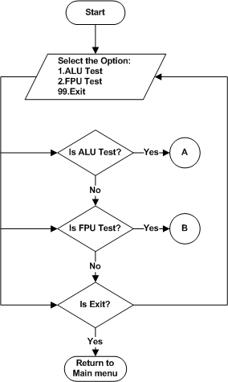
Figure 5.1 : Processor Test Men

ALU Test
- Refer the section 2.1.1.3.1.1and 2.2.1.1.1 for Module Decomposition and Data Decomposition..
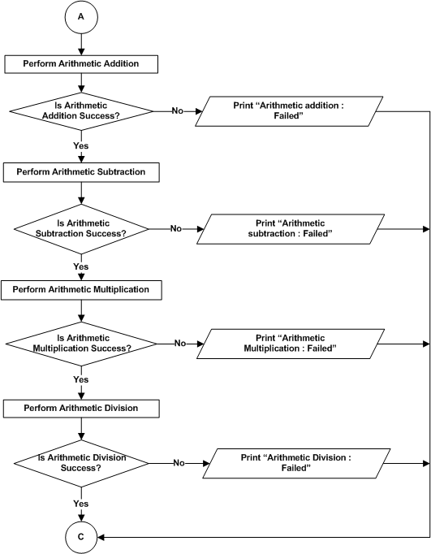

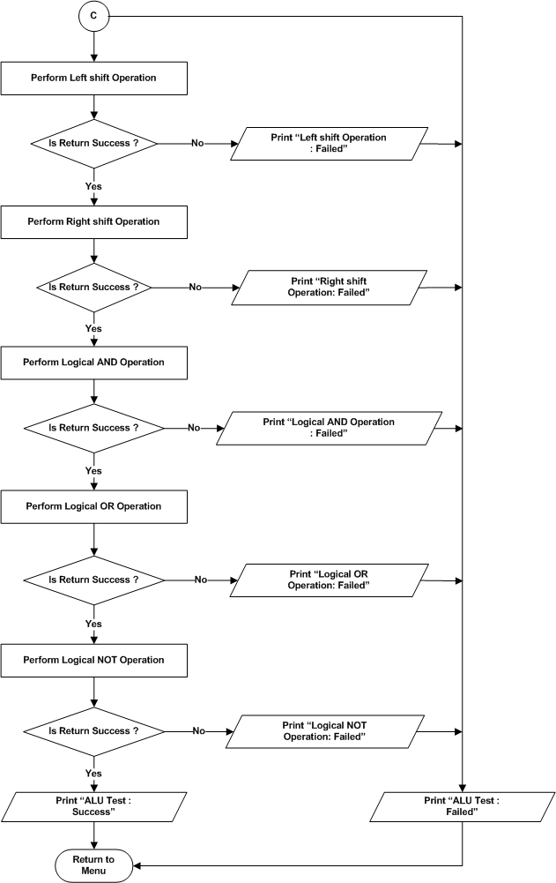
Figure 5.2: Processor Test - ALU Test

FPU Test
- Refer the section 2.1.1.3.1.2 and 2.2.1.1.1 for Module Decomposition and Data Decomposition..
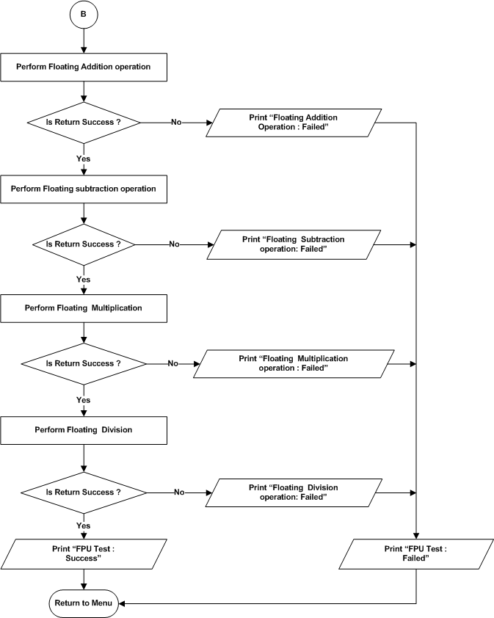
Figure 5.3 : Processor Test – FPU Test

DDR4 Test
- Refer the section 2.1.1.3.2 and 2.2.1.1.2 for Module Decomposition and Data Decomposition..
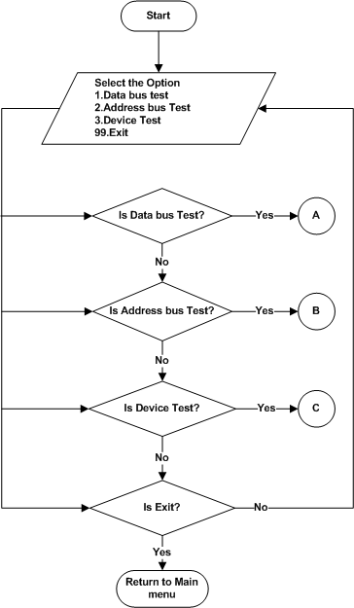
Figure 5.4 : DDR4 Test Menu

Data Bus Test
- Refer the section 2.1.1.3.2.1 and 2.2.1.1.2 for Module Decomposition and Data Decomposition.
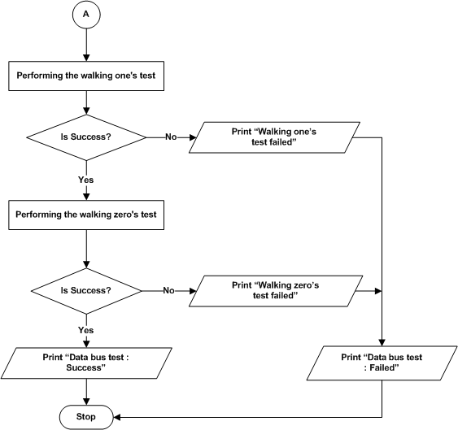
Figure 5.5: DDR4 Test – Data Bus Test

Address Bus Test
- Refer the section 2.1.1.3.2.2 and 2.2.1.1.2 for Module Decomposition and Data Decomposition..
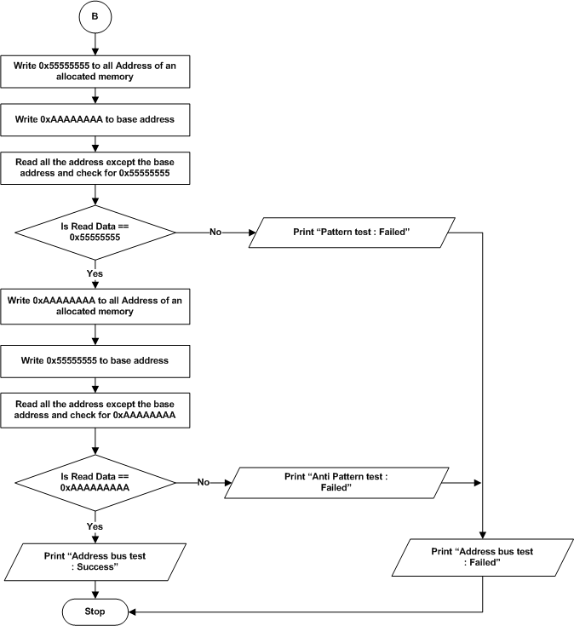
Figure 5.6: DDR4 Test – Address Bus Test

Device Test
- Refer the section 2.1.1.3.2.3 and 2.2.1.1.2 for Module Decomposition and Data Decomposition..
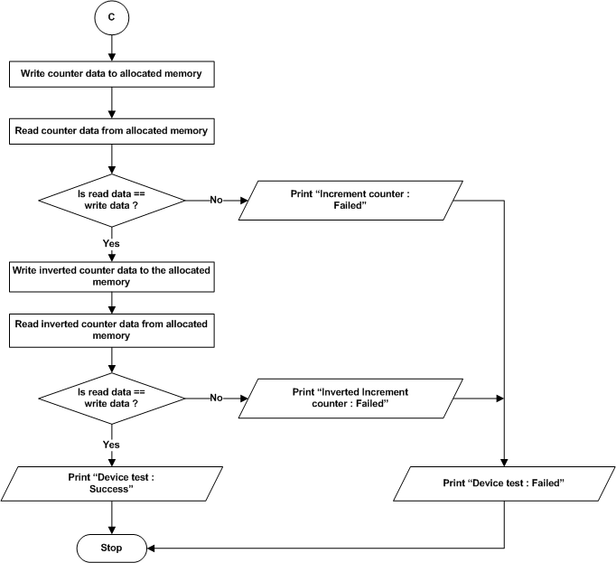
Figure 5.7: DDR4 Test –Device Test

EEPROM Test
- Refer the section 2.1.1.3.3 and 2.2.1.1.3 for Module Decomposition and Data Decomposition..
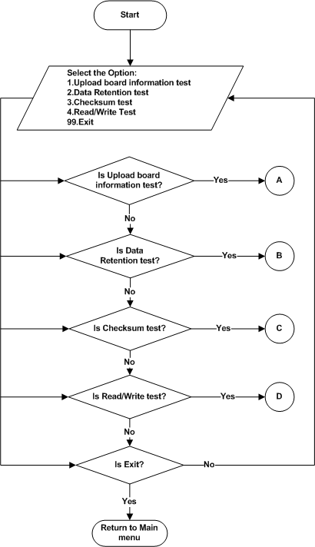
Figure 5.8 : EEPROM Test Menu

Upload Board Information Test
- Refer the section 2.1.1.3.3.1 and 2.2.1.1.3 for Module Decomposition and Data Decomposition..
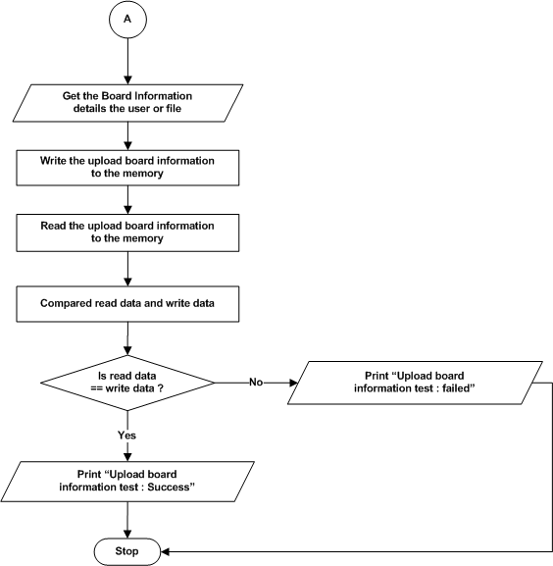
Figure 5.9 : EEPROM – Upload Board Information Test

Data Retention Test

- Refer the section 2.1.1.3.3.2 and 2.2.1.1.3 for Module Decomposition and Data Decomposition..
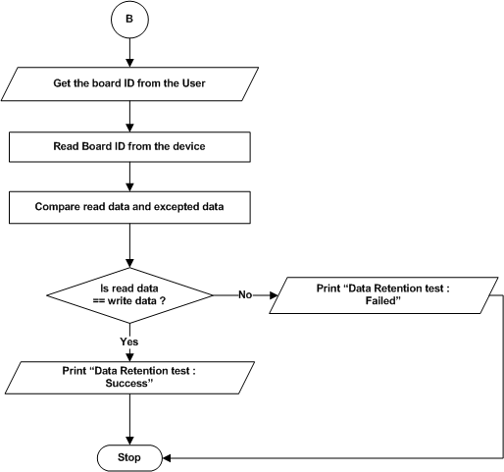
Figure 5.10 : EEPROM – Data Retention Test

Checksum Test
- Refer the section 2.1.1.3.3.3 and 2.2.1.1.3 for Module Decomposition and Data Decomposition..
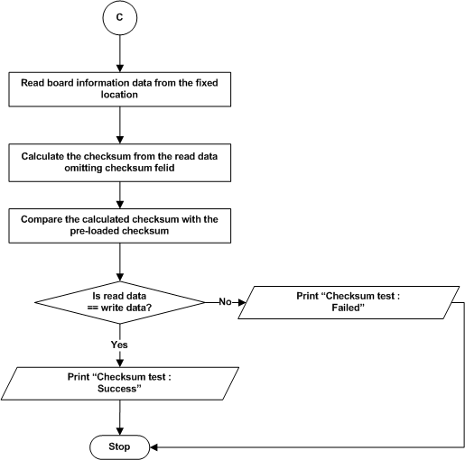
Figure 5.11 : EEPROM – Checksum Test

Read/Write Test
- Refer the section 2.1.1.3.3.4 and 2.2.1.1.3 for Module Decomposition and Data Decomposition.

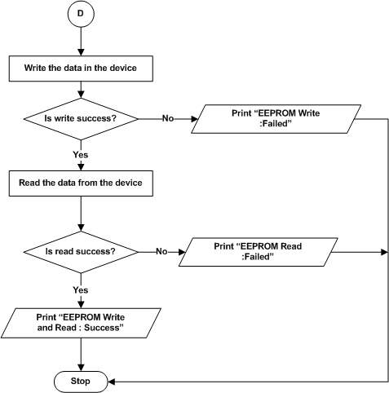

Figure 5.12 : EEPROM – Read/Write Test

MRAM Test

- Refer the section 2.1.1.3.4 and 2.2.1.1.4 for Module Decomposition and Data Decomposition..
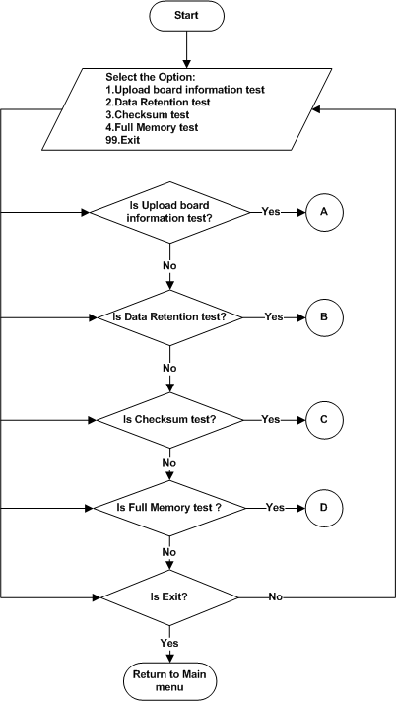
Figure 5.13 : MRAM Test Menu

Upload Board Information test

- Refer the section 2.1.1.3.4.1 and 2.2.1.1.4 for Module Decomposition and Data Decomposition..
- Refer the Section 5.1.1.1.3.1 for Flowchart.

Data Retention test

- Refer the section 2.1.1.3.4.2 and 2.2.1.1.4 for Module Decomposition and Data Decomposition..

- Refer the Section 5.1.1.1.3.2 for Flowchart.

Checksum Test

- Refer the section 2.1.1.3.4.3 and 2.2.1.1.4 for Module Decomposition and Data Decomposition..

- Refer the Section 5.1.1.1.3.3 for Flowchart.

Full Memory test

- Refer the section 2.1.1.3.4.4 and 2.2.1.1.4 for Module Decomposition and Data Decomposition..

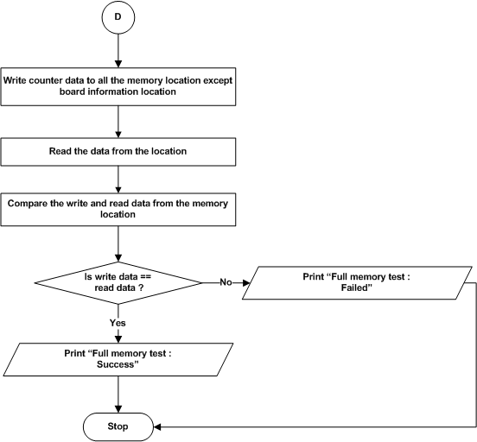
Figure 5.14 : MRAM – Full Memory Test

NAND Flash Test
- Refer the section 2.1.1.3.5 and 2.2.1.1.5 for Module Decomposition and Data Decomposition..
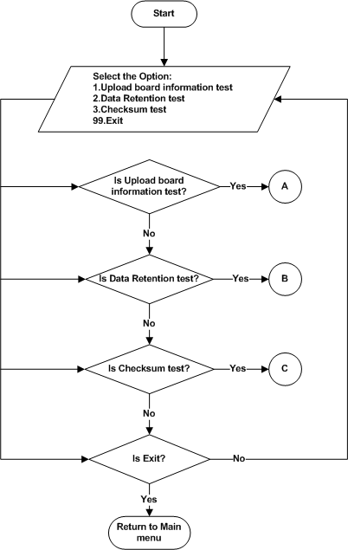
Figure 5.15 : NAND Flash Test Menu

Upload Board Information test
- Refer the section 2.1.1.3.5.1 and 2.2.1.1.5 for Module Decomposition and Data Decomposition..
- Refer the Section 5.1.1.1.3.1 for Flowchart.

Data Retention Test
- Refer the section 2.1.1.3.5.2 and 2.2.1.1.5 for Module Decomposition and Data Decomposition..
- Refer the Section 5.1.1.1.3.2 for Flowchart.

Checksum Test
- Refer the section 2.1.1.3.5.3 and 2.2.1.1.5 for Module Decomposition and Data Decomposition..
- Refer the Section 5.1.1.1.3.3 for Flowchart.

NOR Flash Test
- Refer the section 2.1.1.3.6 and 2.2.1.1.6 for Module Decomposition and Data Decomposition..

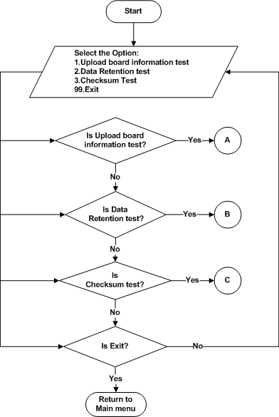
Figure 5.16 : NOR Flash Test Menu

Upload Board Information test
- Refer the section 2.1.1.3.6.1 and 2.2.1.1.6 for Module Decomposition and Data Decomposition.
- Refer the Section 5.1.1.1.3.1 for Flowchart.

Data Retention Test
- Refer the section 2.1.1.3.6.2 and 2.2.1.1.6 for Module Decomposition and Data Decomposition..
- Refer the Section 5.1.1.1.3.2 for Flowchart.

Checksum Test
- Refer the section 2.1.1.3.6.3 and 2.2.1.1.6 for Module Decomposition and Data Decomposition..
- Refer the Section 5.1.1.1.3.3 for Flowchart.

USB Test

Read / Write Test
- Refer the section 2.1.1.3.7.1 and 2.2.1.1.7 for Module Decomposition and Data Decomposition.
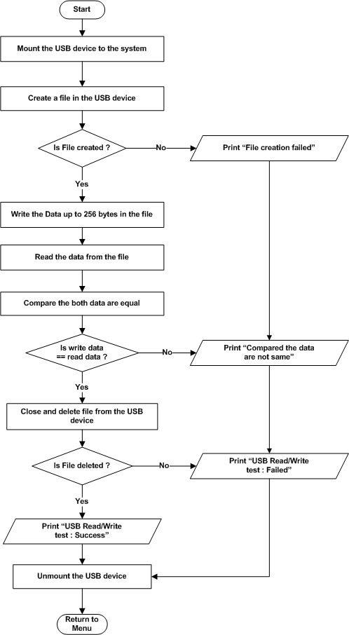
Figure 5.17: USB – Read / Write Test

SATA Test

Read / Write Test
- Refer the section 2.1.1.3.8.1 and 2.2.1.1.8 for Module Decomposition and Data Decomposition..
- Refer the Section 5.1.1.1.6.1 for Flowchart.

UART Test
- Refer the section 2.1.1.3.9 and 2.2.1.1.9 for Module Decomposition and Data Decomposition..
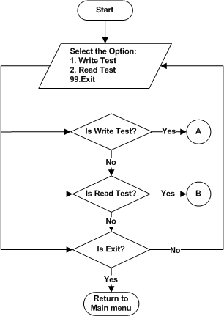
Figure 5.18 : UART Main Menu

Write Test
- Refer the section 2.1.1.3.9.1 and 2.2.1.1.9 for Module Decomposition and Data Decomposition..
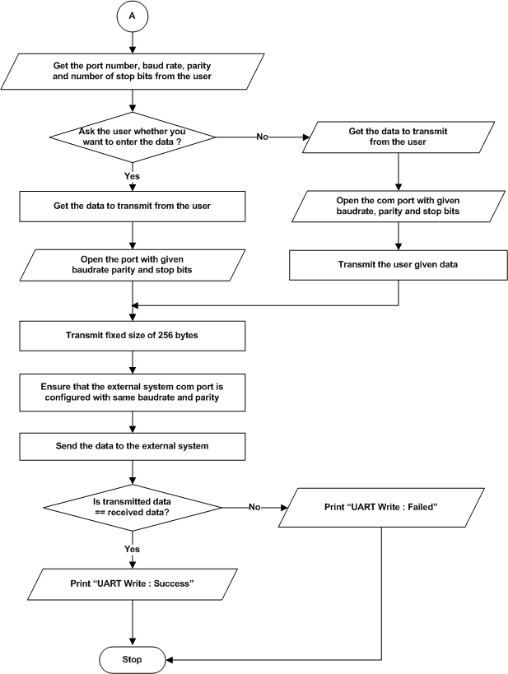
Figure 5.19 : UART – Write Test

Read Test
- Refer the section 2.1.1.3.9.2 and 2.2.1.1.9for Module Decomposition and Data Decomposition..
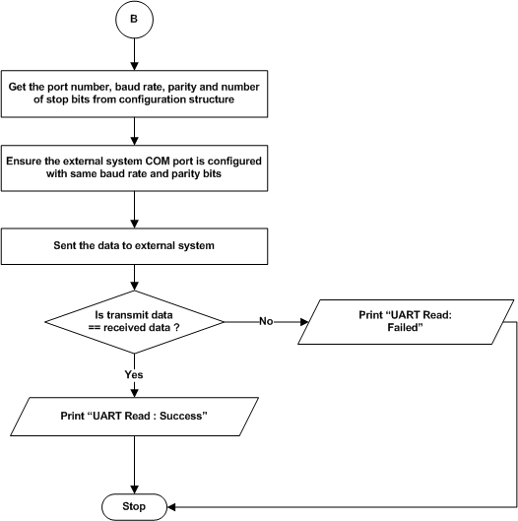
Figure 5.20 : UART – Read

Ethernet Test
- Refer the section 2.1.1.3.10 and 2.2.1.1.10 for Module Decomposition and Data Decomposition..

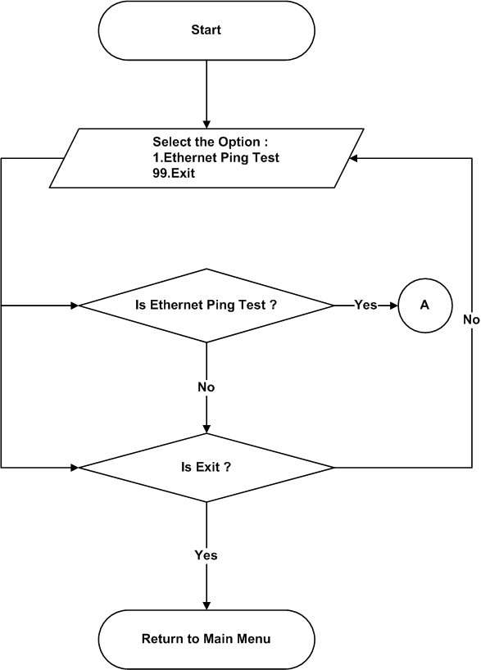
Figure 5.21 : Ethernet - Test Menu

Ethernet ping Test

- Refer the section 2.1.1.3.10.1 and 2.2.1.1.10 for Module Decomposition and Data Decomposition..

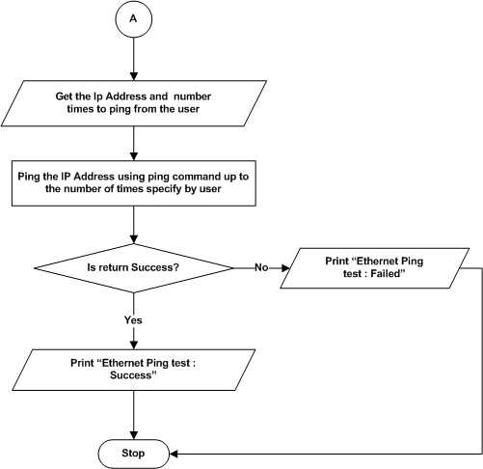

Figure 5.22 : Ethernet Ping Test

RTC

- Refer the section 2.1.1.3.11 and 2.2.1.1.11 for module decomposition and data decomposition.

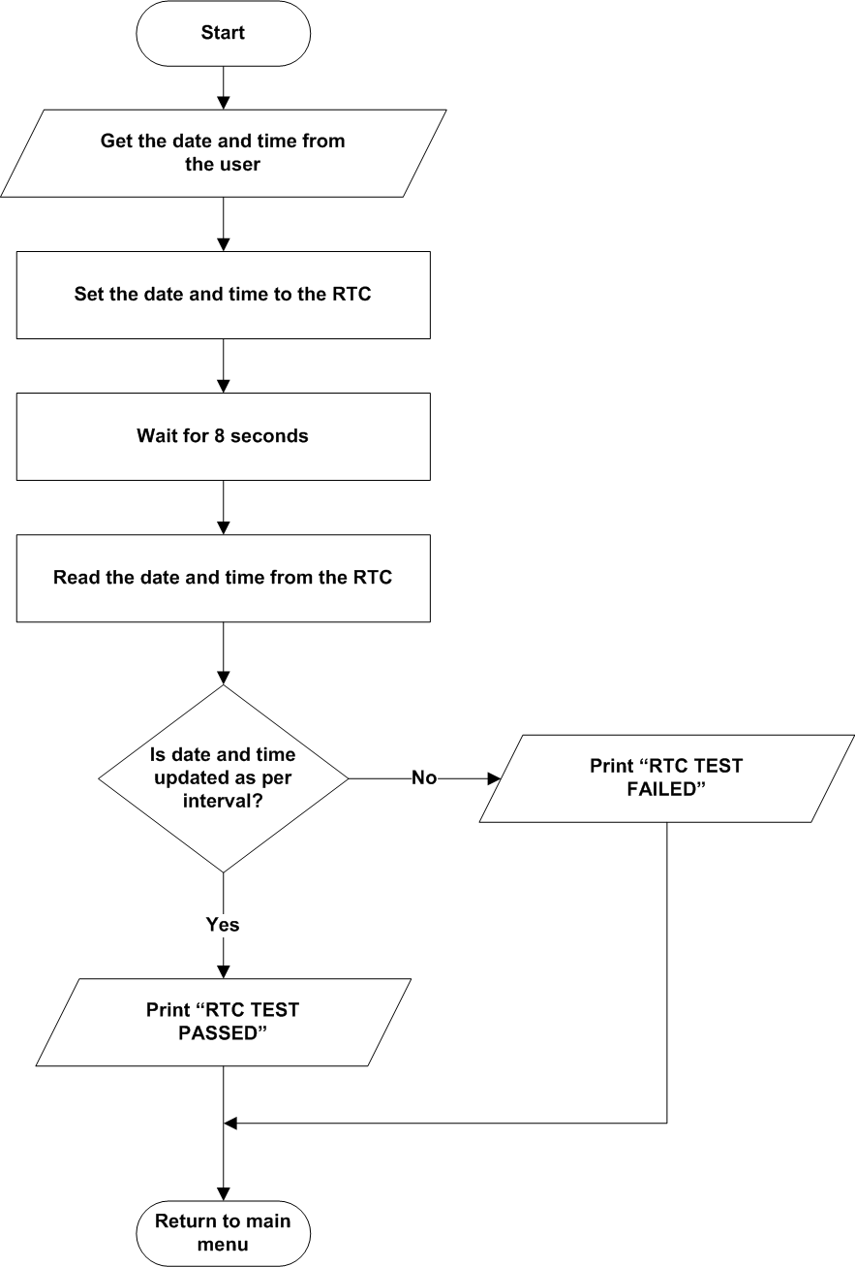
Figure 5.23 : RTC Test

PCI Enumeration Test
- Refer the section 2.1.1.3.12 and 2.2.1.1.12 for module decomposition and data decomposition.
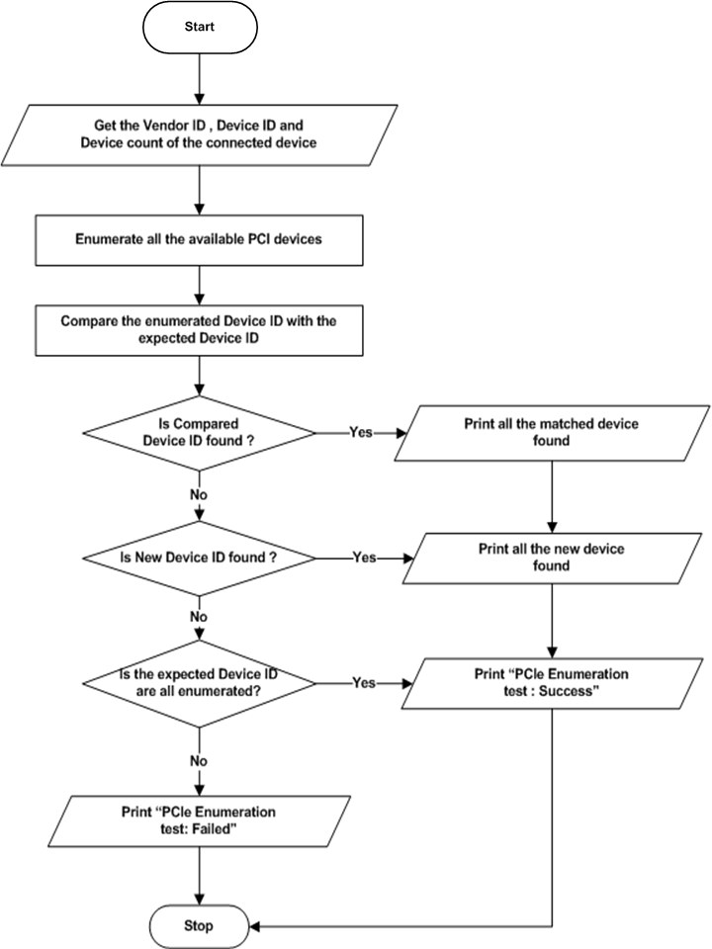
Figure 5.24 : PCI Enumeration Test

Temperature Sensor Test
- Refer the section 2.1.1.3.13 and 2.2.1.1.13 for Module Decomposition and Data Decomposition..

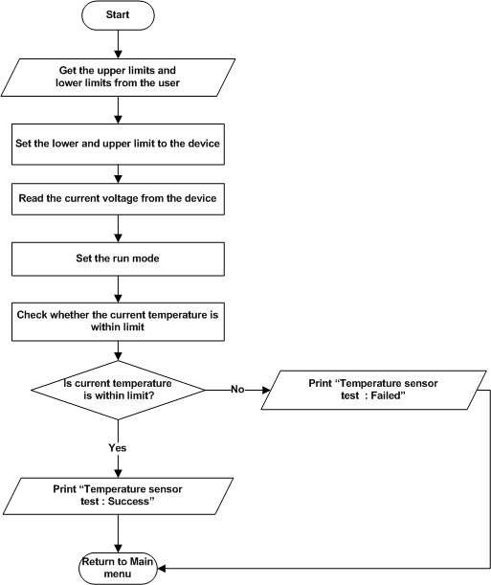
Figure 5.25 : Temperature Sensor Test

Voltage Monitoring Test

- Refer the section 2.1.1.3.14 and 2.2.1.1.14 for Module Decomposition and Data Decomposition..

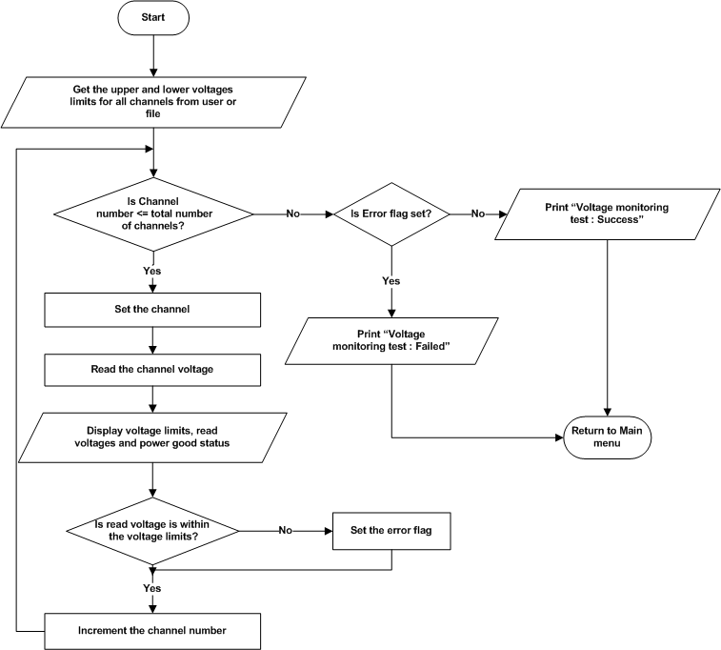
Figure 5.26 : ADM – Voltage Monitoring Test

Programmable Logic

LMK PLL Test
- Refer the section 2.1.1.4.1 and 2.2.1.2.1 for module decomposition and data decomposition.
Start
Select the Option:
1.File Configuration
2.File Dump
3.Single Write
4.Single Read
5.PLL Lock Status
6.Sysref Enable/Disable
99.Exit
Is File Configuration ?
Is File Dump ?
Is Single Write ?
Is Single Read ?
Return to Main Menu
No
A
B
C
D
Yes
Yes
Yes
Yes
No
No
No
No
Yes
Is PLL Lock status ?
No
Yes
E
Is Exit ?
Is Sysref Enable/Disable ?
No
No
Yes
No
No
F

Figure 5.27 : LMK PLL Menu

File Configuration
- Refer the section 2.1.1.4.1.1 and 2.2.1.2.1 for module decomposition and data decomposition.

A
Is Handle Validated?
Print “Invalid Handle”
Get the configuration file from user
Is file is present?
Read data from the file
Write data to the corresponding FPGA registers
Is Write process completed?
Yes
Yes
Yes
No
Print “LMK PLL Configuration : FAIL”
Print “LMK PLL Configuration : SUCCESS”
Return to Menu
No
No
Print “File not found”

Figure 5.28 : File Configuration

File Dump
- Refer the section 2.1.1.4.1.2 and 2.2.1.2.1 for module decomposition and data decomposition.

B
Is Handle Validated?
Get the configuration file from user
Is File Validated ?
Read Address from the configuration file
Write the address in corresponding FPGA Registers
Read Data from the corresponding FPGA Registers and store it in the Output file
Is Read process completed?
Print “LMK PLL Dump : SUCCESS”
Return to Menu
Print “Invalid Handle”
Print “File not found”
Print “LMK PLL Dump : FAIL”
Yes
Yes
Yes
No
No
No

Figure 5.29 : File Dump

Single Data Write

- Refer the section 2.1.1.4.1.3 and 2.2.1.2.1for data decomposition and module decomposition.

C
Is Handle Validated?
Print “Invalid Handle”
Get the address and Data from the user
Write the Data and Address in the corresponding FPGA Registers
Is Write process is completed?
Print “LMK PLL Single Write : FAIL”
Print “LMK PLL Single Write : SUCCESS”
Return to Menu
Yes
Yes
No
No

Figure 5.30: Single Data Write

Single Data Read

- Refer the section 2.1.1.4.1.4 and 2.2.1.2.1 for data decomposition and module decomposition.

D
Is Handle Validated?
Get the address from the user
Write the address and Read the Data from the Corresponding FPGA Read register
If Read process completed?
Print “LMK PLL Single Read : FAIL”
Print ”LMK PLL Single Read : SUCCESS”
Return to Menu
Print “Invalid Handle”
Yes
No
No
Display the read values
Yes

Figure 5.31:Single Data Read

PLL Lock Status
- Refer the section 2.1.1.4.1.5 and 2.2.1.2.1 for data decomposition and module decomposition.
E
Is Handle Validated?
Print “Invalid Handle”
Read the Lock Status from the corresponding PLL Status Register
Is Read process is completed?
Print “LMK PLL Lock Status : FAIL”
Print “LMK PLL Lock Status : SUCCESS”
Return to Menu
Yes
Yes
No
No
Compare the Read data it must be equal to 0x30
Is Comparison was success ?
No
Print “LMK PLL Lock Status : FAIL”
Yes

Figure 5.32:PLL Lock Status

Sysref Enable/Disable

- Refer the section 2.1.1.4.1.6 and 2.2.1.2.1 for data decomposition and module decomposition.
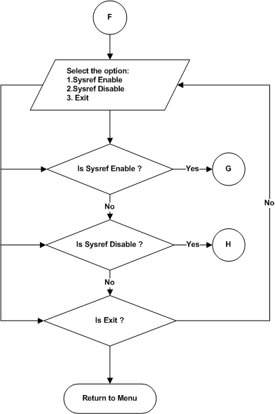
Figure 5.33: Sysref Enable/Disable Menu

Sysref Enable

- Refer the section 2.1.1.4.1.6.1 and 2.2.1.2.1 for data decomposition and module decomposition.

G

Is Handle validated ?
Print “Invalid Handle”
Write Data 0x15 in the corresponding register
Is write process completed ?
No
Yes
Print “SYSREF Enable : FAIL”
Print “SYSREF Enable : SUCCESS”
No
Yes
Return to PLL Menu

Figure 5.34: Sysref Enable Menu

Sysref Disable

- Refer the section 2.1.1.4.1.6.2 and 2.2.1.2.1 for data decomposition and module decomposition.

H

Is Handle validated ?
Print “Invalid Handle”
Write Data 0x5 in the corresponding register
Is write process completed ?
No
Yes
Print “SYSREF Enable : FAIL”
Print “SYSREF Enable : SUCCESS”
No
Yes
Return to PLL Menu

Figure 5.35: Sysref Disable Menu

AFE7096 ADC Test

- Refer the section 2.1.1.4.2 and 2.2.1.2.2 for module decomposition and data decomposition.
Select the option:
1. AFE Core Reset
2. AFE Single Write
3.AFE Single Read
4.AFE Bring up
5.AFE Core Initialization
6.JESD Bond Status
7.ADC Data Logging
8.HD2 Correction Enable
9.NCO Update
10.AFE Dynamic Configuration
11.Band Selection
99. Exit
Is AFE Core Reset?
A
Yes
Start
Is AFE Single Write?
Is ADC Data logging?
No
Is AFE Single Read?
Is AFE Bringup ?
No
No
Is AFE Core Initialization ?
No
Is JESD Bond Status ?
No
No
Yes
Yes
Yes
Yes
Yes
B
C
D
E
F
Is HD2 Correction Enable?
Is AFE Dynamic Configuration?
Is Band Selection?
Is Exit?
G
Yes
Yes
Yes
Yes
H
K
No
No
No
No
Return to Main Menu
Yes
Is NCO Update?
Yes
I
J
No

Figure 5.36:AFE7906 ADC Menu

AFE Core Reset
- Refer the section 2.1.1.4.2.1 and 2.2.1.2.2 for module decomposition and data decomposition.

A
Is Handle Validated?
Reset the AFE chip by writing 1 and 0 in the corresponding FPGA Registers
If Reset process completed?
Print “AFE Core Reset : SUCCESS”
Print “AFE Core Reset : FAIL”
Return to Menu
Print “Invalid Handle”
Yes
No
No
Yes

Figure 5.37: AFE7906 Core Reset

AFE Single Write
- Refer the section 2.1.1.4.2.2 and 2.2.1.2.2 for module decomposition and data decomposition.

B
Is Handle Validated?
Get the Write address and Data from the user
Write the Data and Address in the corresponding FPGA Registers
If write process complete?
Print “AFE
Write : SUCCESS”
Print “AFE
Write : FAIL”
Print “Invalid Handle”
Return to Menu
Yes
No
No
Yes

Figure 5.38: AFE Single Write

AFE Single Read
- Refer the section 2.1.1.4.2.3 and 2.2.1.2.2 for module decomposition and data decomposition.

C
Is Handle Validated?
Get the Read address from the user
Write the address and Read the Data from the Corresponding FPGA Read register
If read process completed?
Print “AFE Read : FAIL”
Print “AFE Read : SUCCESS”
Print “Invalid Handle”
Return to Menu
Yes
No
No
Display the Read Values
Yes
Yes

Figure 5.39: AFE Single Read

AFE Bring up

- Refer the section 2.1.1.4.2.4 and 2.2.1.2.2 for module decomposition and data decomposition.

D
Is Handle Validated?
Get the ADC Configuration File from the user
Write and Read the Data From the corresponding FPGA Registers
If File configuration is completed?
Print “AFE Bringup : FAIL”
Print “AFE Bringup : SUCCESS”
Return to Menu
Print “Invalid Handle”
Yes
Yes
No
No

Figure 5.40: AFE Bring up

AFE Core Initialization

- Refer the section 2.1.1.4.2.5 and 2.2.1.2.2 for module decomposition and data decomposition.
E
Is Handle Validated?
write corresponding Data to the FPGA Register
Then Read the Core Initialization Data from the Corresponding Read Register
Compare the Read Data it must be equal to 0xFFFFF
Is Comparison was success?
Print “AFE Core Initialization : FAIL”
Print “Invalid Handle”
Print “AFE Core Initialization : SUCCESS”
Return to Main Menu
Yes
Yes
No
No

Figure 5.41: AFE Core Initialization

JESD Bond Status

- Refer the section 2.1.1.4.2.6 and 2.2.1.2.2 for module decomposition and data decomposition.

F
Is Handle Validated?
Write corresponding Data to the FPGA Register
Then Read the JESD Bond status from the corresponding FPGA Register
Is chip configured and JESD is Bonded Successfully?
Print “ADC JESD : Success”
Print “ADC JESD : Failure”
Return to Menu
Print “Invalid Handle”
Yes
Yes
No
No

Figure 5.42: JESD Bond Status

Data Logging

- Refer the section 2.1.1.4.2.7 and 2.2.1.2.2 for module decomposition and data decomposition.
G
Is Handle Validated?
Is Rx Channel Selection Validated?
Is Sample Count Validated?
Select the Rx channel by writing channel number in the corresponding FPGA Register
Clear the ADC by writing Corresponding Data in the ADC Reset Register
Read the FIFO count from the corresponding Register
FIFO count must be greater or equal to the number of samples entered by user
Read the Data from the corresponding FPGA Register and log in to a File
Is read process completed?
Print “ADC Data Logging : SUCCESS”
Return to Menu
Print “Invalid Handle”
Print “Invalid Rx Channel Selection”
Print “Invalid ADC Sample Data”
Print “ADC Data Logging : FAIL”
Yes
Yes
No
No
No
No
Get the Sample Count as input from the user
Get the Rx Channel Selection as input from the user
Yes
Yes

Figure 5.43: Data Logging

HD2 Correction Enable

- Refer the section 2.1.1.4.2.8 and 2.2.1.2.2 for module decomposition and data decomposition.

H
Select the Option:
1.HD2 Coefficient Write
2.HD2 Coefficient Read
99.Exit
Is HD2 Coefficient Write?
Is HD2 Coefficient Read?
No
Is Exit?
Return to Menu
No
Yes
No
A
B
Yes
Yes

Figure 5.44: AFE HD2 Menu

HD2 Coefficient Write
- Refer the section 2.1.1.4.2.8.1 and 2.2.1.2.2 for module decomposition and data decomposition.
A
Is Handle Validated?
Is Rx Channel Selection Validated?
Enable the HD2 pages by writing corresponding values in the corresponding registers
Write the channel selection Data in the corresponding Register
Get 2129 and 212a Data from the user
Enable the write sequence by writing corresponding Data in the Corresponding Registers
Is write process completed?
Print “HD2 Write : FAIL”
Print “HD2 Write : SUCCESS”
Return to Menu
Print “Invalid Handle”
Print “Invalid Rx Channel Selection"
Yes
Yes
No
No
No
Get the Rx Channel Selection from the user
Yes

Figure 5.45: AFE7906 ADC – HD2 Correction Write

HD2 Coefficient Read
- Refer the section 2.1.1.4.2.8.2 and 2.2.1.2.2 for module decomposition and data decomposition.

B
Is Handle Validated?
Is Channel Selection Validated?
Write the channel number in the corresponding FPGA Register
Read the Data from 2129 and 212a spi offset
Is Read process completed?
Print “HD2 Read : FAIL”
Print “HD2 Read : SUCCESS”
Return to Menu
Print “Invalid Handle”
Print “Invalid AFE Chip Selection"
Yes
Yes
No
Yes
No
No
Display the Read values

Figure 5.46: AFE7906 ADC – HD2 Correction Read

NCO Update
- Refer the section 2.1.1.4.2.9 and 2.2.1.2.2 for module decomposition and data decomposition.

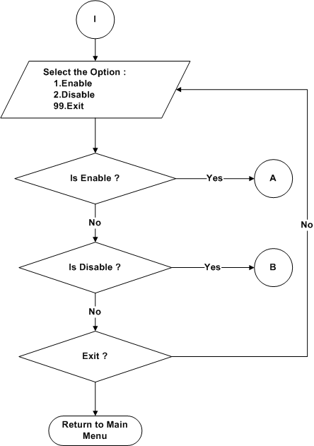

Figure 5.47: NCO Menu

NCO Enable menu

- Refer the section 2.1.1.4.2.9 and 2.2.1.2.2 for module decomposition and data decomposition.
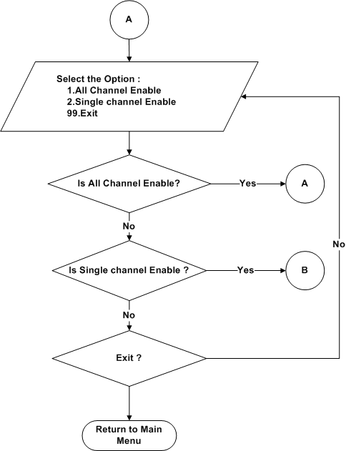
Figure 5.48: NCO Enable Menu

All Channel Enable

- Refer the section 2.1.1.4.2.9.1 and 2.2.1.2.2 for module decomposition and data decomposition.

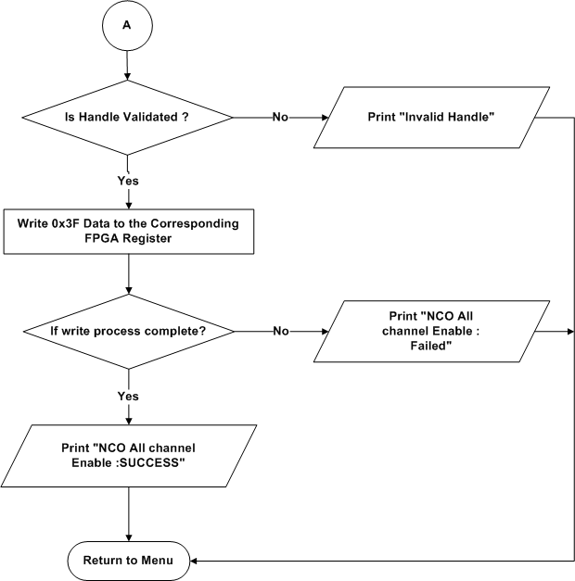

Figure 5.49: All channel Enable

Single Channel Enable

- Refer the section 2.1.1.4.2.9.2 and 2.2.1.2.2 for module decomposition and data decomposition.

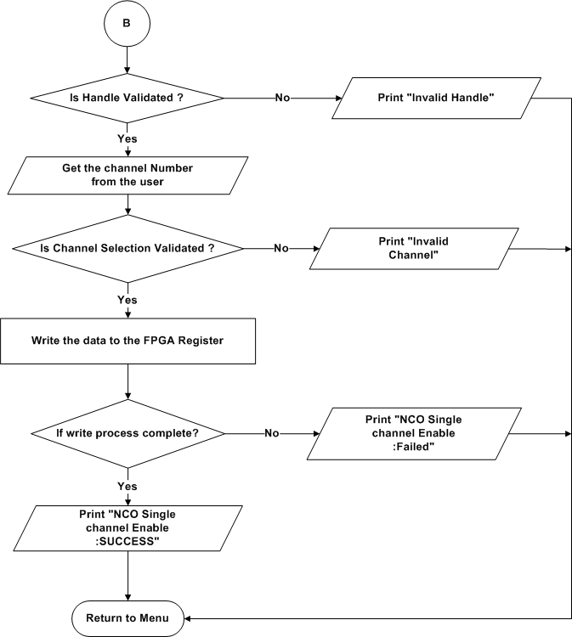
Figure 5.50: Single channel Enable

NCO Disable menu

- Refer the section 2.1.1.4.2.9 and 2.2.1.2.2 for module decomposition and data decomposition.

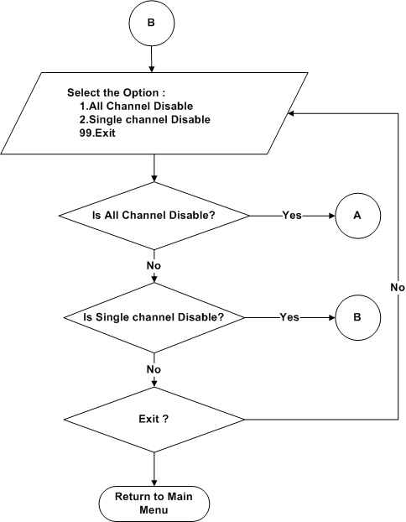
Figure 5.51: NCO Disable Menu

All Channel Disable

- Refer the section 2.1.1.4.2.9.3 and 2.2.1.2.2 for module decomposition and data decomposition.

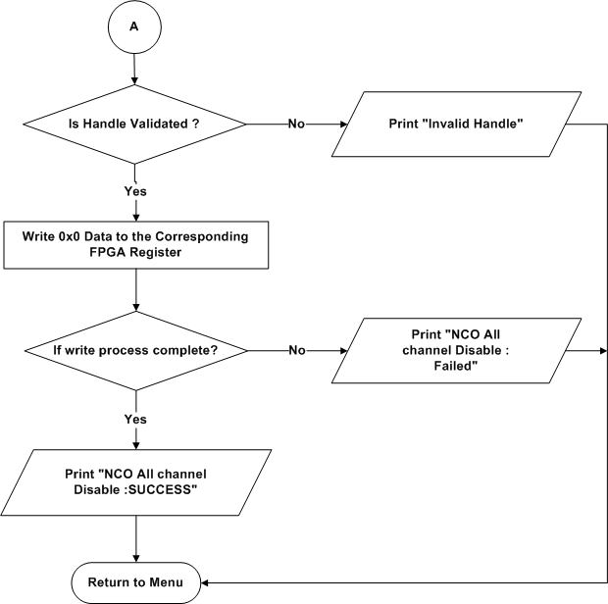
Figure 5.52: All channel Disable

Single Channel Disable

- Refer the section 2.1.1.4.2.9.4 and 2.2.1.2.2 for module decomposition and data decomposition.
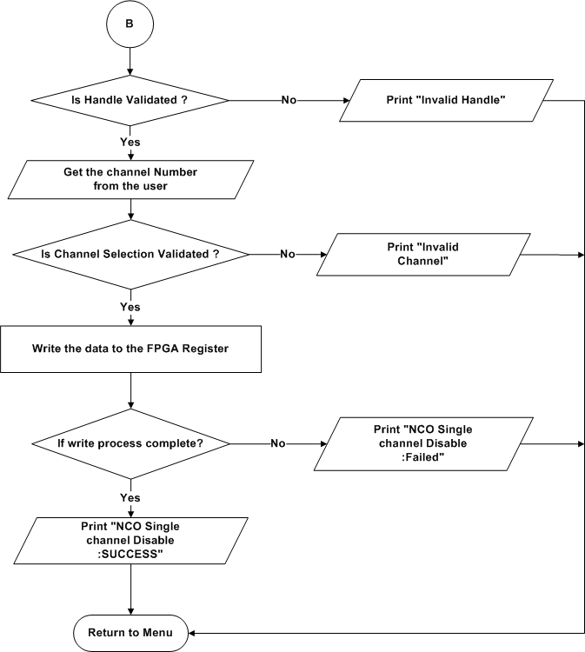
Figure 5.53: Single channel Disable

AFE Dynamic Configuration

- Refer the section 2.1.1.4.2.10 and 2.2.1.2.2 for module decomposition and data decomposition.
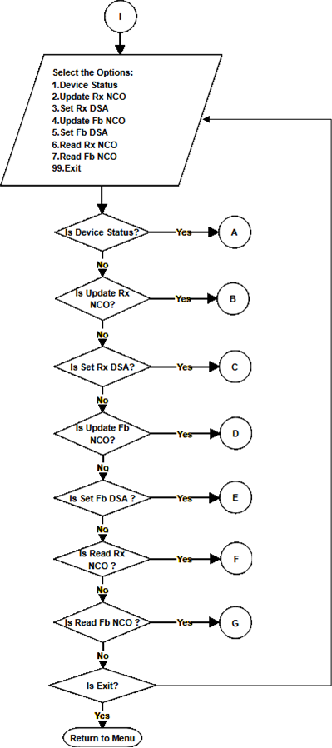
Figure 5.54: AFE Dynamic configuration

Device Health Status

- Refer the section 2.1.1.4.2.10.1 and 2.2.1.2.2 for module decomposition and data decomposition.
A
Read the Health Status of the chip from the Corresponding Registers
Display the Health Status
Return to Menu
Is Read process completed?
Test case declared as Failure
Yes
No

Figure 5.55: Device Health Status

Update Rx NCO

- Refer the section 2.1.1.4.2.10.2 and 2.2.1.2.2 for module decomposition and data decomposition.

B
Get the Rx Mixer frequency from the user in MHZ
Get the Rx Band number from the user
Get the Rx NCO number from the user
Write the Data in the corresponding Registers
Is Write process completed?
Test Case declared as Failure
Test Case declared as Success
Return to Menu
No
Yes

Figure 5.56: Update Rx NCO

Set Rx DSA

- Refer the section 5.1.1.2.2.10.3 and 2.2.1.2.2 for module decomposition and data decomposition.

C
Get the Attenuation Value from the user
Write the value in the corresponding Registers
Is Write process completed?
Test Case declared as Failure
Test Case declared as Success
Return to Menu
No
Yes

Figure 5.57: Set Rx DSA

Update Fb NCO

- Refer the section 2.1.1.4.2.10.4 and 2.2.1.2.2 for module decomposition and data decomposition.
- Refer the section 5.1.1.2.2.10.2 for Flowchart.

Set Fb DSA

- Refer the section 2.1.1.4.2.10.5 and 2.2.1.2.2 for module decomposition and data decomposition.
- Refer the section 5.1.1.2.2.10.3 for Flowchart.

Read Fb NCO

- Refer the section 2.1.1.4.2.10.7 and 2.2.1.2.2 for module decomposition and data decomposition.
- Refer the section 5.1.1.2.2.10.7 for Flowchart.

Read Rx NCO
- Refer the section 2.1.1.4.2.10.6 and 2.2.1.2.2 for module decomposition and data decomposition.

F
Get the Rx Band number from the user
Get the Rx NCO number from the user
Read the Data from the corresponding Register
Is Read process completed?
Test Case declared as Failure
Test Case declared as Success
Return to Menu
No
Yes

Figure 5.58: Read Rx NCO

Band Selection

Refer the section 2.1.1.4.2.11 and 2.2.1.2.2 for Module Decomposition and Data Decomposition.
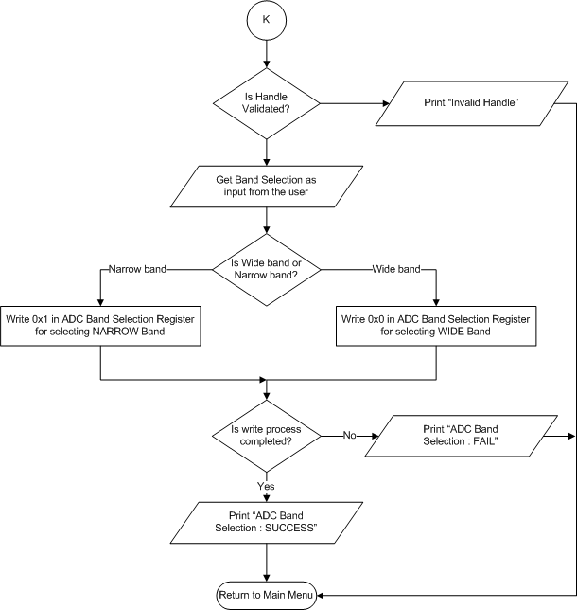
Figure 5.59 : AFE7906 ADC – ADC Band Selection

ADC Automation

Data Logging

Host Application
Refer the section 2.1.1.4.2.12.1.1 and 2.2.1.2.2 for Module Decomposition and Data Decomposition.
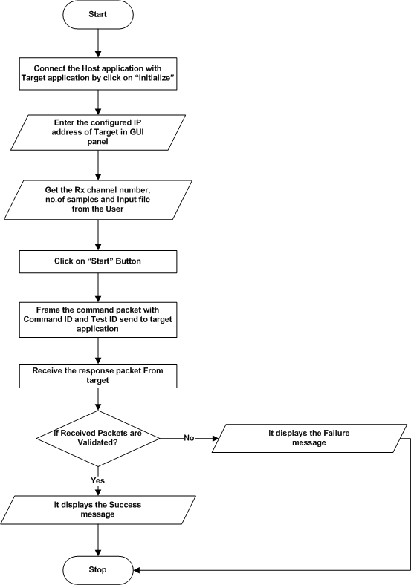
Figure 5.60 : AFE7906 ADC – Automation Data Logging HOST

Target Application
Refer the section 2.1.1.4.2.12.1.2 and 2.2.1.2.2 for Module Decomposition and Data Decomposition.

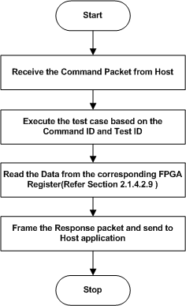

Figure 5.61 : AFE7906 ADC – Automation Data Logging TARGET

Phase Matching

Host Application

Refer the section 2.1.1.4.2.12.1.2 and 2.2.1.2.2 for Module Decomposition and Data Decomposition.
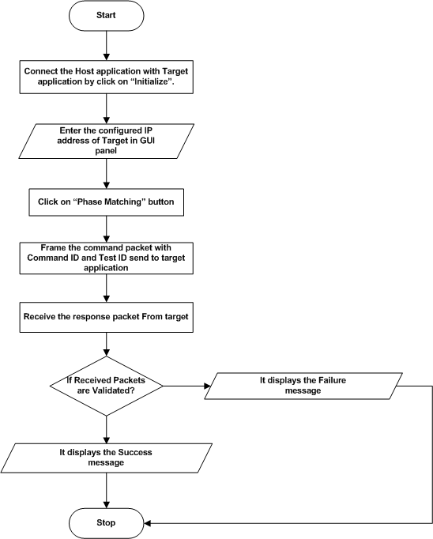
Figure 5.62 : AFE7906 ADC – Automation Phase Matching HOST

Target Application

Refer the section 2.1.1.4.2.12.1.2 and 2.2.1.2.2 for Module Decomposition and Data Decomposition.
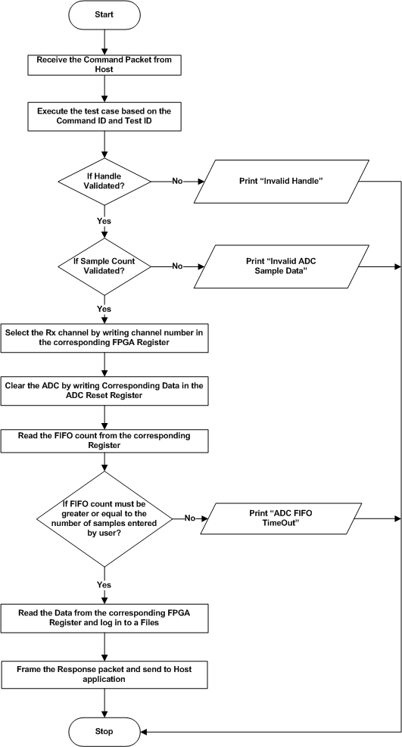
Figure 5.63 : AFE7906 ADC – Automation Phase Matching TARGET

LVTTL Test

- Refer the section 2.1.1.4.3 and 2.2.1.2.3 for module decomposition and data decomposition.

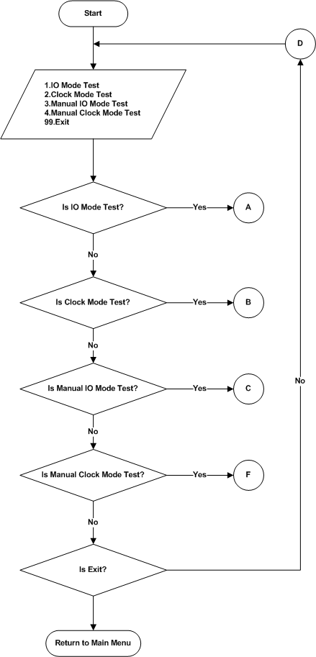
Figure 5.64 : LVTTL Test

IO Mode Test
- Refer the 2.1.1.4.3.1 and 2.2.1.2.3section for module decomposition and data decomposition.

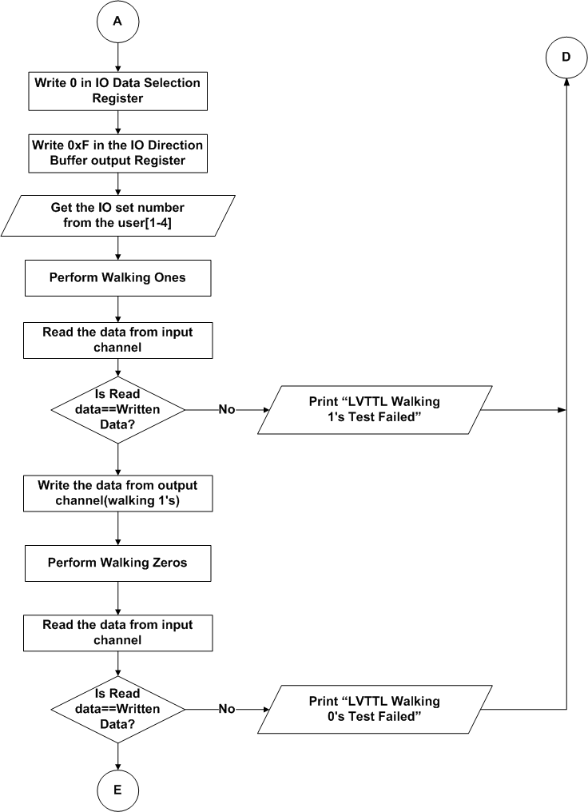
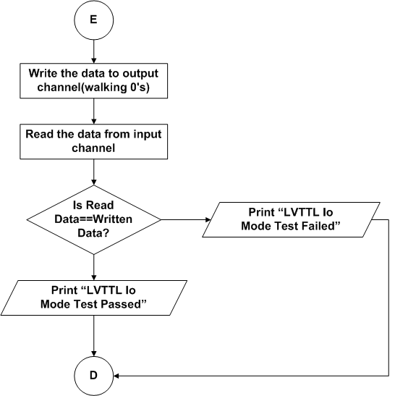
Figure 5.65 : IO Mode Test

Clock Mode Test

- Refer the section 2.1.1.4.3.2 and 2.2.1.2.3 for module decomposition and data decomposition.
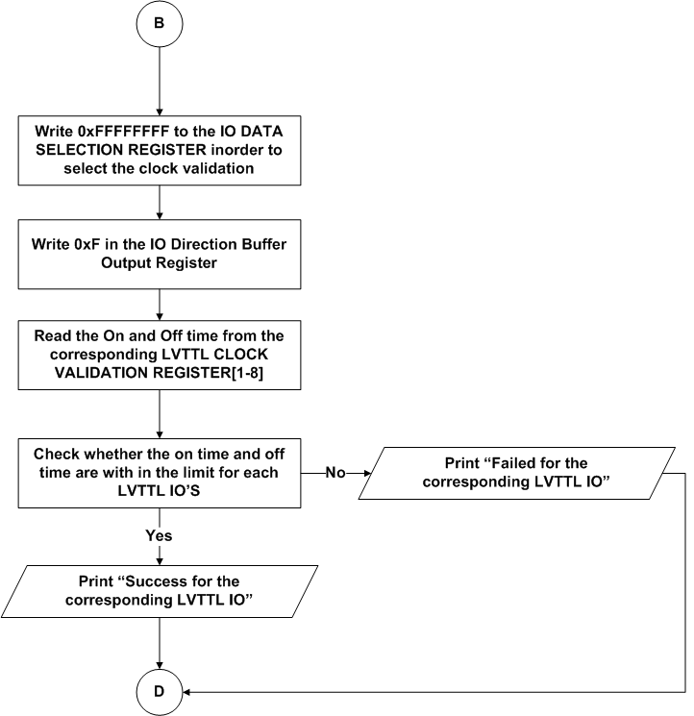
Figure 5.66: Clock Mode Test

Manual IO Mode Test

- Refer the section 2.1.1.4.3.3 and 2.2.1.2.3 for module decomposition and data decomposition.
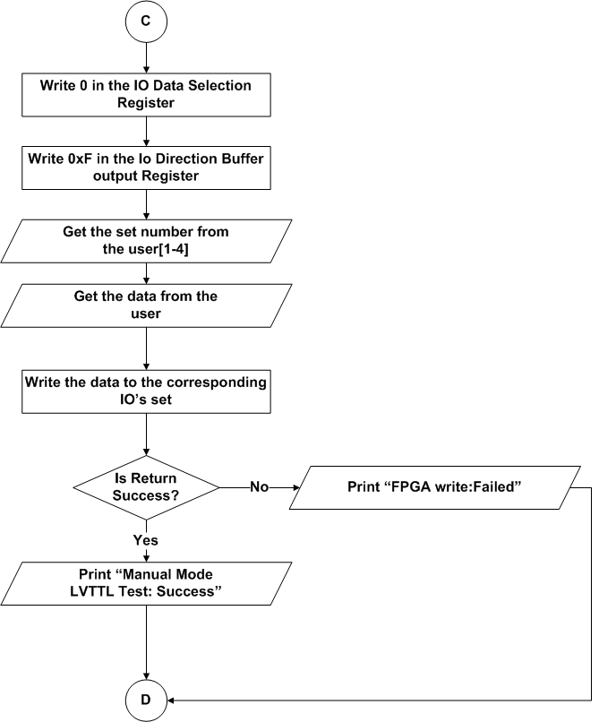
Figure 5.67: IO Manual Mode Test

Manual Clock Mode Test

- Refer the section 2.1.1.4.3.4 and 2.2.1.2.3 for module decomposition and data decomposition.

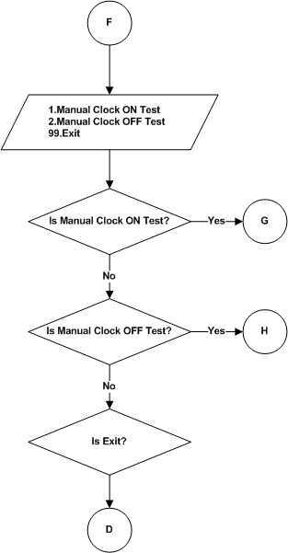

Figure 5.68: Manual Clock Mode Test

Manual Clock ON Test

- Refer the section 2.1.1.4.3.4.1 and 2.2.1.2.3 for module decomposition and data decomposition.
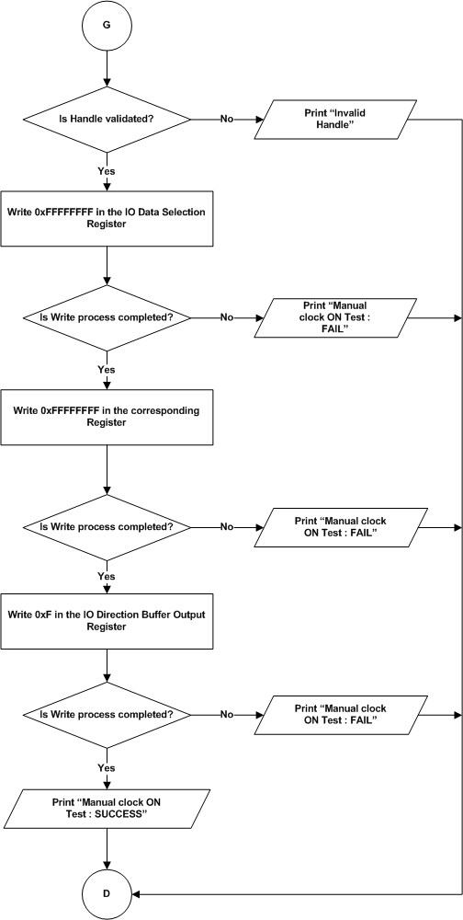
Figure 5.69: Manual Clock ON Test

Manual Clock OFF Test

- Refer the section 2.1.1.4.3.4.2 and 2.2.1.2.3 for module decomposition and data decomposition.
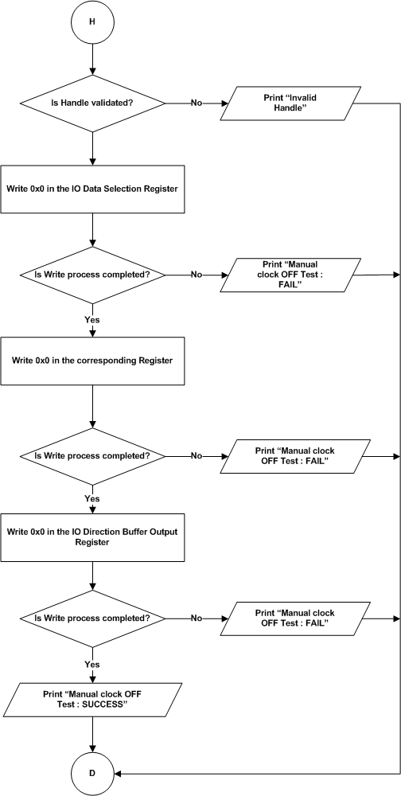
Figure 5.70: Manual Clock OFF Test

LVDS Test

- Refer the section 2.1.1.4.4 and 2.2.1.2.4 for module decomposition and data decomposition.
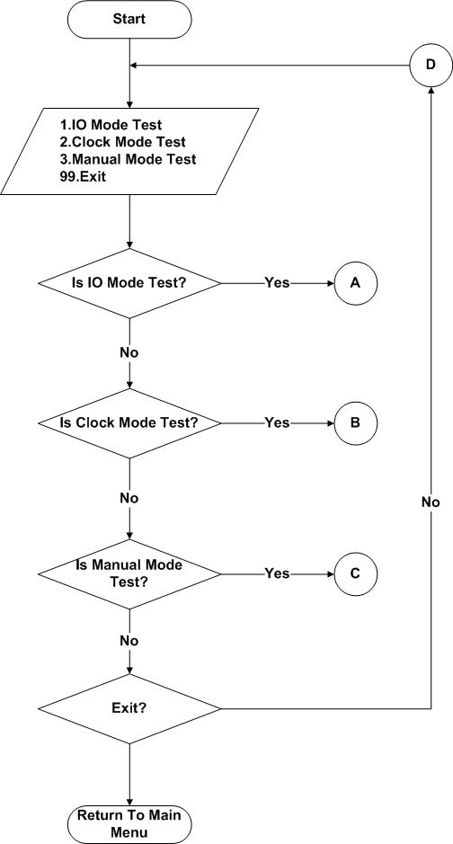
Figure 5.71: LVDS Test

IO Mode Test

- Refer the section 2.1.1.4.4.1 and 2.2.1.2.4 for module decomposition and data decomposition.
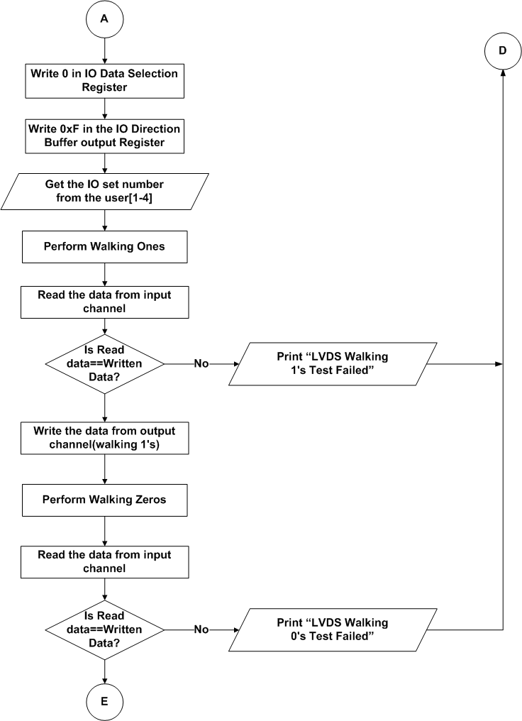

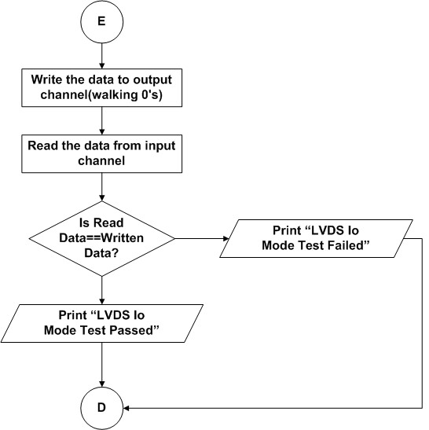
Figure 5.72 : IO Mode Test

Clock Mode Test

- Refer the section 2.1.1.4.4.2 and 2.2.1.2.4 for module decomposition and data decomposition.
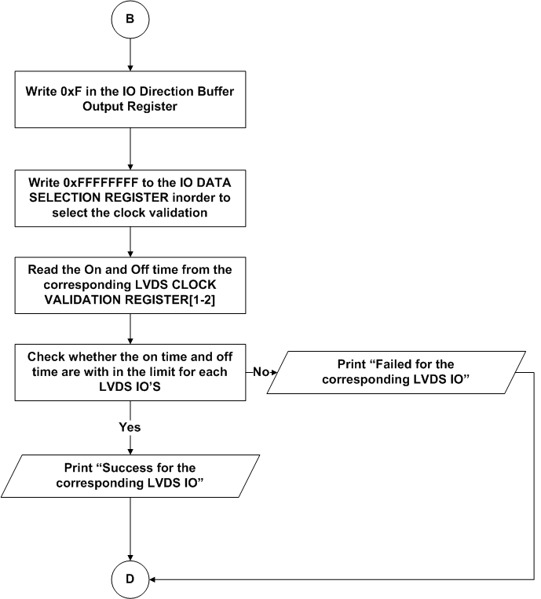
Figure 5.73: Clock Mode Test

Manual Mode Test

- Refer the section 2.1.1.4.4.3 and 2.2.1.2.4 for module decomposition and data decomposition.
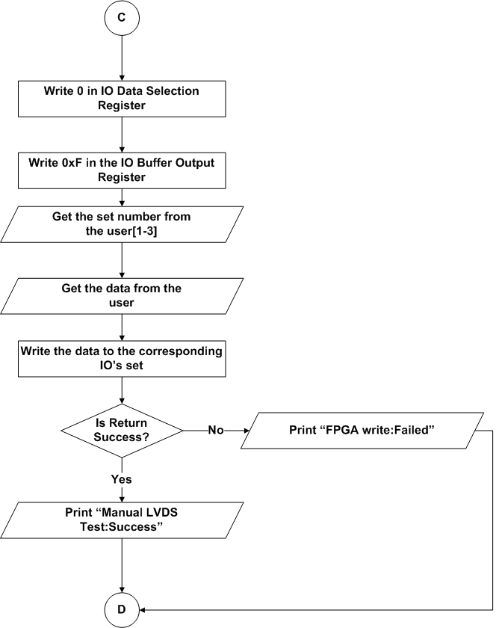
Figure 5.74: Manual Mode Test

GPI/GPO Test
- Refer the section 2.1.1.4.5 and 2.2.1.2.5 for module decomposition and data decomposition.

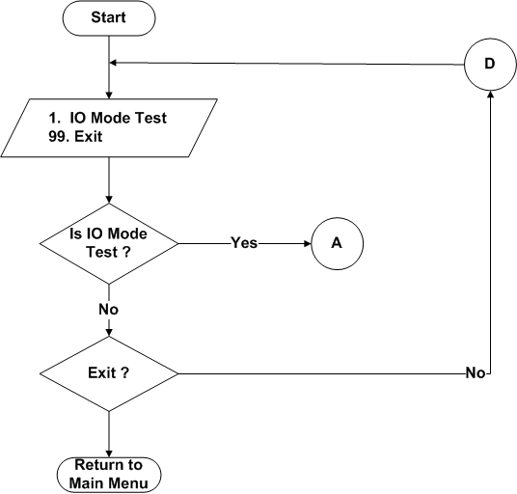

Figure 5.75: GPI GPO Test

IO Mode Test

- Refer the section 2.1.1.4.5.1 and 2.2.1.2.5 for module decomposition and data decomposition.

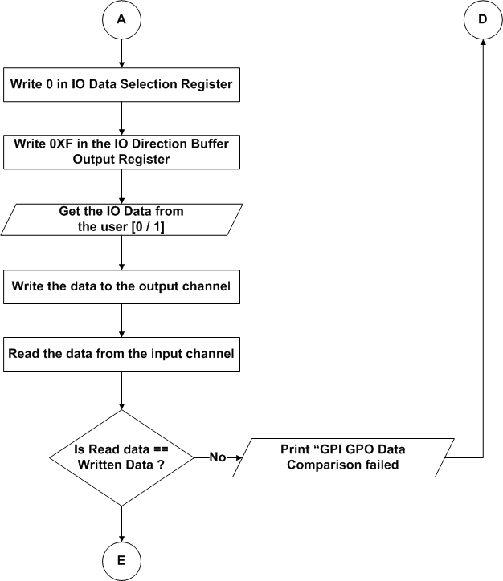

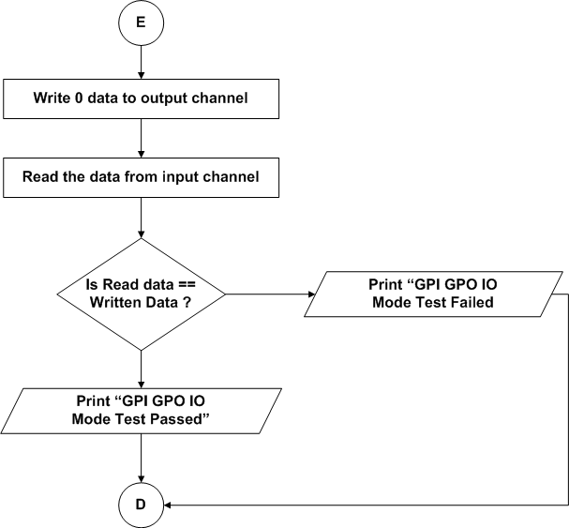
Figure 5.76: IO Mode Test

UART Test
- Refer the section 2.1.1.4.6 and 2.2.1.2.6 for module decomposition and data decomposition.

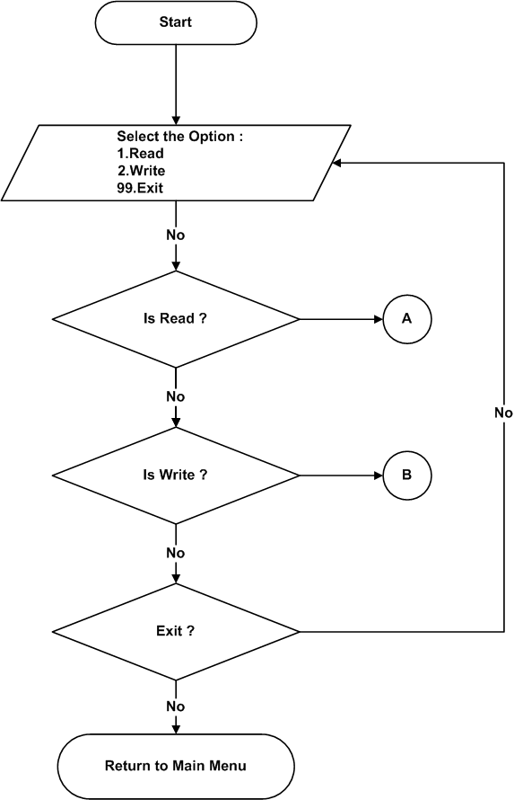
Figure 5.77: UART Test

UART Read

- Refer the section 2.1.1.4.6.2 and 2.2.1.2.6 for module decomposition and data decomposition.
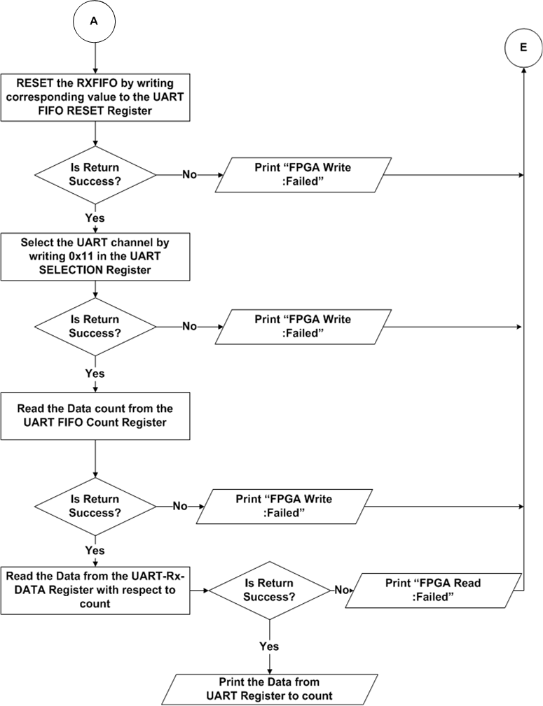
Figure 5.78: UART Read

UART write
- Refer the section 2.1.1.4.6.1 and 2.2.1.2.6 for module decomposition and data decomposition.
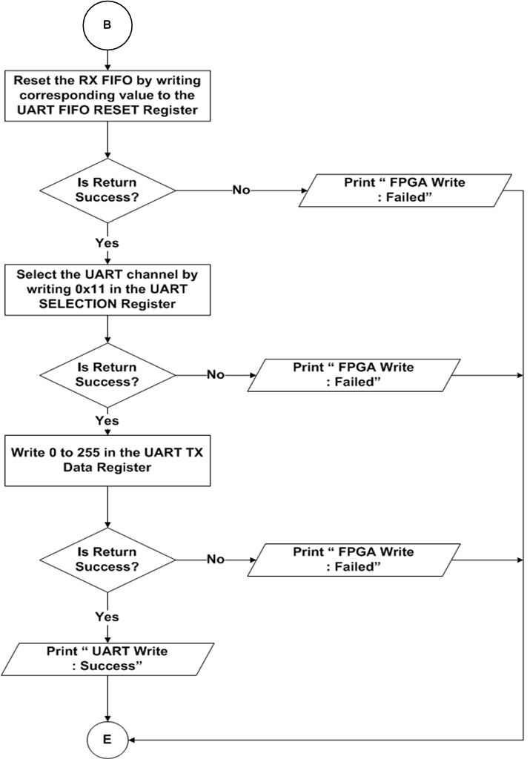
Figure 5.79: UART Write

DDR4(PL) Test
- Refer the section 2.1.1.4.7 and 2.2.1.2.7 for module decomposition and data decomposition.
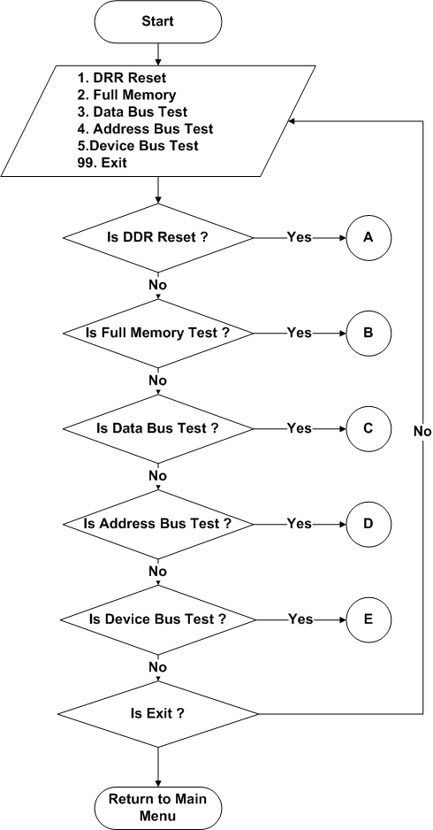
Figure 5.80: DDR4 (PL) Test

DDR4 Reset
- Refer the section 2.1.1.4.7.1 and 2.2.1.2.7 for module decomposition and data decomposition.

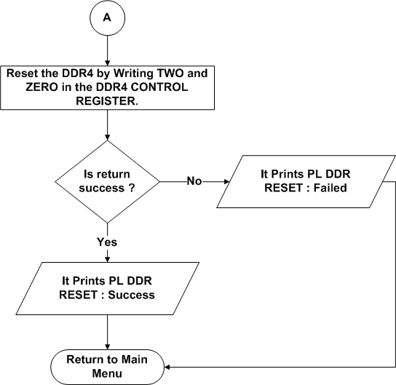
Figure 5.81: DDR4 (PL) Reset Test

Full Memory Test

- Refer the section 2.1.1.4.7.2 and 2.2.1.2.7 for module decomposition and data decomposition.
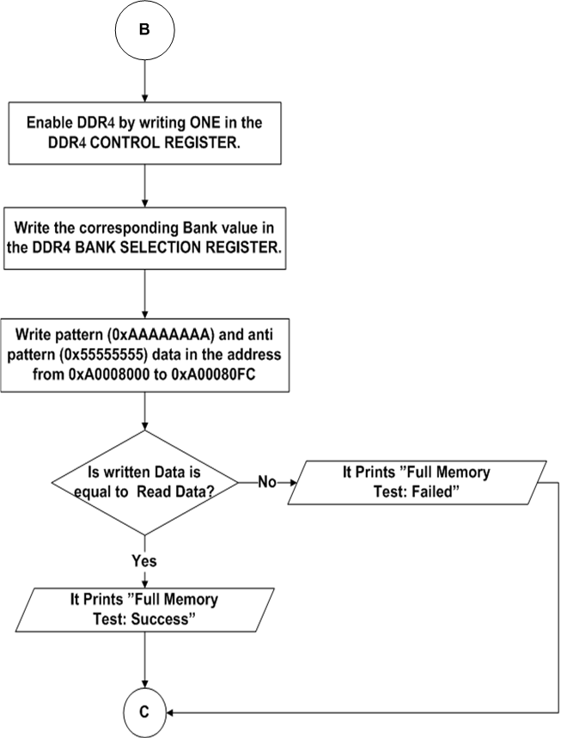
Figure 5.82: Full Memory Test

Data Bus Test
- Refer the section 5.1.1.1.2.1 for Flowchart.

Address Bus Test
- Refer the section 5.1.1.1.2.2 for Flowchart.

Device Test
- Refer the section 5.1.1.1.2.3 for Flowchart.

10G Ethernet Test

Refer the section 2.1.1.4.8 and 2.2.1.2.8 for Module Decomposition and Data Decomposition.
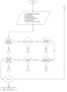
Figure 5.83: 10G Ethernet Test

Lane Repeater Configuration
- Refer the section 2.1.1.4.8.1 and 2.2.1.2.8 for Module Decomposition and Data Decomposition.
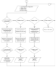
Figure 5.84: Lane Repeater Operation

Core Reset
- Refer the section 2.1.1.4.8.2 and 2.2.1.2.8 for Module Decomposition and Data Decomposition.
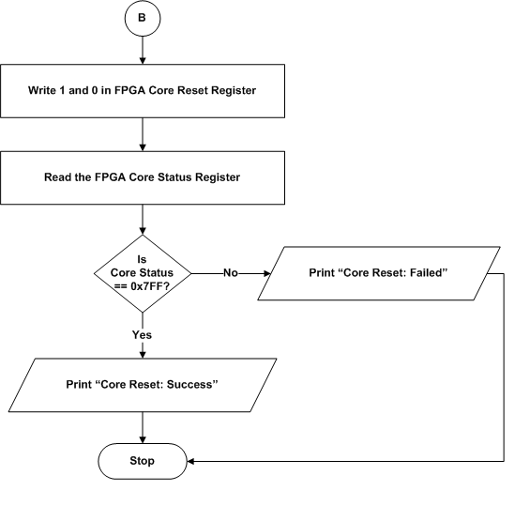
Figure 5.85 : Core Reset

Ethernet Reset
- Refer the section 2.1.1.4.8.3 and 2.2.1.2.8 for Module Decomposition and Data Decomposition.

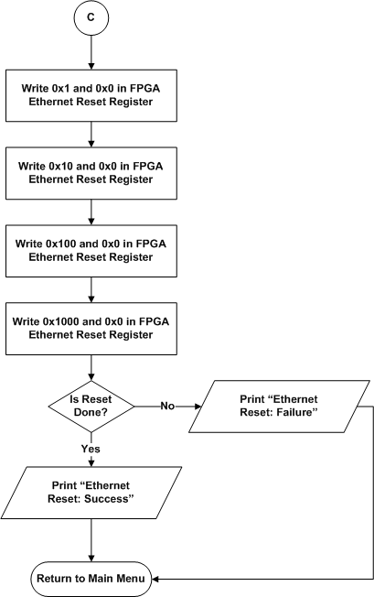
Figure 5.86 : Ethernet Reset

Network Configuration

- Refer the section 2.1.1.4.8.4 and 2.2.1.2.8 for Module Decomposition and Data Decomposition.
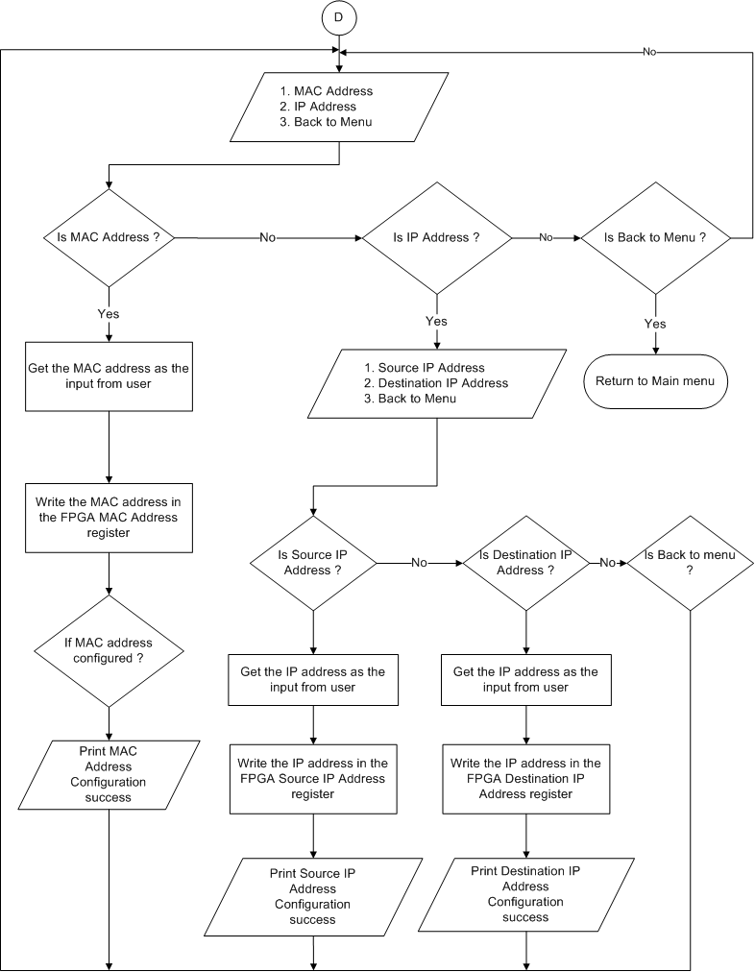
Figure 5.87 : Network Configuration

Transmit Data

Refer the section 2.1.1.4.8.5 and 2.2.1.2.8 for Module Decomposition and Data Decomposition.
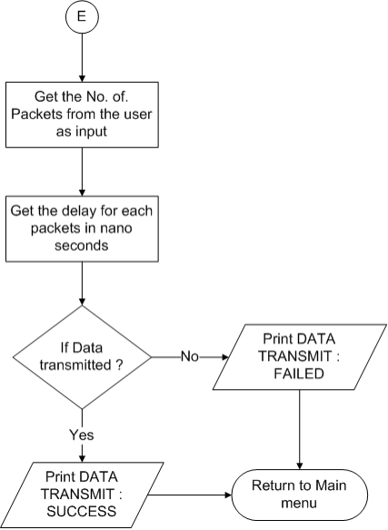
Figure 5.88 : Transmit Data

Receiver Packet Summary
Refer the section 2.1.1.4.8.6 and 2.2.1.2.8 for Module Decomposition and Data Decomposition.
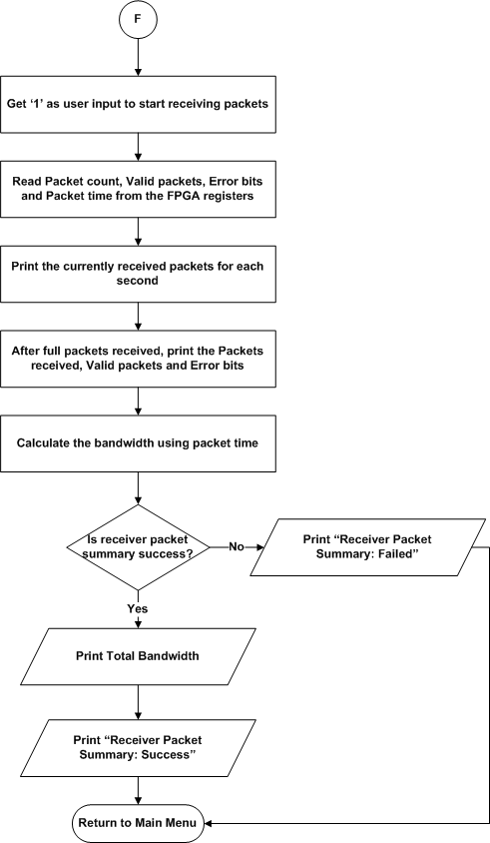
Figure 5.89 : Receiver Packet Summary

DPSPL1255 Module

Programmable Logic

LMK PLL Test

- Refer the section 5.1.1.2.1 for Flowchart.

File Configuration

- Refer the section 5.1.1.2.1.1 for Flowchart.

File Dump
- Refer the section 5.1.1.2.1.2 for Flowchart.

Single Data Write

- Refer the section 5.1.1.2.1.3 for Flowchart.

Single Data Read

- Refer the section 5.1.1.2.1.4 for Flowchart.

PLL Lock Status

- Refer the section 5.1.1.2.1.5 for Flowchart.

RFDAC Test

- Refer the section 2.1.2.2.2 and 2.2.2.1.2 for module decomposition and data decomposition.
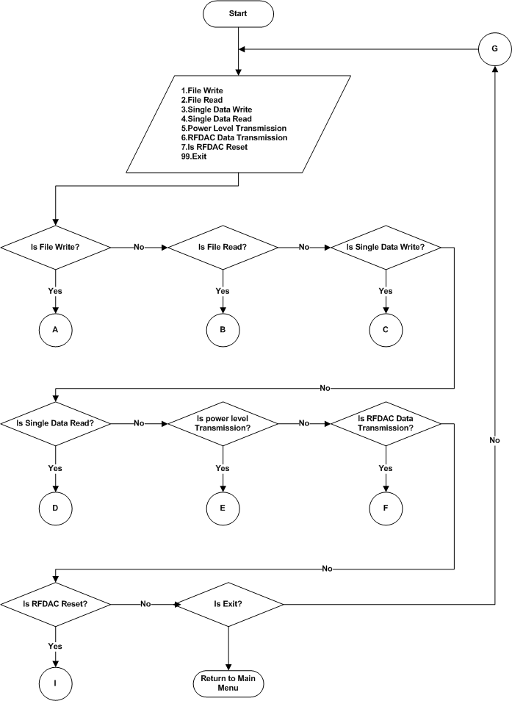
Figure 5.90: RFDAC Test

File Write
- Refer the 2.1.2.2.2.1 and 2.2.2.1.2 section for module decomposition and data decomposition.
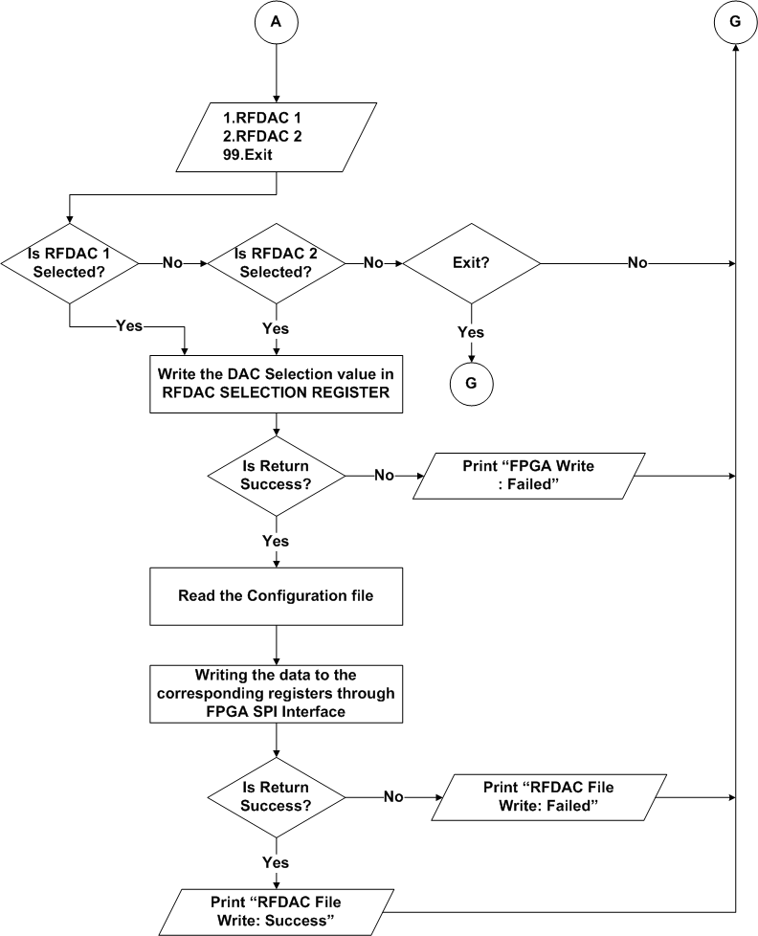
Figure 5.91: File Write

File Read
- Refer the section 2.1.2.2.2.2 and 2.2.2.1.2 for module decomposition and data decomposition.
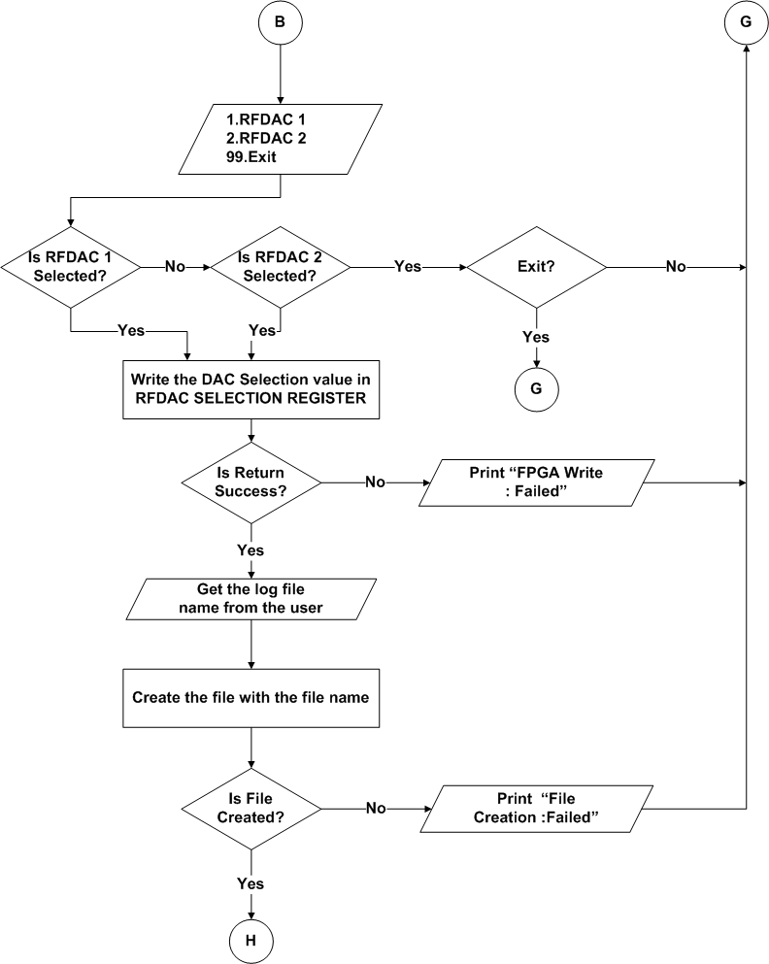
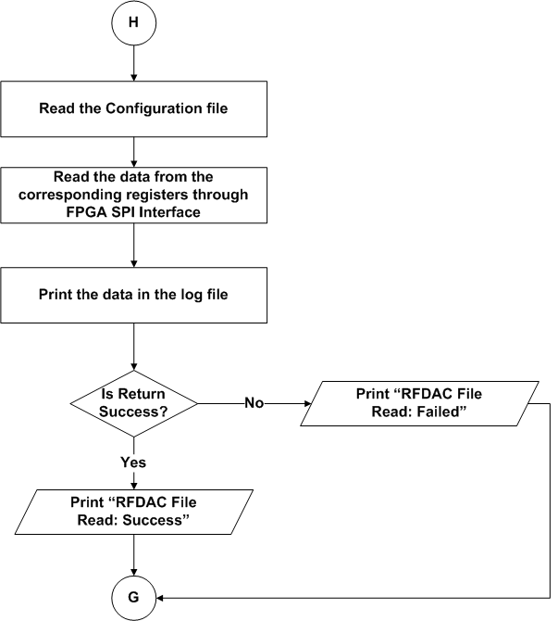
Figure 5.92: File Read

Single Data Write
- Refer the section 2.1.2.2.2.3 and 2.2.2.1.2 for module decomposition and data decomposition.

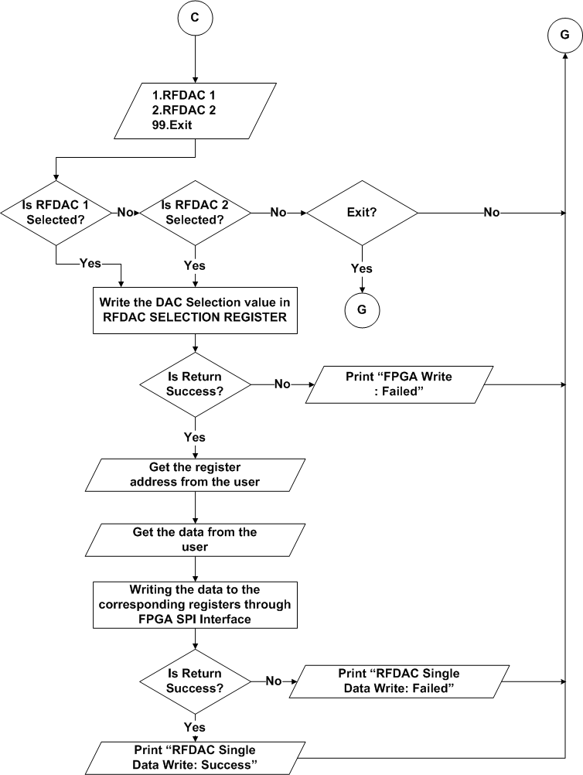
Figure 5.93 :Single Data Write

Single Data Read
- Refer the section 2.1.2.2.2.4 and 2.2.2.1.2 for module decomposition and data decomposition.
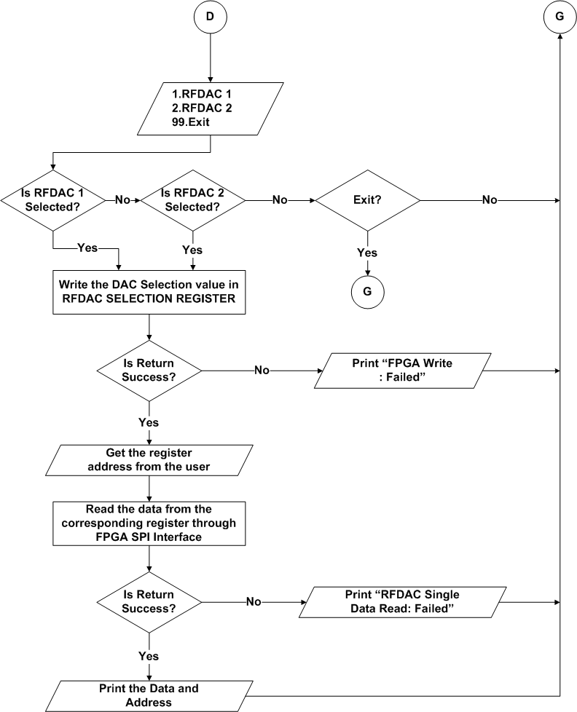
Figure 5.94: Single Data Read

Power Level Transmission

- Refer the section 2.1.2.2.2.5 and 2.2.2.1.2 for module decomposition and data decomposition.

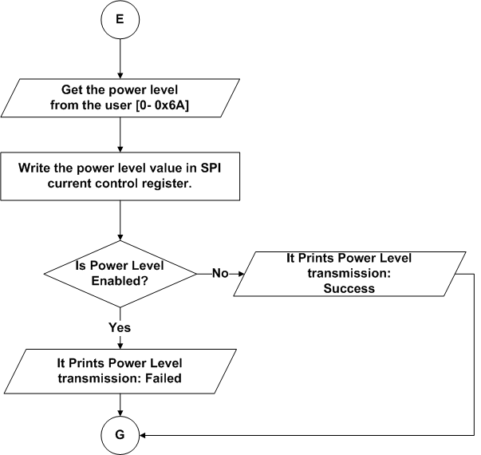
Figure 5.95: Power Level Transmission

RFDAC Data Transmission
- Refer the section 2.1.2.2.2.6 and 2.2.2.1.2 for module decomposition and data decomposition.
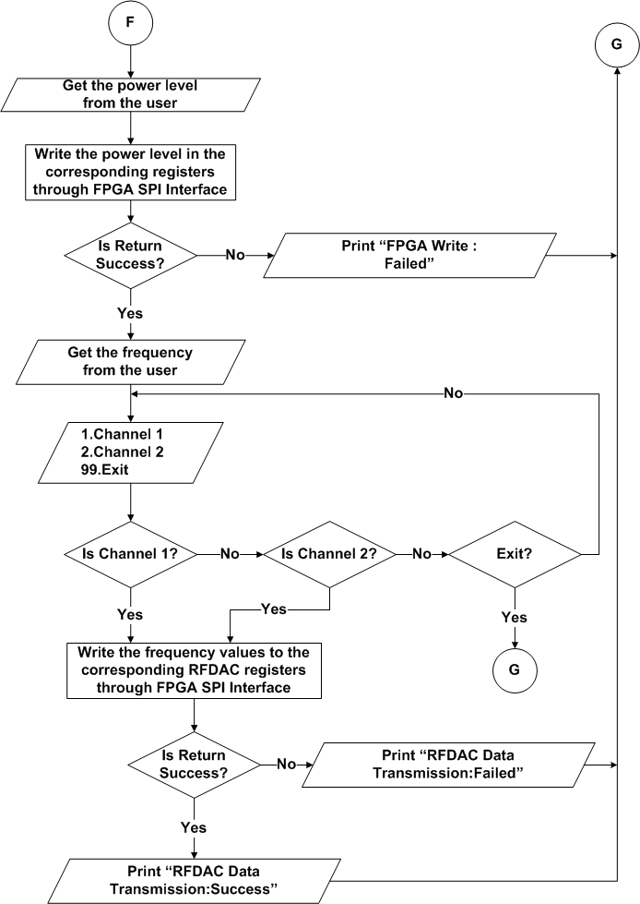
Figure 5.96 : RFDAC Data Transmission

RFDAC Reset
- Refer the section 2.1.2.2.2.7 and 2.2.2.1.2 for module decomposition and data decomposition.

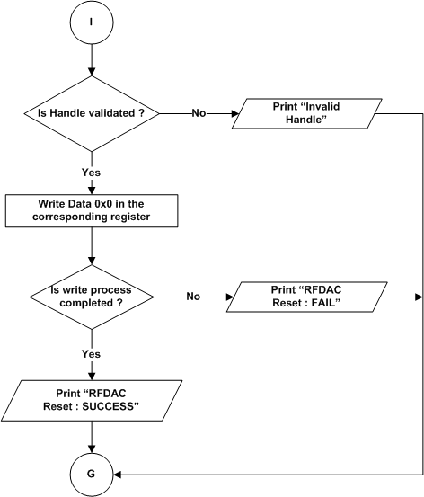
Figure 5.97 : RFDAC Reset

DPSPL1276 Module

Programmable Logic

LMK PLL Test

- Refer the section 5.1.1.2.1 for Flowchart.

File Configuration

- Refer the section 5.1.1.2.1.1 for Flowchart.

File Dump
- Refer the section 5.1.1.2.1.2 for Flowchart.

Single Data Write

- Refer the section 5.1.1.2.1.3 for Flowchart.

Single Data Read

- Refer the section 5.1.1.2.1.4 for Flowchart.

PLL Lock Status

- Refer the section 5.1.1.2.1.5 for Flowchart.

RFDAC Test

- Refer the section 5.1.2.1.2

File Write

- Refer the 5.1.2.1.2.1 for Flowchart.

File Read

- Refer the 5.1.2.1.2.2 for Flowchart.

Single Data Write

- Refer the 5.1.2.1.2.3 for Flowchart.

Single Data Read

- Refer the 5.1.2.1.2.4 for Flowchart.

Power Level Transmission

- Refer the 5.1.2.1.2.5 for Flowchart.

RFDAC Data Transmission

- Refer the 5.1.2.1.2.6 for Flowchart.

RFDAC Reset

- Refer the 5.1.2.1.2.7 for Flowchart.

Data Detailed Design

Board Information Data
- Board ID : DP-VPX-0233
- Hardware version : 1.00
- Software version : 1.00
- Serial number of the board : Serial number given for the specific board
- DDR4 size : 8 GB
- User flash size : 64 MB
- NAND Flash size : 16 GB
- MRAM size : 4 MB
- EEPROM size : 4 Kb

Requirements Traceability
Sl No. | Test Cases | Requirement ID in SRS | Section Number in SDD
1 | Processor Test | DP_VPX_0233_MANUAL_PS_PROCS | 2.1.1.3.1
1 | ALU Test | DP_VPX_0233_MANUAL_PS_PRCS_01 | 2.1.1.3.1.1
1 | FPU Test | DP_VPX_0233_MANUAL_PS_PRCS_02 | 2.1.1.3.1.2
2 | DDR4 Test | DP_VPX_0233_MANUAL_PS_DDR | 2.1.1.3.2
2 | Data bus Test | DP_VPX_0233_MANUAL_PS_DDR4_01 | 2.1.1.3.2.1
2 | Address bus Test | DP_VPX_0233_MANUAL_PS_DDR4_02 | 2.1.1.3.2.2
2 | Device Test | DP_VPX_0233_MANUAL_PS_DDR4_03 | 2.1.1.3.2.3
3 | EEPROM Test | DP_VPX_0233_MANUAL_PS_EEPROM | 2.1.1.3.3
3 | Upload Information Test | DP_VPX_0233_MANUAL_PS_EEPROM_01 | 2.1.1.3.3.1
3 | Data Retention Test | DP_VPX_0233_MANUAL_PS_EEPROM_02 | 2.1.1.3.3.2
3 | Checksum Test | DP_VPX_0233_MANUAL_PS_EEPROM_03 | 2.1.1.3.3.3
3 | Read/Write Test | DP_VPX_0233_MANUAL_PS_EEPROM_04 | 2.1.1.3.3.4
4 | MRAM Test | DP_VPX_0233_MANUAL_PS_MRAM | 2.1.1.3.4
4 | Upload Information Test | DP_VPX_0233_MANUAL_PS_MRAM_01 | 2.1.1.3.4.1
4 | Data Retention Test | DP_VPX_0233_MANUAL_PS_MRAM_02 | 2.1.1.3.4.2
4 | Checksum Test | DP_VPX_0233_MANUAL_PS_MRAM_03 | 2.1.1.3.4.3
4 | Full Memory Test | DP_VPX_0233_MANUAL_PS_MRAM_04 | 2.1.1.3.4.4
5 | NAND Test | DP_VPX_0233_MANUAL_PS_NAND | 2.1.1.3.5
5 | Upload Information Test | DP_VPX_0233_MANUAL_PS_NAND_01 | 2.1.1.3.5.1
5 | Data Retention Test | DP_VPX_0233_MANUAL_PS_NAND_02 | 2.1.1.3.5.2
5 | Checksum Test | DP_VPX_0233_MANUAL_PS_NAND_03 | 2.1.1.3.5.3
6 | NOR Test | DP_VPX_0233_MANUAL_PS_NOR | 2.1.1.3.6
6 | Upload Information Test | DP_VPX_0233_MANUAL_PS_NOR_01 | 2.1.1.3.6.1
6 | Data Retention Test | DP_VPX_0233_MANUAL_PS_NOR_02 | 2.1.1.3.6.2
6 | Checksum Test | DP_VPX_0233_MANUAL_PS_NOR_03 | 2.1.1.3.6.3
7 | USB Test | DP_VPX_0233_MANUAL_PS_USB | 2.1.1.3.7
7 | Read/Write Test | DP_VPX_0233_MANUAL_PS_USB_01 | 2.1.1.3.7.1
8 | SATA Test | DP_VPX_0233_MANUAL_PS_SATA | 2.1.1.3.8
8 | Read/Write Test | DP_VPX_0233_MANUAL_PS_SATA_01 | 2.1.1.3.8.1
9 | UART Test | DP_VPX_0233_MANUAL_PS_UART | 2.1.1.3.9
9 | Write Test | DP_VPX_0233_MANUAL_PS_UART_01 | 2.1.1.3.9.1
9 | Read Test | DP_VPX_0233_MANUAL_PS_UART_02 | 2.1.1.3.9.2
10 | Ethernet Test | DP_VPX_0233_MANUAL_PS_ETHERNET | 2.1.1.3.10
10 | Ethernet ping Test | DP_VPX_0233_MANUAL_PS_ETHERNET_01 | 2.1.1.3.10.1
11 | RTC Test | DP_VPX_0233_MANUAL_PS_RTC | 2.1.1.3.11
12 | PCI Enumeration Test | DP_VPX_0233_MANUAL_PS_PCI | 2.1.1.3.12
13 | Temperature Sensor Test | DP_VPX_0233_MANUAL_PS_TEMPSNSR | 2.1.1.3.13
14 | Voltage Monitoring Test | DP_VPX_0233_MANUAL_PS_ADM | 2.1.1.3.14
15 | LMK PLL Test | DP_VPX_0233_MANUAL_PL_LMK_PLL | 2.1.1.4.1
15 | File Configuration | DP_VPX_0233_MANUAL_PL_LMK_PLL_01 | 2.1.1.4.1.1
15 | File Dump | DP_VPX_0233_MANUAL_PL_LMK_PLL_02 | 2.1.1.4.1.2
15 | Single Data Write | DP_VPX_0233_MANUAL_PL_LMK_PLL_03 | 2.1.1.4.1.3
15 | Single Data Read | DP_VPX_0233_MANUAL_PL_LMK_PLL_04 | 2.1.1.4.1.4
15 | PLL Lock Status | DP_VPX_0233_MANUAL_PL_LMK_PLL_05 | 2.1.1.4.1.5
15 | Sysref Enable/Disable | DP_VPX_0233_MANUAL_PL_LMK_PLL_06 | 2.1.1.4.1.6
15 | Sysref Enable | DP_VPX_0233_MANUAL_PL_LMK_PLL_06_01 | 2.1.1.4.1.6.1
15 | Sysref Disable | DP_VPX_0233_MANUAL_PL_LMK_PLL_06_02 | 2.1.1.4.1.6.2
16 | AFE7906 ADC Test | DP_VPX_0233_MANUAL_PL_ADC | 2.1.1.4.2
16 | AFE Core Reset | DP_VPX_0233_MANUAL_PL_ADC_01 | 2.1.1.4.2.1
16 | AFE Single Write | DP_VPX_0233_MANUAL_PL_ADC_02 | 2.1.1.4.2.2
16 | AFE Single Read | DP_VPX_0233_MANUAL_PL_ADC_03 | 2.1.1.4.2.3
16 | AFE Bring up | DP_VPX_0233_MANUAL_PL_ADC_04 | 2.1.1.4.2.4
16 | AFE Core Initialization | DP_VPX_0233_MANUAL_PL_ADC_05 | 2.1.1.4.2.5
16 | JESD Bond Status | DP_VPX_0233_MANUAL_PL_ADC_06 | 2.1.1.4.2.6
16 | ADC Data Logging | DP_VPX_0233_MANUAL_PL_ADC_07 | 2.1.1.4.2.7
16 | HD2 Correction Enable | DP_VPX_0233_MANUAL_PL_ADC_08 | 2.1.1.4.2.8
16 | HD2 Coefficient Write | DP_VPX_0233_MANUAL_PL_ADC_08_01 | 2.1.1.4.2.8.1
16 | HD2 Coefficient Read | DP_VPX_0233_MANUAL_PL_ADC_08_02 | 2.1.1.4.2.8.2
16 | NCO Update | DP_VPX0233_MANUAL_PL_ADC_09 | 2.1.1.4.2.9
16 | All Channel Enable | DP_VPX0233_MANUAL_PL_ADC_09_01 | 2.1.1.4.2.9.1
16 | Single Channel Enable | DP_VPX0233_MANUAL_PL_ADC_09_02 | 2.1.1.4.2.9.2
16 | All Channel Disable | DP_VPX0233_MANUAL_PL_ADC_09_03 | 2.1.1.4.2.9.3
16 | Single Channel Disable | DP_VPX0233_MANUAL_PL_ADC_09_04 | 2.1.1.4.2.9.4
16 | AFE Dynamic Configuration | DP_VPX_0233_MANUAL_PL_ADC_10 | 2.1.1.4.2.10
16 | Device Health Status | DP_VPX_0233_MANUAL_PL_ADC_10_01 | 2.1.1.4.2.10.1
16 | Update Rx NCO | DP_VPX_0233_MANUAL_PL_ADC_10_02 | 2.1.1.4.2.10.2
16 | Set Rx DSA | DP_VPX_0233_MANUAL_PL_ADC_10_03 | 2.1.1.4.2.10.3
16 | Update Fb NCO | DP_VPX_0233_MANUAL_PL_ADC_10_04 | 2.1.1.4.2.10.4
16 | Set Fb DSA | DP_VPX_0233_MANUAL_PL_ADC_10_05 | 2.1.1.4.2.10.5
16 | Read Rx NCO | DP_VPX_0233_MANUAL_PL_ADC_10_06 | 2.1.1.4.2.10.6
16 | Read Fb NCO | DP_VPX_0233_MANUAL_PL_ADC_10_07 | 2.1.1.4.2.10.7
16 | Band selection | DP_VPX_0233_MANUAL_PL_AFE7906_ADC_11 | 2.1.1.4.2.11
16 | ADC Automation | DP_VPX_0233_MANUAL_PL_ADC_12 | 2.1.1.4.2.12
16 | Data Logging | DP_VPX_0233_MANUAL_PL_ADC_12_01 | 2.1.1.4.2.12.1
16 | Host Application | DP_VPX_0233_MANUAL_PL_ADC_12_01_01 | 2.1.1.4.2.12.1.1
16 | Target Application | DP_VPX_0233_MANUAL_PL_ADC_12_01_02 | 2.1.1.4.2.12.1.2
16 | Phase Matching | DP_VPX_0233_MANUAL_PL_ADC_12_02 | 2.1.1.4.2.12.2
16 | Host Application | DP_VPX_0233_MANUAL_PL_ADC_12_02_01 | 2.1.1.4.2.12.2.1
16 | Target Application | DP_VPX_0233_MANUAL_PL_ADC_12_02_02 | 2.1.1.4.2.12.2.2
17 | RFDAC Test | DP_VPX_0233_MANUAL_PL_RFDAC | 2.1.2.2.2
17 | File Write | DP_VPX_0233_MANUAL_PL_RFDAC_01 | 2.1.2.2.2.1
17 | File Read | DP_VPX_0233_MANUAL_PL_RFDAC_02 | 2.1.2.2.2.2
17 | Single Data Write | DP_VPX_0233_MANUAL_PL_RFDAC_03 | 2.1.2.2.2.3
17 | Single Data Read | DP_VPX_0233_MANUAL_PL_RFDAC_04 | 2.1.2.2.2.4
17 | Power Level Transmission | DP_VPX_0233_MANUAL_PL_RFDAC_05 | 2.1.2.2.2.5
17 | RFDAC Data Transmission | DP_VPX_0233_MANUAL_PL_RFDAC_06 | 2.1.2.2.2.6
17 | RFDAC Reset | DP_VPX_0233_MANUAL_PL_RFDAC_07 | 2.1.2.2.2.7
18 | LVTTL Test | DP_VPX_0233_MANUAL_PL_LVTTL | 2.1.1.4.3
18 | IO Mode Test | DP_VPX_0233_MANUAL_PL_LVTTL_01 | 2.1.1.4.3.1
18 | Clock Mode Test | DP_VPX_0233_MANUAL_PL_LVTTL_02 | 2.1.1.4.3.2
18 | Manual IO Mode Test | DP_VPX_0233_MANUAL_PL_LVTTL_03 | 2.1.1.4.3.3
18 | Manual Clock Mode Test | DP_VPX_0233_MANUAL_PL_LVTTL_04 | 2.1.1.4.3.4
18 | Manual Clock ON Test | DP_VPX_0233_MANUAL_PL_LVTTL_04_01 | 2.1.1.4.3.4.1
18 | Manual Clock OFF Test | DP_VPX_0233_MANUAL_PL_LVTTL_04_02 | 2.1.1.4.3.4.2
19 | LVDS Test | DP_VPX_0233_MANUAL_PL_LVDS | 2.1.1.4.4
19 | IO Mode Test | DP_VPX_0233_MANUAL_PL_LVDS_01 | 2.1.1.4.4.1
19 | Clock Mode Test | DP_VPX_0233_MANUAL_PL_LVDS_02 | 2.1.1.4.4.2
19 | Manual Mode Test | DP_VPX_0233_MANUAL_PL_LVDS_03 | 2.1.1.4.4.3
20 | GPI/GPO Test | DP_VPX_0233_MANUAL_PL_GPI_GPO | 2.1.1.4.5
20 | IO Mode Test | DP_VPX_0233_MANUAL_PL_GPI_GPO_01 | 2.1.1.4.5.1
21 | UART(PL) Test | DP_VPX_0233_MANUAL_PL_UART | 2.1.1.4.6
21 | Write Test | DP_VPX_0233_MANUAL_PL_UART_01 | 2.1.1.4.6.1
21 | Read Test | DP_VPX_0233_MANUAL_PL_UART_02 | 2.1.1.4.6.2
22 | DDR4(PL) Test | DP_VPX_0233_MANUAL_PL_DDR4 | 2.1.1.4.7
22 | DDR4 Reset | DP_VPX_0233_MANUAL_PL_DDR4_01 | 2.1.1.4.7.1
22 | Data bus test | DP_VPX_0233_MANUAL_PL_DDR4_02 | 2.1.1.4.7.3
22 | Address bus test | DP_VPX_0233_MANUAL_PL_DDR4_03 | 2.1.1.4.7.4
22 | Device test | DP_VPX_0233_MANUAL_PL_DDR4_04 | 2.1.1.4.7.5
22 | Full Memory test | DP_VPX_0233_MANUAL_PL_DDR4_05 | 2.1.1.4.7.2
23 | 10G Ethernet Test | DP_VPX_0233_MANUAL_PL_10G | 2.1.1.4.8
23 | Lane Repeater Configuration | DP_VPX_0233_MANUAL_PL_10G_01 | 2.1.1.4.8.1
23 | Core Reset | DP_VPX_0233_MANUAL_PL_10G_02 | 2.1.1.4.8.2
23 | Ethernet Reset | DP_VPX_0233_MANUAL_PL_10G_03 | 2.1.1.4.8.3
23 | Network Configuration | DP_VPX_0233_MANUAL_PL_10G_04 | 2.1.1.4.8.4
23 | Transmit Data | DP_VPX_0233_MANUAL_PL_10G_05 | 2.1.1.4.8.5
23 | Receiver Packet Summary | DP_VPX_0233_MANUAL_PL_10G_06 | 2.1.1.4.8.6

Appendix A
Structure Name : _SDPVPX0233_Command_Header
Member Name | Type | Description
m_uiHeader | Unsigned int | It indicates the test case Id for performing the respective test case operations.  DPVPX0233_HDR_HOST_CMD = 0x40510C3D,  DPVPX0233_HDR_TRGT_RSP = 0x1B610859
m_ucGroupID | Unsigned Char | It refers the selected test mode such as ADC Automation and Phase Matching.  DPVPX0233_GID_ADC = 0,  DPVPX0233_GID_ADC_PHASE_MATCH = 1
m_ucTestID | Unsigned Char | It indicates the test case Id for performing the respective test case operations .  DPVPX0233_TID_ADC_AUTOMATION = 0,  DPVPX0233_TID_ADC_PHASE_MATCH = 1

Structure Name : _SDPVPX0233_Command_Packet
Member Name | Type | Description
m_SHeader | SDPVPX0233_Command_Header | It refers the fixed value for data integrity.
m_usDataSz | Unsigned Short | It refers the Size of the data.
m_arrcData | Char | It refers the Array of Buffer data.
m_ucCheckSum | Unsigned Char | It refers the Checksum of this packet to identify the data loss.

Structure Name : _SDPVPX0233_Response_Packet
Member Name | Type | Description
m_SHeader | SDPVPX0233_Command_Header | It refers the fixed value for data integrity.
m_usDataSz | Unsigned Short | It refers the Size of the data.
m_arrcData | Char | It refers the Array of Buffer data.
m_cMsgStatus | Char | It refers the Status of the command packet.
m_ucCheckSum | Unsigned Char | It refers the Checksum of this packet to identify the data loss.

Appendix B
Description for Phase Matching Buttons:

Get Data :
This Button is used to get the Non-Calibrated values and their Phase Angle and Fundamental Power of each channels in ADC through Target Application.

Calibrate Phase :
This Button is used to Export the Phase Difference of the ADC channels in Log file. This File contains Phase Matching values of All ADC Channels.

Measure Phase Difference :
This Button is used to get Calibrated values and their Phase Angle and Fundamental Power of each channels in ADC.

