Technical Specification – Multifunctional Display

1. Document Control
- Title: Multifunctional Display Technical Specification
- Version: 1.0
- Date: April 2026
- Author: Product Engineering Team
- Approved by: Head of R&D
- Revision Policy: Updates will be issued quarterly or upon major design changes.

2. Introduction
This document defines the technical requirements, design parameters, and compliance standards for the multifunctional display. It ensures consistency across engineering, manufacturing, and quality assurance teams. The display is intended for professional and consumer environments where portability, versatility, and high-quality visuals are critical.
The specification covers hardware, software, performance, and compliance aspects. It also outlines testing procedures and maintenance guidelines to guarantee long-term reliability.

3. Product Overview
The multifunctional display is a 15.6-inch Full HD IPS touchscreen designed to serve as a portable workstation, educational smart display, and entertainment hub. It combines high-resolution visuals with intuitive touch interaction, multiple connectivity options, and advanced display modes.
Key differentiators:
- Ultra-thin aluminum chassis for portability
- Multi-device input support (USB-C, HDMI, wireless)
- Split-screen and picture-in-picture functionality
- Cross-platform compatibility (Windows, macOS, Linux, Android)

4. System Architecture
The system integrates several subsystems to deliver seamless performance:
- Display Panel: IPS LCD with LED backlight for wide viewing angles and color accuracy.
- Touch Controller: Capacitive sensing IC supporting 10-point multi-touch and gesture recognition.
- Main Processor: Embedded ARM-based controller managing input/output and display modes.
- Connectivity Modules: USB-C with Power Delivery, HDMI 2.0, Wi-Fi 6, Bluetooth 5.2.
- Power Management: Intelligent IC regulating power consumption and thermal performance.
Data flows from input sources (wired/wireless) through the processor, which manages scaling, rendering, and display output.
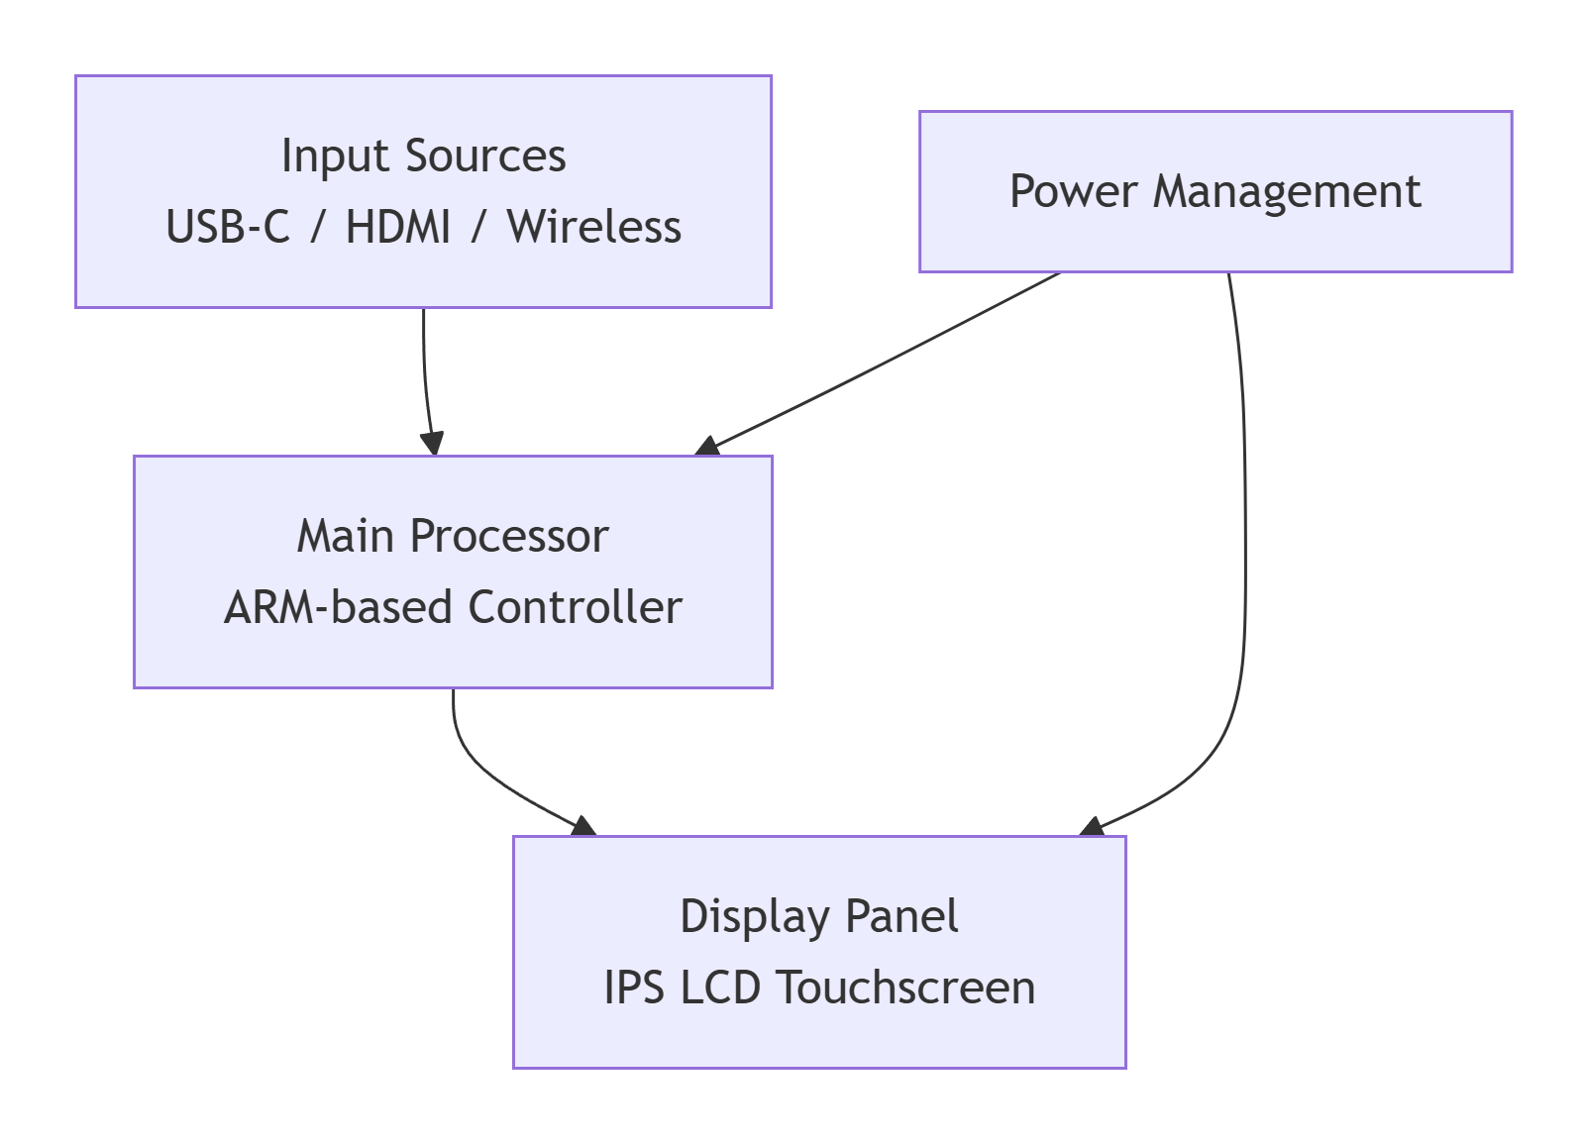

5. Technical Specifications

5.1 Display Characteristics
- Size: 15.6 inches diagonal
- Resolution: 1920 × 1080 (Full HD)
- Aspect Ratio: 16:9
- Brightness: 350 nits typical, 400 nits peak
- Contrast Ratio: 1200:1
- Color Gamut: 100% sRGB, 72% NTSC coverage
- Viewing Angles: 178° horizontal/vertical

5.2 Touch & Input Features
- Technology: Capacitive multi-touch (10-point)
- Gestures: Pinch, zoom, swipe, rotate, drag-and-drop
- Stylus Support: Passive stylus with 2 mm precision

5.3 Connectivity
- Wired: USB-C (DisplayPort Alt Mode + Power Delivery), HDMI 2.0, USB-A 3.0
- Wireless: Wi-Fi 6 (802.11ax), Bluetooth 5.2
- Expansion: MicroSD card slot (up to 1 TB)

5.4 Performance
- Refresh Rate: 60 Hz
- Response Time: 5 ms (GtG)
- Power Consumption: 18 W typical, 25 W max
- Operating Temperature: 0 °C to 40 °C
- Storage Temperature: -20 °C to 60 °C

5.5 Mechanical & Physical
- Dimensions: 360 mm × 220 mm × 9 mm
- Weight: 1.2 kg
- Mounting: VESA 100 × 100 mm compatible
- Materials: CNC-machined aluminum chassis, tempered glass front, matte anti-glare coating

6. Functional Requirements
- Display Modes: Split-screen, picture-in-picture, extended desktop, mirroring.
- Multi-device Connectivity: Supports simultaneous input from two sources (e.g., laptop + smartphone).
- User Interface: On-screen display menu with capacitive buttons for brightness, contrast, and mode selection.
- Software Compatibility: Plug-and-play with Windows, macOS, Linux, Android. No drivers required for basic functions.

7. Compliance & Standards
- Safety: IEC 62368-1 compliant for audio/video equipment.
- Certifications: CE, FCC, UL, RoHS, Energy Star.
- Environmental: WEEE directive compliance, recyclable packaging, lead-free solder.
- Industry-specific: Meets automotive vibration standards for in-vehicle use.

8. Testing & Validation
- Brightness Uniformity: ±10% across screen surface.
- Touch Accuracy: ±1 mm tolerance across active area.
- EMI/EMC: Tested per FCC Part 15 Class B.
- Drop Test: Survives 1 m drop on all six sides.
- Lifecycle Testing: 30,000 hours backlight life, 10 million touch cycles.
- Thermal Stress: Continuous operation at 40 °C for 72 hours.

9. Maintenance & Support
- Firmware Updates: Delivered via USB-C or OTA (Wi-Fi).
- Troubleshooting: Built-in diagnostic mode accessible via OSD.
- Warranty: 2 years limited warranty covering manufacturing defects.
- Customer Support: 24/7 online support portal, regional service centers.

10. Appendices
- Glossary:
  - IPS – In-Plane Switching
  - sRGB – Standard Red Green Blue color space
  - PD – Power Delivery
- Acronyms: HDMI, USB-C, OTA, FCC
- Revision History:
  - v1.0 – Initial release (April 2026)

