Passive RF Signal Detector (ESM Pod)

1. Mission Profile
- Environment: Battlefield EW screen (mounted on mast or MRZR vehicle).
- Target Goals: Detect and geolocate enemy drones (DJI, Mavic), squad radios (PRC-152), and man-in-the-middle attacks.
- Range: 5km (handheld radio), 15km (drone video link).
- Constraints: Must be passive (no emissions). EMI hardened against 50V/m.

2. System Architecture
- Architecture: Antenna array -> Tuner -> FPGA -> ARM CPU -> Ethernet -> GCS.
- Data Pipeline: I/Q samples -> FFT -> Signal Detection -> CNN Classifier -> TDOA Geolocation.

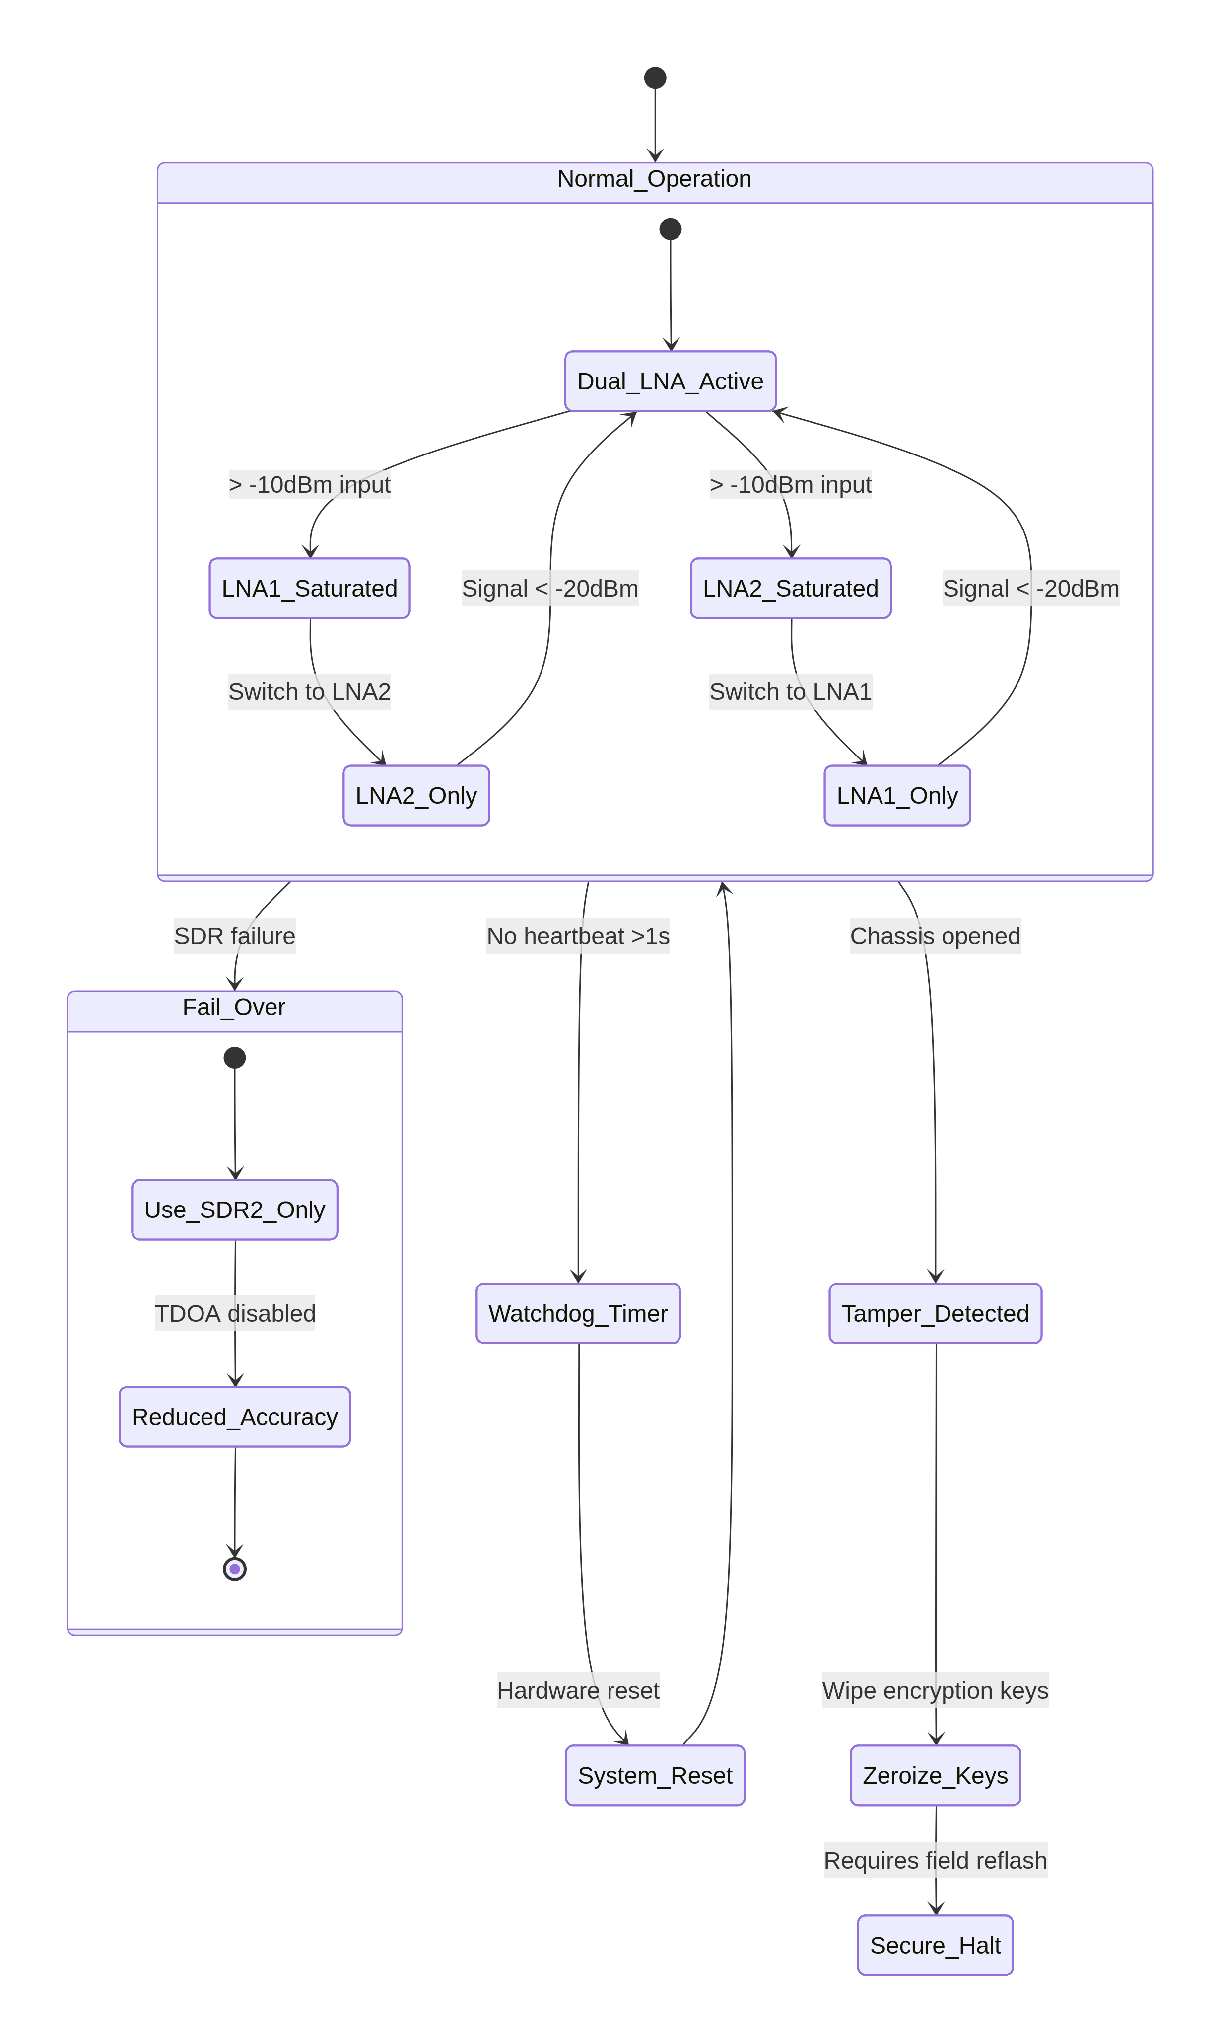
- Redundancy: Dual-channel LNAs to prevent saturation if near friendly transmitter.

3. Hardware Design
- RF Frontend: Ettus Research B205mini (70MHz – 6GHz) or Analog Devices AD9363.
- FPGA: Xilinx Zynq 7020 (FFT acceleration).
- CPU: i.MX 8M Plus (Cortex-A53) for classification.
- Antenna: 4x Crossed-loop Magnetic (H-field) for direction finding.

4. BOM
Component | Model | Specs | Qty | Rationale
SDR | ADALM-PLUTO Rev C | 325 MHz to 3.8 GHz | 1 | Low cost, 2x2 MIMO
FPGA | Artix-7 A100T | 100k logic cells | 1 | Real-time FFT
LNA | Mini-Circuits ZX60-P105LN+ | 0.4dB NF | 4 | Boost weak drone signals

5. Software Stack
- OS: Yocto Project (Poky) for minimal attack surface.
- Signal: GNU Radio 3.10 with custom OOT module for de-hopping.
- AI: TFLite Micro for "Drone/Not Drone" classifier on waterfall images.

6. Real-Time
- Sampling: 61.44 MSPS.
- Latency: < 10ms from signal arrival to frequency ID.

7. AI Model
- Architecture: 1D-CNN on I/Q samples (MobileNetV1 style depthwise conv).
- Optimization: CMSIS-NN on Cortex-M7 core inside Zynq.

8. Security
- Anti-tamper: Voltage glitch detection (TI TPS3808) wipes encryption keys if chassis opened.

9. Deployment
- Field Cal: Automated noise floor calibration at power-up.

10. Validation
- Test: Anritsu MS2720B signal generator simulating frequency-hopping drones.

11. Ruggedization
- Enclosure: IP67, milled aluminum acting as heat sink for the AD9363.

12. Limitations
- Scan speed: Full 6GHz scan takes 2 seconds (misses short burst transmissions).

13. Upgrades
- Add AI: Correlate RF signature with acoustic drone sound for confirmation.

14. AI Model Details – Production Implementation

14.1 Model Architecture

