1.

void setup()

{

pinMode(12, OUTPUT);

pinMode(13, OUTPUT);

pinMode(11, OUTPUT);

pinMode(10, OUTPUT);

pinMode(2, INPUT);

}

void loop()

{

int val=digitalRead(2);

if(val==HIGH)

{

digitalWrite(10, HIGH);

delay(250); // Wait for 250 millisecond(s)

digitalWrite(10,LOW);

delay(250);

digitalWrite(11, HIGH);

delay(250); // Wait for 250 millisecond(s)

digitalWrite(11,LOW);

delay(250);

digitalWrite(13, HIGH);

delay(250);

digitalWrite(13,LOW);

delay(250);

digitalWrite(12, HIGH);

delay(250);

digitalWrite(12, LOW);

delay(250);

if(val==HIGH)

{

digitalWrite(12, HIGH);

delay(500); // Wait for 250 millisecond(s)

digitalWrite(12,LOW);

delay(500);

digitalWrite(13, HIGH);

delay(500); // Wait for 250 millisecond(s)

digitalWrite(13,LOW);

delay(500);

digitalWrite(11, HIGH);

delay(500);

digitalWrite(11,LOW);

delay(500);

digitalWrite(10, HIGH);

delay(500);

digitalWrite(10, LOW);

delay(500);

}

}

}

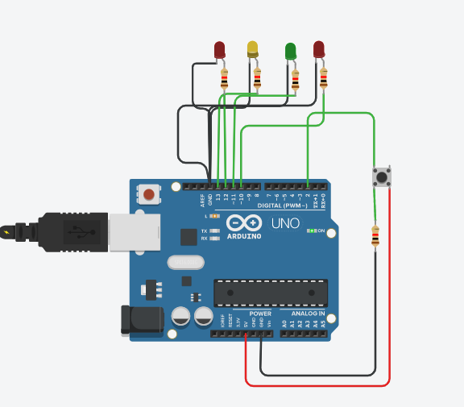

2.

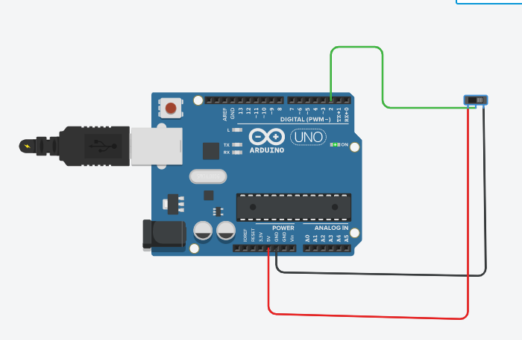

int i=1,j=1;

void setup()

{

Serial.begin(9600);

pinMode(2, INPUT);

}

void loop()

{

int val=digitalRead(2);

if(val==HIGH && i==1)

{

Serial.print("Sagar Gv\n");

i++;

}

else if(val==LOW && j==1)

{

Serial.print("20BCE1753\n");

j++;

}

}

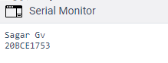

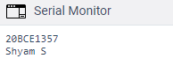

3.

int segpins[]={5,4,7,8,9,11,10,6};

int segcode[16][8]={

{0,0,0,0,0,0,1,1},

{1,0,0,1,1,1,1,1},

{0,0,1,0,0,1,0,1},

{0,0,0,0,1,1,0,1},

{1,0,0,1,1,0,0,1},

{0,1,0,0,1,0,0,1},

{0,1,0,0,0,0,0,1},

{0,0,0,1,1,1,1,1},

{0,0,0,0,0,0,0,1},

{0,0,0,0,1,0,0,1},

{0,0,0,0,0,1,0,1},

{1,1,0,0,0,0,0,1},

{0,1,1,0,0,0,1,1},

{1,0,0,0,0,1,0,1},

{0,0,1,0,0,0,0,1},

{0,1,1,1,0,0,0,1},};

void setup()

{

for(int i=0;i<16;i++){

pinMode(segpins[i], OUTPUT);}

}

void loop()

{

for(int r=0;r<16;r++){

for(int c=0;c<8;c++){

digitalWrite(segpins[c],segcode[r][c]);}

delay(1000); // Wait for 1000 millisecond(s)

}

delay(1000);

for(int r=15;r>=0;r--){

for(int c=7;c>=0;c--){

digitalWrite(segpins[c],segcode[r][c]);}

delay(1000); // Wait for 1000 millisecond(s)

}

}

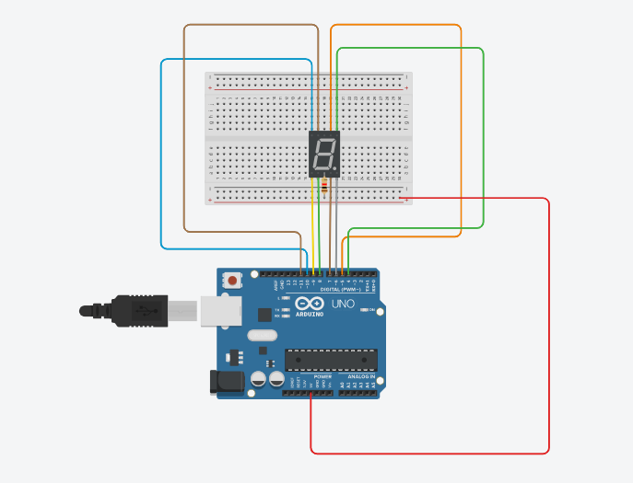

4.

int sensor_pin=11;

int relay_pin= 2;

int output;

void setup()

{

pinMode(sensor_pin, INPUT);

pinMode(relay_pin,OUTPUT);

}

void loop()

{

output=digitalRead(sensor_pin);

if(output==1)

{

digitalWrite(relay_pin,HIGH);

delay(5000);

}

else if(output==0)

{

digitalWrite(relay_pin,LOW);

}

delay(1000);

}

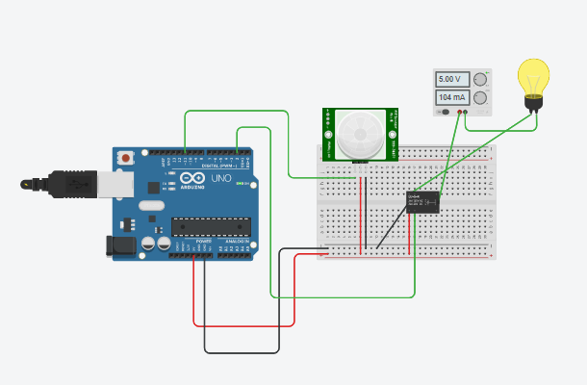

5.

#include <LiquidCrystal.h>

// initialize the library with the numbers of the interface pins

LiquidCrystal lcd(12, 11, 5, 4, 3, 2);

void setup()

{

// set up the LCD's number of columns and rows:

lcd.begin(16, 2);

}

void loop()

{

// set the cursor to column 0, line 0

lcd.setCursor(0, 0);

lcd.print("SAGAR GV");

lcd.setCursor(0,1);

lcd.print("20BCE1753");

delay(1000);

}

