Title: AI-Powered Detection of Phishing Websites Using URL and Webpage Features
Abstract
Phishing websites are one of the major cybersecurity threats because they imitate legitimate websites to deceive users into revealing sensitive information such as usernames, passwords, banking credentials, and personal details. Traditional phishing detection approaches based on blacklists and manually defined rules often struggle to identify newly generated and previously unseen phishing websites. This project proposes an AI-Powered Detection of Phishing Websites Using URL and Webpage Features framework that combines machine learning with URL, webpage, HTML, hyperlink, and text-based analysis to identify phishing and legitimate websites.
The proposed system uses multiple datasets, including the D1 phishing webpage dataset associated with the selected research work, the UCI Phishing Websites Dataset, and the PhiUSIIL Phishing URL Dataset. The system performs data cleaning, preprocessing, feature extraction, and feature engineering before training machine learning models. Important characteristics such as URL length, special characters, subdomains, HTML forms, scripts, iframes, hyperlinks, and suspicious webpage text are analyzed. Additional engineered features such as URL entropy, suspicious keyword score, brand similarity, external-link ratio, and form-domain mismatch are considered to improve the detection capability of the model.
Multiple machine learning models such as XGBoost, CatBoost, and LightGBM will be trained and compared using accuracy, precision, recall, F1-score, ROC-AUC, and confusion matrix. Feature selection and hyperparameter optimization will be used to improve model performance. To make the predictions understandable, explainable AI techniques such as SHAP or LIME will be incorporated to identify the features that contribute most significantly to the phishing or legitimate classification.
The resulting system will provide a web-based interface where users can submit a URL and receive a phishing prediction with an explanation. Prediction history and analysis results can also be stored in a database for monitoring and evaluation. The proposed framework aims to provide an accurate, explainable, and practical phishing website detection system by combining multiple datasets, enhanced feature engineering, optimized machine learning models, and real-world application deployment.
Datasets
Dataset | URL link
D1 – Phishing Webpage Dataset | Research paper / associated data source
UCI Phishing Websites Dataset | UCI Machine Learning Repository – Phishing Websites
PhiUSIIL Phishing URL Dataset | UCI Machine Learning Repository – PhiUSIIL

Approach
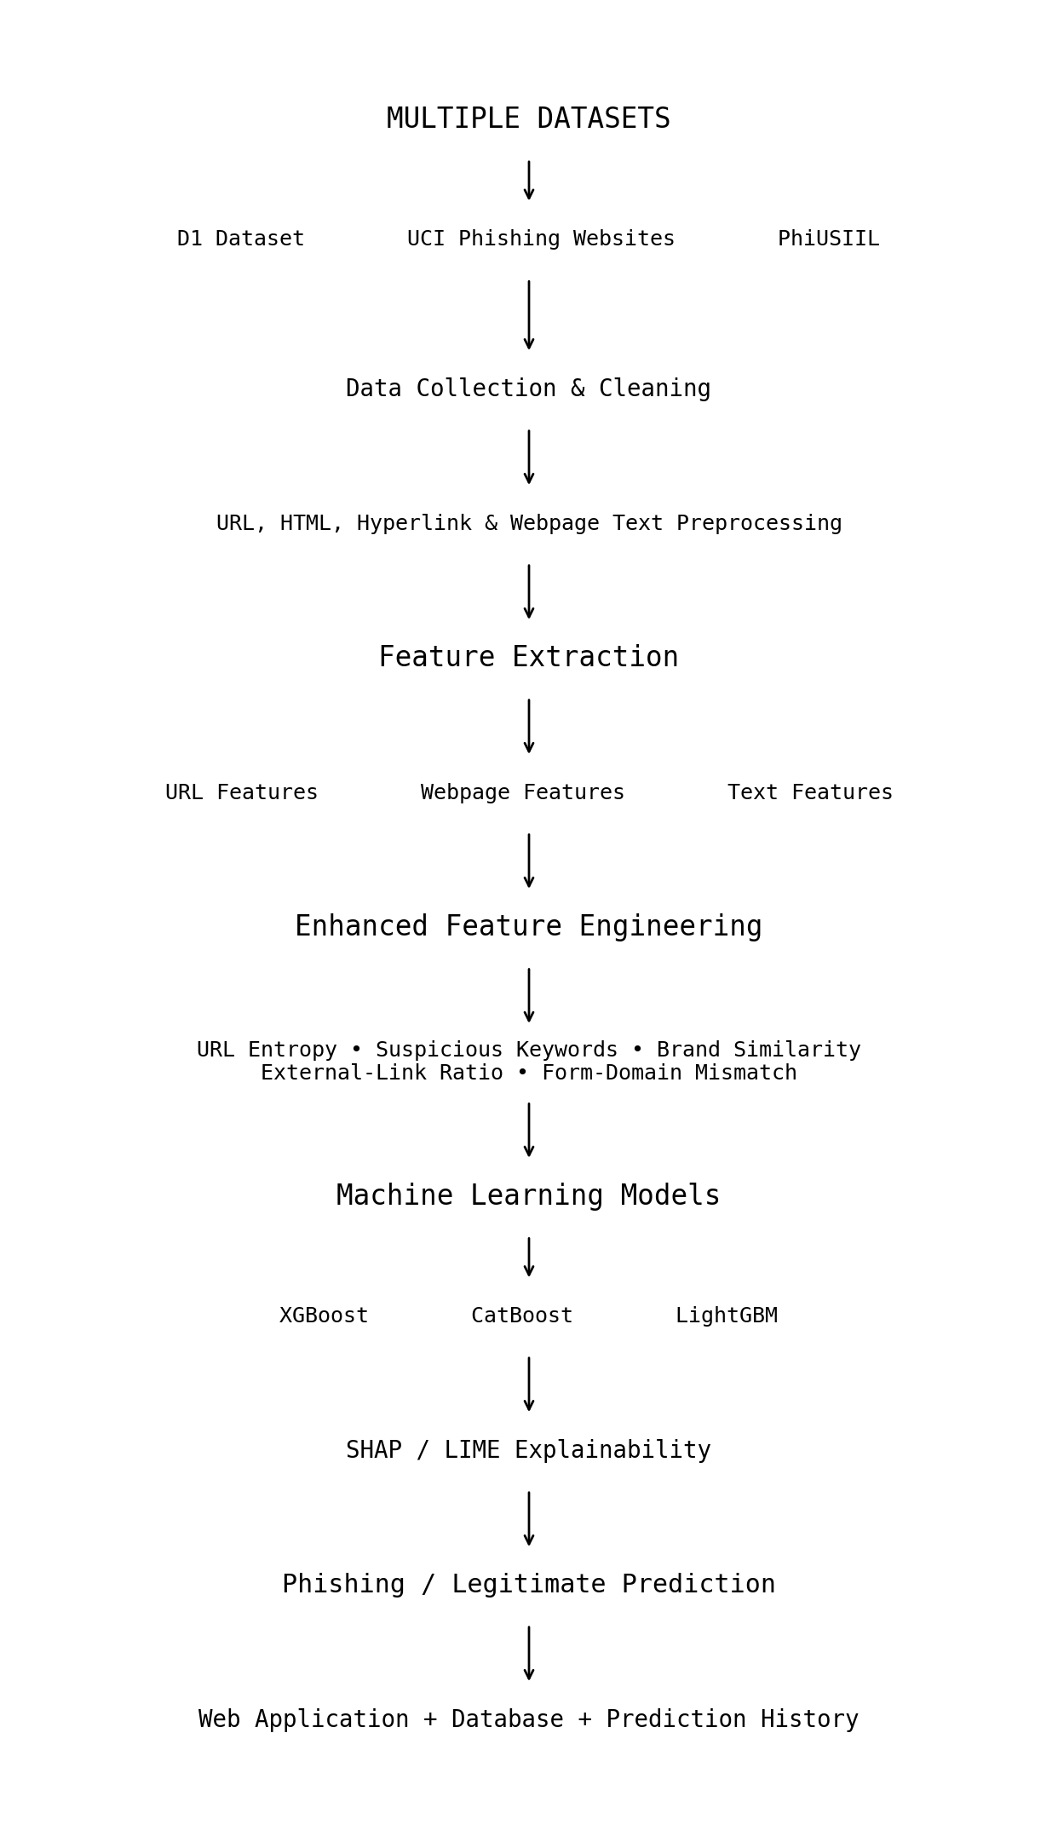
Project Group Members
S.No. | Roll.No. | Student Name
1 | 2420030182 | G. Manaswi
2 | 2420030100 | M. Aruna Grace

