Routing basically means navigating between pages. You have seen many sites with links that direct you to a new page. This can be achieved using routing. Here the pages that we are referring to will be in the form of components. We have already seen how to create a component. Let us now create a component and see how to use routing with it.

During the project setup, we have already included the routing module and the same is available in app.module.ts as shown below −

**app.module.ts**

import { NgModule } from '@angular/core';

import { BrowserModule } from '@angular/platform-browser';

import { AppComponent } from './app.component';

import { HomeComponent } from './home/home.component';

import { ContactusComponent } from './contactus/contactus.component';

import { AppRoutingModule } from './app.routing.module';

@NgModule({

declarations: [

AppComponent,

HomeComponent,

ContactusComponent

],

imports: [

BrowserModule,

AppRoutingModule

],

providers: [],

bootstrap: [AppComponent]

})

export class AppModule { }

**AppRoutingModule** is added as shown above and included in the imports array.

File details of **app.routing.module.ts** are given below –

import { NgModule } from '@angular/core';

import { Routes, RouterModule } from '@angular/router';

import { HomeComponent } from './home/home.component';

import { ContactusComponent } from './contactus/contactus.component';

const routes: Routes = [

{path:"home", component:HomeComponent},

{path:"contactus", component:ContactusComponent}

];

@NgModule({

imports: [RouterModule.forRoot(routes)],

exports: [RouterModule]

})

export class AppRoutingModule { }

Here, we have to note that this file is generated by default when the routing is added during project setup. If not added, the above files have to be added manually.

So in the above file, we have imported Routes and RouterModule from @angular/router.

There is a const **routes** defined which is of type Routes. It is an array which holds all the routes we need in our project.

The const routes is given to the RouterModule as shown in @NgModule. To display the routing details to the user, we need to add <router-outlet> directive where we want the view to be displayed.

The same is added in app.component.html as shown below−

<!DOCTYPE html>

<html>

<body>

<h1>Angular 7 Routing Demo</h1>

<nav>

<a routerLink = "/home">Home</a>

<a routerLink = "/contactus">Contact Us </a>

</nav>

<div>

<router-outlet></router-outlet>

</div>

</body>

</html>

Now let us create 2 components called as **Home** and **Contact Us** and navigate between them using routing.

Component Home

First, we shall discuss about Home. Following is the syntax for Component Home −

ng g component home

C:\projectA7\angular7-app>ng g component home CREATE

src/app/home/home.component.html (23 bytes) CREATE

src/app/home/home.component.spec.ts (614 bytes) CREATE

src/app/home/home.component.ts (261 bytes) CREATE

src/app/home/home.component.css (0 bytes) UPDATE

src/app/app.module.ts (692 bytes)

Component Contact Us

Following is the syntax for Component Contact Us −

ng g component contactus

C:\projectA7\angular7-app>ng g component contactus

CREATE src/app/contactus/contactus.component.html (28 bytes)

CREATE src/app/contactus/contactus.component.spec.ts (649 bytes)

CREATE src/app/contactus/contactus.component.ts (281 bytes)

CREATE src/app/contactus/contactus.component.css (0 bytes)

UPDATE src/app/app.module.ts (786 bytes)

In .html, we have added anchor links, Home and Contact us and used routerLink to give the path to the routes we have created in app.routing.module.ts.

Let us now test the same in the browser −

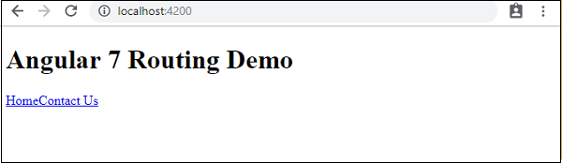

This is how we get it in browser. Let us add some styling to make the links look good.

We have added following css in app.component.css −

**a:link, a:visited {**

**background-color: #848686;**

**color: white;**

**padding: 10px 25px;**

**text-align: center;**

**text-decoration: none;**

**display: inline-block;**

**}**

**a:hover, a:active {**

**background-color: #BD9696;**

**}**

This is the display of the links in the browser −

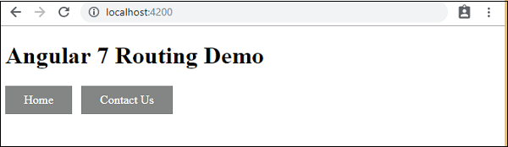

Click on Home link, to see the component details of home as shown below −

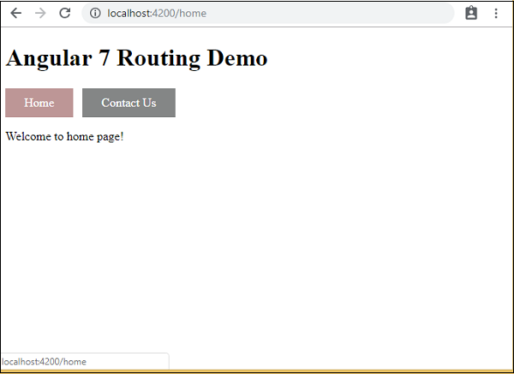

Click on Contact Us, to see its component details as given below −

