Angular 2 - Architecture

The following screenshot shows the anatomy of an Angular 2 application. Each application consists of Components. Each component is a logical boundary of functionality for the application. You need to have layered services, which are used to share the functionality across components.

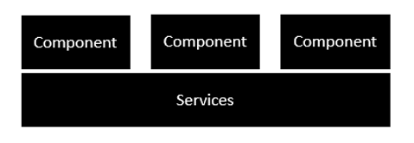

Following is the anatomy of a Component. A component consists of −

* **Class** − This is like a C++ or Java class which consists of properties and methods.
* **Metadata** − This is used to decorate the class and extend the functionality of the class.
* **Template** − This is used to define the HTML view which is displayed in the application.

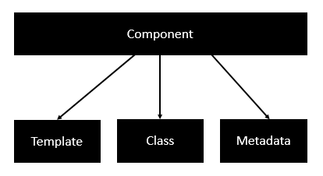

Following is an example of a component.

import { Component } from '@angular/core';

@Component ({

selector: 'my-app',

templateUrl: 'app/app.component.html'

})

export class AppComponent {

appTitle: string = 'Welcome';

}

Each application is made up of modules. Each Angular 2 application needs to have one Angular Root Module. Each Angular Root module can then have multiple components to separate the functionality.

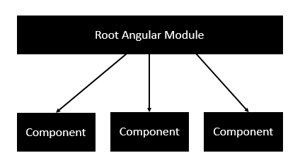

Following is an example of a root module.

import { NgModule } from '@angular/core';

import { BrowserModule } from '@angular/platform-browser';

import { AppComponent } from './app.component';

@NgModule ({

imports: [ BrowserModule ],

declarations: [ AppComponent ],

bootstrap: [ AppComponent ]

})

export class AppModule { }

Each application is made up of feature modules where each module has a separate feature of the application. Each Angular feature module can then have multiple components to separate the functionality.

