Angular 2 also has the facility to create custom pipes. The general way to define a custom pipe is as follows.

import { Pipe, PipeTransform } from '@angular/core';

@Pipe({name: 'Pipename'})

export class Pipeclass implements PipeTransform {

transform(parameters): returntype { }

}

Where,

* **'Pipename'** − This is the name of the pipe.
* **Pipeclass** − This is name of the class assigned to the custom pipe.
* **Transform** − This is the function to work with the pipe.
* **Parameters** − This are the parameters which are passed to the pipe.
* **Returntype** − This is the return type of the pipe.

Let’s create a custom pipe that multiplies 2 numbers. We will then use that pipe in our component class.

**Step 1** − First, create a file called multiplier.pipe.ts.

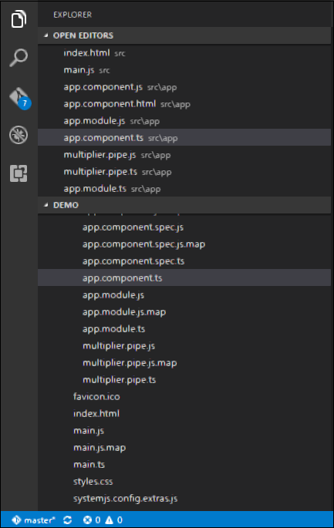

**Step 2** − Place the following code in the above created file.

import {

Pipe,

PipeTransform

} from '@angular/core';

@Pipe ({

name: 'Multiplier'

})

export class MultiplierPipe implements PipeTransform {

transform(value: number, multiply: string): number {

let mul = parseFloat(multiply);

return mul * value

}

}

Following points need to be noted about the above code.

* We are first importing the Pipe and PipeTransform modules.
* Then, we are creating a Pipe with the name 'Multiplier'.
* Creating a class called MultiplierPipe that implements the PipeTransform module.
* The transform function will then take in the value and multiple parameter and output the multiplication of both numbers.

**Step 3** − In the app.component.ts file, place the following code.

import {

Component

} from '@angular/core';

@Component ({

selector: 'my-app',

template: '<p>Multiplier: {{2 | Multiplier: 10}}</p>'

})

export class AppComponent { }

**Note** − In our template, we use our new custom pipe.

**Step 4** − Ensure the following code is placed in the app.module.ts file.

import {

NgModule

} from '@angular/core';

import {

BrowserModule

} from '@angular/platform-browser';

import {

AppComponent

} from './app.component';

import {

MultiplierPipe

} from './multiplier.pipe'

@NgModule ({

imports: [BrowserModule],

declarations: [AppComponent, MultiplierPipe],

bootstrap: [AppComponent]

})

export class AppModule {}

Following things need to be noted about the above code.

* We need to ensure to include our MultiplierPipe module.
* We also need to ensure it is included in the declarations section.

Once you save all the code changes and refresh the browser, you will get the following output.

