Download and install Jenkins

To download and install Jenkins:

* To ensure that your software packages are up to date on your instance, use the following command to perform a quick software update:

[ec2-user ~]$ sudo yum update –y

* Add the Jenkins repo using the following command:

[ec2-user ~]$ sudo wget -O /etc/yum.repos.d/jenkins.repo \

https://pkg.jenkins.io/redhat-stable/jenkins.repo

* Import a key file from Jenkins-CI to enable installation from the package:

[ec2-user ~]$ sudo rpm --import https://pkg.jenkins.io/redhat-stable/jenkins.io.key

[ec2-user ~]$ sudo yum upgrade

* Install Jenkins:

[ec2-user ~]$ sudo yum install jenkins java-1.8.0-openjdk-devel -y

[ec2-user ~]$ sudo systemctl daemon-reload

* Start Jenkins as a service:

[ec2-user ~]$ sudo systemctl start jenkins

You can check the status of the Jenkins service using the command:

[ec2-user ~]$ sudo systemctl status jenkins

Configure Jenkins

Jenkins is now installed and running on your EC2 instance. To configure Jenkins:

* Connect to http://<your_server_public_DNS>:8080 from your favorite browser. You will be able to access Jenkins through its management interface:

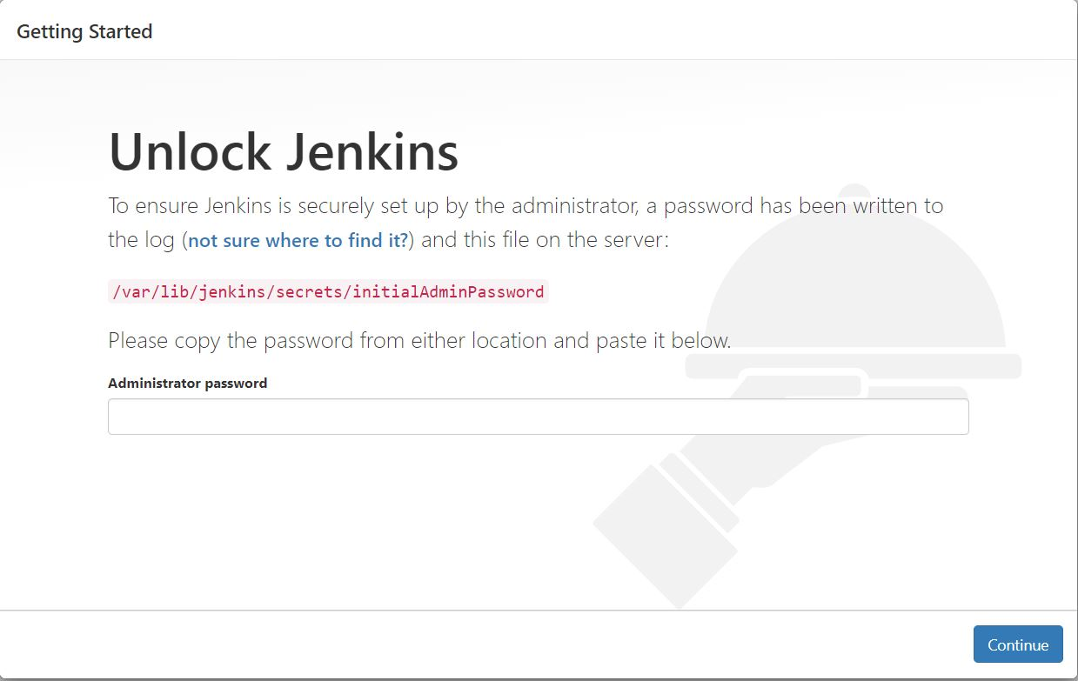

* As prompted, enter the password found in **/var/lib/jenkins/secrets/initialAdminPassword**.

Use the following command to display this password:

[ec2-user ~]$ sudo cat /var/lib/jenkins/secrets/initialAdminPassword

* The Jenkins installation script directs you to the **Customize Jenkins page**. Click **Install suggested plugins**.
* Once the installation is complete, **Create First Admin User**, click **Save and Continue**.

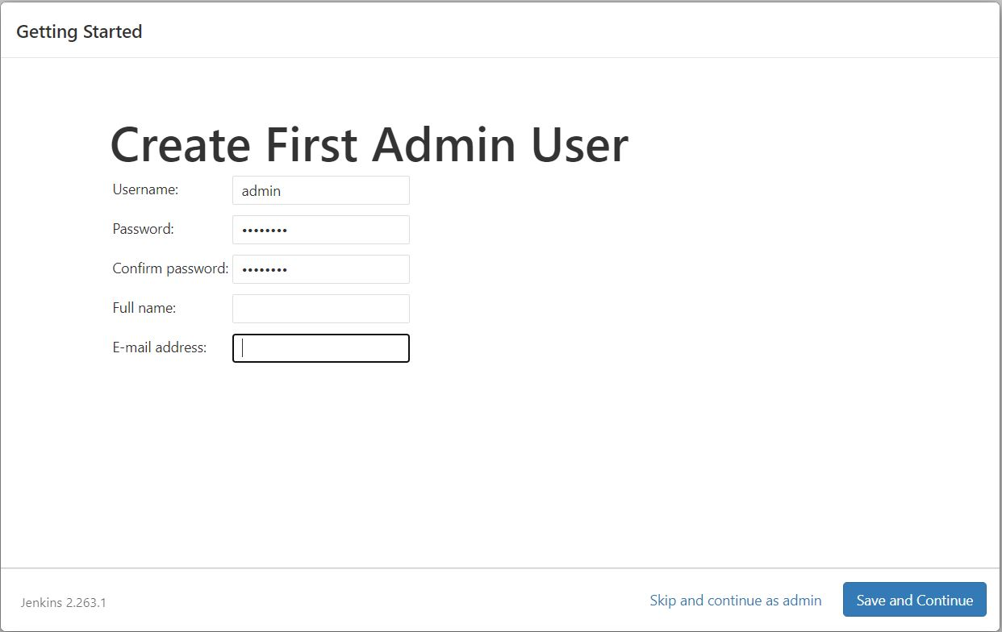

* On the left-hand side, click **Manage Jenkins**, and then click **Manage Plugins**.
* Click on the **Available** tab, and then enter **Amazon EC2 plugin** at the top right.
* Select the checkbox next to **Amazon EC2 plugin**, and then click **Install without restart**.

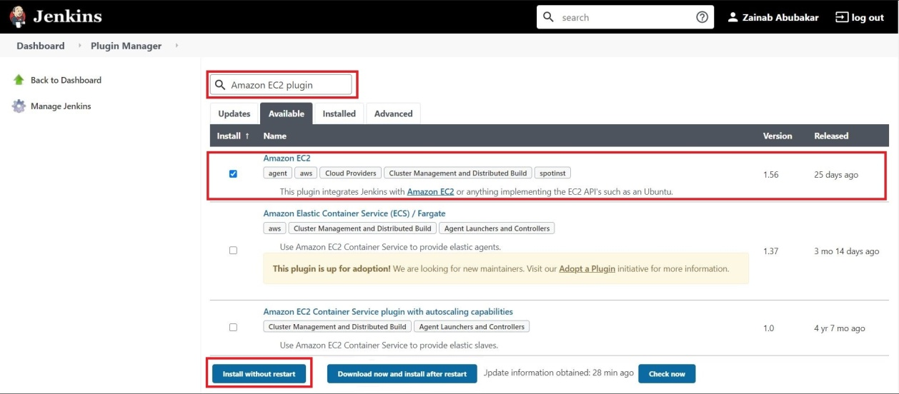

* Once the installation is done, click **Back to Dashboard**.
* Click on **Configure a cloud**.

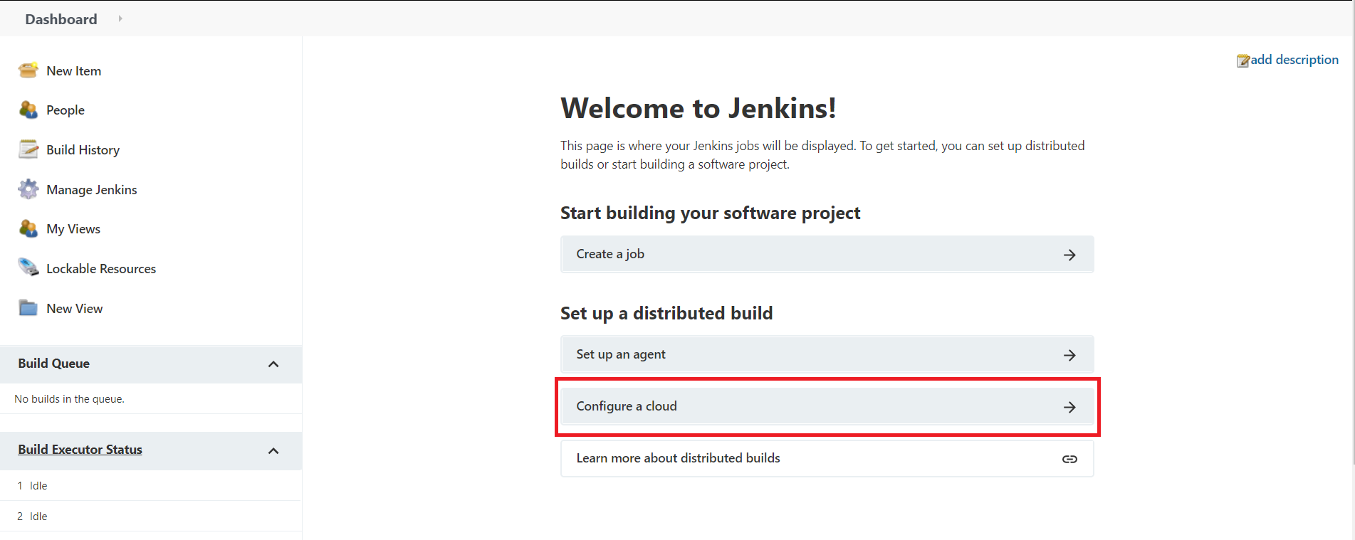

* Click **Add a new cloud**, and select **Amazon EC2**. A collection of new fields appears.
* Fill out all the fields. (Note: You will have to Add Credentials of the kind AWS Credentials.)

You are now ready to use EC2 instances as Jenkins agents.

Clean up

After completing this tutorial, be sure to delete the AWS resources that you created so that you do not continue to accrue charges.

Delete your EC2 instance

1. In the left-hand navigation bar of the Amazon EC2 console, choose **Instances**.
2. Right-click on the instance you created earlier and select **Terminate**.

