Create Bucket

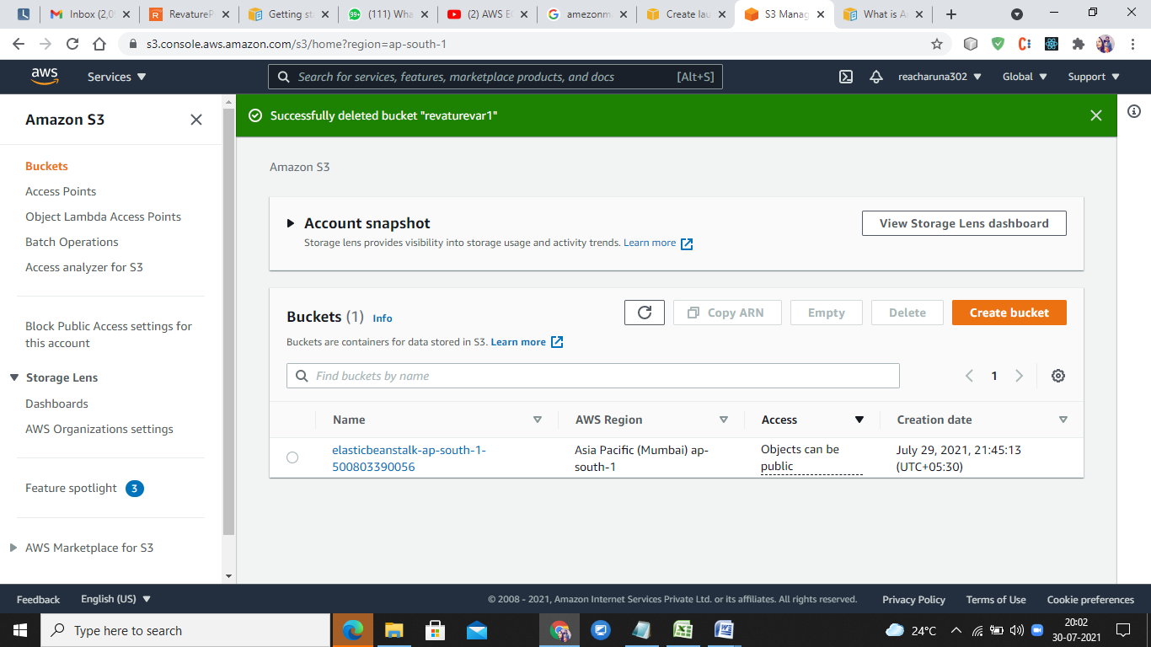

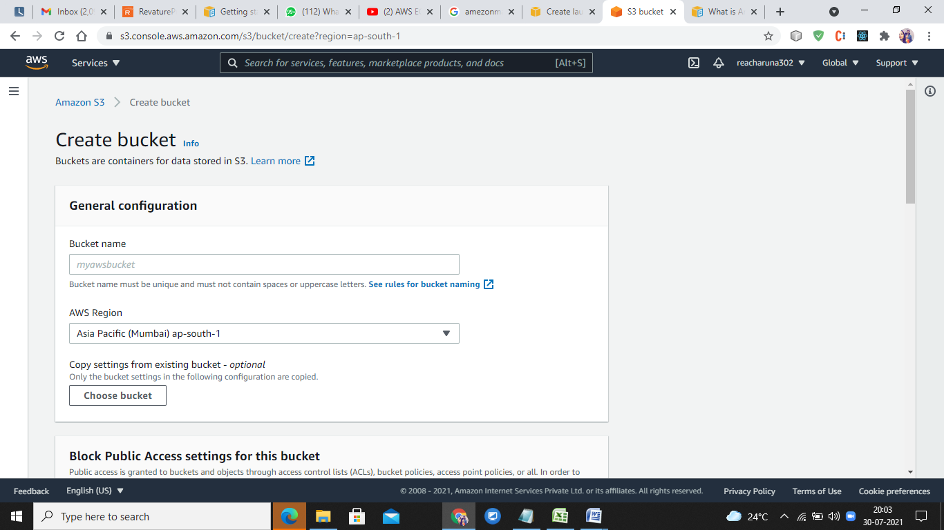

Select accessibility

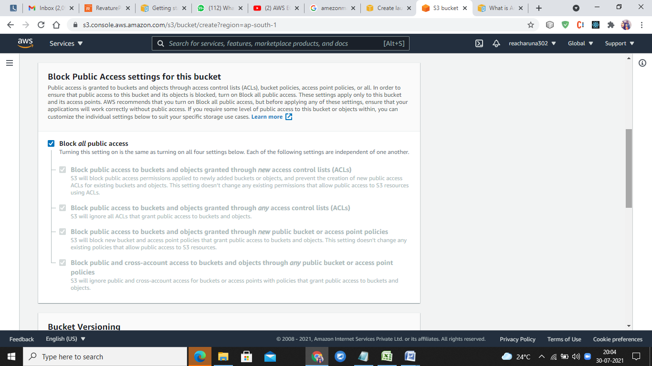

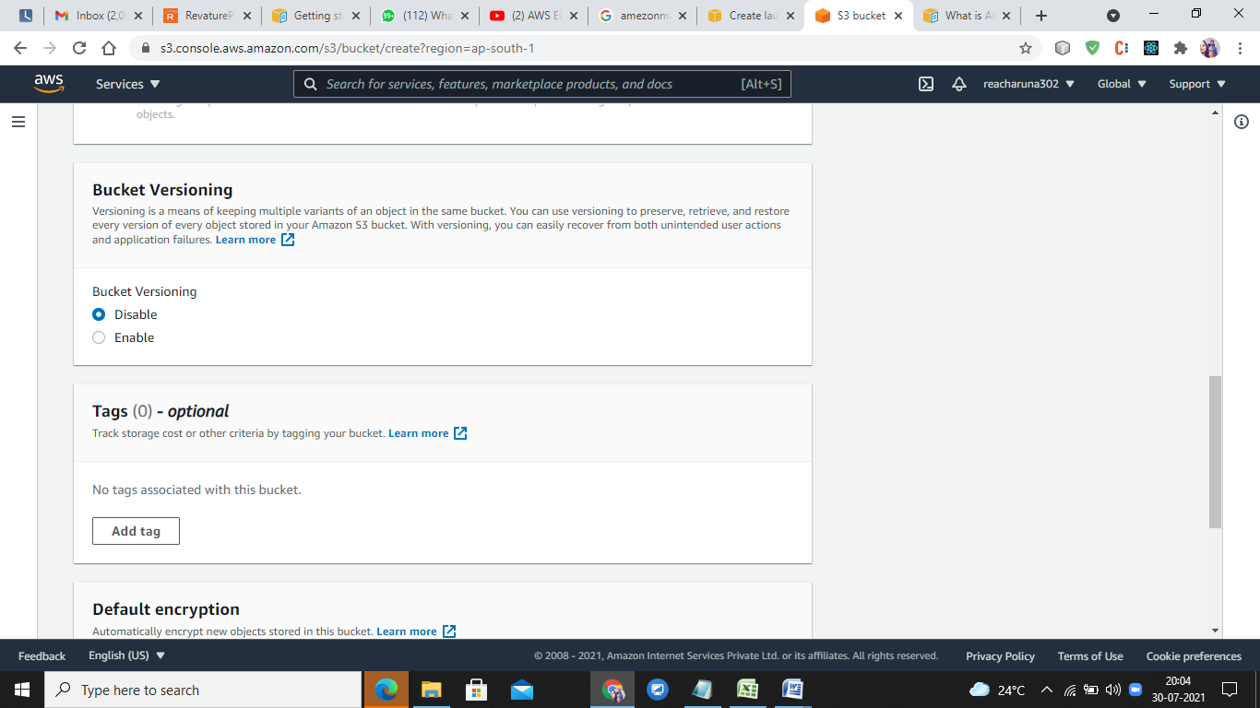

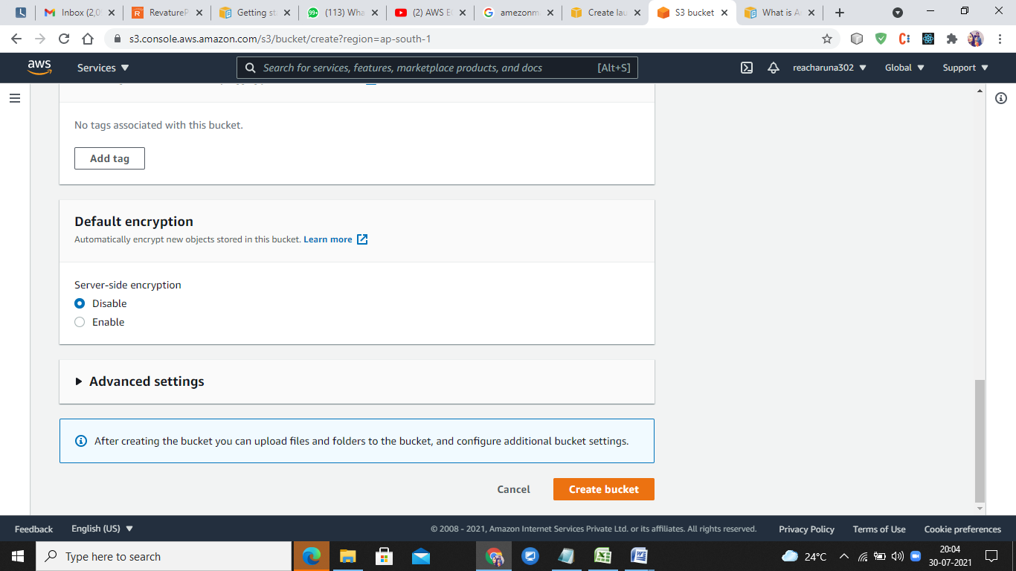

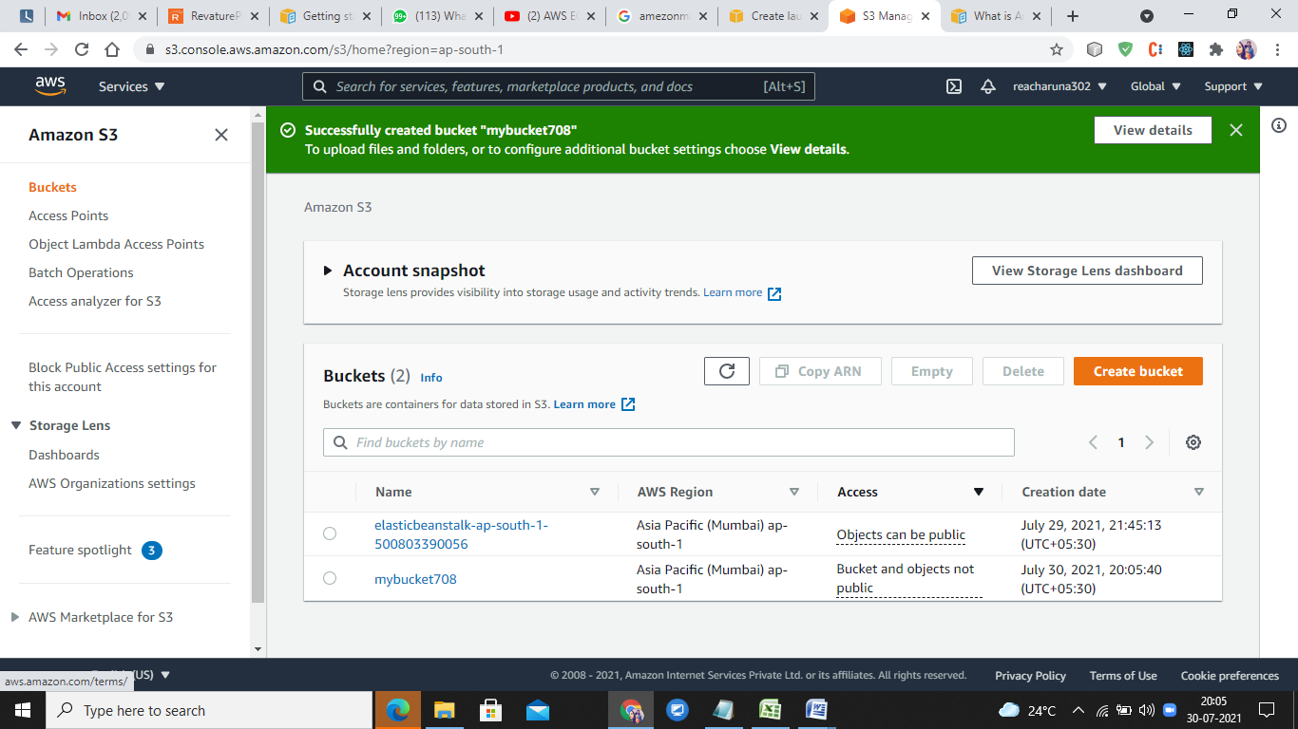

After bucket is created upload the resource

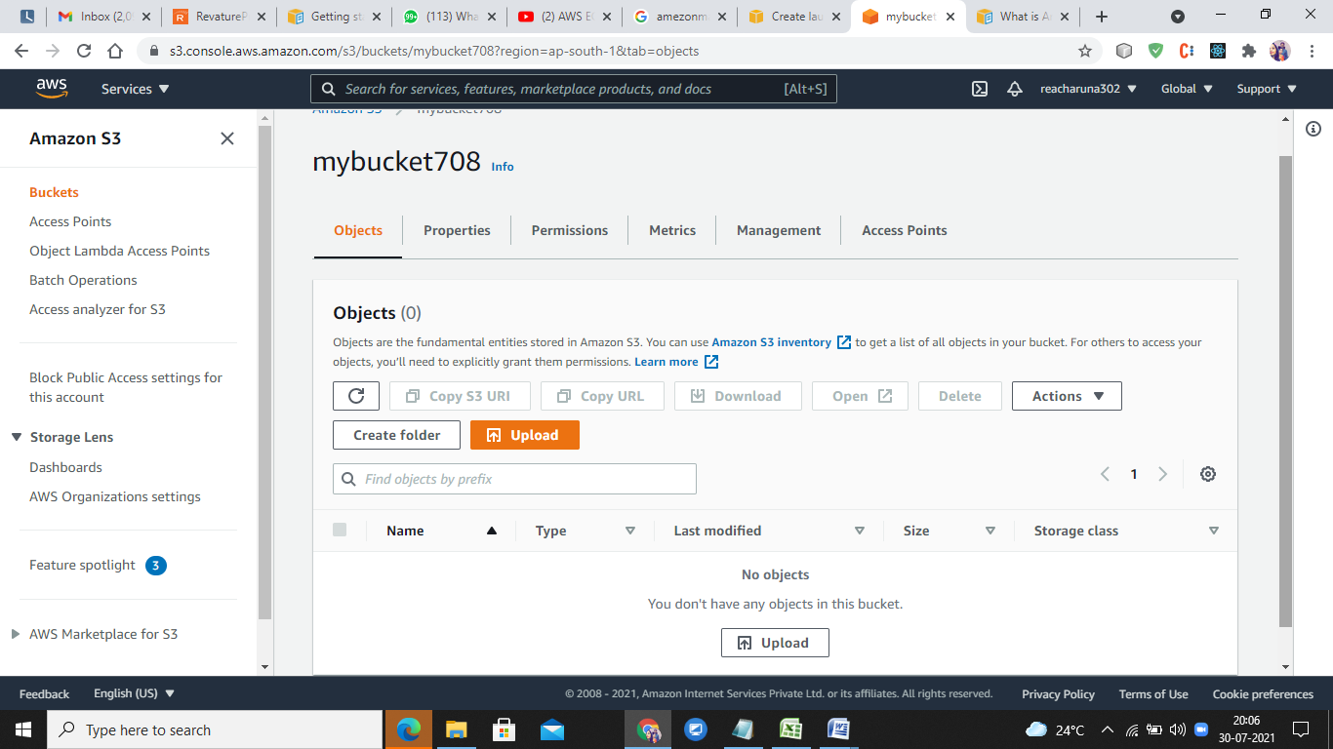

For Static web hosting upload any Html page

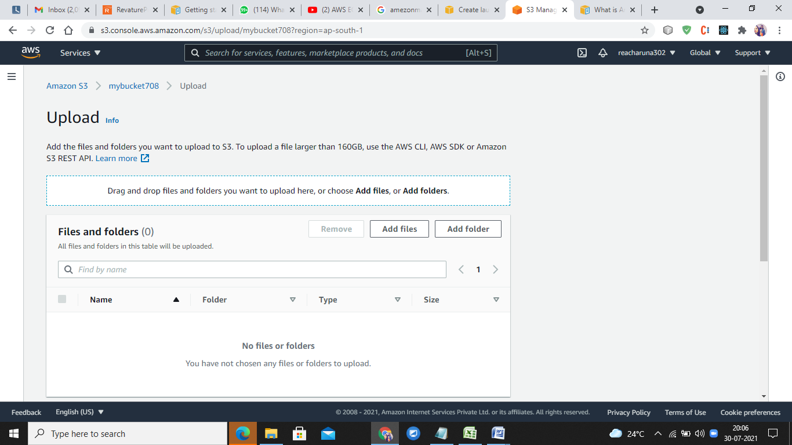

Sample menu.html is uploaded.

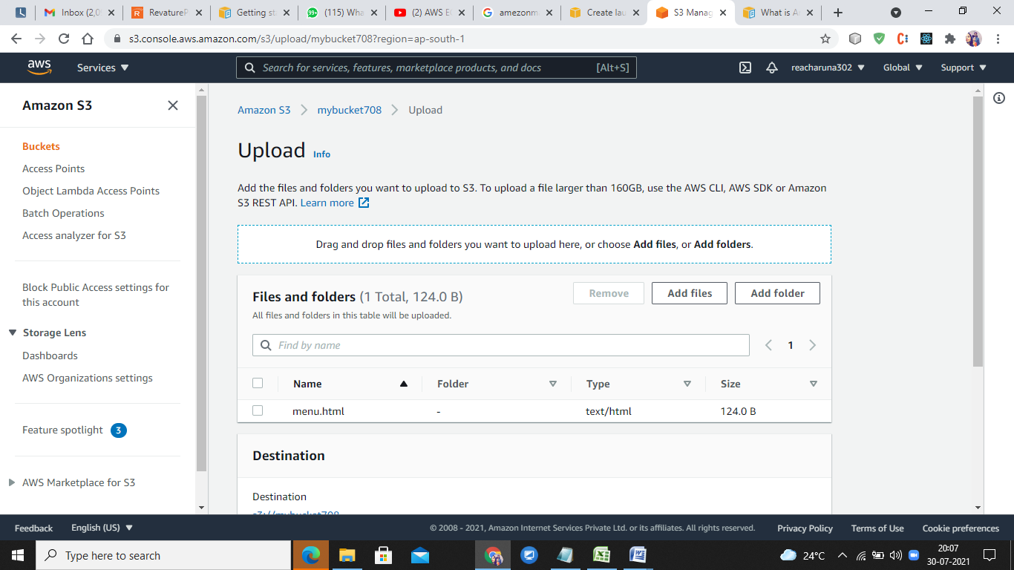

Choose destination and Permission

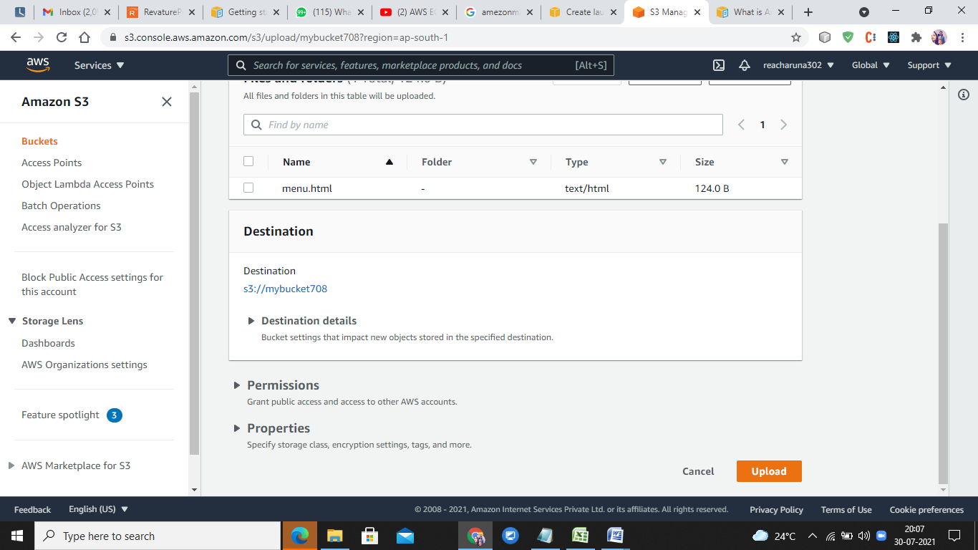

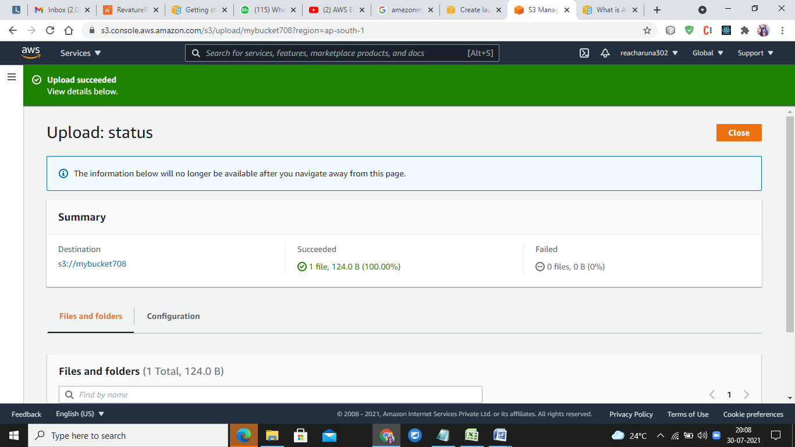

Ckicl on the file that is uploaded

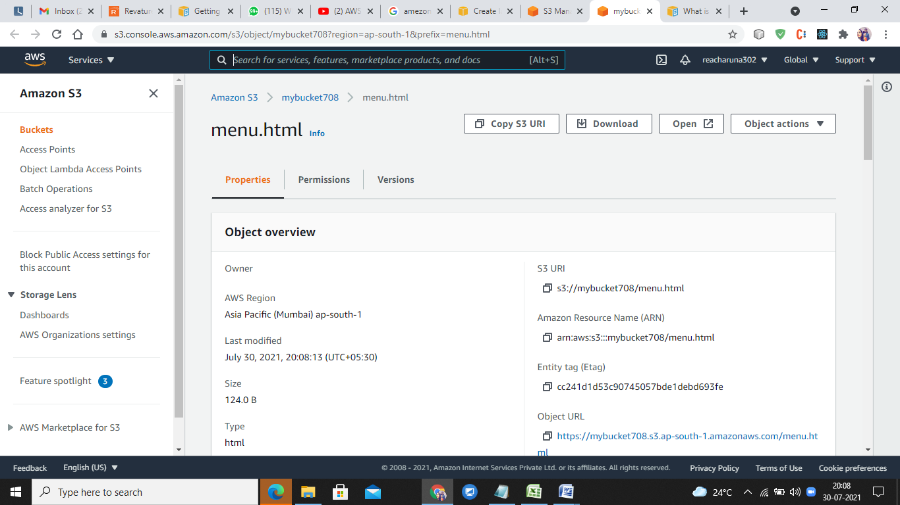

Clink on open button



This is stativ web hosting wth htmlpage using s3 bucket

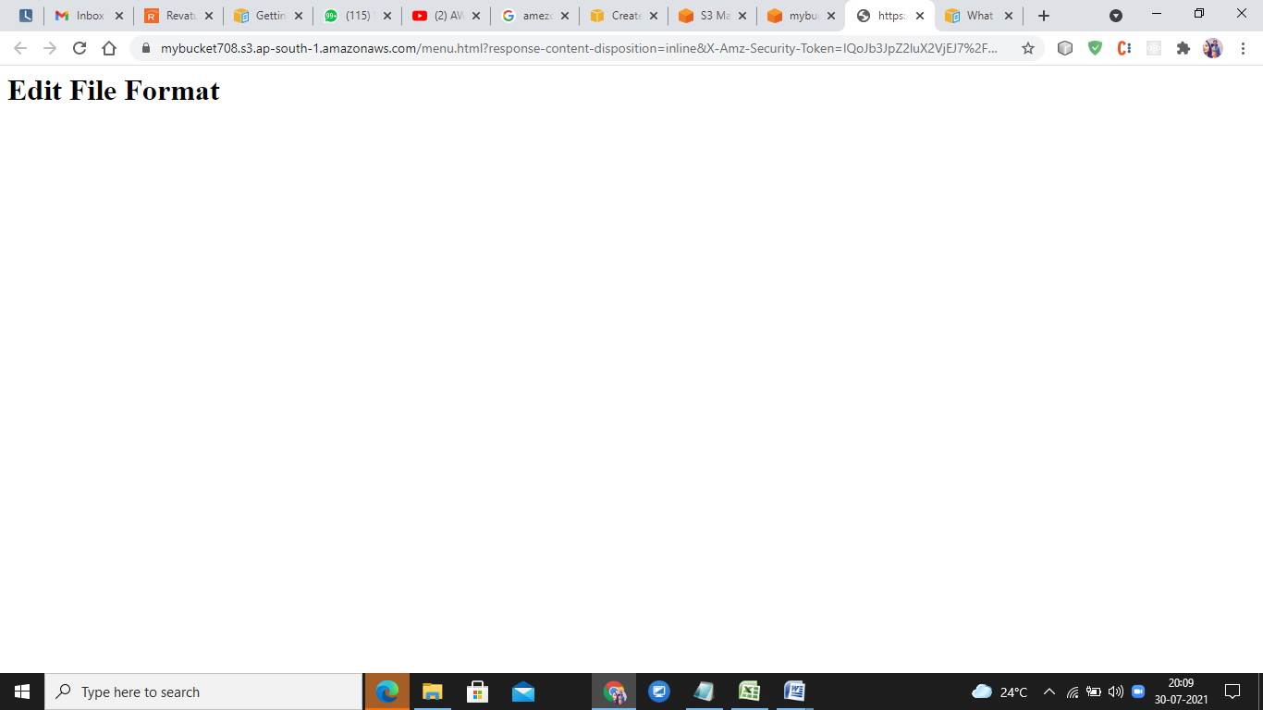

At the don’t forget to delete file and delete bucket

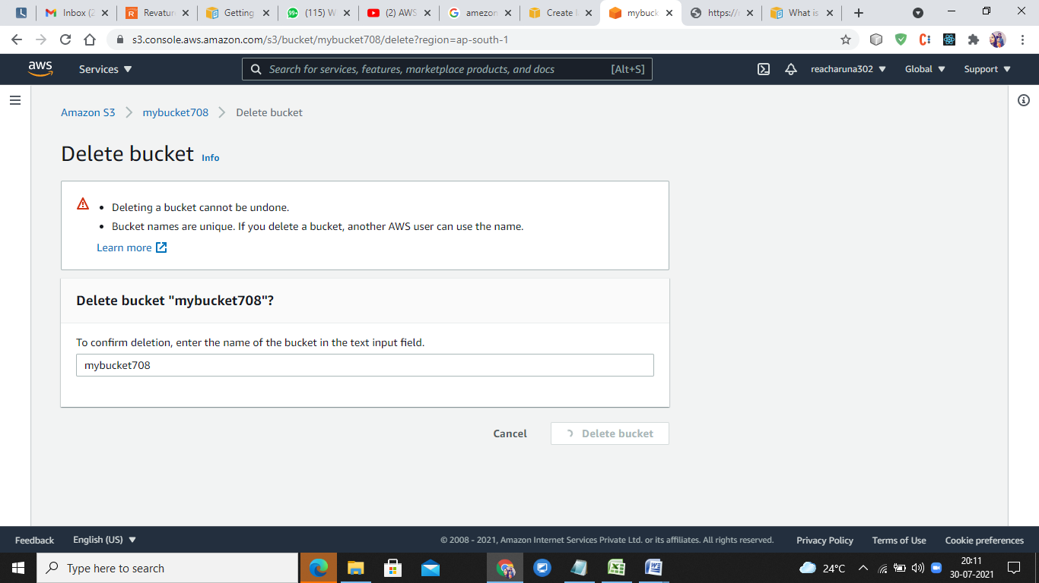

Policy document need to added:

Permission-BucketPolicy tab

"Statement": [

{

"Sid": "AddPermission",

"Effect": "Allow",

"Principal": "\*",

"Action": "s3:GetObject",

"Resource": "arn:aws:s3:::mdfapp1/\*"

}

]