SonarQube is an open-source platform for continuous inspection of code with static analysis of code to detect bugs, code smells, and security vulnerabilities on 20+ programming languages.

SonarQube offers reports on duplicated code, coding standards, unit tests, code coverage, code complexity, comments, bugs, and security vulnerabilities.

Bugs, Security Vulnerabilities, Security Review , Maintainability(code Smells) , coverage,Duplication, Size,

https://www.sonarqube.org/downloads/

Plugin :

<plugin>

<groupId>org.sonarsource.scanner.maven</groupId>

<artifactId>sonar-maven-plugin</artifactId>

<version>3.4.0.905</version>

</plugin>

<plugin>

<groupId>org.jacoco</groupId>

<artifactId>jacoco-maven-plugin</artifactId>

<version>0.8.1</version>

/plugin>

Maven command->Maven build - goal

clean org.jacoco:jacoco-maven-plugin:prepare-agent install

Maven run command->Maven build - goal

mvn sonar:sonar

if it say credential related error:

goto Sonarqube

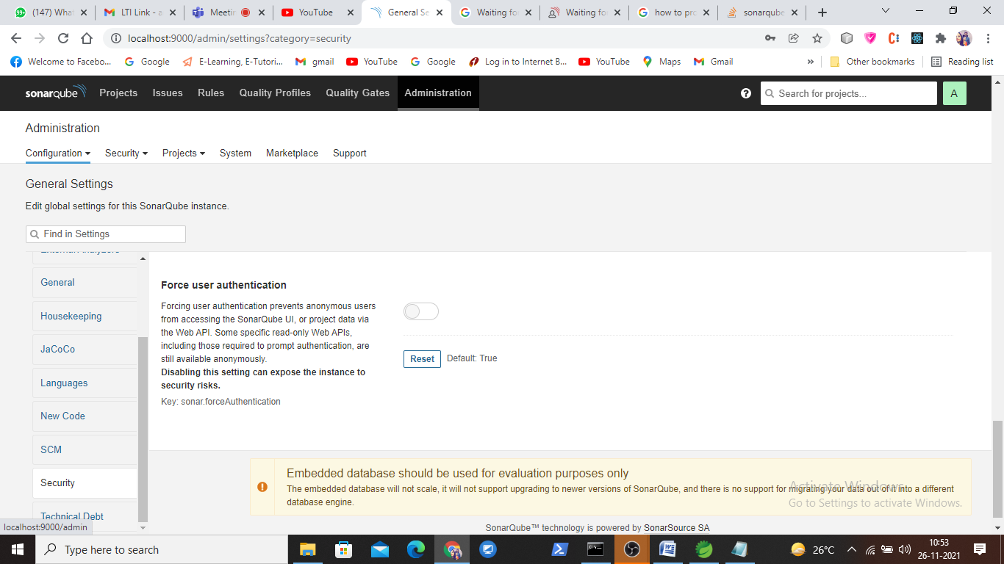

Adiministration->Security ->Force User Authentication -> Disable

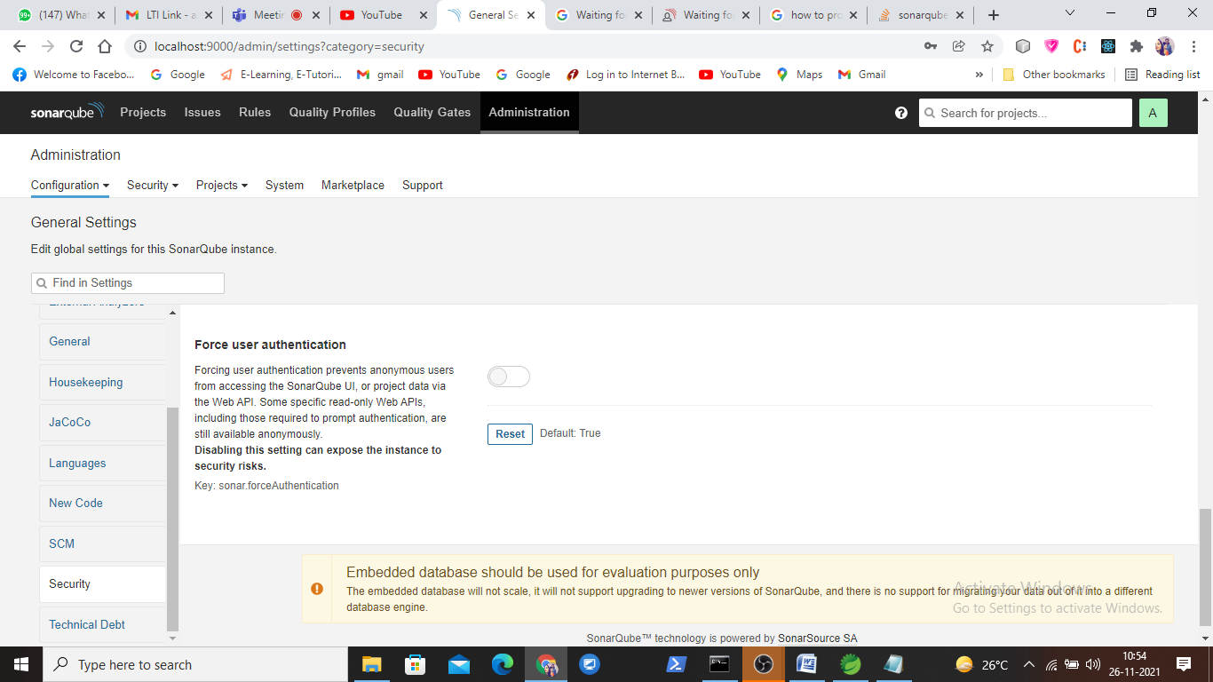

Goto- > Projects ->Issues

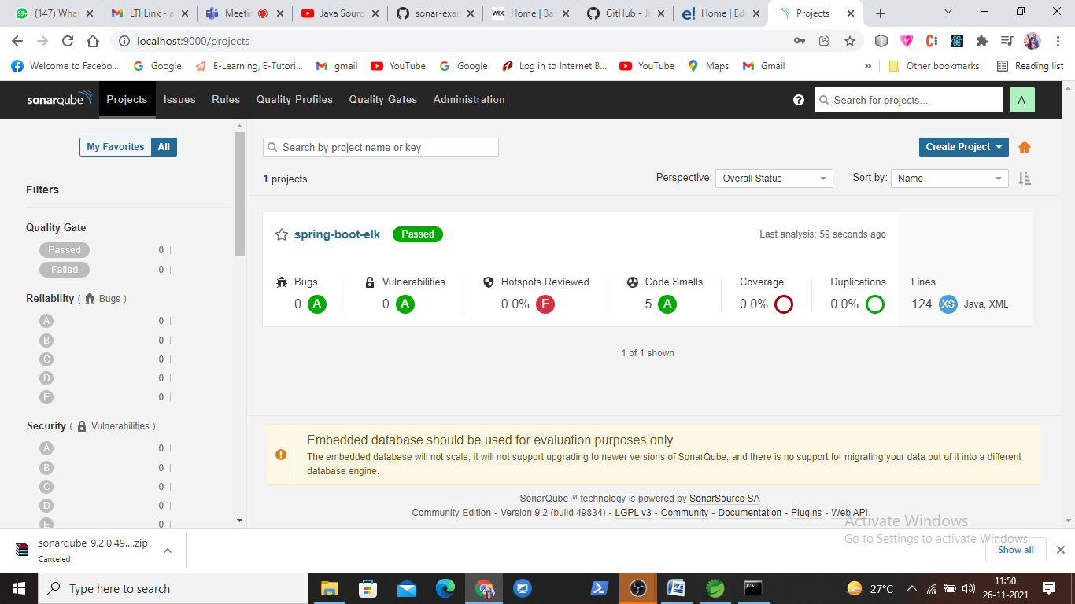

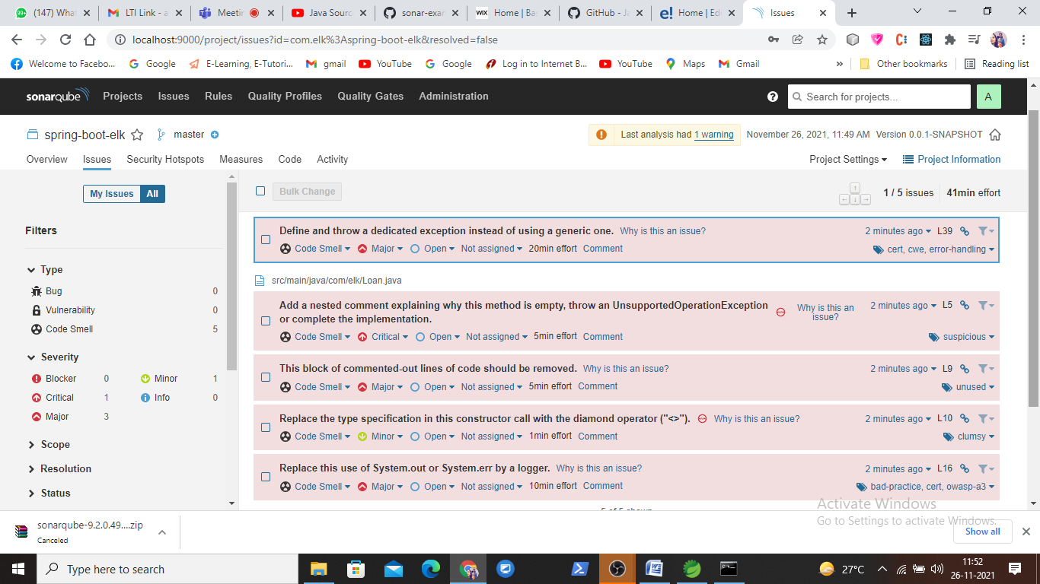

|  |
| --- |
| public class App { |
|  |  |
|  | public App() { |
|  | } |
|  |  |
|  | public void m1() { |
|  | //String s = ""; |
|  | List<Integer> list = new ArrayList<Integer>(); |
|  | list.add(1); |
|  | list.add(2); |
|  |  |
|  | Object obj = getData(); |
|  | if(obj!=null) { |
|  | System.out.println(obj.toString()); |
|  | } |
|  | } |
|  |  |
|  | public Object getData() { |
|  | return null; |
|  | } |
|  |  |
|  | public static void main(String[] args) { |
|  | App app = new App(); |
|  | app.m1(); |
|  | } |
|  | } |