7 steps to create instance

1.create an Image

2.choose instance type

3.configure instance

4.add storage

5.ad tags

6.configure security grup

7.Review

1->Step1

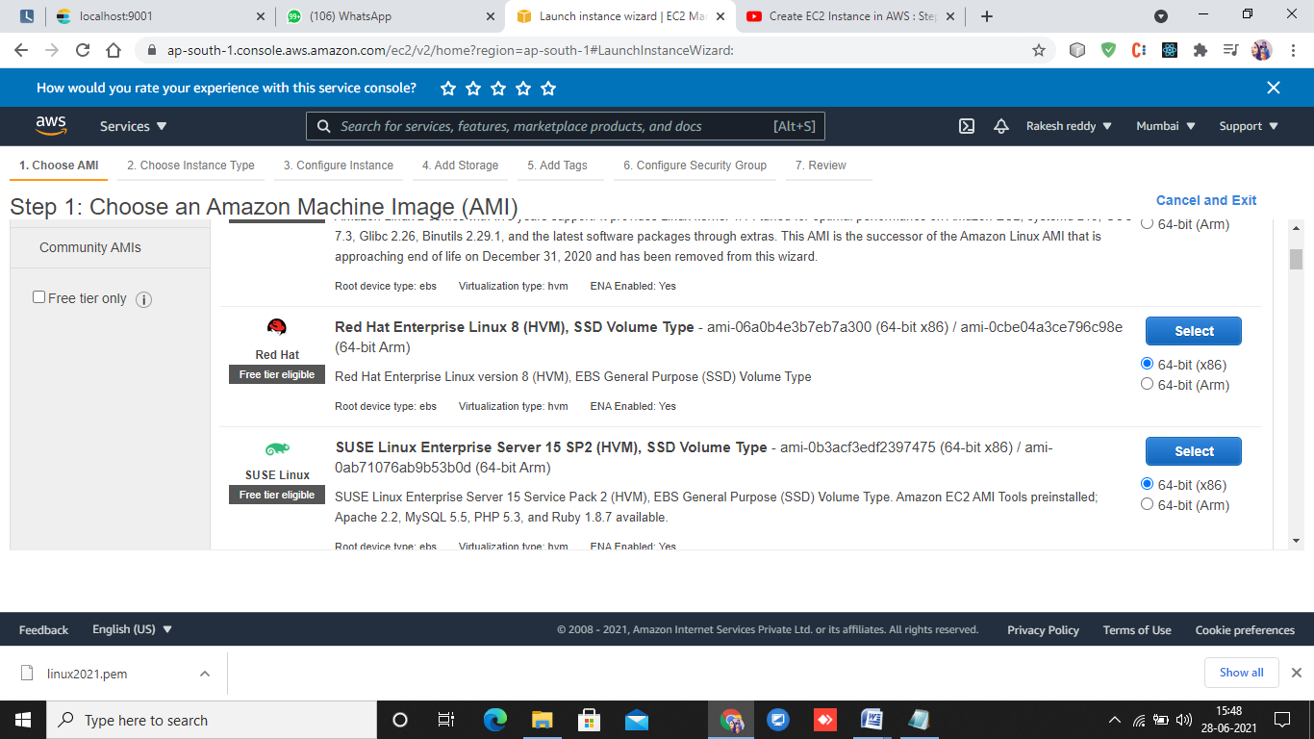

2->step

Choose instance type

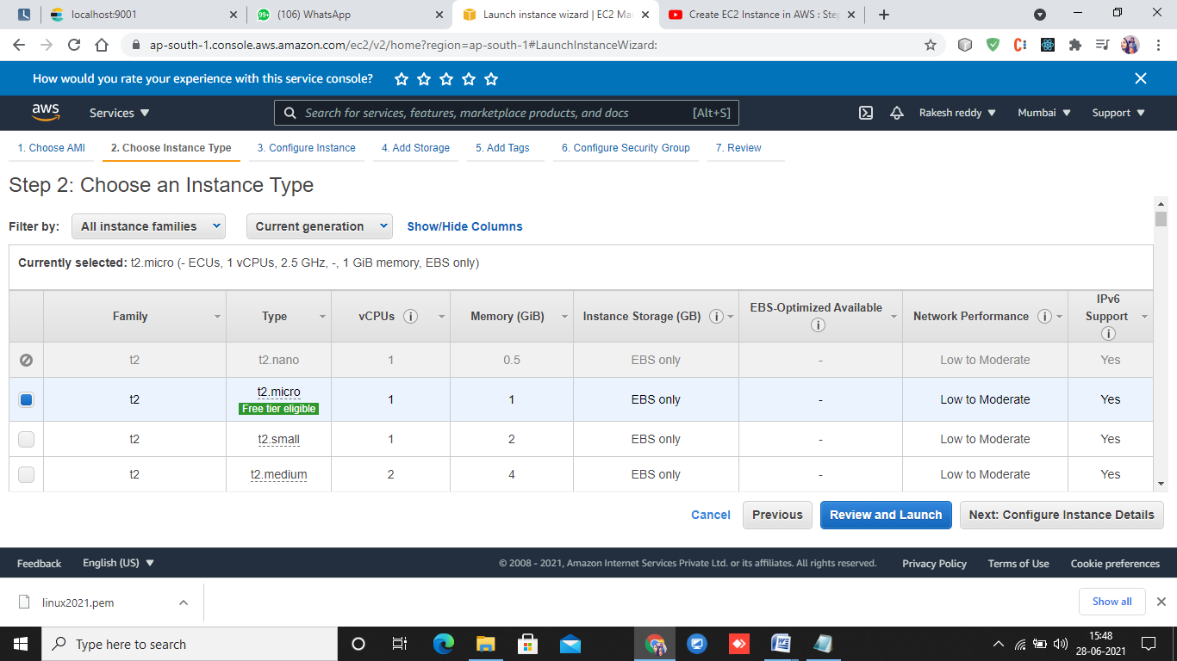

4->step

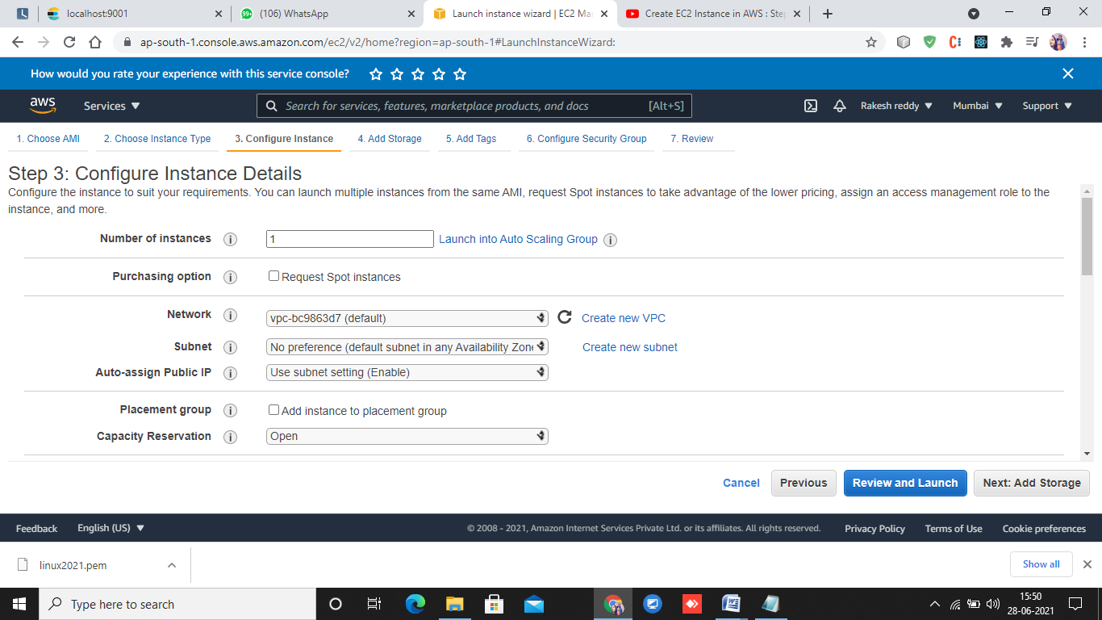

4->add storage

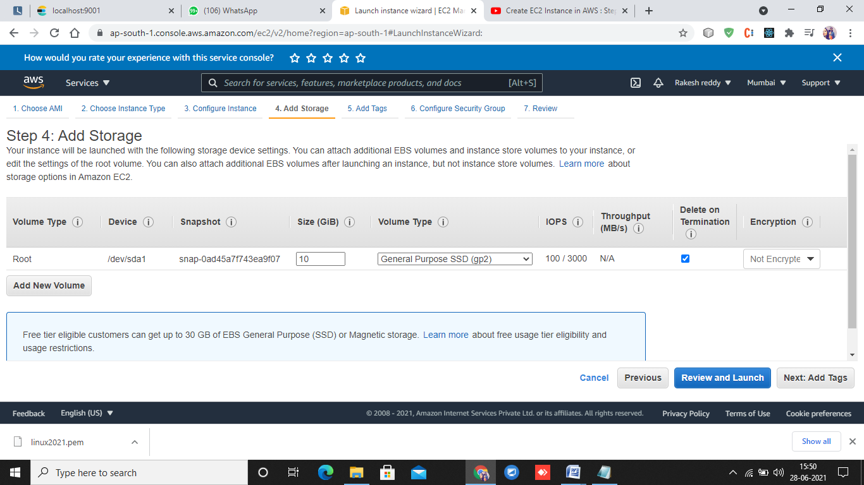

5->ad dtags

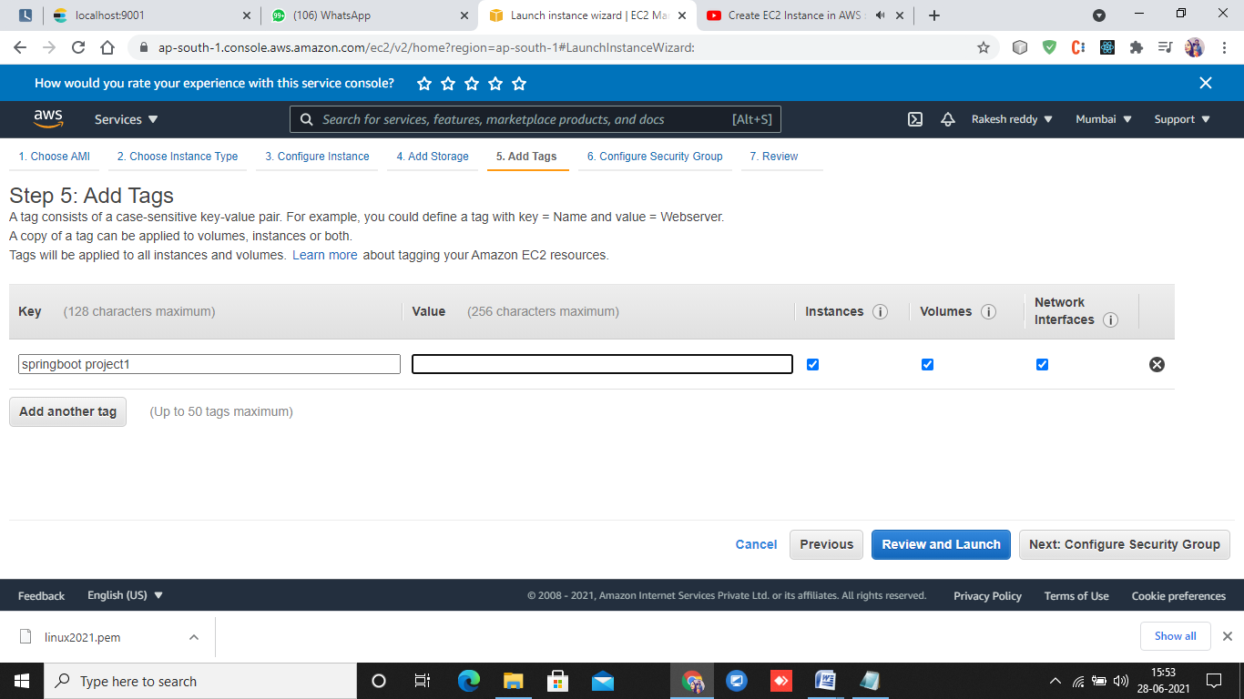

6->step

Configure security Group

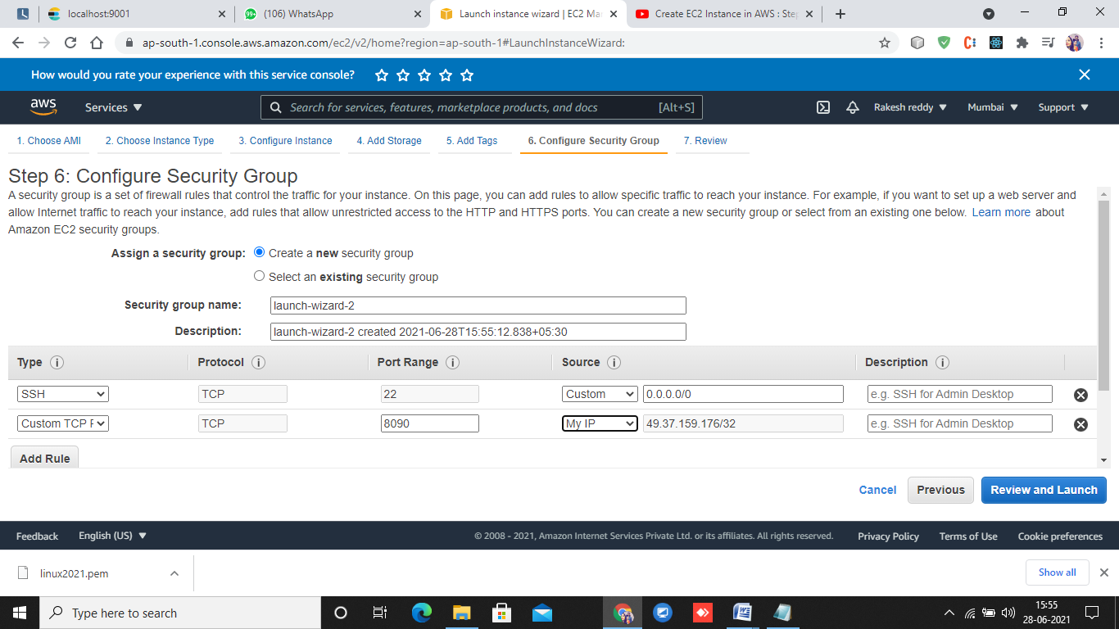

7->Add kaypairs

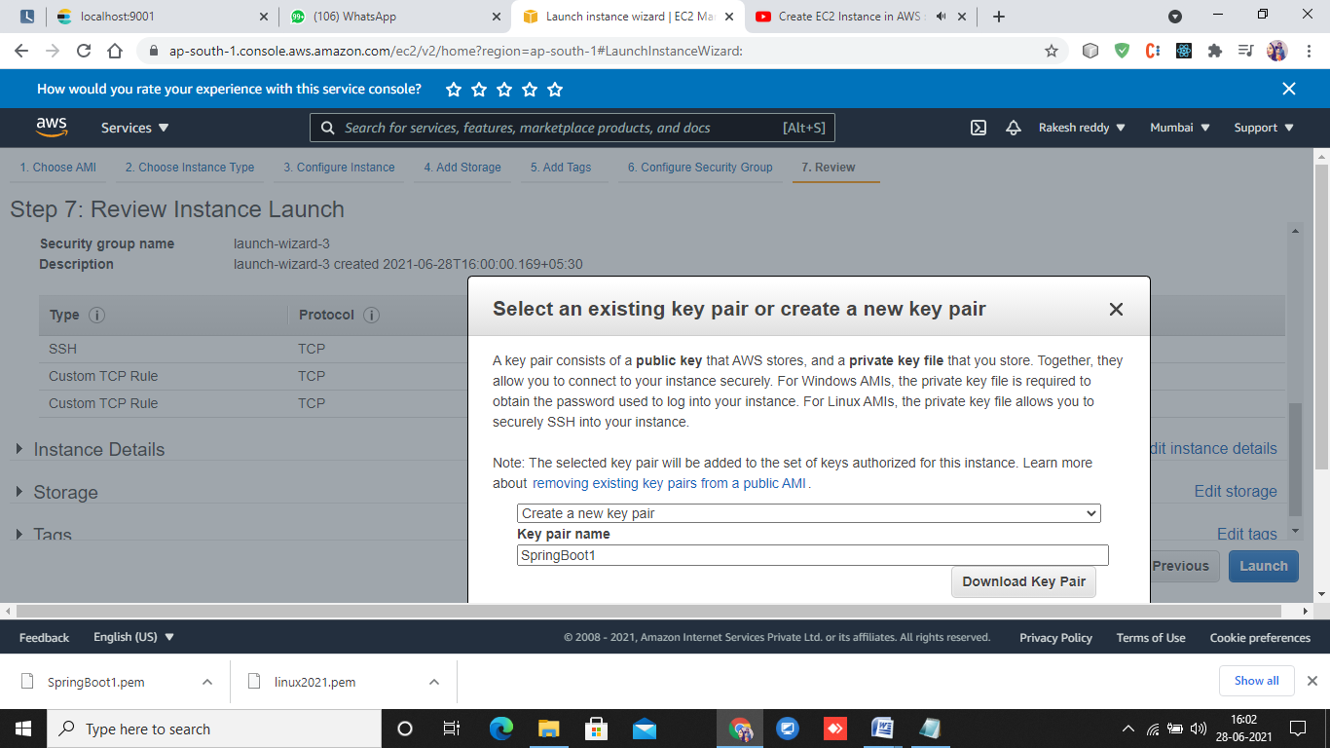

Download the file which contains system host, ipaddress and user details.

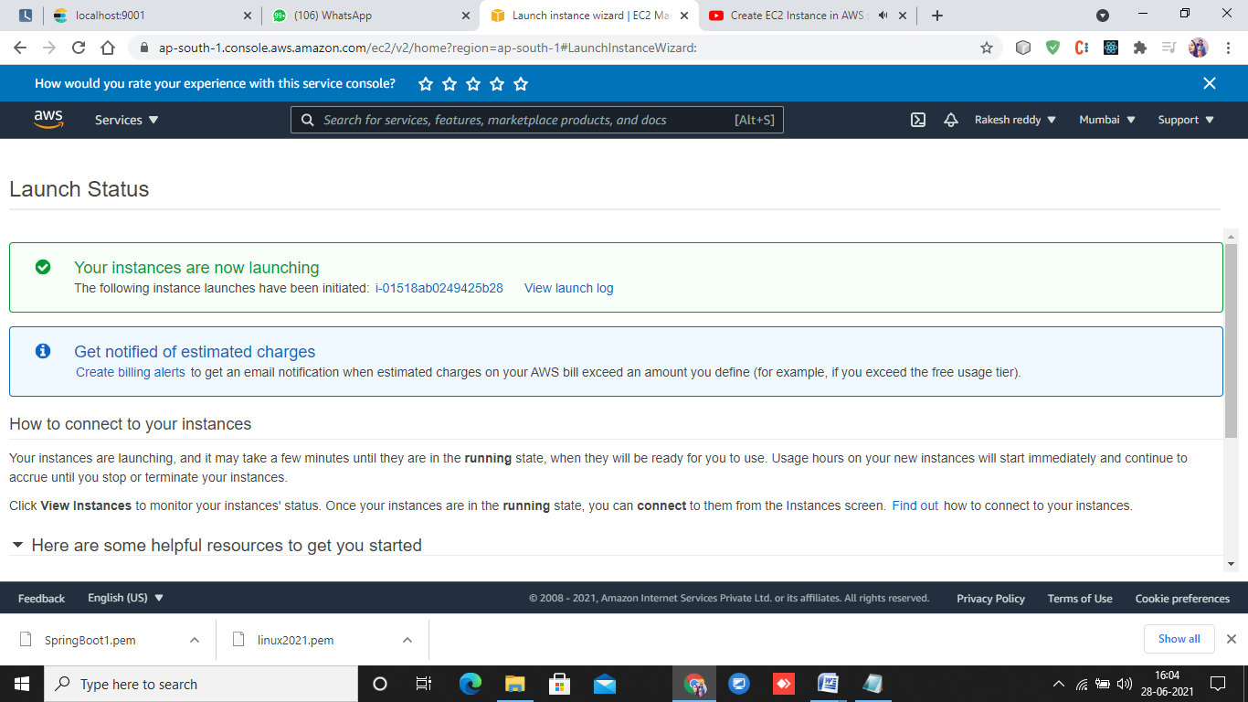

Donwloadd putty.org

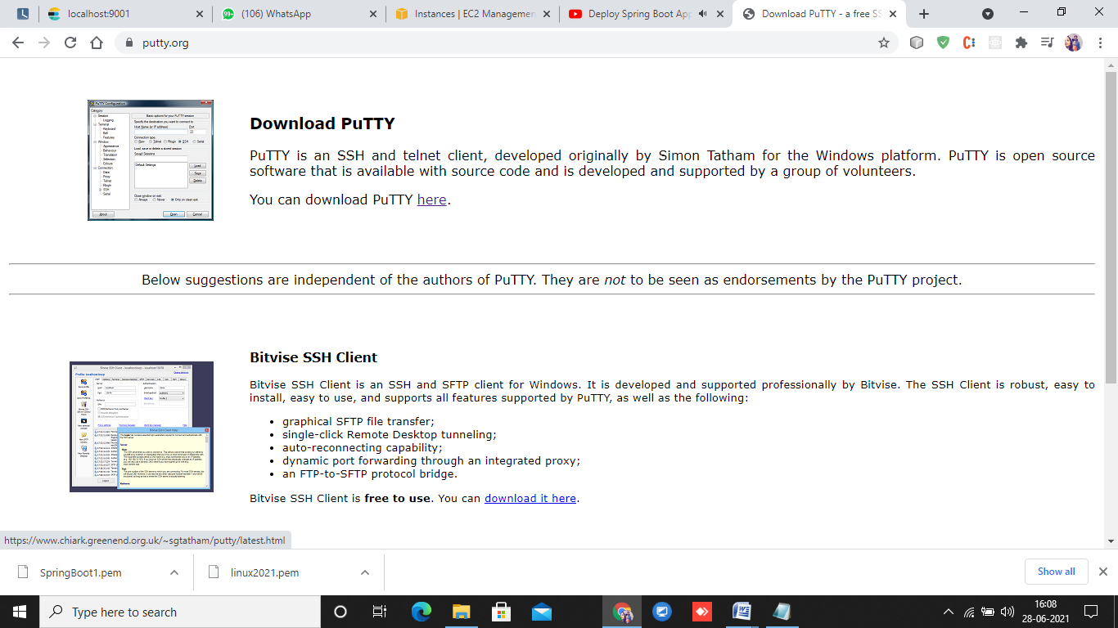

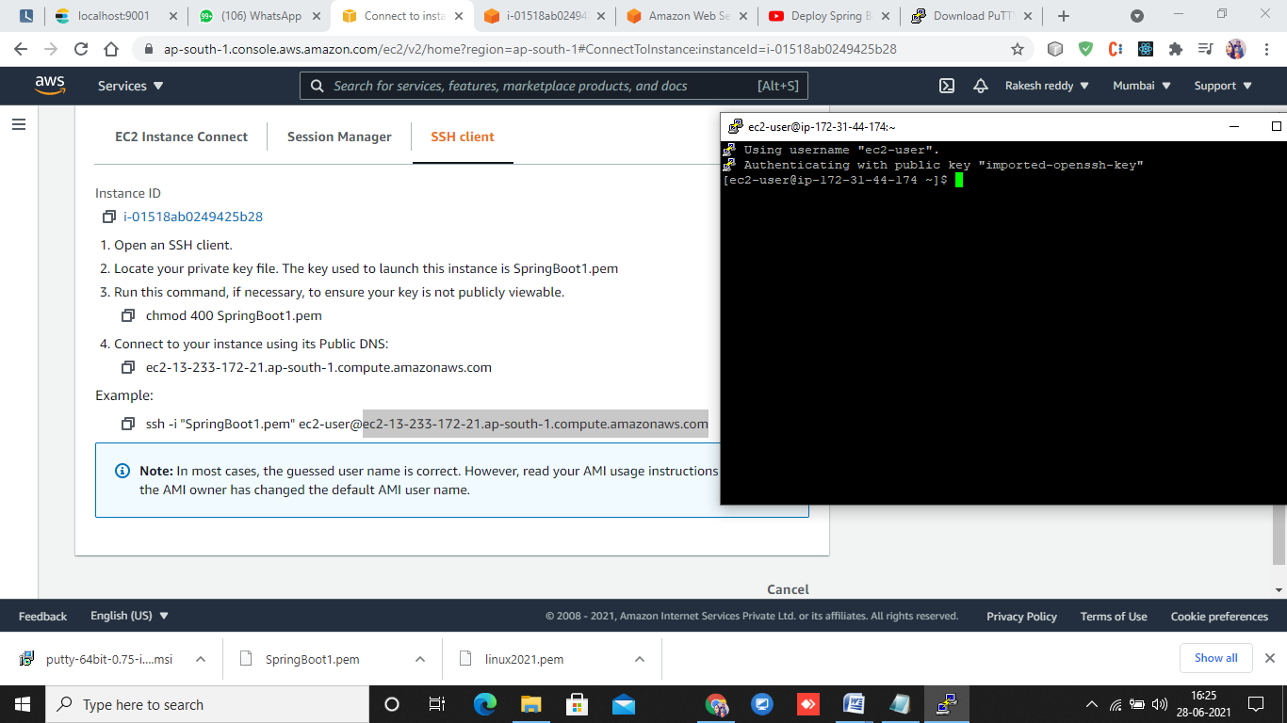

**Add**

**->Hostname**

**->data – ec2-user**

**->AUTH-SSH- select APIkeyname then putty will be connected to ec2 instance**