**VPC: 21 Regions - Defaut North Verginia (AWS head quarters are here- used for testing and deploying first time)**

**(6 Data centers available in one Regions) – Thousands of servers they will manage**

Us-east-1a -- availability zone

Us-east-2a -- availability zone

Us-east-1a -- availability zone

Us-east-1a -- availability zone

Us-east-1a -- availability zone

Us-east-1a -- availability zone

Ex: Mumbai region 3 availability zones

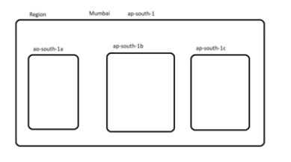

VPC :

**Private IP :** Within your company ..static IP ...DHCP..Freeof cost – when you start purchase laptop – static ip of laptop

**Public IP**: is provided by Internetservice provider – paid id given by intrenet provider.

**Elastic IP** : Region specific IP- 5 EIP can be provide if more than 5 IPs are needed – will be paid services

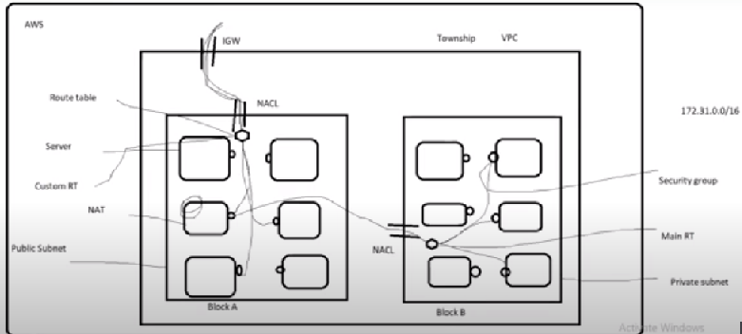

Every Region has default VPC :

VPC : Region

Subnet : Availability Zones