1. Injecting dependencies into a Spring application

|  |  |
| --- | --- |
| **Goals** | * Using IoC to integrate disparate systems in a loosely coupled manner. |
|  |  |

**Problem statement-1.1: Injecting dependencies**

Write an Employee bean. Inject values into bean using DI and display all values. Refer the class diagram below

The output would look as shown below:

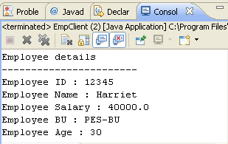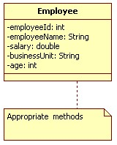

Class Diagram 1: Employee

 Keep each of the lab solutions separate, preferably in different packages/source folders

**Problem statement-1.2: Injecting dependencies**

Code SBU bean.Revisit the Employee bean and provide a method to retrieve SBU details (getSBUDetails()) for the employee. You will need to inject the SBU bean to the Employee bean as shown in the Class diagram below: