**How to Download & Install Jenkins on Windows**

**How to Download Jenkins?**

Following steps should be followed so that to install Jenkins successfully:

**Step 1)** Got to <https://jenkins.io/download/> and select the platform. In our case Windows

[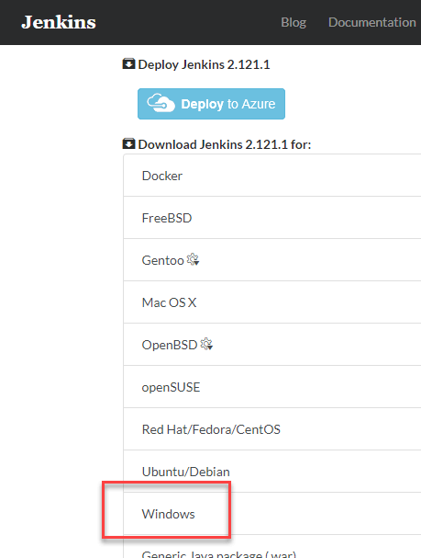](https://www.guru99.com/images/1/063018_1023_HowtoDownlo1.png)

**Step 2)** Go to download location from local computer and unzip the downloaded package. Double-click on unzipped **jenkins.msi**. You can also Jenkin using a WAR (Web application ARchive) but that is not recommended.

[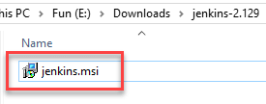](https://www.guru99.com/images/1/063018_1023_HowtoDownlo2.png)

**Step 3)** In the Jenkin Setup screen, click Next.

[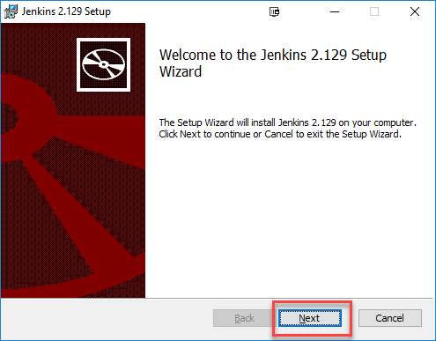](https://www.guru99.com/images/1/063018_1023_HowtoDownlo3.png)

**Step 4)** Choose the location where you want to have the Jenkins instance installed (default location is C:\Program Files (x86)\Jenkins), then click on **Next** button.

[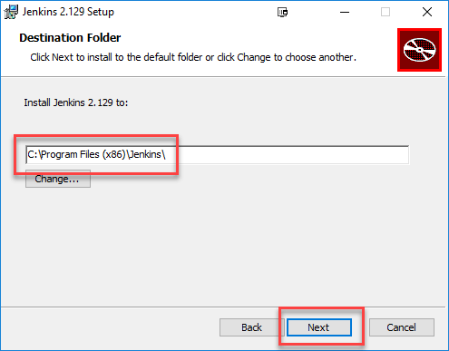](https://www.guru99.com/images/1/063018_1023_HowtoDownlo4.png)

**Step 5)**Click on the Install button.

[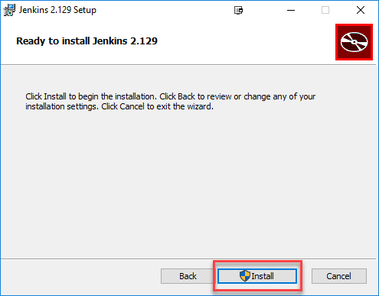](https://www.guru99.com/images/1/063018_1023_HowtoDownlo5.png)

**Step 6)** Once install is complete, click Finish.

[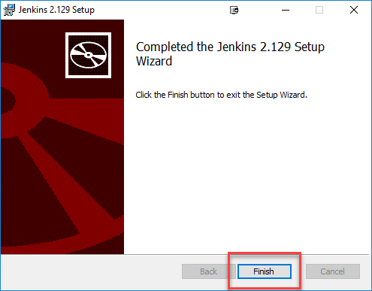](https://www.guru99.com/images/1/063018_1023_HowtoDownlo6.png)

**Step 7)** During the installation process an info panel may pop-up to inform the user that for a complete setup, the system should be rebooted at the end of the current installation. Click on OK button when the Info panel is popping-up:

[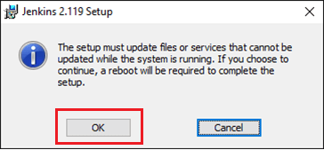](https://www.guru99.com/images/1/063018_1023_HowtoDownlo7.png)

**How to Unblock Jenkins?**

After completing the Jenkins installation phase, you should proceed further and start its configuration. Next steps will guide you how you can unblock Jenkins application:

**Step 1)** After completing the Jenkins installation process, a browser tab will pop-up asking for the initial Administrator password. To access Jenkins, you need to go to browse the following path in your web browser.

http://localhost:8080

If you can access the above URL, then it confirms that Jenkins is successfully installed in your system.

[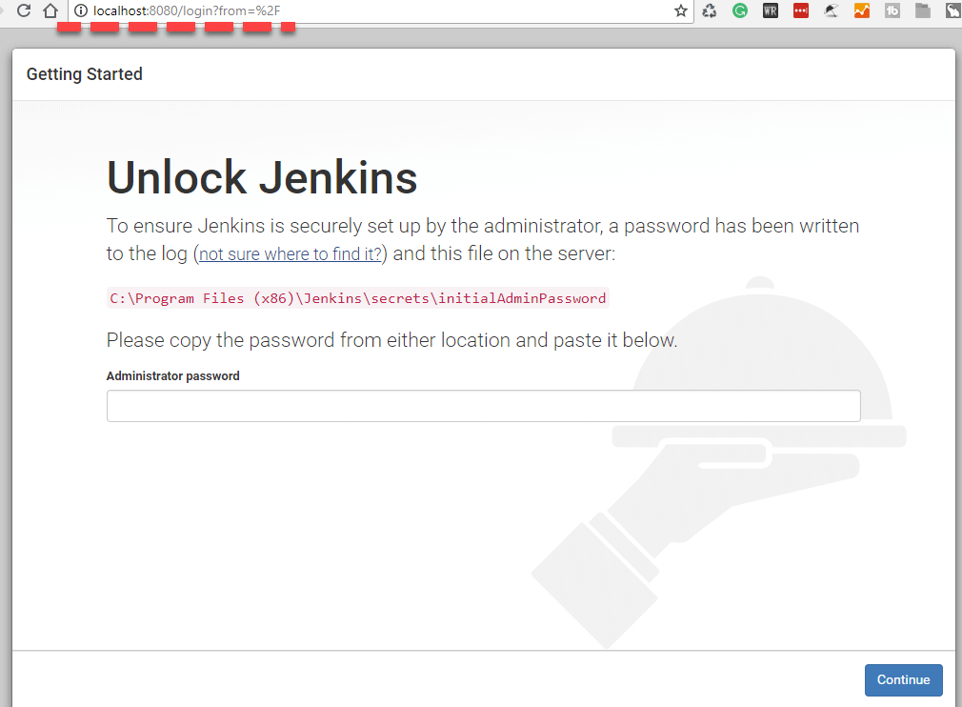](https://www.guru99.com/images/1/063018_1023_HowtoDownlo8.png)

**Step 2)** The initial Administrator password should be found under the Jenkins installation path (set at Step 4 in Jenkins Installation).

For default installation location to C:\Program Files (x86)\Jenkins, a file called **initialAdminPassword** can be found under C:\Program Files (x86)\Jenkins\secrets.

However, If a custom path for Jenkins installation was selected, then you should check that location for **initialAdminPassword** file.

[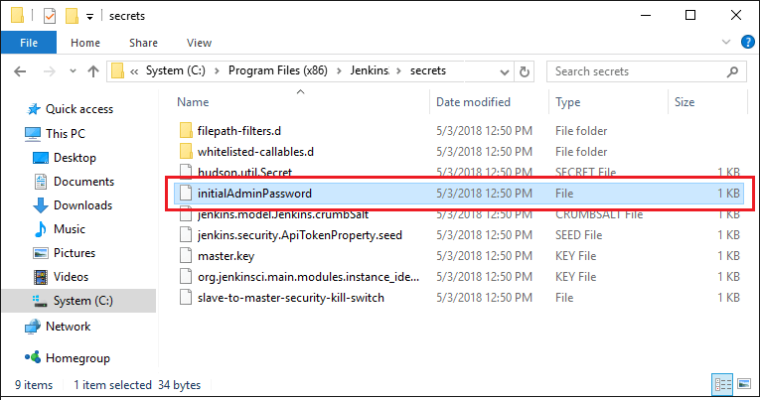](https://www.guru99.com/images/1/063018_1023_HowtoDownlo9.png)

**Step 3)** Open the highlighted file and copy the content of the **initialAdminPassword**file.

[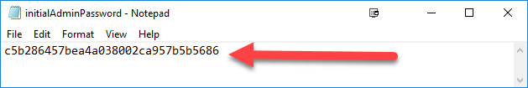](https://www.guru99.com/images/1/063018_1023_HowtoDownlo10.png)

**Step 4)** Paste the password it into browser's pop-up tab (<http://localhost:8080/login?form=%2F>) and click on Continue button.

[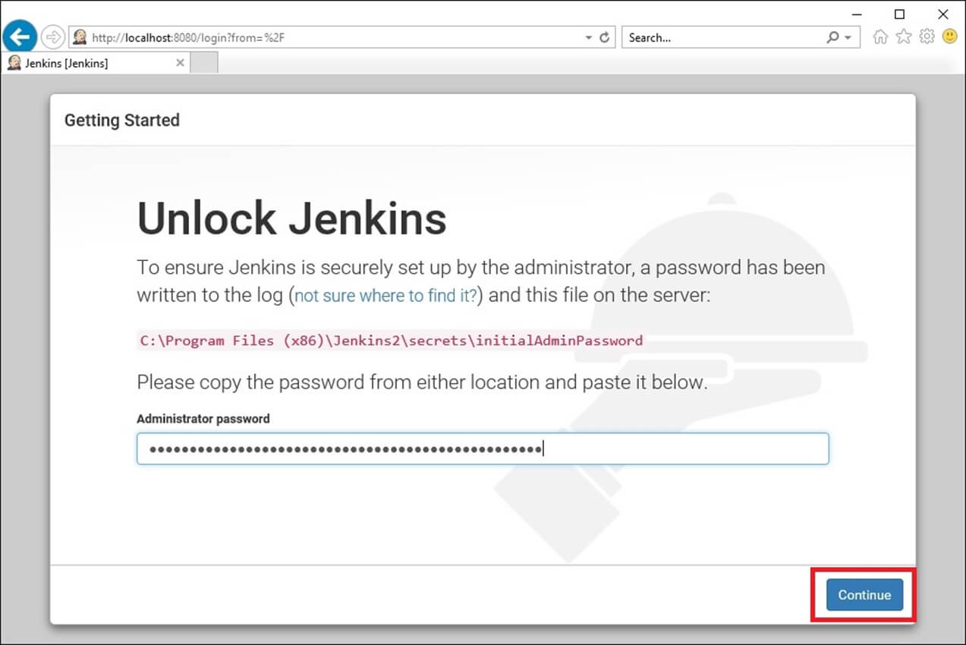](https://www.guru99.com/images/1/063018_1023_HowtoDownlo11.jpg)

**Customize Jenkins**

You can also customize your Jenkins environment by below-given steps:

**Step 1)** Click on the "Install suggested plugins button" so Jenkins will retrieve and install the essential plugins

[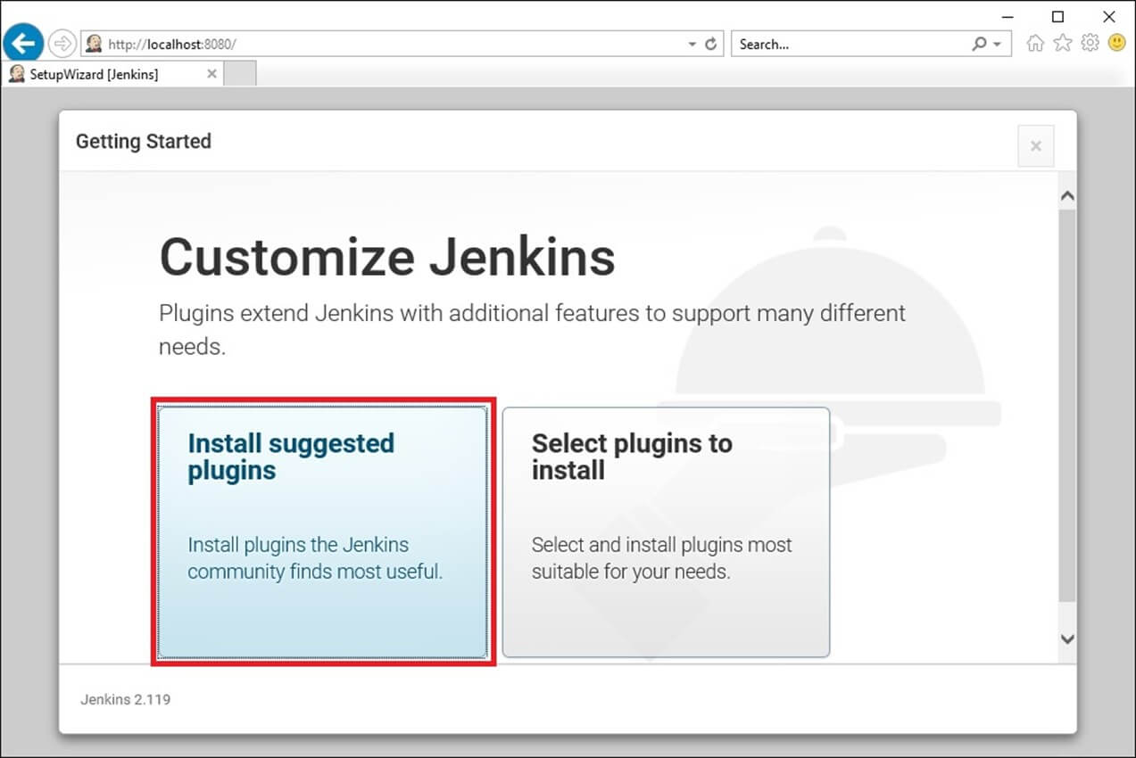](https://www.guru99.com/images/1/063018_1023_HowtoDownlo12.jpg)

Jenkins will start to download and install all the necessary plugins needed to create new Jenkins Jobs.

[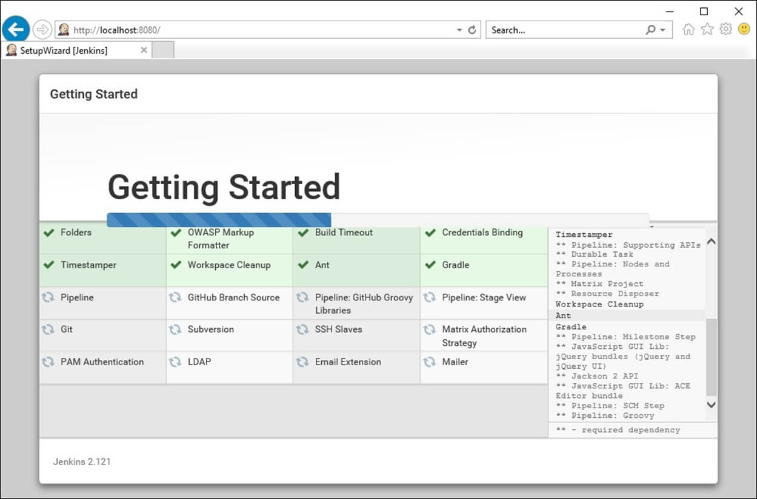](https://www.guru99.com/images/1/063018_1023_HowtoDownlo13.jpg)

**Note**: You can choose the Option "Select Plugins to Install" and select the plugins you want to install

[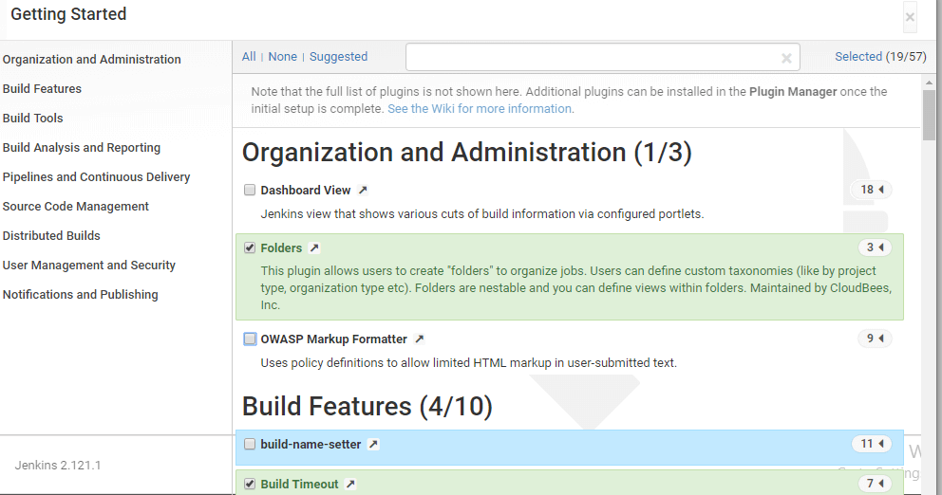](https://www.guru99.com/images/1/063018_1023_HowtoDownlo14.png)

**Step 2)** After all suggested plugins were installed, the "Create First Admin User" panel will show up. Fill all the fields with desired account details and hit the "**Save and Finish**" button.

[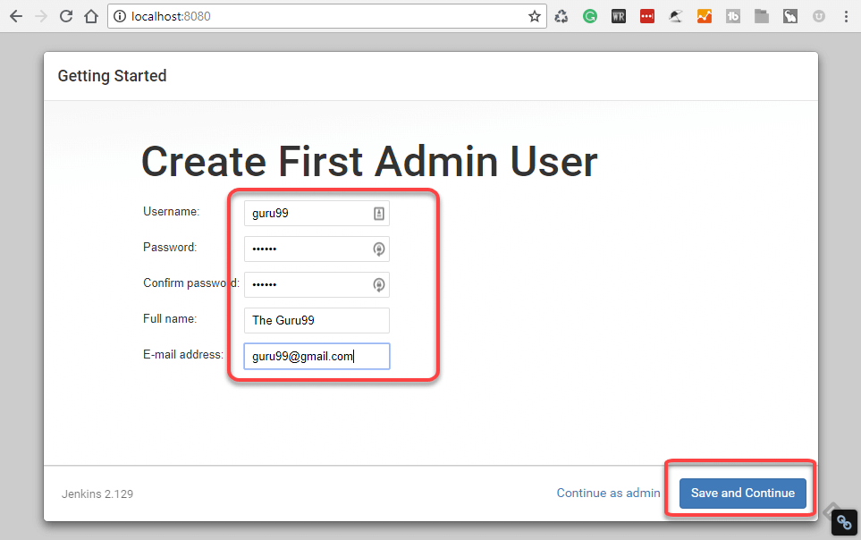](https://www.guru99.com/images/1/063018_1023_HowtoDownlo15.png)

**Step 3)**Once you have filled the above data, finally it will ask for URL information where you can configure the default instance path for Jenkins. Leave it as it is to avoid any confusions later. However, if another application is already using 8080 port, you can use another port for Jenkins and finally save the settings, and you are done with installation of Jenkins. Hit the "**Save and Continue**" button:

[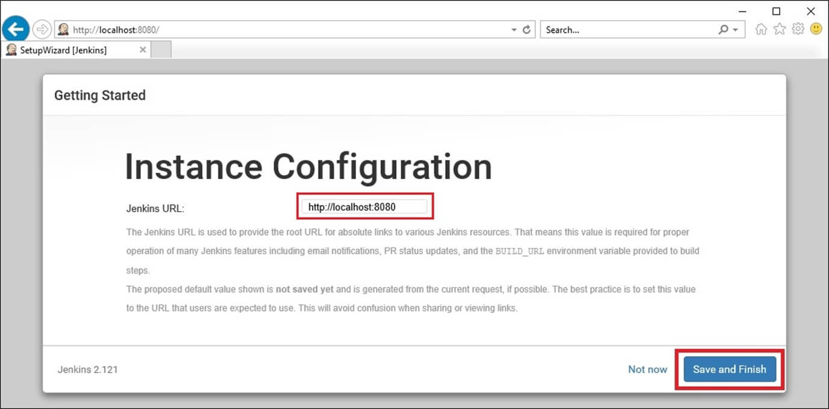](https://www.guru99.com/images/1/063018_1023_HowtoDownlo16.jpg)

Congratulations! We have successfully installed a new Jenkins Server. Hit the "Start using Jenkins" button.

[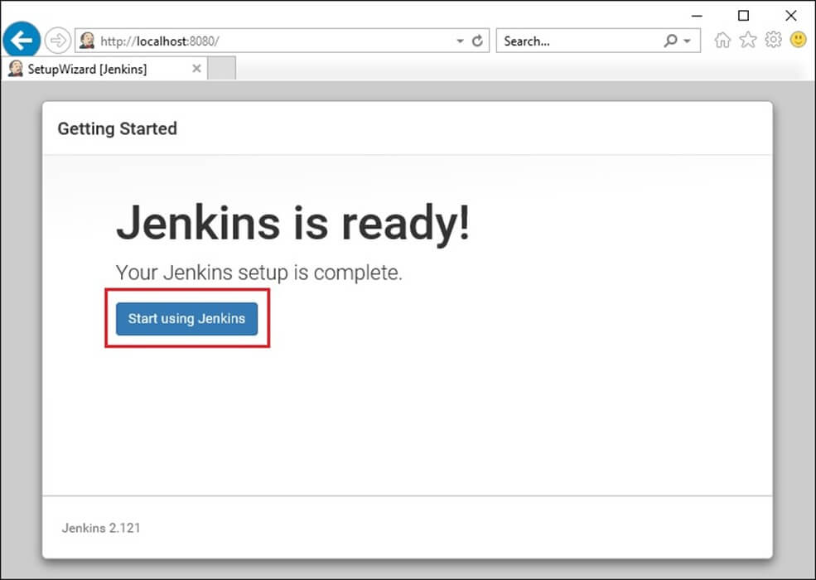](https://www.guru99.com/images/1/063018_1023_HowtoDownlo17.jpg)

Below you can find the Jenkins instance up and run, ready to create first Jenkins jobs:

[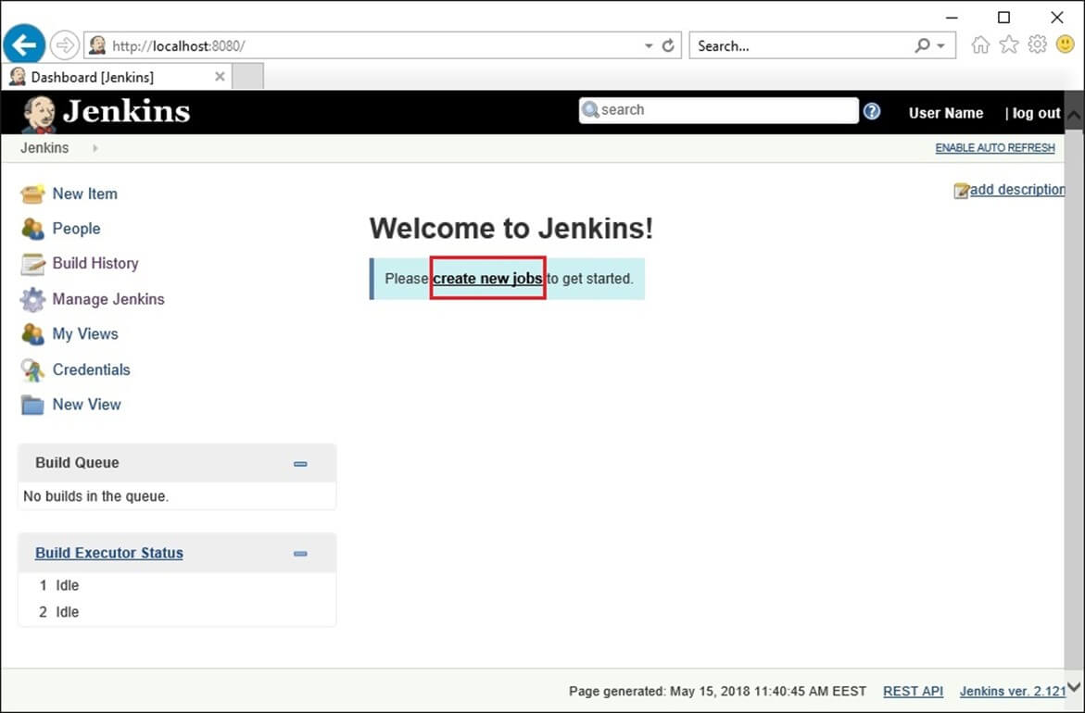](https://www.guru99.com/images/1/063018_1023_HowtoDownlo18.jpg)

Hands on -1

Creating stand alone Jenkins project:

1.create git project

D:\> md gitsample

D:\>cd gitsample

create Hello.java file

**public** **class** Hello {

**public** **static** **void** main(String[] args) {

System.***out***.println("hello..");

}

}

D:\gitsample> git init

D:\gitsample> git add .

D:\gitsample> git commit –m ‘firstcommit’

Open Jenkins :

Create new free style project

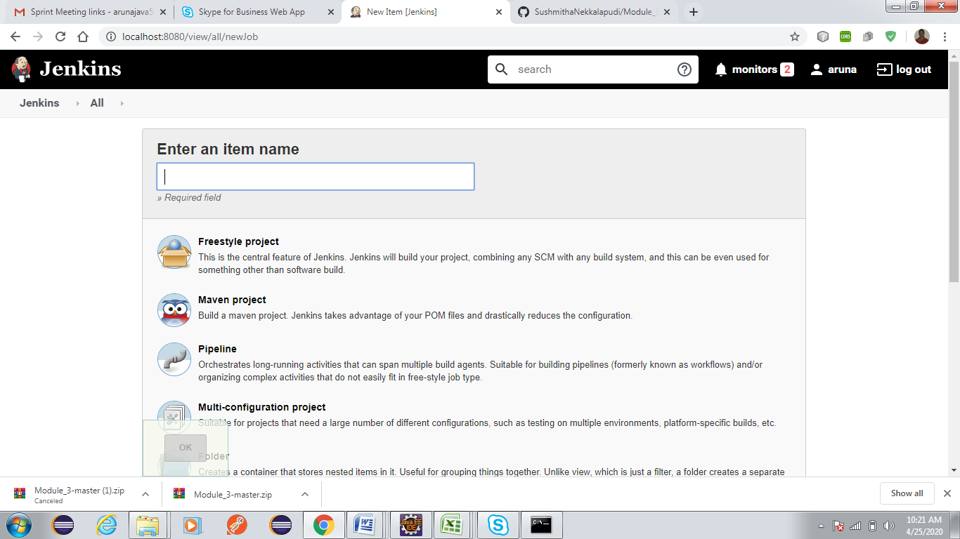

In Generhal tab->SourceCodeManagement section ->t project path of g

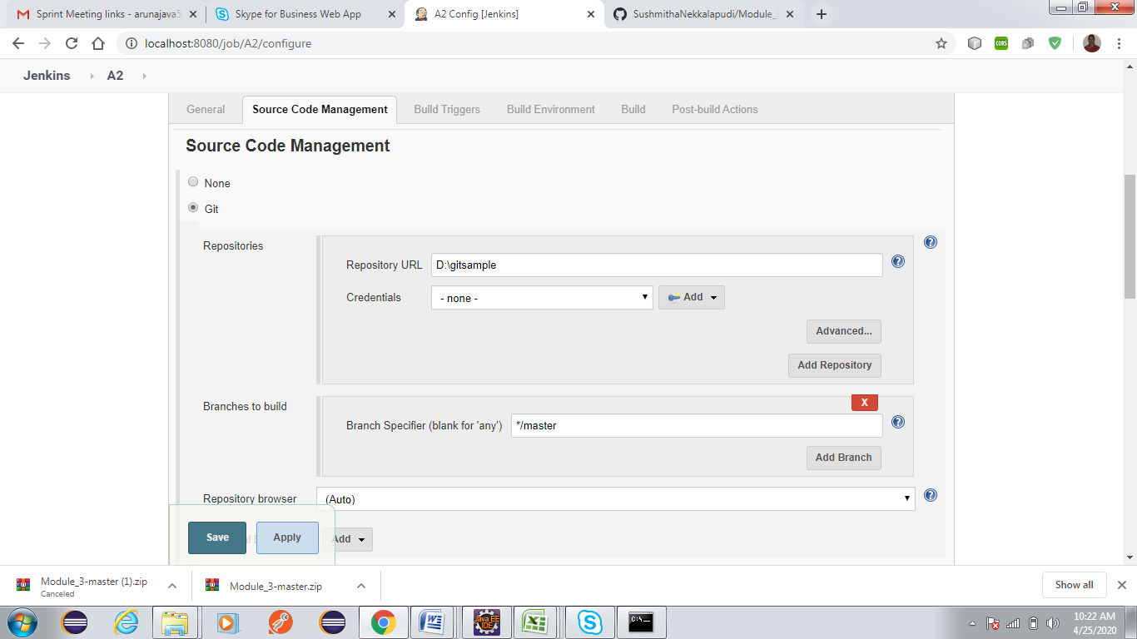

In Build section

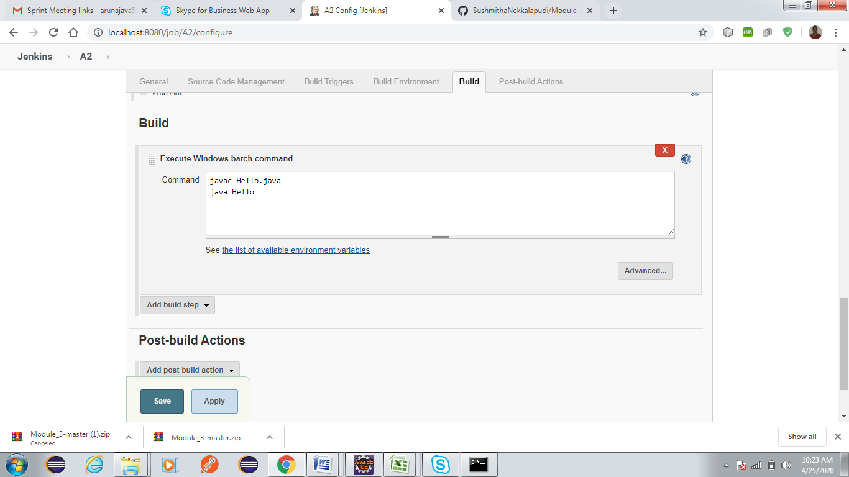

Save and then click on Build Now->display Console output.

Maven configuration:

Configuring Maven :

a) Go to Manage Jenkins->Configure System

b) Configure JDK  
-Give the JDK name  
-JAVA_HOME : C:\Program Files\Java\jdk1.8.0_45

c) Maven configuration  
-Give a maven name  
-MAVEN_HOME : C:\apache-maven-3.2.5\apache-maven-3.2.5-bin\apache-maven-3.2.5

e) Save once done

Configuring Git Plugin:

a) Go to Manage Jenkins-> Manage plugins- >Add Plugins

b) Install the plugins which are required, Eg. GIT client plugin: which Shared library plugin for other Git related Jenkins plugins,  GIT plugin: This plugin integrates GIT with Jenkins etc.

Configuring SonarqubeScanner:

* Open Jenkins on your browser and login using the credentials.
* Click on ‘Manage Jenkins’ on left menu. This will open the Manage Jenkins page with different options.
* Click on ‘Manage Plugins’ option from the list.
* Now click on ‘Available’ tab to search for the plugin.
* Type ‘SonarQube’ in the filter text box and hit enter.
* From the list click on install button of ‘SonarQube Scanner for Jenkins’ plugin.
* This will install the SonarQube scanner plugin.
* Now go to project page and click on ‘Configure’ link from the left menu.
* Scroll down to the ‘Execute SonarQube Scanner’ section under build.
* You can enter the optional fields like task to run, JDK and path to project properties.
* Under analysis properties option add following code and change it as per your project configuration:
* sonar.projectKey=SpringBootApp1
* sonar.projectName=SpringBootApp1
* sonar.projectVersion=1.0
* sonar.sources=E:/capgemini1/SpringBootApp1/src/main/java/com/edureka/SpringBootApp1