## AWS Overview

### What is Cloud Computing?

Cloud computing is the on-demand delivery of compute power, database storage, applications and other IT resources through a cloud services platform via the Internet with pay-as-you-go pricing.

Cloud computing provides a simple way to access servers, storage, databases and a broad set of application services over the Internet.

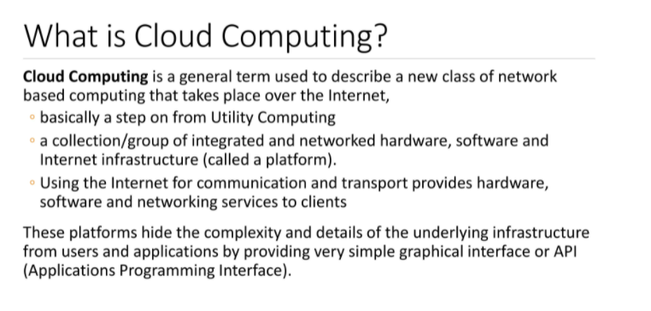

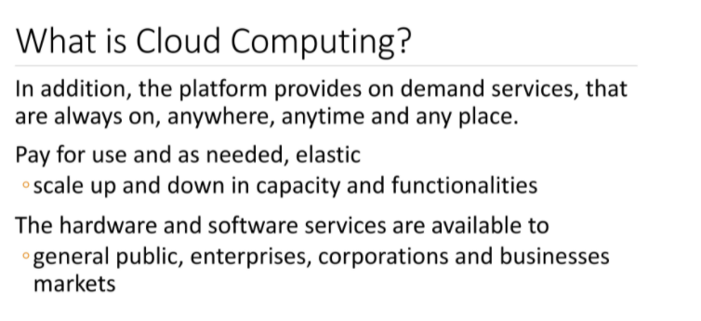

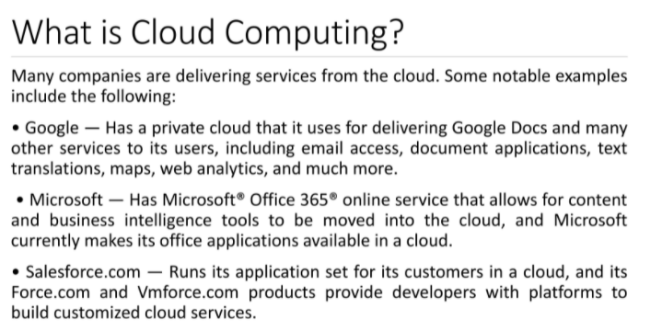

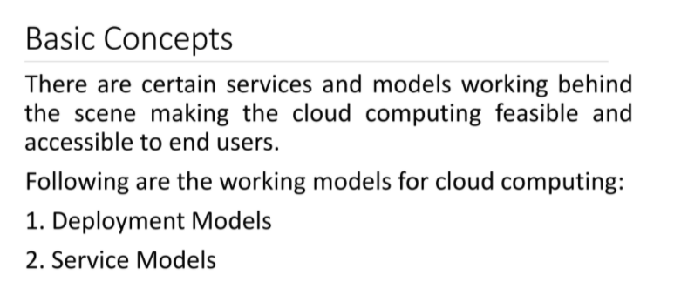

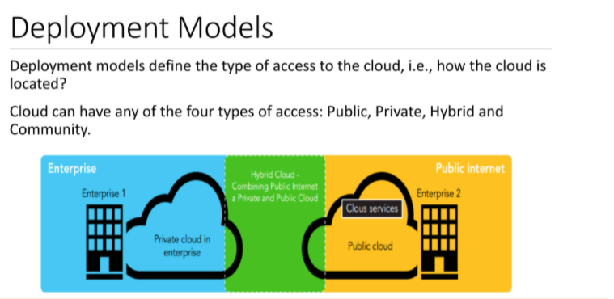

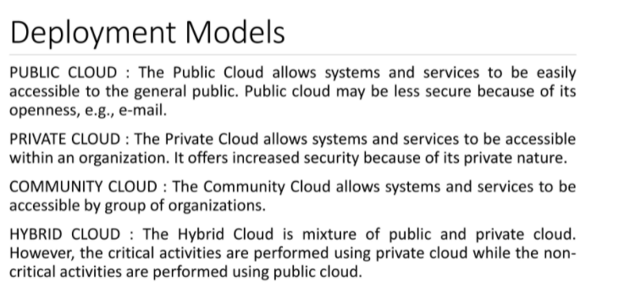

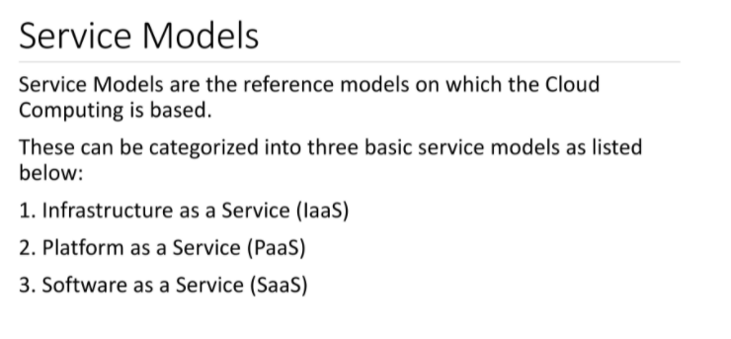

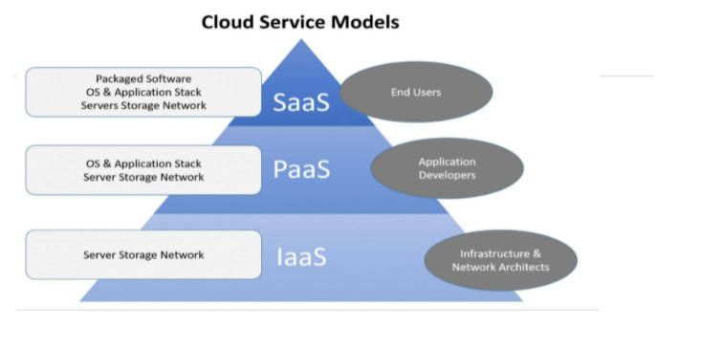

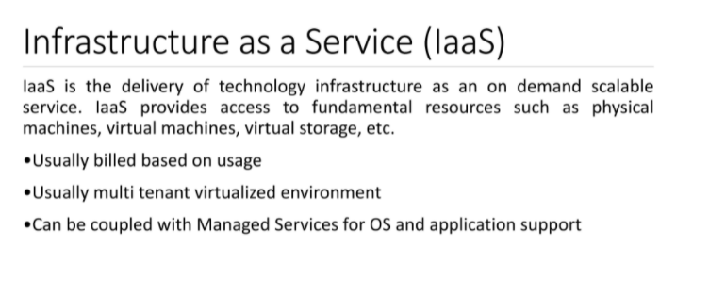

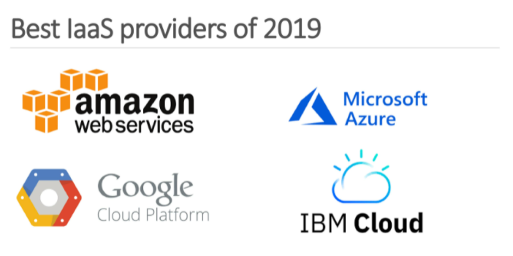

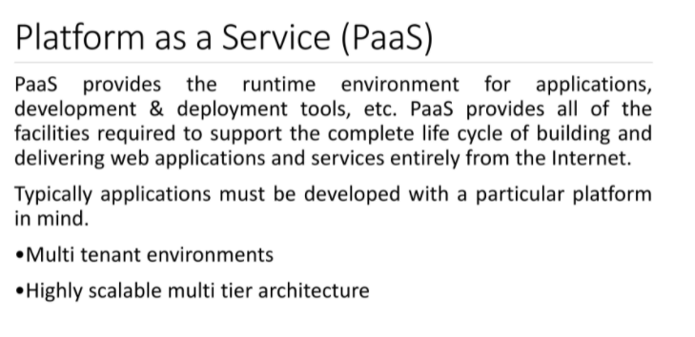

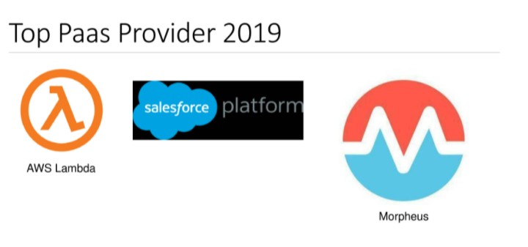

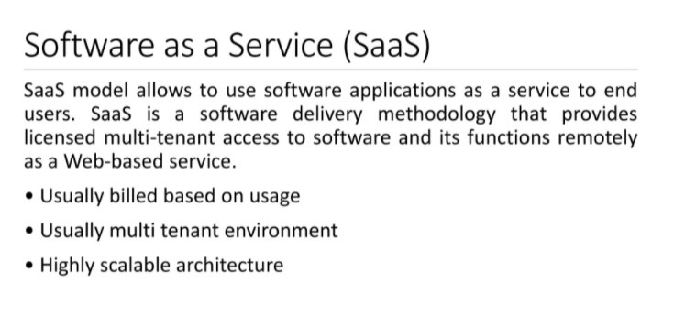

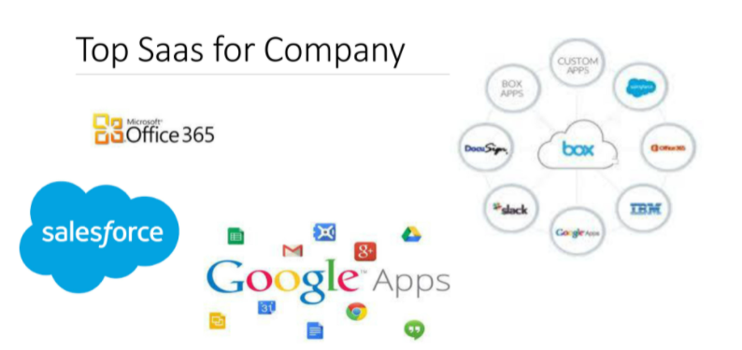

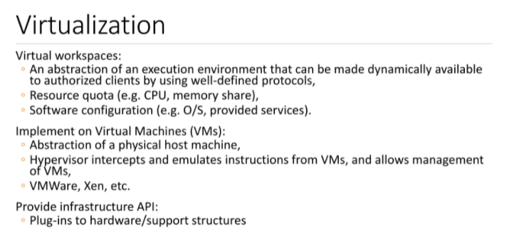

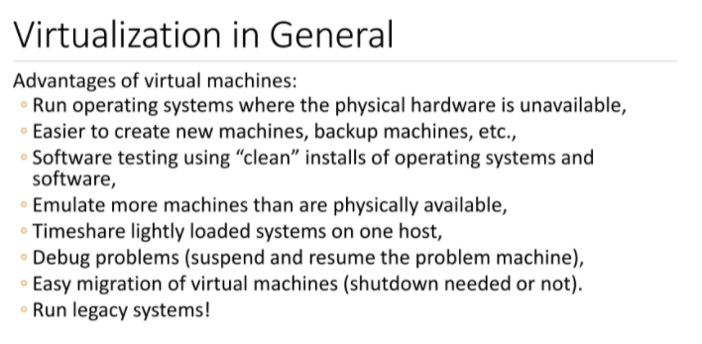

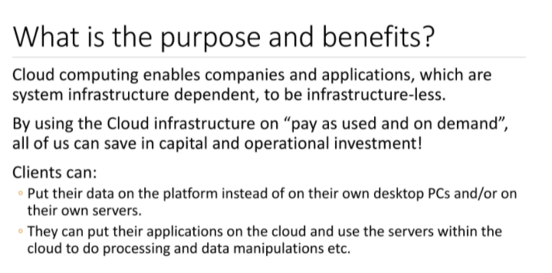

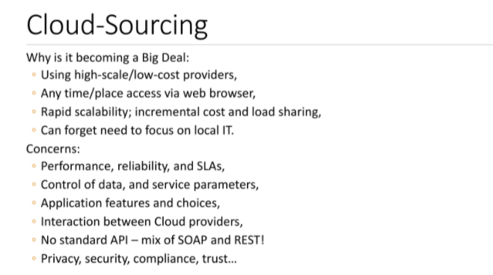

### 6 Advantages of Cloud Computing

1. Trade capital expense for variable expense.
2. Benefit from massive economies of scale.
3. Stop guessing about capacity.
4. Increase speed and agility.
5. Eliminate overhead cost of maintaining data centers
6. Go global in minutes.

#### Trade capital expense for variable expense

Instead of having to invest heavily in data centers and servers before you know how you’re going to use them, you can pay only when you consume computing resources, and pay only for how much you consume.

#### Benefit from massive economies of scale

By using cloud computing, you can achieve a lower variable cost than you can get on your own. Because usage from hundreds of thousands of customers is aggregated in the cloud, providers such as AWS can achieve higher economies of scale, which translates into lower pay as-you-go price.

#### Stop guessing about capacity

Eliminate guessing on your infrastructure capacity needs. When you make a capacity decision prior to deploying an application, you often end up either sitting on expensive idle resources or dealing with limited capacity.

#### Increase speed and agility

In a cloud computing environment, new IT resources are only a click away, which means that you reduce the time to make those resources available to your developers from weeks to just minutes.

#### Eliminate overhead cost of maintaining data centers

Cloud computing lets you focus on your own customers, rather than on the heavy lifting of racking, stacking, and powering servers (infrastructure).

#### Go global in minutes

Easily deploy your application in multiple regions around the world with just a few clicks. This means you can provide lower latency and a better experience for your customers at minimal cost.

### Paying for Cloud Services

AWS offers you a **pay-as-you-go** approach for pricing for over 160 cloud services. With AWS you pay only for the individual services you need, for as long as you use them, and without requiring long-term contracts or complex licensing.

* You can also use [AWS Billing and Cost Management](https://docs.aws.amazon.com/awsaccountbilling/latest/aboutv2/billing-what-is.html)

### 3 Models of Cloud Computing

#### Infrastructure as a Service (IaaS)

Infrastructure as a Service (IaaS) is a self-service model for managing remote data center infrastructures. AWS offers IaaS in the form of data centers.

#### Platform as a Service (PaaS)

Platform as a Service (PaaS) allows organizations to build, run and manage applications without the IT infrastructure. This makes it easier and faster to develop, test and deploy applications.

#### Software as a Service (SaaS)

Software as a service (SaaS) replaces the traditional on-device software with software that is licensed on a subscription basis. It is centrally hosted in the cloud. A good example is Salesforce.com.

### Other Major Cloud Providers

* [Microsoft Azure](https://azure.microsoft.com/en-us/)
* [Google Cloud Platform (GCP)](https://cloud.google.com/gcp/?utm_source=google&utm_medium=cpc&utm_campaign=na-US-all-en-dr-bkws-all-all-trial-e-dr-1009135&utm_content=text-ad-lpsitelinkCCexp2-any-DEV_c-CRE_113120492887-ADGP_Hybrid+%7C+AW+SEM+%7C+BKWS+%7C+US+%7C+en+%7C+EXA+~+Google+Cloud+Platform-KWID_43700009942847400-kwd-26415313501&utm_term=KW_google%20cloud%20platform-ST_google+cloud+platform&&gclid=Cj0KCQjwoJX8BRCZARIsAEWBFMIKqoP4b6G-3OlpQkCrVvMoAvss3kNL_2joyIs7N42TL-2WZRBCUaoaApspEALw_wcB)