**Amazon Elastic Block Store (Amazon EBS)**

Amazon Elastic Block Store (Amazon EBS) provides block level storage volumes for use with EC2 instances.

* EBS volumes behave like raw, unformatted block devices. You can mount these volumes as devices on your instances.
* EBS volumes that are attached to an instance are exposed as storage volumes that persist independently from the life of the instance.
* You can create a file system on top of these volumes, or use them in any way you would use a block device (such as a hard drive).
* You can dynamically change the configuration of a volume attached to an instance.
* With Amazon EBS, you pay only for what you use.

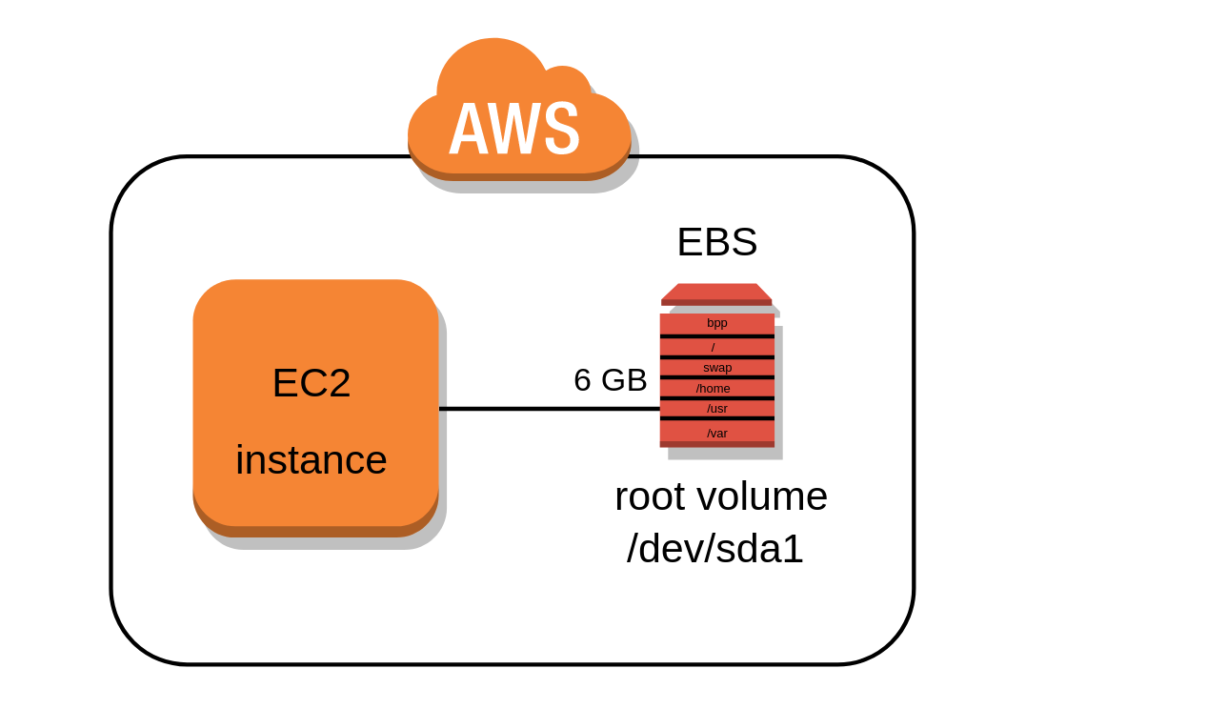

**EBS Volumes**

An Amazon EBS volume is a durable, block-level storage device that you can attach to your instances. After you attach a volume to an instance, you can use it as you would use a physical hard drive. You can use EBS volumes as primary storage for data that requires frequent updates, such as the system drive for an instance or storage for a database application.

* EBS volumes are created in a specific **Availability Zone**, and can then be attached to any instances in that same Availability Zone.

**EBS Snapshots**

ou can back up the data on your Amazon EBS volumes to **Amazon S3** by taking point-in-time snapshots. Snapshots are incremental backups, which means that only the blocks on the device that have changed after your most recent snapshot are saved.

**How to Create an EBS Volume for AWS EC2**

1. Sign into AWS using your administrator account.
2. Navigate to the EC2 Console.
3. Choose a EC2 setup region from the Region drop-down list at the top of the page.
4. Select Volumes in the Navigation pane.
5. Click Create Volume.
6. Click Create.
7. Choose Actions→ Create Snapshot.
8. Type EBS.Backup in the Name field, type Test Backup in the Description field, and then click Create.
9. Click Close. The volume is ready to use.

When you finish this example, you can delete the volume you created by selecting its entry in the list and choosing Actions →Delete Volume. In a real-world setup, you can attach this volume to any EC2 instance or detach it when it’s no longer needed.

**References**

* [AWS EBS Documentation](https://aws.amazon.com/ebs/?ebs-whats-new.sort-by=item.additionalFields.postDateTime&ebs-whats-new.sort-order=desc)