**AWS Elastic Compute Cloud (EC2)**

Amazon Elastic Compute Cloud (Amazon EC2) is a web service that provides secure, resizable compute capacity in the cloud. It is designed to make web-scale cloud computing easier for developers.

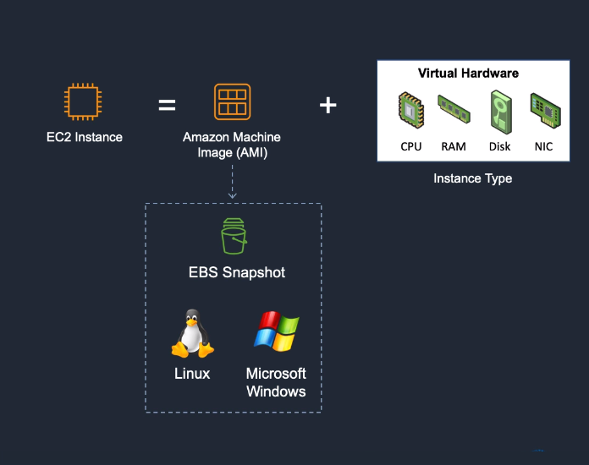

**AMAZON EC2 PROVIDES:**

* Virtual computing environments, known as instances
* Preconfigured templates for your instances, known as **Amazon Machine Images (AMIs)**, that package the bits you need for your server (including the operating system and additional software)
* Various configurations of CPU, memory, storage, and networking capacity for your instances, known as **instance types**
* Secure login information for your instances using key pairs (AWS stores the public key, and you store the private key in a secure place)
* A firewall that enables you to specify the protocols, ports, and source IP ranges that can reach your instances using **security groups**

**Elastic Web-Scale Computing**

You can increase or decrease capacity within minutes and commission one to thousands of instances simultaneously.

**Completely Controlled**

AWS EC2 give you complete control including root accessto each instance and can stop and start instances without losing data and use web service APIs.

**Flexible Cloud Hosting Serices**

You can choose from multiple instance types & operating systems as well as instances with varying memory, CPU, and storage configurations.

**Elasticity**

The “Elastic” nature of the service allows developers to instantly scale to meet spikes in traffic or demand. When computing requirements unexpectedly change (up or down), Amazon EC2 can instantly respond, meaning that developers have the ability to control how many resources are in use at any given point in time.

**Instances**

An instance is a virtual server in the cloud. Its configuration at launch is a copy of the AMI that you specified when you launched the instance.

You can launch different types of instances from a single AMI. An instance type essentially determines the hardware of the host computer used for your instance. Each instance type offers different compute and memory capabilities. Select an instance type based on the amount of memory and computing power that you need for the application or software that you plan to run on the instance. For more information about the hardware specifications for each Amazon EC2 instance type, see [Amazon EC2 Instance Types](https://aws.amazon.com/ec2/instance-types/).

**Create an EC2 Instance**

1. Sign into AWS as a root user. Go to **EC2 Dashboard**. Select Launch Instance.
2. Choose an **Amazon Machin Image (AMI)** - select Amazon Linux 2 AMI (HVM), SSD Volume Type - 64 bit (x86).
3. Choose an **Instance Type** - select t2 micro (Free tier eligible)
4. Skip through steps 3-5 until you get to 6. Configure Security Group.
5. **Configure Security Group**: configure your security group so that you can access your EC2 instance from SSH - change Source to Anywhere.
6. Proceed to launch until you are prompted to Select an existing key pair or create a new key pair.
7. Name your key pair mynewkeypair. Click Download, then click Launch Instance.
8. Your EC2 Instance has now been launched. Go to the [SSH Into EC2 Instance](https://app.revature.com/admin-v2/) to learn how to connect to your EC2 through SSH client.

**References**

* [AWS EC2 Documentation](https://docs.aws.amazon.com/AWSEC2/latest/UserGuide/concepts.html)