<https://www.geeksforgeeks.org/object-pool-design-pattern/>

Object Pool Design Pattern

Last Updated: 17-05-2018

Object pool pattern is a software creational design pattern which is used in situations where the cost of initializing a class instance is very high.  
Basically, an Object pool is a container which contains some amount of objects. So, when an object is taken from the pool, it is not available in the pool until it is put back.  
Objects in the pool have a lifecycle:

* Creation
* Validation
* Destroy.

**UML Diagram Object Pool Design Pattern**

[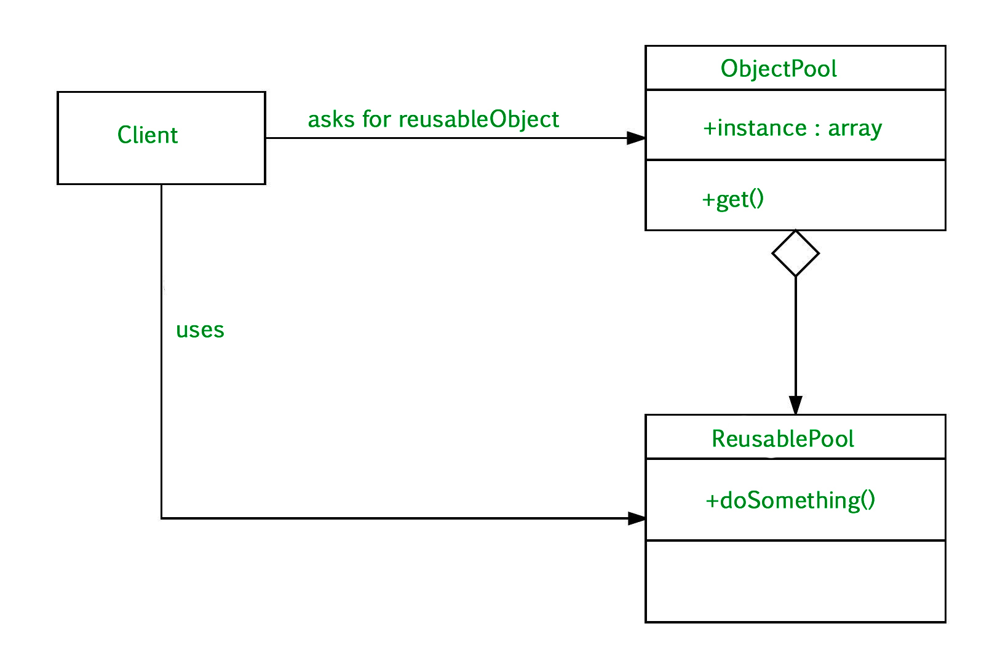](https://media.geeksforgeeks.org/wp-content/uploads/uml-pool-design.jpg)

* **Client :** This is the class that uses an object of the PooledObject type.
* **ReuseablePool:** The PooledObject class is the type that is expensive or slow to instantiate, or that has limited availability, so is to be held in the object pool.
* **ObjectPool :**The Pool class is the most important class in the object pool design pattern. ObjectPool maintains a list of available objects and a collection of objects that have already been requested from the pool.

Let’s take the example of the database connections. It’s obviously that opening too many connections might affect the performance for several reasons:

* Creating a connection is an expensive operation.
* When there are too many connections opened it takes longer to create a new one and the database server will become overloaded.

Here the object pool manages the connections and provide a way to reuse and share them. It can also limit the maximum number of objects that can be created.

filter_none

brightness_4

|  |
| --- |
| // Jave program to illustrate  // Object Pool Design Pattern  abstract class ObjectPool<T> {      long deadTime;        Hashtable<T, Long> lock, unlock;        ObjectPool()      {          deadTime = 50000; // 50 seconds          lock = new Hashtable<T, Long>();          unlock = new Hashtable<T, Long>();      }        abstract T create();        abstract boolean validate(T o);        abstract void dead(T o);        synchronized T takeOut()      {          long now = System.currentTimeMillis();          T t;          if (unlock.size() > 0) {              Enumeration<T> e = unlock.keys();              while (e.hasMoreElements()) {                  t = e.nextElement();                  if ((now - unlock.get(t)) > deadTime) {                      // object has deadd                      unlock.remove(t);                      dead(t);                      t = null;                  }                  else {                      if (validate(t)) {                          unlock.remove(t);                          lock.put(t, now);                          return (t);                      }                      else {                          // object failed validation                          unlock.remove(t);                          dead(t);                          t = null;                      }                  }              }          }          // no objects available, create a new one          t = create();          lock.put(t, now);          return (t);      }      synchronized void takeIn(T t)      {          lock.remove(t);          unlock.put(t, System.currentTimeMillis());      }  }    // Three methods are abstract  // and therefore must be implemented by the subclass    class JDBCConnectionPool extends ObjectPool<Connection> {      String dsn, usr, pwd;        JDBCConnectionPool(String driver, String dsn, String usr, String pwd)      {          super();          try {              Class.forName(driver).newInstance();          }          catch (Exception e) {              e.printStackTrace();          }          this.dsn = dsn;          this.usr = usr;          this.pwd = pwd;      }        Connection create()      {          try {              return (DriverManager.getConnection(dsn, usr, pwd));          }          catch (SQLException e) {              e.printStackTrace();              return (null);          }      }        void dead(Connection o)      {          try {              ((Connection)o).close();          }          catch (SQLException e) {              e.printStackTrace();          }      }        boolean validate(Connection o)      {          try {              return (!((Connection)o).isClosed());          }          catch (SQLException e) {              e.printStackTrace();              return (false);          }      }  }    class Main {      public static void main(String args[])      {          // Create the ConnectionPool:          JDBCConnectionPool pool = new JDBCConnectionPool(              "org.hsqldb.jdbcDriver", "jdbc:hsqldb: //localhost/mydb",              "sa", "password");            // Get a connection:          Connection con = pool.takeOut();          // Return the connection:          pool.takeIn(con);      }  } |

**Advantages**

* It offer a significant performance boost.
* It manages the connections and provides a way to reuse and share them.
* Object pool pattern is used when the rate of initializing a instance of the class is high.

**When to use Object Pool Design Pattern**

* When we have a work to allocates or deallocates many objects
* Also, when we know that we have a limited number of objects that will be in memory at the same time.

**Reference :**

s