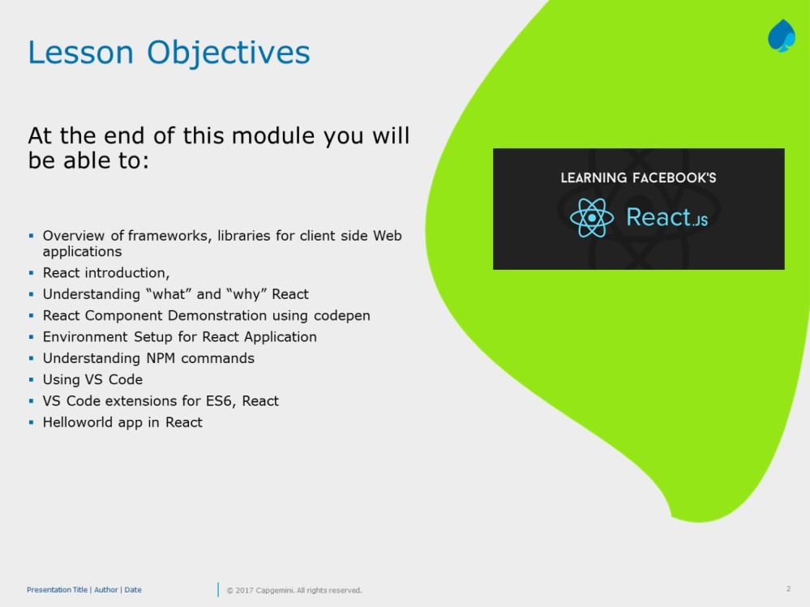

Add instructor notes

here.

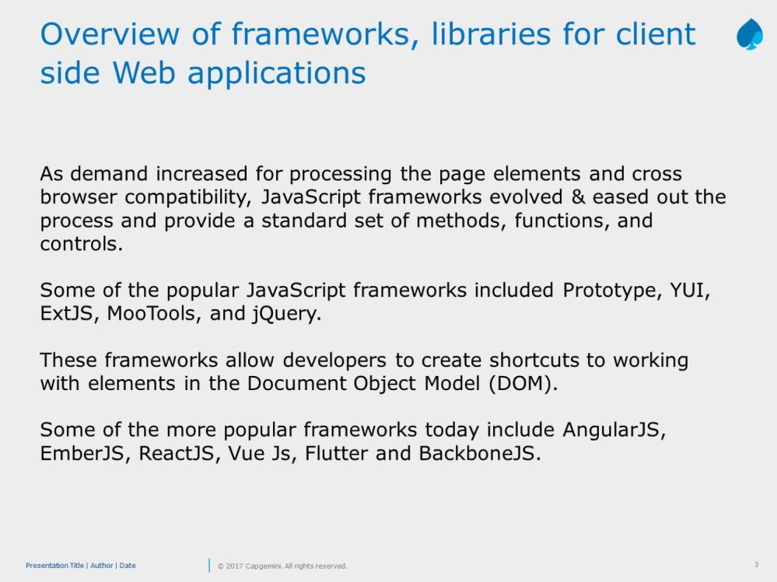

Model :

Model is where the application’s data objects are stored. The model doesn’t know anything about views and controllers. When a model changes, typically it will notify its observers that a change has occurred.

View

View is what's presented to the users and how users interact with the app. The view is made with HTML, CSS,

JavaScript and often templates

Controller

The controller is the decision maker and the glue between the model and view. The controller updates the view when the model changes. It also adds event listeners to the view and updates the model when the user manipulates the view.

JavaScript now has a number of frameworks boasting support for MVC (or variations on it, which we refer to as the MV\* family), allowing developers to easily add structure to their applications without great effort.

These frameworks include the likes of Backbone, Ember.js, and AngularJS.

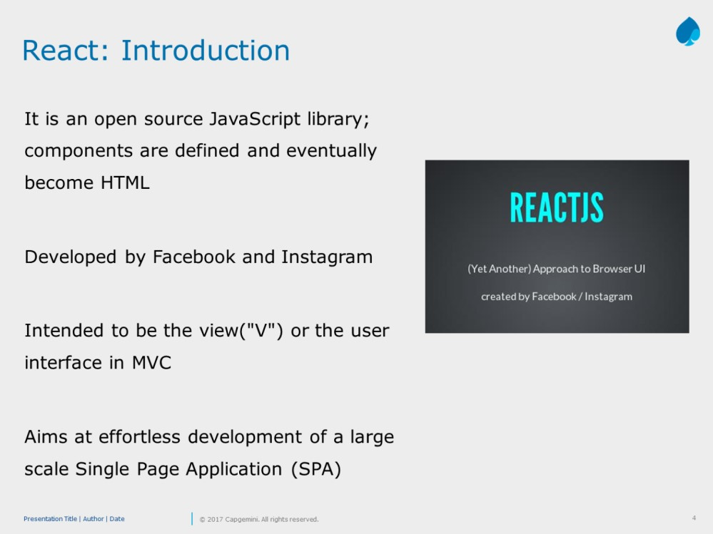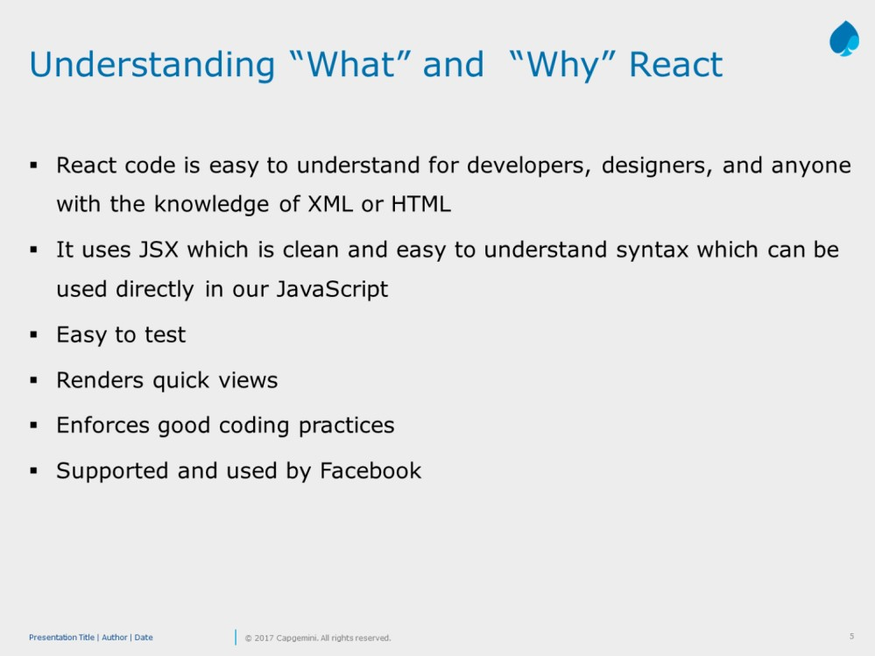

Slide explains regarding

the SOAP format

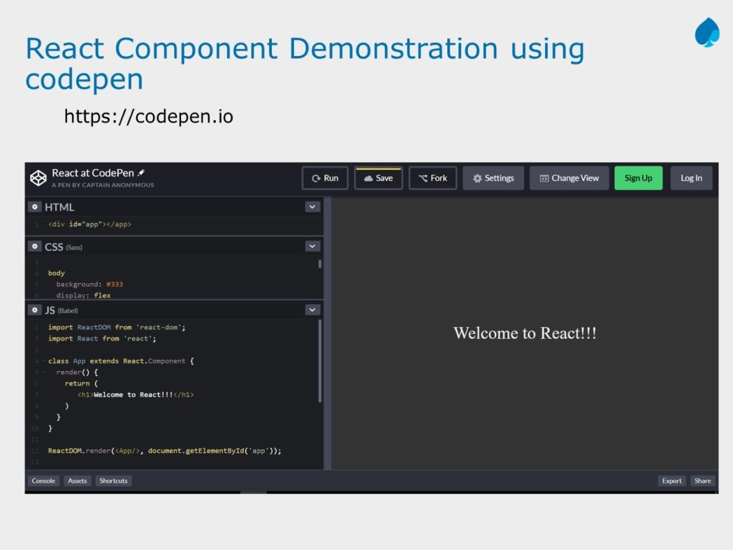

Add instructor notes

here.

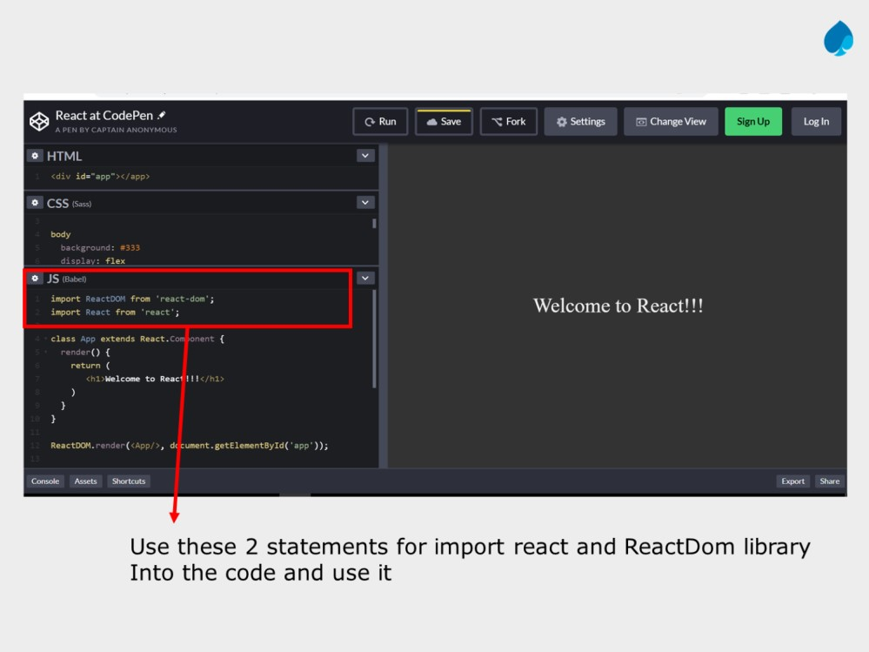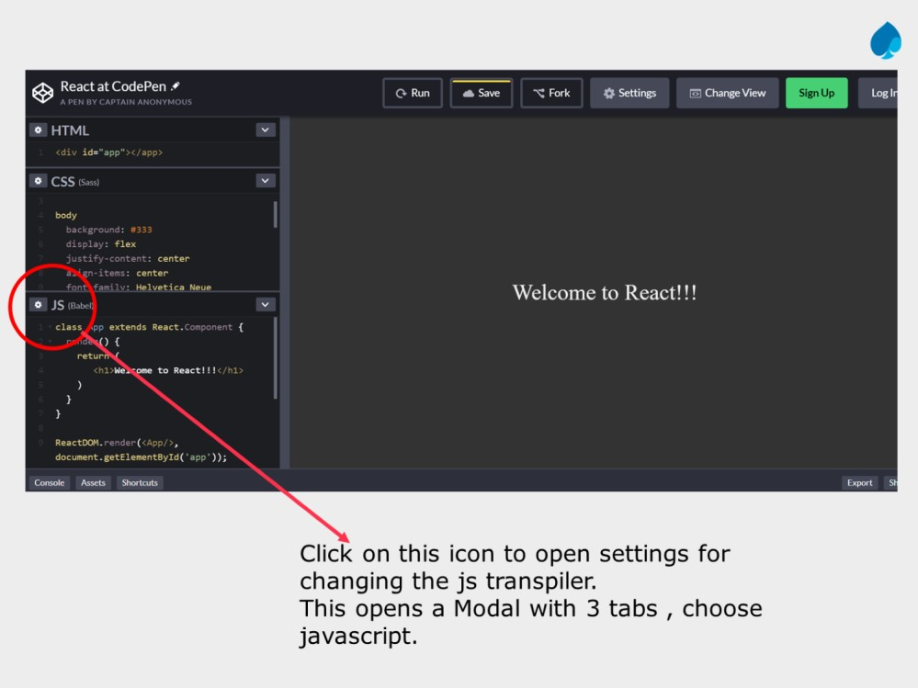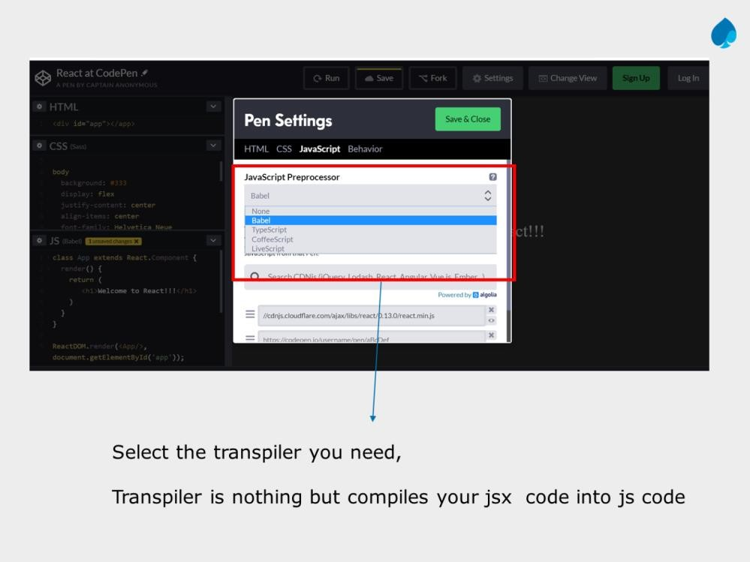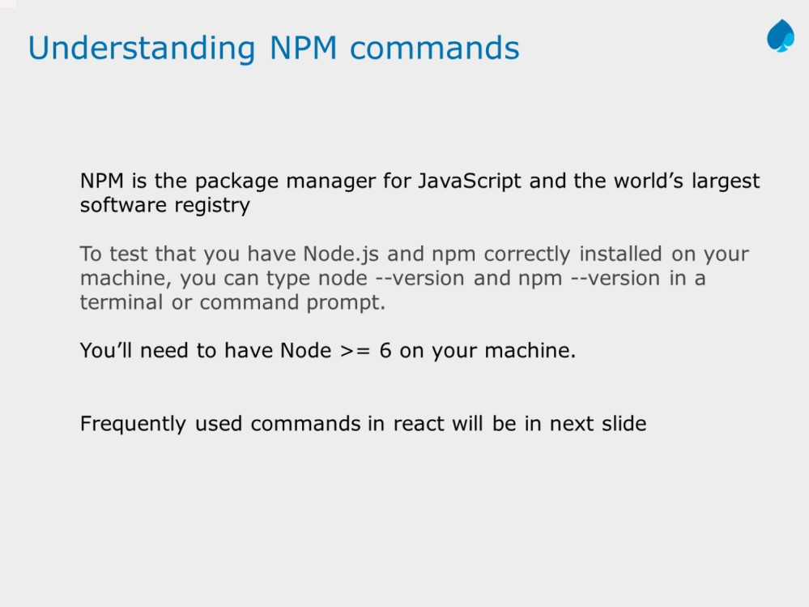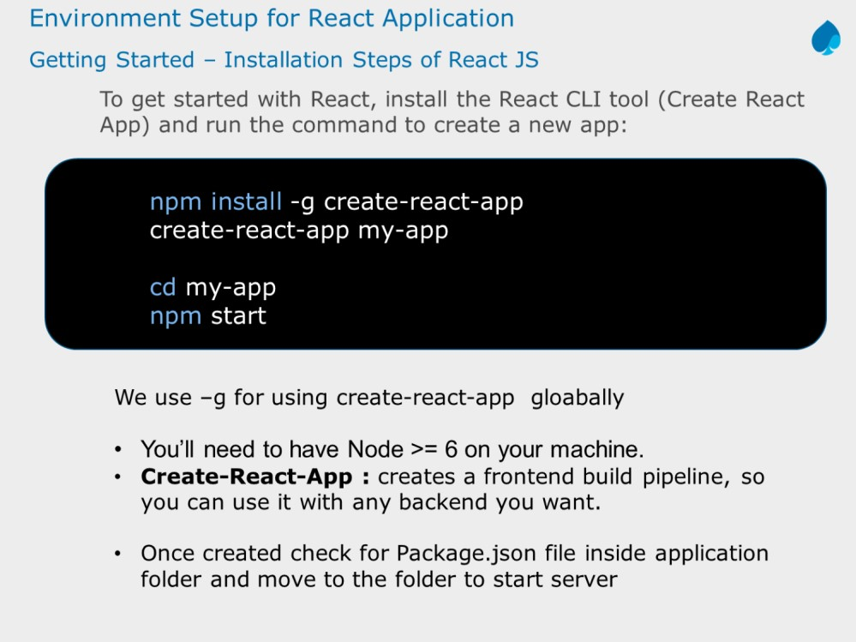

We can also create application using webpack and babel – use another support ppt

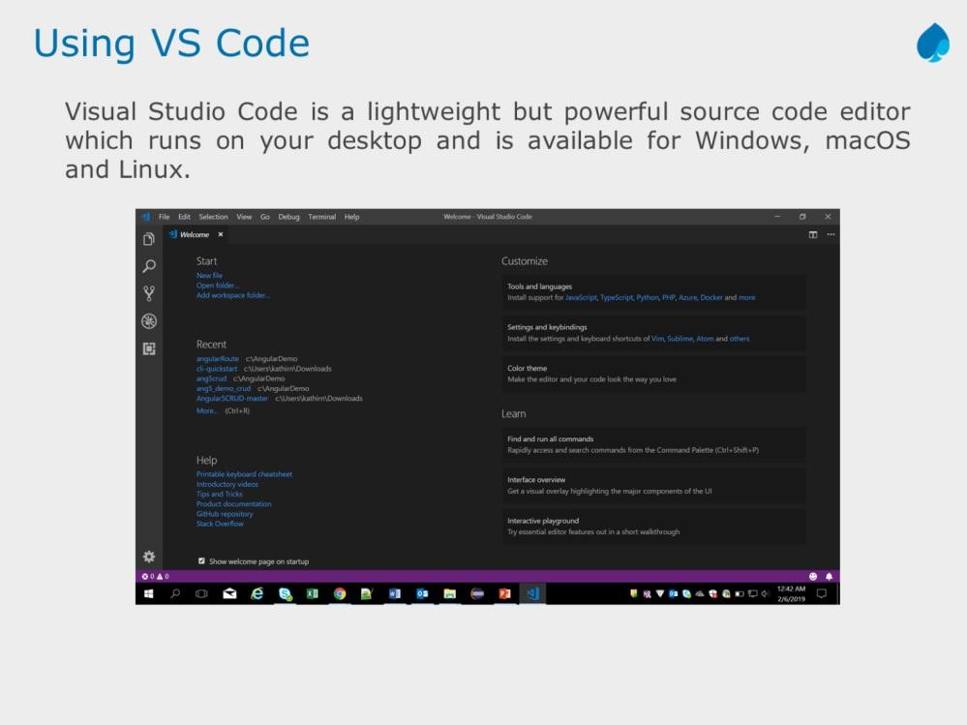

It comes with built-in support for JavaScript, TypeScript and Node.js and has a rich ecosystem of extensions for other languages (such as C++, C#, Java, Python, PHP, Go) and runtimes (such as .NET and Unity).

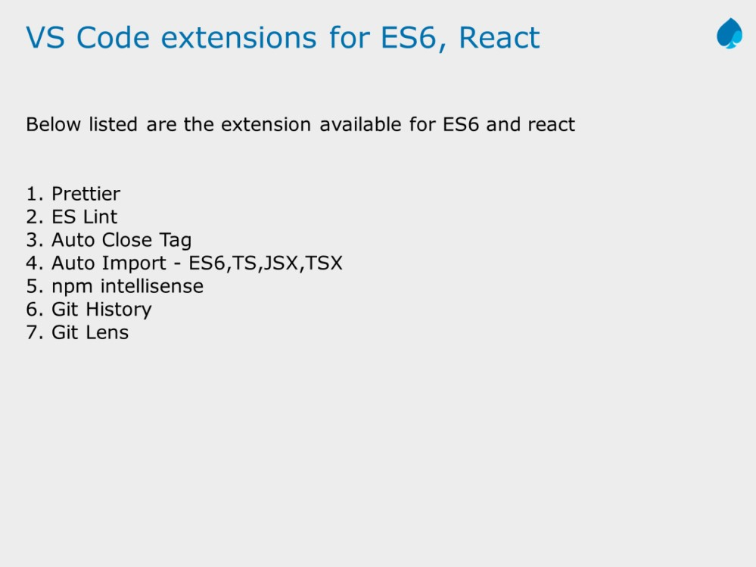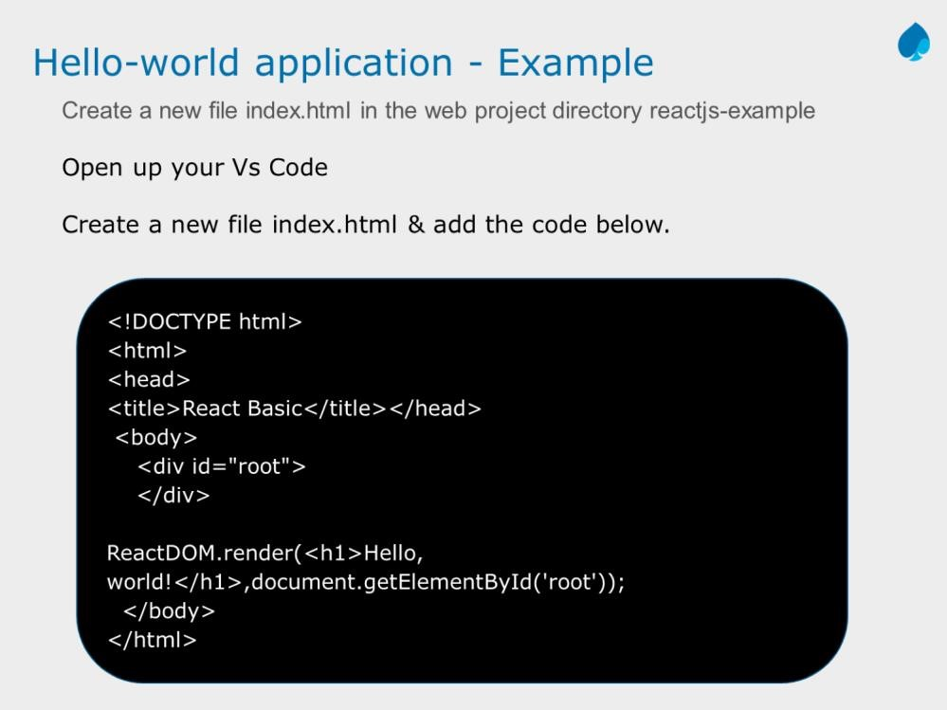

Add instructor notes here.

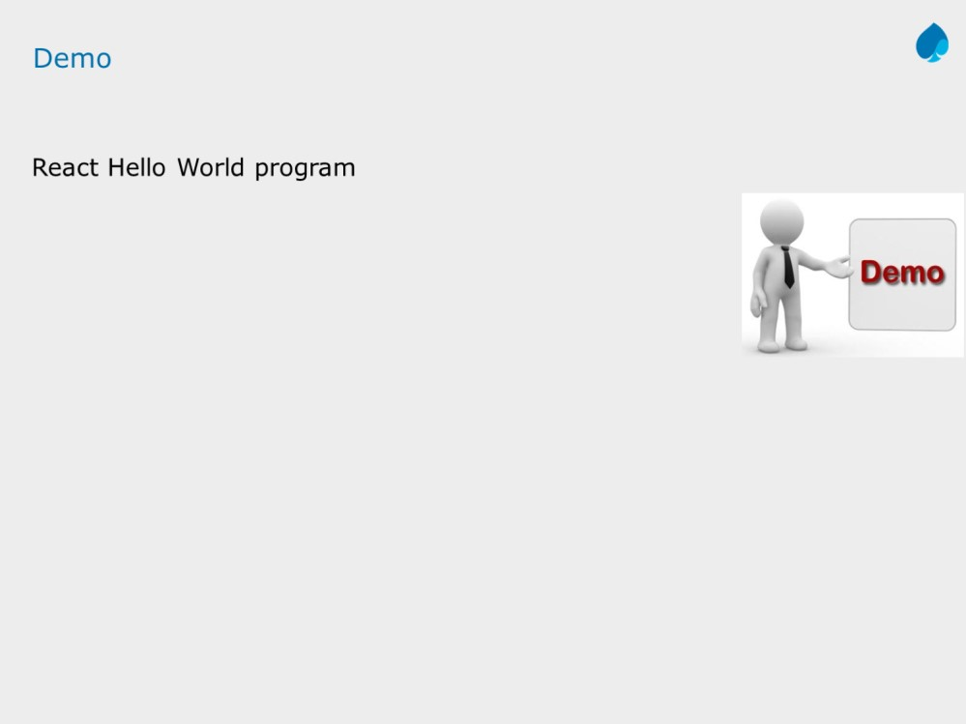

Add the notes here.

Add instructor notes here.

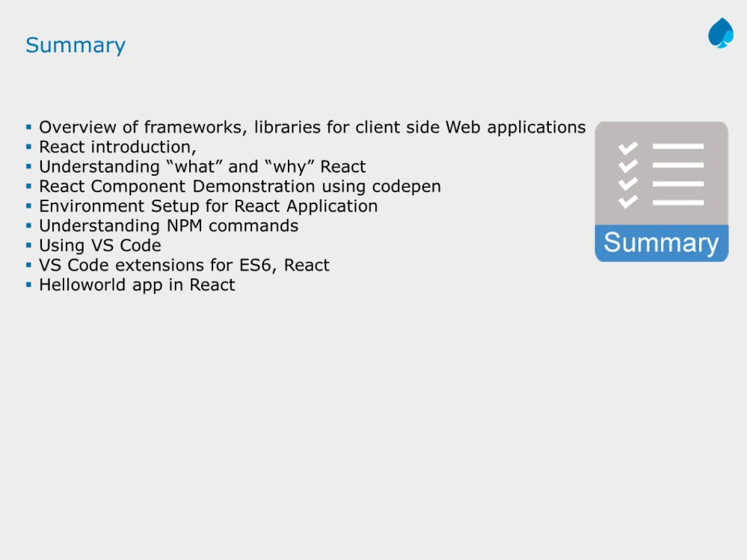

Add the notes here.

