**Fotoshop Image Editor GUI**

CO871 – Advanced Java Programming

Assignment -2

Name Aruna Duraisingam

Student ID 15906743

Username ad543

Email [ad543@kent.ac.uk](mailto:ad543@kent.ac.uk)

Phone 07868003823

## Introduction

The aim of this report is to give an overview of the Fotoshop image GUI editor and its functionalities.

## Overview

Fotoshop is a GUI based image editor is a very user friendly editor where the image is loaded and can do image manipulation operations such as rotate, scale etc. The image editor is designed to handle multiple images which is displayed on multiple tabs. This image editor also has a cache system to hold the multiple images and can retrieve respective images according to the tab selection by the user. This image editor also has a Filter History text area where it displays the list of filters applied on the images in the current tab. This window shows the current selected tab filters. This Images editor also has a console window which provides the current status of the action done on the images.

## Image Editor Layouts

Fotoshop image editor uses different layout panes provided by JavaFX in a user friendly way. The below diagram gives the hierarchy of the layout panes used in the image editor.

Border Pane

Top Center Bottom

VBox HorizontalSplitPane HBox

Toolbar MenuBar VerticalSplitPane VerticalSplitPane Label

Buttons MenuItems

TabPane VBox AnchorPane TabPane

Tab Sliders ScrollPane Tab

ImageView

Image

The fotoshop editor contains menubar, toolbar , a central tab pane which holds multiple images. On the right side it got a slider box where it holds the image manipulation slider options. And at the bottom it got a textarea which holds the current image filter options. At the bottom it got a console window which is also textarea to display the status of the current image.

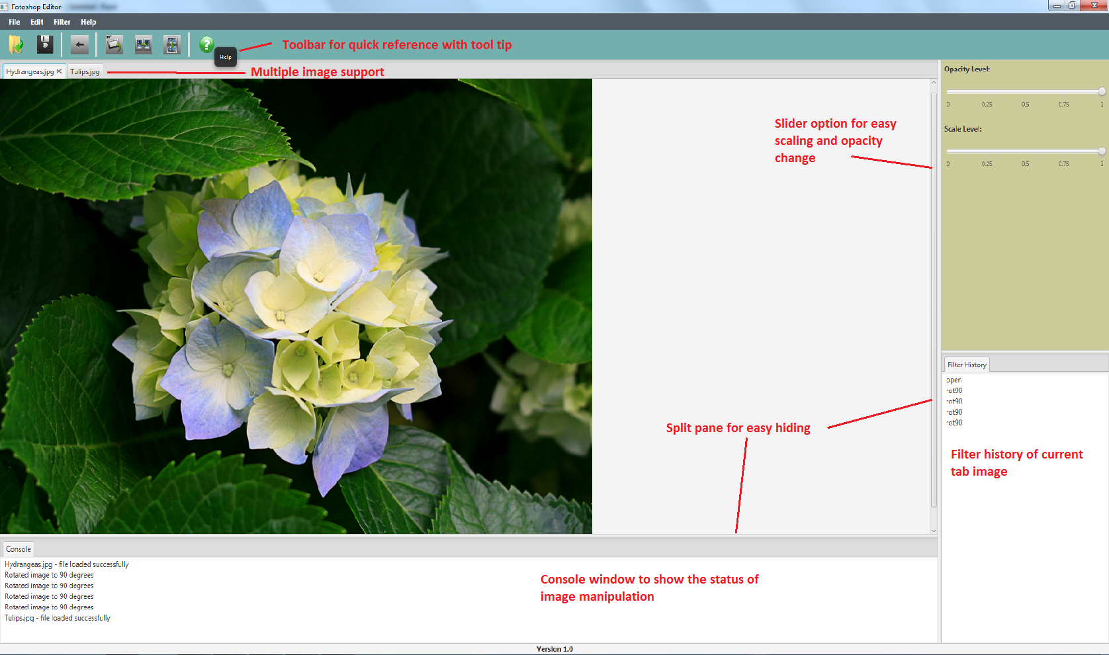

Important Features of image editor

## Menu Bar and ToolBar

On the top of the border pane it holds the menubar which contains the main menu and menu items and the toolbar with buttons for quick access. When each button in the toolbar is hovered it shows the tooltip for user identification.

## Filter history

On the right side bottom of the fotoshop image editor is a tab containing textarea. This textarea lists the list of actions done on the current tab image. The filter list will change based on the image in the selected tab.

## Slider Box

On the right side top of the fotoshop editor is a VBox which holds different sliders which does image manipulation based on increasing or decreasing the slider. Currently there are two sliders one to increase or decrease the scaling of the current tab image and other to increase or decrease the opacity level of the current tab image.

## Console window

At the bottom of the image editor, it has a tab which holds the textarea that displays the status of the image manipulation.

## Image Pane

Fotoshop image editor supports multiple images which is shown in the centre of the image pane. Each opened image will be shown in separate tabs and can manipulate image in each tab individually.

## Filters

Currently Fotoshop image editor supports various kinds of image manipulations (filters) which includes rotating image 90degrees, filp image horizontally , flip image vertically. The image manipulation include increasing and decreasing the scale and opacity which is present in the slider box(right side of image editor).

## Event Handling and lambda expressions

Image editors handle various events when there is click of a button or choosing an option from the menu item. It also uses various listeners to handle when the user moves to another tab or when the slider is increased or decresed

As Lambda expressions are a new feature just recently added to java it is more compact than the anonymous inner classes. Fotoshop image editor takes the advantage of lambda expressions makes the code looks nicer and easy to understand by all java programmers. The following are the sample code used in image editor

when a open button is clicked in the toolbar.

***openBtn.setOnAction((ae) -> imagePane.openImage());***

When a help option is choosed in the menu

***about.setOnAction((ae) -> showHelp());***

## Cache

Fotoshop image editor uses cache functionality to handle the multiple image options. Each tab holds a tabID which is used as key in cache and the image with its filters is added as a value in cache.

## CSS Styling

All the styles in the fotoshop editor are written in separate css style sheet for easy editing.

## Streams

Latest version of Java8 has a new functionality to support parallelism where the collections are computed and processed easily. The below are some of the places where the streams are used in the fotoshop editor.

The stream is used to get a Color image object from a hash map which contains key as TabID and ColorImage as value. The code will convert the hashmap to streams and filter the Map based on the tabID which is a key and get the value. IT will get the resulting first entry or returns null.

***MyColorImage img = imageMap.entrySet()***

***.stream()***

***.filter(e -> e.getKey() == tabID)***

***.map(Map.Entry:: getValue)***

***.findFirst()***

***.orElse(null);***

In an another scenario which is give below, where stream are used iterated to a list of filters and appended to the filter history text area. Using this one line stream code is more elegant way of writing loop iterations more than 3 lines for loop.

**filterList.stream().forEach(s -> appendFilterHistory(s));**

## Testing

Nowadays softwares development becomes test driven where test case are written while writing code. Unit testing is a practice of testing the programs automatically which reduces the time of doing manual and regression testing. In the fotoshop editor, testcases are written for the ColorImage class which helped in improving the performance of the class. Positive, negative , boundary cases are written for through testing.

The below table gives some main test cases in the automated testing.

|  |  |
| --- | --- |
| Method | Description |
| testColorImage_Constructor_nullImage | Testing null pointer exception when the image passed to the constructor is null. |
| testColorImage_Constructor_testingWidth | Positive case. Test whether the class buffered image width and actual image width are same. |
| testColorImage_Constructor_FailtestingHeightNotsame | Negative case. Test whether the class buffered image height and actual image height are not same. |
| testColorImage_Constructor_testingSettingPixels | Positive case. Test whether the colour of a pixel at location(x,y) on actual image is same as colour of pixel at location (x,y) in the buffered image. |
| testSetPixel_nullColor | Testing null pointer exception when the input colour object is null |
| testSetPixel_arrayOutOfBound | Testing array out of bound exception, when the function tries to set a colour values to a pixel which is out of bound. |

## Conclusion

The fotoshop image editor is developed in developed in a user friendly way with a nice layout. It uses the latest streams and lambda expression for elegant coding. Test cases are written for the colour image for better performance.