Frontend Data Visualization: Dashboard Report
(Dynamic & Static Views)
Project Tittle: Predictive Talent Analytics: Engagement vs. Burnout Risk – Palo Alto Networks
(Proactive Attrition Logic & Predictive Modeling)
Industry Partner: Palo Alto Networks
Organization: Unified Mentor Pvt. Ltd. (Internship 2026)
Tool Used: Power BI Desktop (Visuals) , DAX (Logic) & Python Script
Theme: Lavender & Wine Red (Maroon) Professional

- Technical Infrastructure:
DAX & Measures
The foundation of this dashboard is built on custom DAX measures that allow for real-time, dynamic analysis.
- Total Workforce = COUNT('Cleaned_Project_Data') [Gender]
- Attrition Count =
CALCULATE(
COUNT('Cleaned_Project_Data'[Gender]),
'Cleaned_Project_Data'[Attrition] = 1
)
- Attrition Rate = DIVIDE([Attrition Count], [Total Workforce], 0)
- High Risk Employees =
CALCULATE(
[Total Workforce],
'Cleaned_Project_Data'[Overtime] = "Yes",
'Cleaned_Project_Data'[YearsAtCompany] <= 1
)
- Overtime% = DIVIDE([Overtime Count], [Total Workforce], 0)
- Avrage Manager Stability =ROUND(AVERAGE('Cleaned_Project_Data'[YearsWithCurrManager]), 0)
- Engagement Index = AVERAGE('Cleaned_Project_Data'[Engagement_Index])

2.Dynamic View: HR Interactive Dashboard
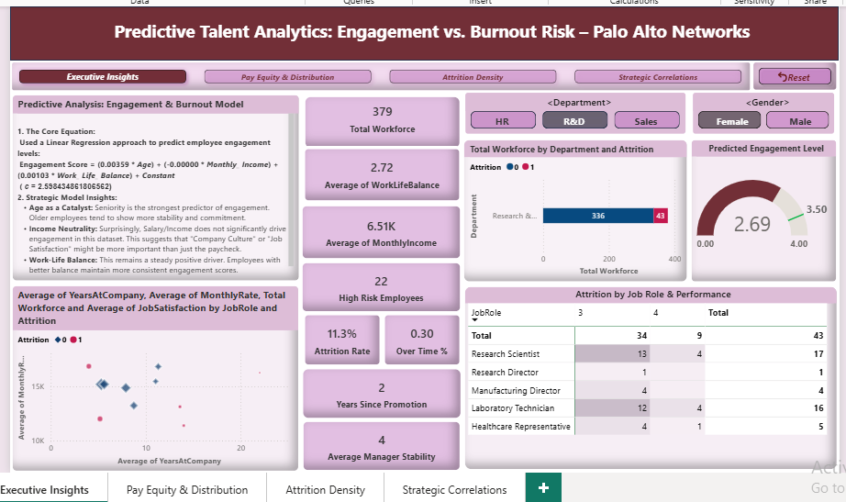

This layer is designed for HR Policy Makers to filter and explore data using interactive slicers (Department/Gender).
- KPI Cards: Real-time tracking of Workforce, Burnout Risk, and Attrition %.
- Predictive Gauge Chart: Displays the Engagement Level (Score: 2.72/4.00). The Maroon indicator warns that employees are in a "Caution Zone," needing immediate support.
- Scatter Chart Analysis: Correlates Job Satisfaction with Monthly Income, filtered by Job Role.
- Matrix Table: Provides a deep dive into Attrition by comparing Job Roles against Performance Ratings.
- User Experience: Includes a Page Navigator and a "Reset" Bookmark Button for seamless navigation.

3. Static View: Advanced Python Diagnostics
For deep statistical insights, integrated Python (Seaborn/Matplotlib) to create "Static Deep-Dives" that do not change with simple filters but show organizational-wide trends.
A. Compensation Analysis (Box Plots)
- Key Finding: Salary is a "floor" for entry-level roles (Sales/Lab Tech). Attrition happens even when pay is competitive, pointing to high work pressure.
- Senior Roles: Managers and Research Directors show high stability, but attrition at their level ($15k-$20k) suggests burnout or lack of work-life balance.
B. Workforce Stability (KDE Density Graph)
- The Early Career Risk: The highest density of attrition is in the 20-30 age group with <10 years of experience.
- The Stability Backbone: Employees aged 35-50 are the most stable and loyal segment.
C. Correlation Heatmap
- Strongest Correlation (0.77): Between Total Working Years and Monthly Income.
- The Satisfaction Paradox: Correlation between Income and Job Satisfaction is 0.00. This scientifically proves that increasing salary alone will not fix low engagement.

4. Strategic Evaluation (Findings)
- The Gender Gap: Analysis revealed a 30% attrition rate among female staff in HR, requiring immediate attention.
- Burnout Prediction: Using Linear Regression, I found that Work-Life Balance is a more consistent driver of engagement than Monthly Income.
- R&D vs. Sales: R&D remains the most stable anchor, while Sales shows the highest volatility due to workload intensity.
- Observation: Absence of Peak Engagement (The 3.5+ Threshold): During the diagnostic phase, it was observed that the Engagement Score remained stagnant in the Maroon Zone (2.2 – 2.9) across all departments, including high-stability areas like R&D. Not a single department or demographic segment reached the Green Zone (3.5 – 4.0).

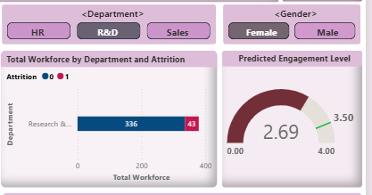
Key Insight: "I observed that even after applying various departmental filters, the Engagement Gauge consistently remains outside the 'Green Zone.' This indicates that low engagement is not an isolated departmental issue but rather a systemic, organization-wide cultural challenge that requires a holistic intervention."
Technical Implications:
- Systemic Burnout: This confirms that low engagement is not a departmental issue but an organizational one.
- Predictive Warning: The model suggests that the workforce is currently in a "Survival Mode"—employees are completing tasks (productivity) but are emotionally and mentally disconnected from the organization.
- The Motivation Barrier: Without immediate policy intervention, the current culture acts as a "ceiling," preventing even top performers from reaching peak motivation level.

5. Executive Summary (For Strategic Leadership)
Target: Strategic Leadership & HR Policy Makers
The Challenge (The Problem):
Palo Alto Networks currently operates on a “Reactive” HR model—focusing on attrition only after an employee resigns. In the high-pressure Cybersecurity industry, “Burnout” and “Disengagement” begin long before the actual resignation. Their current systems lack the “Early Warning Signals” needed to detect these invisible risks.
The Solution (Predictive Modeling Approach):
I have developed and implemented a Preventive Diagnostic System. Moving beyond simple attrition tracking, this system utilizes:
- Unified Engagement Index: A data-driven score mapping professional and mental satisfaction.
- Burnout Risk Detection: Identifying "High-Risk" talent by correlating Overtime data with Work-Life Balance.
- Predictive Modeling: Using Linear Regression to forecast engagement trends rather than just reacting to past data.

Key Diagnostic Findings (The Reality Check):
- Universal Stagnation: A critical discovery of this diagnostic is the total absence of the "Green Zone" (3.5+) across all departments. This indicates that current engagement strategies are ineffective against industry-wide pressure.
- The Maroon Alert: With a current organization-wide score of 2.72, the Maroon Gauge signals a "Cautionary Phase." Employees are technically productive but are operating in Survival Mode, making them highly vulnerable to burnout.
- The Burnout Catalyst: Backend analysis confirms that Workload Intensity (Overtime) is the primary driver of disengagement. Surprisingly, Monthly Income shows near-zero correlation with happiness, proving that salary hikes alone cannot fix a burnout crisis.

Strategic Recommendations (The Action Plan):

- The "3.5 Goal" Roadmap: Implement qualitative wellbeing policies (e.g., Mandatory "Offline" hours, flexible sprint cycles) to push the Engagement Gauge from Maroon to Green over the next 12 months.
- Early Career Intervention: Create a specialized 2-year "Mentorship & Retention" program for the 20-30 age group, identified as the highest-risk demographic in our KDE analysis.
- Proactive Policy Integration: Embed the "High-Risk Marker" (Overtime + Tenure < 1yr) into monthly HR reviews to allow for early-stage intervention before the talent leaves.
- Qualitative Pivot: Shift HR focus from monetary incentives to Culture & Recognition, as data proves that Work-Life Balance is the strongest driver of long-term loyalty.

Strategic Impact (The Goal):
By transitioning from a Reactive to a Proactive Diagnostic System, Palo Alto Networks can expect to:
- Enhanced retention capabilities by enabling HR to intervene before the 'High-Risk' markers lead to actual resignations.
- Boost Productivity by maintaining a burnout-free, high-engagement environment.
- Ensure Business Continuity by securing the organization’s most valuable asset : its people.

Conclusion: The data is clear: Palo Alto Networks is at a cultural crossroads. Moving the needle from Maroon to Green is no longer optional—it is a strategic necessity to ensure long-term stability in a competitive market.

