WEEK 1 INTERNSHIP PROJECT REPORT
Data Cleaning and Preliminary Analysis with R
Virtual R Data Analyst Intern
Dataset: Titanic Passenger Data
Intern Name: ____________________
Submission Date: ____________________

1. Executive Summary
This project addresses the Week 1 requirement of the Virtual R Data Analyst Internship: data cleaning, preprocessing, and preliminary analysis using R. The Titanic passenger training dataset was selected because it contains a useful mixture of numerical and categorical variables, as well as missing values in important fields such as Age, Cabin, and Embarked. The analysis demonstrates a complete preprocessing workflow including missing-value treatment, duplicate checks, IQR-based outlier detection, outlier capping, Min-Max normalization, categorical encoding, descriptive statistics, correlation analysis, and visual exploration.

2. Dataset Selection and Overview
The selected dataset is the Titanic training dataset from Kaggle's 'Titanic - Machine Learning from Disaster' competition. Kaggle states that the training dataset contains 891 passenger records with the survival outcome available as the target variable. The dataset contains 12 variables covering passenger identity, survival, class, demographic information, family relationships, ticket/fare details, cabin information, and embarkation port.
Public source: https://www.kaggle.com/competitions/titanic
Dataset dimensions: 891 rows × 12 columns
Variable | Type | Missing | Purpose
PassengerId | int64 | 0 | Unique passenger identifier
Survived | int64 | 0 | Target: survival status
Pclass | int64 | 0 | Passenger class
Name | object | 0 | Passenger name
Sex | object | 0 | Sex
Age | float64 | 177 | Age in years
SibSp | int64 | 0 | Siblings/spouses aboard
Parch | int64 | 0 | Parents/children aboard
Ticket | object | 0 | Ticket identifier
Fare | float64 | 0 | Ticket fare
Cabin | object | 687 | Cabin identifier
Embarked | object | 2 | Port of embarkation

3. Initial Data Inspection
The first stage was to inspect the dataset structure, dimensions, data types, summary statistics, duplicate records, and missing values. In R, the primary functions used for this stage are dim(), str(), summary(), and is.na().
dim(data)
str(data)
summary(data)
missing_summary <- data %>%
summarise(across(everything(), ~sum(is.na(.))))
Exact duplicate rows detected before cleaning: 0

3.1 Missing Values Before Cleaning
Variable | Missing Count | Missing %
Cabin | 687.0 | 77.1
Age | 177.0 | 19.87
Embarked | 2.0 | 0.22
PassengerId | 0.0 | 0.0
Name | 0.0 | 0.0
Pclass | 0.0 | 0.0
Survived | 0.0 | 0.0
Sex | 0.0 | 0.0
Parch | 0.0 | 0.0
SibSp | 0.0 | 0.0
Fare | 0.0 | 0.0
Ticket | 0.0 | 0.0
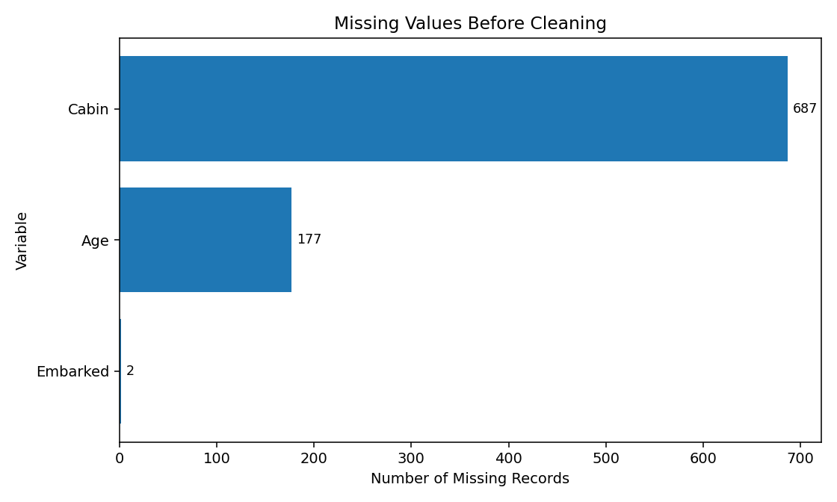
Figure 1. Missing values identified before cleaning.

4. Data Cleaning and Preprocessing

4.1 Missing Value Treatment
Age had 177 missing records. Because Age is numerical and the median is less sensitive to skewed observations, missing Age values were replaced with the median age of 28.0 years. Embarked had 2 missing records and was imputed with the mode, 'S'. Cabin had 687 missing records (77.1%), so it was removed from the preliminary analysis rather than applying a highly speculative imputation method.
age_median <- median(data$Age, na.rm = TRUE)
data$Age[is.na(data$Age)] <- age_median
mode_embarked <- names(sort(table(data$Embarked), decreasing = TRUE))[1]
data$Embarked[is.na(data$Embarked)] <- mode_embarked
data <- data %>% select(-Cabin)

4.2 Outlier Detection
Numerical outliers were identified using the Interquartile Range (IQR) method. For each selected numerical variable, values below Q1 - 1.5×IQR or above Q3 + 1.5×IQR were flagged. Instead of deleting passenger records, outliers were capped at the calculated IQR boundaries to retain the sample size while reducing the influence of extreme values.
Variable | Q1 | Q3 | IQR | Lower Bound | Upper Bound | Outlier Count
Age | 22.0 | 35.0 | 13.0 | 2.5 | 54.5 | 66
Fare | 7.91 | 31.0 | 23.09 | -26.72 | 65.63 | 116
SibSp | 0.0 | 1.0 | 1.0 | -1.5 | 2.5 | 46
Parch | 0.0 | 0.0 | 0.0 | 0.0 | 0.0 | 213
detect_outliers <- function(x) {
q1 <- quantile(x, 0.25, na.rm = TRUE)
q3 <- quantile(x, 0.75, na.rm = TRUE)
iqr <- q3 - q1
lower <- q1 - 1.5 * iqr
upper <- q3 + 1.5 * iqr
sum(x < lower | x > upper, na.rm = TRUE)
}
sapply(data[c("Age", "Fare", "SibSp", "Parch")], detect_outliers)
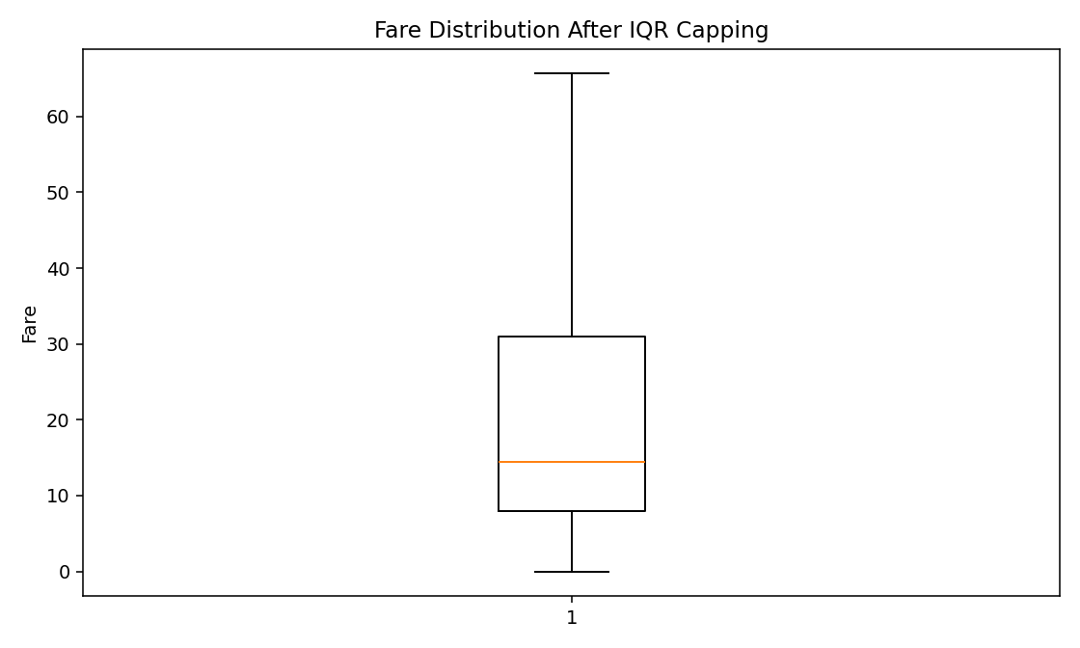
Figure 2. Fare distribution after IQR capping.

4.3 Normalization
Min-Max normalization was applied to Age, Fare, SibSp, and Parch. The transformation scales each selected numerical feature to the 0–1 range. This makes the variables comparable in scale and is useful for later analytical or machine-learning workflows.
min_max <- function(x) {
(x - min(x, na.rm = TRUE)) /
(max(x, na.rm = TRUE) - min(x, na.rm = TRUE))
}
data$Age_Normalized <- min_max(data$Age)
data$Fare_Normalized <- min_max(data$Fare)

4.4 Categorical Encoding
Categorical variables were transformed into numerical representations. Sex was binary encoded as female = 0 and male = 1. Embarked was represented through one-hot encoded indicator variables for Cherbourg (C), Queenstown (Q), and Southampton (S). This creates machine-readable fields without assigning an artificial numerical order to the port categories.
data$Sex_Encoded <- ifelse(data$Sex == "male", 1, 0)
data <- data %>%
mutate(
Embarked_C = ifelse(Embarked == "C", 1, 0),
Embarked_Q = ifelse(Embarked == "Q", 1, 0),
Embarked_S = ifelse(Embarked == "S", 1, 0)
)

5. Exploratory / Preliminary Analysis
After cleaning, descriptive statistics and relationships between key variables were examined. The analysis focuses on survival because it is the main outcome in the dataset.

5.1 Descriptive Statistics
Variable | count | mean | std | min | 25% | 50% | 75% | max
Age | 891.0 | 29.04 | 12.07 | 2.5 | 22.0 | 28.0 | 35.0 | 54.5
SibSp | 891.0 | 0.43 | 0.71 | 0.0 | 0.0 | 0.0 | 1.0 | 2.5
Parch | 891.0 | 0.0 | 0.0 | 0.0 | 0.0 | 0.0 | 0.0 | 0.0
Fare | 891.0 | 24.05 | 20.48 | 0.0 | 7.91 | 14.45 | 31.0 | 65.63
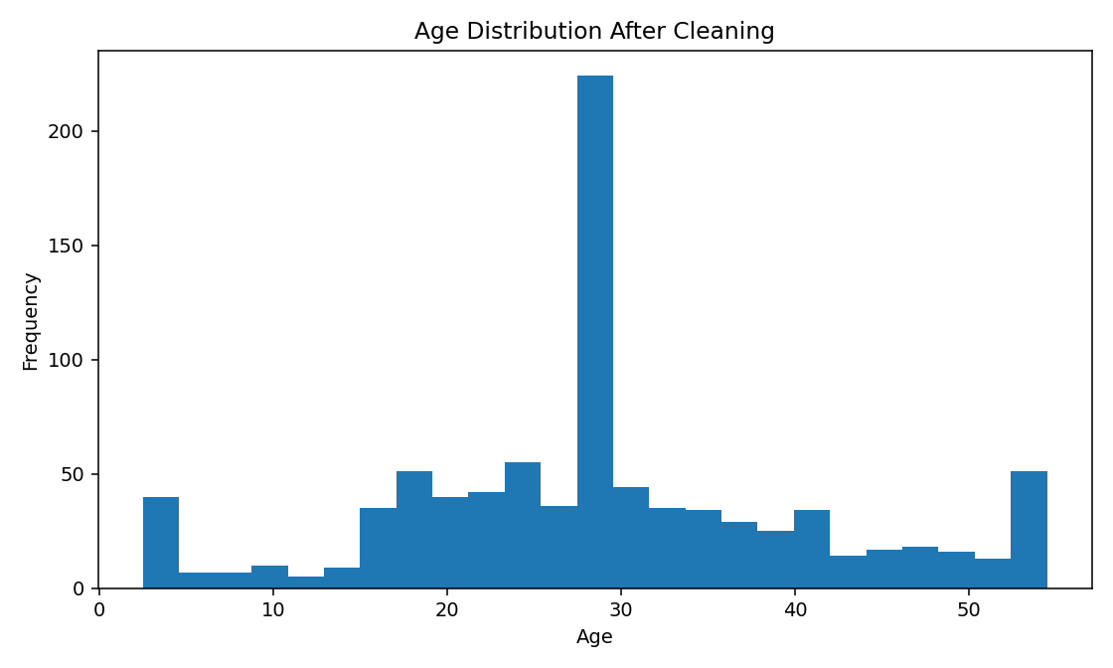
Figure 3. Age distribution after missing-value treatment and outlier capping.

5.2 Survival by Sex
Variable | Passengers | Survivors | Survival_Rate
female | 314.0 | 233.0 | 74.2
male | 577.0 | 109.0 | 18.89
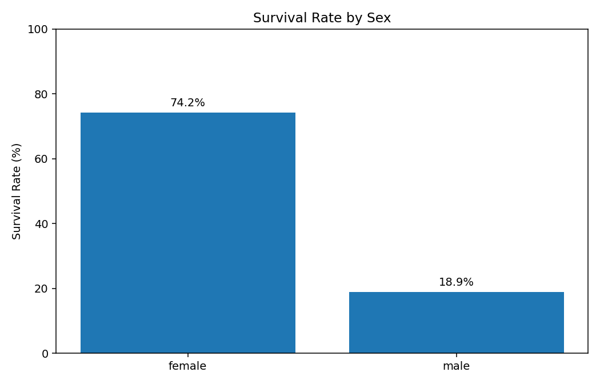
Figure 4. Preliminary survival rate by sex.

5.3 Survival by Passenger Class
Variable | Passengers | Survivors | Survival_Rate
1 | 216.0 | 136.0 | 62.96
2 | 184.0 | 87.0 | 47.28
3 | 491.0 | 119.0 | 24.24
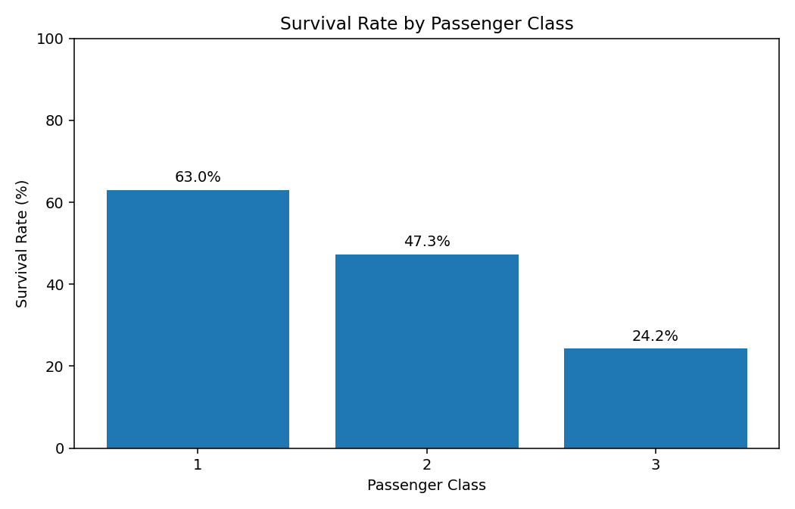
Figure 5. Preliminary survival rate by passenger class.

5.4 Correlation Analysis
Pearson correlation was calculated for the main numerical variables. Correlation indicates linear association and does not establish causation. Passenger class shows a negative association with survival because smaller Pclass values represent higher classes. Fare shows a positive association with survival, while Age has a weaker relationship.
Variable | Survived | Pclass | Age | SibSp | Parch | Fare
Survived | 1.0 | -0.338 | -0.061 | 0.031 | nan | 0.317
Pclass | -0.338 | 1.0 | -0.34 | 0.023 | nan | -0.715
Age | -0.061 | -0.34 | 1.0 | -0.248 | nan | 0.145
SibSp | 0.031 | 0.023 | -0.248 | 1.0 | nan | 0.35
Parch | nan | nan | nan | nan | nan | nan
Fare | 0.317 | -0.715 | 0.145 | 0.35 | nan | 1.0
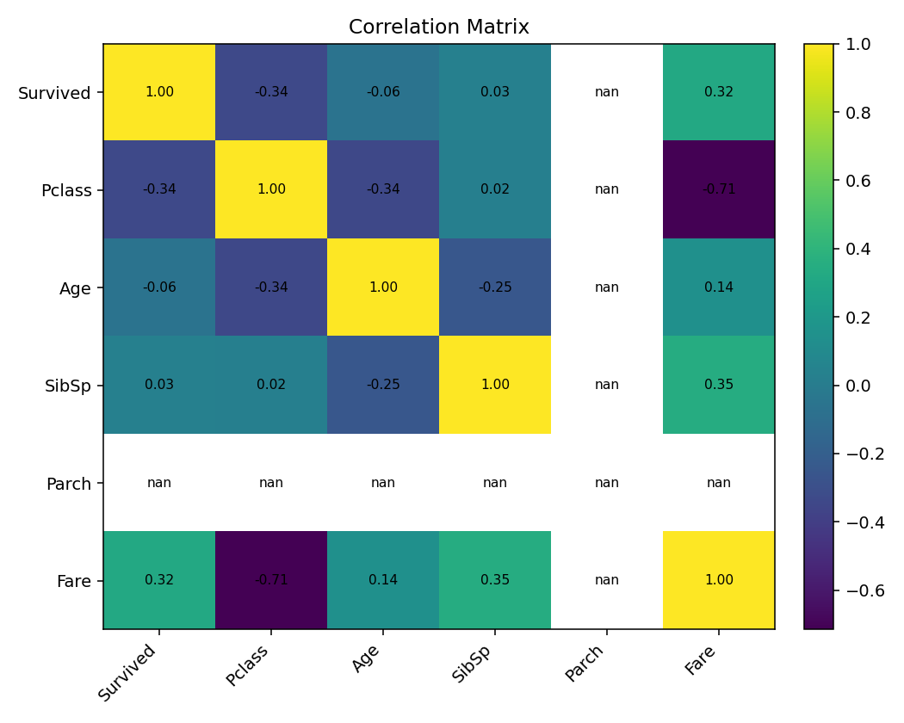
Figure 6. Correlation matrix for key numerical variables.

6. Initial Insights
1. Sex is a strong preliminary differentiator: the survival rate was approximately 74.2% for female passengers versus 18.9% for male passengers.
2. Passenger class is also important: survival rates were approximately 63.0% in first class, 47.3% in second class, and 24.2% in third class.
3. Missing data were not distributed uniformly. Cabin had the largest amount of missingness, so dropping it was more defensible for this preliminary task than attempting to reconstruct individual cabin assignments.
4. Fare contained influential high-value observations. IQR-based capping reduced the effect of extreme fares while preserving all passenger records.
5. The correlation analysis suggests that survival is associated with passenger class and fare, but correlation alone should not be interpreted as a causal relationship.

7. R Code and Reproducibility
The complete R script is provided in the project folder as 'R/week1_titanic_analysis.R'. It is designed to be executed from the project root in RStudio. The script loads the data, performs cleaning and preprocessing, calculates descriptive statistics, creates visualizations, and writes the cleaned dataset.
# Example R output commands
dim(data)
str(data)
summary(data)
# Correlation
cor(data[c("Survived", "Pclass", "Age", "SibSp", "Parch", "Fare")])
# Grouped survival analysis
data %>%
group_by(Sex) %>%
summarise(
Passengers = n(),
Survivors = sum(Survived),
Survival_Rate = round(mean(Survived) * 100, 2)
)

8. Conclusion
The Week 1 analysis successfully demonstrates a structured data-cleaning and preliminary analysis workflow in R. The Titanic dataset provided the required complexity through missing values, numerical variables, categorical variables, and extreme observations. Missing values were treated using median and mode imputation, a high-missingness variable was removed, outliers were detected with the IQR method and capped, numerical variables were normalized, and categorical variables were encoded. Preliminary analysis then identified meaningful differences in survival across sex and passenger class. The resulting cleaned dataset and R script provide a reproducible foundation for further exploratory analysis or predictive modeling in later tasks.

9. References
Kaggle. Titanic - Machine Learning from Disaster. https://www.kaggle.com/competitions/titanic
Kaggle describes the training data as 891 passenger records with survival outcomes.
R Project. R statistical computing environment. https://www.r-project.org/

