Requirements Analysis Document (RAD)
1. Introduction
1.1 Purpose of the system
To entertain the user by allowing fun gameplay with a classic 2D side scroller game. The system will provide further entertainment by allowing the user to replace sounds and images with their own to make it more customizable.
1.2 Scope of the system
This game will be for the Microsoft Windows Platform using OpenGL and OpenAL in C++ as well as a few libraries in C. It is aimed at people that like fun and simple games instead of the newer 3D first person shooter games. The user does not have to have a high computer literacy as it uses the arrow keys and a few others. If the user wants to they will be able to change the keys to ones they like more.
1.3 Objectives and success criteria of the project
The main objective is to make a fully functional 2D side scroller game. This includes gravity, collision detection, enemies in the levels, simultaneous sounds, and levels ending. If that is accomplished than the project is a success. Nice to have goals include customizable sounds and artwork, good story line, and at least one boss fight.
1.4 Definitions, acronyms, and abbreviations
SOIL – Simple OpenGL Image Library
OpenGL – Open Graphics Library
OpenAL – Open Audio Library
SDK – Software Development Kit
1.5 References
http://en.wikipedia.org/wiki/OpenGL
http://www.opengl.org/
http://nehe.gamedev.net/
http://isites.harvard.edu/icb/icb.do?keyword=k62539 (Jeff Parker)
http://www.lonesock.net/soil.html
http://www.devmaster.net/articles.php?catID=6
http://connect.creativelabs.com/openal
1.6 Overview
This game will be a lot of fun for many people. Super East Gate features a Jason Westgate like character (meaning he throws frisbees) who will traverse a world and save the princess Michelle on the other side of the East Gate.
2. Current System
One game that is much like ours is called “Braid” and is also a 2D side scroller game. You are a Mario like character that explores a world full of little goomba like enimies and also rabbit enemies. This game differs from Mario by adding a story line twist at the end and also allows for special controls of time instead of special power ups.
3. Proposed System
3.1 Overview
This will be a 2D like side scroller game called Super East Gate. In it the user will be able to customize images, sound, and keys to make the game more fun and enjoyable. The game will feature at least 4 worlds, each with a few levels.
3.2 Functional requirements
3.2.1 Gameplay Character
3.2.1.1 Actions:
Jump
Left and Right Movement
Interact with action object
3.2.1.2 Interaction With Enemy
If hitting enemy on top, kills enemy or reduces enemy down one stage
If hitting enemy with action object, automatically kills it
3.2.1.3 Interaction With World
Jump on top of world blocks
Smash world blocks
Fall in the gaps in the world floors
3.2.2 Enemy Character
3.2.2.1 Actions:
Jump
Left and Right Movement
Possibility of flight
3.2.2.2 Interaction With Gameplay Character
If hitting gameplay character on top, reduces character one size level, or kills him
If hitting gameplay character on the sides, reduces character one size level, or kills him
Possibility of throwing action objects at gameplay character, which would reduce the character one size level, or kill him.
3.2.2.3 Interaction With World
If approaching a gap in the world floor, certain enemy characters will move away from it
If enemy character is on a game block, it has the ability to stay on the game block or drop to the floor
3.2.3 World Map
Needs to maintain game objects and place them into the world accordingly
3.3 Nonfunctional requirements
3.3.1 Usability
The user should be able to choose a gameworld, navigate through a gameworld, interact with enemy characters, interact with game blocks, and save/load a game state.
3.3.2 Reliability
The game should not crash or lock up the computer during normal gameplay.
3.3.3 Performance
The game should run smoothly and be responsive to control sets as long as the user has a computer comparable or better than the minimum requirements.
3.3.4 Supportability
This product will undergo one release and that will be it for development. There will be no support offered after the final release.
3.3.5 Implementation
Will be done using C++ as the primary language along with OpenGL and OpenAL libraries in Visual Studio 2008.
3.3.6 Interface
The game will be able to be played in both windowed mode and full screen. The keyboard will be the main controller and the mouse will work with the menus but not used in actual gameplay.
3.3.7 Packaging
The game will launch from a single executable file and read in game packs to give game play. These packs will include tga images and wav sound files as well as text files with world level lists.
3.4 System models
3.4.1 Scenarios
3.4.1.1
Scenario Name | PlayLevel
Participating Actor Instances | Richard: GameUser
Flow Of Events | 1) Richard enters level  2) Richard approaches GamePiece and  a) Jumps on top of it  b) Smashes it (if Richard is in Big State)  c) Releases Item (if ItemBlock)  3) Richard then approaches gap in floor and  a) Falls into it and dies  b) Jumps over it  4) Richard then approaches AIObject and  a) Jumps on it, reducing its state  b)Jumps over it and moves on  c) Throw ActionObject at it, reducing its  state  d) Gets hit by AIObject and reduces its state  5) Richard then approaches a pipe and  a) Jumps onto it and then off again  b) Jumps onto it, and goes down into  sublevel  6) Richard pauses the level by accessing the menu  and enters the appropriate option  a) Richard then resumes the game by  accessing the menu and enters the  appropriate option  7) Richard approaches the end of the level and  a) Brought to the next level

3.4.2 Use case model

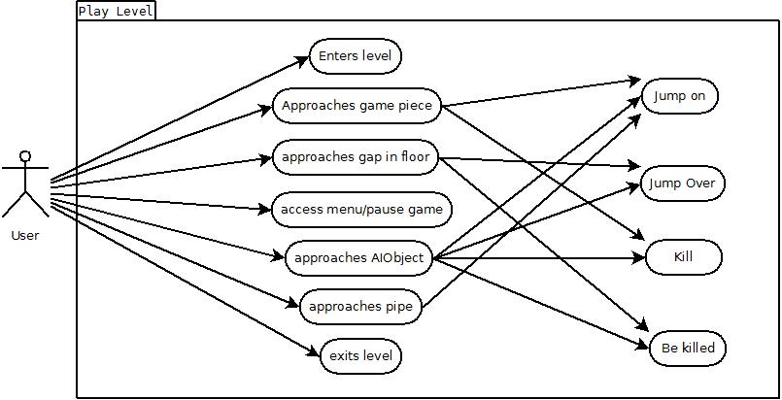

3.4.3 Object model
See Attached Figure 1

3.4.4 Dynamic model
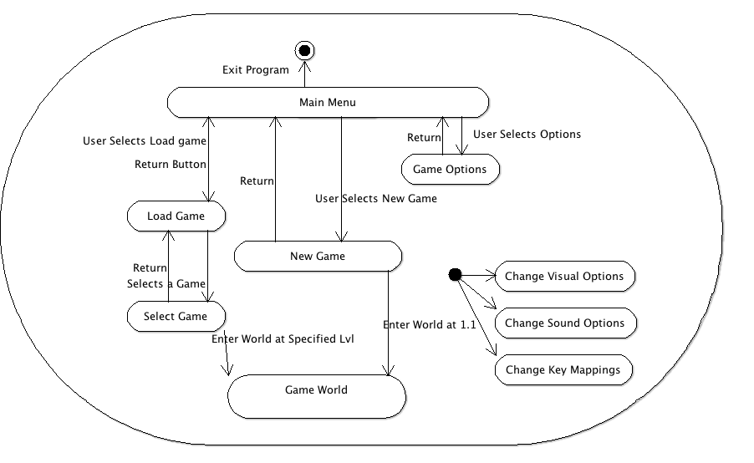

3.4.5 User Interface
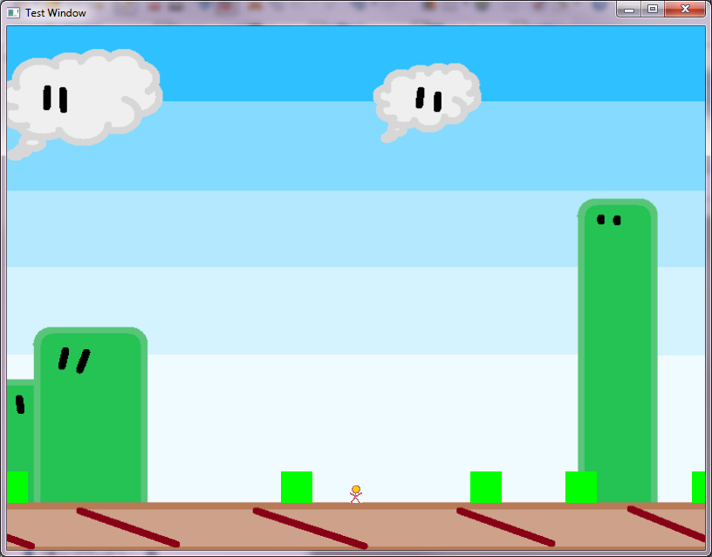

4. Glossary
ActionObject – User controlled weapon item instance
AIObject – Computer controlled enemy in game
GameDude – User controlled on screen object
GamePiece – Object that exists in the game world.
ItemBlock – Block that releases items or power ups
OpenGL – Open source cross platform graphics API
OpenAL – Open source cross platform audio API
5. References
Bruegge, Bernd & Dutoit, Allen H. Object Oriented Software Engineering. Prentice Hall, Upper Saddle River, NJ, 2010.

