ASSIGNMENT-1

Q1. DAXPY Loop: D stands for Double precision, A is a scalar value, X
and Y are one-dimensional vectors of size 2^16 each, P stands for Plus.
The operation to be completed in one iteration is X[i] = a*X[i] + Y[i].
Your task is to compare the speedup (in execution time) gained by
increasing the number of threads. Start from a 2 thread implementation.
How many threads give the max speedup? What happens if no. of threads
are increased beyond this point? Why?
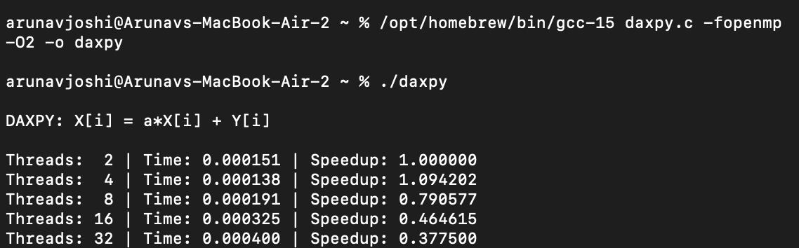
Maximum speed obtain was 1.09 with the use of 4 thread. After thread 4 there is drop in speed because using extra threads and limited memory bandwidth outweigh the benefits of parallel execution.

Q2. Matrix Multiply : Build a parallel implementation of multiplication
of large matrices (Eg. size could be 1000x1000). Repeat the experiment
from the previous question for this implementation. Think about how to
partition the work amongst the threads – which elements of the product
array will be calculated by each thread? Implement 2 version of parallel
implementation for given task. First, use 1D threading(i.e., make a
single loop run in parallel). Second, use 2D threading (i.e., use nested
looping to the most suitable loops to be parallelized)
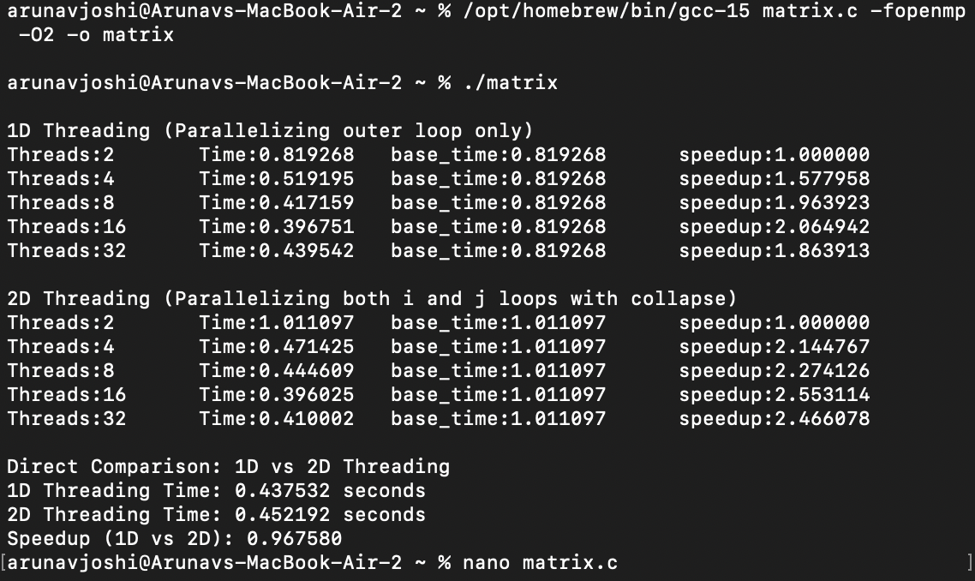
2 differnent approaches were used in this parallel matrix multiplication one is 1d approach and second is 2d approach. 2D threading performs better because the work is more evenly divided among threads, but after a certain point adding more threads causes memory contention and overhead, reducing performance.

Q3. Calculation of π: This is the first example where many threads
will cooperate to calculate a computational value. The task of this
program will be arrive at an approximate value of π. The value of π is
given by the following integral:
π = ∫
4.0
1 + x
2
dx
1
0

This can be approximated as the sum of the areas of rectangles under the
curve.
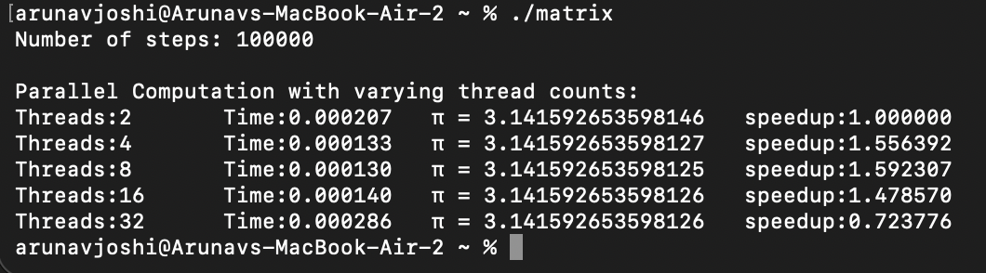
The execution time decreases and speedup improves as the number of threads increases up to 4–8 threads, showing effective parallelization. Beyond that, adding more threads increases overhead and memory contention, which causes performance to drop even though the computed value of π remains accurate.

Arunav Joshi
102303166
3C16

