NIFTY Executive Investment Screening Summary
Generated by: Restructured AI Investment Committee Engine (Gemini 2.5 Architecture)
Advanced Core Financial Ratios & Interactive Data Trendlines
🏢 InterGlobe Aviation Ltd. | Action Recommendation: BUY
🔢 Mathematically Derived Core Ratio History:
• Fiscal Year 2022 | Profitability (NPM): -23.76% | ROI (ROA Proxy): -13.41% | Solvency (Debt/Assets Ratio): 0.91% | Liquidity (Cash/Assets Ratio): 2.21%
• Fiscal Year 2023 | Profitability (NPM): -0.57% | ROI (ROA Proxy): -0.52% | Solvency (Debt/Assets Ratio): 0.00% | Liquidity (Cash/Assets Ratio): 2.14%
• Fiscal Year 2024 | Profitability (NPM): 12.13% | ROI (ROA Proxy): 9.94% | Solvency (Debt/Assets Ratio): 0.00% | Liquidity (Cash/Assets Ratio): 0.85%
• Fiscal Year 2025 | Profitability (NPM): 9.35% | ROI (ROA Proxy): 6.27% | Solvency (Debt/Assets Ratio): 0.00% | Liquidity (Cash/Assets Ratio): 0.93%
🧠 Agentic Committee Forensic Rationale:
InterGlobe Aviation showcases a profound financial resurgence, evidenced by a dramatic shift from a -23.76% Net Profit Margin in Fiscal Year 2022 to robust profitability, reaching 12.13% in 2024 and maintaining 9.35% in 2025. This profitability is strongly backed by liquid cash, as indicated by consistently superior Operating Cash Flows relative to Net Income, mitigating accrual risks. The company exhibits exceptional internal funding capabilities with Free Cash Flow consistently outstripping Capital Expenditures, ensuring no asset strain for expansion. A pristine solvency profile, with a Debt/Assets Ratio at 0.00% from Fiscal Year 2023, complements increasingly efficient capital deployment, manifest in a powerful rebound in ROA Proxy from -13.41% in 2022 to 9.94% in 2024, signaling effective operational conversion and strong financial durability.
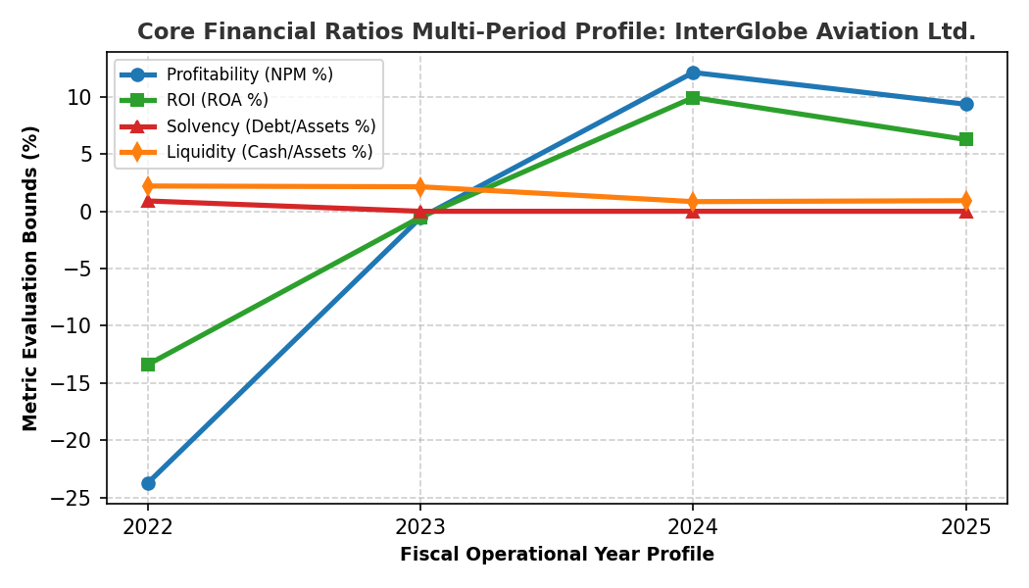
🏢 Wipro Ltd. | Action Recommendation: HOLD
🔢 Mathematically Derived Core Ratio History:
• Fiscal Year 2022 | Profitability (NPM): 15.45% | ROI (ROA Proxy): 11.32% | Solvency (Debt/Assets Ratio): 5.23% | Liquidity (Cash/Assets Ratio): 9.62%
• Fiscal Year 2023 | Profitability (NPM): 12.54% | ROI (ROA Proxy): 9.65% | Solvency (Debt/Assets Ratio): 5.21% | Liquidity (Cash/Assets Ratio): 7.81%
• Fiscal Year 2024 | Profitability (NPM): 12.31% | ROI (ROA Proxy): 9.58% | Solvency (Debt/Assets Ratio): 5.41% | Liquidity (Cash/Assets Ratio): 8.41%
• Fiscal Year 2025 | Profitability (NPM): 14.74% | ROI (ROA Proxy): 10.21% | Solvency (Debt/Assets Ratio): 4.97% | Liquidity (Cash/Assets Ratio): 9.48%
🧠 Agentic Committee Forensic Rationale:
Wipro demonstrates exceptional financial durability, evidenced by the recovery in its Profitability (NPM) to 14.74% and ROI (ROA Proxy) to 10.21% in Fiscal Year 2025, coupled with a robust Cash/Assets Ratio of 9.48%. The enterprise's solvency profile is remarkably strong, maintaining an ultra-low Debt/Assets Ratio of 4.97% in FY2025, significantly mitigating financial risk. However, while capital deployment is structurally sound given its internal cash generation, concerns arise regarding the growth trajectory and efficient operational conversion as reflected by flattened top-line performance. A HOLD rating is recommended pending clearer evidence of renewed revenue expansion, ensuring capital deployment translates into sustained profitable growth.
