NIFTY Executive Investment Screening Summary
Generated by: Hybrid Agentic AI & Custom Strategy Directives
🏢 Bajaj Auto Ltd. | Action: HOLD
🧠 Forensic Rationale:
While Bajaj Auto projects strong revenue growth to 603.86B by FY2026, the company exhibits significant concerns in FY2025, including a 5% decline in Net Income to 73.25B and a troubling shift to negative operating cash flow of -14.06B, largely due to a -90.60B change in working capital. Concurrently, the Debt/Assets ratio surged from 1.61% (FY2024) to 11.22% (FY2025), coupled with a sharp rise in interest expense to 3.89B, indicating increased leverage and financial burden. Despite a forecast rebound in FY2026, the substantial operational and financial risks presented in FY2025 necessitate a cautious approach to assess the sustainability of its performance.
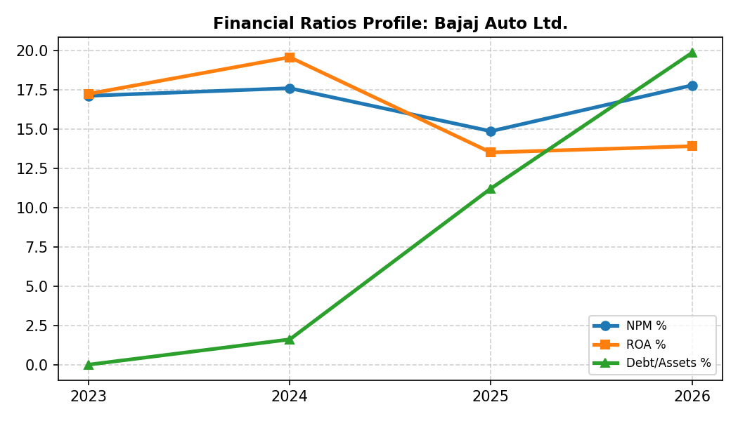
🏢 Bajaj Finance Ltd. | Action: BUY
🧠 Forensic Rationale:
Bajaj Finance demonstrates consistent and robust growth, with total revenue projected to reach 496.65B and net income 190.17B by FY2026, indicating strong market position and operational efficiency. The company maintains impressively high Net Profit Margins, above 38% through FY2026, and a stable ROA for its sector (e.g., 3.40% in FY2026). Its financial model, characterized by significant debt issuance (1252.21B in FY2026) to fund growing lending operations, results in characteristic negative operating cash flows and strong positive financing cash flows, signifying healthy expansion for a non-banking financial company. This consistent growth, strong profitability, and effective capital deployment make it a compelling investment.
