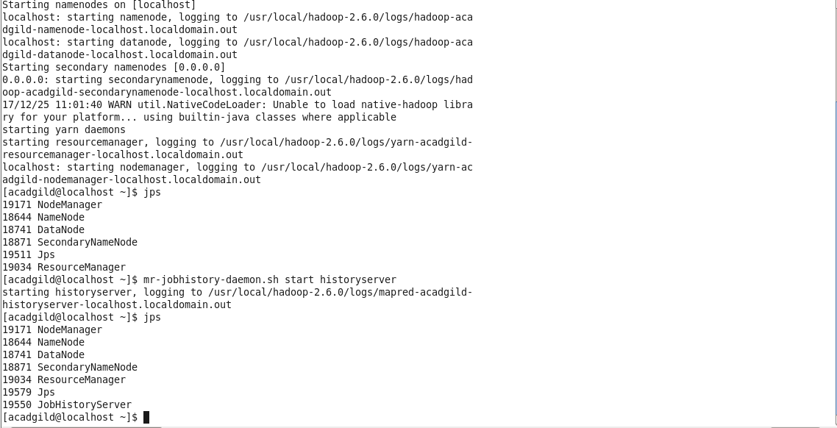

Task1:

Hadoop directory is not present

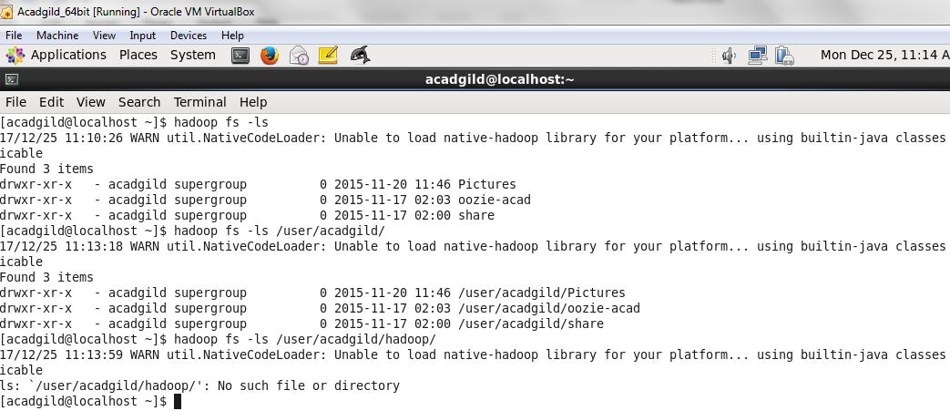

Create a directory /user/acadgild/hadoop

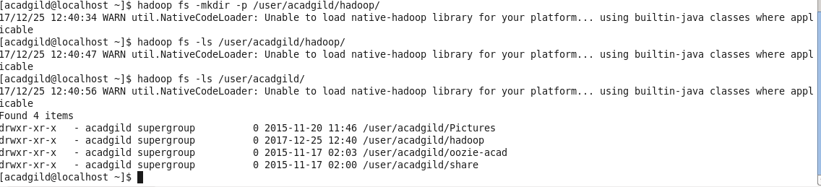

**Task 2:**

Create a file in HDFS under directory /user/acadgild/hadoop, with name word-count.txt.

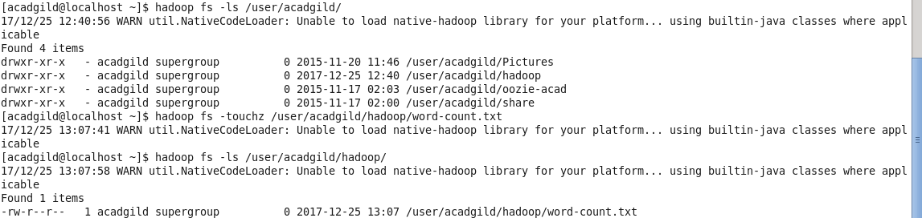

Using put command:

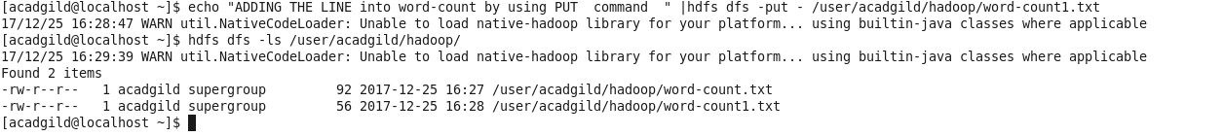

Using appendTofile:

