TASK :3

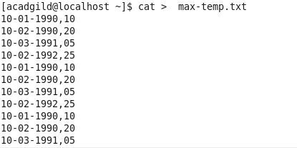

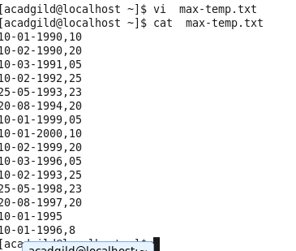

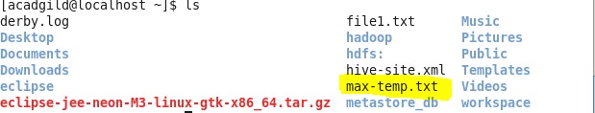

Move this file to HDFS at /user/acadgild/hadoop.

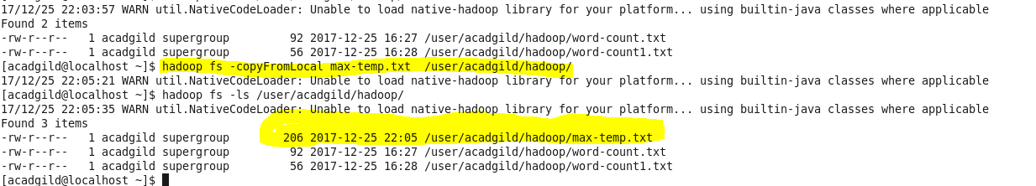

By using PUT 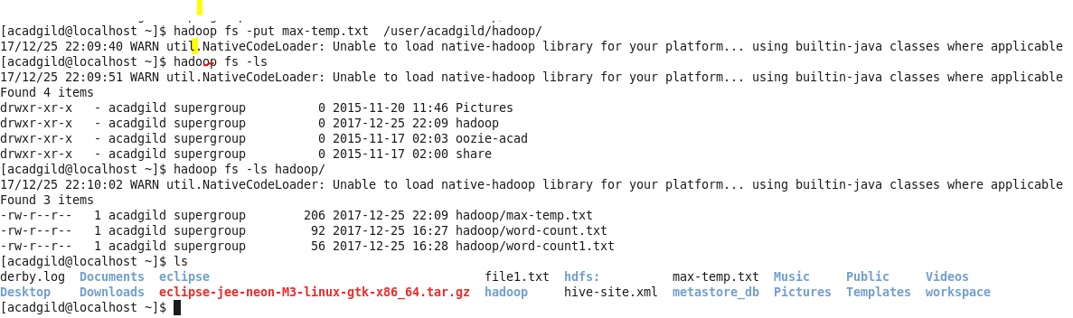

TASK 4:

Change the permission of the file /user/acadgild/hadoop/max-temp.txt,

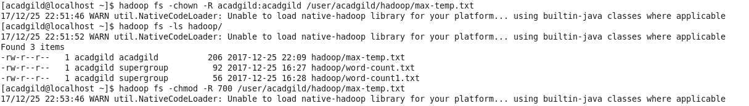

Only the owner and the group members have full control over the file.

