**1) Write a java code with the class named ‘acad’ and a method ‘main’. Hard Code the program with two integers and print the sum of those two.**

1. public class acad {

public static void main(String[] args) {

int x =10;

int y= 20,

int z=0;

z = x + y;

System.out.println("Sum of entered integers = "+z);

}

}

OutPUT:

10

20

30

**2) Rewrite the above code, where, inputs are provided by the user at runtime and the output is printed.**

1. import java.util.Scanner;

public class acad {

public static void main(String[] args) {

int x, y, z;

System.out.println("Enter two integers to calculate their sum ");

Scanner in = new Scanner(System.in);

x = in.nextInt();

y = in.nextInt();

z = x + y;

System.out.println("Sum of entered integers = "+z);

}

}

OutPUT:

10

20

30

**3) Write a program with method name sum() that accepts two parameters from user and print the sum of two numbers. Output format should be as:**

1. import java.util.Scanner;

public class acad {

public static void main(String[] args)

{

Scanner data = new Scanner(System.in);

int num1, num2, sum;

System.out.println(" 1st number");

num1=data.nextInt();

System.out.println(" 2nd number");

num2=data.nextInt();

sum=total(num1, num2);

System.out.println("The SUM IS "+sum);

}

private static int total(int a, int b) {

// TODO Auto-generated method stub

int s;

s= a + b;

return s;

}

}

OUTPUT:

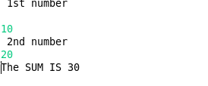

**4.) Write a program to accepts two numbers from stdin and find all the odd as well as evennumbers present in between them.**

**Program:**

import java.util.Scanner;

public class acadOddEven {

public static void getOddEven(int n1, int n2)

{

int greater = 0, lesser = 0;

int evenNo =0, oddNum = 0;

String odd = "",even ="";

if ( n1 > n2 )

{

lesser = n2 +1;

greater =n1;

}

else if(n2 > n1)

{

lesser =n1 + 1;

greater =n2;

}

else

{

System.out.println("please enter valid number");

System.exit(0);

}

while(lesser < greater)

{

if ((lesser%2)==0)

{

even =even +"\t" + lesser;

evenNo++;

}

else

{

odd = odd +"\t" + lesser;

oddNum++;

}

lesser++;

}

System.out.println(" EVEN NUMBERS (" + evenNo + "):" +even) ;

System.out.println(" Odd NUMBERS (" + oddNum + "):" +odd) ;

}

public static void main(String[] args) throws Exception

{

int firstnum;

int secondnum;

Scanner sc= new Scanner(System.in);

System.out.println("Enter the first number:");

firstnum=sc.nextInt();

System.out.println(" Enter the second number:");

secondnum=sc.nextInt();

sc.close();

getOddEven(firstnum,secondnum);

}

}

**Output:**

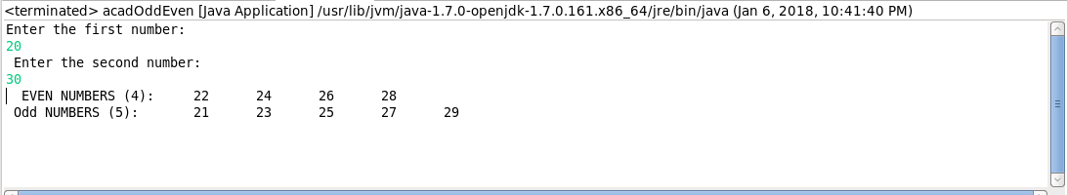

**5) Joe is scared to go to school. When her dad asked the reason, joe said she is unable to**

**complete the task given by her teacher. The task was to find the “first 10 multiples” of the**

**number entered from stdin . Eg:**

**Input: 3**

**O/p:**

**3 x 1 = 3**

**Program:**

import java.util.Scanner;

public class joeMultiplication {

public static void multiplication( int num )

{

System.out.println("First 10 multiple number is:---->>>>");

for(int i=1;i<=10;i++)

{

System.out.println(num+" X "+i+"= "+ num*i);

}

}

public static void main(String[] args)

{

int number;

Scanner sc = new Scanner(System.in);

System.out.println("Enter the number:--->");

number = sc.nextInt();

sc.close();

multiplication( number );

}

}

**OUTPUT:**

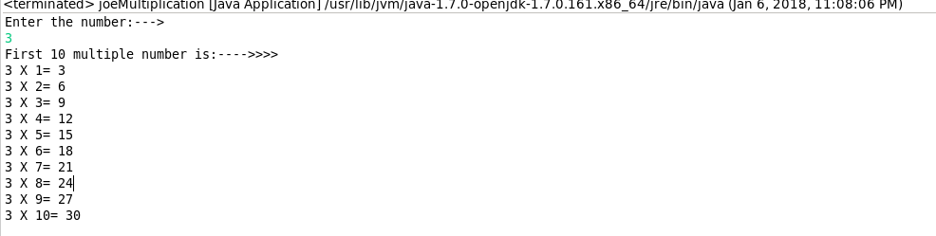

**6) Write a program consisting method sum() and demonstrate the concept of method**

**overloading using this method.**

public class sumOverload

{

public static void sum(int a , int b)

{

int sum = a+b;

System.out.println("I am method sum() but two parameter a and b :" +sum);

}

public static void sum(int a , int b, int c)

{

int sum = a+b+c;

System.out.println("i am method sum() but with 3 parameter a + b + c :" +sum);

}

public static void main(String[] args)

{

int x=10 ,y=20 ,z=30;

sumOverload.sum(x, y);

System.out.println("-------now i am same name but diffrent parameter---- ");

sumOverload.sum(x, y, z);

}

}

**7) Can you overload a method with same return type.? Explain your answer with proper logic.**

You can't do it in Java, The reason is that overloads in Java are only allowed for methods with different signatures, The return value alone is not sufficient for the compiler to figure out which function to call?

example :

public int foo() {...}

public float foo() {..}

...

foo(); // compiler will be confuse that which one is being call?

**8) Write a program in java using Arrays, that sorts the element in descending order.**

import java.util.Arrays;

import java.util.Collections;

public class arraysort {

public static void main(String[] args)

{

String arr[] = {"Kolkata",

"Delhi",

"Chennai",

"Mumbai",

"Bangalore",

};

// Sorts arr[] in ascending order

Arrays.sort(arr);

// Sorts arr[] in descending order

Arrays.sort(arr, Collections.reverseOrder());

System.out.printf("Modified arr[] : \n%s\n\n",Arrays.toString(arr));

}

}

