**1. Introduction**

This assignment will help you to consolidate the concepts learnt in the session.

**2. Problem Statement**

We have employee_details and employee_expenses files. Use local mode while running Pig and

write Pig Latin script to get below results:

https://github.com/prateekATacadgild/DatasetsForCognizant/blob/master/employee_details.t

xt

https://github.com/prateekATacadgild/DatasetsForCognizant/blob/master/employee_expense

s.txt

(a) Top 5 employees (employee id and employee name) with highest rating. (In case two

employees have same rating, employee with name coming first in dictionary should get

preference)

(b) Top 3 employees (employee id and employee name) with highest salary, whose employee id

is an odd number. (In case two employees have same salary, employee with name coming first

in dictionary should get preference)

(c) Employee (employee id and employee name) with maximum expense (In case two

employees have same expense, employee with name coming first in dictionary should get

preference)

(d) List of employees (employee id and employee name) having entries in employee_expenses

file.

(e) List of employees (employee id and employee name) having no entry in employee_expenses

file.

**3. Output**

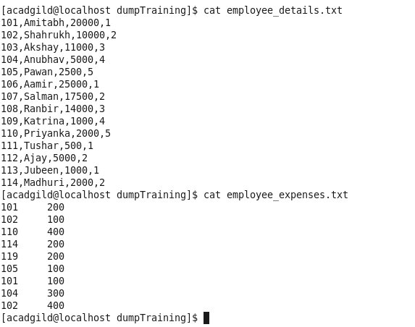

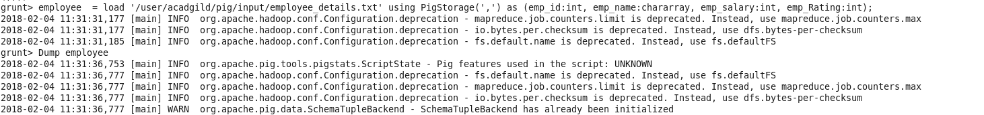

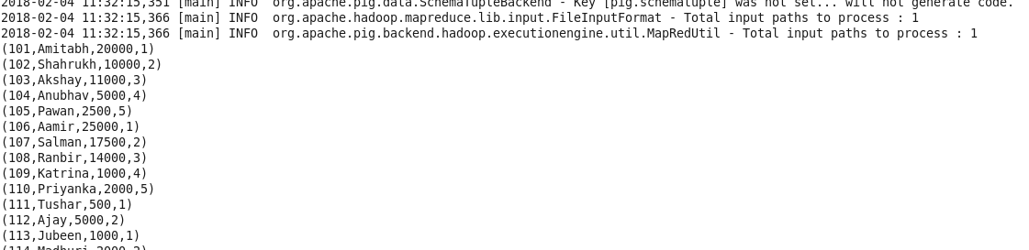

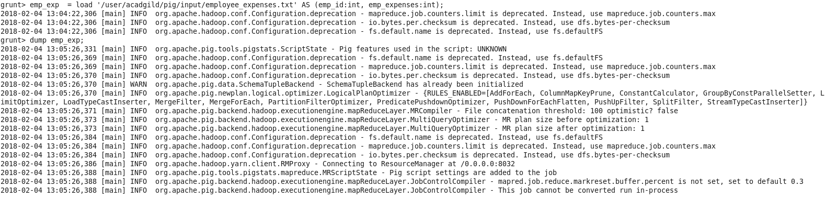

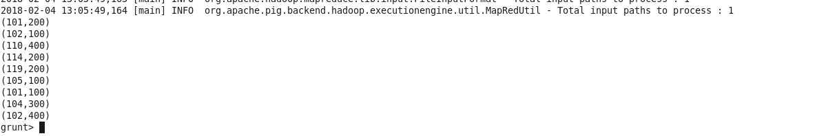

(a) Top 5 employees (employee id and employee name) with highest rating. (In case two

employees have same rating, employee with name coming first in dictionary should get

preference)



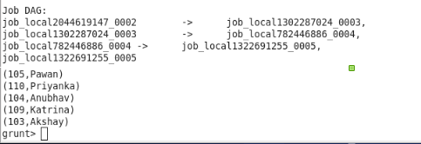

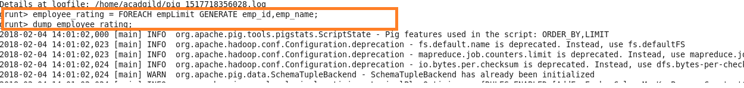

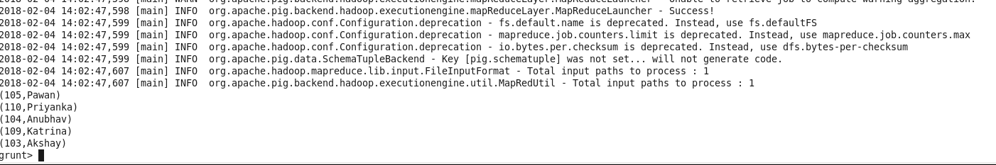

(b) Top 3 employees (employee id and employee name) with highest salary, whose employee id

is an odd number. (In case two employees have same salary, employee with name coming first

in dictionary should get preference)









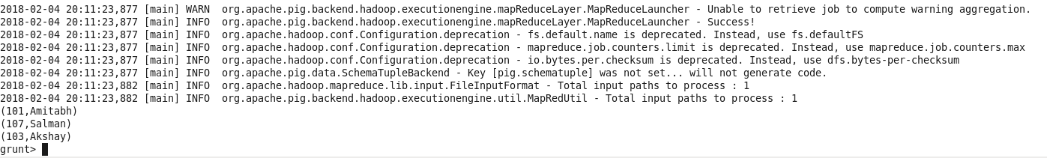

(c) Employee (employee id and employee name) with maximum expense (In case two

employees have same expense, employee with name coming first in dictionary should get

preference)





(d) List of employees (employee id and employee name) having entries in employee_expenses

file.

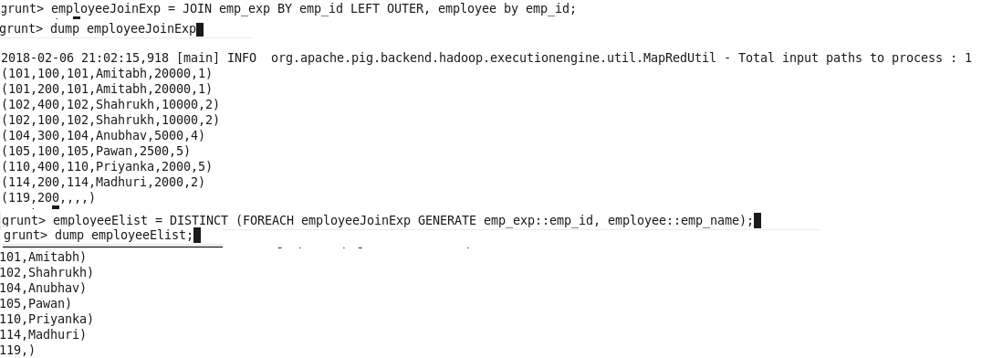

(e) List of employees (employee id and employee name) having no entry in employee_expenses file.



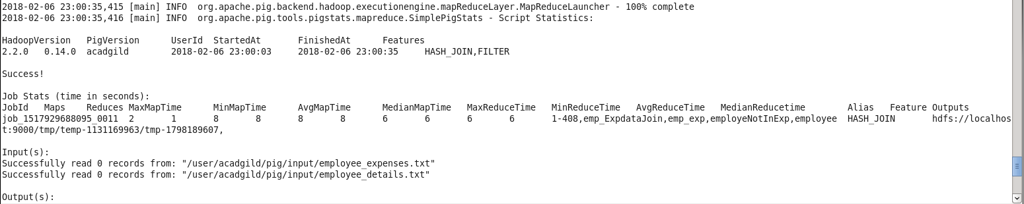



--------------------------------------------------------------------------------------------------------------------

Use local mode while running Pig and write Pig Latin script

Assignment5.pig

---------------

employee = load '/user/acadgild/pig/input/employee_details.txt' using PigStorage(',') as (emp_id:int, emp_name:chararray, emp_salary:int, emp_Rating:int);

emp_exp = load '/user/acadgild/pig/input/employee_expenses.txt' AS (emp_id:int, emp_expenses:int);

empLimit =LIMIT(ORDER employee BY emp_Rating Desc, emp_id Asc)5;

dump emplimit;

employee_rating = FOREACH empLimit GENERATE emp_id,emp_name;

dump employee_rating;

oddEmpId = FOREACH employee GENERATE emp_id,(

CASE emp_id % 2

WHEN 0 THEN -1

WHEN 1 THEN emp_salary

END);

emp_data_filtered = FILTER oddEmpId BY (emp_salary != -1);

emp_join = JOIN emp_data_filtered by emp_id, employee by emp_id;

dump emp_join

emp_limit = FOREACH (LIMIT (ORDER emp_join BY employee::emp_salary Desc) 3)GENERATE employee::emp_id, employee::emp_name;

dump emp_limit;

employeeJoinExp = JOIN emp_exp BY emp_id LEFT OUTER, employee by emp_id;

dump employeeJoinExp

employeeElist = DISTINCT (FOREACH employeeJoinExp GENERATE emp_exp::emp_id, employee::emp_name);

dump employeeElist;

employeeJoinMaxExp = JOIN employee BY emp_id , emp_exp by emp_id;

emp_MaxExp = FOREACH (LIMIT (ORDER employeeJoinMaxExp BY emp_expenses Desc, emp_name Asc) 1) GENERATE employee::emp_id, employee::emp_name;

dump emp_MaxExp

emp_ExpdataJoin = FILTER (JOIN emp_exp by emp_ID RIGHT OUTER, employee by emp_id) by (emp_exp::emp_id IS NULL)dump emp_MaxExp

employeNotInExp = FOREACH emp_ExpdataJoin GENERATE employee::emp_id, employee::emp_name;

DUMP employeNotInExp



