1:

**Problem Statement 1**

Find out the top 5 most visited destinations.



2:

## Problem Statement 2

Which month has seen the most number of cancellations due to bad weather?



3:

## Problem Statement 3

Top ten origins with the highest AVG departure delay



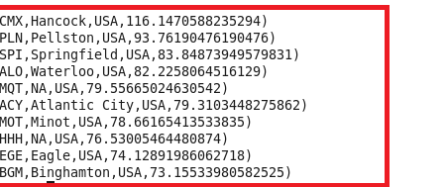

4.

## Problem Statement 4

Which route (origin & destination) has seen the maximum diversion?

