**1. Introduction**

In this assignment you need to perform the tasks given.

**2. Objective**

This assignment will help you to consolidate the concepts learnt in the session.

**3. Prerequisites**

None

**4. Associated Data Files**

https://drive.google.com/file/d/0Bxr27gVaXO5sa0JBamZXdkpYUFk/view?usp=sharing

**5. Problem Statement**

• Fetch date and temperature from temperature_data where zip code is greater than

300000 and less than 399999.

• Calculate maximum temperature corresponding to every year from temperature_data

table.

• Calculate maximum temperature from temperature_data table corresponding to thoseyears which have at least 2 entries in the table.

• Create a view on the top of last query, name it temperature_data_vw.

• Export contents from temperature_data_vw to a file in local file system, such that eac

file is '|' delimited

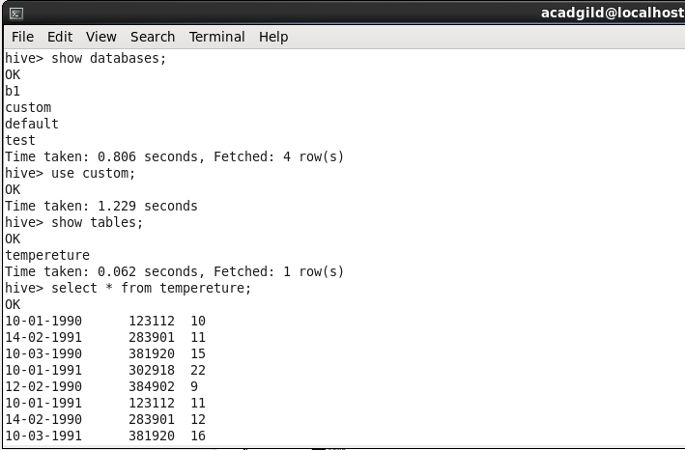

1. Fetch date and temperature from temperature_data where zip code is greater than

300000 and less than 399999.

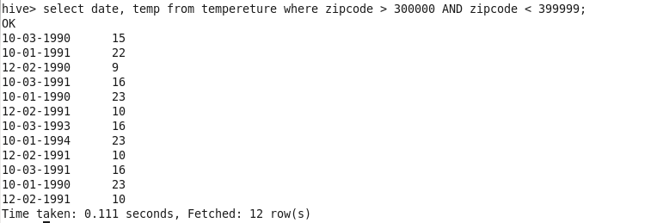

2 Calculate maximum temperature corresponding to every year from temperature_data

table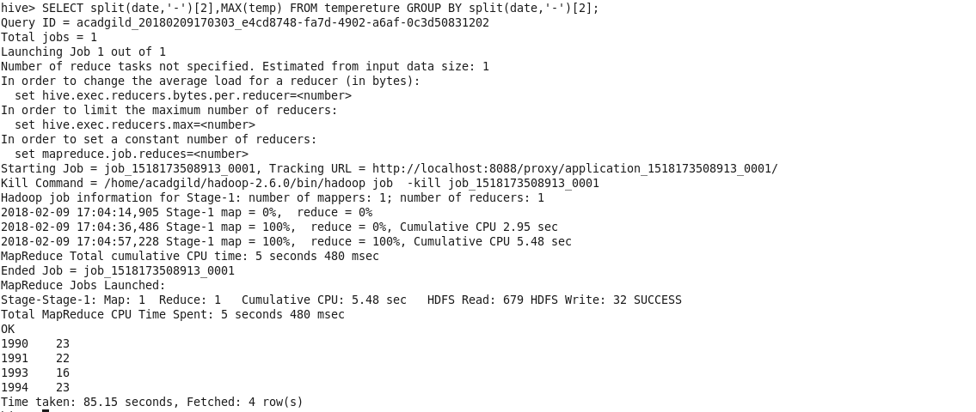

3. Calculate maximum temperature from temperature_data table corresponding to thoseyears which have at least 2 entries in the table

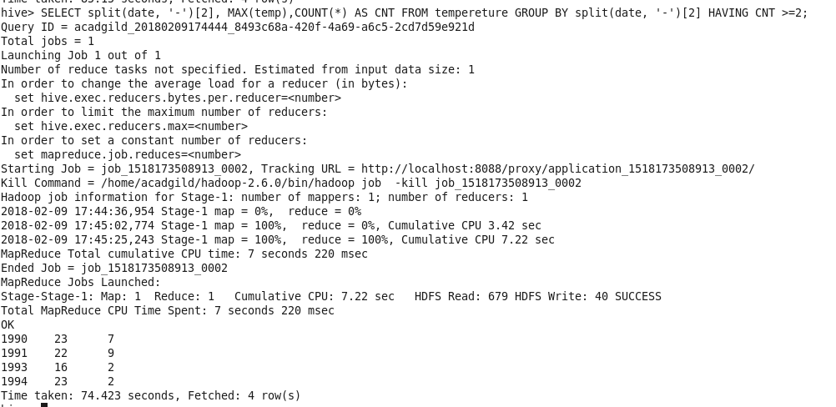

4.Create a view on the top of last query, name it temperature_data_vw.

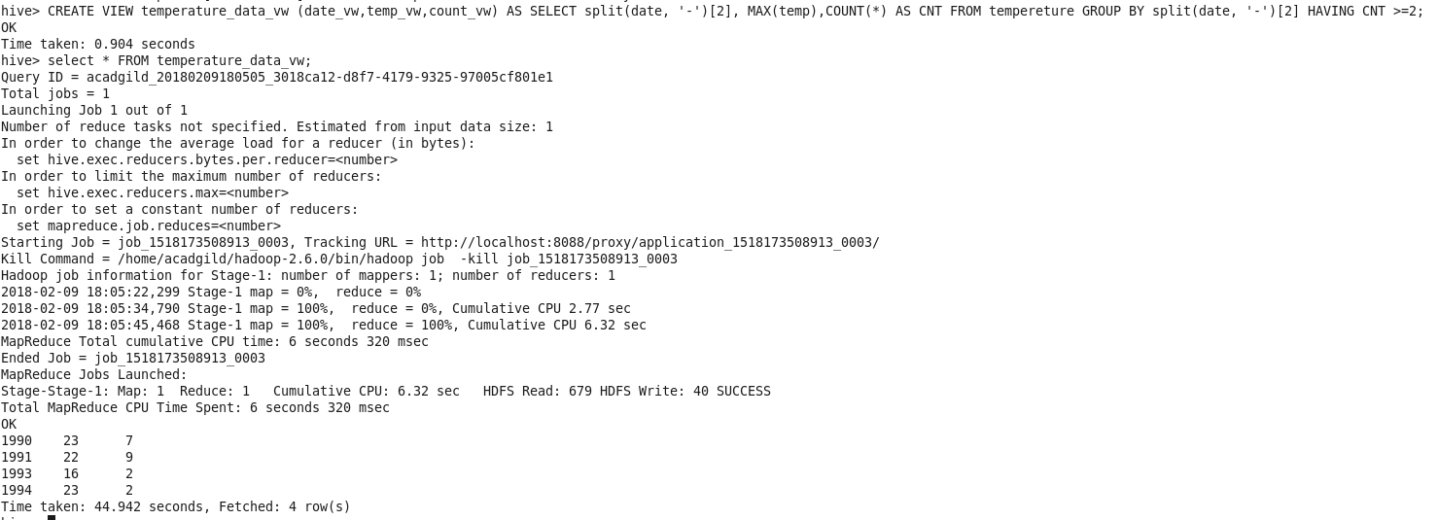

5. Export contents from temperature_data_vw to a file in local file system, such that eac

file is '|' delimited

