Session​ ​ 08:Advanced​ ​ Hive

Assignment​ ​ 1

Big​ ​ Data​ ​ and​ ​ Hadoop​ ​ Development

Table​ ​ of​ ​ Contents

1.​ ​ Introduction​ ​ ..........................................................................................................................................3

2.​ ​ Objective​ ​ ...............................................................................................................................................3

3.​ ​ Prerequisites:​ ​ ........................................................................................................................................3

4.​ ​ Associated​ ​ Data​ ​ Files​ ​ ............................................................................................................................3

5.​ ​ Problem​ ​ Statement...............................................................................................................................3

6.​ ​ Expected​ ​ Output...................................................................................................................................3

7.​ ​ Approximate​ ​ Time​ ​ to​ ​ Complete​ ​ Task​ ​ ...................................................................................................3

**1. Introduction**

This​ ​ assignment​ ​ will​ ​ help​ ​ you​ ​ to​ ​ consolidate​ ​ the​ ​ concepts​ ​ learnt​ ​ in​ ​ the​ ​ session.

**2. Problem**​ ​ **Solution**

**Dataset**​ ​ **:**​ ​​ **Emp_Sal**

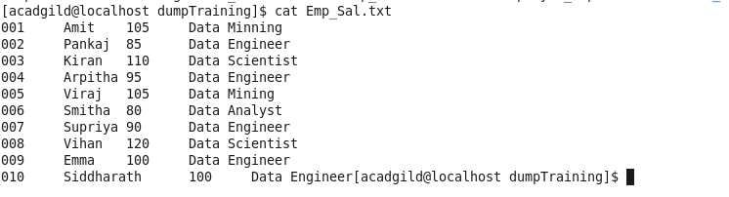

**Dataset**​ ​ **Details**

**Column1:**​ ​​ Employee_Id

**Column2:**​ ​​ Employee_Name

**Column3:**​ ​​ Employee_Salary

**Column4:**​ ​​ Employee_Unit​ ​ (Department_Name)

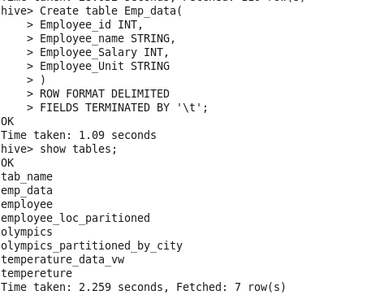

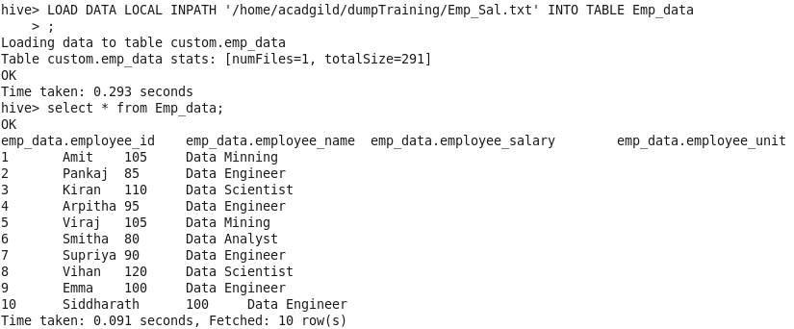

● Get​ ​ the​ ​ list​ ​ of​ ​ employees​ ​ who​ ​ receive​ ​ a​ ​ salary​ ​ less​ ​ than​ ​ 100,​ ​ compared​ ​ to​ ​ their

immediate​ ​ employee​ ​ with​ ​ higher​ ​ salary​ ​ in​ ​ the​ ​ same​ ​ unit

SELECT

Employee_name,Employee_Salary,LEAD(Employee_Salary)

OVER

(PARTITION BY Employee_Unit ORDER By Employee_Salary )

FROM

Emp_data

WHERE

Employee_Salary<100;

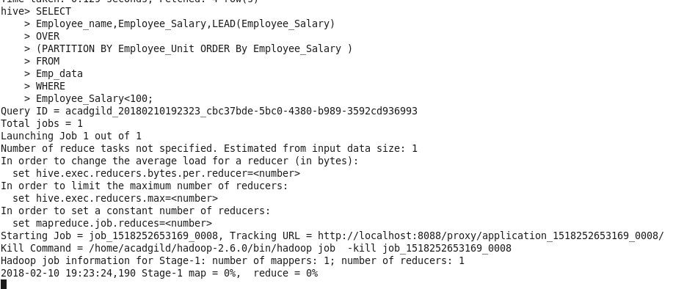

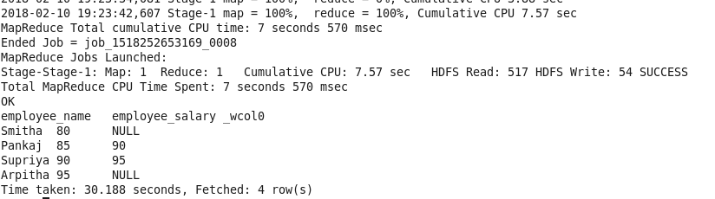

● List​ ​ of​ ​ all​ ​ employees​ ​ who​ ​ draw​ ​ higher​ ​ salary​ ​ than​ ​ the​ ​ average​ ​ salary​ ​ of​ ​ that​ ​ department

SELECT

Employee_id,Employee_name,Employee_Salary,Employee_Unit ,AVGSALARY

From

(SELECT Employee_id, Employee_name,Employee_Unit,Employee_Salary,AVG(Employee_Salary) OVER (PARTITION BY Employee_Unit) AS AVGSALARY

FROM Emp_data) temp WHERE Employee_Salary > AVGSALARY ;