*Big Data and Hadoop Development*

Session 08: Advanced Hive

Assignment 2

**A C A D G I L D Page 1**

*Big Data and Hadoop Development*

**A C A D G I L D**

**Table of Contents**

1. Introduction .......................................................................................................................................... 3

2. Objective ............................................................................................................................................... 3

3. Prerequisites: ........................................................................................................................................ 3

4. Associated Data Files ............................................................................................................................ 3

5. Problem Statement ............................................................................................................................... 3

6. Expected Output ................................................................................................................................... 3

7. Approximate Time to Complete Task ................................................................................................... 3

**Page 2**

*Big Data and Hadoop Development*

**A C A D G I L D**

**1. Introduction**

In this assignment you need to perform the tasks given.

**2. Objective**

This assignment will help you to consolidate the concepts learnt in the session.

**3. Prerequisites**

None

**4. Associated Data Files**

N/A

**5. Problem Statement**

Write a hive UDF that implements functionality of string concat_ws(string SEP, array<string>).

This UDF will accept two arguments, one string and one array of string.

It will return a single string where all the elements of the array are separated by the SEP.

Create table

**age Create table**

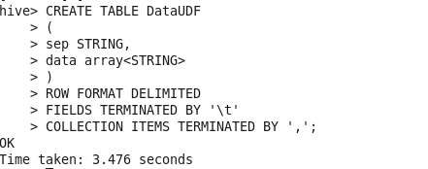

Load data into table

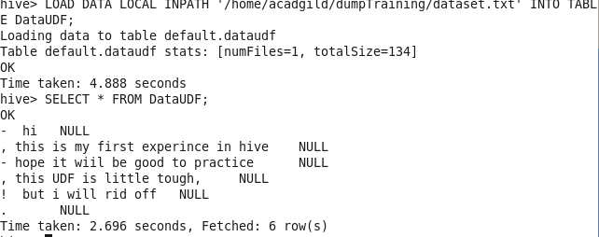

crate java concrete UDF class

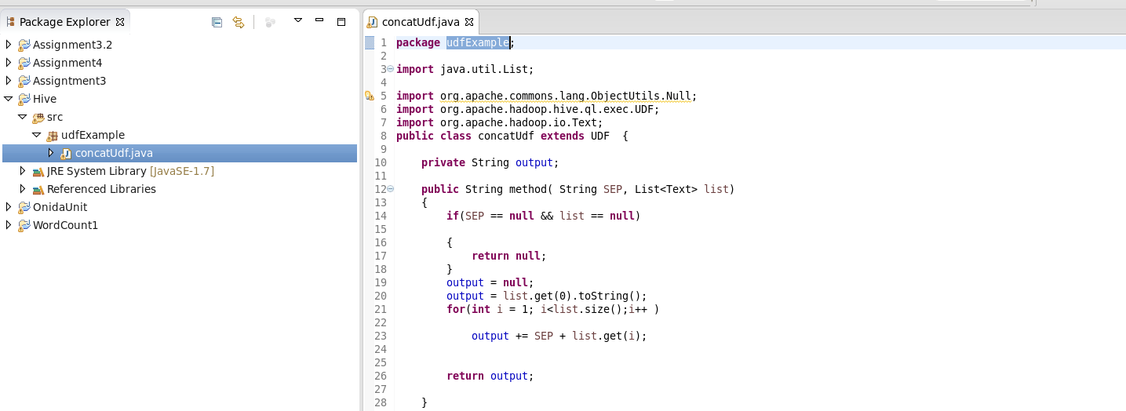

Hive load data

