*Big Data and Hadoop Development*

Session 09: HBase

Assignment 2

**A C A D G I L D Page 1**

*Big Data and Hadoop Development*

**Table of Contents**

1. Introduction .......................................................................................................................................... 3

2. Objective ............................................................................................................................................... 3

3. Prerequisites ......................................................................................................................................... 3

4. Associated Data Files ............................................................................................................................ 3

5. Problem Statement ............................................................................................................................... 3

6. Expected output .................................................................................................................................... 3

**A C A D G I L D Page 2**

*Big Data and Hadoop Development*

**1. Introduction**

In this assignment you need to implement the skills learnt in the session.

**2. Objective**

This assignment will help you to understand the concepts HBase

**3. Prerequisites**

N/A

**4. Associated Data Files**

N/A

**5. Problem Statement**

**Problem 1:**

Create an HBase table named 'clicks' with a column family 'hits' such that it should be able to store last 5 values of qualifiers inside 'hits' column family.

**Problem 2:**

Add few records in the table and update some of them. Use IP Address as row-key. Scan the

table to view if all the previous versions are getting displayed.

Need to start HBASE

first go to the directory Where Hbase is located

we can find out the loaction of hbase using ~./.bashrc





**Then start HBASE**

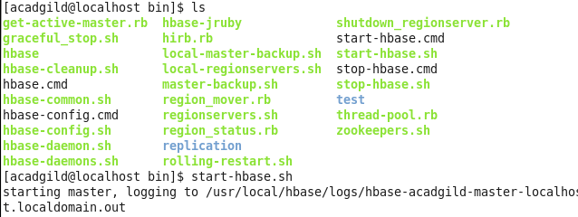

**using jPS we can verify it**

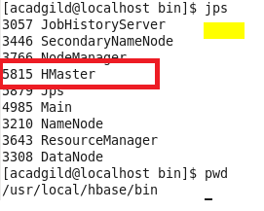

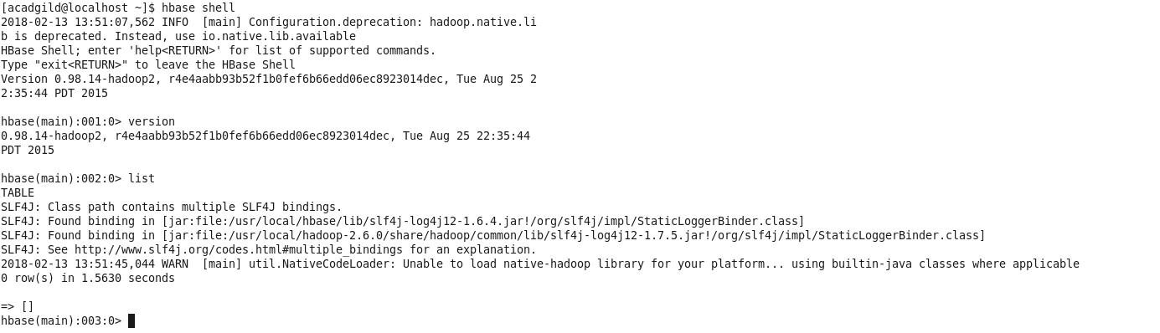

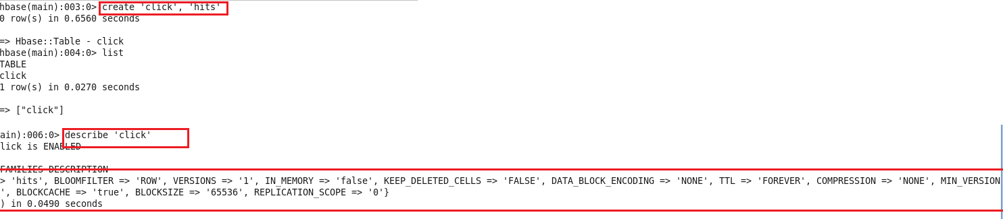

**it should be able to store last 5 values of qualifiers inside 'hits' column family.**

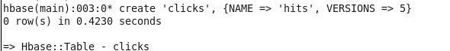

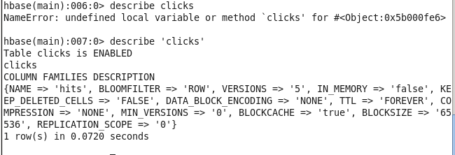

**Problem 2:**

Add few records in the table and update some of them. Use IP Address as row-key. Scan the

table to view if all the previous versions are getting displayed.

