ES6 Environment Setup

JavaScript can run on any host, any operating system, and on any browser. To start experimenting with [JavaScript](https://www.javatpoint.com/javascript-tutorial), you have to download the latest version of the Node.

Node is a platform that runs on the **V8 JavaScript engine (**It is a JavaScript engine that is responsible for running the JavaScript code**) of Google.**It helps you to create scalable and fast applications by using pure JavaScript.

You will require the following for writing and testing of a JavaScript program standard:

Text Editor

Text Editor is a computer program that edits plain text. It is used to write the source code. Some of the text editors include **notepad or notepad++**for **Microsoft** **Windows. UNIX**or Unix-like operating systems use the **Pico editor**but may also use the**VI**and**Emacs editor.**

**Classic Mac OS**of **Apple Macintosh (**Macintosh is a family of personal computers which are designed, manufactured and sold by Apple**)**was used the native **Simple text** **(**native text editor of Apple classic Mac OS**)** which was replaced by the **TextEdit**in **MAC OS**and combines the features of a text editor including the characteristics of a word processor such as the rulers, margins and several font selections.

The editors may vary with the operating system. The source files should be named with the **.js extension.**

Installing the Node.js

The **Node.js**is an open-source server-side environment that is free and can run on multiple platforms such as Windows, [UNIX](https://www.javatpoint.com/unix-interview-questions), [Linux](https://www.javatpoint.com/linux-tutorial), etc. It uses the JavaScript on the server. It uses the **Google V8 JavaScript engine** for executing the code. It uses the **asynchronous programming** **(**It is a design pattern that ensures the execution of non-blocking code**)**.

Installation on Windows

You can download the [Node.js](https://www.javatpoint.com/nodejs-tutorial) from its official website. For downloading the **Node.js**, you can click on this link [https://nodejs.org/en/.](https://nodejs.org/en/)

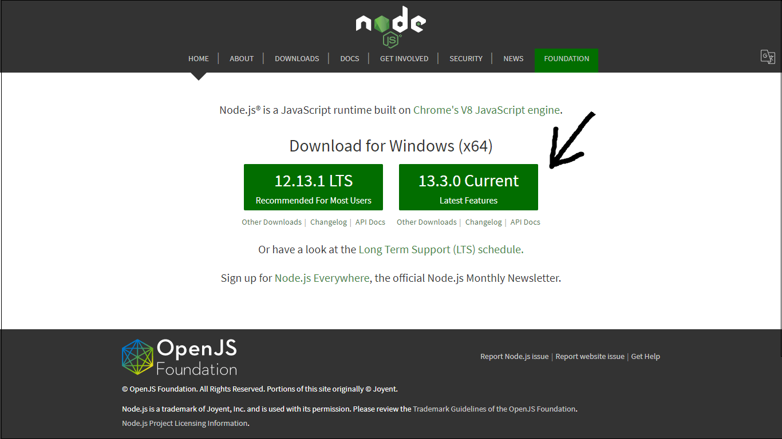

Click on the current version and [install the Node.js](https://www.javatpoint.com/install-nodejs) in your system.

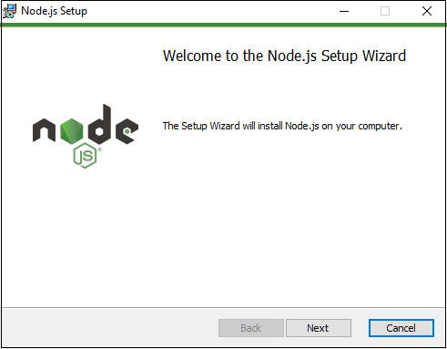

Then, click on the Next button and accept the License agreement, and after setting up the path, you can successfully install the Node.js in your system.

If the installation was successful, you could check it by entering the following command in your terminal window:

1. node -v

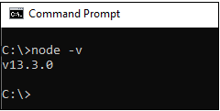

Installation on MAC OS X

For installing the node.js on your [OS](https://www.javatpoint.com/os-tutorial) X, you need to download a pre-compiled binary package. It will make your installation easy.

For downloading the binary package, click on this link <https://nodejs.org/en/download/current/>

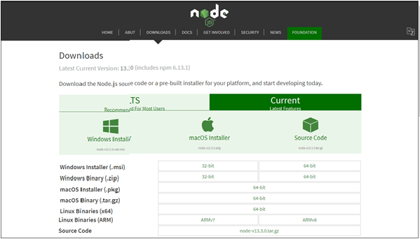

Download the package and launch it, it will look like as

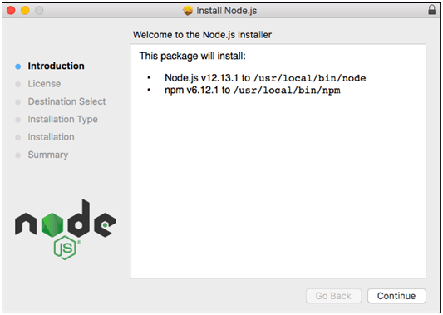

Click on the **Continue** button, and accept the license and select the destination where you need to install the **Node.js**. After that, it will ready to use. It will also install the **npm** in your system.

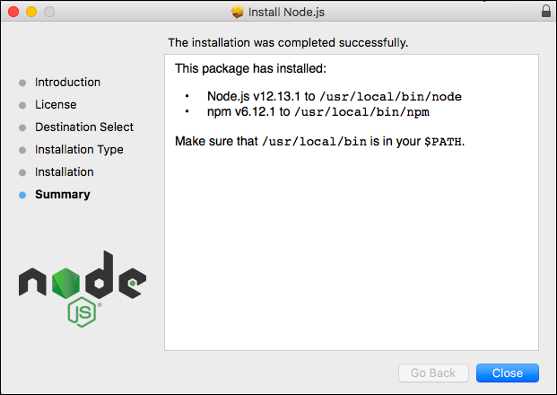

To check whether the **Node.js or npm** is installed or not, open the terminal of your **MAC OS X** and type the following commands:

* To check the version of **Node.js** and to verify that the **Node.js** is installed or not, type the following command in your terminal of MAC OS X

1. node -v

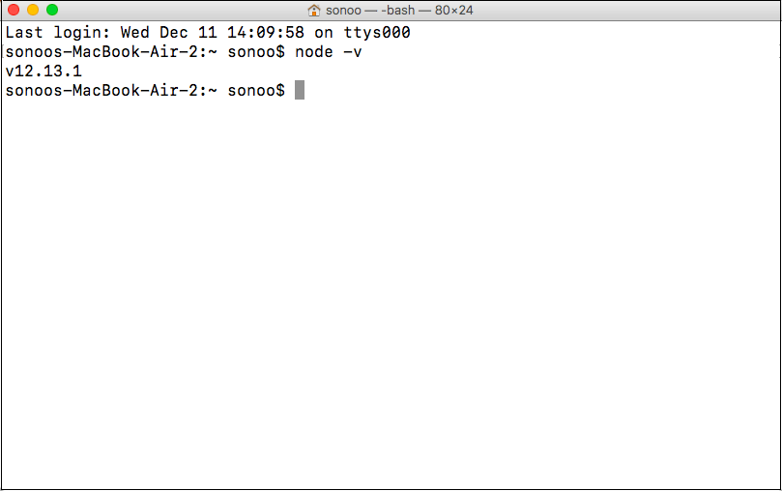

* To check the version of **npm** and to verify whether or not the **npm** is installed, type the following command in your terminal of **MAC OS X**:

1. npm -v

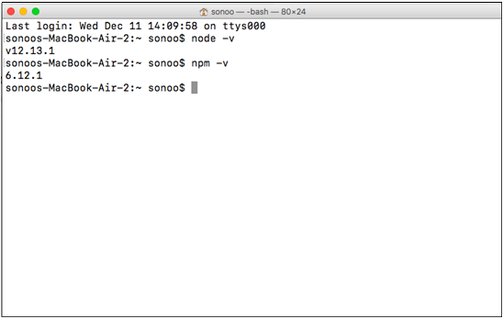

Installation on Linux

For installing **Node.js**on Linux, you should be familiar with the Linux terminal since you will require to use it to install and test the **Node**and **NPM.**You will also require the terminal to use **Node.js**and**NPM.**

**Dependencies:** You have to install some dependencies before installing the **Node.js**and **NPM.**

**1. Ruby and GCC:** You will require the **Ruby 1.8.6**or the latest and **GCC 4.2**or current.

* For the **Ubuntu**or **Debian-based Linux**distributions, you have to run the following command in your terminal window:

1. sudo apt-get install build-essential curl <a href="https://www.javatpoint.com/git">git</a> m4 ruby texinfo libbz2-dev libcurl4-openssl-dev libexpat-dev libncurses-dev zlib1g-dev

After that, select **Y** to continue and wait for the installation of packages.

* For **Fedora-based Linux** distributions, you need to run the following command in your terminal:

1. sudo yum groupinstall 'Development Tools' && sudo yum install curl git m4 <a href="https://www.javatpoint.com/ruby-tutorial">ruby</a> texinfo bzip2-devel curl-devel expat-devel ncurses-devel zlib-devel

After that, select Y to continue and wait for the installation of packages.

**2. Homebrew:** Homebrew is a package manager which is initially required for the MAC, but it's been ported to Linux as You can study more about Homebrew at <https://brew.sh/>.

For installing the Homebrew for Linux, open the terminal and paste the command given below:

1. ruby -e "$(curl -fsSL https://raw.githubusercontent.com/Homebrew/linuxbrew/go/install)"

Then, follow the terminal instructions for completing the installation process.

Installation

Installing the **Node.js**and **NPM** is quite simple by using Linuxbrew **(**the Linux port of Homebrew**).**It will handle the downloading, unpacking, compiling, and installing **Node**and **NPM**on your system.

Now, for installing the **Node**, you need to **open your terminal**and type the following command:

1. brew install node

To verify that you have **Node** and **NPM** installed and also to check the version of Node.js and NPM, you need to run the following command in your terminal:

* For Node.js, you need to type the following command in your terminal:

1. node -v

* For **NPM**, you have to write the following command in your terminal:

1. npm -v

If you want to update the **Node** and **NPM** in Linux, then you can use Homebrew for updating.

* First, you have to make sure that the **Homebrew** has the latest version of the Node package. Open the terminal and type:

1. brew update

* To upgrade the Node, you have to type the following command:

1. brew upgrade node

Integrated Development Environment (IDE) support

An IDE is a software application that gives ample facilities to computer programmers for the software application. It usually consists of the source code editor, builds automation tools, and a debugger.

JavaScript can be created in development environments such as Visual Studio, Eclipse, Brackets, Sublime Text 2, etc.

Here the development environment that we are using is **Visual Studio Code (Windows platform).** You can download the Visual studio code by this link [https://code.visualstudio.com](https://code.visualstudio.com/?utm_expid=101350005-31.YsqwCVJESWmc4UCMDLsNRw.0)

When you click on the above link you will see the webpage shown below:

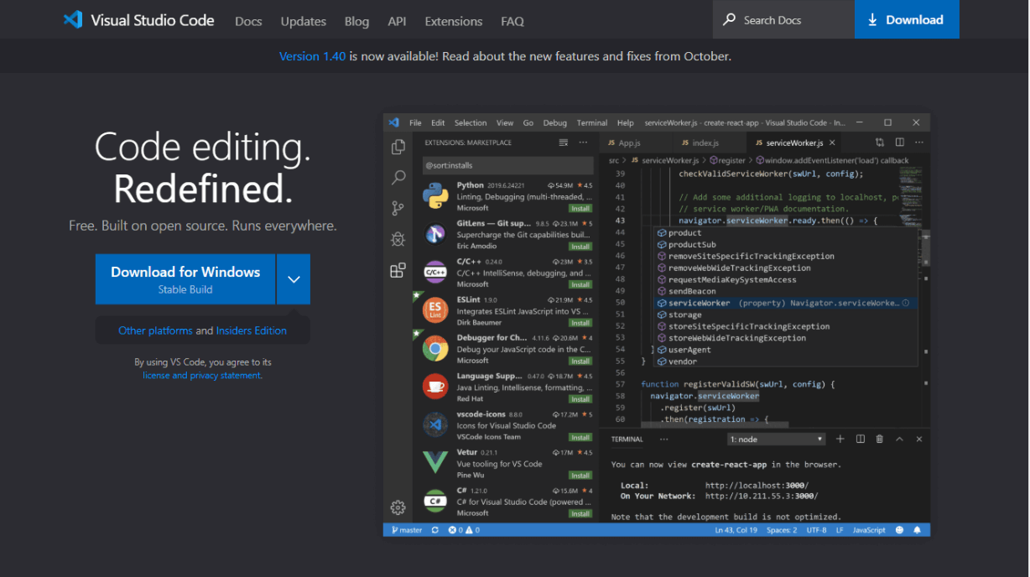

Installation on Windows

You can download the visual studio code for windows by clicking on the button which is shown in the above image:

Once the **VSCodeUserSetup.exe**gets downloaded, you have to double-click on it for **l**aunching the setup process.

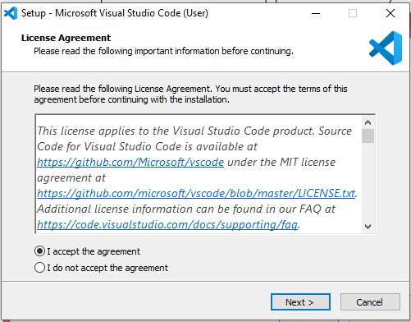

Then, accept the License Agreement and click on next. Further, choose the destination and click on next then your visual studio will be entirely installed on your system:

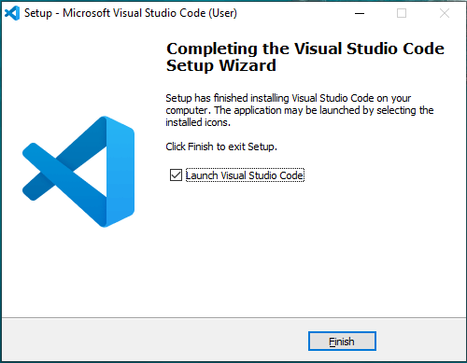

When you open the Visual studio, it will look like this:

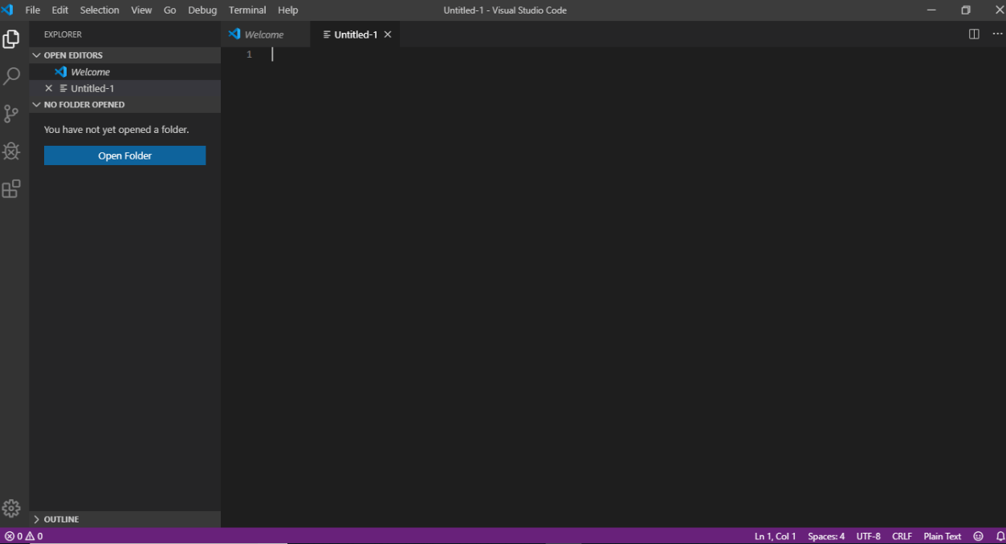

I