Microsoft Azure Tutorial

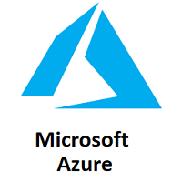

Microsoft Azure is a cloud computing platform that provides a wide variety of services that we can use without purchasing and arranging our hardware. It enables the fast development of solutions and provides the resources to complete tasks that may not be achievable in an on-premises environment. Azure Services like compute, storage, network, and application services allow us to put our effort into building great solutions without worrying about the assembly of physical infrastructure.

This tutorial covers the fundamentals of Azure, which will provide us the idea about all the Azure key services that we are most likely required to know to start developing solutions. After completing this tutorial, we can crack job interviews or able to get different Microsoft Azure certifications.

What is Azure

Microsoft Azure is a growing set of cloud computing services created by Microsoft that hosts your existing applications, streamline the development of a new application, and also enhances our on-premises applications. It helps the organizations in building, testing, deploying, and managing applications and services through Microsoft-managed data centers.

Azure Services

* **Compute services:**It includes the Microsoft Azure Cloud Services, Azure Virtual Machines, Azure Website, and Azure Mobile Services, which processes the data on the cloud with the help of powerful processors.
* **Data services:**This service is used to store data over the cloud that can be scaled according to the requirements. It includes Microsoft Azure Storage (Blob, Queue Table, and Azure File services), Azure SQL Database, and the Redis Cache.
* **Application services:** It includes services, which help us to build and operate our application, like the Azure Active Directory, Service Bus for connecting distributed systems, HDInsight for processing big data, the Azure Scheduler, and the Azure Media Services.
* **Network services:**It helps you to connect with the cloud and on-premises infrastructure, which includes Virtual Networks, Azure Content Delivery Network, and the Azure Traffic Manager.

How Azure works

It is essential to understand the internal workings of Azure so that we can design our applications on Azure effectively with high availability, data residency, resilience, etc.

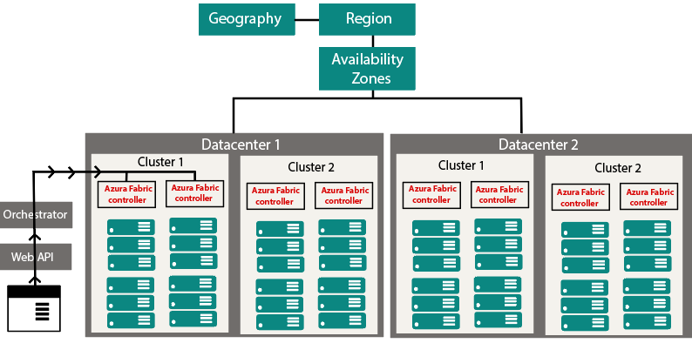

Microsoft Azure is completely based on the concept of virtualization. So, similar to other virtualized data center, it also contains *racks*. Each rack has a separate power unit and network switch, and also each rack is integrated with a software called *Fabric-Controller*. This *Fabric-controller* is a distributed application, which is responsible for managing and monitoring servers within the rack. In case of any server failure, the Fabric-controller recognizes it and recovers it. And Each of these Fabric-Controller is, in turn, connected to a piece of software called *Orchestrator*. This *Orchestrator* includes web-services, Rest API to create, update, and delete resources.

When a request is made by the user either using PowerShell or Azure portal. First, it will go to the Orchestrator, where it will fundamentally do three things:

1. Authenticate the User
2. It will Authorize the user, i.e., it will check whether the user is allowed to do the requested task.
3. It will look into the database for the availability of space based on the resources and pass the request to an appropriate Azure Fabric controller to execute the request.

Combinations of racks form a cluster. We have multiple clusters within a data center, and we can have multiple Data Centers within an Availability zone, multiple Availability zones within a Region, and multiple Regions within a Geography.

* **Geographies:**It is a discrete market, typically contains two or more regions, that preserves data residency and compliance boundaries.
* **Azure regions:**A region is a collection of data centers deployed within a defined perimeter and interconnected through a dedicated regional low-latency network.

Azure covers more global regions than any other cloud provider, which offers the scalability needed to bring applications and users closer around the world. It is globally available in 50 regions around the world. Due to its availability over many regions, it helps in preserving data residency and offers comprehensive compliance and flexible options to the customers.

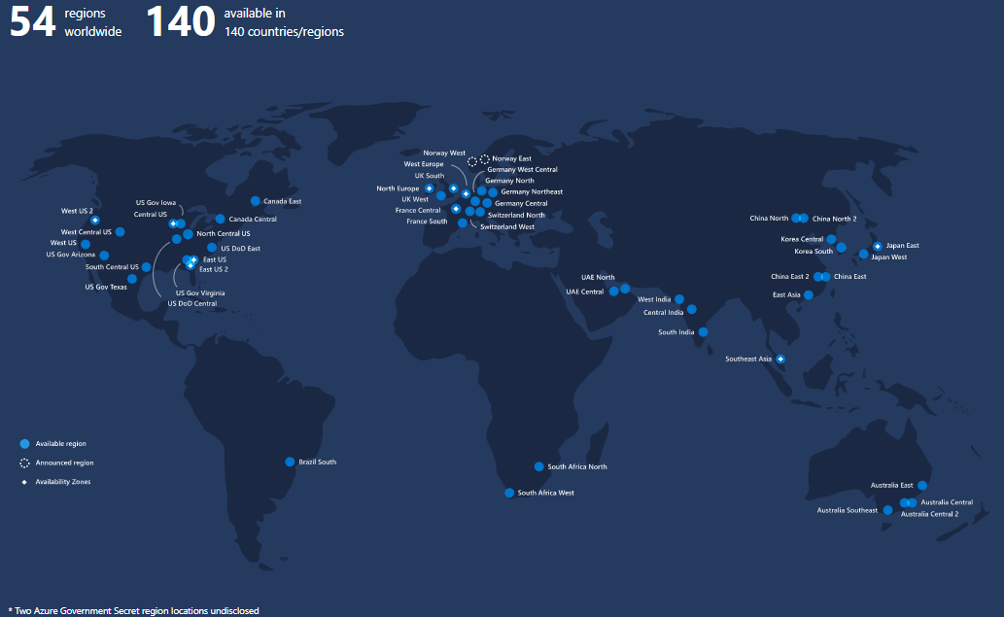

* **Availability Zones:**These are the physically separated location within an Azure region. Each one of them is made up of one or more data centers, independent configuration.

Azure Pricing

It is one of the main reasons to learn Microsoft Azure. Because Microsoft is providing free Credits in the Azure account to access Azure services for free for a short duration. This credit is sufficient for people who are new at Microsoft Azure and want to use the services.

Microsoft offers the **pay-as-you-go** approach that helps organizations to serve their needs. Typically the cloud services will be charged based on the usage. The flexible pricing option helps in up-scaling and down-scaling the architecture as per our requirements**.**

Azure Certification

Microsoft Azure helps to fill the gap between the industry requirement and the resource available. Microsoft provides Azure Certification into three major categories, which are:

* **Azure Administrator:** Those who implement, monitor, and maintain Microsoft Azure solutions, including major services.

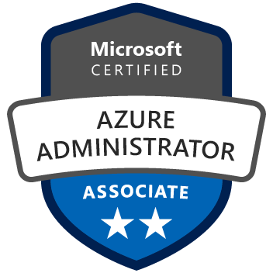

* **Azure Developer:** Those who design, build, test, and maintain cloud solutions, such as applications and services, partnering with cloud solution architects, cloud DBAs, cloud administrators, and clients to implement these solutions.



* **Azure Solution Architect:** Those who have expertise in compute, network, storage, and security so that they can design the solutions that run on Azure.

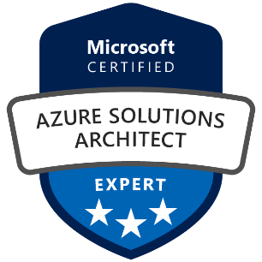

All these certifications are divided into different levels. If anyone is planning to get certified, then he/she first has to get an associate-level certification and then go for the advanced level.

Introduction to Cloud Computing

Cloud Computing is the delivery of computing services such as servers, storage, databases, networking, software, analytics, intelligence, and more, over the Cloud (Internet).

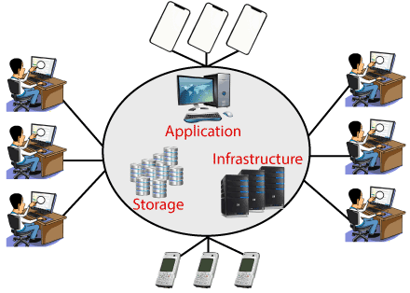

Cloud Computing provides an alternative to the on-premises datacentre. With an on-premises datacentre, we have to manage everything, such as purchasing and installing hardware, virtualization, installing the operating system, and any other required applications, setting up the network, configuring the firewall, and setting up storage for data. After doing all the set-up, we become responsible for maintaining it through its entire lifecycle.

But if we choose Cloud Computing, a cloud vendor is responsible for the hardware purchase and maintenance. They also provide a wide variety of software and platform as a service. We can take any required services on rent. The cloud computing services will be charged based on usage.

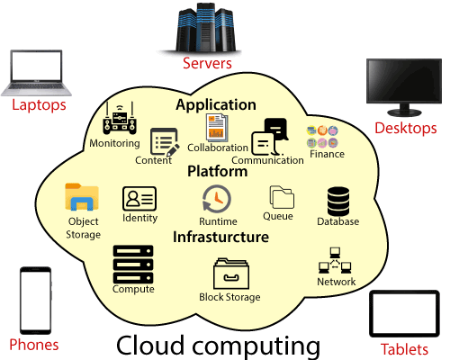

The cloud environment provides an easily accessible online portal that makes handy for the user to manage the compute, storage, network, and application resources. Some cloud service providers are in the following figure.

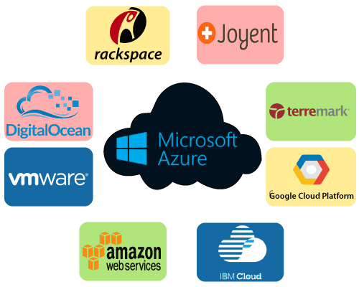

Advantages of cloud computing

* **Cost:** It reduces the huge capital costs of buying hardware and software.
* **Speed:** Resources can be accessed in minutes, typically within a few clicks.
* **Scalability:**We can increase or decrease the requirement of resources according to the business requirements.
* **Productivity:**While using cloud computing, we put less operational effort. We do not need to apply patching, as well as no need to maintain hardware and software. So, in this way, the IT team can be more productive and focus on achieving business goals.
* **Reliability:**Backup and recovery of data are less expensive and very fast for business continuity.
* **Security:**Many cloud vendors offer a broad set of policies, technologies, and controls that strengthen our data security.

Types of Cloud Computing

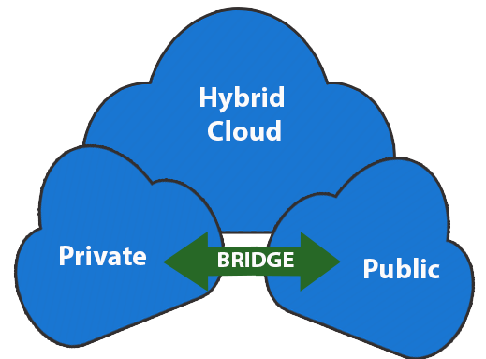

* **Public Cloud:**The cloud resources that are owned and operated by a third-party cloud service provider are termed as public clouds. It delivers computing resources such as servers, software, and storage over the internet
* **Private Cloud:**The cloud computing resources that are exclusively used inside a single business or organization are termed as a private cloud. A private cloud may physically be located on the company’s on-site datacentre or hosted by a third-party service provider.
* **Hybrid Cloud:**It is the combination of public and private clouds, which is bounded together by technology that allows data applications to be shared between them. Hybrid cloud provides flexibility and more deployment options to the business.

Types of Cloud Services

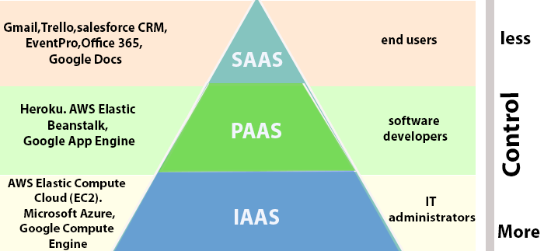

1. **Infrastructure as a Service (IaaS):**In IaaS, we can rent IT infrastructures like servers and virtual machines (VMs), storage, networks, operating systems from a cloud service vendor. We can create VM running Windows or Linux and install anything we want on it. Using IaaS, we don’t need to care about the hardware or virtualization software, but other than that, we do have to manage everything else. Using IaaS, we get maximum flexibility, but still, we need to put more effort into maintenance.
2. **Platform as a Service (PaaS):** This service provides an on-demand environment for developing, testing, delivering, and managing software applications. The developer is responsible for the application, and the PaaS vendor provides the ability to deploy and run it. Using PaaS, the flexibility gets reduce, but the management of the environment is taken care of by the cloud vendors.
3. **Software as a Service (SaaS):** It provides a centrally hosted and managed software services to the end-users. It delivers software over the internet, on-demand, and typically on a subscription basis. E.g., Microsoft One Drive, Dropbox, WordPress, Office 365, and Amazon Kindle. SaaS is used to minimize the operational cost to the maximum extent.

