create function hello123(s char(20)) returns char(30) deterministic

return concat('Hello Welcome ',s,'!');

select hello('LTI user');

Ex2:

DELIMITER $$

CREATE FUNCTION Customer_Occupation(

age int

)

RETURNS VARCHAR(20)

DETERMINISTIC

BEGIN

DECLARE customer_occupation VARCHAR(20);

IF age > 35 THEN

SET customer_occupation = 'Scientist';

ELSEIF (age <= 35 AND

age >= 30) THEN

SET customer_occupation = 'Engineer';

ELSEIF age < 30 THEN

SET customer_occupation = 'Actor';

END IF;

-- return the customer occupation

RETURN (customer_occupation);

END$$

select Customer_Occupation(40);

DELIMITER &&

**CREATE** **PROCEDURE** getdepartments ()

**BEGIN**

**SELECT** * **FROM** department **WHERE** id > 3;

**SELECT** COUNT(id) **AS** Total_Depatrments **FROM** department;

**END** &&

DELIMITER ;

CALL getdepartments()  ;

**Step 1:** Open the database and table.

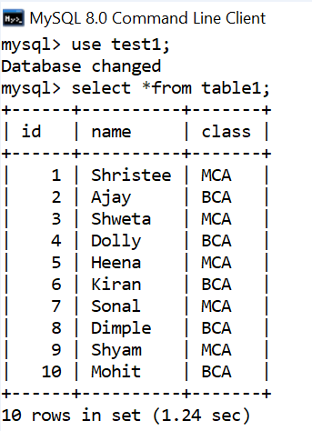

**Step 2:** Now create the cursor.

**Query:**

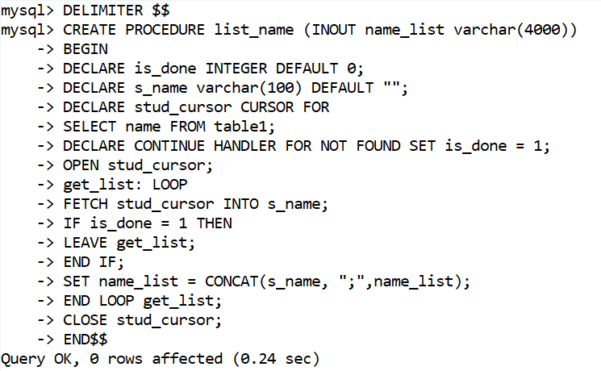

**Step 3:** Now call the cursor.

**Query:**

1. **SET** @name_list ="";
2. CALL list_name(@name_list);
3. **SELECT** @name_list;

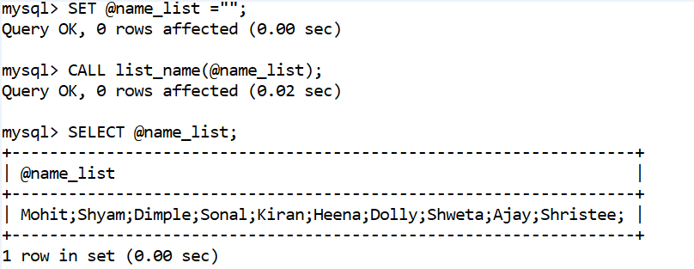sss