**1.**Create custom attribute directive to achieve the requirement as shown below:

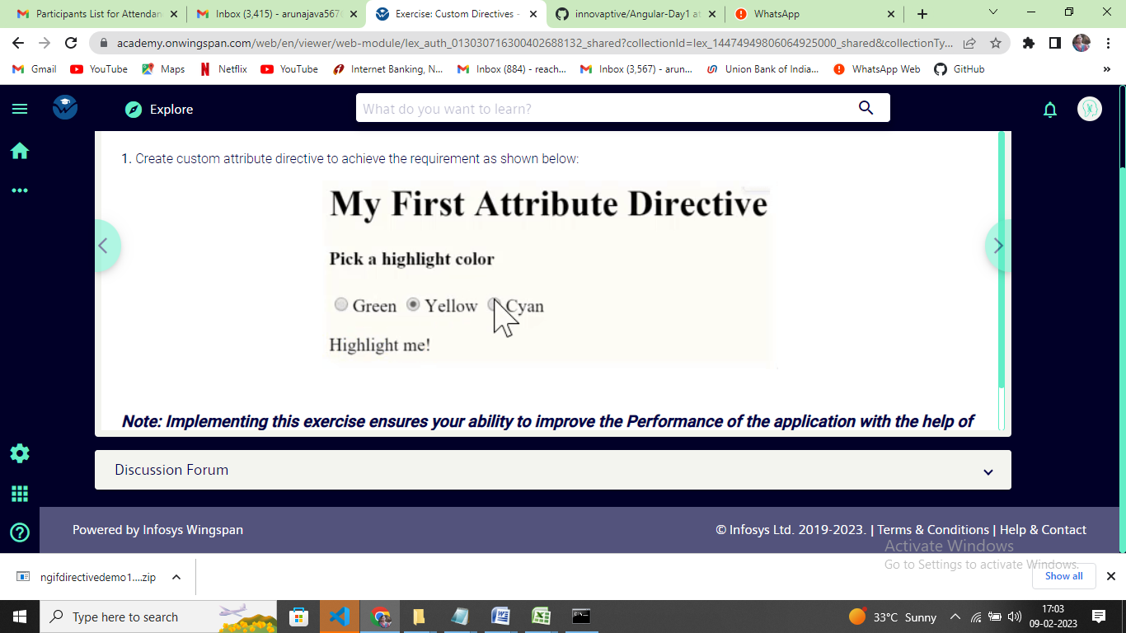

***Note: Implementing this exercise ensures your ability to improve the Performance of the application with the help of reusable custom attribute directives.***