**Problem Statement:**

Observe the output given below and implement the same functionality using Angular.

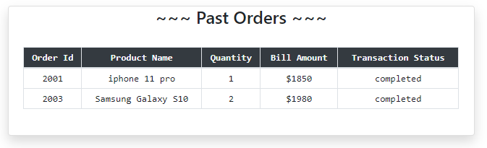

* Use the below array data to achieve the desired output:

1. [
2. { orderId: 2001, productName: "iphone 11 pro", quantity: 1, billAmount: 1850, transaction:'completed' },
3. { orderId: 2002, productName: "iphone 10", quantity: 1, billAmount: 990, transaction:'pending' },
4. { orderId: 2003, productName: "Samsung Galaxy S10", quantity: 2, billAmount: 1980, transaction:'completed' },
5. { orderId: 2004, productName: "Motorolla Edge+", quantity: 1, billAmount: 980, transaction:'pending' }
6. ]

* The products should be displayed only if the transaction is completed