**Problem Statement:**

Observe the output given below and implement the same functionality using Angular Directives and appropriate Data Binding:

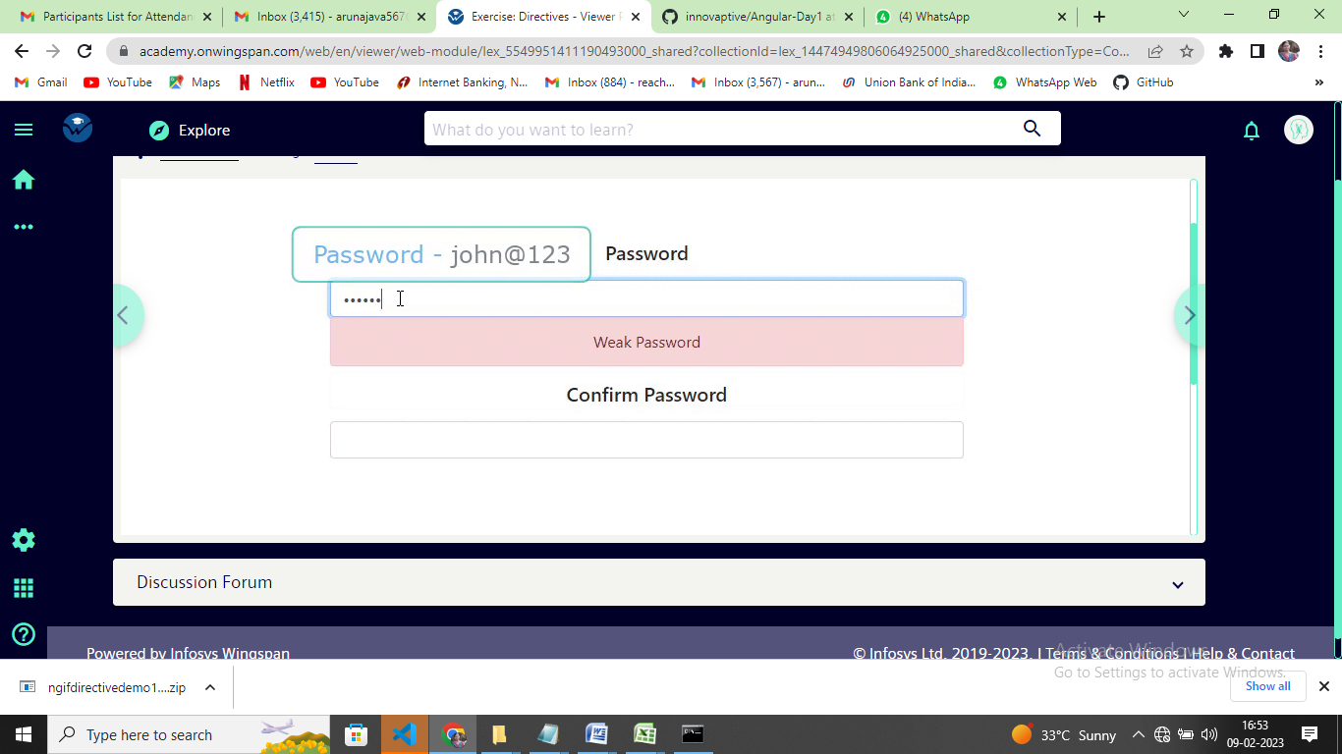

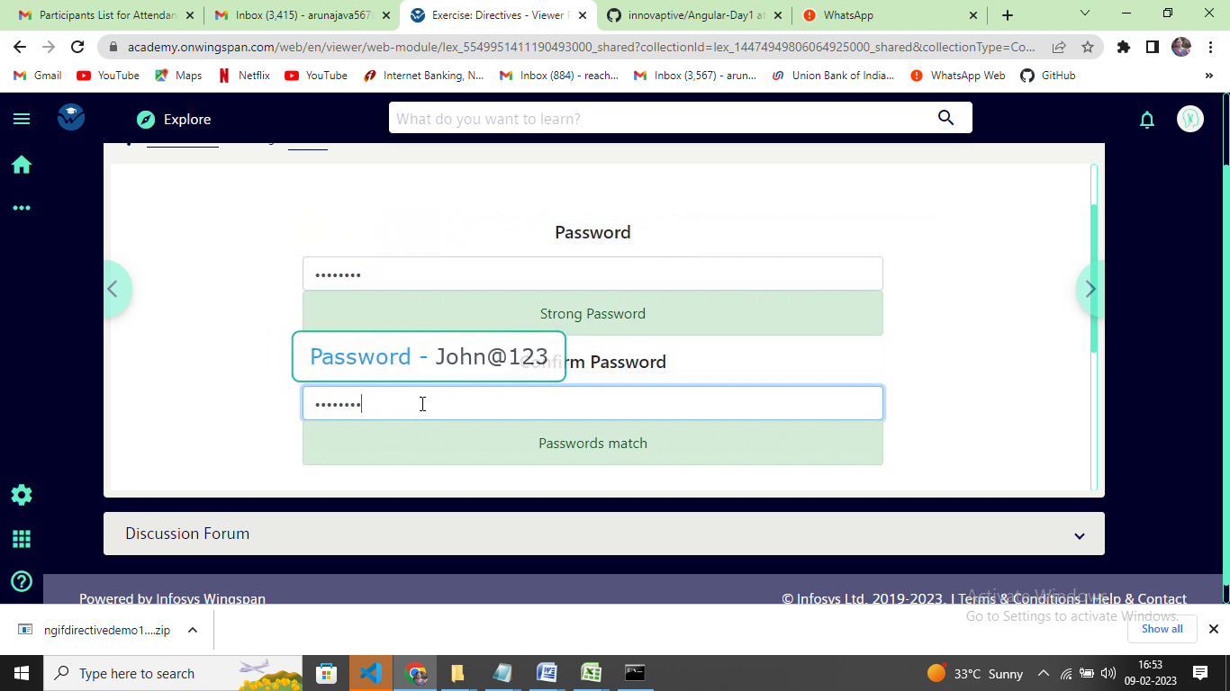

**Note:-**

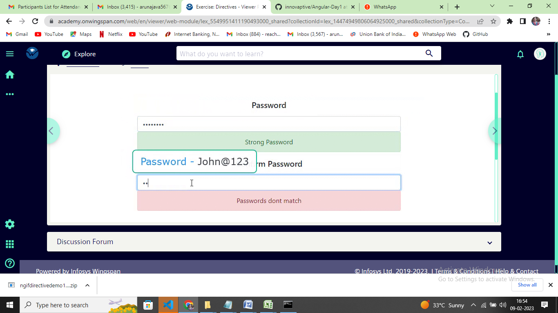

* If the entered password has an uppercase alphabet, lowercase alphabet, a number and a special character either of @ $ . _ and also is 8 or more characters in length, it is considered as ***strong password***
* If the entered password has an uppercase alphabet or lowercase alphabet along with a number and a special character either of @ $ . _ and also is 8 or more characters in length, it is considered as ***good password***
* In all other cases it is considered as a ***weak password***
* If confirm password value matches with the password fields value, display ***Passwords match,***else display ***Passwords dont match***