**Demo Steps**

**Problem Statement:**Create a login form. If the user enters correct credentials i.e. userName - admin & password - admin@123, it should display the message **"Welcome <<username>>"**  otherwise, it should render **"Invalid Credentials"** as shown below:

**Initial Page View**

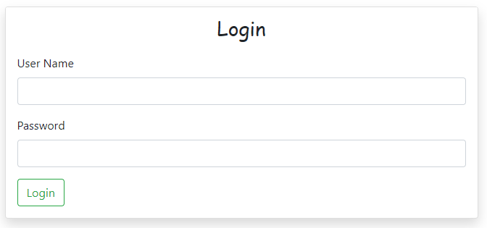

After entering correct/incorrect credentials and clicking on the **Login**button:

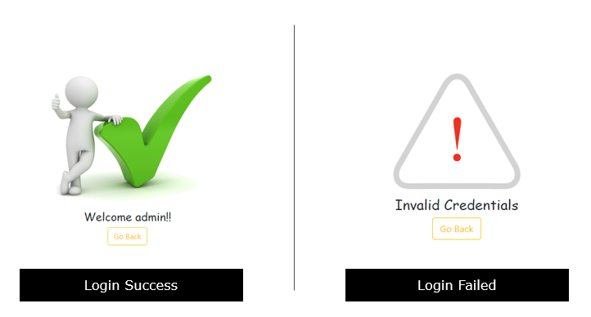

1. Add the below code in **app.component.ts** file:
2. import { Component } from '@angular/core';
3. import { FormBuilder, FormGroup } from '@angular/forms';
4. @Component({
5. selector: 'app-root',
6. templateUrl: './app.component.html',
7. styleUrls: ['./app.component.css']
8. })
9. export class AppComponent {
10. title = 'directives-app';
11. userName: string='';
12. password: string='';
13. loginSuccess = false;
14. loginFailed = false;
15. login() {
16. this.loginFailed = this.loginSuccess = false;
17. if (this.userName == "admin" && this.password == "admin@123") {
18. this.loginSuccess = true
19. } else {
20. this.loginFailed = true;
21. }
22. }
23. }

**Line 12-15: userName, password, loginSucess**and**loginFailed** are the AppComponent class properties

**Line 17 -24:** login method is invoked when user clicks on **Login** button. This method checks the username and password values entered are correct or not and accordingly assigns a Boolean value to loginSuccess or loginFailed property.

   2. Add the below code in **app.component.html** file

1. <div class="container-fluid">
2. <div class="row mt-5">
3. <div class="col-md-6 offset-md-3">
4. <div class="card shadow" *ngIf="!loginSuccess && ! loginFailed">
5. <div class="card-header text-center">
6. <h3 style="font-family: cursive;">Login</h3>
7. </div>
8. <form class="ml-3 mr-3 mb-3">
9. <div class="form-group">
10. <label for="userName">User Name</label>
11. <input class="form-control" type="text" name="userName" [(ngModel)]="userName">
12. </div>
13. <div class="form-group">
14. <label for="password">Password</label>
15. <input class="form-control" type="password" name="password" [(ngModel)]="password">
16. </div>
17. <button type="submit" class="btn btn-outline-success" (click)="login()">Login</button>
18. </form>
19. </div>
20. <div *ngIf="loginFailed" class="text-center">
21. <img src="loginfailed.png" alt="login failed">
22. <h4 style="font-family: cursive;">Invalid Credentials</h4>
23. </div>
24. <div *ngIf="loginSuccess" class="text-center">
25. <img src="loginsuccess.png" alt="login successful">
26. <h4 style="font-family: cursive;">Welcome {{userName}}!!</h4>
27. </div>
28. <div *ngIf="loginSuccess || loginFailed" class="text-center">
29. <button class="btn btn-outline-warning" (click)="loginSuccess=loginFailed=false">Go Back</button>
30. </div>
31. </div>
32. </div>
33. </div>

**Line 4:** **\*ngIf** directive is used to ensure the login form is displayed only if neither of **loginSuccess**or **loginFailed** is **true**

**Line 20:**It displays the error message if the user enters incorrect credentials and the **loginFailed**property is **true**

**Line 24:**It displays the success message if the user enters correct credentials and the **loginSuccess**property is **true**

**Line 28:**It displays the Go Back button if either of **loginSuccess**or**loginFailed** properties is **true**

If we observe in the above code we are using multiple **\*ngIf** directives to solve the requirement. There is an even better way to solve this using **if-else** followed by **ng-template** directive. Let us take a look at how to use **ng-template** directive.