**Demo Steps**

**Problem Statement:**Create a login form. If the user enters correct credentials i.e. userName - admin & password - admin@123, it should display the message **"Welcome <<username>>"**  otherwise, it should render **"Invalid Credentials"** as shown below:

**Initial Page View**

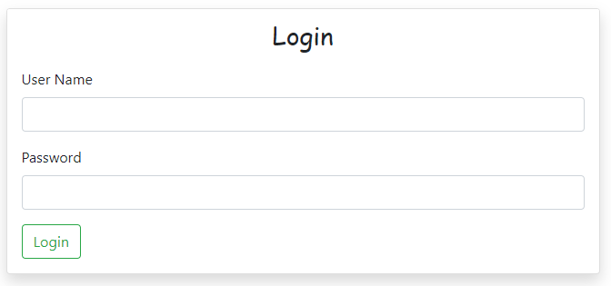

After entering correct/incorrect credentials and clicking on the **Login**button:

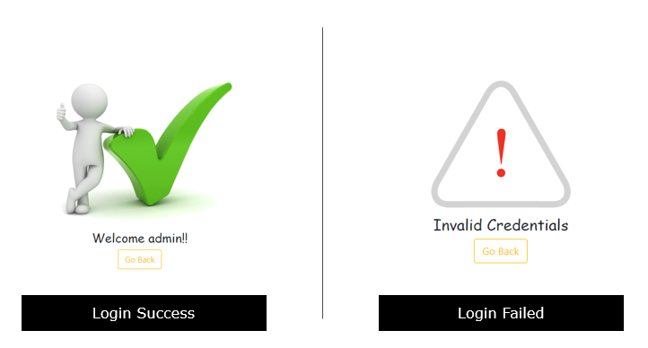

1. Add the below code in **app.component.ts** file:
2. import { Component } from '@angular/core';
3. import { FormBuilder, FormGroup } from '@angular/forms';
4. @Component({
5. selector: 'app-root',
6. templateUrl: './app.component.html',
7. styleUrls: ['./app.component.css']
8. })
9. export class AppComponent {
10. title = 'directives-app';
11. userName: string='';
12. password: string='';
13. loginSuccess = false;
14. loginFailed = false;
15. login() {
16. this.loginFailed = this.loginSuccess = false;
17. if (this.userName == "admin" && this.password == "admin@123") {
18. this.loginSuccess = true
19. } else {
20. this.loginFailed = true;
21. }
22. }
23. }

**Line 12-15: userName, password, loginSucess**and**loginFailed** are the AppComponent class properties

**Line 17 -24:** login method is invoked when user clicks on **Login** button. This method checks the username and password values entered are correct or not and accordingly assigns a Boolean value to loginSuccess or loginFailed property.

   2. Add the below code in **app.component.html** file

1. <div class="container-fluid">
2. <div class="row mt-5">
3. <div class="col-md-6 offset-md-3">
4. <div class="card shadow" *ngIf="!loginSuccess && ! loginFailed">
5. <div class="card-header text-center">
6. <h3 style="font-family: cursive;">Login</h3>
7. </div>
8. <form class="ml-3 mr-3 mb-3">
9. <div class="form-group">
10. <label for="userName">User Name</label>
11. <input class="form-control" type="text" name="userName" [(ngModel)]="userName">
12. </div>
13. <div class="form-group">
14. <label for="password">Password</label>
15. <input class="form-control" type="password" name="password" [(ngModel)]="password">
16. </div>
17. <button type="submit" class="btn btn-outline-success" (click)="login()">Login</button>
18. </form>
19. </div>
20. <div *ngIf="loginFailed" class="text-center">
21. <img src="loginfailed.png" alt="login failed">
22. <h4 style="font-family: cursive;">Invalid Credentials</h4>
23. </div>
24. <div *ngIf="loginSuccess" class="text-center">
25. <img src="loginsuccess.png" alt="login successful">
26. <h4 style="font-family: cursive;">Welcome {{userName}}!!</h4>
27. </div>
28. <div *ngIf="loginSuccess || loginFailed" class="text-center">
29. <button class="btn btn-outline-warning" (click)="loginSuccess=loginFailed=false">Go Back</button>
30. </div>
31. </div>
32. </div>
33. </div>

**Line 4:** **\*ngIf** directive is used to ensure the login form is displayed only if neither of **loginSuccess**or **loginFailed** is **true**

**Line 20:**It displays the error message if the user enters incorrect credentials and the **loginFailed**property is **true**

**Line 24:**It displays the success message if the user enters correct credentials and the **loginSuccess**property is **true**

**Line 28:**It displays the Go Back button if either of **loginSuccess**or**loginFailed** properties is **true**

If we observe in the above code we are using multiple **\*ngIf** directives to solve the requirement. There is an even better way to solve this using **if-else** followed by **ng-template** directive. Let us take a look at how to use **ng-template** directive.

With ng-template

**Problem Statement:**

Create a login form. If the user enters correct credentials i.e. userName - admin & password - admin@123, it should display the message **"Welcome <<username>>"**  otherwise, it should render **"Invalid Credentials"** as shown below:

**Initial Page View**



After entering correct/incorrect credentials and clicking on the **Login**button:



1. Modify the code in **app.component.html**with the below code

1. ​<div class="container-fluid">
2. <div class="row mt-5">
3. <div class="col-md-6 offset-md-3">
4. <div class="card shadow" *ngIf="!loginSuccess && !loginFailed; else messages">
5. <div class="card-header text-center">
6. <h3 style="font-family: cursive;">Login</h3>
7. </div>
8. <form class="ml-3 mr-3 mb-3">
9. <div class="form-group">
10. <label for="userName">User Name</label>
11. <input class="form-control" type="text" name="userName" [(ngModel)]="userName">
12. </div>
13. <div class="form-group">
14. <label for="password">Password</label>
15. <input class="form-control" type="password" name="password" [(ngModel)]="password">
16. </div>
17. <button type="submit" class="btn btn-outline-success" (click)="login()">Login</button>
18. </form>
19. </div>
20. <ng-template *#messages>*
21. <div class="text-center">
22. <ng-container *ngIf="loginFailed">
23. <img src="loginfailed.png" alt="login failed">
24. <h4 style="font-family: cursive;">Invalid Credentials</h4>
25. </ng-container>
26. <ng-container *ngIf="loginSuccess">
27. <img src="loginsuccess.png" alt="login successful">
28. <h4 style="font-family: cursive;">Welcome {{userName}}!!</h4>
29. </ng-container>
30. <button class="btn btn-outline-warning" (click)="loginSuccess=loginFailed=false">Go Back</button>
31. </div>
32. </ng-template>
33. </div>
34. </div>
35. </div>

**Line 4:**  form card will be displayed if loginSuccess and loginFailed properties are **true**else it will display an alternate template with reference name messages.

**Line 20:** **ng-template** is an angular element for rendering HTML. It does not get displayed directly and needs to be used with a structural directive. Here again we have used a template variable to store the **<ng-template>** reference. This variable can be used to display the associated **<ng-template>**.

2. Save the files and check the output in the browser.

Now that we have learnt how to manipulate the DOM using ngIf, let us continue our discussion on structural directives by taking up **ngFor** next.